- Network: is a group of computers and other devices (such as printers) that are connected by some type of transmission media.
  - Variations on the elements of a network and the way it is designed are nearly infinite.
  - It can be as small as 2 computers connected by a cable in a home office or as large as several thousand computers connected across the world.
  - Networks can link mainframe computers, printers, plotters, fax machines, and phone systems.
  - Can communicate through copper wires, wfiber optic ables, or radio waves.

- WHY USE NETWORKS
  - Has advantages over “ stand alone” computers ( a computer that is not connected to other computers and that uses software applications and data stored on its local disks)
  - Enable multiple users to share devices (printers) and data (spreadsheet files) resources**
  - Sharing devices save :
    - Money (ie: 1 printer for 2 employees instead of 2 printers)
    - Time: (ie: faster to share data over a network then to transfer on disks or usbs) sneakernet “people wore sneakers when walking from computer to computer”
  - Allow you to manage resources on multiple computers from a central location.
  - All organizations depend on their networks to stay competitive. Networks increase productivity.

TYPES OF NETWORKS (2)
  - Peer-To-Peer Networks:
    - Simplest
    - Communicate directly with each other. No computer has more authority than the other.
    - Each computer can be configured to share only SOME of its resources and prevent access to other resources.
    - Consists of two or more general purpose computers with modest processing capabilities.
    - Every computer is able to send and receive information to and from every other computer.
    - Advantages:
      - They are simple to configure. They may be used in environments in which time or technical expertise is scarce.
      - They are often less expensive to set up and maintain than other types of networks. This fact makes them suitable for environments in which saving money is critical.
    - Disadvantages:
      - Not very flexible. As they grow adding or changing significant elements of the network will be difficult.
      - Not secure – data and other resources shared can be easily discovered and used by unauthorized people.
      - Not practical for connecting more than a handful of computers because they do not always centralize resources.
    - a common way to share resources on a P2P network is by modifying the file sharing controls via the computers operating system. Configure a directory to allow all networked computers to access and read the files in the directory.
    - Typically small and contained with a home or office
    - Large ones have emerged (bit torrent) sharing over the internet.
  - Client/Server Networks:
    - Use a central computer known as the Server which facilitates communication and resource sharing between other computers on the network, which are known as Clients (personal computers also known as workstations or mobile devices).
    - A server that enables clients to share data, data storage space, and devices is known as such.
    - Architecture : refer to the design of a network in which clients rely on servers for resource sharing and processing
    - A server only allows authorized users to access its resources ( like a library and its librarian)
    - Clients can still run applications from and save data to their local disk, but by connecting to a server they can also have the option of using shared applications data and devices.
    - Don't share info directly, use the server as an intermediary.
    - They communicate through connectivity devices such as switches or routers
    - A server must be functioning on an NOS (network operating system)
      - NOS is a special type of software designed to:
        - Manage data and other resources for a # of clients
        - Ensure that only authorized users access the network
        - Control which type of files a user can open and read
        - Restrict when and from where users can access the network
        - Dictate which rules computers will use to communicate
        - Supply applications to clients.
        - Ie: UNIX, LINUX, WINDOWS, MAC OSX
      - More complex in their design and maintenance than peer to peer networks
      - Advantages:
        - User logon accounts and passwords for anyone on a server based network can b assigned in one place.
        - Access to multiple shared resources (such as data files or printers) can be centrally granted to a single user or group of users
        - Problems on the network can be monitored, diagnosed, and often fixed from one location.
        - Serves are optimized to handle heavy processing loads and dedicated to handling requests from clients, enabling faster response time.
        - Can connect more than a handful of computers on a network.
        - It is easier to add computers and other devices on a client/server network.
  - LANS, MANS, WANS:
    - LAN ( local area network ) a network of compuers and other devices that is confined to a relatively small space. Building or office. 1980. Handful of computers P2P fashioned. Todays lans are much larger and more complex client/server networks.
    - MAN ( metropolitan area network ) connects clients and servers from multiple buildings.
    - WAN ( Wide area network ) a network that connects two or more geographically distinct LANS or MANS. MANS can be WANS. Commonly connect separate offices in the same organization whether they are across town or around the world. THE INTERNET IS A WAN!
  - Elements Common to Client/Server Networks:
    - Client: a computer on the network that requests resources or services from another computer on a network in some cases a client could also act as a server. The the term client may also refer to the human user of a client workstation or to client software installed on the workstation
    - Server: a computer on the network that manages shared resources; servers usually have more processing power, memory, and hard disk space than clients, they run network operating software that can manage not only data, but also users, groups, security and applications on the network.
    - Workstation: A personal computer, which may or may not be connected to a network; most clients are workstation computers.
    - Network interface Card (NIC): the devices that connects a computer to the network media, thus allowing it to communicate with other computers; many companies manufacture nics, which come with a variety of specification that are tailored to the requirements of the workstation and the network. Some connect to the motherboard, which is the main circuit that controls the computer, some are integrated as part of the motherboard, and others connect via an external port. Also known as NETWORK adapters.
    - Network Operating System (NOS): software that runs a server and enables the server to manage data, users, groups, security, applications, and other networking functions.
    - Host: a computer that enables resource sharing by other computers on the same network.
    - Node: a client, server, or other device that can communicate over a network and that is identified by a unique number, known as its network address.
    - Connectivity device: a specialized device that allows multiple networks or multiple parts of one network to connect and exchange data. A small client/server network can operate without connectivity devices. However medium and large sized LANS use them to extend the network and to connect with wans. Wans use them to connect to the internet and other WANS.
    - Segment: a part of a network. Usually a segment is composed of a group of nodes that use the same communications channel for all their traffic.
    - Backbone: The part of a network to which segments and significant shared devices (routers, switches servers) connect. A backbone is sometimes referred to as a network of networks because of its role in interconnecting smaller parts of a lan or wan.
    - Topology: The physical layout of a computer network. Vary according to the needs of the organization and available hardware expertise. Networks can be arranged in a RING, BUS or STAR information and the star formation is the most common. HYBRID combinations of these patterns are also possible.
    - Protocol: a standard method or format for communication between networked devices.
    - Packet: a distinct unit of data exchanged between nodes on a network. Breaking a large steam of data nto many packets allow a network to deliver that data more efficiently and reliably.
    - Addressing: the scheming for assigning a unique identifying a number to every node on the network.
    - Transmission: The means through which data are transmitted and received. May be physical like a wire or atmospheric wireless such as radio waves.

  - How Networks Are Used
    - Network services are the functions provided by the network
      - Network service with the highest visibility is email
    - File and Print Services
      - File Services: Servers ability to share data files, applications, and disk storage space.
      - Server that provides file service is called a file server
      - Data stored at a central location is more secure because a network administer can take charge of backing up this data, rather than relying on individual users to make their own copies.
      - Print services is used to share printers across a network which saves time and money
    - Access Services
      - This allows remote users to connect to the network

  - Communications Service
    - Using the same network to deliver multiple typed of communication services known as convergence (email, telephone, video, fax, smart phone)

  - Internet Services
  - Most popular web server is Apache

  - Management Services
    - As networks grow they become more difficult to manage
    - Service which fall under management services are..
      - Traffic Monitoring
    - Load balancing: distributing data transfer activity o no single device becomes overwhelmed
    - Asset Management: Server is able to electronically examine each clients software and hardware automatically and save data in the database
    - RDIF (radio frequency identification) uses tags which emit a wireless signal at all times (ex. on wheel chairs in a hospital so they know where they are at all times)
    - License tracking
    - Security auditing
    - Software distribution
    - Address management
    - Backup and restoration of data

  - Becoming a Network Professional
    - Mastering technical challenges
    - Developing soft skills
    - Certifications

Networking Standards Organizations
  - Standards: documented agreements containing technical specifications or other precise criteria that stipulate how a particular product or service should be designed or performed.
  - Standards define the minimum acceptable performance of a product or service, NOT the ideal
  - ANSI an IEEE are involved in setting standards for wireless networks.
  - ANSI prescribes the kind of NIC that the consumer needs to accept a wireless connection
  - IEEE prescribes how the network will ensure that different parts of a communication sent through the atmosphere arrive at their destination in the correct sequence.

  - American national standards institute (ANSI)
  - Electronic industries alliance Telecommunications Industry Associations (EIA & TIA)
  - Institute Of Electrical And Electronic Engineers (IEEE)
  - International Organization of Standardization (ISO)
  - International Telecommunication Union (ITU)
  - Internet Society (ISOC)
  - Internet Assigned Numbers Authority & Internet Corporation For Assigned Names & Numbers (IANA & ICANN)

- The Osi Model

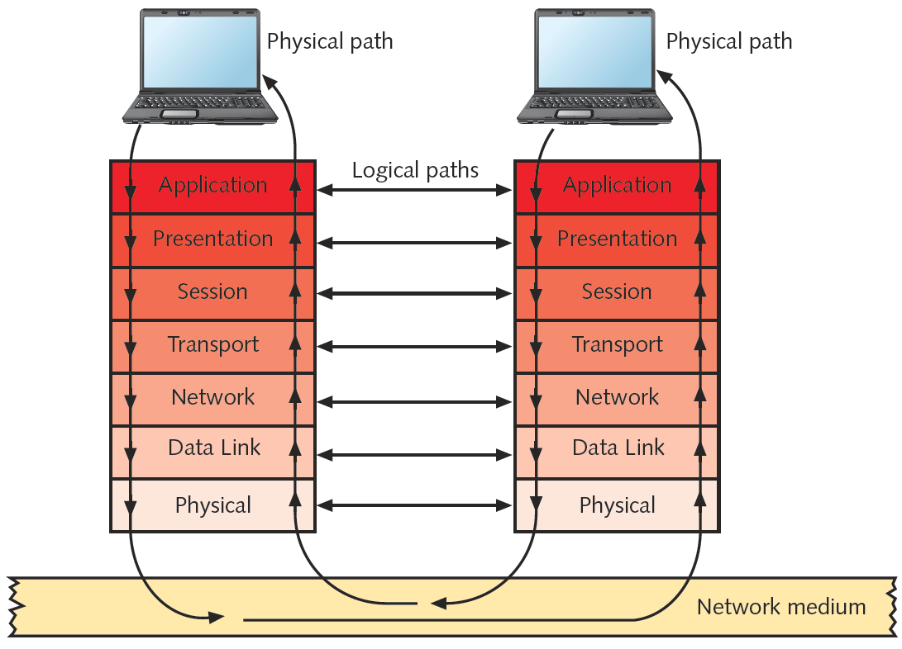
  - Open Systems Interconnection Model
  - At each layer protocols perform services unique to that layer.
  - Protocols interact with other protocols on layers above and below.
  - Protocols are a set of instructions written by a programmer to perform a function or group of functions.
  - The OSI model is a theoretical representation of what happens between two nodes communicating on a network.

- Layers | - Functions | - Protocols | - Hardware
- 7 Application | - User Interface: ex. browser | - http, ftp, smtp, pop3, | - Gateway
- 6 presentation | - Data format, encryption, compression, text, GIF, JPEG  - ENGLISH, FRENCH, SPANISH ETC. | - PGP (pretty good privacy, email encryption), SMIME, EFS, | - Gateway
- 5 Session | - Handshaking, (3 types:  - Simplex one way communication ex. radio tv  - Half Duplex two way communication system BUT one at a time, ex. Walkie-talkie  - Full Duplex is the true way communication system ex. phone system, network interface | - Ping | - Gateway
- 4 Transport | - Data delivery | - TCP (transmission control protocol) , UDP (User data protocol) | - Gateway
- 3 Network Layer | - Addressing | - IP, ICMP, IGMP, VOIP | - Router, Switch^3, iPhone, iPad, iPod, GPS, Gateway
- 2 Data Link | - LLC Function: Data flow (Generates frame= binary packet  - Mac Function: Physical Addressing 12, first 6 called manufacture ID, second six called the device ID or Nic ID | - LLC (LOGICAL LINK CONTROL), MAC (physical address) media access control  - ARP (Address resolution protocol)it maps IP to mac  - RARP (reverse address resolution protocol) Given a MAC address it will return its IP  - PING | - NIC, SWITCH, BEIDGE, MODEM
- 1 Physical Layer | - Signal the processing | - 802.1 Defined network  - 802.3 Ethernet (Bus, Star)  - 802.5 Token Ring (IMB)  - 802.6 Man (metro area network)  - 802.8 fiber protocol  - FDDI  - 802.11 Wireless (versions a,b,g) b is wifi  - 802.15 PAN, HAN  - 802.16 Wireless Broadband | - Network Cable (coaxial cable, trusted pair ex. cat 5, fiber), Hub, Repeater, AP

- IEEE Networking Specifications
- 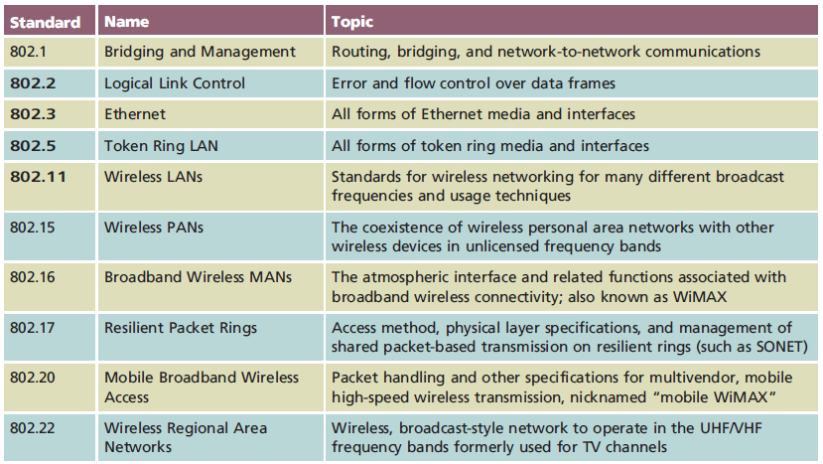

- Transmission: refers to either the process of transmitting or the progress of signals after they have been transmitted.

- Analog & Digital Signaling:
  - Computers generate and interpret digital signals as electrical current, the pressure of which is measured in volts. The strength of the signal is directly proportional to its voltage.
  - Analog signals are also generated as voltage. In analog signals voltage varies continuously and appears as a wavy line when graphed over time.
    - Characterized by four fundamental properties; amplitude, frequency, wavelength and phase.
    - Amplitude is the measure of strength at any give point in time. It is the height of the wave at anytime on the graph.
    - Frequency is the number of times that a waves amplitude cycles from its starting point, through its highest amplitude and its lowest amplitude and back to the starting point. It is expressed in cycles per second or Hertz (HZ)
    - Wavelengths the distance between corresponding points on a waves cycle. Is measured in meters for feet.Is inversely proportional to its frequency… the higher the frequency the shorter the wave length.
    - Phase Refers to the progress of a wave over time in relationship to a fixed point.
    - One benefit of analog signals is that they can convey greater subtleties with less energy.
    - One drawback is that analog transmission is more susceptible to transmission flaws such as noise, or any type of interference that may degrade the signal.
  - Digital signals are composed of pulses of precise, positive voltages and zero voltages. A pulse of a positive charge represents a 1 and a pulse of zero voltage is a 0. The use of the 1’s and 0’s to represent information is characteristic of a binary system. Every pulse in a signal is called a binary digit or a BIT.
    - A bit can only be a 1 or 0. Eight bits together form a byte. One byte carries one piece of information.
- 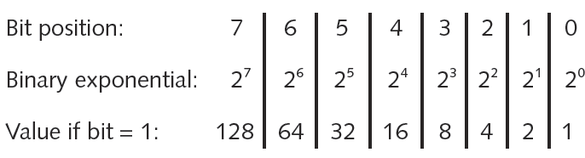
  - Overhead is a term used by networking professionals to describe non data information that must accompany data for a signal to be properly routed and interpreted by a network.

- Data Modulation :
  - Is a technology used to modify analog signals to make the suitable for carrying data over a communication path. MODULATION, a simple wave, called a carrier wave is combined with another analog signal to produce a unique signal that gets transmitted from one node to another.
  - Modulation can be used to make a signal conform to a specific pathway, as in the case of FM (frequency modulation) radio in which data must travel along a particular frequency.
    - In FM the frequency of the carrier signal is modified by the application of the data signal.
    - In AM (Amplitude modulation) the amplitude of the carrier signal is modified by the application of the data signal.
  - Modulation may also be used to issue multiple signals to the same communications channel and prevent the signals from interfering with one another.
- Simplex, Half-Duplex, Duplex
  - Simplex : signals that travel in one direction. Ie) speaking through a megaphone. (unidirectional, one-way communication)
  - Half Duplex: signals may travel in both directions over a medium but in only one direction at a time. Contain only one channel for communication, and that channel must be shared for multiple nodes. Ie) an intercom system in an apartment building.
  - Full Duplex: signals are free to travel in both directions over a medium simultaneously. (bidirectional transmission, duplex) ie) Phone conversations. Used in data networks. Ethernet networks to achieve duplex transmission using multiple on the same medium. A channel is a distinct communication path between nodes.
  - Multiplexing: allows multiple signals to travel simultaneously over one medium . To carry multiple signals , the mediums channel is logically separated into multiple smaller channels, or subchannels.
    - A MULTIPLEXER (MUX) is required at the transmitting end of the channel. At the receiving end a demultiplexer (demux) separates the combined signals and regenerates them in their original form. Networks rely on multiplexing to increase the amount of data that can be transmitted in a given time span over a given bandwidth.
    - Type of Multiplexing : TDM (time division multiplexing) , divides a channel into multiple intervals of time or time slots. It assigns a separate time slot to every node on the network and in that time slot, carriers data from that node.
    - Statistical Multiplexing: similar to TDM, but rather than assigning a separate slot to each node in succession, the transmitter assigns slots to nodes according to priority needed. More efficient then TDM.
    - FDM (Frequency division multiplexing):

