Final Exam Study/Prep: covers material from weeks 8 to 13; Lectures 14 – 23; Chapters 8, 9, 10, 11, 13, and 14 (pp. 369-386)] See Below:
Week | Lecture | Date | Topic | Reading
8 | 14 | March 6 | Fitness to stand trial & criminal responsibility | Chapter 8
9 | 15  16 | March 11  March 13 | Sentencing  Parole decision making & public attitudes  (Guest lecture Henriette Bergström) | Chapter 9  Chapter 9
10 | 17  18 | March 18  March 20 | Risk assessment  Risk assessment & Domestic Violence | Chapter 10  Chapter 13
11 | 19  20 | March 25  March 27 | Domestic violence & Stalking  Homicide | Chapters 13  Chapter 14 (pp 369-386)
12 | 21  22 | April 1  April 3 | Multiple murderers  Psychopathy | Chapter 14 (pp 369-386)  Chapter 11
13 | 23 | April 8 | Psychopathy | Chapter 11

Study Notes:
Week:8 / Lecture:14 / Date: March 6 ---- Theme: Fitness to Stand Trial
Info from Slides/Lecture Notes:
- Ashley Smith Case – 19 year old commits suicide in prison-preventable death?
- Key Concepts in regards to pleading:
  - Mute by malice
    - “peine forte et dure”
    - Mental disorder
  - Mute “ex visitatione Dei” spared this ordeal
    - Visitation of God
- Fitness: Section 672 of CCC:
  - Unable on the account of a mental disorder to
  - Understand the nature or object of the proceedings
  - Understand the possible consequences of the proceedings
  - Communicate with counsel
  - Presumed to be fit to stand trial
- Fitness to stand trial’s 4 core elements:
  - 1) Focus is on defendant’s present ability (not based on past mental state)
  - 2) Focus is on capacity not willingness
  - 3) Possess a reasonable knowledge
  - 4) Emphasis is on cognitive functioning and not on mental disorder
- Limitations of treatment order:
  - Treatment order can force person to participate in treatment
  - Cannot be forced to undergo Electric Shock Therapy or Surgery
- Prevalence of Mental Disorders: Most common disorder among male offenders age 18-44?
  - Anti-Social Personality Disorder
  - Drug Abuse
  - Schizophrenia not as common
- Competency Screening Test
  - Criticism:
    - High rate of false positives (20%)
    - Score could be low because … Unfit, cynical, depressed
  - 22-item sentence completion/ 3-point scale (2 = competent,1 = unsure, 0 = incompetent)
  - Low scores (e.g. < 20) possibly incompetent
- NCRMD = Not criminally responsible on account of a mental disorder:
  - No person is criminally responsible for an act or omission committed while suffering from a mental disorder that rendered that person incapable of….
    - 1) Appreciating the nature and quality of the act or omission or
    - 2) Knowing that it was wrong
  - Comparison of NCRMD and Fitness:
NCRMD | Fitness to stand trial
Requires presence of mental disorder | Requires presence of mental disorder
Legal defense to criminal charges | Postpones trial process
Requires admission of crime | Does not require admission of crime
Focus on mental state at time of offence | Focus on mental state at any point during trial process

- Some myth busting stats:
  - Canada: 2 in 1000 cases use NCRMD as a defense (myth: Large number of defendants use the defense)
  - Successful in 25% of cases that use NCRMD (myth: defense is always successful)
- Automatism
  - Definition: Unconscious, involuntary behavior, the state of a person who, though capable of action, is not conscious of what he is doing
  - Not voluntary = not criminally liable
Study Notes from Textbook / Chapter 8
- Fitness to Stand Trial – Legislation and Key Cases
  - Bill C-30 -1992
    - Acknowledged problems with the mental disorder provisions in criminal code
    - Stated a fitness to stand trial standard
    - “Addressed length of time a defendant could be held in custody for a fitness evaluation”
      - 5 day limit on court ordered assessments
      - Extensions granted are not to exceed 30 days
      - Entire detention is not to exceed 60 days
  - Criminal Code (C-46) – “A defendant is assumed to be fit to stand trial unless the court is satisfied on the balance of probabilities that he or she is unfit”
    - Burden of proof of unfitness rests on whoever raised the issue….Both the defense and the crown has the right to raise issue of fitness.
  - Bill C-10 (key case involved: R v. Demers)
    - A court can rule for a stay or proceedings if the defendant is unlikely to become fit if three main conclusions are rendered:
      - 1) The accused is unlikely ever to become fit
      - 2) The accused does not pose a significant threat to the safety of the public
      - 3) A stay of proceeding is in the interest of the proper administration of justice
  - Who Can Assess Fitness?
    - Canadian Criminal Code excludes criminal psychologists from conducting the fitness assessment and states that it must be a medical practitioner. A psychologist can however to evaluations such as that of diagnosis mental disorders that may assist in the process.
  - R v. Prichard = key case for “fitness standard”
  - R v Taylor = key case – “the court ruled that a defendant need only be able to state the facts relating to the offence that would allow an appropriate defense” - test in regards to being able to communicate with counsel is cognitive based
- Fitness to Stand Trial – Key Concepts
  - Fitness Instruments
    - FIT-R – semi-structured interview designed to assess the 3 main psychological abilities in the fitness codes standard. (rated on a 3 point scale)
      - 1) “Understand the nature or object of the proceedings”
      - 2) “Understand the possible consequences of the proceedings”
      - 3) “Communicate with counsel”
      - Final decision has 3 stages:
        - 1) Determine existence of mental disorder
        - 2) Determine defendant’s capacity regarding the three psychological abilities
        - 3) Examine section ratings to constitute a separate judgment based on the severity of impairment
    - CST – Competency Screening Test
      - Sentence completion by respondent to a series of 22 questions
      - Measures 3 key constructs:
        - 1) Understanding court process
        - 2) Emotional capability of coping
        - 3) Potential for constructive relationship between defendant and lawyer.
      - Scoring: 3 point scale – score below 20 suggests need for more comprehensive evaluation
    - CAI – Competency to Stand Trial Assessment Instrument = Interview style assessment designed to accompany the CST
    - IFI – Interdisciplinary Fitness Interview
      - Semi-structured interview measures 3 key areas of competency:
        - 1) Functional memory
        - 2) Appropriate relationship with lawyer
        - 3) Understanding of justice system
      - Four main sections:
        - 1) A-Legal items
        - 2) B- Psychopathological items
        - 3) C – Overall evaluation
        - 4) D- Consensual judgment
    - MacCAT-CA - McArthur Competence Assessment Tool-Criminal Adjudication
      - Interview that includes hypothetical scenarios in which a series of questions are asked pertaining to them. Total 22 questions.
      - Assess competency in three main areas:
        - 1) Factual understanding of the legal system and the adjudication process
        - 2) Reasoning ability
        - 3) Understanding of own legal situation and circumstances
  - Insanity: “Impairment of mental or emotional functioning that affects perceptions, beliefs, and motivations at the time of the offence” …. “In a legal context, insanity removes the responsibility for performing a particular act because of uncontrollable impulses or delusions, such as hearing voices”
    - Two British cases of precedence:
      - Moran 1985 – Criminal Lunatics Act was established
      - R v. McNaughton 1843 – critical elements pertaining to insanity that emerged:
        - A defendant must be found to be suffering from a defect of reason/disease of the mind
        - Defendant must not know the nature and quality of the act he or she is performing
        - Defendant must not know that what they are doing is wrong in nature
    - Bill C-30 replaced insanity plea with NCRMD standards and plea also creating review boards which are legal bodies mandated to oversee care of defendants deemed NCRMD --- also introduced “capping” meaning limiting the time a person with a mental illness could be affected by their disposition.
    - NCRMD defendants possible outcomes:
      - Absolute discharge: released into society with no conditions
      - Conditional discharge
      - Admitted to mental health facility
  - Automatism: See slides notes and pg. 217-220 of the textbook

Week9 /Lecture 15 / Date: March 11 --- Theme: Sentencing
Info from Slides/Lecture Notes:
- Goals of Sentencing:
  - Denunciation (7)
  - Specific deterrent (3)
  - General deterrent (5)
  - Incapacitation (6)
  - Rehabilitation (4)
  - Reparation (2)
  - Promote responsibility (1)
- Sentencing Options
  - Absolute/conditional discharge
  - Probation
  - Restitution
  - Fines/Community Service
  - Conditional sentence
  - Imprisonment
- Fundamental Principle
  - “A sentence must be proportionate to the gravity of the offence and the degree of responsibility of the offender”
    - CCC, Section 718 (1996)
- Automatism
  - Premise
    - Voluntary conduct is essential to be found guilty of committing an offence
  - Definition
    - Unconscious, involuntary behavior, the state of a person who, though capable of action, is not conscious of what he is doing
- Capital Punishment
  - 1976 death penalty abolished
  - 1962 last execution in Canada
- Death Penalty Pros and Cons
  - What arguments support the death penalty?
    - Specific deterrence: will deter offender from killing anyone
    - General deterrence: if you have it on the books, maybe it will stop people from committing murder
    - An eye for an eye
    - Cheaper than holding someone for life, prisons are getting overcrowded
  - What arguments challenge the death penalty?
    - General deterrence doesn’t work because many offenders commit reactive, impulsive murders
      - The state with death penalty has higher homicide rates
    - There have been 138 DNA exonerated individuals who were executed before the evidence was found
      - Chance of error is too high
    - Conscience of killing—murder should be wrong whether it’s from offender or state
- Case: Roper v Simmons(Key Case: Banned juvenile death penalty)
  - At the age of 17, Simmons planned and committed a capital murder. After he had turned 18, he was sentenced to death. His direct appeal and subsequent petitions for state and federal post-conviction relief were rejected. Simmons filed a new petition for state post- conviction relief, arguing that Atkins reasoning established that the Constitution prohibits the execution of a juvenile who was under 18 when he committed his crime. The Missouri Supreme Court agreed and set aside Simmons' death sentence in favor of life imprisonment without eligibility for release.

Week9 /Lecture 16/ Date: March 13---Parole decision making & public attitudes (Guest lecture Henriette Bergström)
Info from Slides:
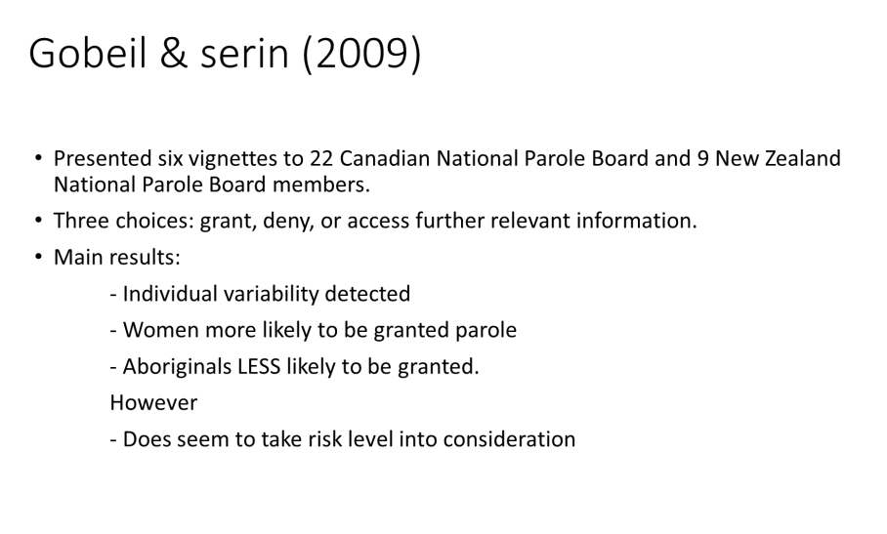
Week:10/ Lecture:17/Date: March 18/ Theme: Risk Assessment
Info from Slides:
- Principles of Effective Treatment (Don Andrews)
  - Risk principle (WHO)
    - Match risk level to treatment services level
  - Need principle (WHAT)
    - Target criminogenic needs rather than non-criminogenic needs
      - Criminogenic needs = dynamic factors that are associated with criminal behavior
  - Responsivity principle (HOW)
    - Match style and mode of treatment delivery to offender’s ability and learning style
- Risk Factors for Criminal Behavior
  - Central Eight
    - Family/marital problems
    - School/work problems
    - Problematic leisure time
    - Substance abuse
  - Big Four
    - History of antisocial behavior
    - Antisocial attitudes
    - Antisocial associates
    - Antisocial personality pattern
Study Notes from Textbook / Chapter 10/ Lecture
- Death Row – Competency- Ricky Ray Rector
  - Had brain damage killed police officer, shot himself in the head and it caused huge damage. He was found guilty of capital murder, put on death row
  - When given last meal he asked for steak, fried chicken, cherry Kool-Aid, big slice of pecan pie
  - Told the correctional officers who take him to death chambers not to eat his pie
    - Key point… He thought he was going to come back and eat his pie, his IQ was around 60, Obviously, he would not have been found competent if they analyzed further
- Duty to Warn
  - In Canada, the Code of Ethics for Psychologists says that you must do anything possible to prevent serious injury/death to anyone.
- MAY include reporting to the appropriate authorities or an intended victim
- MAY, not SHALL—don’t necessarily have to
  - Relevant Key Case:
    - Tarasoff Case
      - Tardar—student from India. Came to India. Didn’t know the norms of relationships in North America.
      - New Year’s Eve—victim (Tatanna) kissed him under mistletoe at New Year’s Eve. He thought they would get married and live together. Became very focused on her. She wasn’t interested. Kept pestering her, she rejected him.
      - She left to go to Brazil/Peru for summer program.
      - He went to counseling services—talked to psychologist, mentioned how upset he was that she “led him on”. Over second interview, he told psychologist that he wanted to kill her.
      - Psychologist had to make a decision—there’s a threat, he knows who the victim. Do I break patient-therapist confidentiality or not? Psychologist decided to phone campus security (broke confidentiality), told them that he was worried about the boy. Security went to his dorm and talked to him, he denied it. Campus security AGAIN did a risk assessment determined he was not at risk
      - Tatanna came back—October 1969—he went to her dorm with a knife and stabbed her to death
      - Her parents sued the university and the psychologist for not protecting the victim. They claim that they and she were never told that she was at risk.
      - Case was settled—university paid family.
- Predictions and Outcomes – Risk Assessment
  - Prediction can either be…
    - Low risk
    - High risk
  - Outcome can either be…
    - Violent
    - Not violent
  - Prediction + outcome =
    - 1) predict high risk + outcome commit violent offence = true positive (correct prediction)
    - 2) predict low risk + outcome don’t commit violent offence = true negative (correct prediction)
    - 3) predict high risk + outcome don’t commit violent offence = false positive (incorrect)
    - 4) predict low risk + outcome commit violent offence = false negative (incorrect)
- Risk Assessments – When is it necessary?
  - Civil Contexts:
    - Civil commitment – hospitalization mandatory of a person who is a danger to themselves or others due to possibility of harm
    - Child Protective Services contexts – temporarily removing a child from home or parental rights.
    - Immigration Laws – someone who is at risk of violent behavior not permitted to enter Canada
    - School and labor regulations
    - Duty to warn/limits of confidentiality
  - Courts/Sentencing
    - Dangerous offender / long term offender – risk assessment as high risk= indefinite detention of offender

