Module 1.1
Learning Objective Questions:
- What ideas did philosophers have about children and childhood? (related material on pg. 4 of the textbook)
- How did the modern science of child development emerge? (related material on pg. 5 of the textbook)
- How do child-development scientists use research findings to improve children’s lives? (related material on pg. 6-7 of the textbook)
Side Q&A (copied directly from textbook):
Q - 1.1: Morgan is 18 months old. Her father believes she should have a structured day, on that includes some physical activity, time spent reading and doing puzzles, and, finally, lots of reassuring hugs and kisses. Is Morgan’s dad a believer in Rousseau’s or Locke’s view of childhood?
Answer = His emphasis on structure suggests that he believes in the importance of children’s experiences, which is a basic concept in Locke’s view of childhood.
Check Your Learning (pg.7):
- What two events set the stage for the creation of child development science?
  - The industrial revolution in England and Charles Darwin’s publication of the Evolutionary Theory as well as Baby Biographies set the stage for the creation of child development science.
- Explain the similarities between Rousseau’s and Plato’s views of child development; how did their views differ from those shared by Locke and Aristotle?
  - Plato and Rousseau were similar in their viewpoints because they both believed in an innate sense of knowledge. Aristotle denied the existence of innate knowledge and believed people were born as blank slates which would contradict both Plato and Rousseau’s views. Locke also believed that experiences moulded people.
Chapter Notes:
- Historical View: Philosophers
  - Plato and Aristotle shared similar views however different
    - Similarities = “schools and parents had responsibility for teaching children the self-control that would make them effective citizens….also worried that too much self-discipline would stifle children’s initiative and individuality, making them unfit to be leaders.” (pg.4)
    - Differences in their viewpoints are their thoughts on knowledge.
      - Plato = experiences cannot lead to knowledge because knowledge is innate. Experiences trigger innate knowledge which everyone is born with. Learning is not necessary.
      - Aristotle = denied that innate knowledge existed and believed that people were born as a blank tablet ready to learn from experiences that will write onto their tablet. (perceptual experience)
  - John Locke
    - “experience moulds the infant, child, adolescent, and adult into a unique individual” (pg. 4)
    - “the human infant is a tabula rasa” (pg.4) = The child is a blank slate
    - “parents should instruct, reward, and discipline young children, gradually relaxing their authority as children grow” (pg.4)
  - Jean-Jacques Rousseau
    - Believed children have an innate sense of justice and morality. – key is having parents or caregivers that provide for the child’s needs, less emphasis on instruction from parents.
    - Similar to Plato in believing that children are born with a basic pre-set of knowledge which well prepares them for experiences.
- Origins of a New Science:
  - Two major events leading to the formation of the new science field of Child Development:
    - Mid 18th century – Industrial Revolution
    - 1859 – Charles Darwin publicizes the Theory of Evolution and Baby Biographies
  - Key people:
    - G. Stanley Hall – theories of Child Development through the perspective of evolutionary theory / founded first English journal for scientific findings from child development to be published / first president of the American Psychological Association
    - Alfred Binet – developed first mental tests
    - Sigmund Freud – “startled the world with his suggestion that the experiences of early childhood seemed to account for patterns of behaviour in adulthood” (pg.5)
    - John B. Watson – “began to write and lecture on the importance of reward and punishment for childrearing practices.” (pg.5)
    - Mark Baldwin – responsible for setting up the first psychology laboratory in Canada. Began his research in 1891
  - Key events:
    - 1920 – University of Toronto becomes first to have psychology department independent from philosophy department.
    - 1930’s – CPA/Canadian Psychological Association was founded
    - 1933 –SRCD/ Society for Research in Child Development was formed

Module 1.2
- Learning Objective Questions:
  - What are the major tenets of the biological perspective? (related material on pg. 8-9 of the textbook)
  - How do psychodynamic theories account for development? (related material on page 9-10 of the textbook)
    - Answer: Early experiences handling conflicts/stages instil patterns that determine development
  - What is the focus of learning theories? (related material on pg. 11-12 of the textbook)
    - Answer: early childhood experiences shape development (learning through conditioning/observation)
  - How do cognitive-developmental theories explain changes in children’s thinking? (related material on pg. 14 of the textbook)
    - Answer: Children form theories based on their surroundings and experiences. Changes in their thinking occur when they realize that their currently held theory has a flaw and so they adapt and form a new theory. There are four stages at which it is critical through age 2 u to adolescence and beyond that thinking drastically changes and new theories are formed. (Table 1.2 pg. 15 of the textbook)
  - What are the main points of the contextual approach? (related material on page 15-16 of the textbook)
- Check Your Learning (pg.19):
- Explain the similarities and the differences between Erikson’s and Piaget’s stage theories of children’s development.
-Piaget described the cognitive development of children in his theory, which stresses internal growth and development. Erickson's theory describes how external social structure influences an individual
-Both are stage based theories
-Both believe that how a particular stage is handled predicts how the next phase will go
-Both believe that the earliest stages are critical to development
-in both theories stages are related to age categories
- What are the main features of the contextual perspective on child development?
  - Culture – development within a society (focus on environmental factors)
  - Looks at both immediate environment and distal environment
- Chapter Notes:
  - Erikson’s Stages of Psychosocial Development
    - “development comprises a sequence of stages, each defined by a unique crisis or challenge”(pg.10 of the textbook)
    - “Emphasises the challenges posed by the formation of trust, autonomy, initiative, industry, and identity” (pg. 18 of the textbook)
    - Earlier stages provide a foundation for later stages. If a challenge in a particular stage is not met then it will affect later stages.
    - 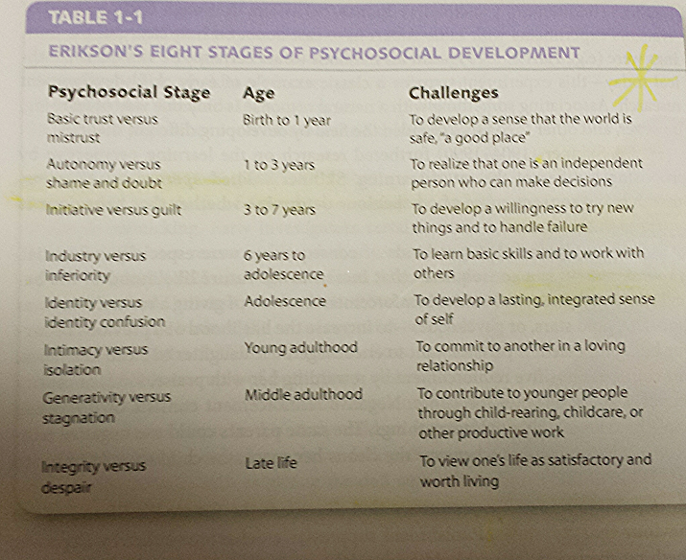
  - Paiget’s Theory of Cognitive Development
    - “Argued that as children try to comprehend their surroundings they act like scientists, creating theories about the physical and social worlds. They try to weave all they know about objects and people into a complete theory.” (pg. 14 of the textbook)
    - “Emphasises the different stages of thinking that result from children’s changing theories of the world” (pg. 18 of the textbook)
    - Dramatic revisions to their own theories are applied when at critical points in their development they see flaws in their theories.
    - 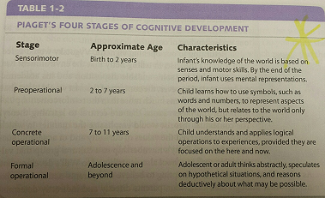

  - Contextual Perspective
    - Bronfenbrenner Theory of Ecological Systems
      - Microsystem: consists of people and objects within immediate environment (family, siblings parents, caregivers)
      - Meso-system: the connections and interaction of what is within your microsystem
      - Exo-system: second-hand social settings that effect development in some way (neighbours, community services, mass media)
      - Macro-system: the influences of a culture as a whole and all systems combined that form attitudes and beliefs (culture, heritage, beliefs)
      - Theory- “Emphasizes the interaction of different aspects of the environment and their influence, direct or indirect upon the child” – (Pg. 18 of the textbook)
    - Vygotsky Theory
      - “Emphasises the role of parents (and other adults) in conveying culture to the next generation” (pg. 18 of the textbook)
    - Contextual = “Development is influenced by both immediate and more distant environments, which typically influence each other” (pg. 18 of the textbook)
  - Biological Perspective
    - “development is determined primarily by biological forces” (pg. 18 of the textbook)
      - Maturational Theory: “Child development reflects a specific and pre-arranged scheme or plan within the body” (pg. 8 of the textbook) – this meaning that experience has little relevance and focuses on letting the child develop naturally – development is automatic/spontaneous
        - Later theory discarded for not accounting for environment
      - Ethological:
        - “views development from an evolutionary perspective” (pg. 9 of the textbook)
      - Critical period = “is the time when a specific type of learning can take place; before or after the critical period the same learning is difficult or even impossible” (pg. 9 of the textbook)
      - Imprinting “creating an emotional bond with the mother” (pg. 9 of the textbook)
Module 1.3
- Learning Objective Questions:
  - How well can developmental outcomes be predicted from early life?
  - How do heredity and environment influence development?
  - What role do children have in their own development?
  - Is development in different domains connected?
    - All above questions – related material on pg.20-22 of the textbook
- Check You Learning
  - Describe the difference between continuous development and discontinuous development.
    - Continuous = “once a child continues down a particular development path, the child stays on that path throughout life” (pg.20 of the textbook)
    - Core issue: Are early aspects of development consistently related to later aspects?
- Chapter Notes
  - Nature vs. Nurture
    - Nature = biology
    - Nurture = environment
    - “Today we know that virtually no aspect of child development is due exclusively to either heredity or environment. Instead, development is always shaped by both: nature and nurture interact.” (pg. 21 of the textbook)
  - Continuity
    - Case example Copied directly from textbook – Question 1.3
      - Q: “As a child, heather was painfully shy and withdrawn, but as an adult she is very outgoing, the life of many a party. What does Heather’s life tell us about the continuity or discontinuity of shyness?”
      - A: “In Heather’s life, shyness has definitely been discontinuous. Even though Heather was shy early in life, she is not shy now.”
    - “Early development is related to later development, but not perfectly”(pg.22 of the textbook)
Module 1.4
- Learning Objective Questions:
  - 1) How do Scientists measure topics of interest in children’s development?(related material on pg. 27 of the textbook)
  - 2) What general research designs are used in child-development research? (related material on pg. 29-33 of the textbook)
  - 3) What designs are unique to the study of age-related change? (Related information on pg. 33-37 of the textbook)
    - Longitude design: “the same individuals are observed or tested repeatedly at different points of their lives” (pg.33 of the textbook)
    - Micro-genetic study: “special type of longitudinal design, children are tested repeatedly over a span of days or weeks, typically with the aim of observing change directly as it occurs” (pg.34 of the textbook)
    - Cohort effects: “children in a longitudinal study are observed over a period of several years, the developmental change may be particular to a specific generation of people knows as a cohort” (pg. 35 of the textbook)
    - Cross-Sectional Design: “developmental changes are identified by testing children of different ages at one particular point in their development.” (pg.35 of the textbook)
    - Longitudinal-sequential study: “includes sequences of samples, each studied longitudinally” (pg.36 of the textbook)
  - 4) What ethical procedures must researchers follow? (related information on pg.39-40 of the textbook)
  - 5) How do researchers communicate results to other scientists? (related material on pg.40 of the textbook)
  - 6) How does child-development research influence family policy?(related information on pg. 41-42 of the textbook)
- Check Your Learning:
  - List the ethical responsibilities of scientists who do research with children.
    - Answer:
      - Seek to do research that benefits humanity
      - Minimize risks to research participant
      - Describe research to potential participants so they can determine whether they wish to participate
      - Avoid deception
      - Keep results anonymous or confidential
      - Give a debrief afterward
  - What steps are involved in reporting the results of research to the scientific community?
    - Answer:
      - Submit a report to a scientific journal
        - Standard formatting: intro that describes the topic, hypothesis, methods sections describing research design, results of findings, analysis.
- Chapter Notes:
  - Measuring Behaviour in Child Development Research
    - Systematic Observation – “involves watching children and carefully recording what they do or say” (pg. 24 of the textbook)
      - Two main forms
        - Naturalistic = “Children are observed as they behave spontaneously in a real-life situation” (pg.24 of the textbook)
          - Example/Key study = Researchers: Pepler, Craig, Roberts
            - Children aged 6-12 studied responses to peers. Used video cameras to observe school playgrounds. Searched for responses that were aggressive or pro-social.
        - Structured = “the researcher creates a setting likely to elicit the behaviour of interest” (pg. 24 of the textbook)
          - Example/Key study = Researchers: Sturge-Apple, Davies, Cummings
            - A mother is observed after playing a game with their child and cleaning up the mess. Researchers focus on the nature of parenting and factors such as praise and approval being used in their interaction.
          - “Structured observation involves creating a situation – such as asking children to play a game, that is likely to lead to behaviours of interest such as competition” (pg. 25 of the textbook)
    - Biases in observational studies:
      - Observer bias = “occurs when the researcher tends to notice those behaviours that support the hypothesis and to discount those that do not, or interprets behaviours in such a way that they support the hypothesis.” (pg. 25 of the textbook)
        - Expectancy effect = “where the observer’s experiences influence their observations” (pg.25 of the textbook)
        - Can be safeguarded: how= before beginning observations provide definitions for behaviours being observed and create strict guidelines
      - Observer influence = “is a form of participant bias, when the participants change their behaviour because they are being observed.” (pg. 25 of the textbook)
        - Can be safeguarded: how= disguise that participants are being observed. Example = one-way mirror
        - Habitation = “allows participants to get used to the researcher” (pg.25 of the textbook)
    - Sampling Behaviour with tasks:
      - “Specific tasks such as choosing a picture may be used to sample behaviour.” (pg.26 of the textbook)
      - Pitfall = “determining whether the task really samples the behaviour of interest” (pg. 26 of the textbook)
    - Self-reports:
      - “Are simply children’s own responses to questions about the topic”(pg.26 of the textbook)
      - Pitfall = response bias. This is when socially acceptable answers are given even if they are untrue just because the responder does not want to say the non-acceptable answer.
    - Physiological Measures:
      - Example: measuring heart rate: determines attention span in children because heart rate is known to decrease when paying attention to something interesting.
      - Example: hormone cortisol: secreted in response to stress. Can be used to study stress levels
      - “Physiological measures are usually specialized-they focus on a particular aspect of a child’s behaviour; attention and stress in the two examples.” (pg. 27 of the textbook)
  - 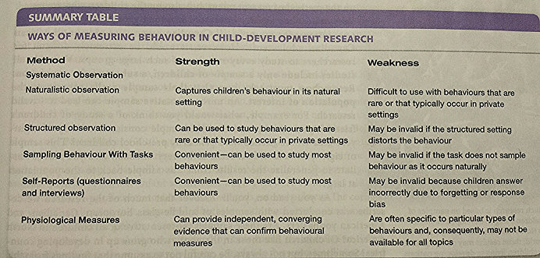
- General Designs for Research
  - Pre steps:
    - Formulate hypothesis
    - Identify variables
    - Select data collection method, implement research design
  - Two main research designs are Correlational and Experimental
  - Correlational Studies
    - “investigators look at relations between variables as they exist naturally in the world” (pg. 29 of the textbook)
    - “Researcher measures two variables then sees how they are related.” – Correlations do not show causation.” (pg. 29 of the textbook)
    - “The results of a correlational study are usually expressed as a correlation coefficient, abbreviated as r, which stands for the direction and strength of a relation between two variables.” (pg. 29 of the textbook)
    - Interpreting:
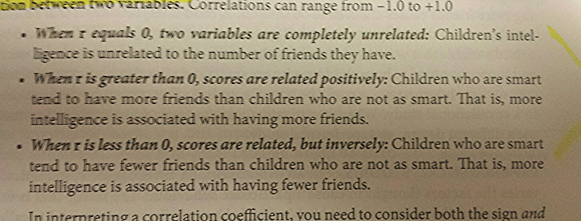
- Positive and negative correlations do not mean “good/bad”; they actually mean:
  - Positive = “larger values on one variable are associated with larger values on the second variable” (pg. 29 of the textbook)
  - Negative =”means that larger values on one variable are associated with smaller values on a second variable” (Pg. 29 of the textbook)
  - “The strength of a relation is measured by how much the correlation differs from 0, either positively or negatively”(pg. 29 of the textbook)
- Experimental Studies:
  - “in an experiment, an investigator systematically varies the factors thought to cause a particular behaviour.” (Pg. 30 of the textbook)
  - Independent variable = “The factor that is varied” (Pg. 30 of the textbook)
  - Dependant variable = “the behaviour that is measured” (Pg. 30 of the textbook)
  - Experimental studies can be used to interpret causation
  - 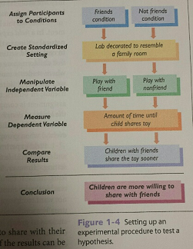

Sample Chapter Quizzing Questions (pg. 47 of the textbook copied):

Q ) _______________ are detailed, systematic observations of individual children.
A) baby biographies

Q) The biggest advantage of longitudinal studies is that a researcher can_______________
A) determine the extent to which behaviours at a younger age are related to behaviours at an older age.

Q) A system view of families divides the environment into the microsystem, the mesosystem, the exosystem, the macrosystem, and the _________________
A) chronosystem

Q) According to Jean Piaget, children of all ages create _____________
A) theories that help them in understanding the world

Q) A potential shortcoming of structured observations is that ____________
A) artificial nature of the setting may distort the behaviour of interest

