LAB 8: Dyes in Food

Purpose
The purpose of this experiment was to become familiar with the electrophoresis technique and apply it to the analysis of different food dyes found in candy.
Results/ Observations
Obtained via picture supplied on CU Learn
Well 1 contained: Blue and Red Standard dyes
Well 2 contained: Yellow #5 and Yellow #6 standard dyes
Well 3 contained: a blue band (from a blue Smartie)
Well 4 contained: a red band (from a red Smartie)
Well 5 contained: a blue, red and yellow band ( brown m&m)
Well 6 contained: a single red band (red M&m)
Well 7 contained: a yellow band (yellow M&M)
Well 8 contained: a yellow band (orange M&M)
Discussion
Based on the results obtained from the agarose gel electrophoresis certain characteristics of the dyes became evident. The blue dyes moved the least down the gel, indicating that the blue dye molecules are the largest. Electrophoresis works by separating molecules based on size; combined with the use of standards these unknowns can then be compared to the standards in order to qualitative determine what molecules are present in a solution. The gel demonstrates that the blue dye has the largest molecule size, followed by red/yellow#5 and then yellow#6 being the smallest. Also from the gel, it is clear the brown m&m is actually a combination of 3 of the dyes; blue, red and yellow #6. Additionally, although hard to distinguish, yellow#5 may be present but due to red dye having is the same molecular size it is not possible to determine from observing the gel. The other candies had their corresponding colours of dye (Blue smartie= blue dye, etc). The only other colour of note is with the orange m&m, which obtains it’s colour from yellow #5 meaning this dye is more orange than yellow. The gel also shows that all the dyes from the candies are represented by the standards; if there had been any unidentifiable bands further down the gel then there would have been colours not represented by the standards.

Years ago, food manufacturers would utilize dyes that had detrimental effects on human health. Over time these hazardous dyes were phased out in favour of the currently used and safe dyes used today. Previously used dyes were copper sulfate (blue colouring) Lead chromate (yellow) and mercury sulfide (red). Just from the names alone it is clear that these old colouring agents utilized heavy metals that could cause health problems.

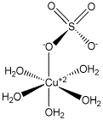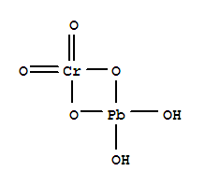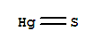
Copper sulfate Lead Chromate Mercury sulfide

The new and safe dyes have completely different structures to these formerly used dyes. The most obvious change is the removal of any heavy metals (copper, lead, mercury). Additionally, the dyes used now are larger molecules that contain multiple benzene rings, nitrogen and sulfur trioxide groups. These new dyes are also barely absorbed by the human body and generally leave the body in waste expulsion. These new dyes, while safer, still pose some minimal risk. Toxicity levels would require massive ingestion of these dyes to cause negative effects and even then the effects would be less severe than the old, heavy metal based dyes. An example of blue 1, the largest of the dyes experimented with, is shown below, demonstrating the typical structural components of most dyes used today.
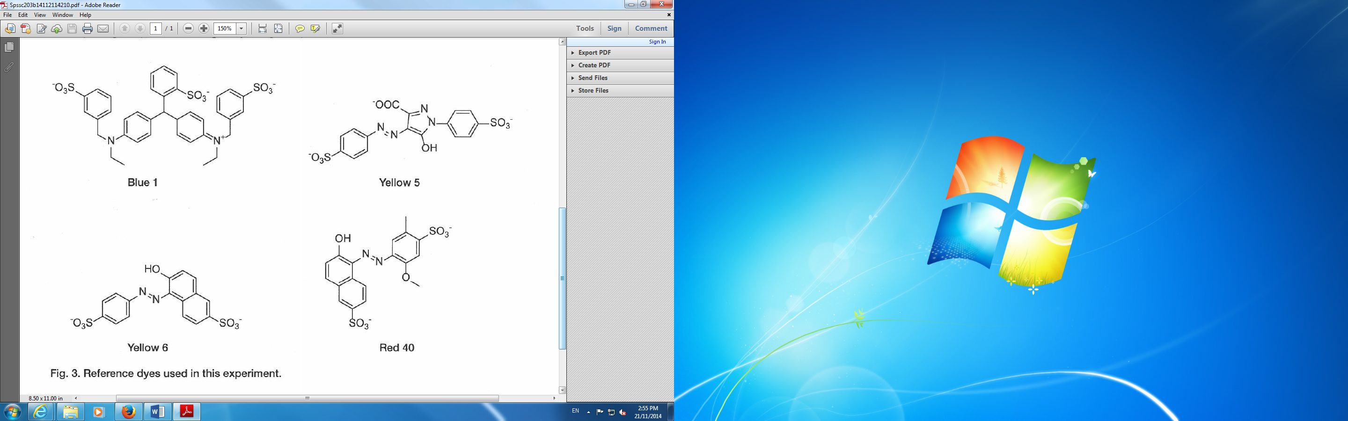
We have come to associate certain colours with specific flavours. For instance a consumer would expect a yellow candy to be either lemon or banana. It wouldn’t make sense if it was kiwi. This associate of colour to candy has become an important indicator for consumers; not only does it signal flavour but it also provides pleasing aesthetic qualities. It is for those reasons that removing dyes from food would not be a feasible endeavour.
Conclusion
The technique of electrophoresis allows for the qualitative determination of what molecules are present provided a standard is available for comparison. By utilizing this technique the types of dyes present in popular candies were identified. Because of its low cost and relative ease of set up, this technique is clearly valuable in a laboratory environment for qualitative analysis of molecules of different sizes.

