ORGANIC CHEMISTRY REACTIONS
-Review functional groups
-Substitution rxns: one functional group substitutes for another. E.g. alcohol + aldehyde ether + leaving group
-Elimination rxns: atoms or groups on adjacent carbons are eliminated as a small molecule. E.g. alcohol (H and OH- are on adjacent carbons) alkene + water
-Addition rxns: opposite of elimination reactions. Double bond becomes a single bond, and triple bond becomes a double bond.
-Nucleophile is negatively charged and is attracted to positive charges. Also may be with parts that have lone pairs or pi bonds.
-ideal nucleophiles:
- easily donate e-. e.g. OH- is better than H2O because it is – charged
-more polarizable. E.g. I- is stronger and more polarizable than F-. Large radius makes e- easily drawn to the substrate.
-has less steric hindrance. E.g. smaller the better.
-Electrophile is positively charged and is attracted to negative charges (i.e. attracted to electrons). Also are positively polarized atoms are electrophilic.
-Work on identifying nucleophiles and electrophiles. And the movement of electrons.
-either bond-making (a bond forms as a nucleophile and an electrophile interact) or bond-breaking (bonding electrons move to an atom, breaking the bond, and the atom leaves)
-arrows point towards where the electrons are moving. In bond-making, electrons move from the – part to the + part, from the charge on the – to the + part in which the bond will be formed. In bond-breaking, electrons move from the bond and point to the part that will leave the compound.
-electrophile is also called the substrate.
-water is a nucleophile (- charge on the oxygen atom)
-Substitution reactions can either be Sn1 or Sn2.
-Sn2 reaction rate depends on the concentration of both the nucleophile and the substrate. One step. Has an intermediate where one bond shortens and the other lengthens simultaneously.
-Sn1 reaction rate depends on the concentration of just the substrate. Two steps. The first step is slow and is rate limiting. In this first step, the substrate changes into an intermediate carbocation (often the non-carbon, e.g. Cl, disconnects. In the second step, the intermediate carbocation and the nucleophile react quickly to combine.
-Factors affecting rate of Sn1:
-stronger base (as the leaving group), makes it slower to leave and therefore slower reaction rate.
-“stability” of intermediate carbocation: 3º (fast) , 2º , 1º (slow)
-for Sn2, the stability of the intermediate carbocation is 3º (slow) , 2º , 1º (fast)
-with aromatic substitution reactions, a H atom of one of the carbons is replaced with a bond to the nucleophile
-Elimination reactions can either be E2 or E1. A saturated bond (single) becomes unsaturated (double bond), and the compounds at the end of the original single bond, are the leaving group, replaced by hydrogens. Or a dehydrohalogenation reaction occurs, in which a base is added to a compound containing a halogen and the base leaves with a hydrogen and the halogen on its lonesome
-E2 reaction rate depends upon the concentration of both.
-Regioselectivity: the double bond goes to the more highly substituted alkene (the more stable one!). A major and minor product will be created. In both situations, the double bond is created, one in the middle (major product) and one on the end of the compound (minor product).
-Stereoselectivity: the double bond goes to the lower energy transition state (which is always the trans- form!). Minor product is the double bond in cis formation and major product is the double bond in trans formation.
-E1 reaction rate depends on the concentration of the substrate. First step is slow, second step is fast.
-For addition reactions, pi bonds become sigma bonds (double bonds become single bonds).
-alkene + H2O is hydration. H goes at one end, OH goes at other, and double bond becomes single bond.
-alkene + H2 is hydrogenation.
-alkene + X2 is halogenation, where X=halogen.
-alkene + HX is hydrohalogenation, where X=halogen.
-In many cases for addition reactions, there may be two possible results. So the halogen follows Markovnikov’s Rule and is placed at the most stable carbon. i.e. the hydrogen will go with the carbon atom already with the most hydrogen atoms.
-what determines whether or not a reaction will occur? – the strength of the nucleophile and how badly the leaving group wants to leave.

SPONTANEITY OF CHEMICAL PROCESSES
-spontaneous change always releases energy, but does not always release heat.
-Entropy= disorder in a closed system. Tendency for all matter and energy in the universe to evolve toward a state of inert uniformity.
- S = k ln W, where k=Boltzmann constant and W= number of ways that state can be achieved
- low entropy is less probable (poker metaphor—pairs are more probable than royal flushes)
-with entropy, the path taken and the rate of change is irrelevent! ΔS= S final – S initial
-ΔS > 0 for: melting, vaporizing (liquid to gas), when making a solution, a reaction that produces an increased number of moles and heating a substance.
-ΔS rxn= sum of: ((stoichiometric coefficient of species)(S of species))
-in general, if a process is spontaneous, the reverse is non-spontaneous under the same conditions. Non-spontaneous processes are only possible if the conditions are changed!
-first law of thermodynamics: the energy of the universe is constant
-second law of thermodynamics: the entropy of the universe is increasing
-favourable when ΔS > 0 and ΔH < 0 (H is enthalpy! Enthalpy is the amount of heat content used or released in a system at constant pressure)
-ΔS surr= ( -ΔH sys )/ T
-ΔS univ = ΔS sys + ΔS surr
-Gibbs free energy change : ΔG = ΔH – TΔS
-ΔG < 0 for a spontaneous change
ΔH o | ΔS o | ΔG o | Spontaneous?
- | + | - | Always
+ | - | + | Never
- | - | + or - | At lower T
+ | + | + or - | At higher T

-cleaning up your house is a process having ΔS system < 0. How can this be spontaneous?
ΔH system < 0, thus ΔS surr > 0 and thus ΔS uni > 0.
-G is also a state function: path and rate of reaction are irrelevant. ΔG = G final – G initial
- ΔG = ΔG o + RT ln Q , where Q is the reaction quotient. Q = [C] [D] / [A] [B]
- ln (p2) = ln (p1) + ( ΔHvap / R ) [1/T1 – 1/T2]
-to help remember equation, p1 and T1 go on same side of equation
-entropy of vapourization (liquid to gas): at eq, ΔG vap = 0 = ΔH ovap – Tb ΔS ovap, where Tb is boiling temperature.
- a ΔH < 0 is exothermic (negative), ΔH > 0 is endothermic (positive)
-if ΔG is – the reaction is spontaneous as written. If ΔG is + the reaction is spontaneous in the reverse direction.
-At its boiling point, a substance is at equilibrium between the liquid and gas phases. At eq, ΔG=0.
- ΔG orxn = - RT ln (k), where k is the equilibrium constant: k= (Pc)^{c}(Pd)^{d} / (Pa)ª(Pb)^{b}
-remember that e^{lnk}=k!
-Clausius-Clapeyron equation:
Ln (P2/P1) = (ΔHvap/R) (1/T1 – 1/T2) or ln(P) = (-ΔHvap/R)(1/T) + C
-boiling point of a liquid occurs when vapour pressure is 1 atm or 760 torr.
-predict signs of ΔH and ΔS for the following:
a. 2NO2(g) N2O4(g). bond formed so ΔH is - and 2 mol of gas to 1 mol of gas so ΔS is –
b. block of gold melts in a crucible (Au(s) Au(l))
bonds broken so ΔH is + and solid to liquid phase so ΔS is +
c. CH4(g) + 2O2(g) CO2(g) + 2H2O(g) (combustion!)
ΔH is – and mol on right = mol on left so ΔS = 0.
d. CH3OH(g) CH3OH(l) at 250oC
ΔH is – , ΔS is – , ΔG is +
e. KOH(s) K+(aq) + OH-(aq) (solution gets warm)
ΔH is –, ΔS is +, ΔG is –
f. CO(g) + ½ O2(g) CO2(g) (notice that it’s a combustion!)
ΔH is -, ΔS is – and Δ G is –
g. H2O(5oC) H2O (1oC)
ΔH is -, ΔS is -, ΔG is + at 25oC and – if Tsurr < 1oC
h. H2O(l) H2(g) + ½ O2(g)
ΔH is +, ΔS is + and ΔG is +

-positive ΔH is endothermic, negative ΔH is exothermic
-Δ G is negative when the reaction is spontaneous
CHEMICAL EQUILIBRIUM
-see notes for basic equations
-Keq applies only at equilibrium and is independent of initial conditions (i.e. temperature)
-Q is the reaction quotient. Q = concentrations of products/ concentrations of reactants
-does not include pure solids and pure liquids
-before eq is established, Q ≠ K
- k = exp (-ΔG o/RT)
-use eq constant (k) for:
-testing for equilibrium. Q values don’t need to be at eq to insert into equations. Q < K, system moves reactants to products, striving to reach eq.
-calculating eq concentrations. Build an ice table. Solve for k.
-increasing T shifts eq in endothermic (+) direction
e.g. 2NO2 N2O4 + heat or ΔH = - 57kJ/mol
shifts to the left (in endothermic direction)
e.g. 2NO2 <-> N2O4 , brown <-> colourless
temperature decreases and eq moves to products—becomes lighter in colour.
-use Q when we don’t know if its in eq or not
-when pressure is increased or decreased, the eq shifts to the side of the reaction with more moles
ΔG rxn = ΔG orxn + RT ln Q
ΔG o = -RT ln Keq
ΔG orxn = (sum of coefficient and ΔG o products) – (sum of coefficient and ΔG o reactants)
-reaction goes right when Q < Keq, ΔG rxn < 0
-equilibrium when Q = Keq, ΔG rxn = 0
-reaction goes left when Q > Keq, ΔG rxn > 0
-for exothermic reaction (-ΔH), keq decreases as T increases
-for endothermic reaction (+ΔH), keq increases as T increases
ln keq = (-ΔHº/RT) + (ΔSº/R)
-le chatelier’s principle: when a change is imposed on a system at equilibrium, the system will react in the direction that reduces the amount of change
-adding a reactant decreases the value of Q, so the system responds in a way that restores equilibrium, and so the reaction proceeds to the right (to make more products)
-removing a product from a system also decreases Q, so the reaction will proceed to the right to make more additional products
-catalysts do not affect the keq

KINETICS: MECHANISMS AND RATES OF REACTIONS
-rate law: effect of concentration of reactants on the rate of a particular reaction
-rate= k [A]^{y} [B]^{z}
-rate = concentration/time
-orders of a reaction can only be found through experimentation
-rate determining steps:
-orders that are fractional, negative or overall orders greater than 2 are indications that a fast first step is followed by a slow step.
-if given an experimental rate law, and given mechanisms, and asked which mechanisms are consistent with the experimental rate law: find the slow step (rate determining step), and find its rate. Sometimes to find the rate, the fast step is used (if its equilibrium), and the two rxns that make it up are set to equal one another—if rate is not equal to the experimental, then the mechanism is inconsistent with the experimental rate law.
-e.g. experimental rate law is rate= k [O3] [NO]. Which of the following is consistent with the experimental rate law?
Mechanism #1: Mechanism #2
O3 + NO O + NO3 (slow) O3 <-> O2 + O (fast)
O + O3 2O2 (fast) NO + O NO2 (slow)
NO3 + NO 2NO2 (fast)
For mechanism 1, the first step is rate determining which means the predicted rate law is the same as the rate expression for the first step: Rate = k [O3][NO].
For mechanism 2, there is fast reversible ozone decomposition followed by the rate-determining bimolecular collision. Rate of slow step is: Rate= k [NO][O]. Now assume rate of first step is equal to rate of its reverse process: k1[O3] = k-1[O][O2], then solve for the intermediate of the mechanism (O): [O] = k1[O3] / k-1[O2]. This is inconsistent with the experimental rate law.
-Arrhenius equation: k = Ae^{-Ea/RT}, where Ea is activation energy and A is the value that the rate constant would have IF all molecules had enough energy to react. If Ea > 0, then as T increases, k increases.
- ln k = ln A – Ea/RT ln (k2/k1) = (Ea/R) (1/T1 – 1/T2)
ln k = – Ea/RT (1/T) + ln A y=mx+b. Can find the slope (-Ea/R)
-homogenous catalyst: the catalyst and the reactants are present in the same phase (e.g. gas/solid/liquid).
-heterogenous catalyst: the catalyst is in a different phase than the phase in which the reaction occurs.
-most reactions are multistep (e.g. Sn1 mechanism) although some are single step (e.g. Sn2 nucleophilic substitution)
-OZONE DESTRUCTION:
-2 elementary reactions
- O3 + O 2 O2 (overall rxn)
- O3 + Cl OCl + O2 (Step 1) (slow)
- OCl + O Cl + O2 (Step 2) (fast)
- OCl is an INTERMEDIATE
-Cl is a CATALYST (destroyed in earlier step and regenerated in a later step)
-this reaction proceeds much faster that the uncatalyzed reaction
-rate determining step is the slowest elementary reaction in a multi-step reaction
-heterogenous catalysis (ethene + H+ ethane)
-1. Adsorbtion of H+ onto metal surface—then substrate attaches
-2. Migration across surface
-3. Reaction
-4. Desorption—ethane leaves the metal surface
-explosions:
1. thermal explosion. Assume A B is exothermic. As T rises, k (the catalyst activity) rises, the reaction goes faster, and T rises faster!
2. chain reaction. E.g. 2H2 + O2 2H2O(g). radicals contain unpaired e- (e.g. H, O, HO2, HO (ALL HAVE DOTS OVER TOP)). Radicals are very reactive. More radicals, higher reaction rate, more radicals, explosion!
a. initiation step—radicals are produced.
H2 + O2 HO2 + H
b. propagation step—new radicals are formed
H2 + HO2 HO + H2O
H2 + OH H + H2O no net radical production in first two!
H + O2 HO + O in next two,
O + H2 HO + H “branching” occurs (# of radicals increases)
-e.g. smog peaks for different compounds at different points in the day! At 8am peaks for NO, at noon peaks for NO2 and at 3pm peaks for O2. Reaction= 2N2O5 4NO2 + O2
-rate= concentration/time. Changes with time throughout the day.
-e.g. rate of formation of O2(g) is 0.65 M/s. Find the rate of change of [N2O5(g)]
(0.65 mol O2/Ls) (-2 mol N2O5 / 1 mol O2 ) = -1.30 mol N2O5/Ls
-rate depends on the concentration of the reactants. Rate goes down and there are less molecules to collide with and react with.
[A] = [A]_{o} e^{-kT}
-linearity implies first order!
-for first order, if needed to calculate t at 80% completion, [A] = 0.2 [A]_{o}. ln(0.2) = -kt
-you can find the order of a rxn based upon the units. E.g. if k= 0.0380 L mg⁻¹h⁻¹, order of reaction is 2
e.g. L²mol⁻²s⁻¹ (third order). ALWAYS IGNORE L!
-in rate=k[A]^{m}[B]^{n}, m+n is overall order
-if B is held constant:
If doubling [A] doubles the rate, then m=1
If doubling [A] quadruples the rate, then m=2
-3 things affect reaction rate:
1. rate of collisions b/w A and B
-collision rate = Z [A] [B], where Z is related to molecular speeds

2. fraction of collisions having correct orientation
-p= steric factor= fraction of collisions with the correct orientation
3. fraction of collisions having sufficient activation energy to cause reaction
-if energy of collision > Ea, products may be formed
f = e^{-Ea/RT}
-some reactions may be negative Ea
-e.g. a reaction rate is observed to double as the T increases from 25oC to 35oC. Find Ea.
k=Ae^{-Ea/RT}
k1/k2 = 2 = e^{-Ea/RT1}/e^{-Ea/RT2} take ln of both sides and solve for Ea.
ln2= -Ea/298K + Ea/308K
-case in which solids are included in the keq expression—note that they are changing state!
UO2(s) + 4HF(g) <-> UF4(s) + 2H2O(g)

ACID-BASE CHEMISTRY
-acid hydrolysis:
HA + H2O <-> H3O+ + A-
Ka = [H3O+][A-] / [HA]
-base hydrolysis:
B + H2O <-> OH- + BH+
Kb= [OH-][BH+] / [B]
-ksp solubility product
-kf formation constant
-Bronsted-Lowry: acids donate protons and bases accept protons
-water is amphoteric, can react as acid or base
- H2O + H2O <-> H3O+ + OH- (this eq present in all aqueous solutions)
-Lewis: acids accept e- pair, bases donate e- pair
-strong acid: keq is large
-weak acid: keq is small
-weak acids have strong conjugate bases
-strong acids have weak conjugate bases
-reason why a reaction may not go if the product base is stronger than the reactant base (even tho a forward reaction goes, the reverse reaction may not go)
-in acid-base reactions, the proton is transferred to the stronger base
-what is the difference between a strong acid and a concentrated acid?
Answer: strong acid will easily disassociate in water
Concentrated acid is either pure (no solvent) or high concentration. Any type of acid (strong or weak), can be concentrated.
-e.g. 1M HCl and 1M H2CO3
-same concentrations
-HCl is a stronger acid because it has a higher Ka value
-[HCl] << [H2CO3]
Stronger acid  Weaker acid | HClO4 |  | ClO4- | Weaker base  Stronger base
Stronger acid  Weaker acid | HNO3 |  | NO3- | Weaker base  Stronger base
Stronger acid  Weaker acid | HF |  | F- | Weaker base  Stronger base
Stronger acid  Weaker acid | H2CO3 |  | HCO3- | Weaker base  Stronger base
Stronger acid  Weaker acid | H2O |  | OH- | Weaker base  Stronger base
Stronger acid  Weaker acid | NH3 |  | NH2- | Weaker base  Stronger base
Stronger acid  Weaker acid | OH- |  | O⁻² | Weaker base  Stronger base

pH = -log [H3O+]
pOH = -log [OH-]
Kw = [H3O+][OH-]
14= pOH + pH
-negative pH is OK so long as its not super big! A little over 14 is also OK.
-Ka = 1.0 x 10^-14 for 2H2O <-> H3O+ + OH-
-polyprotic acids: have more than one H+ (e.g. H2SO4, H3PO4, etc.)
-hydrolysis—mix acid with water. Will get H3O+ and conjugate base (of the acid)
-in limestone lined lakes there are excess Ca+2 ions
CaCO3(s) <-> Ca+2(aq) + CO3-2(aq)
HCO3- + H2O <-> H3O+ + CO3-2(aq) (eq shifts left)
H2CO3 + H2O <-> H3O+ + HCO3- (eq shifts left and pH rises!)
-big Kb (more negative pKb) = strong base
-binary acids (HX acids, where X is a halogen)
---------->bond energy
HI > HBr > HCl > HF
<----------acid strength
-as larger bond energy, it becomes a weaker acid
-oxoacids (HOX acids)
-if X is electronegative, acid is stronger and the base easily pulls away the H+
-------> EN(X) increases
HOI < HOBr < HOCl
--------> Acid strength
-with more oxygens, the acid is stronger
e.g. HNO3, HNO2, H2SO4, H2SO3…etc.
-strengths of carboxylic acids
-little effect of carbon chains on Ka values
-the closer the R group is to the acidic carbon, the higher the Ka
-the more R group (e.g. Cl2 rather than Cl), the higher the Ka
-organic bases amines
-include many drugs
-react with strong acids to form water soluble salts
-fish smell due to amines
-when adding a Ka and Kb expression (to get Kw), make sure to multiply Ka and Kb
SALTS
-cation + anion salt(s)
-salt(s) + water salt(aq) (solution may be acidic, neutral or basic)
-salt solutions
A. cation from strong base, anion from strong acid
e.g. NaCl (Na is conjugate acid of NaOH and Cl is conjugate base of HCl)
Na+ + H2O no rxn, Cl- + H2O no rxn
No rxn therefore no change in pH (neutral)
Neutral salt solutions from the cations Li+, Na+, K+, Ca+2, Sr+2, Ba+2; and
the anions Cl-, Br-, I-, NO3-
B. cation from weak base, anion from strong acid
e.g. NH4Cl
NH4+ + H2O NH3 + H3O+
Cl- + H2O no reaction
Therefore an acidic reaction!
Acidic salt solutions from the cation NH4+; from anions Cl-, Br-, I-, NO3-, ClO4-
C. Cation from strong base, anion from weak acid
e.g. NaCH3COO
Na+ + H2O no rxn, CH3COO- + H2O CH3COOH + OH-
Therefore a basic solution!
Basic salt solutions made from cations Li+, Na+, K+, Ca+2, Sr+2, Ba+2
and the anions NO2-, F-, CO3-2, SO4-2, CH3COO-, CN-, S-2, etc.

-acid-base indicators are weak acids or weak bases
Hin(aq) + H2O <-> H3O+ + In- (aq) , where Hin is Colour A and In- is Colour B
e.g. alizarin yellow—if bonds become conjugated (single, double, single, double…), e- can flow and colour change occurs
-best indicator for a titration has a pkln that is as close as possible to the pH of the solution at the stoichiometric point
-common ion effect
-AgCl(s) + H2O <-> Ag+(aq) + Cl-(aq)
-AgNO3(s) + H2O Ag+(aq) + NO3-
Ag+(aq) is the common ion. This eq is forced to the left, and AgCl(s) precipitates
-common ions can affect pH. Common ions reduce solubility!
-HF(aq) + H2O <-> H3O+(aq) + F-(aq)
-NaF(s) + H2O Na+(aq) + F-(aq)
F-(aq) is the common ion. If we increase the common ion, eq shifts left.
pH rises and is less acidic.
-NH3 + H2O <-> NH4+ + OH-
-NH4Cl(s) + H2O NH4+ + Cl-
Eq shifts left, and pH falls (more acidic).
-buffer solutions rely on common ion effect to suppress the concentration of H3O+ ions and maintain a steady pH
-buffered solutions resist changes in pH (e.g. blood)
- a buffer = a weak acid and its salt OR a weak base and its salt
-can use Henerson-Hasselbach equation:
pH=pKa – log [HA]/[A-]
pH is the desired pH
pKa is of an acid that is chosen so that its pKa ~ pH
ratio is then adjusted to get exact pH
-buffer capacity: if enough base is added to a buffered system, the acid is completely consumed.
This happens when [HA]/[A-] > 10 or < 0.1
-e.g. blood, pH = 7.4 +- 0.2, 3 buffers:
1. carbonate buffer (H2CO3/HCO3-)
CO2(g) + H2O <-> CO2 (aq)
CO2(aq) + H2O <-> H2CO3(aq) (carbonic acid)
H2CO3 + H2O <-> H3O+ + HCO3-(aq)
pH= pKa – log (pCO2/[HCO3-]) pKa= 6.1
exercise lactic acid H3O+ pH in blood drops exhale CO2
(partial pressure of CO2 is higher when you exercise)
2. proteins (containing –N: and –COOH groups)
(in intracellular fluid)
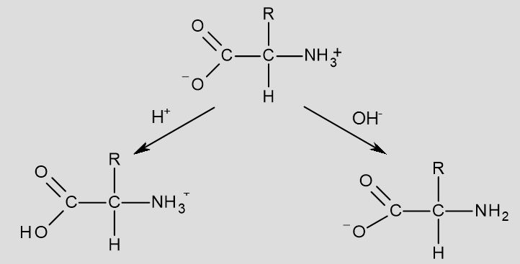
3. phosphate buffer (H2PO4-/HPO42-)
-nucleic acid breakdown
-H3PO4 + H2O <-> H3O+ + H2PO4- pKa = 2.1
-H2PO4- + H2O <-> H3O+ + HPO4-2 pKa= 6.9
-HPO4-2 + H2O <-> H3O+ + PO4-3 pKa= 12.8
-salt solubility vs. pH
-basic anion + H3O+ <-> H2O + conjugate acid
Lower pH = greater solubility
e.g. CaC2O4(s) <-> Ca+2(aq) + C2O4-2(aq) (basic anion)
C2O4-2 + 2H3O+ <-> H2C2O4 + 2H2O
Lower pH less C2O4-2 more CaC2O4 dissolves

e.g. CaCO3 (limestone) is dissolved by acid rain!
H3O+ represents acid rain and CO3-2 is the basic anion (CaCO3 separates)
-complexation equilibria
- Many metal ions form complexes with ligands that can donate electrons to empty orbitals on the metal
-Kf = K1K2K3
Fe+3 + CN- <-> Fe(CN)+2 K1
Fe(CN)+2 + CN- <-> Fe(CN)2+ K2
Fe(CN)2+ + CN- <-> Fe(CN)3 K3
Fe+3 + 3CN- <-> Fe(CN)3 Kf
-CN- is the ligand
-Kf is HUGE
-EDTA is a ligand that prevents food from spoiling—has metal ion chelated with nitrogens and oxygens

THE TRANSITION METALS (READ THIS CHAPTER IN TEXTBOOK)
-as atomic weight increases, eventually they will have e- occupying antibonding orbitals
-TRENDS:
-As we move across the periodic table from right to left, covalent radius increases.
-As we move down a group (from row 1 to 2), covalent radius increases. Corresponding second- and third-row metals are roughly the same size.
-As we move across the periodic table from left to right, ionization energy and electronegativity increase.
-As we move down a group, high oxidation states become more accessible.
-As we move down a group, basicity increases and acidity decreases.
-As we move down a group, metal–main group bond strengths increase.
-e.g. V, s2d3. At V4+ = d1, at V5+ = d0
-e.g. Cr, s1d5. At Cr2+ = d4, at Cr3+ = d3, at Cr6+ = d0
-coordination complexes
Co-ord # | Example
2 | [Ag(NH3)2]+
3 | [HgI3]-
4 | [Ni(CN)4]2-
5 | [Fe(CO)5]
6 (most common) | [Cr(H2O)6]+3
7 | [ZrF7]-3
8 | [Mo(CN)8]-4

-[Ca(EDTA)]-2 is a hexadentate ligand and an octahedral complex that sequesters metal out of food (prevents spoilage)
-other ligands: bromo-, chloro-, cyano-, carbonyl, aqua, pyridine, bidentate, bipyridine, glycinato, oxalato
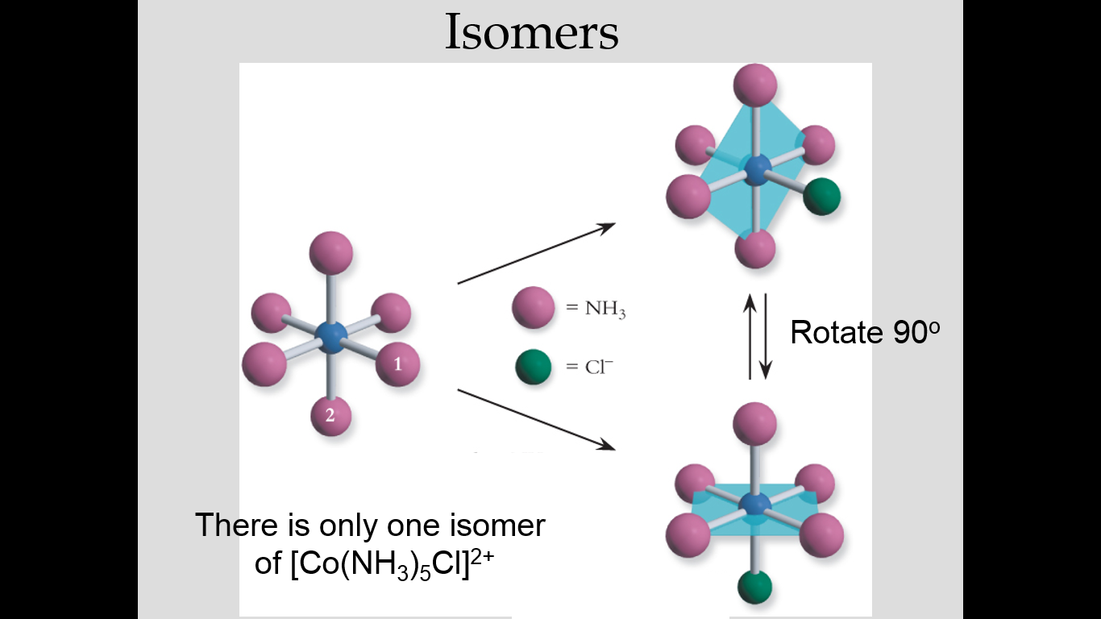
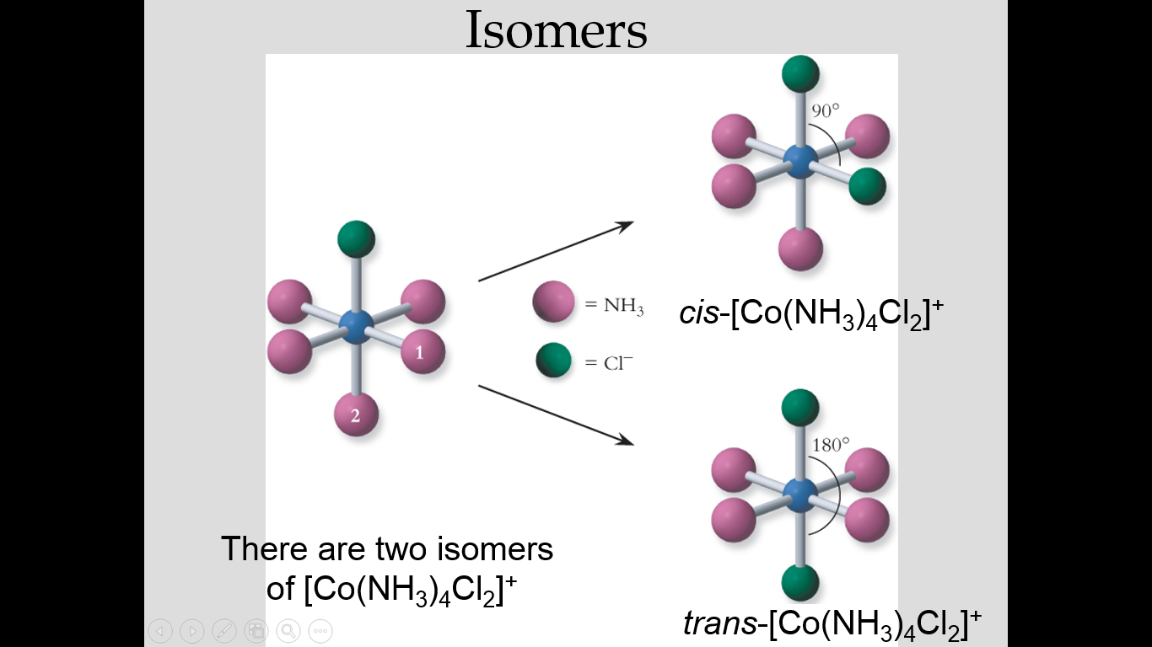
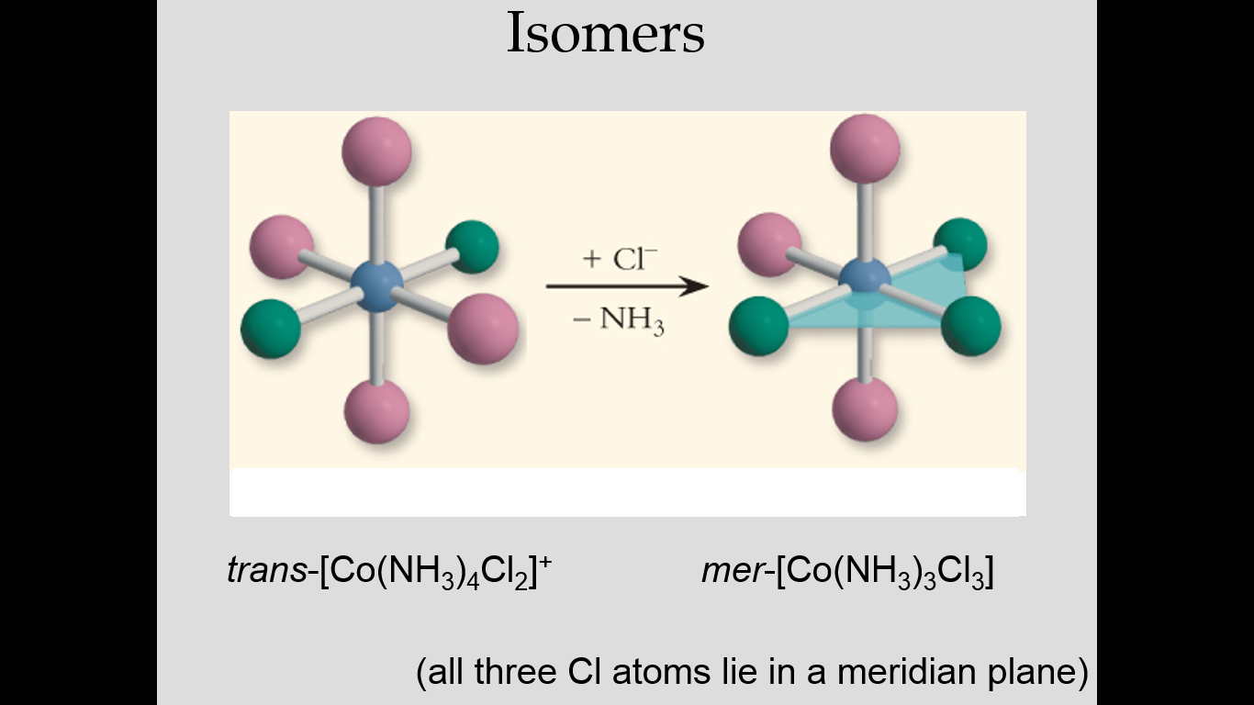
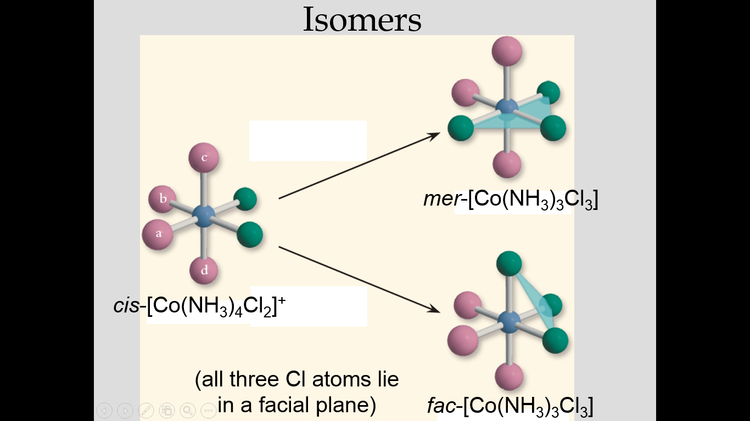
-naming coordination compounds:
1. name cation before the anion
2. name the ligands first (in alphabetical order), then the metal
3. use di-, tri-, etc., and bis-, tris-, etc.
4. give oxidation state of the metal
5. indicate any isomers
-e.g. [Ni(CO)4] tetracarbonyl nickel(0) (CO has no charge)
-e.g. [Ir(NH3)6]Cl3
NH3 is cation, Cl3 is anion
Hexaamine iridium(3) chloride
-e.g. [Cr(en)2I2]F
en is cation, F is anion
bis(ethylenediamine)diiodo chromium(3) fluoride
-sometimes the metal ion is part of the anion:
Iron… ferrate
Copper… cuprate
Silver… argentate
Tin… stannate
Gold… arate
Lead… plumbate
-e.g. Na[Cu(CN)3]
Na is cation, CN is anion
Sodium tricyano cuprate (2) (find the 2 using oxidation #s!)
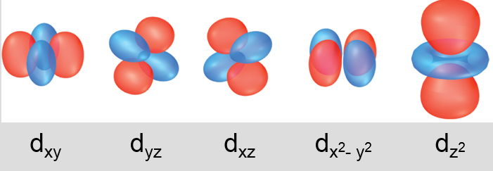
-crystal field theory
-when two d-orbitals point at the ligands, the e- tend to push apart and destabilize the complex.
This involves dz2 and dx2-y2 orbitals.
OR
-when three d-orbitals point b/w the ligands, the e- separate the crystal/ligand and destabilizes
the complex. But not as much as in the first example. This involves dxz, dyz and dxy orbitals.
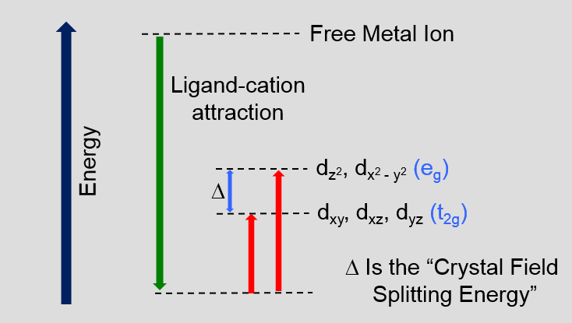

[Fe(CN)6]-4 | [FeCl6]-4
Fe+2 (d6) | Fe+2 (d6)
Octahedral | Octahedral
Diamagnetic | Paramagnetic
Low spin | High spin
Δ > pairing energy | Δ < p
Thus the ligand has an effect

[Fe(NH3)6]+2 | [Co(NH3)6]+3
Fe+2 (d6) | Co+3 (d6)
Octahedral | Octahedral
Paramagnetic | Diamagnetic
High spin | Low spin
Δ < pairing energy | Δ > p
In general, Δ increases as charge increases (ligands are closer to the metal ion)

[Fe(NH3)6]+2 | [Ru(NH3)6]+2
Fe+2 (3d6) | Ru+2 (4d6)
Octahedral | Octahedral
Paramagnetic | Diamagnetic
High spin | Low spin
Δ < pairing energy | Δ > p
In general, Δ increases as size of metal increases (the d-orbitals protrude more)

-The spectrochemical species
- in increasing order of Δ: I-, Br-, Cl-, F-, OH-, H2O, NH3, en, NO2-, CN-, CO
(up periodic table, basically)
-colour is a result of Δ (we see colours that are not absorbed)
-metalloproteins
-in body, made of transition metals that are complexed by ligands (amino acids) in proteins
-e.g. ferritin – 24 polypeptides that store about 4500 Fe atoms
-the desaturase reaction
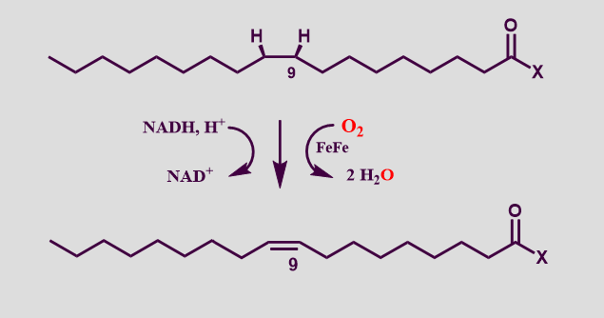
-e- transfer proteins: imporant in respiration, photosynthesis and nitrogen fixation (all involve redox processes)… cytochromes, blue copper proteins, plastocyanins.
-metallurgy
-ores pure metals
-1. Separation (from the rock)
-a. leaching (oxidation of metal to make it soluble)
4Au(s) + 8CN-(aq) + O2(g) + 2H2O 4[Au(CN)2]- + 4OH-
-b. then Au is reduced
2[Au(CN)2]- + Zn(s) 2Au(s) + [Zn(CN)4]-2
-c. strong acid dissolves the ore
U3O8(s) + HClO4 UO2+2
-2. Conversion (to oxides, chlorides or halides)
-by roasting: 2NiS(s) + 3O2(g) 2NiO(s) + 2SO2(g)
-3. Reduction (to metals)
-done chemically (e.g. HgS(s) +O2(g) Hg(l) + SO2(g)) or electrolytically
-4. Refining (to pure metals)
-various electrorefining techniques

ELECTRON TRANSFER REACTIONS
-Is a reaction plausible? Only if there is an oxidation and a reduction
-The activity series:
K (Strong reducing agents) (reduction happens easily)
Ca
Mg
Zn
Fe
H₂
Cu
Ag
Pt
Au (Weak reducing agents) (reduction does not happen easily)
-common reducing agent in industry is carbon
-e.g. steel-making
-Fe(s) + Cu+2(aq) Fe+2(aq) + Cu(s)
Fe is above Cu in activity series and therefore the reaction works. I.e. the part being oxidized is above the part being reduced in activity series
-Ag(s) + Cu+2(aq) no rxn because Ag is below Cu in activity series
-oxidation occurs at the anode, reduction at the cathode (oxan, redcat)
-cations migrate towards the cathode, anions migrate towards the anode
-shorthand notation:
Cu(s) | Cu+2(aq) || Ag+(aq) | Ag(s)
Ox (anode) Red (cathode)
- Flow of e-
-the stronger the oxidizing agent, the higher the standard reduction potential
-F2(g) + 2e- 2F(aq) has a high reduction potential, a high E^{O} and happens easily BECAUSE fluorine is highly electronegative and therefore is a strong oxidant
-whereas Li+ + e- Li(s) has a low reduction potential, a low (and negative) E^{O} and does not happen easily because lithium is not very electronegative and therefore is a weak oxidant
-E cell = E cathode + E anode
-if you add the reactions occuring at the anode and cathode, if the resultant E is positive, the rxn is spontaneous
-E cell = -W/q Work/charge
-W max = ⌂G (max work of cell = delta free energy change of system)
-⌂G = -q Ecell
-⌂G = -n F Ecell where F is Faraday’s constant and n is the # of electrons transferred
-if ⌂G < 0 and Ecell >0, the reaction is spontaneous
-e.g. Cu(s) +2Ag+ Cu+2 + 2Ag(s)
Ecell = +0.46 V
G= -n F Ecell
= - (2) (96500 Cmol-)(0.46 JC-)
= -88,800
Ecell > 0 and G < 0, so rxn is spontaneous
-Will gold dissolve in 1M nitric acid?
1. Set up redox reaction
2. Solve for Ecell
Au(s) Au+3 + 3e- E= -1.50
NO3- + 2H+ + e- NO2(g) + 2H2O E=0.79
Au(s) + 6H+(aq) + 3 NO3- Au+3 + 3NO2(g) + 3H2O E=-0.71

3. Solve for G
G= -n F Ecell
= -3 (96500 Cmol-)(-0.71 JC-)
= 205545 J
= 206 kJ

4. Determine if spontaneous
Nope

-most cells are not at standard conditions
-G=G^{O} + RT ln (Q)
-Nernst equation: E= E⁰ – (RT/nF) ln (Q)
-to find Q, must take concentrations of products divided by reactants
-temperature also affects Ecell: as temperature greatly increases, E will slightly increase
-balancing redox reactions in acidic and basic solutions.
-disproportionate reaction: when some of something is oxidized and some of it is reduced! Balance as usual, but use the same compound in both half-reactions.
e.g. P4(s) H2PO2- + PH3(g)
-formation reaction of water: 2H2(g) + O2(g) 2H2O ….
-for non-standard state conditions, the Nernst equation must be used
-Which of the following would oxidize Fe to Fe+2, but not Pb to Pb+2?
ANSWER: Look at periodic table! Any element in between Fe and Pb that has a + charge
-Electroplating. Use equation it=nF, where i is the current and t is time in seconds
-from this, can find mass of something being electroplated
-Useful galvanic cells: A. Primary batteries (irreversible rxns, disposable), and B. Secondary batteries (reversible rxns, rechargeable)
-larger batteries produce more current
-all voltages are the same (1.5V)
-9V battery has six 1.5V batteries in series
-2 things destroy the battery:
-anode is destroyed—eventually the anode will be dissolved by the acidic ion (shelflife)
-nernst equation… as the reaction proceeds, Q increases and the Ecell decreases
-alkaline cells last longer—Zn does not corrode as fast at high pH (as compared to carbon batteries)
-electrowinning of metals—removing metal from solution
-the cathode reaction with the most positive reduction potential will occur preferentially
-the anode reaction with the most positive oxidation potential will occur preferentially (i.e. least positive reduction potential)
-to prevent corrosion, keep o2 and h2o away from Fe or use cathodic protection
-cathodic protection:
1. passive: sacrificial anode used (e.g. Zn and Mg)
2. active: externally applied voltage (use inert electrode)
-e.g. electrolyze MnCl2(aq). What happens?
Its aqueous so there is water!
At the anode:
2Cl- Cl2(g) + 2e- -1.36V
Or 2H2O O2(g) + 4H+ + 4e- -1.23V
Choose the reaction with the most positive Eo
At the cathode:
Mn+2 + 2e- Mn(s) -1.18V
2H2O + 2e- H2 + 2OH- -0.83V
-e.g. electrolyze MnCl2(l).
Its liquid so it means that its melted!
At the anode: 2Cl- Cl2(g) + 2e-
At the cathode: Mn+2 + 2e- Mn(s)

MAIN GROUP ELEMENTS
-Lewis acids accept a pair of e- and have vacant valence orbitals (#1) or have delocalized pi-orbitals involving oxygen (#2) or are metal cations or atoms (#3)
-Lewis bases donate a pair of e- and are molecules with lone pairs or anions (e.g. NH3, F-, OH-, SO2)
- A + :B A—B
A= acid with vacant 2p orbital
:B= base with lone pair
A—B= adduct with a coordinate covalent bond
-hard-soft concept (periodic trends):
-polarizability increases going down and to the left
-e- further from nucleus going down
-higher z_{eff} going to the right
-hard lewis bases:
-low polarizability
-small
-high electronegativity
-e.g. F, Cl, O2-, H20, CH3OH, OH-, NH3, H2NCH3
-soft lewis bases:
-high polarizability
-large
-low electronegativity
-e.g. I-, SCN-, R3P, R2S, C2H4, CN-
-hard lewis acids:
-low polarizability
-small
-high oxidation states
-e.g. H+, Na+, Zr4+, Al3+, most metal ions
-soft lewis acids
-high polarizability
-large
-low oxidation states
-e.g. Ag+, Au+, Br2, metal atoms
-HSAB (Hard-Soft-Acid-Base) Principle:
-hard acids tend to combine with hard bases
-soft acids tend to combine with soft bases
-Metathesis reactions: rxn proceeds in direction that couples harder acid with harder base
e.g. 3LiCH2CH3 + AlCl3 Al(CH2CH3)3 + 3LiCl
(Al is softer acid, CH2CH3 is softer base, Li is harder acid, Cl is harder base)
-Lead. Gas additive until 1986. PbS in nature. Soft.
-Tin. SnO2 in nature. Hard. Oxidation potential = +0.137V. Coat iron with tin plating (e.g. tin can). Tin-lead solder (T vs. %Sn graph).
Metalloids:
-Sb. Flame retardtants—SbOCl, Sb2O3, SbCl3
-Te. In alloys with Fe, Cu, Pb. Improves machinability.
-B. Absorbs neutrons.
-Si, Ge, As: used in semiconductors.
-Si. 27% of the Earth’s crust
-Phosphorous.
-white P4. Melting point=44C. in trigonal pyramid formation. Removed from water, flames immediately
-red P4. Melting point=400C. Pyramids connected together.
-black P4. Melting point=597C. 2D sheets.
-Other non-metals: C, S, F, Cl, Br, I.
-Carbon.
-graphite. Sp2. Sheets (why its slippery!)
-diamond. Sp3
-carbon fullerenes. C60, C70, C540. Look like soccer balls.
-carbon nanotubes. Nm in diameter. Multiwall carbon nanotube. Multi-walled carbon nanotubes combined with polyethylene glycol provides a lot of surface area, (in water, a lot of organic stuff will stick to them).
-carbon nanobud. Not sure what it is yet.
-Arrhenius acid: when added to water, H+ concentration increases. HCl(g) H+(aq) + Cl-(aq)
-Arrhenius base: yields OH- in aqueous solution (NaOH, NH3). NH3 + H2O NH4+ + OH-
-Bronsted acid: able to donate a proton (i.e. H+)
-Bronsted base: able to accept a proton. E.g. NH3, NaOH. Br- cannot be because it is the anion of a strong acid.
-# of ionizable protons (acidic H+ atoms) per formula unit (monoprotic, diprotic and triprotic), (H3PO2, H3PO3, H3PO4).

NUCLEAR AND RADIOCHEMISTRY
-nucleus is very dense for its size
 | Mass (amu) | Charge (esu)
Proton | 1 | +1
Neutron | 1 | 0
Electron | 0.00055 | -1

-difference between ²³⁸U and ²³⁵U: very little difference between their chemistry but very different nuclear reactions.
-the bottom # is the atomic number. For U is 92. Remember that this is the number of electrons and the number of protons.
-the top number is the number of protons + the number of neutrons
-there is electrostatic repulsion b/w protons
-nuclear force (strong) is independent of charge and the nuclear force is stronger than electrostatic repulsion
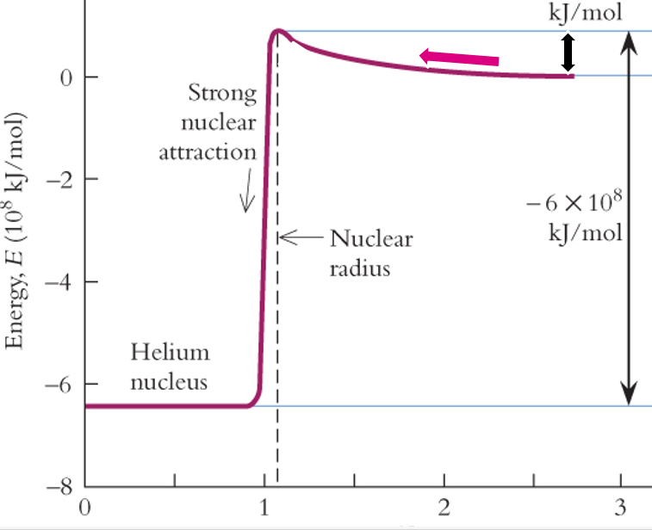
-in the nuclear reaction A + B C, mass A + mass B does not equal mass C
-e.g. ⁵⁶Fe, 26p + 30n ⁵⁶Fe, find mass before and after reaction
Mass before= 26mp + 30 mn = 26(1.00728 amu) + 30(1.00866 amu) = 56.44908 amu
Mass after= mass ⁵⁶Fe atom – 26 me = 55.9349 amu – 26(0.0005486 amu) = 55.92070
Mass defect= final – initial = -0.52838
The mass has been converted into energy. Mass and energy are equivalent. And energy
can be converted into mass!
Amu= g/mol
-heavier elements become more stable upon fission and lighter elements become more stable upon fusion… in both cases they release energy
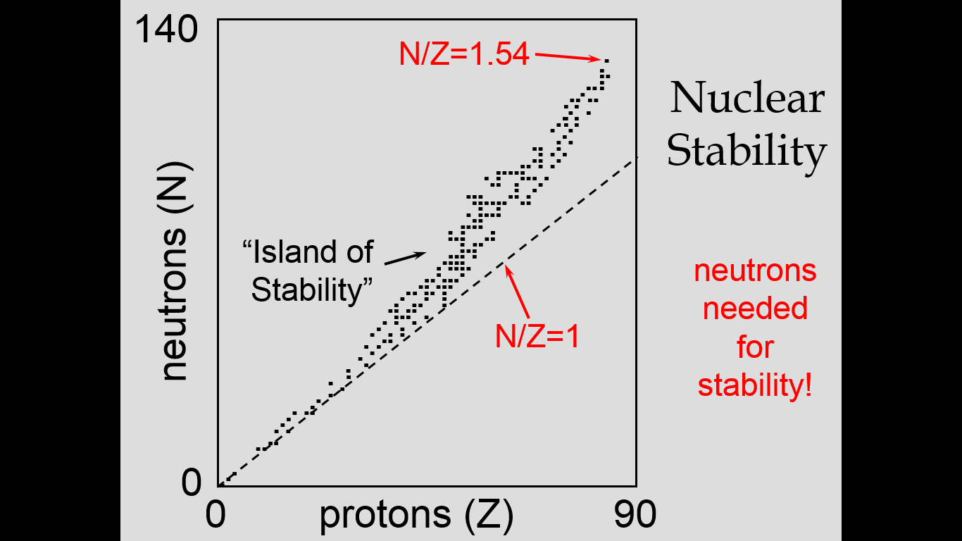
-at the island of stability… i.e. they have a measurable half-life
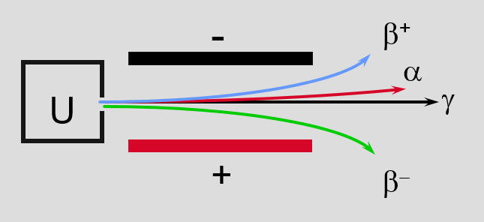
-alpha particles
+ positively charged
Massive
⁴He nuclei: 2 protons, 2 neutrons
-if after reaction is greater than before reaction, the nuclear reaction is spontaneous:
Before: After:
²³⁸U ²³⁴Th
N/Z = 146/92 N/Z = 144/90
= 1.59 = 1.60
-N/Z after is greater so the reaction is spontaneous
-alpha particle flies away fast—this is the radiation! Meanwhile the heavy particle recoils slightly
ΔE = Δmc², where Δm is the mass lost for every particle
-beta minus particles
-negative charge
-electrons come out
-small mass
-they are electrons: ⁰₋₁ e⁻
-also produces v_{e} – an electron antineutrino
-energy of the electron as it flies off is dependent on the energies of the mom, daughter and v_{e}
-beta plus particles
+ positively charged
-positron comes out
Small mass
Like positrons (+ charged e-)
⁰₁ e⁺
e⁺ energy depends on energies of mom, daughter and v (a neutrino)
-electron capture
-a 1s e- is captured by the nucleus, and as this happens, an e- falls from 2s to 1s orbital—which emits an x-ray
-a proton captures an e- and is turned into a neutron
-gamma ray emission
-as a daughter nucleus goes from high energy to lower energy, a gamma ray is emitted
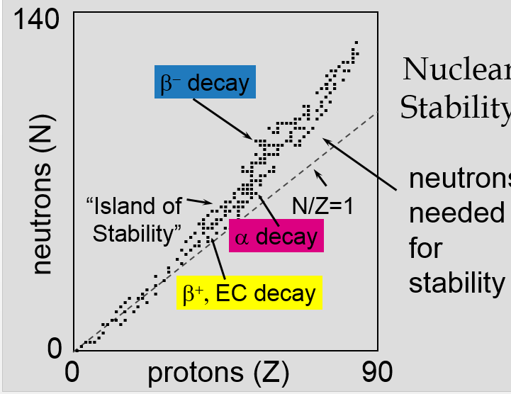
-decay rates: rate = kN, where k is the decay constant and N is the # of radioactive nuclei
-ALWAYS first order for radioactive decay.
Ln [N/No] = -kt and k= 0.693/t_{1/2}
e.g. calculate time required for 99% of a ²⁵⁷Lw sample to decay. T1/2= 8.0 s.
ln [1/100] = -0.693/8.0s t
t=53 s
-magic numbers are when nuclei are very stable (large half life) when n or p = 2, 8, 20, 28, 50, 82, 126
-nuclear fission: nucleus splits into pieces
-subcritical= no rxn
-just critical= controlled release of power
-supercritical= a bomb
-small mass of U-235 – many neutrons escape and reaction dies – subcritical
-large mass of U-235 – few neutrons escape and reaction is self sustaining—supercritical
-nuclear fusion: nuclei collide and join to form a new nucleus
-sun generates its energy by nuclear fusion of hydrogen nuclei into helium
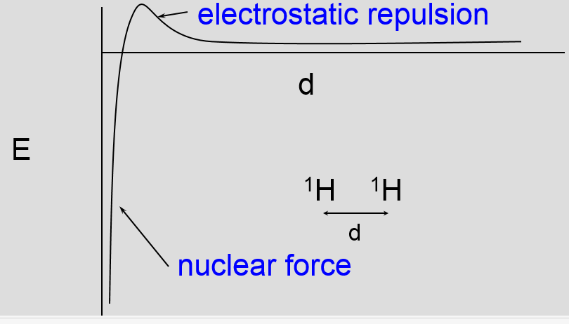
-e.g. 3 ¹n is the release of 3 neutrons (remember that its 0 charge)
ΔE= J/fission event
-neutron capture reactions:
¹⁴N (in air) + ¹n (from sun) ^{15m} N (metastable—short half-life) ¹²C + ³H
-Tc-99m, a medical isotope for diagnostic imaging
-Mo-98 + n-1 Mo-99 + gamma ray
-Mo-99 Tc-99m + ⁰₋₁ B
-Tc-99 (injected) Tc-99 + gamma ray (used for imaging)
-synthetic elements
-nucleus A + nucleus B -------> compound nucleus
-high energy drives process
-although mass is not conserved, charge and nucleons are conserved
-e.g. when an electron and positron annihilate one another, the result is two gamma rays.
-⁰₋₁ e- + ⁰₊₁ e+ 2 gamma rays
m_{e}=9.11x10⁻³¹kg
Δm = 0 – 2(9.11x10^-31kg) = -1.822x10^-30 kg
ΔE=Δmc²= -1.63x10⁻¹³ kg m² s⁻²
ΔE= -1.63x10^-13 J (per 2 photons)
ΔE= -0.815x10^-13 J per photon
E=hc/λ = 6.63x10^-34 Js (3x10^8 m/s) / -(-0.815x10^-13 J) = 2.42 x 10^-12 m = 0.00242nm

