EASYTAB for Kids
MARKETING PLAN

Executive Summary

Our company develops kids tablet menus with a unique application that allows children to entertain themselves at the dinner table. This marketing plan illustrates our market segments, who we are targeting, a review and analysis of our potential competitors and the environment, and how our product will be reaching the end user.

Our mission is to provide a way for children to entertain themselves at the dinner table in family oriented restaurants. Our product is unique because the application developed comes pre loaded only on our tablet - it cannot be downloaded on any regular device such as an iPad. What makes our product different from other tablet menus is that our end user is strictly kids and we are providing a way for them to entertain themselves by playing games and being able to order their food on the tablet. Our product fulfills the need of keeping children occupied and entertained during meal time.

By targeting the distributors as opposed to the restaurants, not only do we eliminate potential competitors, but the distributors also become our potential allies because, for them to compete with us would require spending lots of money on research and development when we have already completed this stage. We will be approaching app development companies, such as Joist, to create the application that will be loaded onto our tablet. Joist is capable of creating a game based application for children that integrates the restaurant’s menu into the application so the child can order directly through the application. The application will be loaded on android-based tablets that will be user-friendly for children and just as durable and aesthetically appealing to our target market.

Using demographics, social trends, and technological advances as the main factors that we use to analyze our environment, we are able to optimize the usefulness of our product in ways that coincide with the appropriate demographics, the current trends using the most updated pieces of technology. By focusing all of our efforts into the usage of tablet menus by children, we set ourselves a part from the rest with the creation of product that is distinct and unique and is the first of its kind – this results in a competitive advantage. In doing this, we are also able to establish our positioning strategy relative to any potential competitors.

We are fully committed to making our product environmentally friendly and will ensure proper reuse and recycling of materials. With our innovation, we will not compromise our responsibility preserve and sustain a clean environment. We will reduce our environmental impact by preserving resources, use energy efficient procedures in developing our product, and eliminate harmful toxins.
The full product to be developed:

Our final product is a Menu on a custom android based Tablet with a unique game oriented application designed and developed for children under 12 years of age. Our product consists of two elements, which are:

SOFTWARE

The custom game menu application will be developed by one of the two selected entities – Joist, a Toronto based app developing company, or Game Maker, a student recreational group that specializes in game development at Ryerson University – which will be determined by the best proposal presented between the two. Our kids menu will not only revolutionize the tablet menu industry but will also create a completely new experience of family dining. The application to be developed is much like any other child friendly game with the addition of a unique, interactive, decision-making platform, based on the restaurant’s kid’s menu that makes choosing food much more exciting as it is easier.
HARDWARE

The physical tablet will be manufactured by Kilwa Tablet, an android tablet manufacturing company based in Shenzhen, of the People’s Republic of China. Using Kilwa’s pre-existing children’s tablet products and child friendly preloaded applications, we can reduce our research and developing cost and manufacturing cost drastically. These tablets come readily equipped with a silicon/rubber bumper; anti-shock sleeve, and screen protection, providing extra protection when dropped and if knocked into hard objects such as a table, which is more likely to occur in the hands of children.

Our sample kids only tablet menus.
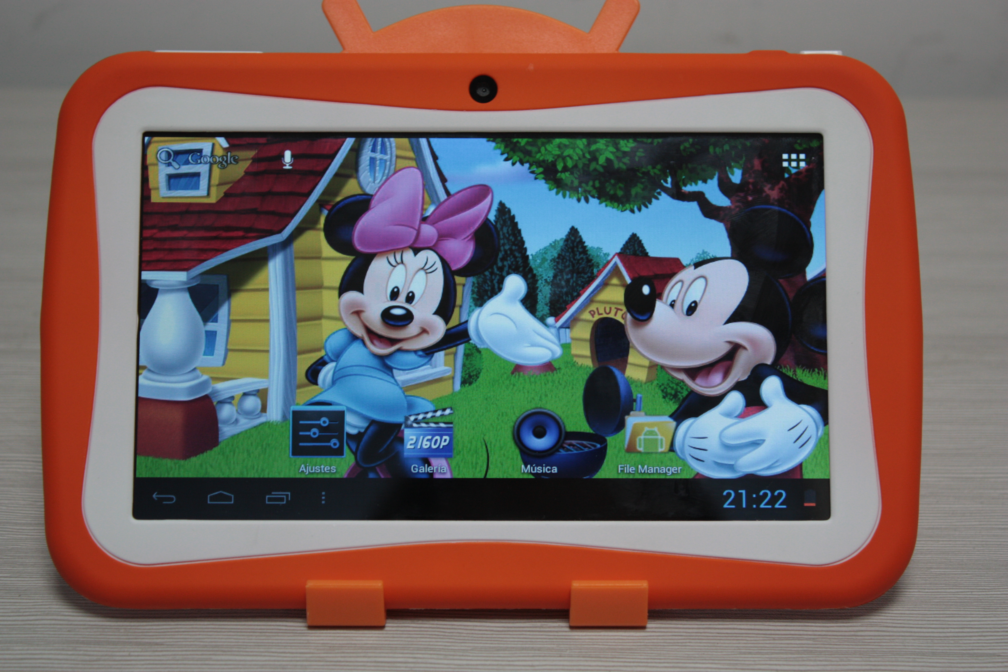

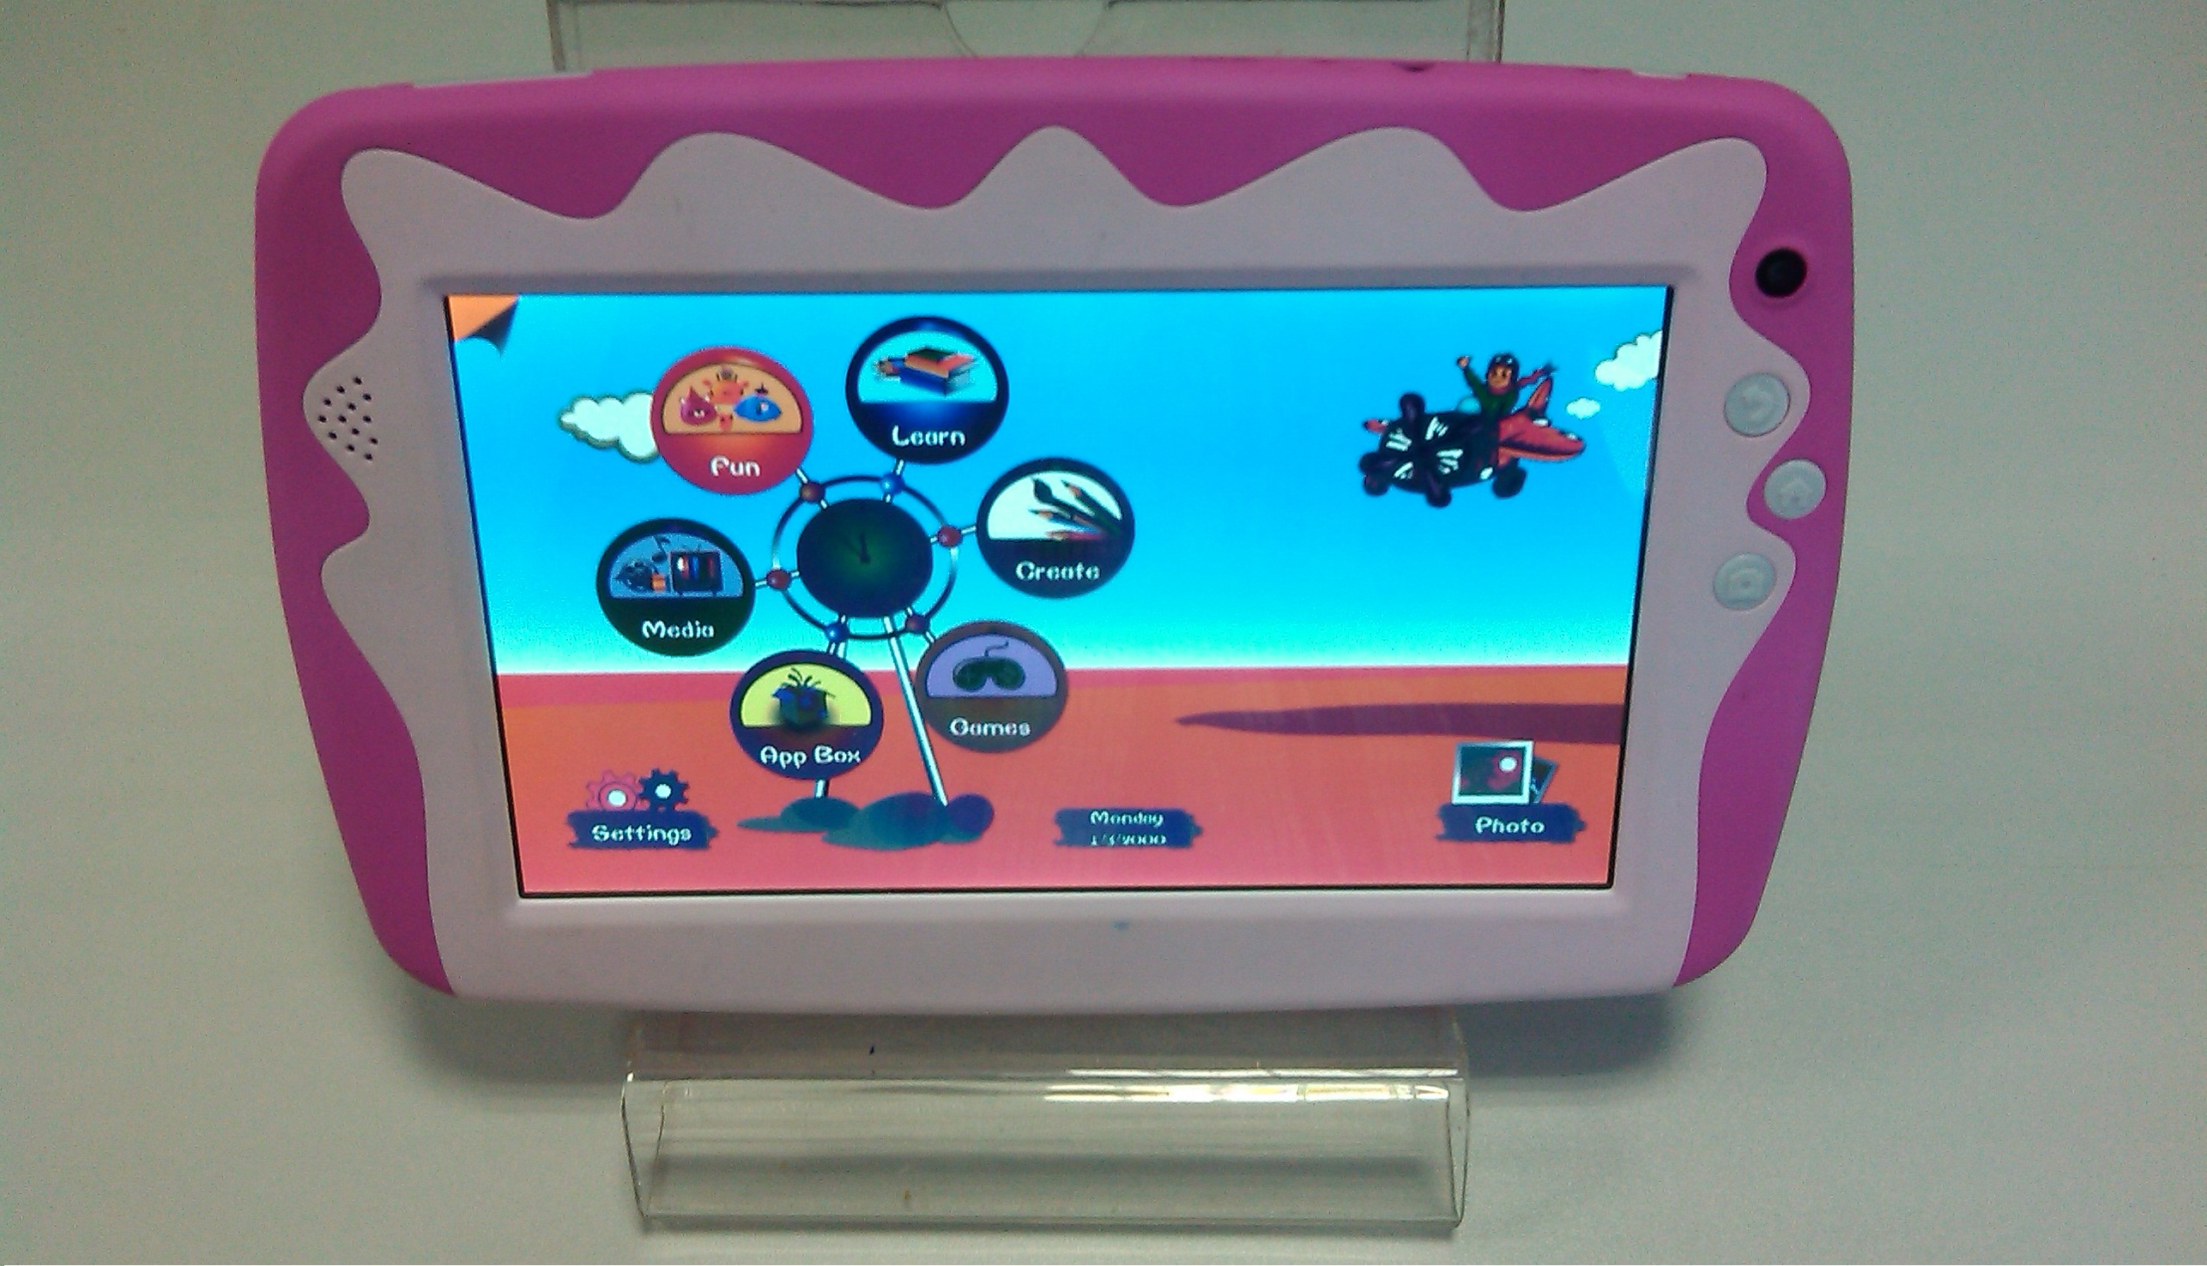
THE OVERALL MARKET
Our aim is to provide mid to large size restaurants with the technology not only to improve their customer satisfaction, but also to redefine seamless processes for restaurant’s staff. We do this by providing them tablets preloaded with an android-based operating system, which have pre-installed interactive games designed to engage the customers to enhance and customize the ordering experience. These games are easy to play and are well designed to work with the items on the restaurant’s menu.
Our marketing challenge is to attract the right businesses and create value for the product in the eyes of our target market. We intend to accomplish this by leveraging a multi-pronged approach that involves social media, email marketing and search engine optimization strategies to gain market share. As we gain traction in the marketplace, word of mouth will diffuse the awareness of our product significantly. We target restaurants that are family oriented, located in central locations that cater to younger individuals (18-35) & families (with kids ages 6-12). Restaurants that promote customer engagement are the type of restaurants that strive for efficiency in the order-taking process to maximize their production and therefore will believe in the value we provide. The tablet is a more technological advance yet simple method of order taking, that majority of restaurants will be able to integrate this fashion of ordering, as it doesn’t require staff to be tech savvy and it dramatically improves the customers dining experience.

Over the years, we have become more co-dependent on technologies like tablets or even our cell phones. This systematic integration of games in the tablet follows this rising market trend & provides the restaurant with the ammunition to further engage their customers, resulting in more attraction and ultimately attain greater market share.
When it comes to segmenting the market we chose Geodemographic, this includes a combination of attributes such as geographic, demographic and lifestyle. Consumers in a busy environment such as Toronto, tend to dine at similar restaurants that provide high quality and prompt service and therefore will react similarly to our marketing strategies and initiatives. The lifestyle of individuals in our society has vastly changed over time. Almost everything we do in the way we live today requires us to be in contact with some form of technology, which has only recently been developed. In fact, statistics show that fifty percent of the technology we use today did not exist five years ago ^{[1]}. The way in which we choose to live our lifestyle can be based on many factors such convenience, self-concept and self-values. This entails how we wish to reach our organization goals, allowing us to shape the very decision making process across the dinner table at our partnered restaurants. In another example, the use of iPads to communicate information to students in primary school is becoming more common ^{[2]}. This phenomenon is witnessed in a variety of cases as it provides us with the ability to redefine the transfer of information in a more engaging and appealing form.
In our case, the consumers are the restaurants that have goals of achieving higher productivity and drive more families with children to dine at their location, simply by enhancing the entertainment provided towards the children. These restaurants may be prioritizing social factors such as improving the interaction between customers around the dinner table. This desire for higher productivity brings various restaurants within our reach as we will provide a solution towards seamless order taking. We understand based on research that recently “Applebees” has contracted “Ziosk” (Also another tabletop for menus and entertainment) for the use of their devices on their dinner tables ^{[3]}. This proves to us that there is a positive response towards the integration of technology within this category, refining the dining experience. Many of the company’s outlined in our business proposal have been identified on bases of their nature of dining and the experience they provide to customers. For example JackAsstors is a well-established franchise that provides quality service consistently. This consistency of high quality is what makes a restaurant identifiable as it illustrates the desire for success within that very industry. Overall it comes down to profitability, and after some research we were able to conclude that we will be able to sustain a valuable profit margin, not only because of the tablet distributors we choose to provide our product to, but also because our wholesalers provide immensely competitive prices for the hardware and software incorporated into this product.
Following is a bulls-eye diagram illustrating our relative competition at this time in the market.
Ziosk
Same Target Market Diff Position



Coloring Book
Diff Target Market Same Position

US

Itamae Sushi
Diff Target Market Diff Position

Target Market

Our target market is directed towards companies selling tablet menus to family oriented restaurants. Often, families deciding where to go out to eat can sometimes be effected by having children who are constantly searching for some form of entertainment or are simply restless and indecisive. In the absence of thorough engagement, children tend to seek out the attention of their parents or someone close to them, which forces their family members to shift their attention away from whatever they are focusing on, to the child. What we are trying to achieve is higher productivity for restaurants by providing a means by which kids can entertain themselves. The software we provide will be android based. Children will be able to use our software to entertain themselves so that their parents can socialize with other guests at the table and enjoy their meals more effortlessly. Generally, kid’s menus are targeted for kids under the age of twelve, therefore our tablet and software will be directed towards the same age group. Our software is unique because it is pre-loaded only on our tablet, and is not available for download on other tablets, such as iPads.

Our strategy is to target businesses who sell tablet menus to restaurants that experience high volumes of families with kids that cannot entertain themselves or need constant attention. In addition, we will be directly targeting any restaurant chain within a minimum of one hundred locations in North America who are family oriented, giving them samples of our product for the purpose of surveying and data collecting, and potentially gaining interest by showing them the value of our product. However, we will be using tablet manufacturers to build our tablets and load our software onto the tablet. This is done to avoid high distribution costs because the business we are selling to already have their own distribution network in place.

Many restaurants have a “kids menu” that has child oriented activities like crossword puzzles, mazes and hang man. But with our software we will be able to collaborate the ‘gaming’ concept to the menu decision making process to help kids choose their meals while keeping them entertained. It will be programed to have the restaurant’s menu so that kids can order their meals right on the tablet. The software will be loaded onto our tablet for ease of access and will be handed out just like any regular menu. The tablet is a simple piece of technology, allowing an easy, user - friendly experience for the child. When turned on, the tablet will show a screen of pictures and visuals so that they have an idea of what the game is about. Based on the path the child follows in the game, a certain menu item can be chosen by the end of the game. However, at any time, the child can simply order their food if they already know what they by pressing the “home” button on the tablet and then tapping “Menu”. At that point the game can simply be used just for entertainment. With the simplicity of our tablet and our software combined, the parents do not have to stress about helping their kids figure out how to use the technology. With our software, kids will have something to entertain them while waiting for their orders and/or cheques.

By targeting a business that will sell our product to the restaurants, we avoid incurring high distribution costs. When we sample our product to restaurant chains for the purpose of market research, we are trying to show them value and see how likely they would purchase our product. With the simplicity, uniqueness and design of our software and tablet, both the children and parents will be able to enjoy their night out at the restaurant.

Competitive Analysis & REview

Our Business structure is business-to-business and we are selling our product to an existing business; our business-to-business sales marketing strategy is that we will sell our kids only tablet menu to other tablet menu distribution companies. As a business that strictly develops kids tablet menus (the first of its kinds), there are no specific competitors in the market at the present time other than
a) occasional coloring books or pages handed out at restaurants which is very rare now a days for starters,
b) downloadable free games on regular tablets that restaurants can distribute to kids, which can also be a potential competition as well and lastly,
c) the tablet menu distributors themselves like the ones we are partnering up with, who can potentially become our competitors if they choose to imitate our idea.
Selling & partnering with tablet menu distributors, who essentially would be the ones to compete against us, eliminates our major potential competitors. To compete, these distributors would have to spend a large sum of money on research and on development. However, since we have already done all the work,all that is needed is for them to monetize on it and our potential competitors would become our allies. In addition, this method significantly reduces marketing and distribution costs and several other variable and fixed costs. On the other hand, businesses that sell directly to consumers incur several overhead costs and face a number of potential competitors.

Along with avoiding costs, this method is much simpler and requires less effort without having to deal with multiple location vendors, distribution and compliance which is typically associated with B2C marketing. The business we sell our product to will already have distribution channels and compliance departments established. Above all they are already in business and have credibility amongst the consumers. By practicing a business-to-business channel, it allows us to position our marketing strategy to the business we are selling to.

Although we are entering an emerging market, our product is simply a supplement to the menus in the restaurants. Restaurants such as Applebee’s and Chili’s have already made orders for 100,000 tablet menus ^{[4]}. Our product’s uniqueness lies in its purpose to entertain children using gaming applications pre-loaded onto the tablet with a multi-purpose functionality as a menu, that enhances the overall dining involvement, as opposed to just supplying the restaurant with an electronic menu application. With a rising demand in this market of tablet menus, our product has a high potential to grow while eliminating competitors.
Following is our SWOT analysis comparing us to our current and potential competition.
SWOT | Kids only tablet menu  (Our Company) | Downloadable Games on a regular Tablet | Coloring books & pages with crayons
Strengths | Well equipped tablets geared towards kids only (Kid Appealing Tablet Size & Skin / Game & Learning based Menu / Silicon bumper and screen protection etc) | - Easily accessible  - Cheap software (game) solution | - Extremely Cost Effective  - Not dependant on Electricity
Weaknesses | Initial cost to develop the game based menu for kids only | Expensive tablets and lack of age specific targeted product aesthetically  (for the kids its nothing special, its just another tablet they have at home) | - Environmentally Negative (wasting paper)  - Limited to younger age of children only (after 6-7 years of age kids are not interested)
Opportunities | To partner with every major tablet menu distributor as The Brand that represents kids only tablet menus. | An investment in branding their tablets in which they downloaded games with skins and specific games geared towards food in their restaurant. | Get licensing to use popular characters like Disney etc can help them attracted kids more.
Threats | Any major tablet menu distributor deciding to do their own kids only tablet menu and backing it with significant planning, development, marketing & funding. | - Commercial use of equipment and software sometimes require licensing. | - Environmentalist groups targeting against paper waste  - Children can ingest paper or crayons
POSITIONING
The way that we are positioning our company and our product, is product attributes since we are the only company that has a product that is designed to keep kids entertained with a unique application. We want businesses that we are selling these tablets to perceive us as innovators of the best kid’s tablet. Our tablet is made for tablet menu distribution companies that sell menus to family oriented restaurants, who experience high volumes of parents with kids that seek some form of entertainment. Our kid’s tablet includes the restaurant’s menu and a game that assists in choosing food, and is unlike other tablet menus as it offers a solution to parents who are most concerned about what their children want to eat.
Our target market sells tablets to family based restaurants. We have understood the industry and have provided them with a tablet that they need to make their customers, especially the kid’s more involved and interested. Most potential competitors use a product that is geared to all-aged customers whether it be adults, seniors, teens, or kids. They position themselves as the generic kind of restaurant tablet menu. Our consumers use similar tablets that are used by adults, for kids, in which both parties will be satisfied by the level of interactivity with the restaurant. By recognizing and acknowledging this need we position ourselves as the kid’s only tablet company, and since there is no one else with a tablet that is designed for just kids in the same manner as ours, this will give us an advantage over potential competition.
If we were to look at the perceptual map for the tablet, we would notice that our tablet has an ideal point for our target market because it not only focuses on children but its usefulness appeals to more kids, aged 12 and under, compared to the potential competitions age restriction.
Restaurants such as Caplansky’s, Pizzeria Libretto Danforth, Barque, uses coloring books to entertain children which entertains only half of children leaving kids older than ages 4 to 5 uninterested. Restaurants that use tablets by companies such as Ziosk and E la Carte have tablets that are made for adults and are not as easy to use for kids. Lastly, not a lot of restaurants provide their own tablets. The ones that have downloaded menus themselves such as Itamae Sushi haven’t provided anything interesting for the children, but if they were to do so then they would become our potential competitors.
Our advertisement shows the message we want to bring to our customers: “Now it’s fun for everyone”. With this motto, we want our consumers to notice that our product will bring joy to every single one of their customers. Other companies might be targeting couples and with that they are missing the whole other side of the market – families with children. In contrast, our product tackles that side of the market and engages every member of the family that visits.
For tablet distributors who aim to increase the number of restaurants that want their company’s tablets, the EasyTab for Kids is a tabletop menu for children that acts as both entertainment and an order placing system connected to the restaurant, for children to keep themselves occupied but just as interactive during their dining experience. Unlike potential competitors, such as coloring books, and generic tablets distributed by companies like Ziosk, our product is a strictly kids only, android based tabletop menu designed to be aesthetically pleasing to children, that combines an interactive gaming software and the restaurant’s menu so that the child can choose what they want without having to feel bored during the waiting periods.
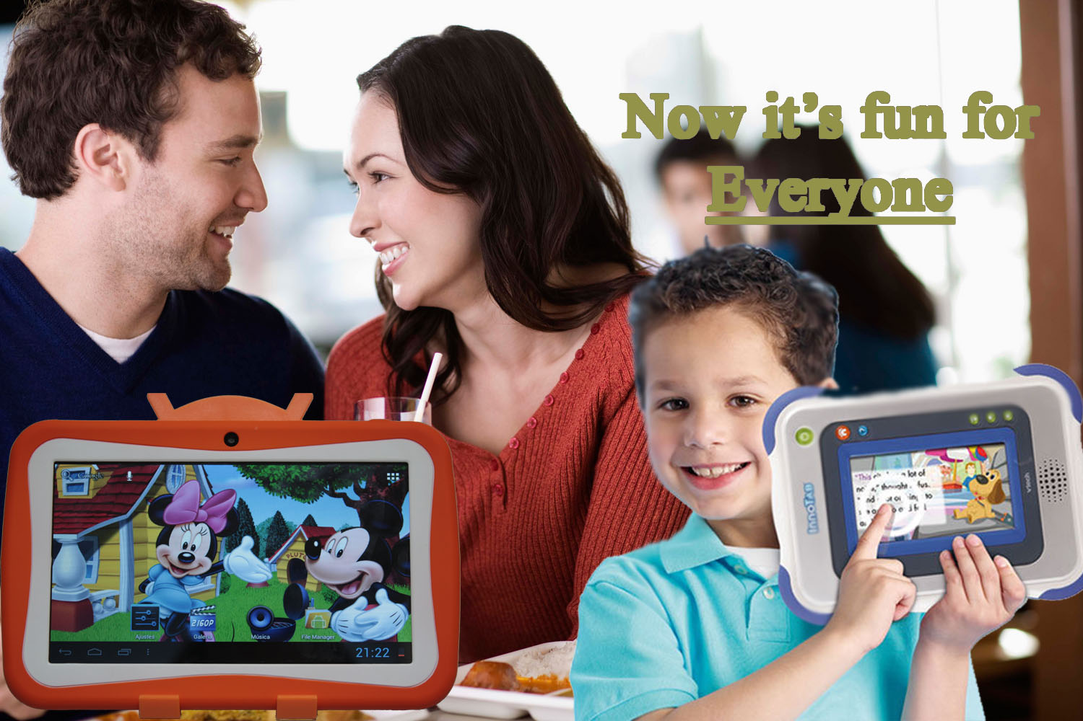

Environmental Analysis
Market Trend Analysis:
INDUSTRY
The tablet menu industry provides a user friendly interface that creates a delightful experience, in addition to efficient and convenient services for the customer, once seated in the restaurant. Not only does the tablet menu enhance overall experience, but the tablet menu also makes more money by reducing operating costs. The cost of editing the restaurant menu can be reduced or even eliminated as the process would be simplified to just changing the items right from the tablet’s main interface. This would also reduce the waste of producing more physical menus each time a new item is added. Subsequently, this industry of tablet menus allows for the proficient use of technology in the dining room.
MARKET SIZE
Research has shown that the use of technological devices in restaurants are increasing. As it is, a significant number of consumers already use some form of technology to interact with restaurants from outside, whether to order a meal for delivery or to pay for a meal. The use of these products inside the restaurants would only further enhance the dining experience. Statistics show that seventy percent of consumers use smartphones and/or tablets on a day to day basis, and thirty-two percent of the aforementioned, admitted to wanting to use their devices to pay rather than using cash or debit, if such offer existed ^{[5]}. With such a large chunk of consumers being exposed to these kinds of technologies, the majority of guests should not be thrown off using self-service tablets when they walk into a restaurant. The market’s expansion has pushed restaurant chains like Chili’s to introduce approximately 45,000 Ziosk tablet menus, in 800 different locations ^{[6]}, as the benefits – such as the ability to generate more tips, and its improved service efficiency – contribute greatly to the company’s overall revenue.
MARKET TREND
As today’s technological innovations continue to evolve, so too do the capabilities and their functionalities. Inevitably enough, these advancements have found many ways into our normal day-to-day activities, and being used as an interactive tabletop menu at restaurants is just one of the ways. In a research conducted, more than one-third of consumers were reported to have been using more technology related options (e.g. ordering meals, paying, and redeeming rewards) in restaurants now than they had two years ago^{[7]}. Hudson Riehle, the National Restaurant Association’s senior vice president of research had stated that the number of restaurants offering some type of technology related service is a trend that has rapidly increased over the past two years and will continue to do so for years to come ^{[8]}. Riehle quotes “As restaurants integrate more customer-facing technology, usage among consumer is growing” (Hudson, FSR Magazine) ^{[9]}. This of course does not only refer to how people decide where and what to eat, but also includes how employees and other operators engage and interact with consumers.
SALES
With the convenience and level of functionality that tablet menus provide in restaurant dining areas, the sale and demand are continually increasing. As mentioned previously, restaurants using such means of ordering (e.g. Applebee’s) have experienced growth in revenue, with both appetizers and desert sales increasing by twenty percent and thirty percent respectively, the amount of food people order has grown simply because ordering food has become that easy^{[10]}. Having witnessed the improvements in service efficiency and restaurant revenue, from both increased tips and the sale of more menu items, it’s no wonder why restaurants such as Applebee’s and Chili’s have decided to implement this automated menu format at their several branches. The tablet menu not only makes ordering a lot faster and waiting for a bill shorter; but it also generates more orders as it does for the customer’s appetite with ordering food being as simple as pressing a button. Without having to wait for a server for a bill or to order food, the waiting times are reduced and the dining experience is enhanced. The two chains mentioned above are not the only exceptions, but they are simply just examples of how extensive the overall sales are with the addition of this product.
MACROENVIRONMENTAL ANAYSIS

When analyzing the environmental factors of this particular tablet menu market; culture, demographics, social, technology, economic, and political/legal are all involved in the potentiality of the market at the Macro-level, each to their own degree. The culture of the environment refers to the beliefs, shared meanings, values, behaviors, of a group of people that are passed from generation to generation. Two dimensions that are included in ‘culture’ that marketers must also take into account, are country culture and regional subcultures. Country culture refers to the visible distinctions in that particular country such as behaviors, ceremonies, language, color, food preference and more subtle hints that are more difficult to identify. On the other hand regional subcultures refers to how certain objects or rituals are referenced relative to the country in discussion.
The economic environment refers to the changes that occur in the economy that can affect the way consumers purchase products and the way they spend money. Some economic changes include inflation, in which prices of goods and services increase, foreign currency fluctuations, interest rates, and recession, in which the economic growth is negative for consecutive quarters. The political or legal environment consists of the political parties, government organizations, legislation and laws that allow or prohibit certain marketing activities. A legal case that could arise within the production of our tablet menu, for example, would be if we were to use a system that was not open-sourced, such as apple.

The demographics are the specific characteristics of the different population segments that segregate people based on age, gender, race, income and ethnicity which is used when identifying consumer markets. By focusing on a particular demographic, this helps us as marketers determine a target market, rather than mass marketing to the general public which has proven to be ineffective over time and is thus no longer used. In our case, we are able to appeal to the appropriate customers that apply to our product, because had we just settled on any demographic, such as seniors, we would not garner the same attention as we do with children.
Social trends, which is closely related to the concept of culture, are the activities that shape the values of consumers worldwide. Though social trends are variable by default and changes occur regardless of the surrounding culture, identifying the emerging trends are important in differentiating an opportunity from a threat. The trend that occurs in our product’s scenario is the use of tablet menus over the standard physical menus to enhance the dining experience. As mentioned earlier in the environmental analysis, the use of tablets as menus in restaurants has enhanced the over dining experience in restaurants, so with such a market already in existence and having been quite successful, its only reasonable for us to make use of an increasing market.
The technological aspect analyzes the existence of the technological advancement, and its contribution to the improvement of the products and services it pertains to. By merging with an already existing market, that is the tablet menu, we are further enhancing the use of technology in restaurant dining rooms by creating an android – based tablet menu aim specifically for children. In that aspect not only adults, are interactive with these devices but so too are their children. Our hopes in providing our product is to reinvent the dining experience for customers so that tablet oriented ordering will become the norm not only for adults but for kids as well, much similar to how “pay at the pump” is now a presumed option. We know that the use of technology in this generation has increased over the past years, even the use of it in connection to restaurants has bloomed. Taking advantage of this, we are able to successfully incorporate our product, not only because the market is already there as well as pre-existing distribution channels, but also because our target, the younger generation - the millennium - are already well acquainted with such devices, so to use it in such ways only adds more excitement in restuarants.

Why spend funds on this Idea?
Our Kids Tablet Menu is the best idea to spend funds on because it is a one of a kind product, the first of its nature. While most tablet-menu selling companies in the market are generic towards all its customers – whether it be adults, seniors, teenagers and/or children – we have focused our efforts and attention towards children specifically using interactive and educational games to enhance their dining experience. The idea of providing the tablet rather than simply creating an application, reduces the hassle of the customers needing to download it upon arrival, in which case they would default to the simpler route that is using an ordinary menu. Having a standardized tablet menu created especially for children, establishes our uniqueness as a family-oriented restaurant and is our means of differentiation. In addition, not every family owns such devices or brings them along with them wherever they go, so by providing it for them, we ease the efforts needed for the family to bring their children.
As engaging as dining with children is, the process of deciding on a meal can require some effort from both the child and the parent. In some cases they may not know what they want and other times they simply may be uncooperative, such as when they do not want to eat. In addition, they tend to have very limited patience due to the long waiting spans before and after ordering food which can result from short attention spans while going over the menu, and having to follow behavioral procedures like remaining seated. Consequently, by all means not a rare sight, children can be seen throwing tantrums, or wondering around and getting distracted when dining out. With their innate amount of energy and restlessness, ordering food for younger children can become quite the chore if the parents don’t know how to gain their attention and cooperation. Our product’s capabilities will address and ease this issue by raising the level of engagement at the dinner table and reducing the child’s state of boredom and indecisiveness.

Our tablet’s unique game based menu can help children concentrate on something they already enjoy which is playing interactive games. By retaining their interests into this game based application, it not only gets the job done (by selecting the correct corresponding menu item), but it keeps the child from feeling restless and improves the overall experience of pleasure for the entire family’s dining experience. We are reinventing a child’s experience when visiting a restaurant. The purpose of the application is to enhance the dining involvement through cooperativeness and interactivity when deciding what to eat, while at the same time keeping them under control. This allows for a more enjoyable and peaceful meal-time for both the children and the parents, and overall adds new meaning for restaurant hospitality and service.

BIBLIOGRAPHY

Pink Tablet:
http://www.kilwatablet.com/images/V721Y/V721Y.Kid.Tablet.jpg
Mickey Mouse Tablet: http://www.kilwatablet.com/images/V711E6/V711E6.kid.tablet.1.front.JPG

Colt, Sam. "Tablets Are Making Waiters Obsolete - And Chili's Is Leading The Way." Business Insider. Business Insider, Inc, 24 June 2014. Web. 18 Nov. 2014.
http://www.businessinsider.com/tablets-are-making-waiters-obsolete-2014-6

"DESS IPads - DESS." DESS IPads - DESS. N.p., n.d. Web. 18 Nov. 2014.
http://www.dess.org/index.php/news-and-events/dess-in-the-press/item/340-dess-ipads.html

"Technology Use In Restaurants On The Rise." FSR Magazine. N.p., n.d. Web. 18 Nov. 2014.
http://www.fsrmagazine.com/technology/technology-use-restaurants-rise

"Why Tabletop Tablets Can't Replace Servers." FSR Magazine. N.p., n.d. Web. 18 Nov. 2014.
http://www.fsrmagazine.com/kitchen-sink/why-tabletop-tablets-cant-replace-servers

Wong, Venessa. "That Tablet on the Restaurant Table Will Make You Spend More." Bloomberg Business Week. Bloomberg, 17 Sept. 2013. Web. 18 Nov. 2014.
http://www.businessweek.com/articles/2013-09-17/that-digital-tablet-on-the-restaurant-table-will-make-you-spend-more

FOOTNOTES:
[1] Brent Barr lecture
[2] Dess Ipads
[3] Wong, Vanessa (Bloomberg, Buisiness Week)
[4] Wong, Vanessa (Bloomberg, Business Week)
[5] FSR Magazine “Technology Use in Restaurant On the Rise”
[6] Colt, Same (Business Insider)
[7] FSR Magazine “Technology Use…”
[8] FSR Magazine “Technology Use…”
[9] FSR Magazine “Technology Use…”
[10] Austen Mulinder (FSR MAGAZINE)

