Chapter 1
Assets = Liabilities + Owner’s Equity

Assets: Anything that you own and has value, in the present or in the future.
Liabilities: Something that you owe and must pay off.
Equity: What’s left of your asset after you have paid off your liabilities.
Revenue: Is something you earned, regardless id you got paid or not.
Expenses: Are assets consumed to help earn the revenue?

Balance Sheet (Continuous) | Income Statement (Snapshot) | Statement of R. Earnings
Assets | Revenue | Retained Earnings (Opening & Closing)
Liabilities | Expenses | Net Income
Shareholder’s Equity |  | Dividends

Sales Returns, Sales Allowances and Sales Discounts are Contra-accounts.
Contra-accounts are used for control and analysis purposes.
Depreciation shows up on the Operating Expense section of the Income Statement.
Multi-Step Income Statements got four important subtotals:
- Gross Profit
- Income from Operations
- Income before taxes
- Net Income

Income Statement example:

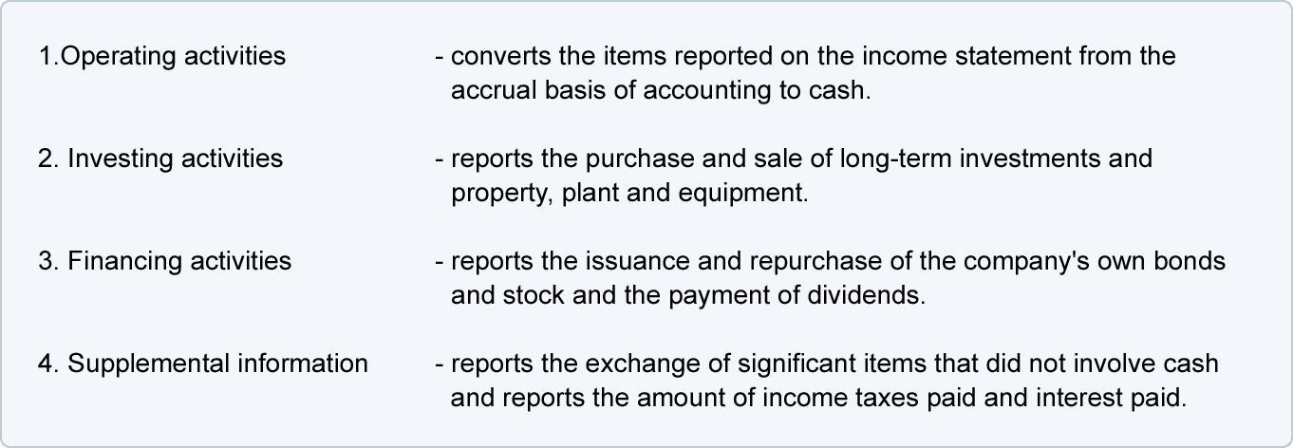
Statement of Cash Flow:

Statement of Cash Flow example:
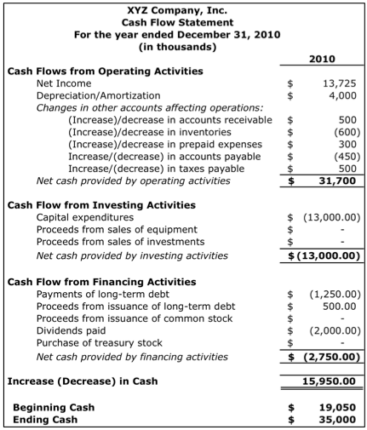
- Assets are a running total.
- Negative numbers go in brackets
- Accumulated Depreciation is an Asset since you already own that amount of the asset.
- Economic Entity Concept: each entity has its own books, records and Financial statements that are separate from its owners.
- Cost Principle: Assets are recorded at the cost paid to acquire the, and continue to record them at Historical cost. This is more objective than market value.
- Going Concern: Assume business will continue indefinitely into the foreseeable future. This justifies using Historical Cost.
- Monetary Unit: How we measure things. Assumes that the economic measure is relatively stable and no adjustments for inflation is made.
- Time Period Assumption: Assumes that is possible to break up an entity’s earnings into time periods since it is necessary to provide users with financial results on a timely basis. Requires estimates.
- $Net Income=Revenue-Expenses$
- $Current Ratio= \frac{Current Assets}{Current Liabilities}$
- Current Ratio > 1 in order for a company to be considered liquid.
- Assets are listed in order of liquidity in the Balance Sheet.

Chapter 2
- Primary objective of financial reporting is to provide information for decision-making.
- Secondary objective of financial reporting is to:
- Assess investor/ creditor cash receipts
- Assess cash flows to company
- Reflect resources and claims to them
- A shareholder’s primary concern is whether the company’s net income will drive up the share prices.

Qualitative Characteristics:
- Understandability: to those willing to take the time to understand it.
- Relevance: has capacity to make a difference.
- Reliability: represents what it is supposed to.
- Verifiability: free from error
- Representational Faithfulness: information that corresponds to an actual event.
- Neutrality: the information should not be slanted in any way.
- Conservatism: when in doubt, err on the negative side.
- Materiality: will the size of errors or omissions make a difference to decision makers.
- Benefit vs. Cost: benefit of accounting information must its exceed cost.
- Comparability: be able to compare between companies
- Consistency: be able to compare from one period of the company to another.

Chapter 3
- External Events are interactions between entity and the outside environment.
- Internal Events are interactions within the entity.
- Only Transactions are recorded.
- If an Event is Measureable and Realized, then it is a Transaction
- Source Documents are used to determine if an event is a transaction. (e.g.: purchase invoice, payroll records, receiving documents, etc.)

Debit (Left) = DEAL | Credit (Right) = GIRLS
Dividends | Gains
Expenses | Income
Assets | Revenue
Loses | Liabilities
 | Stockholder Owner’s Equity

Chapter 4
Economic Events like the purchase of land or payment of an invoice
are
Recognized using words like account names, numbers and dollar amounts
and
Measured with characteristics, attributes and monetary amounts

Cash Basis:
- Revenue: is recorded when CASH (or credit cards, cheques) is RECEIVED.
- Expenses: is recorded when CASH is PAID.
- Shows how a company manages their cash.
- Does not show ALL of the company’s economic activities.
- Can be manipulated. (e.g: if revenue is already high enough for this month, you can ask to be paid next month instead, even though you did not do any work next month)
- The movement of cash does not provide the External user with full information to make decisions.
- The Cash Flow Statement uses Cash Basis of accounting.

Accrual Basis:
- Revenue: is recorded when it is EARNED.
- Expenses: are recorded when it is USED, incurred, or consumed to generate revenue.
- Shows the Economic activity that the company is engaged in.
- Accrual Basis Income Statement allows the reader to focus on the long term profitability of the business rather than simply on the amount of cash received and paid in any given year.
- The Income Statement and Balance Sheet uses Accrual Basis of accounting.
- Answers the question of when to recognize the revenue and record the expenses.

- The difference between the two is the Time Period that we record the transactions in.
- External users need to understand all economic transactions (accrual accounting) and to know how a company manages its cash (cash accounting)
- If you have to break the life of a company up into time periods (using the Time Period Assumption), you must use the Accrual Basis of accounting.

Transactional Entries:
- Is the External Entry that is recorded when a Revenue or Expense is paid for.

Adjusting Entries:
- Is the Internal Entry that is needed when revenue is earned or expenses were consumed during the period after the first External Entry
- Never includes the Cash Account, always uses one Balance Sheet Account and one Income Statement Account.
- $Depreciation Expense per year= \frac{(Original Cost-Slavage Value)}{Estimated useful Life}$
- Not adjusting entries leads to under or overstating of accounts.

Types of Adjusting Entries are:
  - Prepaid Expense: Cash paid before expense is incurred. (An asset)
- Costs are initially recorded as Assets.
- Later on, decrease the Asset and Expenses are increased. This also decreases Shareholder’s Equity.
- Depreciation is a Contra-Asset that also reduces Shareholder’s Equity.
- Matching Principle

  - Accrued Liability (Expense): An expense that been incurred and has yet to be paid.
- There is never an initial entry
- Record Expenses and corresponding Liabilities in the period incurred.
- Always involves an increase to the Liabilities and Expenses accounts.
- There is always a subsequent cash payment
- Matching Principle.
  - Accrued Asset (Revenue): Is income that has been incurred but has yet to be received.
- Record Revenue and Accounts Receivable in period it is earned
- Always involves an increase to the Asset and Revenue accounts.
- There is always a subsequent cash receipt.
- Revenue Recognition Principle

  - Unearned Revenue: Cash received before revenue is earned. (A liability)
- Receipts are initially recorded as Liabilities under Unearned Revenue.
- Later on once the Revenue is earned, the Liabilities are decreased while the Shareholder’s Equity increases.
- Revenue Recognition Principle.

Chapter 5
- $Gross profit= Sales-Cost of Goods Sold$
- $Net Income=Gross Proft-Operating Expenses$

- Perpetual System of Inventory
- Detailed records of the cost of each inventory purchase and sale are maintained.
- Cost of goods sold is determined each time a sale occurs.
- Provides better control over inventory.

- Periodic System of Inventory
- Detailed records are not kept throughout the period.
- Cost of goods sold determined only at the end of the accounting period, when a physical inventory count is taken.

FOB Shipping Point: Freight is paid by the BUYER
- The cost of shipping is added on to the inventory, since it is included in the TOTAL COST to get the product ready for sale.
FOB Destination: Freight is paid by the SELLER
Goods in Transit:
FOB Shipping Point:
-The seller will record a sale and receivable, but will not include the goods in transit as its inventory.
-The buyer is the owner of the goods in transit and will need to report a purchase, a payable, and must add the goods in transit to its own inventory.
FOB Destination:
-The seller will not have a sale and receivable until the buyer receives it, this means they must report the goods in transit in its inventory.
-The buyer will not have a purchase, payable or inventory until the goods actually arrive.

Purchasing Transactions:
 | Accounting Equation Impact
Transaction | Assets = | Liabilities | + Shareholders' Equity
Purchase inventory for resale using cash. | + Inventory
 | - Cash
Purchase inventory for resale on account. | + Inventory | + Accounts Payable
Paying freight costs on inventory purchased, | + Inventory
FOB shipping point | - Cash
Returning inventory to supplier for cash. | + Cash
 | - Inventory
Returning inventory to supplier for credit. | - Inventory | - Accounts Payable
Paying suppliers on account within the | - Inventory | - Accounts Payable
discount period. | - Cash
Paying suppliers on account after the | - Cash | - Accounts Payable
discount period.
Credit Terms: in order to encourage early payment of accounts, some companies provide “terms”
e.g.: 2/10 , n/30 means:
- Pay within 10 days to get a 2% discount
- If not paid within 10 days, the net amount is due by the 30th day.
  - Discounts make inventory cheaper that has to be reflected in the Inventory account since inventory has to be equal to the cost to get it ready for sale.
Sales Transactions:

 | Accounting Equation Impact
Transaction | Assets = | Liabilities | + Shareholders' Equity
Selling inventory to customers – sales entry at | + A/R OR |  | + Sales (Revenue)
the selling price. | + Cash
Selling inventory to customers – cost entry at | - Inventory |  | - Cost of goods sold (Exp.)
the cost of inventory.
Paying freight costs on inventory sold, | - Cash |  | – Freight Out Expense
FOB destination.
Customer returns inventory – reversal of the | – A/R OR |  | ‘- Sales Returns and
Sales entry. | - Cash |  | Allowances *
Customer returns inventory – reversal of the | + Inventory |  | + Cost of goods sold (Exp)
Cost entry.
Customer pays their account within the | + Cash |  | - Sales Discounts *
discount period. | - A/R
Customer pays their account after the | + Cash
discount period. | - A/R

SALES always has 2 entries:
- Sales entry at the selling price to the Sales account.
- Cost entry at the cost of inventory to the Cost of goods sold account.

If a buyer pays within the discount period:
e.g. $50 discount on a $5000 dollar A/R:
Assets = | Liabilities + | Shareholders' Equity
+ Cash $4,950  - A/R $5,000 |  | - Sales Discount $50

Sales Returns has a negative entry on Shareholder’s Equity.

