The Cytoskeleton Motility And Microfilaments.

Experiment #7

By: Siv Darmalingum- 100857056
Partners: Steve Orfanidis & Ryan Boddis

BIOL 3201 Thursday P.M.

Results.
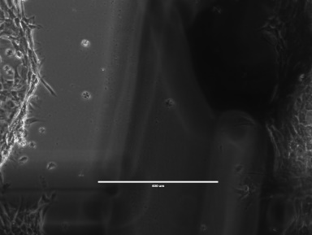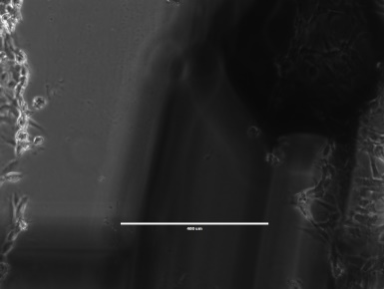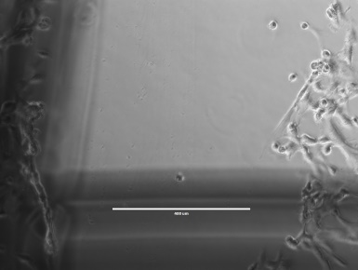
C
B
A
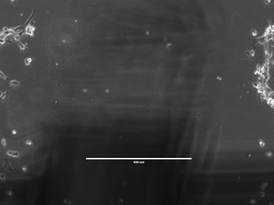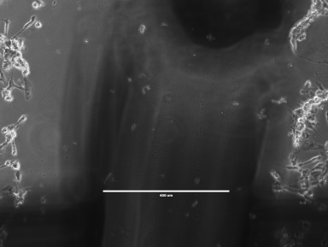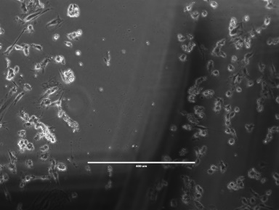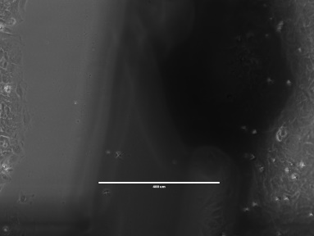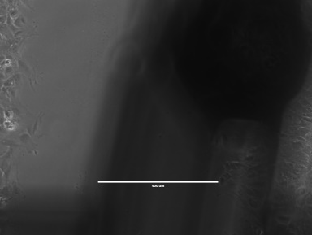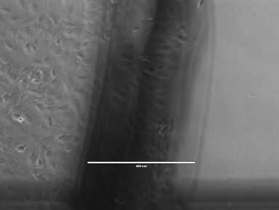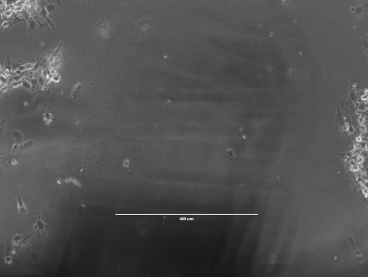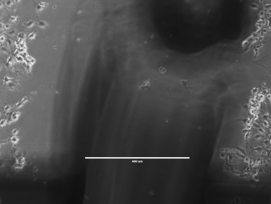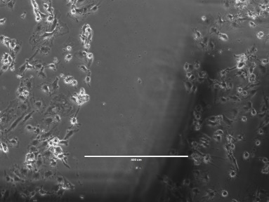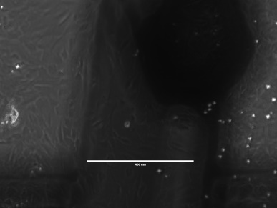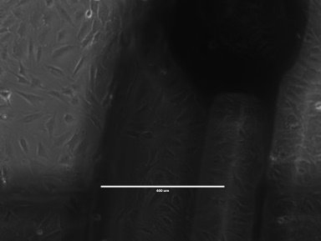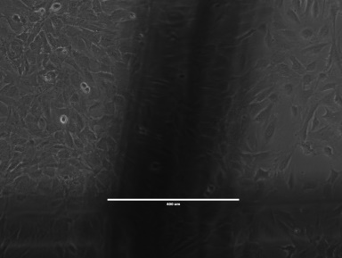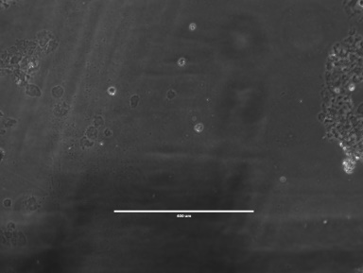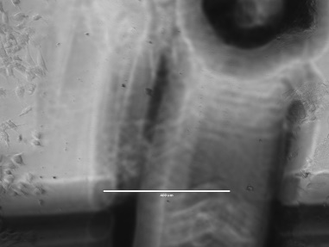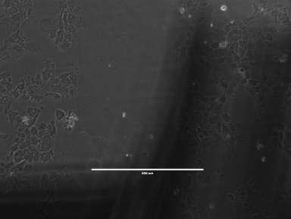
R
Q
P
O
N
M
J
K
L
I
H
G
F
E
D
Fig 1. Illustrates 3T3 cells in two 35nm dishes, one treated with media containing cytochalasin B and the other treated with control media. Photographs were taken with the 10X objective of the left, center and right wound at 0hr, 4hrs and 18 hrs after treatment.(A-0hrContC, B-0hrContL, C-0hrContR, D-0hrCytbC, E-0hrCytbL, F-0hrCytbL, G-4hrContC, H-4hrContL, I-4hrContR, J-4hrCytbC, K-4hrCytbL, L-4hrCytbR, M-18hrContC, N-18hrContL, O-18hrContR, P-18hrCytbC, Q-18hrCytbL, R-18hrCytbR).

Fig 2. Illustrates the average wound width of the control media treatment and the cytochalasin B (Cyt B) treatment as a function of time. The Cyt B wound width remains fairly steady whereas the control wound gradually decreases.

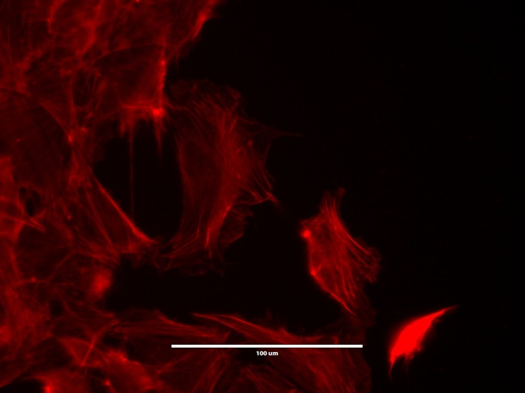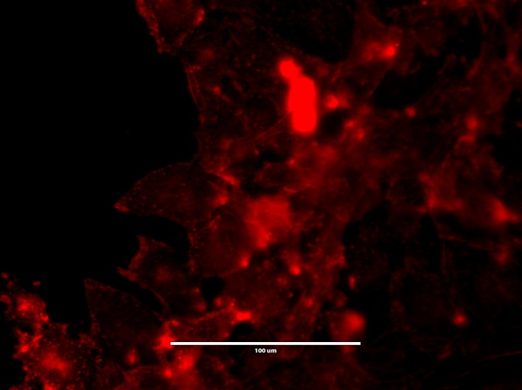
B
A
Fig 3. Illustrates 3T3 cells with one dish treated with cytochalasin B and Rhodamine Phalloidin (B) and the other treated with complete media with no additives serving as a control (A). The photographs were taken on channel 3 of a fluorescent microscope at 40X objective.
Discussion.
As observed in figure 3, there is a noticeable difference in cell shape between the control cells and the cells treated with cytochalasin B; in figure 3A the cells appear much more fibular whereas the cells in figure 3B they appear more rounded. Figure 3A suggest the presence of stress fibers towards the edges closer to the wound furthermore suggesting movement of the cell towards the wound; whereas figure 3B suggests the absence of such fibers hence insinuating no movement (Hotulainen, 2006). The cells closest to the wound appeared to be more branched out in comparison to cells further away from the wound, this can be seen in the control photographs in figure 1, the cells treated with cytochalasin on the other hand appear more rounded; however, some branching is still observed but less in comparison to the control cells.
In figure 2, we notice that in the dish treated with cytochalasin B, the wound width did not deviate much from the initial scratch over a period of 18 hours; whereas, in the dish with the control media the wound width gradually decreased over time. This implies that the cell motility has been reduced due to the treatment with cytochalasin (Cooper, 1987).
Cytochalasin B reduces cell motility by binding to the end of actin filaments hence reducing the rate of actin polymerization and the dissociation of the actin subunits (Cooper, 1987; Fletcher, 1980). This binding of cytochalasin also causes the cell to become less stiff, round up, and enucleate (Cooper, 1987). Krishan (1972) observed that cells exposed to cytochalasin B had reduced motility, resulting in the daughter cells not being able to move away from each other and reuniting to form multinucleate cells, Krishan also observed that mitotic cell exposed to cytochalasin B for long periods of time showed vigorous blebbing and contraction of the cell surface (Krishan, 1972).
A practical use of cytochalasin B is due to its ability to induce polyploidy; Stanley (1981) used cytochalasin B to induce polyploidy in oysters to study their sterility and growth (Stanley, 1981).

References.
Cooper, J.A. 1987. Effects of cytochalasin and phalloidin on actin. J. Cell Biol. 105:1473-1478.
Hotulainen, P. and P. Lappalainen. 2006. Stress Fibers are generated by two distinct actin assembly mechanisms in motile cells. J. Cell Biol. 3:383-394.
Krishan, A. 1972. Cytochalasin B: time-lapse cinematographic studies on its effects on cytokinesis. J. Cell Biol. 3:657-664.
Stanley, J.G., S.K. Allen, H. Hidu. 1981. Poluploidy induced in the American oyster, Crassostrea virginica, with cytochalasin B. Aquaculture. 23:1-10.

