Chapter 14: Negotiable Instruments

Negotiable Instrument- consists of a contract that contains an obligation to pay money. It is not actually money. It is a contract that is intended to eventually result in the payment of money.
Nemo dat quod non habet- no one can give what they do not have (page 321 footnote)
Exception is cash, cash needs to flow freely otherwise every purchase would involve a long, expensive, and impossible process of proving ownership of the coins and bills

Many of the rules that govern contract do not apply in the same way to negotiable instruments:
- Consideration- cheque is enforceable only if it is supported by consideration, the requirement of consideration in this case is easily satisfied (page 322)
  - Bill of Exchange Act s 52. The Act also presumes that consideration was give by every person whose signature appears on a negotiable instrument (page 322 footnote)
- Privity- Normal a contract can only be enforce by someone with privity. In the case of a cheque, anyone who holds a cheque can sue on it
- Assignment- Contractual obligation can generally be assigned to a stranger. Negotiable instruments, depending on the circumstances can improve as it is passed from one person to the next

The Bills of Exchange Act

- Intention of this legislation was to increase economic efficiency.
- Bills of Exchange Act is much less flexible than the Sales of Goods Act. The Sales of Goods Act is a statute that provides default rules, the parties are free to choose amongst those rules, their contract still fall within the Act.
- The Bills of Exchange Act contains a large number of rules that a contract must satisfy. If those requirements are not met, the Act does not apply.
- The Sales of Goods Act normally involves two parties, whereas negotiable instruments are designed to be freely transferred amongst many people.
- Sales of goods are a provincial matter, but negotiable instruments are a federal matter.

Types of Negotiable Instruments

- The Bills of Exchange Act only applies to 3 types of negotiable instruments: cheques, bills of exchange, and promissory notes.
- A cheque may be valuable even if the person who wrote it is penniless. It may be possible to collect money from anyone who endorsed the cheque.
- Five requirements that must always be met before the act will apply:
  - Signed and written (page 324)
    - Although most contracts can be created orally, a negotiable instrument must signed and written
  - Parties identified
  - Certain sum of money
    - Obligation must deal entirely with the payment of money, not with such things as the delivery of goods or performance of services. Negotiable instrument may involve the payment of interest. However, it cannot require the payment of “reasonable price”
  - Time of payment
    - Time of payment must be clearly stated.
  - Unconditional obligation
    - It must be possible for a person who buys a negotiable instrument to immediately know exactly what they are receiving
- A document that does not meet these requirements may still be a valid contract, but it does not fall under the Bills of Exchange (Footnote page 324)

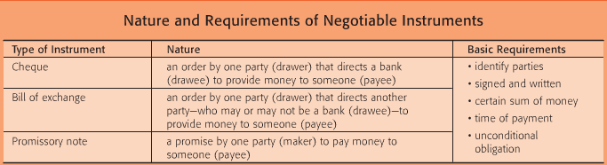

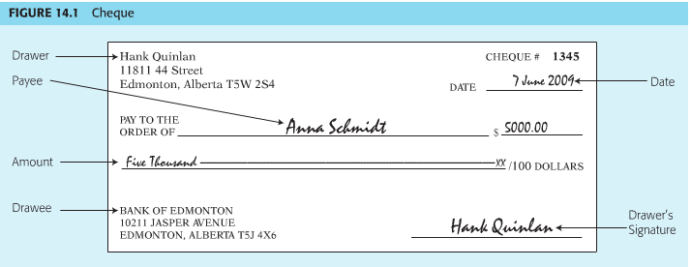

Cheques

- A cheque is created when a person orders a bank to pay a specific amount of money to someone
- Page 325- Relationship that could exist between the two parties; Hank and Anna, Hank and the Bank of Edmonton, Anna and the Bank of Edmonton
- The bank has a contractual relationship with the drawer; it does not normally owe any obligations to the payee. Unless the bank certified the cheques.
- The term “bank” includes some credit unions and trust companies: if an instrument is not drawn on a bank, it cannot be a cheque, but it may be a bill of exchange (Footnote page 325)
- There are five possible complications: postdated cheques, staledated cheques, overdrawn cheques, countermanded cheques, and certified cheques (page 326):
  - Postdated Cheques- is dated in the future. The bank is only allowed to debit the account only if it acts in accordance with his instructions. Postdated cheques are often used if a contract requires instalment payments
  - Staledated Cheques- A cheque is staledated when the payee does not seek payment within a reasonable time. Payee seeks payment too late. Banks normally will not honour a cheque that is presented more than six months after the date that appears on it. If this is the case, the payee can sue the drawer
    - Although a bank may not honour a cheque that is presented more than six months after its date, the payee usually has two or six years to sue the drawer. Statutes of limitation say that contracts, including cheques, become unenforceable only after that time (Footnote page 327)
  - Overdrawn Cheque- A cheque is overdrawn when the drawer’s account does not hold enough money to satisfy it completely. “NSF” non sufficient funds, bank has two options; it can refuse to honour the cheque, or the bank treat the drawer overdrawn cheque as his request for a loan, pay the payee, then seek repayment from the drawer. This would be true, even if the bank failed to realize that the drawer’s account was overdrawn and paid the payee by mistake.
    - If a person knew that when he/she writes the cheque, that his/her account did not contain sufficient funds, he could be charged with the crime of false pretences; Criminal Code (Footnote page 327)
  - Countermanded Cheques- occurs when a customer orders a bank to refuse payment on a cheque. Also known as “stop payment order”, by countermanding the cheque, the drawer would remove the bank’s authority to deal with his account. In practice it is limited in two factors:
    - First, a bank will not normally accept a countermand unless the drawer gives that order in person and unless the cheque in question is fully described (date, payee, amount)
    - Second, many bank contracts include a term that allows a bank to debit a customer’s account if a countermanded cheque is honoured by mistake.
    - A cheque is automatically countermanded if the bank is notified that the drawer has died before the payee receives payment
  - Certified Cheques (page 328) - occurs when a drawee bank promises to honour a cheque. To avoid countermanded by the drawer or dishonoured by the drawee is to certify the cheques. Certification occurs when a drawee bank promises to honour a cheque (to pay). A cheque can be certified by the payee (holder), or it can be certified by the drawer. Whether a cheque is certified by the payee or by the drawer, the consequences are the same. Court treat certification as “something equal to money”
    - Usually a bank owes an obligation to its own customer. If the bank certified a cheque it also owes an obligation to the payee. By certifying the cheque, the bank assured to the payee that it will not dishonour the cheque. If it broke its promise, the payee can sue the bank
    - A bank normally will not certify a cheque until after it has transferred funds from the drawer’s account into a suspense account
    - Certification assures the payee that the drawer account is not overdrawn, could not be countermanded. Once certify, drawer lost the right to countermand the cheque (page 328). Bank has to pay payee even if the drawer objected. There is an exception- may occur when a cheque is certified by the drawer. If the drawer returns the cheque to the bank, the bank will cancel it and return the funds from the suspense account to the chequing account
  - Footnotes on Page 328
    - Bills of Exchange Act does not refer to certification
    - Bank may allow a certified cheque to be countermanded if the drawer is willing to provide indemnification by promising to provide compensation to the bank if it is sued by the payee

Bills of Exchange

- Page 329- Bills of exchange is created when one person orders another person to pay a specific amount of money to a third party.
- A cheque is a special type of bills of exchange; the major difference between them is that a cheque must be drawn on a bank, while a bill of exchange may be drawn on a bank or anyone else.
- Olaf is not entitled to payment immediately, since the parties’ contract said that payment for the steel was not due until September 1. Marisa created the bill on March 1; she expressly stated that payment was due “six months after date.” Olaf wanted some assurance that he would actually receive $100,000 on that date (September 1). Olaf presented the bull to Red River Trust Company on March 15.
- Red River Trust Company had two options when it received the bill; it could indicate that it was not prepared to pay $100,000 on September 1. If the trust company dishonoured the bill, the Olaf would be entitled to sue Marisa for immediate payment. Olaf could sure Marisa immediately, even though the bill was not due until September. If Marisa’s line of credit was large enough to satisfy the bill then Red River Trust Company (which happened in this case) indicated that it was willing to honour the bill when it came due.
- Acceptance occurs when the drawee promises to pay a bill. At that point, the trust company became the acceptor rather than simply the drawee. Acceptance of a bill is very similar to certification of a cheque. Once the drawee accepted a bill, it can be sued by the payee. Once a bill is accepted, the drawer loses control of it (Marisa lost the ability to cancel a bill).
- Consideration in this case- Olaf gave consideration for Marisa’s bill when he promised to deliver steel to her, that fact is indicated by the phrase “for valued received” that appears on the bill
- Cheque must be payable “on demand” – drawee make payment as soon as payee presents the cheque. A bill of exchange may be payable on demand, it is called demanded draft. Can also be a sight draft- like demand draft, except that the payee is not entitled to receive any money until three days after the bill has been presented to the drawee. Can be a time draft- which is payable on future date. PAGE 330
- Footnotes Page 330
  - Marisa also could have asked the Red River Trust Company to accept the bill before she delivered it to Olaf
  - Randy’s acceptance (agent that signed for Red River Trust Company), he signed “for Red River Trust Company.” If he had not used those words, he might be personally liable as the acceptor.
  - Postdated cheques is payable on demand, but the payee cannot demand payment before the date that appears on the cheque
- Even though the debt under the sales of contract arose on March 1, Olaf is not entitled to receive $100,000 until September 1.

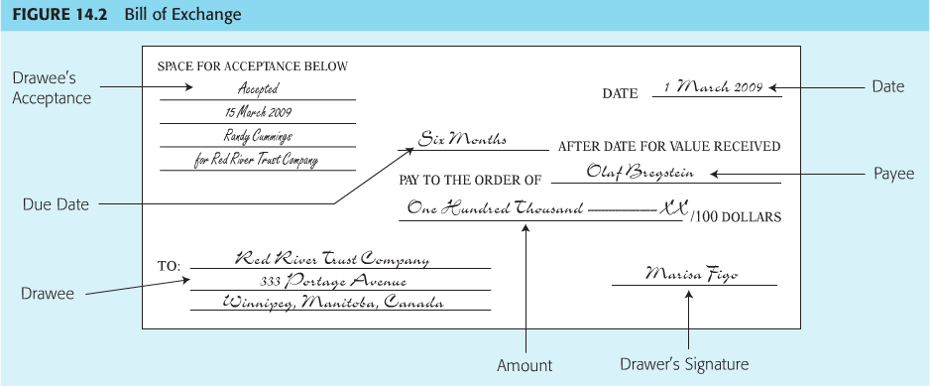

Promissory Notes

- Page 331 Promissory Notes is created when one person gives another person a written promise to pay a specific amount of money
- A cheque or a bill of exchange normally involves an order between three parties: drawer, drawee and payee. A promissory note is usually a promise between two parties.
- Person who creates the instrument is called the maker, person who intent to receive the money is payee
- Although payment was postponed under the promissory note, Rita could have received payment immediately if she had sold the note to a third party. That third party, as the holder of the note, would have been entitled to receive $50,000, plus 10% interest, from John starting on November 1.
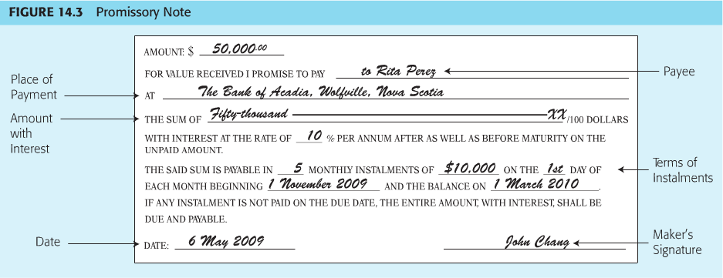
- Although there is no drawee under promissory note, document indicated that Rita was entitled to collect the money at the Bank of Acadia in Wolfville, Novia Scoita. If the note did not say anything about the place of payment, Rita could have collected the money at John’s office
- Like a cheque or a bill of exchange, a promissory note can be payable as a lump sum. Notes are often payable in instalments. Risk management- John should ensure that there is a short receipt written on the note each time that an instalment was paid. Without that, John might have been forced to make the same payment twice. Usually allows a third party to take a negotiable instrument at face value.
- Acceleration Clause- states that the entire amount of the promise becomes due immediately if a single instalment is not paid on time (page 332)

Negotiation

- Negotiable instruments can be negotiated, that is, transferred from one party to another

Methods of Negotiation

- Process of negotiation depends on whether an instrument is payable to bearer or to order
- Negotiable Instruments- is payable to bearer (possessor, carrier, owner) if any person who holds it is entitled to receive payment
- Bearer instruments can arise in several ways (page 333)
  - Leave the name of the payee blank
    - Footnote page 333- Rita could have filled in her own name
  - John could have made the note payable to “to Rita Perez or bearer” or “to bearer”
  - Make note payable to a fictitious person (ex; “to Sherlock Holmes”) or to a non-person such as “to cash”
  - Although the note in figure 14.3 is an order note, it would have become a bearer note if Rita had deliver it to someone else after endorsing it with her signature and nothing more “Rita Perez” the note would than remain a bearer instrument unless some later party turned it back into an order instrument by using a special endorsement
    - Footnote page 333- It appears that an instrument that starts as a bearer instrument (for example; John made the note “to bearer”) always remain a bearer instrument
    - Endorse- signature
  - Negotiable instrument is payable to order if the party entitled to receive payment is name. For example; note is payable “to Rita Perez” or “to the order of Rita Perez” pr “to Rita Perez or order.” Figure 14.3 is an order note
  - An order instrument cannot be negotiated unless it is endorsed and delivered to a new party

Liability

- Page 333- Negotiation can affect liability
- Figure 14.3
  - John Chang made a promissory note payable “to Rita Perez”
  - Rita changed that order note into a bearer note by simply signing her name on it before delivering it to her sister, Carmen
  - Carmen sold the note to Vlad Hlinka in exchange for a car. Because the note is a bearer instrument, Carmen was able to negotiate it to Vlad by simply giving it to him. Vlad changed the instrument back into an order note by delivering it to his business associate, Enya McCall, along with the endorsement.
  - If it is a bearer instrument, you are able to negotiate it by simply giving it to someone (delivery only). If it is an order instrument it must be endorsed and delivered.
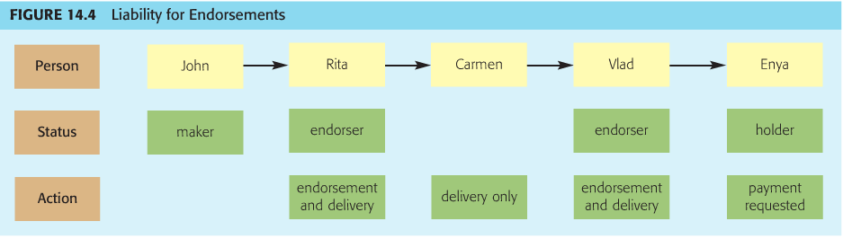
Page 334-335
- The primary liability under a promissory note falls on the maker. John has an obligation to pay Enya. This applies to cheques and bills of exchange as well. The drawer or maker has the primary liability.
- Endorser may also be held liable. A person who provides an endorsement promises people who later acquire the instrument that it will be paid
  - If John doesn’t pay, Enya can sure everyone who endorses the note. Rita could be liable even though she does not have a direct contract with Enya. Enya cannot sue Carmen, Carmen negotiated the note when it is in its barrier form. Since Carmen did not endorse the note she did not promise that it would be paid
  - An endorser who is held liable can sometimes sue a person who negotiated the instrument at an earlier time. Example; Enya collected payment from Vlad, he might be able to shift that loss to either Carmen or Rita.
  - Unlike Enya, Vlad could sure Carmen even though she did not endorse the note. There are two possibilities; the Act would allow Vlad to sue Carmen if she gave him an instrument that (i) is not genuine, (ii) she had no right to transfer, or (iii) she knew was worthless. Second, on the basis of their sales of contract if, in exchange for his car, she had promised that she would pay the note if asked to do so.
  - If Enya collect payment from Rita, Rita CANNOT sue Vlad because he endorsed the note after she did. A person who wants payment on an instrument must look to an earlier party.
- Liability Limitation
  - Liability generally cannot be imposed on an endorser unless that person received a notice of dishonour.
  - A notice of dishonour- consists of a statement that the person who was primarily liable on the instrument failed to pay.
  - NOTICE REQUIREMENT
    - Notice must be given within one business day
    - Notice does not have to be in writing but it must clearly identify the instrument in question
    - Notice must be given by a holder who wants payment from an endorser. For example; Enya should have given notice to Vlad and Rita as soon as John refused to pay. Notice must be given by one endorser who wants payment from another.
    - If notice is not properly given, an endorser is discharged and cannot be liable
    - Notice is not required, however, if (i) the endorser cannot be reached through a reasonable effort, or (ii) the endorser waived the need for notice
- If the person who is primarily liable is unable to pay, you must give notice as soon as possible to everyone you might want to sue. If you fail to do so, your rights may be lost
- A delay may be excused if the circumstances were beyond a person’s control. If a notice is sent by mail, it merely needs to be mailed by the next day. Notice is deemed to have been given even if it is lost in the postal system
- As risk management, notice should be given in writing as it is much easier to prove

Forms of Endorsement

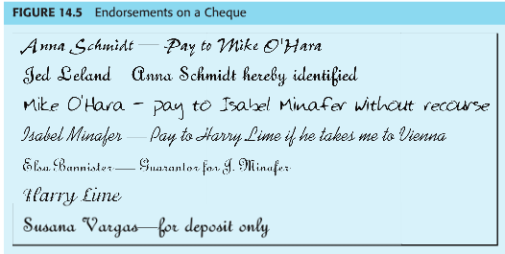
Seven forms of endorsement (page 336)
Special Endorsement-Anna after receiving the cheque she added special endorsement, by signing her name on the back of the cheque and by indicating that the money should be paid to Mike O’Hara. Once Mike obtained the cheque, he replaces her as the only person who was entitled to receive payment
Identifying Endorsement- Before Mike received the cheque from Anne, Jed Leland was added as an identifying endorsement. Presumably, Mike was reluctant to buy the cheque from Anna because he did not know her. Jed knew both parties and was willing to assure Mike that Anna was indeed the payee. Jed (identifying endorser) cannot be held liable as a normal endorser. Mike can only hold Jed liable if Anna was not who she said she really was.
Qualified Endorsement- After receiving the cheque from Anna, Mike transferred it to Isable Minafer under a qualified endorsement, by stating his endorsement was “without recourse” Mike indicated that he was not willing to be held liable if the cheque was later dishonour. If Susana Vargas was unable to collect payment from Hank, she cannot sue Mike.
Conditional Endorsement- A cheque must contain an unconditional obligation. Hank, for instances, could not have drafted the cheque payable to “Anna Schmidt if she takes me to Vienna” That order would be conditional. The Act also indicates that later parties can assume that the condition is fulfilled. In this case, Isabel has endorsed the cheque “to Harry Lime if he takes me to Vienna.” Consequently, if Isabel was later sued on her endorsement, she could in turn she Harry if he did not take her to Vienna.
Accommodation Endorsement- before Isabel delivered the cheque to Harry, Elsa added an accommodation endorsement. Presumable, Harry was concerned that if he ever tried to sue Isabel on her endorsement, she might not have enough money to pay. Elsa signed “Guarantor for J.Minafer” Called accommodation because it helped Isabel’s effort to negotiate the cheque to Harry. Called “anomalous” because it is unusual. Elsa was not trying to transfer her own property; instead she was assisting in the transfer of Isabel’s property. Elsa could be held liable as an endorser.
General Endorsement- Harry added his general (or blank) endorsement, by simply writing his signature and nothing more, Harry transform the cheque from an order instrument into a bearer instrument.
Restrictive Endorsement- Susana received the cheque from Harry, she added her restrictive endorsement, by writing “for deposit only” Susana prevented the instrument from being negotiated any further. The cheque can only be used to pay funds into Susana’s bank account. This is a good risk management, as this type of endorsement provides protection against theft.
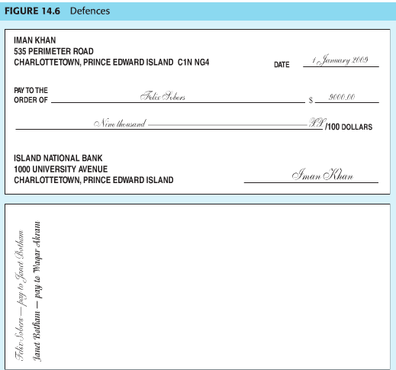

Defences

- Negotiable instrument is a special type of contract. The rights under an instrument can be easily transferred and they can be improved as they are transferred.

3 Types of Parties (page 338)
- Immediate parties- are parties who dealt directly with each other.
- Holder- is a person who has possession of a negotiable instrument. In the example; Waqar is the holder. Depending on the circumstance, he may also be the holder in due course.
- Holder in due course- is a person who acquired a negotiable instrument under specific conditions. They all relate to honesty, only honest person deserves the special treatment that the Act gives to a holder in due course. Unless there is evidence to the contrary, the Act assumes that every holder is a holder in due course.
  - Supported by value- that is consideration. Waqar could be a holder in due course if he did not personally give consideration. It would be enough if someone before him gave consideration for the cheque.
  - Complete and regular on its face- An instrument that is not complete if an important part is left blank. For example, the cheque did not state the amount. And an instrument is not regular if it looks suspicious. For example; if the cheque contains obvious erasure or alterations
  - Without notice of dishonour- Waqar would not be a holder in due course if, for example, he knew or strongly suspected either that the Island National Bank had already refused to honour the cheque or that Iman had countermanded it.
  - Good faith and without notice of defect- Holder must have taken the instrument in good faith and without notice of any defect in the title of the person who negotiated it. Waqar could not be a holder in due course if he knew or strongly suspected that Iman had been forced or tricked into drawing the cheque, or that Janet had forged Felix’s endorsement
  - Before overdue- the holder must have acquired the instrument before it was overdue.
- Footnote page 339
  - Unless there is evidence to the contrary, the Act presumes that every person who signs an instrument gave value
  - The holder of an instrument generally has the right to fill in any blanks
- Every person who acquires an instrument after a holder in due course, and who is not involved in any fraud or illegality, is also considered a holder in due course
- Footnote page 340
  - A bill of exchange or promissory note that is payable on a specific day, rather than on demand, is due on that day
  - A promissory note that is payable on demand is not overdue simply because a reasonable length of time has passed. That is because a promissory note, unlike a bill or cheque, is normally used to extend credit.

Three Type of Defences

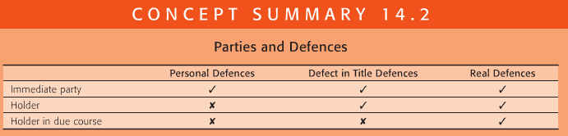
Page 340
Personal Defences
- personal defenses
  - affects the parties (not the instrument)
  - right of set-off arising from separate transaction
    - Janet could set off any debt that Waqar owes to her, suppose Waqar failed to pay Janet. If Waqar sued Janet on the cheque, she could admit liability, set off the price of the boat and pay only $4000.
  - failure of consideration
    - For example; if the car that Waqar sold to her was defective and required $3000 in repair, she could admit liability, plead for breach of contract and pay only $6000. After all, she expected to receive a car worth $9000 but received one worth only $6000.
    - If consideration was never given in exchange for the cheque, that instrument would be entirely unenforceable (footnote page 341)

- available against immediate party only

Defect in Title Defences (page 341)

- defect in title defences
  - arise because instrument improperly obtained
    - fraud or duress
    - illegal consideration
    - drunkenness or insanity
    - absence of delivery
    - lack of authority
    - discharge or renunciation
- available against immediate party or holder
- it is different from a personal defence because it affects the instrument itself
- If Waqar sue Iman because Island National Bank refuse to honour the cheque because Imann account was overdrawn. If Waqar sue Iman, Iman could avoid liability by proving any of the following defect in title defences;
    - fraud or duress
      - Iman would not have to pay if she initially drafted the cheque as a result of Felix fraud or duress. Perhaps Felix tricked her, or threaten her with a beating unless she created the instrument.
    - illegal consideration
      - example; if Felix promised to deliver drugs to Iman
    - drunkenness or insanity
      - If Iman is drunk or insane when she drafted the cheque
    - absence of delivery
      - If Iman drafted the cheque but never deliver or actually gave it to Felix. If he took it from her without her permission, he would obtain a defective title, as would Waqar
      - There was a defect in title because Iman did not deliver a completed instrument. However, she would have a real defence if she did not deliver the cheque and if that instrument was incomplete. Perhaps Felix stole it from her desk, filled in the amount (which she had left blank), and gave it to Janet, who sold it to Waqar. In that case, Waqar could not demand payment from Iman, even if he was a holder in due course.

    - lack of authority or no authority
      - If Iman gave the cheque to Felix with instructions to fill in $7000 as the amount, but he instead fill in $9000. He would have obtained a defective title.
    - discharge or renunciation
      - Waqar would have received defective title if the cheque that he acquired from Janet had been discharged or renounce. For example; Iman issued a cheque to Felix, he wrote her a note that said “You don’t really owe this money to me. Therefore I won’t ask for payment.” He gave the cheque to Janet, who sold it to Waqar. Because of Felix renunciation, Iman does not have to pay Waqar.
Footnote page 341
- If consideration was never given in exchange for the cheque, that instrument would be entirely unenforceable
- If Janet received the cheque as a gift from Felix. She would not be a holder in due course in the examples that follow, Waqar could not become a holder in due course by obtaining a cheque from her
- Fraud is usually a defect in title defence. However, it may be a real defence if it amounts to “non est factum” (means “this is not my deed”). For example; if Iman is illiterate, infirm, or blind, was tricked into signing the cheque because she thought she was being asked for her autograph.
- Insanity normally creates a title in defence. However, it can also lead to real defence if the person was legally declared to be mentally incompetent.
Footnote page 342
- There was a defect in title because Iman did not deliver a completed instrument. However, she would have a real defence if she did not deliver the cheque and if that instrument was incomplete. Perhaps Felix stole it from her desk, filled in the amount (which she had left blank), and gave it to Janet, who sold it to Waqar. In that case, Waqar could not demand payment from Iman, even if he was a holder in due course.
- Risk management- a cheque that has been honoured should have “paid” written on its face. Suppose Felix was allowed to keep the cheque even though he had been paid. If Waqar later became a holder in due course, he could force Iman to pay again if the cheque had not been stamped “paid”
- Although Iman could not be liable to anyone on the cheque, she could be liable to Felix on the sales contract if he provided her with necessary goods or services

Real Defences

- real defences
  - arise because instrument itself is defective
    - some overlap with defect in title defences
    - minority
      - Iman would not have to pay if she created the cheque when she was a minor. Waqar could , however, demand payment from either Felix or Janet on the basis of their endorsement if they were adults
      - Although Iman could not be liable to anyone on the cheque, she could be liable to Felix on the sales contract if he provided her with necessary goods or services

    - Material alteration
      - may create a real defence.
      - If Felix changed the amount of the cheque from $9000 to $29,000 after he received it from Iman.
        - If alteration was not apparent to the naked eye, Waqar could enforce the cheque against Iman but only for the original amount $9000. However, he could enforce the cheque against Felix or Janet for $29,000. Janet would be liable because she chose to add her endorsement to the cheque after it was altered. She therefore promise to pay $29,000
        - If alteration was apparent to the naked eye, Waqar cannot enforce it against Iman at all. He could enforce it against Janet
    - Forgery
      - A person whose signature is forged generally cannot be held liable.
      - A person who signed an instrument before a forgery occurred generally cannot be held liable
      - A person who signed an instrument after a forgery occurred generally can be held liable. Waqar can demand payment from Janet, even if she did not know that Felix signature had been forged. By adding her own endorsement, she promised to pay in any event
      - If National Bank honoured the cheque and paid Waqar. Iman can recover that money from the bank, only if she promptly notified the bank after learning about the forgery
        - If an endorser’s signature had been forged, Iman would have to give notice within one year, if her own signature, as the drawer, had been forged, Iman would have to notify the bank within a reasonable time.

      - If the bank honoured the cheque, it can recover the amount from either Waqar (because he received the money) or Janet (because she endorsed the cheque after the forgery). But only if the bank notified them within a reasonable time after it learned of the forgery.

- available against all parties (immediate party, holder, holder in due course)
- A holder in due course cannot be defeated by personal defences or defect in title defences. Real defences- occur when an instrument is fundamentally flawed.
- Waqar should be worry about real defences
- Fraud or duress, drunkenness or insanity, absence of delivery, and discharge of renunciation can lead either a defect in title defense or a real defence
- The loss usually falls on the first person who endorse the instrument after forgery

Consumer Bills and Notes

- Page 344
- A consumer instrument- is a bill of exchange, cheque, or promissory note that is used by a consumer to buy goods or services from a business on credit.
  - Only for credit purposes. That requirement is fulfilled by a promissory note, and by a bill of exchange or cheque that is postdated at least 31 days
  - Instrument must be used to purchase a goods or service from a business person
  - Purchase for personal purposes
- Front of consumer instrument must be marked with the words “consumer purchase.” Any person, including a holder in due course, who acquires it properly marked consumer instrument takes it to subject equities. If that person sues on the instrument, the consumer can use almost any defence that it could have used against the original seller.
- If the instrument is not marked
  - A holder in due course who acquires an instrument without notice that it was used for a consumer purchase does not take it subject to the equities. Consequently, it can be defeated only by a real defence
  - In the hand of any other sort of person, an unmarked consumer instrument is void
  - A seller who fails to properly mark a consumer instrument can be fined or imprisoned. The same is true for people who transfer unmarked instruments that they know were used for consumer purchases

- consumer instrument (cheque, bill, or note)
- used for credit purposes
- used for purchase from a business
- purchase made for personal use
- consumer instrument must be marked as such
  - substantial penalties for non-compliance
- unmarked instrument is generally void
  - exception: valid for holder in due course
- marked instrument is subject to the equities
  - all defences available against all parties

