- Chapter 1

- Health Psychology is understanding psychological influences on:

  - How people stay healthy
  - Why people get ill
  - How they respond to illness

- What do the WHO (World Health Organization) do?

  - To give worldwide guidance in the field of Health
  - To set global standards for Health
  - To cooperate with governments in strengthening national health programs
  - To develop and transfer appropriate health technology, information and standards

- Health Psychologists focus on:

  - Health promotion and maintenance
  - Prevention and treatment of illnesses
  - Etiology (investigation of the cause of illness) and correlates of health, illnesses and dysfunction
  - Improving the health care system and policy

- Mind-Body Relationship – Early Times

  - Over time our views around mind and body in terms of health has changed
  - Early cultures believed that mind and body were a unit
    - Disease arose when evil spirits entered
    - Employed trephination
      - They would drill a hole in the skull to release evil

- The Greek’s View on mind-body relationship

  - The Greeks introduced the humoral (body fluids) theory of illness
    - Four essential fids:
      - Blood
      - Black Bile
      - Yellow Bile
      - Phlegm
    - Disease arouse when there was imbalance in one of these four
    - Personality types were associated with dominant humeral variables
    - Aligns with body-mind unitary hypothesis

  - Four main temperaments are faces of which they explain your personality
  - Constant flux between temperaments
  - Today temperaments = psychological disposition

- 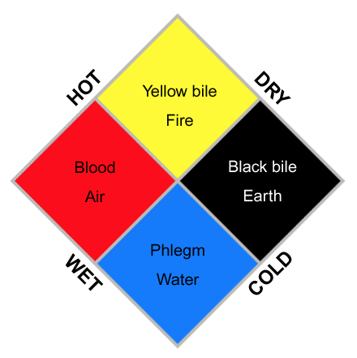

Mind-Body Relationship – Middle Ages

  - Period of supernatural and mysticism beliefs
  - Disease was attributed to evil forces
    - Disease arose when evil enters
    - Rituality torture was employed
  - Trlegion infiltrated with …..
  - Priest was the doctor
  - If you were sick it’s because you didn’t pray enough

Mind-Body Relationship – Renaissance

  - Impairments in biotechnology
    - Microscopy (Leeuwenhoek)
    - Autopsy (Morgagni)
  - Led to rejection of the humoral theory
  - Supported by cellular pathology
  - Initiated the mind-body dualism movement (Descartes)
  - Physicians associated with the body

- Mind-Body Relationship – Dualism

  - The mind according to Desecrates, was a thinking thing and an immaterial substance
  - The mind can exist apart from the extended body and therefore, the mind is a substance distinct from the body, a substance whose essence is thought
  - How can an immaterial mind cause anything in a material body, and vice versa?
  - Descartes’s illustration of dualism inputs are passed on by the sensory organs to the penal gland the brain and from there to the immaterial spirit.
  - Descartes illustration; the dire displaces the skin, which pulls a tiny thread which opens a pore in the ventricle allowing the animal spirit to flow through a hollow tube, which inflates the muscle to the leg causing the foot to withdraw

- Things are Changing

  - Fred introduces conversion hysteria
    - Mind causes deficit in the body
    - Pt converts conflict into a symptom
    - Address the psychological issue (He’s saying that the issue is happening because it’s something wrong with our body and brain)
  - Views continued to sway towards psychosomatic medicine
    - Bodily disorders causes by psychosomatic issues
    - Ulcers hypertension colitis
    - Disease prone individuals
  - In 1973.Biofeedback: Behavioural Medicine
  - Defines behavioural medicine as:
    - The interdispelinary field which integrates behavioural science and biomedical science for understanding physical health

  - Physical Health is correlated with both psychological and social environment
  - Personal control of health factors:
    - Diet, physical fitness, harmful behaviours
  - Socially determined factors:
    - Culture
    - Socio-economic factors
    - Availability of health resources

- Biomedical vs Biopsychosocial Model

  - The biopsychosocial model assumes the coordinated influence of:
    - Biological factors
    - Psychological factors
    - Social factors
  - The biomedical model assumes that psychological and social factors are independent
    - Based on biomedical or neurophysiological differences

- Biopsychosocial Model

  - Both macro and micro level processes interact
    - Macro:
      - Depression
      - Social support
    - Micro:
      - Chemical imbalance cellular disorder
  - A healthy state is not the steady state

- Importance of Health Psychology

- 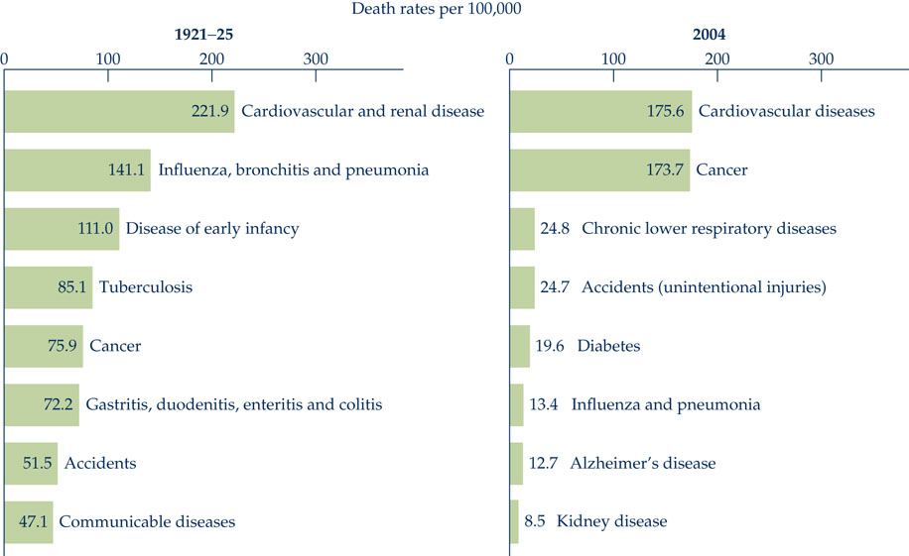

Chapter 2

The Nervous System – CNS

  - Brain and Spinal cord
  - Brain Injury
    - Movement of brain inside skull hurts the brain – injuries

- The Nervous System – PNS

  - Consists of the somatic and autonomic nervous system
  - The somatic nervous system:
    - Also known as voluntary
    - Connects brain to voluntary muscles
    - Provides sensory feedback about voluntary movement
  - The Autonomic nervous system
    - Also known as involuntary
    - Connects brain to internal organs
      - We don’t feel it nor know what’s happening, does it in the background
    - Further divided into sympathetic and parasympathetic
      - The sympathetic division
        - Responds to danger and stress
        - Physiological changes – heart rate, blood pressure
        - Adrenaline (“fight or flight”)
          - Acute stress response (general adaptation syndrome)
      - The Parasynpathetic division:
        - Controls organs at baseline
        - Antagonistic to the sympathetic nervous system
        - Active when individual feels relaxed
        - Stimulates digestion (“rest and digest”)

- 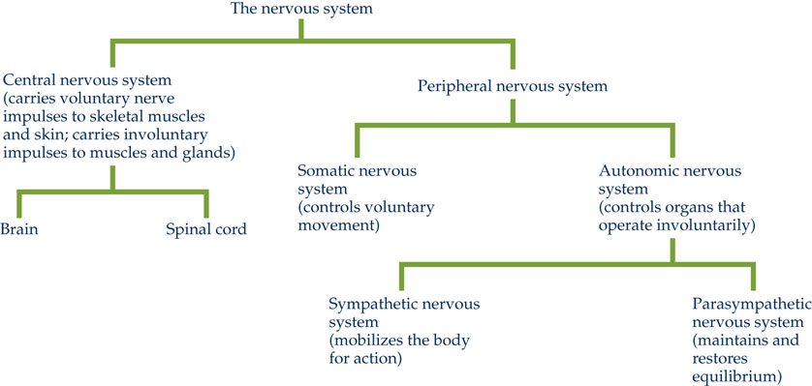

- The Brain

  - The brain consists of three sections
    - Hindbrain
      - Medulla – mediates heart rate, blood pressure and CO2/O2 concentration
      - Pons – Link between hindbrain and midbrain and helps control respiration
      - Cerebellum – coordinates voluntary muscle movement, balance/equilibrium, muscle tone and posture
  - Midbrain
    - Relay of sensory and motor info between forebrain and hindbrain
    - Visual and auditory reflexes
    - Production of DA in substantia nigra
  - Forebrain
    - The forebrain has two main sections: diencephalon and telencephalon
    - The diencephlon contains the thalamus and hypothalamus
      - Thalamus – relay sensation, spatial sense, and motor signals to cerebral cortex, along with the regulation of consciousness, sleep and alertness
      - Functions of Thalamus
        - Relay sensation, spatial sense, and motor signals to cerebral cortex
        - The basics from our “cave man” days, what was developed or the old part of the brain is in the center (where the thalamus is)
        - Regulation of consciousness sleep and alertness
        - switchboard
      - Functions of the hypothalamus
        - Regulate parts of the medulla that control cardiac function, bp and respiration
        - Regulation of water balance, appetite and sexual desire
        - Link to the endocrine system via pituitary gland
    - The telencephalon contains the left and right cerebral cortex
      - Corpus colosum connects both sides
      - New development for humans
      - For personality
      - Functions of cerebral cortex
        - Involved in higher order intelligence, memory and personality
        - Processing of sensory and motor information
        - Contains four lobes
        - More folds to create more space like the picture of the human brain and the other species’ brains
      - Ramon Cajal – cell bodies and dendries are different in different areas in the brain. There is order.
      - Outer region of the brain represents the cortex (2 – 4 mm)
  - Neurotransmitters
    - Neurotransmitter (NTs)
      - Regulate both CNS and PNS function
        - Electrical and chemical signals
      - Sympathetic nervous system secretes norepinephrine and epinephrine (catecholamines)
      - Can modulate physiology and alertness
      - Repeated activation linked to chronic disease
        - System isn’t designed to work for this long, and it’s being stressed disease.

- 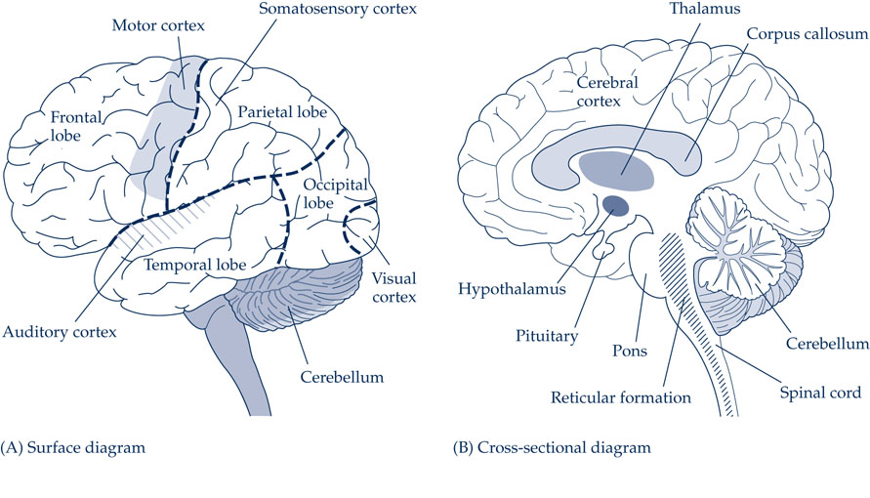

- Disorders of the Nervous System

  - Approximately 1 in 3 afected in their lifetime
    - Epilepsy
    - Parkinson’s disease (PD)
    - Alzheimer’s disease (AD)
    - Cerebral palsy (CP)
    - Multiple sclerosis (MS)
    - Huntington disease (HD)
  - Why is it happening? Many environmental factors, aging population, what’s in our food, quality of life, etc.

- The Endocrine System

  - System of ductless glands which secrete hormones directly in to the blood
  - Interacts with the nervous system
  - Slow – acting, long – lasting changes to the body
  - Pituitary Gland
    - Contains two lobes – anterior and postwrior
      - Anterior love secretes hormones for growth
        - Somatotropic hormone (STH)
        - Gonadropic hormone (GTH)
        - Adrenocorticotropic hormone (ACTH)
      - The posterior lobe produces oxytocin (controls contractions during labour), vasopressin (water absorption in kidneys)
  - Adrenal Glands
    - Two small glands located on top of kidneys
    - Each adrenal gland consists of
      - Adrenal medulla (epinephrine, NE)
      - Adrenal cortex – stimulated by ACTH from the pituitary gland, then releases hormones (steroids)

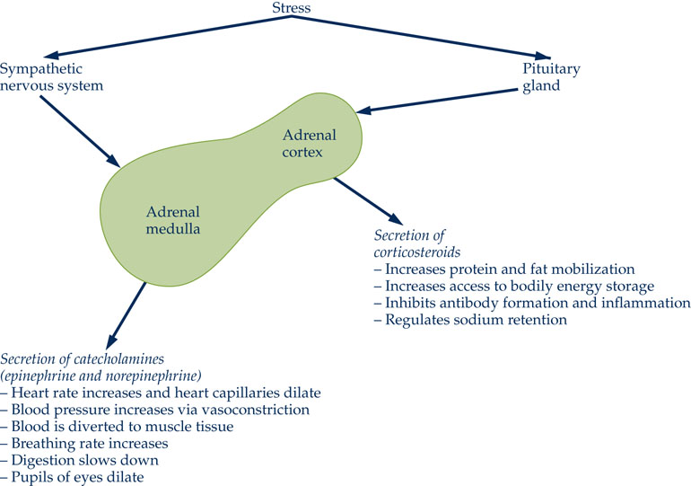

Disorders of the Endocrine System

  - Disorders can include
    - Diabetes (type 1, type 2)
      - Extremely high, about 40% of expenditures for health care (testing, medicine, etc), because we’re becoming obese.
      - More people are obese than not.
      - Considered a disease now in the US
    - Osteoporosis
    - Cushing’s syndrome
    - Menopause
    - Obesity

- Cardiovascular System

  - Composed of the heart, blood vessels and blood
  - House keeping work within the body
  - Arteries and veins taking things in blood where they need to go and back
  - Blood carries O2 from the lungs to the tissues and CO2 expelled as breath
  - Blood also carries nutrients, waste and hormones
  - The heart
    - Four chambers in the heart
      - Left side of the heart takes in oxygenated blood from the lungs
      - Right side sends deoxygenated blood to the lungs
    - Systole – blood is pumped out of the heart (contract)
    - Diastole – blood is taken into the heart (expand)
      - Numbers on machine measuring this and the one above it
  - Disorders of the Cardiovascular System
    - Can include
      - Atherosclerosis
        - Angina pectoris
        - Myocardial infraction (heart attack)
      - Arteriosclerosis
      - Aneurism
        - Flow of blood in neurosystem

- The Respiratory System

  - Respiration has three main functions:
    - Acquire oxygen into the body
    - Excrete carbon dioxide out of the body
    - Regulate the composition of the blood
  - Inspiration of air is an active process
    - Contraction of muscles
    - Lungs expand inside thorax
  - Expiration of air is a passive process
    - Relaxation of the lungs
  - Respiration is controlled by the medulla
    - Chemical composition of the blood can modulate activity
    - Higher CO2 and respiration increases
    - Lower CO2 and respiration decreases

- Disorders of the respiratory system

  - Can include
    - Chronic obstructive pulmonary disease (COPD)
    - Pneumonia
    - Tuberculosis
    - Asthma
    - Asphyxia, anoxia, hyperventilation

- Don’t include L05 – L07

- The immune System

  - The immune systems main function is to protect the body from foreign substances
  - Can interact with psychological and neuroendocrine factors to modulate health
    - How you feel will affect your immune system
      - Happy = immune system works well
      - Feeling bad = immune system compromised
  - Disease can be caused by:
    - Infection (most important)
    - Genetic defects
    - Hormone imbalances
    - Nutritional deficiencies
  - Infection is transmitted by
    - Direct transmission
      - Genital herpes, HPV
    - Indirect transmission
      - Influenza
    - Biological transmission
      - Mosquito
        - Yellow fever
    - Mechanical transmission
      - Hands
      - Rats
      - H1N1

- Chapter 5/6

- Substance Dependence

  - Defined in the DSM-IV as:
    - When an individual persists in use of alcohol or other drugs despite problems related to use of the substance, substance dependence may be diagnosed.
    - Compulsive and repetitive use may result in tolerance to the effect of the drug and withdrawal symptoms when use is reduced or stopped
      - Coffee example
      - Cigarettes
      - Drugs
    - Withdrawal Symptoms range form:
      - Headaches to
      - Like you’re dying
  - APA (2000) defines it as
    - When user has repeatedly self-administered an agent resulting in tolerance, withdrawal, and compulsive behaviour
  - Substance abuse can include:
    - Physical dependence
    - Tolerance
    - Addiction
    - Withdrawal
      - Body changes

- Substance Dependence – Harms Reduction

  - Harms reduction is described as:
    - “an approach that focuses on the risks and consequences of substance use rather than on the drug use itself”
      - Reduce lung cancer chance by stopping smoking
    - Sets more realistic goals
      - Success rate is higher
    - Implemented through community-based programs
      - Methadone clinics
      - Needle exchange programs
        - Promoting a negative thing but:
          - Going to do it anyway
          - Reduce cost
          - Controlled (removing spread of disease and use of contaminated equipment)
          - Less danger to others

- Substance Dependence – Insite Program

  - Insite program started in 2003 in Vancouver
  - Canada’s first safe-injection site
  - Offers disposable injection kit, sterile tools, medical support
    - Dropped crime and deaths by injections and overdose by about half
    - Not exactly opening a safe haven for drug users
  - Benefits of Insite Program:
    - Reduce rates of transfer of infection disease
    - Lowers long-term costs to the healthcare system
    - Improved access health care services, including primary care and addiction treatment
    - Brings stability to the community, safer environment
    - Gives a chance for people working there to become friends with the users and slowly offer ideas and chances to change their lives, offer things to read, etc.

- Illicit Drug Use

  - Illicit drugs represent those that are illegal
  - Four main classes of illicit drugs include
    - Opiates (example – Heroin)
    - Cocasine
    - Cannabis/THC
    - Amphetamine-type stimulant
    - Psychoactive prescription drugs are a growing problem (biggest problem) (example – Opioids, oxycontin, stimulants in general)
  - Consequences of illicit drug use include:
    - Physical issues
      - Physiological damage
      - Infectious disease
    - Mental health issues
      - Anxiety, rebound depression
      - The higher the high, the lower the low
        - Chemically change the composition of the brain. But they will come back, but when they do, they’ll come lower than they were
    - Social issues
      - Misjudgement, risky sexual behaviours, poor decisions in general

- 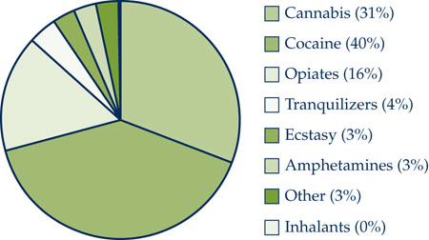

- Alcohol Abuse

  - Alcoholism recognized as a disease by AMA in 1957
  - Responsible for more than 8000 deaths/yr (but it should be a lot more)
  - Linked to health issues including
    - High blood pressure
    - Liver damage
    - CVD
    - Fatal-alcohol syndrome
  - Alcoholics are physically addicted to alcohol
    - Display both withdrawal and tolerance (they can take a full bottle of vodka, we can’t – harder to reach that high), loss of control
  - Problem drinkers have social, psychological and medical problems resulting from alcohol
    - Harder to integrate into society (activities that don’t involve alcohol)
    - Rebound depression
    - Liver damage

- Alcohol Abuse – Origins/Causal Factors

  - Factors that influence the incidence
    - Genetic factors/genetically linked
    - Men vs women
    - Socio-economic status
    - Response to stress
    - Social cues
      - Christmas party – drinking is expected
    - Cultural cues
      - Associated drink with each culture

- Alcohol Abuse – Treatment

  - Factors that influence treatment include:
    - Alcoholics age, rates improve (“maturing”)
    - Socio-economic status
    - Access to care and social support
  - Commonly employed treatments include:
    - Alcoholics anonymous
      - Because in a circle you make a commitment, people tend to keep their word
      - People with the same problem, work together and tend to stick to it
    - Cognitive behavioural therapy
    - Detoxification
  - Other factors to consider include:
    - Relapse
      - Every time you try to go back it gets harder because you keep remembering how you fail
    - Preventative approaches (beundrunk)
      - Video of seniors partying
    - Can alcohol be healthy?
      - HDL vs. LDL (good and bad cholesterol)
        - A few times a week – red wine, white wine types of spirits, increases good cholesterol
      - Polyphenols
        - Prevents things like cancers, aging etc.
      - At low doses boost immune system
      - Brandy may indirectly help someone who is sick by letting them sleep
        - Nyquil has alcohol

- Usage of Cigarette Smoking

  - 1913 – Year of the Camel
  - 1960 – Introduction of the filter (made of asbestos)

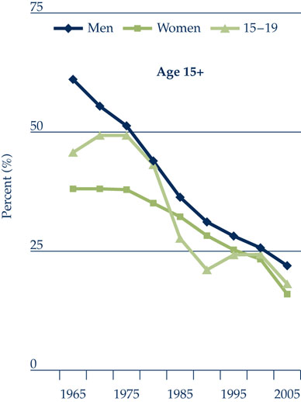

Effects of Cigarette Smoking

  - single greatest cause of preventable death
  - smoking accounts for 30% of all cancer deaths
  - associated with 46,000 deaths in 2010 – 3 airbuses x 365 days
  - Smokers are at higher risk for:
    - CVD
    - Lung cancer and other cancers
    - Chronic bronchitis
    - Emphysema
  - Smokers show an overall lower level of health
    - Overall health throughout life
  - May have synergistic effects:
    - Soming and cholesterol CVD
    - Smoking and stress
    - Smoking and cancer (example – breast)
    - Smoking and depression Cancer
    - Synergistic effect (1 drunk + 1 high = 8 drunk and high EXPLOSION!)
  - Factors that influence why individuals smoke:
    - Generally linked (DA function)
    - Social drivers (peer/family)
    - Body image
    - Self image (are you cool?)
    - Mood state

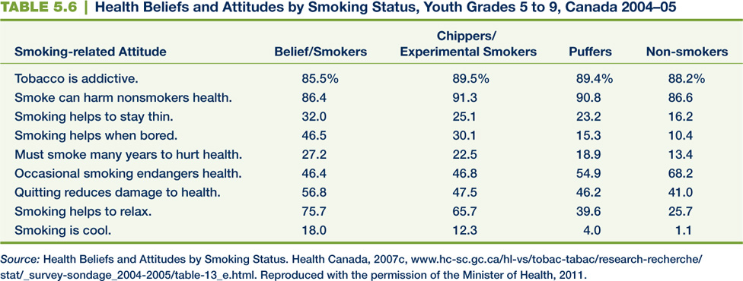

- Nicotine (mechanism)

  - In CNS nAChR are found on presynaptic nerve terminals of:
    - Dopamine neurons
    - Acetylcholine neurons
    - Glutamine neurons
  - Increase DA levels in limbic system
    - Dopamine reward pathway
  - Nicotine attaches to the alpha4beta2 nACH receptor
  - Displaces 75% of radiolabeled tracer after 3 cigarettes
    - Radioactively traced Glucose or nicotine, inject or ingest it, if it makes an effect it’ll light up where in the brain it is
    - “replaces old keys form the key holes and goes in instead”
    - Buzz happens in milliseconds – Think the steps from when you take the first puff

- How can I stop smoking

  - There are two strategies:
    - Smoking prevention (long-term benefit)
    - Smoking cessation (“short” term benefit)
  - Treatment strategies:
    - Changing social views (example – media)
      - Has happened
      - Surgeons used to smoke in open heart surgeries
    - Nicotine replacement therapies (NRTs)
      - Most commonly employed strategy
    - Cognitive behavioural therapy (CBT)
    - Treat comorbid issues
      - Treat reasons to start smoking:
        - Depression

- Smoking Prevention

  - Try to stop individuals BEFORE they start
  - Can be clinically effective and cost effective
  - Evan social influence intervention:
    - Individuals model smokers, so introduce modeling of high-status non-smokers
    - Behavioural inoculation – slow and steady messaging
    - Start early
  - Life-skils training approach
  - Community based/social drivers
    - Taxes, packaging, by laws
    - Make it harder to smoke
      - Can’t smoke publicly
      - More taxes, can’t pay 15 bucks a pack
      - Pictures of medical consequences

Smoking Cessation – (Therapy)

  - Substitute cigarettes with other nicotine vehicles: (nicotine-replacement-therapies, NRT)
    - Transdermal patch
    - Nicotine gun
    - Nicotine nasal spray
    - Nicotine inhalers
  - Increase DA levels in limbic system
  - Nicotine without the harmful things in the cigarette
  - Pharmacotherapies introduced:
    - Bupropion (Wellbutrin, Zyban)
    - Varenicline (Champix)

- 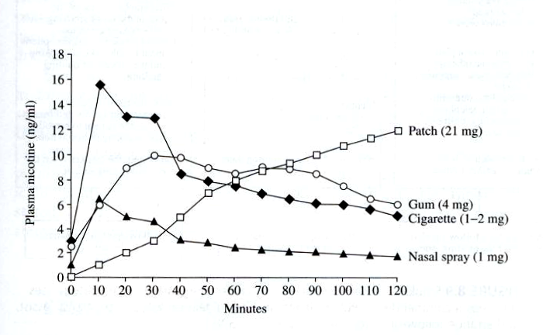

- Eating Disorders

  - Not restricted to women
  - Disorders may be linked to:
    - Unrealistic culture standards
    - Overcompensation of weight loss
    - “over” working out
  - Over 500,000 Canadians suffered an eating disorder in 2005
  - Typically starts during adolescence
    - Vulnerable to things like media telling them what they need to look like.
  - Tools used to facilitate weight loss:
    - Diet pills
    - Restricted diet
      - Salad all day long
    - Use of laxatives
    - Cigarette smoking
    - Self-induced vomiting
  - Fatal, people don’t see long term issues

Eating Disorders – Anorexia Nervosa

  - Is an obsessive disorder amounting to self starvation
  - Weight loss drops below a sub-optimal level
  - Risk factors include:
    - Genetic link
    - Hyperactive HPA axis
    - Social cues
  - Physical symptoms include:
    - High blood pressure
    - Heart rate reactivity to stress
    - High urinary levels of cortisol
    - Cognitive issues
      - Depression, anxiety, low self-esteem

- Eating Disorder – Bulimia

  - Characterized by alternating cycles of binge eating and purging
    - Realization of how much was eaten then purge
    - Starvation so as soon as the opportunity comes, binge again
    - Cycle over and over again
  - Behaviours include:
    - Vomiting
    - Use of laxatives
    - Extreme dieting
    - Fasting
    - Drug and alcohol abuse
  - Typically normal weight or overweight
    - Some food stays
  - Binge vs. purge phase
  - Internal vs. cognitive cues
    - Guilty feeling but hungry
  - Linked to stress
  - Barriers to treatment include self-realization
    - Think they’re okay, won’t want help
    - Look okay and they “ate” but fail to say they ate a lot of what they ate then purged
  - Combo therapy (pharma + CBT)

- Midterm

- 1 – 7, plus notes

- 60- 65 mc
- 10 T/F
- 6 Short answer

- Diagrams from the notes. Two of them.
- Read the chapters, study the notes

- Focus on chapter 7 on his notes

- Chapter 6 – Stress and Coping

- Overview

  - Describe and define stress
  - Models and theories of stress
  - Appraisal of stress
  - What is coping
  - Factors influencing coping
  - Coping strategies

What is stress?

  - Stress is defined as: EXAMMMMMMM
    - A negative emotional experience accompanied by predictable biochemical, physiological, cognitive, and behavioural changes that ate directed either toward altering the stressful event or accommodating to its effects
      - Staying up and acing night before (not positive like what we think) – lack of sleep, time restraints, memory not working as well, etc, negative.
      - Can’t control but it’s happening – biochemical
      - Physiological – happening to your body
      - Cognitive – feeling, mind. Cottage with a corona, feeling good. Freaking out won’t help on an exam.
      - Behavioural – how do you act based on how stressed you are. (Allow more things and relaxed when you’re not stressed)

  - Stress is initiated or aggravated by exposure to a stressor
    - Not everything is a stressor for everyone – public speaking
  - Stressors are defined as:
    - An event, situation, experience or trigger that causes stress
  - Stressors can include:
    - Noise
    - Overcrowding, large population
    - Bad relationships
    - Work-related activities
    - Environmental factors
      - Idea is that a stressor will evoke a stress response

- Person-Environment Fit

  - Perception of stress is determined by an individual’s appraisal of resources
    - Exam
      - Evaluate time, energy, drive, etc.
  - This is termed person-environment fit
  - Assessment of personal resources dictates degree of stress
    - Adequate resources – low stress, challenge
    - Inadequate resources – stressed out

- Theories and Models of Stress

  - Several theories and models exist including:
    - Fight or flight (cannon, 1932)
      - Caveman times, fight mammoth with a spear or run away
    - General adaptation syndrome (selye, 1956) EXAM
    - Tend and befriend

- General Adaptation Syndrome

  - Selye exposed rats to various stressors
  - Found that all stressors produced the same physiological response
    - No matter the stressor, physiological speaking it will react the same way
      - Sweat
      - Appetite
      - Etc
      - Interesting because lets us know at the core of stress response a process that is consistent
  - Stressors led to:
    - Enlarged adrenal cortex
    - Shrinking of thymus and lymph glands
    - Ulceration of the stomach and duodenum
  - Chronic stress can lead to wear and tear of the system
    - Not made to deal with chronic stress, but some of can manage it
    - Heartburn and all the symptoms
  - The GAS consists of three phases: need to know
    - Alarm – mobilize to meet the threat
    - Resistance – cope through confrontation
    - Exhaustion – deplete physical resources

- 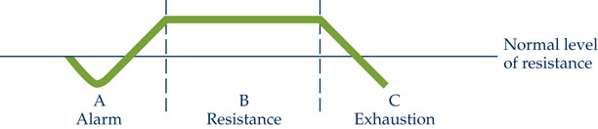

  - GAS model has several limitations
    - Limited role to psychological factors
      - How prepared is someone for the stress (fighting a bear example or sleeping in and ending the day if you miss the bus)
    - Responses to stressors are uniform
    - Stress is only evident in the presence of a stressor
      - This is false
      - Miley Cyrus song example – anticipation will evoke stress response
  - Tend-and-befriend model introduces social aspect to stress:
    - More prevalent in females
    - Seeking social contact during stress (example – herding)
      - Study group to hate on Terry and so on.
    - Increased levels of oxytocin
      - More in women
      - Endocrine system
      - Released during times of stress
        - Childbirth

- Psychological Appraisal of Stress

  - Degree of stress is determined by psychological appraisal
    - Evaluation of situation when a bear walks in the class
  - Primary appraisal determines the meaning:
    - Positive
    - Negative
    - Neutral
    - Harm vs. threat vs. challenge
  - Secondary appraisal determines coping abilities and resources available
    - How to deal with it and what’s the situation looking like

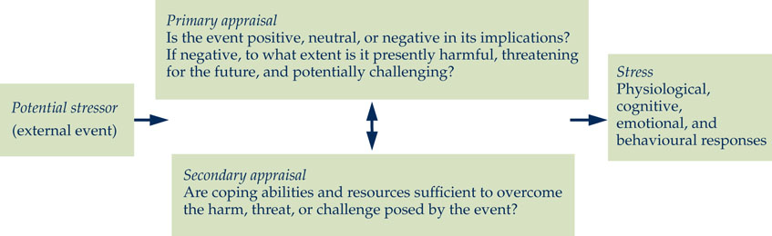

Physiology of Stress

  - Stress causes short and long term changes to health
  - Two physiological systems affected by stress include:
    - Sympathetic-adrenomedullary (SAM) system
    - Hypothalamic-pituitary-adrenocortical (HPA) axis
    - Need to know basics

- SAM System

  - Harmful events are labeled by the cerebral cortex
  - Info is transmitted to the hypothalamus
  - Initiates earliest response to stress
    - Sympathetic nervous system arousal
      - (fight or flight response)
      - confrontation or representing yourself
  - stimulates the medulla of the adrenal glands
  - secretion of epinephrine, norepinephrine
  - leads to sympathetic arousal: bp, hr, sweating

- HPA Axis

  - Activation of the hypothalamus releases corticotrophin-releasing factor (CRF)
  - Stimulates pituitary gland to secrete adrenocorticotropic hormone (ACTH)
  - Stimulates adrenal cortex to release cortisol
  - Cortisol
    - Conserve stores of carbs, reduces inflammation
    - Inhibits release of CRF
    - Bring body back to steady state
  - Chronic activation of HPA axis alters cortisol levels
  - Cortisol needs to stay low

- 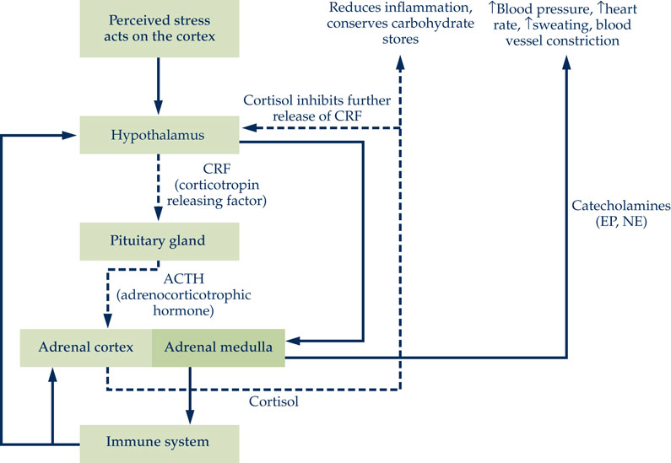

- Long Term Stress

  - System was not designed for long-term stress exposure to stress
  - Excessive discharge of cortisol, epi, NE can:
    - Suppress immune system
    - Increased bp and hr
    - Arrhythmias
    - Neurochemical imbalance – mood disorders
    - Lipids and fatty acids
    - Sleep issues
    - Students and exams example (notes)
    - The better you cope with stress the better overall health

- What makes events Stressful

  - Degree of stress is dependant on assessment
  - Negative events are more likely to cause stress
  - Uncontrollable or unpredictable events
    - Student’s butt disease example
    - Answer or no answer to the problem – difference of level of stress
  - Ambiguous events
    - US – code orange – what the hell is it
    - No control, goes together with one on top
  - Level of individual tasks (example – overloaded)
  - Central-life vs. peripheral stressors
    - Debt vs. disease spread
    - Each has a different weight
    - Family and what’s close is usually higher
  - How people asses their stress – EXAM

Active vs. Anticipated Stress

  - Anticipated stressor can be just as stressful
  - After-effects of stress are also common
  - Seen with post-traumatic stress disorder (PTSD)
    - In response to dramatic stressor
    - Can persist for years
      - War veterans after wars
    - Symptoms include cognitive deficits, sleep disturbances, feelings of guilt, violence

- Stressful life events

  - Different life events carry varying levels of stress
    - Divorce, fight, death, etc
  - Events cause changes in one’s life
  - More changes result in higher stress
  - Higher stressful life events can result in illness
  - Inventory of stressful events seen in social readjustment rating scale (SRRS)

- 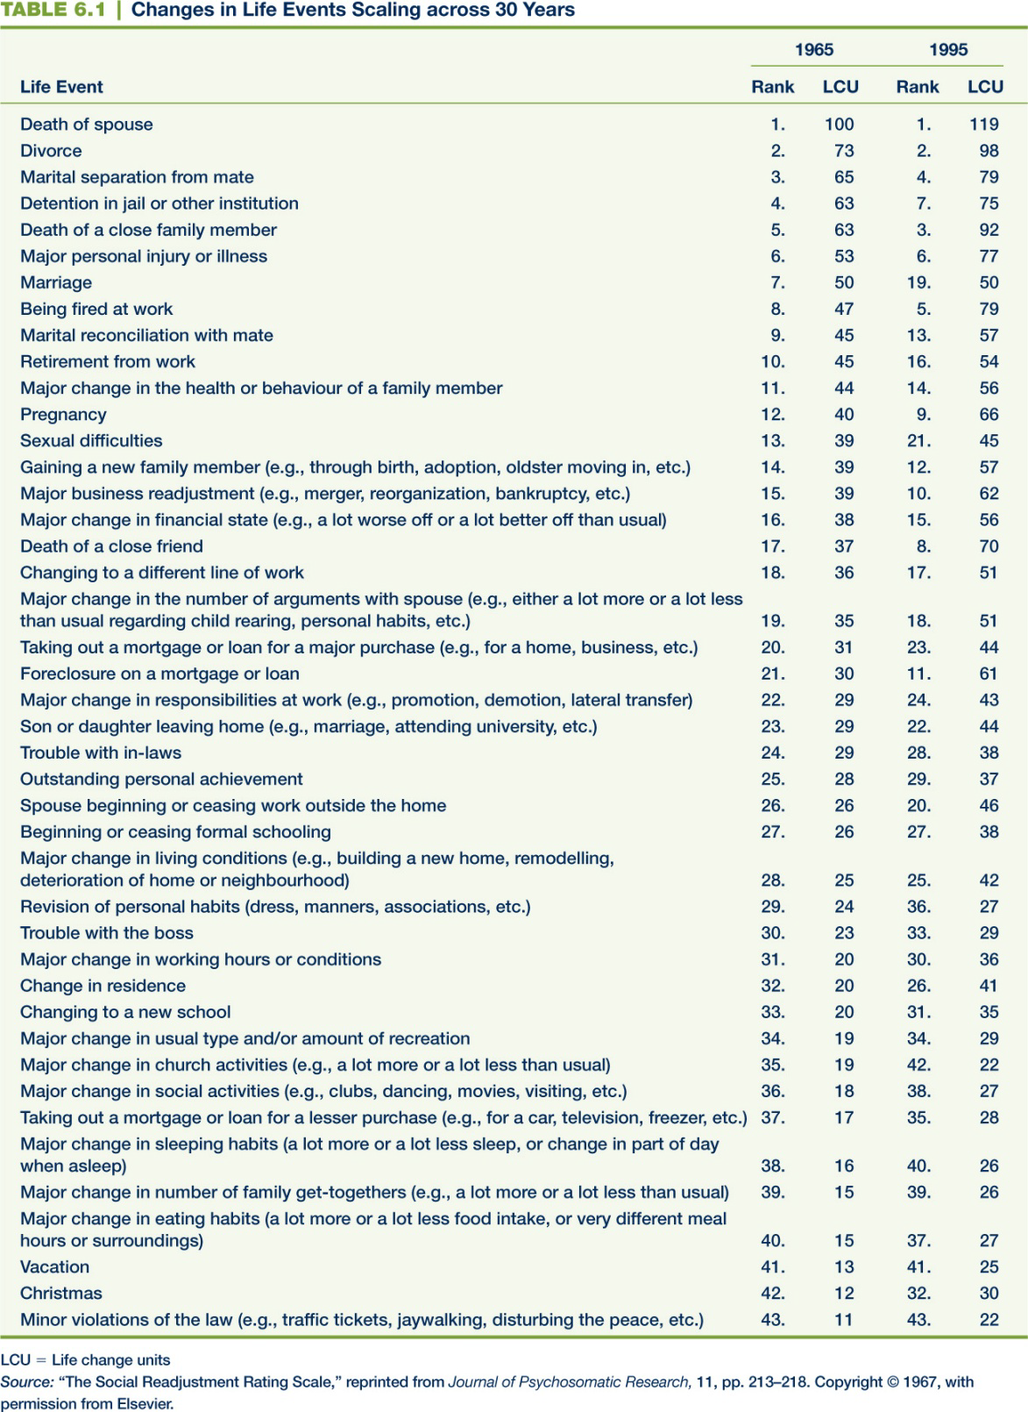

- Chapter 7

- What is Coping

  - Coping is defined as:
    - The thoughts and behaviors used to manage the internal and external demands of situations that are appraised as stressful.
      - Internal – energy, mental and physical strength
      - External – Time, etc
  - Dynamic (changes over time/adapt etc) process which persists over time
    - Guy who got fired and turned into an exotic dancer example
  - Includes many reactions, large breadth
  - Ability to cope is highly affected by personality
    - Very important
    - How people react
    - Pessimist or optimist

- Personality and Coping

  - Individual coping is shaped by genetic and environmental factors
  - Negative affectivity (neuroticism)
    - Linked with poorer health
    - Can show symptoms, distress even when they are not sick
    - Out of 10… ehh solid 4. Negative. Nothing wrong with them but they don’t think they’re well or “great”
    - Lower level of coping skills
  - Pessimistic explanatory style
    - Associated with individuals with negative affectivity
    - Lower level of coping skills
  - Perfectionism
    - Constant pursuit of ideal standards
    - Unrealistic goals can lead to stress
    - Lower level of coping skills
    - Can be negative if it supersedes the original goal
    - Levels are unattainable or more important than original goal – negative. Causes stress

- How can I cope

  - Dispositional optimism
    - Positive outlook on life (“Glass half full”)
    - Better mental and physical health
      - “This sucks but I’ll do the best I can” fights a good part of the battle
      - psyc or even really believe yourself to be more optimistic you’ll get better outcomes
    - Promotes more active and persistent coping efforts
    - More positive appraisal of stressors
      - Individuals who are positive deal with stress better
  - Psychological control
    - Individual feels they have “control” over environment, behavior, and desired outcomes
    - Perceived control of stressful events linked to better health
    - Perceived control linked to better outcomes of coping strategies
  - Self-esteem
    - High self-esteem may moderate stress-illness
    - More protective in low levels of stress
    - Interventions bolster self-esteem, self-worth
      - Girls in schools about being beautiful no matter their shape, etc.
    - Ego-strength: dependability, trust, lack of impulsivity have health benefits
    - Higher self-confidence lowers effects of stress
      - Talking in front of class

- Coping Style

  - Individual much like personality
    - Preparing for test
  - Avoidant (minimizing) vs. approach (confrontative) coping style.
    - Avoider deals well with short-term stress not long-term
    - Confronter deals well with long-term stress
    - Approach is considered the more beneficial style
    - Bully example
  - Problem-focused vs. emotion-focused coping
    - Problem focused takes a constructive approach
      - Finance or school example
    - Emotion focused tries to regulate emotions to stress
    - Typically people use a combination of both
      - Pick and choose
      - Funeral, they’re kind of there, they’re problem focused.

- External Factors Influencing Coping

  - Coping skills can be influence by factors outside of the individual control (internal vs. external)
    - Alone and something big happens – no one to lean on.
  - Socio-economic status (SES) strong external driver
  - Multiple stressor can influence coping capacity
  - More money (rich and low debts), lower annual death rate vs less money (poor and more debts), higher annual death rate

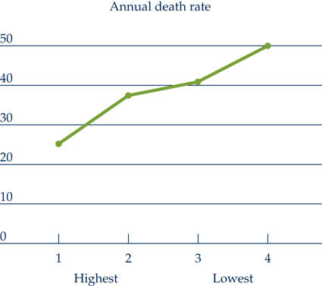

Coping interventions

  - Interventions can supplement coping skills
  - Mindfulness-based stress reduction (MBSR)
    - Use systematic training in meditation
    - Focus on stressor at hand and remove other factors
    - MBSR improved QoL, sleep quality, lowered stress
  - Disclosure and coping
    - Dialogue around emotional and psychological factors
    - Both verbal and written dialogue was beneficial
      - Screwed for chapter 5, collectively coping and feeling better
  - Stress management
    - Program-based learning, workshops, groups
    - Three phases include:
      - Identify stressors
      - Acquire/practice coping skills for stress
      - Practice coping skills in real world examples
      - Example being pushed around and not ask for subway whole wheat example.
  - Interactive stress-management program
    - Used quite often in university/college setting
    - Carleton stress resource link
- Chapter 10

- Measuring Pain

  - Personal report of pain (acute/chronic) can be very subjective
  - There is no “gold standard” in measuring pain outcomes

  - More commonly used assessment tools include:
  - Verbal reports
    - Pt uses their experience and vocabulary to describe pain
    - Throbbing pain vs. shooting pain vs. dull ache
    - NEED TO KNOW McGuill Pain Questionnaire (MPQ) (1975)
    - NEED TO KNOW Pain Catastrophizing Scale (MPQ) (1995)
      - Hard to describe.
      - Need to know if someone is a catastophizer before a surgery etc to know who you’re dealing with
  - Pain behavior
    - Observable behaviors that arise from pain
      - Facial and audible expressions of distress
      - Distortions in posture and gait
      - Negative affect
      - Avoidance of activity
    - Pain is viewed as a complex biopsychosocial event involving:
      - Psychological
      - Behavioral
        - Do you have kids, etc
      - Physiological
        - What shape are you in

- Physiology of Pain

  - Nociception NEED TO KNOW
    - Refers to the system that carries signals of damage and pain to the brain
    - Nociceptive neurons have cell bodies in the dorsal root ganglia
    - Can detect mechanical, thermal, and chemical stimuli.
    - Polymodal nociception (combination of all)

- Physiology of Pain

  - Nociception transmission:
    - Bidirectional axons synapse in dorsal horn of the spinal cord
    - Signal continues to brain where its processed
    - Nociception occurs through several types of peripheral nerve fibers
      - Insulated signal, travels faster
    - A-delta fiber
      - Small myelinated fibers
        - Transmit first pain and sharp pain rapidly
          - Affects sensory aspects of pain
            - Opens gate
      - C-fibers
        - Unmyelinated fibers
          - Transmit secondary dull or arching pain
            - Affects motivational and affective elements of pain
              - Opens gate
      - A-beta fibers
        - Large diameter myelinated fibers
          - Transmit information about vibration and position
            - Concurrent stimulation can suppress pain transmitted by C-fibers
              - Closes gate

- Theories of Pain

  - Traditional model suggested pain resulted from transmission of pain signals to the brain. Degree of pain was dictated by tissue damage
  - Gate control theory
    - Proposed that psychological factors contributed to pain experience
    - Neural “pain gate” can open/close to modulate pain signals to the brain
    - Other factors can contribute to opening/closing of the gate
  - Weakness in gate control theory:
    - Unable to explain phantom limb pain
    - Neuromatrix theory:
      - Felt representation of a unified physical self
      - Genetically determined initially
      - Neurosignature can give rise to pain

- Pain Management

  - The body produces endogenous opioids:
    - Beta-endorphins – peptides that project to limbic system, brainstem
    - Proenkephalin – peptides found in endocrine and CNS
      - Pleasure and rewards
    - Prodynorphins – peptides in the gut, pituitary, brain
  - Natural pain suppression system of the body
  - Acute-stress (SIA) and Physical activity reduces sensitivity to pain
  - Traditional pain management techniques:
    - Pharmacological – pain medications
    - Surgical – lesions of pain fibers
    - Sensory techniques – counterirritation, exercise
  - Psychologists pain-management techniques:
    - Biofeedback
      - Deep breathing etc
      - You teaching your body to control your own symptoms
    - Relaxation
    - Hypnosis
    - Acupuncture
    - Distraction

- Acute vs. Chronic Pain

  - Chronic pain pts develop maladaptive coping strategies
  - Pain control strategies are different
  - Chronic pain involves various components:
    - Physiological
    - Psychological
    - Social
    - Behavioral
  - Chronic pain induces individual, familial and societal challenges

Pain and personality

  - Personality traits can influence the experience of pain
  - Minnesota Multiphasic Personality Inventory (MMPI):
    - Chronic pain pts show elevated scores in three areas:
      - Neurotic Triad
        - Hypochondrias
        - Hysteria
        - Depression
  - Chronic pain is associated with depression, anxiety, substance abuse
    - All interconnected
    - Chicken or the egg, no one really knows which came first but they’re both present

- The OxyContin Story

  - OxyContin is a time release formulation of Oxycodone
  - Similar to morphine
    - Releases slowly, doesn’t peak
    - Addictive
    - The greater the peak, the more addictive
    - Consistent release
  - Can be snorted and liquefied and shot
  - Used for moderate to severe pain
  - High abuse-liability and addiction potential
  - Synergistic effects with alcohol
  - One of the most popular street-drugs
    - Epidemic
    - 12 – 17 year olds used most
  - Recent ban
  - OxyNeo
    - New
    - Tamper resistant
    - Can’t crush to snort or liquify

- Chapter 11

- Chronic and Terminal Illness

- What is Chronic Illness?

  - Chronic refers to the duration of the disease/illness
  - Has a long term effect on your body
  - Ranges from relatively mild to severe (life threatening)
    - Can be things like knee injuries
    - CVD heart disease, etc as well
  - Factors NEED TO KNOW:
    - Genetics (hereditary – Alzheimer’s, MS
      - Chances of getting it are higher than the person next to you.
      - Research shows there is genetic link in alzheimers
      - If family has it, chances, CHANCES are you will too.
      - Being prewired (predispositionded) to get it, doesn’t mean you will.
      - You still need a trigger to get it, still unknown
      - Get it around 30/35+ symptoms at 50
      - Not always 100%, Some who have no family that ever got it, can get it.
    - Environmental – Cancer, asthma
      - Living next to a nuclear reactor, chances you will get it
      - Fumes from a factor
    - Lifestyle – CVD, HIV, gout
      - Do you eat lots of bad food
      - Do you Smoke
      - Risky sex behavior
    - Previous injury or prolonged strain – lower back pain, tinnitus
      - Working on cars, chronic strains, tiling, flooring
      - All will lead to injury
      - Being hit in hockey

- Prevalence and Impact

  - 58% of the population has a chronic condition
  - 81% in the elderly subpopulation
  - Chronic conditions are more common in:
    - Women
    - Lower income
    - Seniors
    - Certain ethnic subpopulations (Aboriginal people)
  - In general people who worked harder to make ends meet (under the normal mean of living standards)
  - The same ideas as the rest of the chapters

- Prevalence and Impact

  - More than 63% of death globally
  - “How healthy is Earth”
  - Can impact quality of life
  - Staggering economic consequences:
    - Diabetes - $10 billion
    - Cancer - $18 billion
    - Arthritis - $20 billion
    - CVD/Hypertension/Stroke - $26 billion

- Quality of Life

  - Different from “standard of living”
  - Impacted by severity of chronic illness
    - Are you able to function
    - Travel, socialize, etc
  - Influences patients interpretation of the illness
  - Helps determine psychological contribution:
    - Depression
    - Anxiety
    - Distress
    - Stress (contributor)
  - These show up because Quality of life decreases

Quality of Life

  - Quality of life has several components
    - Physical functioning
    - Psychological status
    - Social functioning
    - Disease or treatment-related symptomology
  - QoL assessments gauge the extent to which normal life activities have been compromised

- Evaluating Quality of Life

  - Assessment tools can be used to determine QoL
  - Population norms can be established
    - Carleton
    - Ontario
    - Canada
  - Correlate with things happening in the country
    - Recession
    - Smoking problem etc
  - Allows for a comparative analysis across conditions between countries
  - WHO also developed an assessment tool in 1991 named WHOQOL-BREF:
    - Comprised of 26 items
    - Physical health, psychological heath social relationships, and environment
    - Quality of life may be different from the government or from other people
  - Quality of life may fluctuate:
    - Characteristics of the Illness
      - Acute phase vs. symptom-free or managed phases
    - Acute changes in symptoms
      - Progression of the illness, flare ups
    - Age related changed over time
      - Elderly vs. patients under 35 years
    - Culture
      - Impact how people experience common illness

- Why Study Quality of Life?

  - Why study quality of life?:
    - Documentation or history
    - Identify trends between illness and QoL factors
    - Impact of treatment on QoL
    - Comparative effectiveness between treatments
    - Inform decision and policy makers
  - To consider: multiple chronic condition and QoL

- Emotion and Chronic Illness

  - Chronic illness requires long term dramatic change
  - Emotional phases of chronic illness:
    - Denial
      - Helps pt control emotional reactions
      - May interfere with treatment
    - Anxiety
      - Elevated self-vigilance
      - Being overly sensitive
        - Forgetting keys, acts sensitive about it
        - CVD, chest pains.. turns out gas
      - May interfere/tamper treatment
    - Depression
      - Potentiates chronic illness symptoms
        - For some people, acute or episodic, but it can also spiral you into a worse state
        - Symptoms of AD, CVD, it gets worse
        - Increase risk of suicide
        - Difficult to diagnose

- Chronic Disease and “self”

  - Self-concept – stable set of beliefs about one’s qualities and attributes
  - Self-esteem- - general evaluation of self-concept
  - Self concept is a composite of:
    - Physical self
      - Body image – perception of physical function/look
      - Poor body image linked to low self-esteem and higher rates of depression and anxiety
      - Disfigurement of body image

- Chronic Disease and “Self”

  - Achieving self
    - Job and hobbies contribute to self-esteem/concept
    - May be used as motivator
  - Social self
    - Social interaction helps with self-esteem
    - Source of information and support
  - Private self
    - Increased dependence on others
    - Loss of an unrealized dream

- Coping with Chronic Illness

  - Chronic illness can be considered a chronic stressor
  - Avoidant coping – may cause psychological distress
  - Active coping – less psychological distress, better overall outcomes
  - Social support can provide positive reinforcement
  - Multiple coping strategies are most effective
  - Physical rehabilitation goals:
    - Use your own body as much as possible
    - Sense changes in the environment
    - Learn new physical management skills
    - Learn a necessary treatment regimen
    - Learn how to control expenditure of energy
  - Previous energy
  - Age-related decline
  - Adherence

Positive Changes with Chronic Illness

  - Positive emotions can be seen with chronic illness
  - Benefit finding is acknowledgement of the positive effects of chronic illness
  - Re-evaluation of relationships
  - Realization of one’s abilities

- Psychological Interventions

  - Psychological interventions for chronic illnesses:
    - Individual therapy (medical vs. psychotherapy)
      - More likely episodic than continuous
      - Familial collaboration
      - Therapist must have understanding of illness
    - Brief psychotherapeutic interventions
      - May help calm or mediate over-reactions
    - Patient education
      - Internet, expressive writing
    - Relaxation, stress management, exercise
      - Mindfulness-based stress reduction (MBSR)
      - Combination with other interventions
    - Social support interventions (Support Group)
      - Commit to change in front of others
    - Family Support
      - Adherence to treatment

- Chapter 12

- Death Across Our Life Span

  - Death from infectious disease is much lower today
  - Average life span in Canada is 81 years
  - Death in infancy or childhood:
    - Infant mortality is high (5.1 per 1000)
    - Location and socio-economic status may be contributors
    - Primary sudden infant death syndrome (SIDS)
      - Not so well understood
      - Not very well understood or discrovered
      - Sleeping position causing suffocation
      - Other factors; accidents, cancer leukemia
      - Children have a poor understanding of death until age 9 – 10
        - Deep sleep, won’t come again
        - Just that it’s negative
  - Death in middle age:
    - More realistic and fearful
    - May be triggered by death of parent or friend
    - Premature death:
      - Most dramatic
      - Before age of 79 is premature (in consideration to life expectancy)
      - Not emotionally/financially/socially prepared
      - Sudden vs. prolonged death
        - Prolonged infection that takes a while, slow and nastaaaayy
        - Sudden is like being hit by a bus
      - Declining rates
        - More aware of it
          - Smoking rates going down
          - Helmets
          - Etc
      - Gender differences
    - Death in old age:
      - Typically die of degenerative diseases
      - Elderly women – financial and psychological distress
        - Not to stereotype but in that generation, man was the breadwinner. Women maintained the house and now there is issue of money
      - Elderly men – lower education and widowhood
        - Being alone, no women to care for him

Psych Issues in Advancing Illness

  - Continued treatment can cause psychological distress
  - Is the treatment worth it?
    - Enjoy the time left with family and enjoy the rest of their life
  - Patients hope for a good death:
    - Free from avoidable suffering for pt, family, caregivers
    - Some factors to consider include:
      - Pain and symptom management
      - Clear decision making
        - Who’s making the decision if he’s not cognitively there?
      - Preparation for death
      - Completion
  - Does a patient have the right to die?
  - Euthanasia – ending the life of a person who is suffering from a painful terminal illness
    - Who’s in late stage, going to die.. in a month but wants to take life into his/her own hands
  - Patients request euthanasia or aid of dying when:
    - They are experiencing distress and or fatigue
    - They are in pain or suffering
    - They feel they are a burden to their family
  - Polarized views – Doctor’s oath
    - Against the oath of doing the best they can to tend to pts
  - Euthanasia is legalized in Netherlands, Belgium, Luxemburg
  - Physician-aid in dying (PAD) is legal in three states in US
  - Living wills – advance directives indicating that extraordinary measures should not be taken
    - If heart stops, don’t try to save the person
    - Still goes against that oath
  - Many physicians disregard living wills or are unaware

Stages in Adjustment to Dying IN THE EXAM

  - Kübler-Ross’s five stage theory:
    - Denial
      - Many provide some benefit, long-term may affect therapy
    - Anger
      - “Why me?”, difficult for family and friends
      - Why not the person who smokes.. etc etc
    - Bargaining
      - Trading good behavior for good health
        - Won’t work
        - Late stages
    - Depression
      - Realize lack of control, anticipatory grief, grief their own death while they’re still there
    - Acceptance
      - Calm arrives, make preparations
      - Making wills etc, setting things in order

- Alernatives to Hospital Care

  - Previously hospitals were the primary setting for terminally ill patients
  - Recently two alternatives have become prominent:
    - Hospice Care
    - Home Care
  - Hospice Care:
    - Acceptance of death in a positive manner
    - Hospitals make it depressing, this place is the opposite, working on things to improve QoL for the remaining time
    - Focus on improving quality of life not cure the illness
    - Pain management, emotional support, palliative care
      - You can everything you want because they want to improve QoL, put painting on walls, etc.
      - Brandy and all, it’s open to keep the pts happy and comfortable
    - Personalize setting, unrestricted familial visits
  - Home Care:
    - Still requires regular contact with medical staff
      - Doctor/nurse visits regularly, still has interaction
    - Increased responsibility for family members
    - Psychological benefits for patients
    - Personal choice is returned to patient/family
      - Personal control is given in their life
- Chapter 13

- What is Coronary Heart Disease?

  - CPR is produced in the liver and released in the bloodstream
  - Weight gain and low physical activity cause elevated CRP levels
  - CHD is considered to be a systemic disease due to an inflammatory process
  - Other risk factors for CHD include
    - High blood pressure
    - Diabetes
    - Cigarette smoking
    - Obesity
    - High serum cholesterol
    - Low physical activity
  - NEED TO KNOW Metabolic syndrome is when an individual has three or more of the following:
    - Obesity centered around the waist
    - High blood pressure
    - Low levels of HDL
      - More of the Good cholesterol, less of the bad
    - Difficulty metabolizing blood sugar (pre-diabetes)
      - You need sugar, just get rid of the bad and keep it consistent
      - Sugar rush is never good
      - Anytime can’t maintain sugar levels – pre diabetes
    - High levels of triglycerides
    - 3 or more of these considered metabolic syndrome
  - CHD has a genetic link (family history)
    - Back then exercise didn’t really matter
    - You lived then died, simple as that
    - Now we know the difference it makes
    - Now we also know genetics makes a difference, it can be pre-wired
  - Worsened by lower socio-economic status
  - Certain risk factors still remain unidentified

Stress and CHD

  - Cardiovascular reactivity contributes to CHD by:
    - Damaging endothelial cells
    - This facilitates the deposit of lipids
    - Increases inflammation
    - Development of atherosclerotic lesions
  - Acute stress can cause angina/heart attack:
    - Emotional stress
    - Anger
    - Extreme excitement
    - Negative emotions
    - Sudden bursts of activity
  - Reactivity or coping to stress with hostility increases risk factors (example – cholesterol)
  - Daily life stressors, work related stress, modernization, and low levels of control contribute to CHD
    - Makes factors worse

Prime Candidate

  - CHD is more common with:
    - Low socio-economic status
    - Males
      - Linked with
        - Higher rates of physical Inactivity
        - Smoking
        - Elevated cholesterol
        - Being overweight

- Why do we eat too much?

  - Personal food consumption has increased
    - Serving size
      - McDonalds
    - Food access
      - We’ve grown from people 100 years ago
        - Size
        - Girth
        - BMI Index
    - Social context
      - We socialize by eating
    - Stress
      - A lot more stress than there was 15 years ago
      - Eat poor foods when stressed
      - Salad or fatty foods when you’re late
      - Pizza in the middle of the night

- Women and CHD

  - CHD is a leading cause of mortality in women
  - Less is known about CHD in women
  - Occurs later in life for women but recovery rates are lower
  - Fewer women are referred to cardiologist
  - Fewer women return to work after heart attack
  - Younger women are protected via higher levels of HDL
  - Estrogen diminishes sympathetic N.S. arousal
  - After menopause CHD increases because of:
    - Weight gain
    - Increased blood pressure
    - Increased cholesterol, triglycerides
  - HRT does not reverse effects?
  - Less media messaging and education for women
  - Less counseling about lifestyle
  - Less likely to use pharmacotherapy
  - More likely to be misdiagnosed
  - Risk factors for CHD are similar for men/women:
    - Hostility is linked to poor cardiovascular recovery from stress
    - Negative attitude (Example – pessimism)
    - Anger and metabolic syndrome atherosclerosis
    - Depression is a risk factor for metabolic syndrome
    - Job-related stress
  - Women tend to display a lower QoL after treatment
  - Women more likely to go to long-term care facilities

- Cardiovascular Reactivity, Hostility

  - Anger and hostility are risk factors for CHD
  - May act as:
    - Potential risk factor for CHD
    - Predictor for survival
    - Potential trigger for heart attack/angina
  - Hostility linked to higher levels of proinflammatory cytokines and to metabolic syndrome
  - Most dramatic hostility includes:
    - Cynical hostility (suspiciousness, resentment, antagonism, distrust of others)
  - Response to stress is heightened and lasts longer in hostile individuals
    - The parking example
  - Reactivity-hostility relationship is biopsychosocial process

- Cardiovascular Reactivity

  - In some individuals stress causes:
    - Vasorestriction in peripheral areas of the heart
    - Simultaneously increases heart rate
  - Trying to transfer increased blood volume through constricted blood vessels
  - Eventually produces atherosclerotic lesions and plaque formation
  - Change in catecholamines may indirectly alter resilience of blood vessels
  - Stress and anxiety linked to CHD via changes in:
    - Blood coagulation
    - Fibrinolytic activity (breakdown of blood clots)

- Depression and CHD

  - Depression plays an important role in the development and aggravation of CHD
  - Strong link between depression and metabolic syndrome
  - Depression just before coronary event is linked to inflammation
  - Depression is linked to elevated CRP (inflammation)
  - Treatment of depression may improve long term recovery from coronary events

Management of Heart Disease

  - Many patients delay before going for treatment
  - Reasons for delay include:
    - Denial of episode
    - Interpret as mild symptoms
    - Self-treatment
  - Elderly and those who have had initial symptoms checked by doctor delay longer
  - Daytime attack or presence of family member increase delay
  - Initial treatment
    - Coronary artery bypass graft (CABG)
    - Hospitalization with monitoring
    - Assessment of anxiety, depression, PTSD
    - Home-care with rehabilitation
  - Cardiac rehabilitation:
    - Education, lifestyle modification
    - Goal is to produce relief from symptoms, reduce severity of the disease, limit progression
  - Cardiac rehabilitation (cont’d):
    - Promote psychological and social adjustment
    - Restore self-efficacy
  - Pharmacotherapy
    - Antiplatelet agents: aspirin (low-dose)
    - Beta-adrenergic blocking agents
    - Statins – target LDL (example – Lipitor, Crestor)
  - Diet and activity level:
    - Lower cholesterol level, lose weight
    - Reduce smoking, alcohol consumption
    - Exercise
    - Return to worK
  - Stress management
    - Stress is a proven trigger and contributor
    - Treatment programs are lacking
    - Patients show inability to lower stress
  - Depression:
    - An issue throughout all phases of CHD
    - May impact response to CHD treatment
    - Improve QoL and perceived health
  - Social support
    - Spouse or family significantly improves recovery
    - Disconnect with caregiver (overbearing)
    - Cardiac invalidism – pt. & spouses see abilities as lower than they actual are

What is hypertension?

  - Hypertension or high blood pressure:
    - Occurs when supply of blood through vessels is high
    - Puts pressure on arterial walls
    - Also occurs in response to peripheral resistance to blood flow in the small arteries of the body

- Measurement of Hypertension

  - Assessed by levels of systolic and diastolic blood pressure
  - Systolic: force generated by contraction of heart
  - Diastolic: pressure in the arteries pressure in the arteries when the heart is relaxed
  - Mild hypertension: systolic pressure between 140 – 159
  - Moderate hypertension: systolic pressure between 160 – 179
  - Severe hypertension: systolic pressure above 180
  - Less rapid recovery following sympathetic arousal
  - Greater reactivity to stress

- Causes of Hypertension

  - 5% caused by failure of kidneys to regulate bp
  - risk factors include:
    - genetic link (hereditary)
    - >50 men are at greater risk
    - cultural differences
    - low socio-economic status
    - dietary sodium intake (35% higher)
    - emotional factors (anger, hostility, family environment)
    - chronic stress (work, life, environmental)

- Treatment of Hypertension

  - Typical interventions include:
    - Low-sodium diet
    - Reduce alcohol consumption
    - Weight reduction and exercise
    - Reduce caffeine intake
    - Diuretics: reduce blood volume via excretion of Na+
    - Beta-adrenergic blockers: decrease cardiac output and plasma renin activity
    - Cognitive behavioral therapy
    - Anger-management

- Issues with Hypertension

  - Many individuals are unaware they have hypertension
  - Symptom-less disease early on
  - High rate of non-adherence to therapy

- What is Stroke?

  - Third leading cause of death
  - Much more difficult to recover from
  - Disturbance in blood flow to the brain:
    - To a localized area of the brain (ischemic)
    - Cerebral hemorrhage (bleeding)
  - Recurrence rates are high (~20)
    - Build up is still there
  - For those who have s stroke:
    - 15% die
    - 10% recover completely
    - 25% minor disability
    - 40% moderate-severe disability
    - 10% long term care
  - Warning signs for stroke include:
    - Weakness: loss of strength, numbness
    - Trouble speaking: temporary loss of speech
    - Vision problems: temporary loss of vision
    - Headache: unusual headache
    - Dizziness: sudden fall
  - Daily aspirin is very effective: prevents coagulation

- Consequences Of Stroke

  - After a stroke, 71% require assistance with daily life
  - Other consequences after stroke include:
    - Motor deficits: bilateral effects
    - Cognitive problems:
    - Left brain: lower intellect, difficulty learning new tasks
    - Right brain: hampered visual feedback, feel “crazy”
  - Emotional problems:
    - Left brain: anxiety, depression
    - Right brain: seemingly indifferent

- What is Diabetes?

  - Rates are increasing rapidly in Canada
  - Many remain undiagnosed
  - Is a chronic condition of
    - Insufficient secretion of insulin
    - Or insulin resistance
  - Glucose breakdown is used as energy in cells
  - Insulin is produced by the beta cells of the pancreas
  - Mediates entry of glucose into cells
  - With diabetes the glucose does not enter the cells and remains in the blood
  - Hyper- and hypoglycemia
  - Type I diabetes:
    - Insufficient secretion of insulin
    - Immune system attacks beta-cells
    - Develops earlier in life
    - Accounts for 10%
    - Insulin-dependent
  - Type II diabetes:
    - Insulin resistance
    - Develops later in life
    - Related to obesity and diet
    - More common in men
    - Socio-economic factors
    - Preventable
  - Health implications of diabetes include:
    - Thickening of arteries CHD
    - Shorter life expectancy
    - Depression
    - Sexual dysfunction
  - Diabetes is part of the “deadly quartet” along with:
    - Interabdominal body fat
    - Hypertension
    - Elevated lipids
- Chapter 14

- The Immune System – Natural Immunity

  - Natural Immunity
    - Defense against a variety of pathogens
    - --------
  - Macrophages release cytokines which:
    - Lead to inflammation
    - Good thing, immune system saying there’s a problem and needs backup
    - Fever
    - Promote wound healing
  - Natural Killer (NK) cells:
    - Recognize viral infections or cancer cells
    - Lyse cells by releasing toxic factors
    - Break apart other cells
    - Biological warfare
    - Important in signaling potential malignancies
    - Limits early phases of viral infections

- The Immune System – Specific Immunity

  - Specific immunity
    - Slower process but more specific
    - Lymphocytes have very specific receptors for one antigen
    - Once activated they divide to create a proliferative (multiply themselves) response
      - Make their own army in a sense
  - Both types of immunity work together
  - Natural followed by specific

- Immune System NEED TO KNOW THIS SLIDE

  - Humoral immunity is mediated by B lymphocytes:
    - Provide protection against bacteria
    - Neutralize toxins produced by bacteria
    - Prevent viral infections
  - Cell mediated immunity
    - Involves T lymphocytes from the thymus gland operates at the cellular level
    - Cytoto

    - _______

- Immunocompetence

  - Immune function can be assessed by:
    - Studying distribution of immune cells in blood samples
    - Examining the functioning of immune cells
  - Blood examination counts numbers of:
    - T, B and NK cells
    - Assesses the amount of circulating lymphokines or antibody level
  - Flu shot works by having a dead strain injected and for the body to learn what it is and “how to kill it” so it can be ready before flu attacks
  - Assessing the functioning of cells includes examining:
    - Activation
    - Proliferation
    - Transformation
    - Cytotoxicity of cells
  - Common assessements include: lymphocyte toxicity, phagocytotic activity
  - Mitogenic simulation technique
  - Antibody production to latent virus:
    - If body produces antibodies to inactive virus, it is a sign the immune system is not working well
    - Epstein-Barr virus, herpes simplex-virus
  - Immune response to vaccine is also an indicator
    - If you got the flu shot, shouldn’t feel that bad, should be okay by a day or two
    - The body should produce enough antibody to the vaccine
    - Determines the degree of immune response to antigen
  - Immunocompetence vs. immunocompromise
  - Wound repair is also an indicator

- Stress and Immune Function

  - Short term stressors:
    - Produce fight or flight response
    - Elicit immune response to potential injury or infection
    - Increase in NK cells, large granular lymphocytes
    - Also leads to down regulation of specific immunity
  - Long term stressors:
    - Causes both cellular and humoral down regulation
    - Stronger among elderly or those with other issues
    - Cam impact other co-morbid issues

- Immune Response

  - Intense (short term stressor)
    - Recuit cells that help defend against wounds/infection
  - Acute
  - ____________

- Stress and Immune Function

  - Stress involving threat to self can increase proinflammatory cytokine activity
  - Anticipatory stress can compromise immune functioning:
    - Decreased number of Th Cells NEED TO KNOW
  - Effects of stress on immune system can be delayed
  - Those under stress show increased vulnerability to ID
  - Stress may aggravate diseased associated with inflammatory processes
  - Pg 389 – green box QUESTION ON ACADEMIC STRESS
  - Stress may increase negative emotions which compromises immune function
  - Depression is positively correlated with immunity
  - Social support found to increase NK cell activity
  - Optimism improves immune function
  - Self-efficacy over stressful events is associated with less immunocompromise
  - Relaxation (and massage) may mute stress and prevent immunocompromise
    - CAM medicine

- AIDS

  - Acquired immune deficiency syndrome
  - Estimated to have begun in Central Africa (70’s)
  - Spread quickly within countries around there
  - Factors that have contributed include:
    - High rates of extramarital sex
    - Low condom use
    - High rate of gonorrhea
  - Non-sterile techniques propagated the spread
  - First case reported in Canada in 1982 – pg 394 interesting read some fact
  - Due to education new infections are declining

- AIDS – Mechanism

  - Human immunodeficiency virus (HIV):
    - Attacks the helper T cells
    - Attacks macrophages of the immune system
    - Exchange of cell-containing bodily fluids
  - Time between HIV AIDS is variable
  - Lack of symptoms
  - _____________________
  - grows rapidly and spreads over first few weeks
  - early symptoms include:
    - swollen glands
    - mild-flu like symptoms
  - may be followed by asymptomatic period
  - Virus continues to Th cells making pts vulnerable
  - Progressive symptoms include:
    - Chronic diarrhea
    - Wasting
    - Skeletal pain
    - Blindness
  - CNS impairment becomes apparent
    - Compromise in your body and ability to function

- AIDS – Therapy

  - Highly active antiretroviral therapy (HAART)
    - Combination of antiretroviral medications
    - Must be taken religiously
    - Expensive
    - Cost is huge barrier
    - Government have demanded that they be given for free or a low cost
    - Treatments may be complex and disruptive
    - Depression may also be a contributor to non-adherence
  - Ottawa based intervention program
    - Did better if they were educated
  - SES and housing status can contribute to adherence

- AIDS – Population

  - Initially two major risk groups included:
    - Homosexual men
    - Intravenous drug users
  - Currently, aboriginal and minority populations are increasingly at risk
  - Adolescents and young adults are the most at risk – represent 50% of all new cases
  - IDU leads to higher rates of infection

- AIDS – Psychosocial

  - Large group that are HIV+ but don’t yet have symptoms
  - Depression vs. positive changes in behaviour
  - Disclosure is essential by law
  - Non-disclosure can be associated with other aberrant behaviour and lower health outcomes
  - Employment after diagnosis contributes to better psychological well-being
    - Can get fired if diagnosed
    - Can’t be a surgeon with AIDS

- AIDS – Interventions

  - Interventions focus around reducing risk-related behaviour
  - Educate in safe-sex practices, sterile techniques
  - Culturally sensitive interventions are effective
  - Self-efficacy can lower risk-related behaviours
  - Sexual negotiation skills are crucial in adolescents
  - CBT has been shown to assist in compliance of other interventions

- Cancer – Mechanism

  - Results from a dysfunction in DNA
  - Causes excessive rapid cell growth and proliferation
  - Cancerous cells

  - _________________

- Cancer – Prevalence

  - 2007 leading cause of death in Canada
  - Thyroid and liver cancer rates are on the rise
  - Lung, breast, cervical, prostate on the decline
  - 12 million deaths by 2030 globally
  - There is a familial link to cancer
    - Genetics
    - Diet
    - Lifestyle factors
  - Regional differences across Canada lifestyle
  - Individual diet can also contribute to cancers
    - Fatty foods
    - Alcohol
    - Food additives (nitrites)
    - ________________

- Cancer Psychosical

  - Depression has bee positively linked to cancer
    - Elevated endocrine response (cortisol, NE)
  - Decreasing depression improves survival
  - Does stress cause cancer?
    - Steam up cancer, but doesn’t cause it.
  - Avoidant or passive coping can further the disease
  - Psychological stress can lower efficacy of NK cells

- Arthiritis – Population

  - Most prevalent autoimmune disease
  - A chronic progressive disease
  - Arthritis means inflammation of a joint
  - One in six people in Canada are affected
  - Two-thirds are women
  - Three out of five are under the age of 65
    - Lupus
    - Ankylosing sponndilitis (spine)
    - Rheumatoid arthritis
    - Osteoarthritis
    - Gout

- Arthritis – Rheumatoid

  - Three times more common in women
  - Primarily targets 25 – 50 year olds
  - Targets small joints of the hands, feet, wrists
  - ____________
  - RA affects individuals lifestyle and independence
  - Comorbidity with other chronic health conditions
  - Most common complication is depression
  - Treatment options revolve around pain management exercise is essential to maintain mobility

Chapter 15

- Future Priorities

  - Select improvement of certain poor health habits
    - Smoking
    - High-cholesterol foods
    - High fat foods
    - Exercise
  - Other heath habits are on the rise:
    - Diabetes
    - Obesity
    - Cancer
  - Social marketing is defined as:
    - The application of marketing technologies developed in the commercial sector to the solution of social problems where the bottom line is behavioural change
  - Factors
  - _____________

Future Priorities – Prevention

  - continuation of prevention initiatives
  - window of vulnerability NEED TO KNOW
  - Behavioural immunization NEED TO KNOW

- Future Priorites

  - need to know focus on the elderly…

  - ___________________
  - We are spending a disgusting amount of money on managing health but we’re not using it the right way
  - Focus on health promotion
    - Physicians need to incorporate heath promotion
    - Use status as “tools for change”
    - Complementary and alternative medicine
    - Leads to long-term health change
    - 23.5 hours

Future Factors for Consideration

  - Impact of technology:
    - growth of medical innovation
    - ethics and psychosocial issues
    - Help or hinder (East vs. West)
  - Associated costs
  - Consideration of Treatment effectiveness:
    - Evidence-based medicine (show me the evidence?)
    - Health psychology vs. pharmacology vs. policy
  - Consideration of cost-effectiveness:
    - Increasing population and chronic illness are drivers
    - _______
    - Personalized medicine… way of the future?

