Objective

Aim:
The purpose of this experiment was to investigate the characteristics of the pendulum motion. The experiment consists of 2 sections.
Section 1:
To measure and observe the dependency of the time period of oscillation to the following controlled criteria independently:
- Varying amplitudes.
- Varying string lengths.
- Varying bob masses.
Section 2:
To measure period of a rod and compare the results against theoretical values deduced from the period formula.
Background Information:
Even though the pendulum appears to be a humble and simple device to the common masses, it is of great significance in modern and historical science. The extensive study of the pendulum by Galileo Galilei in the 17th century led to the discovery of its most important characteristic that makes pendulums useful as timekeepers; i.e. isochronism.^{[1]} This discovery has inspired the development of the world’s first pendulum clock that was accurate to 1 minute per day.^{[2]}
Another significant use of a pendulum by scientists is measuring the gravity of earth. Furthermore, through the use of a pendulum, Jean Bernard Leon Foucault was able to demonstrate Earth’s rotation about an axis, in 1851. In addition, a year later, it helped him invent the gyroscope based on his work.^{[3]}
As can be seen, the continued research of the pendulum motion to substantiate and possibly improve previous theories is crucial to modern science.

Theory
A simple pendulum ideally consists of a small heavy mass, called “bob” attached to a pivot by means of a light inextensible string. The bob is then moved at an angle, called amplitude and released. The system is then allowed to swing back and forth freely. When we speak of the motion of the simple pendulum, we refer to the oscillations it performs, when the bob is taken to a height (the string remaining taut) and released. Further, with reference to the above kind of motion, we define amplitude, time-period, and frequency as follows:

Amplitude: The amplitude of a simple pendulum is defined as the maximum angular deviation from the equilibrium position of the bob.
Oscillations: If the pendulum moves from one extreme position to the other and back to the first it is said to have performed one oscillation.
Time Period: The time period of the simple pendulum is defined as the time required by the pendulum to complete one oscillation.
Frequency: The frequency of the simple pendulum is defined as the number of oscillations performed per unit time.

When a simple pendulum is displaced from its equilibrium position, there will be a restoring force that moves the pendulum back towards its equilibrium position. As the motion of the pendulum carries it past the equilibrium position, the restoring force changes its direction so that it is still directed towards the equilibrium position. If the restoring force F is opposite and directly proportional to the displacement x from the equilibrium position, the following relationship can be observed:
F = - k x (1)
where k is a scalar constant.
Therefore the motion of the pendulum will be in simple harmonic motion and its period can be calculated using the equation for the period of simple harmonic motion:
$T =2π \sqrt{\frac{m}{k}}$ (2)
where T is the period, m is the mass and k is a scalar constant.
It can be shown that if the amplitude of the motion is kept small, the motion of a simple pendulum will be in simple harmonic motion and Equation (2) will be satisfied:

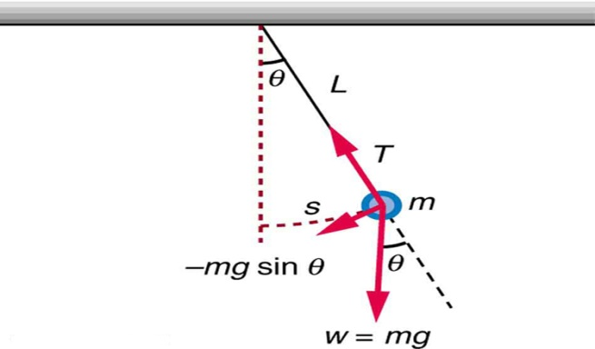
Figure 1: The geometry of a simple pendulum^{[4]}

The restoring force of a simple pendulum is supplied by the vector sum of the gravitational force on the mass mg, and the tension in the string, T. The magnitude of the restoring force depends on the gravitational force and the displacement of the mass from the equilibrium position. Consider Figure 1 where a mass m is suspended by a string of length L and is displaced from its equilibrium position by an angle θ and a distance s along the arc through which the mass moves. The gravitational force can be resolved into two components: One along the radial direction, and the other along the arc in the direction that the mass moves. The component of the gravitational force along the arc provides the restoring force F and is given by:
F = - mg sinθ (3)
where g is the acceleration of gravity, θ is the angle the pendulum is displaced, and the negative sign indicates that the force is opposite to the displacement. For small amplitudes where θ is small, sinθ can be approximated by θ so that Equation (3) can be written as:
F = - mgθ (4)
The angle θ in radians is $\frac{s}{L}$ ; the arc length divided by the length of the pendulum or the radius of the circle in which the mass moves. The restoring force is then given by:
F = - mg $\frac{s}{L}$ (5)

and is directly proportional to the displacement s and is in the form of Equation (1) where $k= \frac{mg}{l}$ . Substituting this value of k into Equation (2), the period of a simple pendulum can be deduced by:
$T=2π √\frac{m}{(\frac{mg}{L})}$ (6)
Or,
$T=2π √\frac{L}{g}$ (7)

Therefore, for small amplitudes the period of a simple pendulum depends only on its length and the value of the acceleration due to gravity.

Procedure

Apparatus:
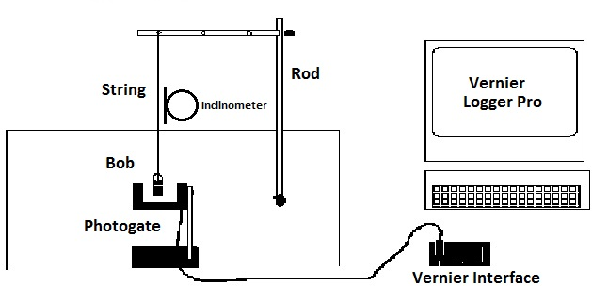
Figure 2: Experiment Apparatus

The following apparatus was used in this experiment:
- Computer with Vernier Logger Pro program - a general-purpose data collection and analysis computer program used with Vernier interfaces.
- Vernier Photogate – a device that allows for extremely accurate timing of events within physics experiments, used to record the pendulum’s periods.
- Inclinometer - an instrument for measuring angles of slope (or tilt), used to measure the amplitude.
- Bob – wood, brass and steel spherical masses with identical volume used.
- Ring Stands & Pendulum Clamp – used to hold the pendulum and the photogate in place.
- String – variable lengths are used in different sections of the experiment.
Rod – used for section 2 of the experiment.
- Meter Stick - used for the measurement of the pendulum’s string’s length.

As stated earlier, this experiment consisted of two sections. Furthermore, the first section consisted of 3 independent parts. Below is the general procedure followed for each part:

Section 1 - Part 1:
This part observed and measured the period of the pendulum with varying amplitudes as follows:
- Any of the 3 bobs was chosen for this part and tied to the pendulum.
- The Logger Pro Software was started and set to record the periods through the photogate.
- The bob was moved from its equilibrium position to 10º of amplitude using the inclinometer and released.
- The pendulum was then allowed to swing freely until the software recorded 5 instances of the period.
- The average of all 5 instances was then recorded.
- Steps 2-5 were repeated for amplitudes of 15º, 20º, 25º and 30º respectively.

Section 1 - Part 2:
This part observed and measured the period of the pendulum with varying string lengths as follows:
- Any of the 3 bobs were chosen for this part and tied to the pendulum.
- The Logger Pro Software was started and set to record the periods through the photogate.
- The string length was measured using the meter stick.
- The bob was moved from its equilibrium position to an amplitude of 20º using the inclinometer and released.
- The pendulum was then allowed to swing freely until the software recorded 5 instances of the period.
- The average of all 5 instances was then recorded.
- The string length was then increased or decreased in increments of 10 cm.
- Steps 2-7 were repeated for 5 varying lengths.

Section 1 - Part 3:
This part observed and measured the period of the pendulum with varying bob masses as follows:
- One of the 3 bobs were chosen and weighted.
- The bob was then tied to pendulum.
- The Logger Pro Software was started and set to record the periods through the photogate.
- The bob was moved from its equilibrium position to an amplitude of 20º using the inclinometer and released.
- The pendulum was then allowed to swing freely until the software recorded 5 instances of the period.
- The average of all 5 instances was then recorded.
- Steps 1-6 were repeated for the two remaining bob masses.

Section 2:
This section measured the period of a rod and compared the results against theoretical values deduced from the period formula as follows:
- The rod was measured and attached to the pendulum clamps.
- It was then moved from its equilibrium position at an amplitude of 10º using the inclinometer and released.
- The rod was then allowed to swing freely until the software recorded 5 instances of the period.
- The average of all 5 instances was then recorded.
- The period formula was then used to calculate the theoretical period and the results were compared.

Observations and Results
The following were the results obtained from each part in the experiment and the corresponding observations:

Section 1 – Part 1:
Table 1: Average Time Periods of Varying Aplitudes
Amplitude (degrees) | Average Period (s)
10 | 1.33544 ± 0.00108
15 | 1.34172 ± 0.00182
20 | 1.34722 ± 0.00428
25 | 1.34598 ± 0.00362
30 | 1.3542 ± 0.0044

As observed in Table 1, the average of 5 readings of the period in each instance of amplitude applied was taken to assure a more precise measurement. The maximum deviation between the highest reading and the lowest reading of each set was also noted to take into account the uncertainty in the measurement.
By studying Table 1, it is observed that all values of the average periods for varying amplitudes are very close to each other. With a deviation of approx. 0.00698 it can be safely assumed that these values are equal, which substantiates Galileo Galilei Law of Amplitude Independence; which states that the period is independent of the Amplitude.^{[2]}
The minimal variance in the values could be attributed to experimental errors such as an applied force to the bob as it was released by the experimenter. This would violate the assumptions of the simple harmonic motion and therefore negates the theoretical laws and formulas for that instance.

Section 1 – Part 2:

Table 2: Average Time Periods of Varying Lengths
Length (cm) | Average Period (s)
23.4 ± 0.05 | 1.0138 ± 0.003
33.4 ± 0.05 | 1.1874 ± 0.0045
43.4 ± 0.05 | 1.34722 ± 0.00428
63.4 ± 0.05 | 1.61326 ± 0.00704
73.4 ± 0.05 | 1.70284 ± 0.0356

As observed in Table 2, the average of 5 readings of the period in each instance of amplitude applied was taken to assure a more precise measurement. The maximum deviation between the highest reading and the lowest reading of each set was also noted to take into account the uncertainty in the measurement. The accuracy of the apparatus used to measure the length was also added.
By studying Table 2, it is observed that the values of the average periods of varying lengths increase as the length of the string is increased. This implies that the period of a pendulum is proportional to its length. This result, validates Equation (7):
$$T=2π √\frac{L}{g}$$
Or more specifically,
${ T}^{2}=(\frac{{4π}^{2}}{g}) . L$ (8)
Which implies that by assuming that $(\frac{{4π}^{2}}{g})$ is a scalar, the period is proportional to the square root of the length.

Section 1- Part 3:

Table 3: Average Time Periods of Varying Masses
Material | Mass (g) | Average Period (s)
Wood | 5.9 ± 0.05 | 1.34722 ± 0.00428
Steel | 66.9 ± 0.05 | 1.39084 ± 0.00046
Brass | 72.7 ± 0.05 | 1.3992 ± 0.0008

As observed in Table 3, the average of 5 readings of the period in each instance of amplitude applied was taken to assure a more precise measurement. The maximum deviation between the highest reading and the lowest reading of each set was also noted to take into account the uncertainty in the measurement. The accuracy of the apparatus used to measure the mass of each bob was also added.
By studying Table 2, it is observed that the values of the average periods of varying lengths are relatively close. It is noted however, that the average amplitude has a significantly higher deviation than the other two readings. This implies a slightly lower precision in its reading. Therefore, taking into account the higher deviation, it can be safely assumed that all the values are equal. This again substantiates Galileo’s discoveries, specifically, that the period is independent of the mass of the bob.^{[2]}

Analysis:

- The aim of the experiment is to record the period under different conditions. The period is the time it takes for the pendulum to complete a full cycle andreturn to its equilibrium position. It can be observed that the first time it the pendulum blocks the photogate, the velocity is moving in the opposite direction and has not completed its cycle yet. Therefore the Logger pro software is set to the time between every other blocking of the photogate.

As observed, Graph 1 is closer to direct propotion.

- Yes it is always true that for a simple pendulum, the period T is related to the length L and free-fall acceleration g by equations (7) and (8). Refer to Section 1 – Part 2 of the Observations and results above for explanation.

References
[1] Van Helden, Albert (1995) "Pendulum Clock". The Galileo Project. Rice University
[2] Michael R. Matthews, Michael P. Clough, and Craig Ogilvie (n.d.) Pendulum Motion: The Value of Idealization in Science, 5
[3] Channing l. Bete Co. (1971) A Scriptographic Booklet: About Foucault Pendulums. Retrieved from: http://www.calacademy.org/products/pendulum/page1.htm
[4] OpenStax College (n.d.) The Simple Pendulum, Retrieved from: http://cnx.org/content/m42243/latest/?collection=col11406/latest

