Hallucinogens
1. Where does the word hallucinate come from?
A: Latin word meaning to wander the mind
2. What effect do hallucinogenic drugs have?
A: produce unusual perceptual and cognitive distortions which some people find noel, stimulating or even spiritually uplifting
-affect nearly all aspects of psychological functioning
3. Where do hallucinogens come from?
A: synthesized and found in plants (over 90 species of plants can produce these effects)
-except LSD
4. What is mescaline?
A: From the peyote cactus in Mexico and south west U.S.
-legalized as part of the sacrament of native American church
-taken orally, “mescal buttons” are dried slices of cactus
-chewed, onset in 30-90 minutes, duration about 10 hours, excreted in the urine unchanged (i.e. not metabolized)
-5mg/kg dose causes psychic effects and visual hallucinations, also in novel users can cause anxiety, tremors, and sympathomimetic effects (heart rate/BP increase)
5. What is psilocybin?
A: compound found in several mushroom species, differ greatly in concentration of the active ingredient
-most found in southern U.S., Mexico and Central American
-associated with ancient religious practices
-metabolized to psilocin (active ingredient) “god’s flesh” by Aztecs
-1/200 as potent as LSD; lasts 6-10 hrs
-well absorbed orally (eaten/chewed raw)
-hallucinations and sensory distortions resemble those produced by LSD
6. Who is Gordon Wasson?
A: NY banker and one of the first non Native Americans to consume psilocybin in a ritual
-first described the affects of psilocybe mushrooms in 1955
-timothy leary (big promoter of LSD in 1960s) read this account and was inspired
7. What is DMT?
A: dimethyltryptamine and 5-MeO-DMT
-found in many plants indigenous to South American
-native tribes make snuffs from these plants (nasal)
-in Amazonian rain forest they make ayahuasca known as “vine of the soul”
-from plants, banisteriopsis caapi (beta-carbolines; inhibit MAO – more DA,NE,5-HT, epinephrine) and psychotria viridis (DMT) together make ayahuasca (beverage – which is a way to get into your self to discover reasons for depression/anxiety/demons)
8. What is bufotenine?
A: unusual because it is found in both plants and animals
-snuff made from beans if a species of tree from genus anadenanthera in south and central American; also found in flesh of fish and skin of toad
-not hallucinogenic orally; must be inhaled or injected (toad licking not going to work)
-similar to DMT
9. What is the history of LSD?
A: Discovered in the lab in 1943 by Dr. Albert Hoffman (Sandoz) when experimenting with ergot (fungus) derivatives because their reputed effects of inducing uterine contractions
-accidently got some on his fingers and absorbed through skin, he experienced the first LSD trip
-following this he decided to test a very small amount (250 ug)
-however, actually high dose, twice as potent as normal dose (25-125 ug)
10. What are the psychotherapeutic uses of LSD?
A: scientific interest developed in the hallucinations, because hallucinations also occur in sz, but they are not the same (visual (LSD) vs. auditory (SZ))
-LSD does not produce model for psychosis
-but antipsychotic drugs antagonize LSD effects suggesting that they may share some mechanisms of action
-no evidence that LSD is more useful is psychotherapy than a placebo
NOTE: LSD 1960’s
-us exploded
-significant figures: Harvard psychologist Timothy Leary
-“Turn on. Tune in. Drop out.” club for young undergraduate females to trip out on LSD
-writer ken kesey “one flew over the cukoo’s nest
11. What is the recent history of LSD?
A: made illegal in 1960’s as part of the response to the thalidomide epidemic of birth defects (drug prescribed to young women for nausea against pregnancy)
-late 1960s: negative publicity
-1970/1980s: usage declined , increased again in 1990s and declined deeply since then
12. What are the pharmacokinetics?
A: Administration: (usually oral) most common form of LSD called blotter acid (sheets of paper soaked in LSD and perforated into ¼ inch square, individual dosage units)
-LSD most potent and is well absorbed after oral ingestion
-usual dose 25-300 micrograms
-only 1% gets to brain
-absorbed and distributed rapidly (body, brain, placenta): 20-69 mins to effects; peaks around 3h, lasts 8-12h
-Metabolism and eliminated are also rapid: LSD is detectable in urine for only 72 hrs
13. What are the acute physiological effects?
A: sympathomimetic: pupil dilation, increase heart rate, bp, temperature and sweating
-low toxicity
-ED50 = 50ug; LD50= 14,000ug
-most deaths due to accidents, homicides or suicides
14. What are the 4 phases on LSD-induced psychedelic experiences?
A:
1. Onset phase (30-60 mins):first signs are autonomic activation
-increase body temp, heart rate, bp, and blood glucose, dilation of pupils, drowsiness and nausea
2. Plateau phase: subjective sense of time begins to slow down
-giddiness, laughter for no reason
-mood euphoric and expansive
-labile mod swings notable
4. Peak phase: visual hallucinations occur, appearance of geometric shapes, maximum drug effect
-characterized by sensory distortions
-alternations in perception, thinking, arousal and self image
-colours reported as more brilliant and intense
5. Come down phase: drug effects gone, however person many not feel normal until following day
15. What are the adverse effects?
A: no evidence for risk of fetal damage
-panic or paranoid reactions
-flashbacks (now called hallucinogen persisting perception disorder [flash back of trip], DSM-5) major long term effect
-re-experiencing some aspect of the hallucinogenic experience
-may precipitate psychosis or emotional disturbances in vulnerable people
-may be precipitated by smoking marijuana
16. What is the DEA Statement on LSD (drug enforcement agency)?
A: LSD is not considered an addictive drug- that is it does not produce drug seeking behaviour as cocaine, heroin and methamphetamines do. However, LSD users may develop tolerance to the drug, meaning that they must consume progressively larger doses of the drug in order to continue to experience the hallucinogenic effects that they seek
17. What is the control status of LSD?
A: LSD is schedule 1 substance under the controlled substances act
-substances which have no accepted medical use and have a high abuse potential (include MDMA and heroin)
18 What are the pharmacodynamics?
A: alteration of serotonin activity
-LSD binds with high affinity to at least 8 diff serotonergic receptor subtypes (most commonly 5HT2A and 5HT2C)
-disruption of serotonin activity in thalamus (main part that receives incoming sensory information), striatum (habit and reward), and cortex hallucinations
NOTE: 5HT2A and 5HT2C Study on Psilocybin
-study done in humans
-if you get the placebo or just the 5HT2A antagonists or D2 antagonist, the dependent variable (what’ being measured) is how much visual hallucinations are being experienced
-drug induced visual illusions produced by psilocybin are blocked by ketanserin and risperidone (5HT2A antagonists) but not haloperiodol (D2 antagonist)
-conclude that the 5HT2A receptor is critical for visual hallucinations when you take psilocybin
NOTE: 5HT2A and 5HT2C drug discrimination studies
-train animals to respond for food pellets (using levers)
-inject with LSD
-put back in operant chamber and match LSD state with receiving food from left leaver and when injected with a saline vehicle (0.9% NaCl) associate pellet with right leaver
-rationale: if you give a drug that blocks the subjective state of LSD then the animal will not press on the left leaver
-5HT2A antagonists all reduced responding on the LSD appropriate lever (interoceptive cue produced by LSD blocked there for receptor is involved in mediating effects of LSD)
19. Describe in detail the pharmacodynamics of hallucinogenic drugs.
A:
1. Activation of 5HT2A receptors enhances glutamate excitation of the pyramidal neurons in later 5 of the prefrontal cortex
-the glutamate is released from thalamocortical afferents, interfering with thalamic filtering of sensory information, and resulting in overload at the cortical level
normal state : this circuitry thought to regulate sensory experiences
-5HT neurons in brain stem (raphe nucleus) project broadly to deep cortical layers and frontal region of brain specifically to 5HT2A receptors on layer 5 of the prefrontal cortex (pyramidal cells that project to parts of the thalamus using NT glutamate) leads to activation of thalamus
-when you take hallucinogens you get an overload of input at 5HT2A receptors, causing an increased release of glutamate therefore increased activation of the thalamus all deterring sensory filtering
2. Pyramidal cells in cortical layer 5 are directly stimulated by activation of 5HT2A receptors and secondarily stimulated by glutamate released from other pyramidal cells in the deep cortical layers that project to layer 5
-this activation disrupts normal functioning of glutaminergic networks in the prefrontal cortex
Anxiety Disorders
1.What is the difference between fear and anxiety?
A: Although, they are related emotions they are also different:
-fear is an emotional response to clear and current danger (activates ANS)
-anxiety is apprehension about future events or misfortune and our ability to deal with them
-they also differ in terms of psychological and neurobiological consequences
2. Describe in detail the immediate response during fear in response to a threat
A: immediate (subcortical) response to threat
-sensory stimuli reach thalamus
-info immediately goes to dear center in the amygdale
-amygdala alerts other brain structures including the hypothalamus and locus coeruleus producing sweaty palms, tachycardia, increased bp, and surge of NE
-subject then prepared for flight or flight response
3. Describe in detail the cognitive processing of this immediate response during fear in response to a threat
A: After fear activation, information sent from thalamus to the cortex for cognitive processing
-the neocortex analyzes the raw data from the sensory organs and decides whether to continue or discontinue the fear response
-if neocortex decides to maintain fear response, the amygdala remains on alert
4. What is the neural circuitry of fear?
A: amygdala is key region
-different sub-regions (lateral, basolateral, medial) react to stimulus and send message to the central nucleus of the amygdala (CeN)
-CeN transmits information to brainstem centers
-evoking 3 types of emotional responses:
1. Central grey (periaqueductal gray) pathway: emotional behaviours
2. Lateral hypothalamus pathway: autonomic responses
3. Bed nucleus of stria terminalis pathway: hormonal responses
5. What is the fear conditioning paradigm?
A: animal within a specific context
-pair experience of something fearful (aversive stimulus) with a neutral stimulus
-in ex. Animal every time animal shocked it freezes, pair foot shock of context floor with discrete stimulus (tone), learns to predict shock with tone, soon just tone elicits the freezing behaviour
-conclude: eventually first stimulus (CS) by itself can produce fear, including freezing and autonomic changes (CR), like increased bp
key point: conditioned fear acquisition (and expression depends on the amygdala
-if you lesion the BLA (basal laternal nucleus of the amygdala) and associated regions this affects the acquisition of fear conditioning
-before condition lesion put through fear conditioning paradigm will not acquire freezing to the tone (will freeze when shocked but will never learn to associate shock with tone)
-if you lesion the CeN (central nucleus of the amygdala) this disrupts expression of fear conditioning
-put animal through fear conditioning paradigm pair tone/shock and freeze in response to shock legion CeN animal wont produce freezing motion when they hear shock alone (meaning animal learned but cant express what they’ve learned)
6. What is the neural circuitry of anxiety?
A: the physiology of anxiety may be somewhat different from that of fear
-amygdaloid processing plays a central role in anxiety, but behavioural responses may be initiated by the bed nucleus of the stria terminalis (BNST) “extended amygdala”
-the BNST projects to same regions as central nucleus
-BNST initiates emotional response when stimuli are less precise predictors of potential danger
-produces a state of sustained preparedness for an unclear danger and prolonged anticipation of unpleasantness
7. What evidence has been collected that depicts the role of the BNST in anxiety?
A: elevated plus maze (2 arms have walls/2 arms open to the environment [based on idea that rodents don’t like open spaces], allowed to freely to navigate arms and prefer to go into closed arms (base line)
-can give drugs to manipulate base line findings
-in animals, anxiety in the elevated plus maze is modulated by manipulations of the BNST (legions of BNST reduce anxiety, and so on)
-chronic stress increases dendritic length and branching, and volume of the BNST (to cope with anxiety)
-modulated by sex hormones
8. What is generalized anxiety disorder (GAD)
A: characterized by persistent, excessive and unrealistic worry about everyday things
-worry goes on everyday, possible all day
-ppl with GAD feel their worrying is beyond control and cant be turned off
-often expect worst, event with no good reason for concern
-excessive worrying about health, family, money or work
-occurs for at least 6 months
-unrelenting worry interferes with everyday living and can affect all areas of life, including social, work, school, family
-females>males
9. What is the neural basis of GAD?
A: patients with GAD have increased volume of the amygdala, similar to that of lab animals exposed to repeated stressors
-PET scans show greater amygdala activity with exposure to negative stimuli in GAD than in healthy individuals
-possibly due to too little inhibitory control by the prefrontal cortex
10. What is obsessive compulsive disorder?
A: reoccurring, persistent, intrusive thoughts of contamination, violence, sex or religion (obsessions) that the individual tries to resist but that cause a great deal of anxiety, guilt, and shame
-compulsions are repetitive rituals to relieve the tremendous anxiety generated by the obsessive thoughts
-individual is convinced that unless the compulsive ritual is completed, disastrous consequences will occur
-they recognize that the compulsions are inappropriate or irrational and consumes most of their waking hours, yet feel forced to do them against their will
11. What is the neural basis of OCD?
A: abnormal cell activity in the basal ganglia and frontal lobes correlates with severity of symptoms, and increases when patients are presented with feared stimuli
-SSRIs are effective for OCD because they enhance activity of serotonergic neurons of the raphe nuclei, which interrupts the neural loop by inhibiting cell firing in the caudate
-raphe nuclei (main 5-HT projecting neurons) inhibit caudate nucleus, SSRIs enhance this inhibitory effect
12. What are panic disorders?
A: Panic disorder is diagnosed in ppl who experience spontaneous, seemingly out of the blue panic attacks and are preoccupied with the fear of it happening again
-over activation of sympathetic NS
-attacks occur unexpectedly, sometimes even when person is asleep
-defined as the abrupt onset of intense fear that reaches a peak within a few mins
-can lead to agoraphobia (don’t want to leave the house) – shut ins are described as people who don’t leave the house for a lengthy period of time
13. What are typical situations avoided by ppl with agoraphobia?
A: 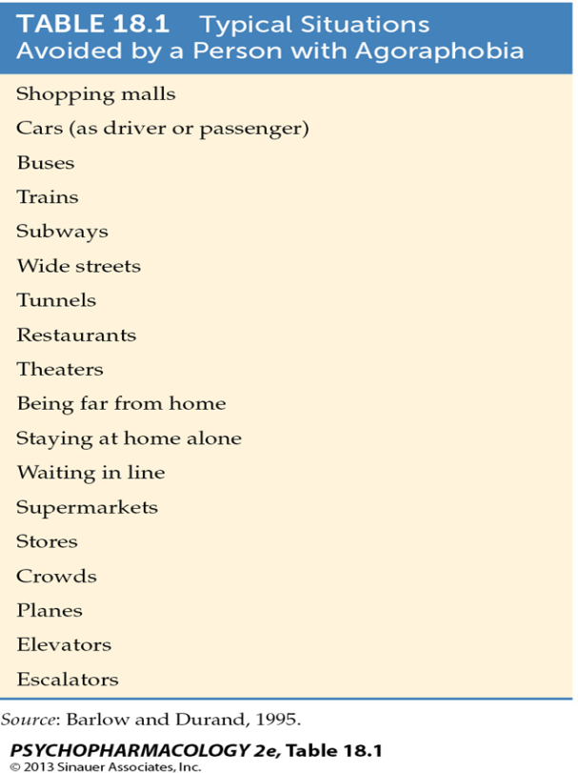
14.What is the neural basis of panic disorders?
A: genetic predispositions exists
-attacks can be triggered by various techniques, such as injecting caffeine that do not trigger attacks in healthy subjects
-the ability of these agents to induce ANS arousal suggest that dysregulation of the adrenergic function may occur in the disorder
15. What is post traumatic stress disorder (PTSD)?
A: condition that can occur in ppl who have experienced or witnessed a life threatening event, such as a natural disaster, serious accident, terrorist incident, sudden death of a loved one, war/violent personal assault (such as rape)
-most ppl who experience such events recover from them, ppl with PTSD continue to be severely depressed and anxious for months or even years following the event
-they frequently re-live the event through flashbacks and nightmares
-relaxing, concentrating or sleeping may be difficult
16. What are the symptoms of PTSD?
A:
1. re-experience trauma through intrusive distressing recollections of the event, flashbacks and nightmares
2. emotional numbness and avoidance of places, people and acitivities that are reminders of the trauma
3. increased arousal including difficulty sleeping and concentrating, feeling jumpy, easily irritated and angered
-PTSD is diagnosed after a person has been experiencing the above symptoms for at least one month following a traumatic event. Sometimes symptoms of PTSD do not appear until several months or even years later
17. Describe the gene x environment interaction of PTSD
A: nature vs. nature
-looked at identical twins,
- both normal volume of hippocampus one twin goes to war both low risk of PTSD development
-both susceptible brain with equal hippocampus volume one twin goes to war that twin has high risk for PTSD, where other twin is at low risk
-PTSD can be predicted by pre existing neuronal differences
18. What are the risk factors for PTSD?
A: 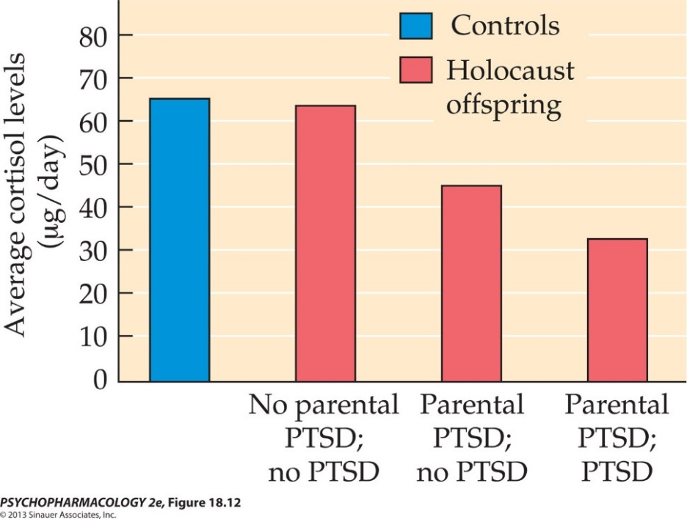
- Children who have parents with PTSD have increased risk for PTSD and tend to have lower-than-normal blood cortisol
-The normal feedback mechanism that turns off cortisol secretion may be hypersensitive in PTSD
19. What is specific (simple) phobia?
A: involve fears that the individual recognizes as irrational
-may focus on specific objects or situations such as high places or closed in places, snakes or other animals, or relation to social situations
-phobias can affect daily existence and reduce quality of life
20. How are anxiety disorders treated?
A: 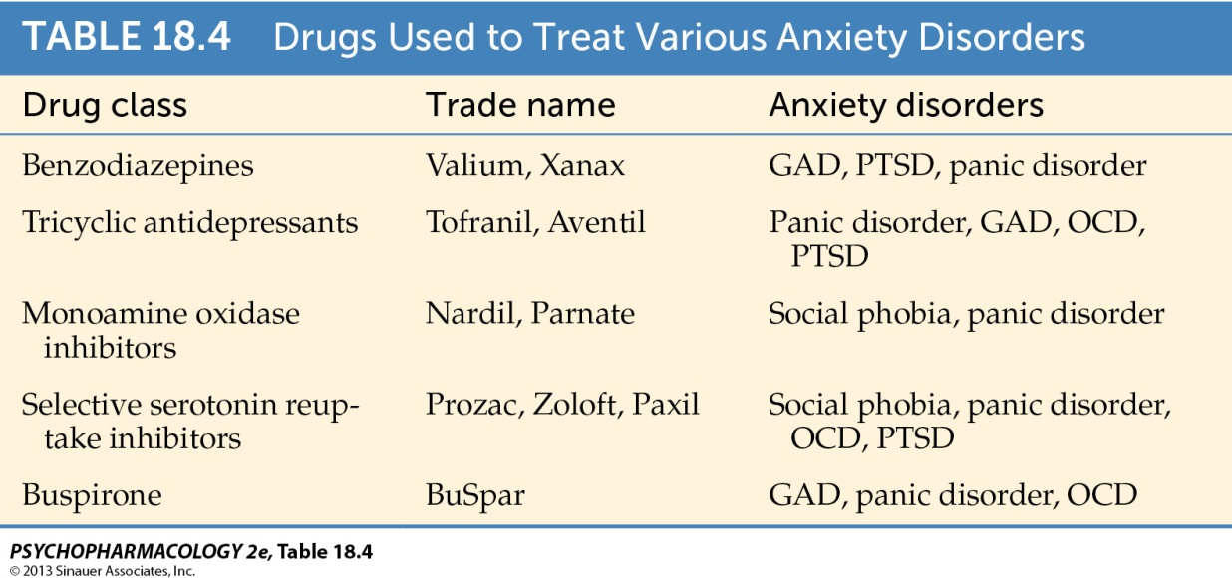
-different classes of drugs that are used to treat anxiety
-benzos/barbiturates are more used for short term, rest are recently used
21. What is the role of GABA in anxiety?
A: Classical sedative hypnotics and benzos increase GABAergic transmission effective anxiolytics
-GABAa agonists (GABAa = benzo/,barb binding site locations, increase amount of Cl- into cell)
-e.g. diazepam increases membrane hyperpolarization
-competitive antagonist flumazenil (binds to benzo site but has no effect on GABA receptor) prevents benzo induced enhancement of GABA
22. Are their natural ligands for benzos?
A; endogenous substance (inverse agonist – bind to site but produce opposite actions) bind to benzo site
-produce opposite actions of drugs
-causing increase anxiety, arousal, seizures
-e.g. beta-carbolines: in humans, produces extreme anxiety and sense of panic
-uncouple the GABA receptors from Cl- channels; GABA less effective in allowing Cl- into cell
23. What is the role of CRH in anxiety?
A: Corticotropin-releasing hormone (not factor)
-HPA axis; negative feedback –factors feedback to higher levels to shut down, important cause you done want high levels of hormone in blood
- Acts as a neurotransmitter in neural circuits involved in the stress response, including amygdala
-ICV (intracellular ventricularly- putting directly into ventricles, to target brain specifically) administration of CRH stimulates the SNS
-Increased adrenaline
-Increased heart rate, blood pressure
-CRH levels higher in CSF of combat veterans with PTSD compared to those without PTSD
-CRH antagonists useful in treatment? Problem because main current drug used as abortion pill as well
24. What is the role of NE in anxiety?
A: reciprocal connections between amygdala and locus coeruleus (LC)
-responsible for arousal, orienting response, and response to fear evoking stimuli suggests involvement in mediating anxiety
-Evidence of role:
1. Cells in the LC fire in response to novel stimuli that signal threat or reward
-hypervigilance in PTSD?
2. Electrical stimulation or administration of yohimbine (selective alpha2 autoreceptor antagonist; increase NE release) leads to fear response (piloerection, pupil dilation)
3. Clonidine (α2-autoreceptor agonist) has anti-anxiety effects
4. Therapeutic effects of anxiolytics may be explained by modulation of LC firing

25. How can the therapeutic effects of anxiolytics be explained by modulation of LC firing?
A: LC nuclei project to amygdala and release NE this correlating to anxiety
-have neurons that feed to other parts of the limbic system that release CRH to LC neurons this causes excitation of LC neurons
-benzos (chart)
-SSRIs (chart)
-TCA and MAOs work at level of the autoreceptor, which when activated get decreased NE release
** all centralized at level of LC
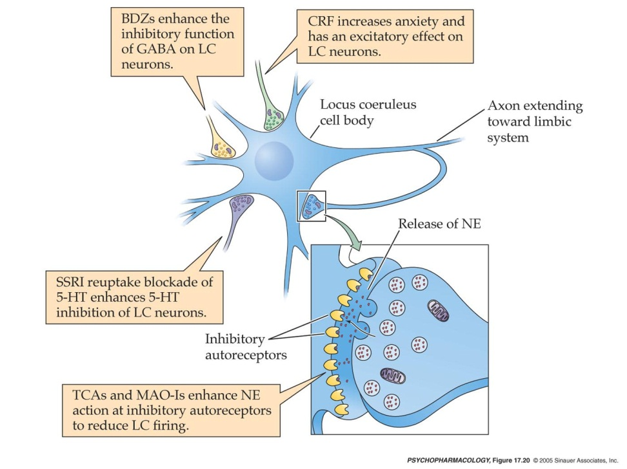
NOTE: Summary
- Patients with generalized anxiety disorder (GAD) exhibit increased metabolic rates in several brain regions compared with healthy controls. Hyperactive neurotransmitter circuits between the cortex, thalamus, amygdala and hypothalamus have been implicated in the disorder. Hypofunction of serotonergic neurons arising from the dorsal raphe nucleus and GABAergic neurons that are widely distributed in the brain may result in a lack of inhibitory effect on the putative GAD pathway. Furthermore, overactivity of noradrenergic neurons arising from the locus coeruleus may produce excessive excitation in the brain areas implicated in GAD.

