Chapter 1
Scarcity – limited nature of society’s resources.
Economics – How society manages its scarce resources
- People; How much to work, save spend, and buy
- Firms; how much to produce, how many workers to hire
- Society; divide resources between national defense, consumer goods, protecting environment.

Principle #1: People Face Tradeoffs
- Going to a party the night before your midterm leaves less time for studying.
Efficiency vs. equity
Efficiency – getting the most out of scarce resources.
Equity – distributing prosperity fairly among society’s members.
Principle #2: The Cost of Something is what you give up to get it
- Making decisions requires comparing the costs and benefits of alternative choices.
Opportunity Cost – Whatever must be given up to obtain it. Relevant cost for Decision making.
- Seeing a movie is not just the price of the ticket, but the value of time also.
Principle #3: Rational people think at the margin
Rational – person purposely does best they can to achieve their goals.
Marginal changes – Incremental adjustments to an existing plan.
- A firm considers whether to increase output, comparing the cost of the needed labor and materials to the extra revenue.
Principle #4: People respond to incentives
Incentive – Something that induces a person to act.
- Prospect of a reward or punishment.

Principle #5: Trade can make everyone better off
- Rather than being self-sufficient, people can specialize in producing one good or service and exchange it for other goods.
Principle #6: Markets are usually a good way to organize Economic activity
Market – Group of buyers and sellers.
“Organize economic activity”
- What goods to produce
- How to produce them
- How much of each to produce
- Who gets them

- The invisible hand works through the price system.

Principle #7: Governments can sometimes Improve Market Outcomes
- Important role for government: ENFORCES PROPERTY RIGHTS.
People are less inclined to work, produce, invest or purchase if there is a large risk their property might get stolen.
- Government may alter market outcome to PROMOTE EFFICIENCY.
Market Failure – Market fails to allocate society’s resources efficiently.
Causes:
Externalities: Production or consumption of a good affects bystanders.
Market Power: Single buyer or seller has substantial influence on market price.
Principle #8: A country’s standard of living depends on its ability to produce goods & services
- The most important determinant of living standards:
Productivity – amount of goods and services produced per unit of labor. (depends on equipment, skills, technology)
Principle #9: Prices rise when the government prints too much money
Inflation – Increases in general level of prices; In long run, caused by excessive growth in quantity of money, causing value of it to fall. Faster govt. creates money, greater inflation rate.
Principle #10: Society faces a short run tradeoff between inflation and unemployement

Chapter 2
Circular – Flow Diagram – Visual model of the economy shows how dollars flow through markets among households and firms.
- Actors: Households, firms
- Markets: Goods and services; factors of production
Factors of production – Resources that the economy uses to produce goods & services.
Include: Labor, Land, Capital (buildings, machines used in production)

Production Possibilities Frontier (PPF):
Graph showing the combinations of two goods the economy can possibly produce given the available factors of production and the available production technology.
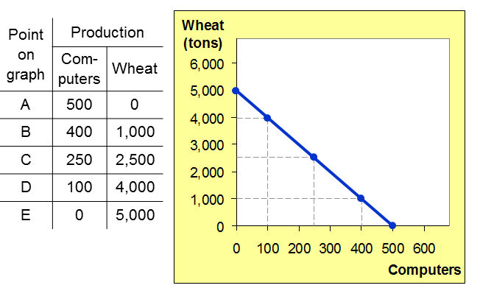

The steeper the curve, the higher the opportunity cost.
- If the opportunity cost ramins constant, PPF is a straight line.
- If the opportunity cost rises as the economy produces more of the good, PPF will be bow-shaped. Bow shaped PPF illustrates concept of increasing opportunity cost.
Microeconomics – Study of how households and firms make decisions and how they interact in markets.
Macroeconomics – Study of economy-wide phenomena, including inflation, unemployment and economic growth.
Positive Statements – Describe worlds as it is.
Normative Statements – attempt to prescribe how the world should be.

Chapter 3
Exports – Goods produced domestically and sold abroad.
Imports – Goods produced abroad and sold domestically.
ABSOLUTE ADVANTAGE: The ability to produce a good using fewer inputs than another producer.
*If each country has an absolute advantage in one good and specializes in that good, then both countries can gain from trade.
COMPARATIVE ADCANTAGE: The ability to produce a good at a lower opportunity cost than another producer.
*Differences in opportunity cost and comparative advantage create the gains from trade.
When each country specializes in the good(s) in which it has a comparative advantage, total production in all countries is higher, the worlds “economic pie” is bigger, and all countries can gain from trade.
*Comparative advantage means being able to produce a good at a lower opportunity cost. Absolute advantage means being able to produce a good with fewer inputs.
Chapter 4
Market: Group of buyers and sellers of a particular good or service.
Competitive Market: One in which there are so many buyers and so many sellers that each has a negligible impact on the market price.
QUANTITY DEMANDED: Amount of good that buyers are willing and able to purchase.
LAW OF DEMAND: Quantity demanded of a good falls when the price of the good rises.
- Demand for a NORMAL GOOD is positively related to income. (An increase in income causes increase in quantity demanded at each price, shifting D curve to the right.)
- Demand for an INFERIOR GOOD is negatively related to income. (An increase in income shifts D curve to the left.)
Substitutes: If an increase in the price of one good causes an increase in demand of another good; these goods are substitutes. (I.e. coke & Pepsi, laptops & desktop computers)
Complements: If an increase in the price of one good leads to a fall in demand of another good; these goods are complements. (I.e. Computers and software; computer price rises -> people buy fewer computers and therefore less software. Software demand curve shifts left)
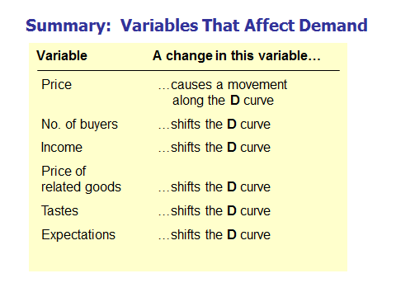
QUANTITY SUPPLIED: The amount that sellers are willing to sell.
LAW OF SUPPLY: The quantity supplied of a good rises when the price of the good rises.
*A fall in input prices makes production more profitable at each output price, so firms supply a larger quantity at each price, and S curve shifts to the right.
* A cost-saving technological improvement has the same effect as a fall in input prices, Shifts S curve to the right.
* Suppose firm expects the price of good it sells to rise in future. Firm may reduce supply now, to save inventory to sell later at higher price, therefore shifts S curve to the left.

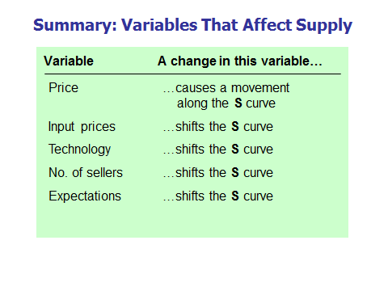
Equilibrium price: The price that equates quantity supplied with quantity demanded.
Equilibrium quantity: The quantity supplied and quantity demanded at the equilibrium price.
Surplus: When quantity supplied is greater than quantity demanded.
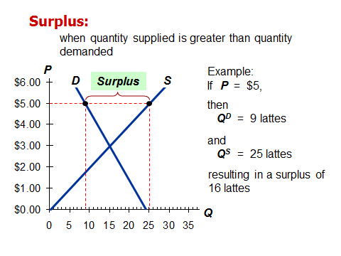
Facing surplus, sellers try to increase sales by cutting price -> Qd rises, Qs falls which reduces surplus. Prices continues to fall until market reaches equilibrium.
Shortage: When quantity demanded is greater than quantity supplied.
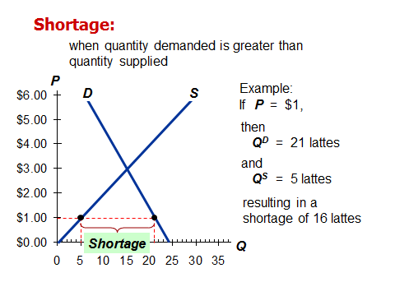
Facing shortage, sellers raise price -> Qd falls, Qs rises, which reduces the shortage. Price continues to rise until market reaches equilibrium.
*If demand increases more than supply, P rises.
*If supply increases more than demand, P falls.

Chapter 5
Elasticity: Measures how much one variable responds to changes in another variable. (a numerical measure of the responsiveness of Qd or Qs to one of its dereminants.
PRICE ELASTICITY OF DEMAND measures how much Qd responds to a change in P.
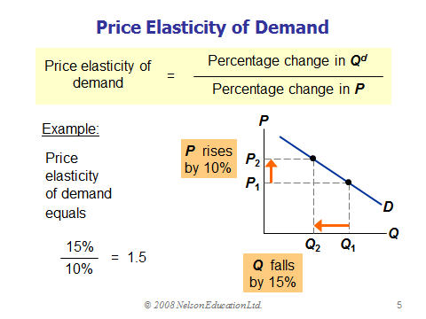
MIDPOINT METHOD: ( End value – Start Value / midpoint ) x 100%
- PRICE ELASTICITY IS HIGHER WHEN CLOSE SUBSTITUTES ARE AVAILABLE.
- PRICE ELASTICITY IS HIGHER FOR NARROWLY DEFINED GOODS THAN BROADLY DEFINED ONES.
- PRICE ELASTICITY IS HIGHER FOR LUXURIES THAN FOR NECESSITIES.
- PRICE ELASTICISTY IS HIGHER IN THE LONG RUN THAN THE SHORT RUN.
THE FLATTER THE CURVE, THE BIGGER THE ELASTICITY. THE STEEPER THE CURVE, THE SMALLER THE ELASTICITY.
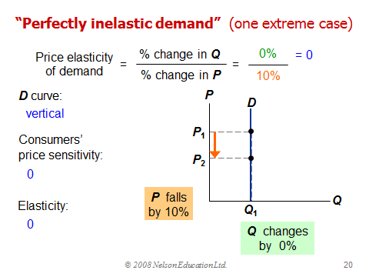
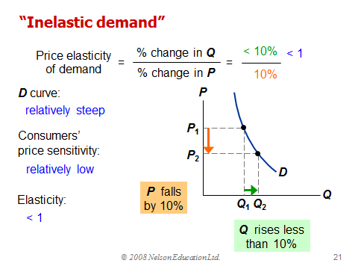
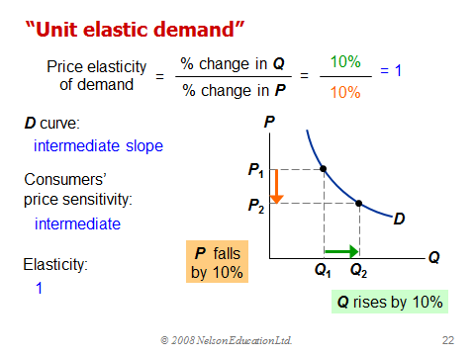
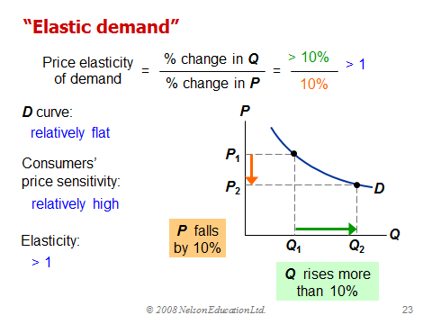
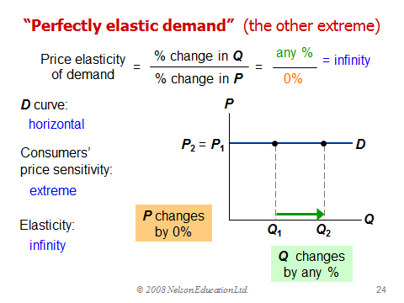
REVENUE = P x Q
- When D is elastic, a price increase causes revenue to fall.
- When D is inelastic, a price increase causes revenue to rise.
PRICE ELASTICITY OF SUPPLY measures how much Qs responds to a change in P.
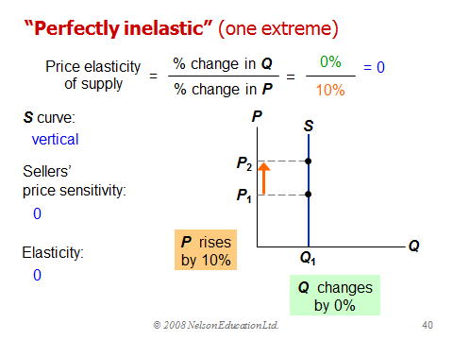
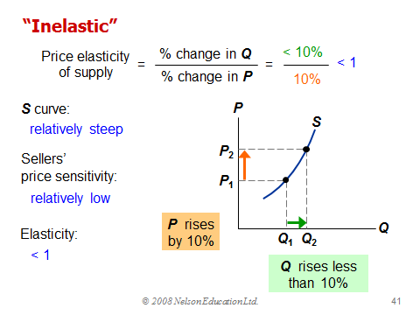
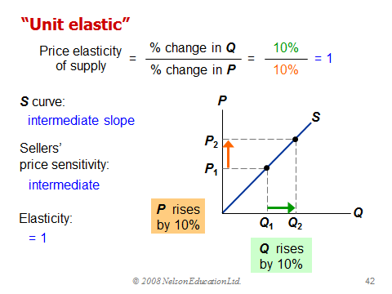
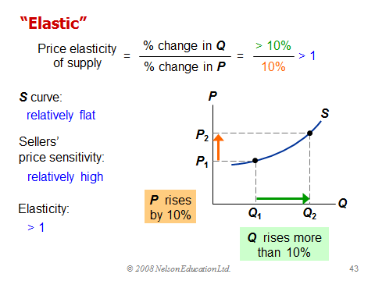
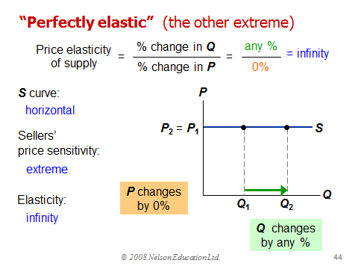
- When supply is inelastic, an increase in demand has a bigger impact on price than on quantity.
- When supply is elastic, an increase in demand has a bigger impact on quantity than on price.
INCOME ELASTICITY OF DEMAND measures the response of Qd to a change in consumer income. = (% change in Qd / % change in income)
Normal goods, income elasticity > 0.
Inferior goods, income elasticity < 0.
CROSS PRICE ELASTICITY OF DEMAND measures the response of demand for one good to changes in the price of another good.
= (% change in Qd for good 1 / % change in price of good 2)
Substitutes, cross-price elasticity > 0.
Complements, cross-price elasticity < 0.

Chapter 6
Price ceiling: legal maximum on price of a good or service (i.e. rent control)
Price floor: legal minimum on price of a good or service (i.e. minimum wage)
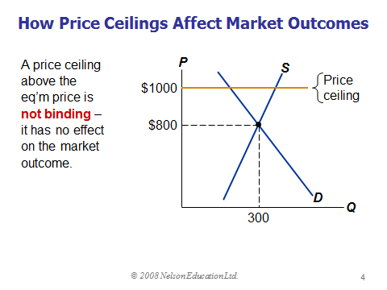
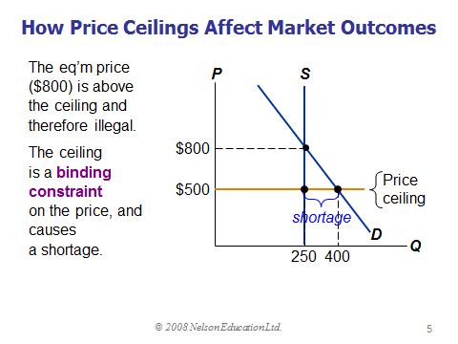
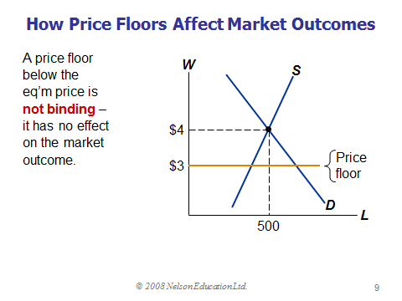
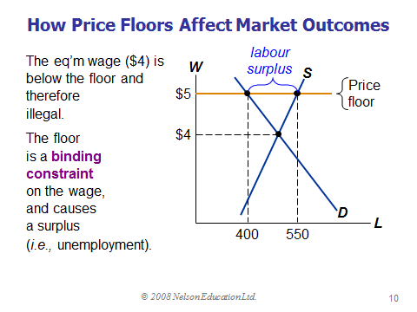

Taxes
- The government levies taxes on many goods & services to raise revenue to pay for national defense, public schools, etc.
- The government can make buyers or sellers pay the tax.
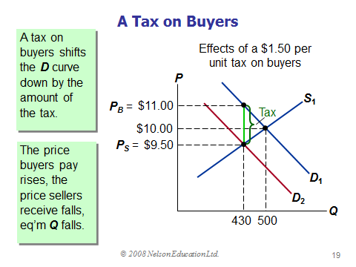
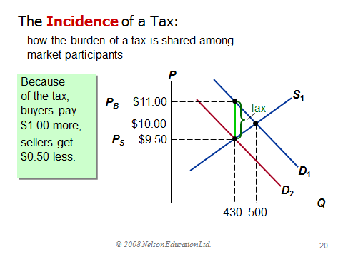
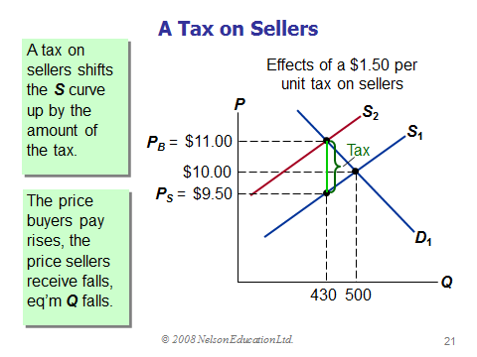
- The effects on P and Q, and the tax incidence are the same whether the tax in imposed on buyers or sellers!
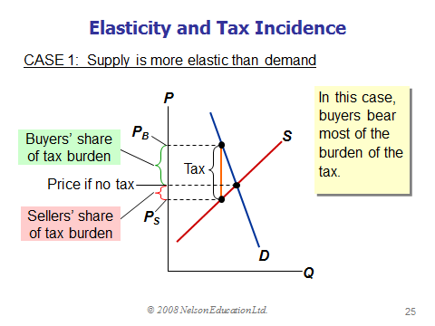
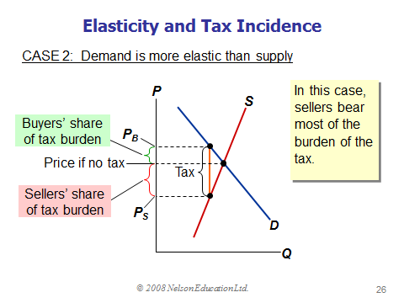
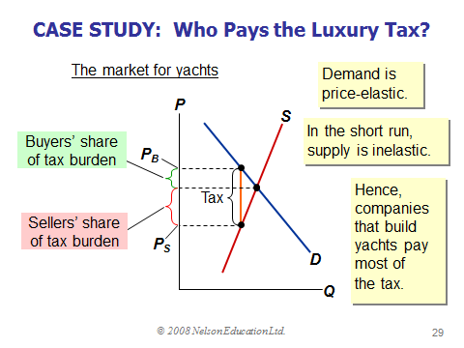
Chapter 7

Consumer surplus: amount a buyer is willing to pay minus the buyer actually pays.
(=WTP – P)
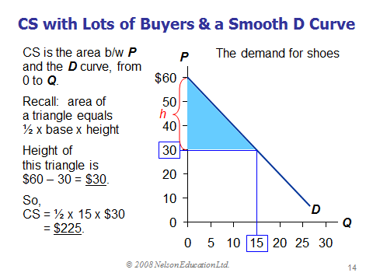

Example
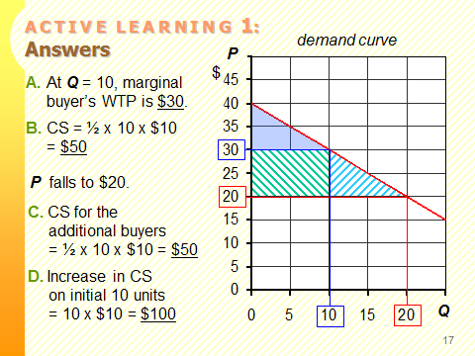
Producer Surplus: The amount a seller is paid for a good minus the seller’s cost.
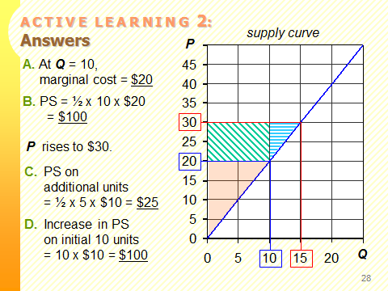
TOTAL SURPLUS = CS + PS = (value to buyers) – (cost to sellers)

Evaluating the market equilibrium
- The goods are produced by the producers with lowest cost
- The goods are consumed by the buyers who value them most highly
- The Equilibrium of supply and demand maximizes the sum of consumer and producer surplus. It generates an efficient allocation of resources.

Market failures: When unregulated markets fail to allocate resources efficiently.
Causes:
- Market power (a single buyer or seller can influence the market price, e.g. monopoly)
- Externalities (side effects of transactions, e.g. pollution)
*Efficiency means that total surplus is maximized, that the goods are produced by sellers with lowest cost, and that they are consumed by buyers who most value them.
* A tax is a wedge between the price buyers pay and the price sellers receive.
* A tax raises the price buyers pay and lowers the price sellers receive.
* A tax reduces the quantity bought and sold.
Chapter 8
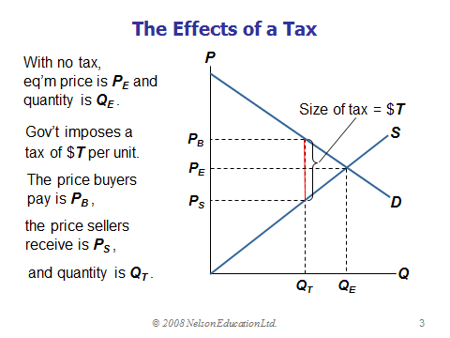
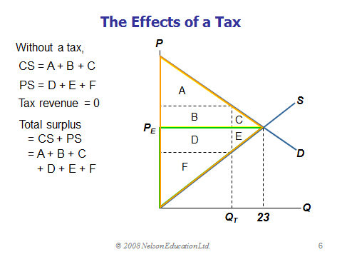
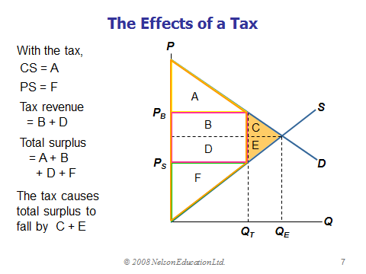
C + E are called the DEADWEIGHT LOSS (DWL) of the tax, the fall in total surplus that results from a market distortion, such as a tax. The losses to buyers and sellers exceed the revenue raised by the government.
EXAMPLE
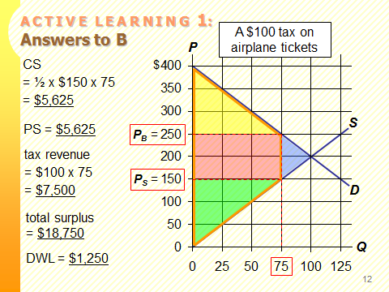

- The price elasticity’s of demand and supply measure how much buyers and sellers respond to price changes. Therefore, higher elasticity’s imply higher DWLs.
When tax rates are low, raising them doesn’t cause much harm, and lowering them doesn’t bring much benefit. When tax rates are high, raising them is very harmful, and cutting them is very beneficial.

Chapter 9
Pw = World price of a good; price that prevails in world markets.
P_{D} = Domestic price without trade.
If P_{D}<P_{W}:
- Country has comparative advantage in the good.
- Country exports the good.
If P_{D}>P_{W}:
- Country does not have comparative advantage.
- Country imports the good.
When a small economy engages in free trade, P_{W} is the only relevant price:
- No seller would accept less than P_{W} because she could sell the good for P_{W} in world markets.
- No buyer would pay more than P_{W} because he could buy the good for P_{W} in world markets.
EXAMPLE 1
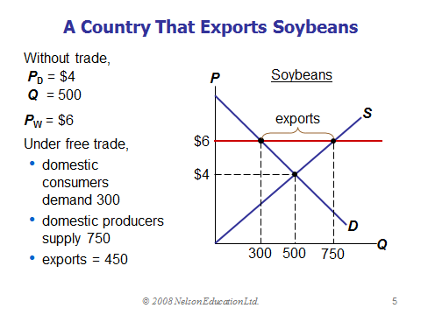
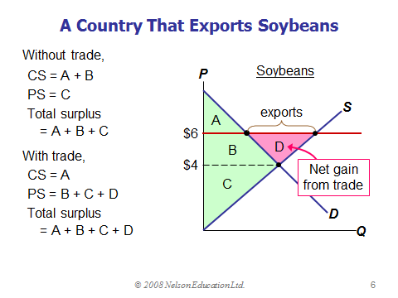

EXAMPLE 2
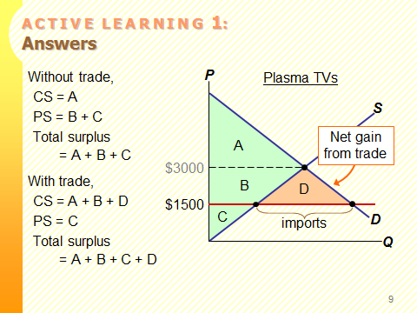

Tariff: A tax on imports.
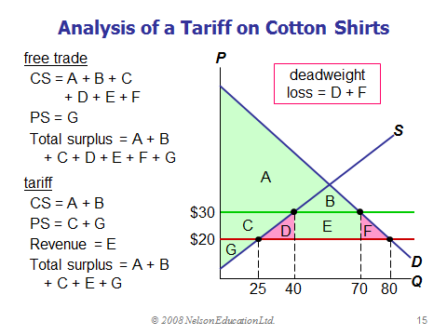
D – Deadweight loss from overproduction of shirts.
F – Deadweight loss from under-consumption of shirts.
Import quota: Quantitative limit on imports of a good.
Common arguments for restricting trade include:
- Protecting jobs
- Defending national security
- Helping infant industries
- Preventing unfair competition
- Responding to foreign trade restrictions
Chapter 10
Externality: Uncompensated impact of one person’s actions on the well-being of a bystander.
- Negative externality: effect on bystanders is adverse.
- Positive externality: effect on bystanders is beneficial
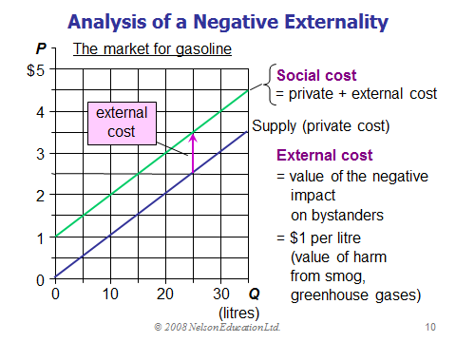
Internalizing the externality: Altering incentives so that people take account of the external effects of their actions.
Pigovian taxes: Taxes that internalize negative externalities.
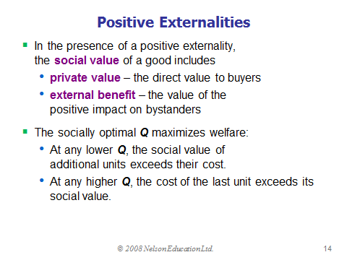
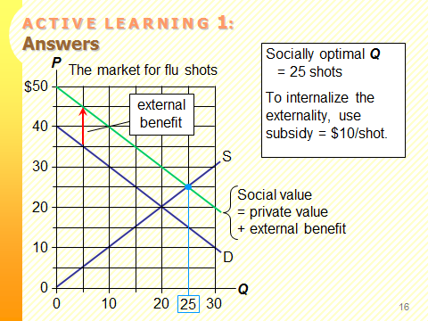
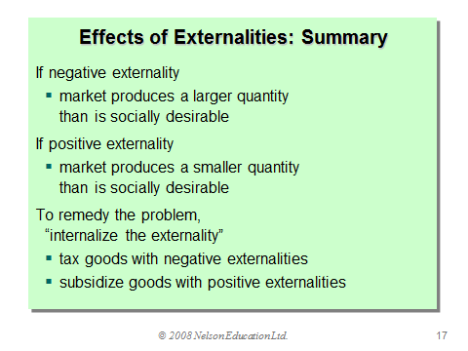
Transaction costs: the costs that parties incur in the process of agreeing to and following through on a bargain.
Command and control policies: regulate behavior directly.
Examples:
- limits on quantity of pollution emitted
- requirements that firms adopt a particular technology to reduce emissions
Market-based policies: provide incentives so that private decision-makers will choose to solve the problem on their own.

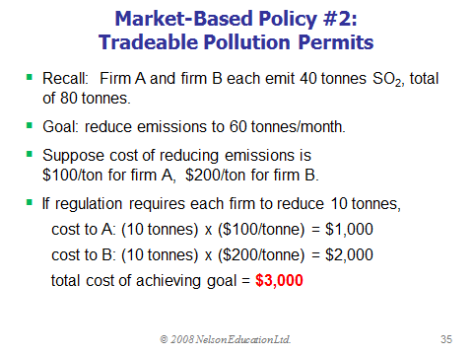
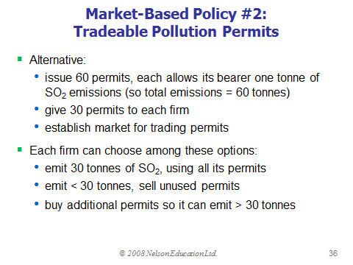
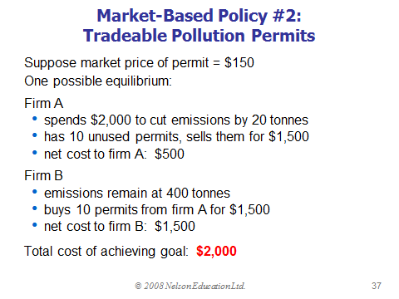
Like most demand curves, firms’ demand for the ability to pollute is a downward-sloping function of the “price” of polluting.
- A corrective tax raises this price and thus reduces the quantity of pollutions firms demand.
- A tradable permits system restricts the supply of pollution rights, has same effect as the tax.
When policy makers do not know the position of this demand curve, the permits system achieves pollution reduction targets more precisely.
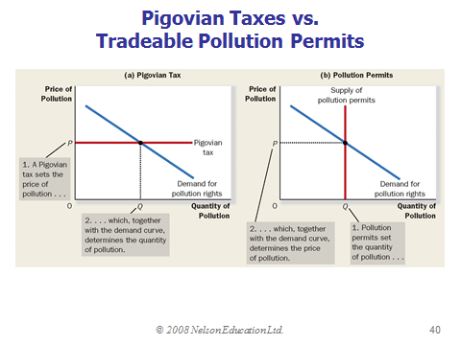
COASE THEOREM: the private market can reach the socially optimal allocation of resources as long as people can bargain without cost.

Chapter 11
- A good is Excludable if a person can be prevented from using it.
Excludable: fish tacos, dial-up internet service.
Not excludable: FM radio signals, national defense.
- A good is Rival in consumption if one person’s use of it diminishes other’ use.
Rival: fish tacos
Not rival: An MP3 file of Coldplay’s latest hit song.
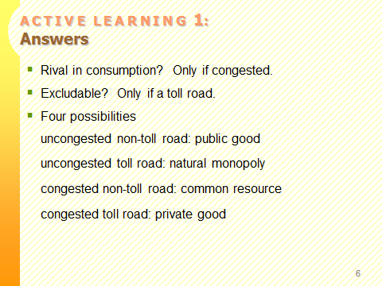
Free-rider: A person who receives the benefit of a good but avoids paying for it.
Cost-benefit analysis: A study that compares the costs and benefits of providing a public good.

Chapter 12
Federal government responsibilities:
- Matters of national interest: national defense, international trade, criminal law and money and banking.
- Delivery of national social programs (employment insurance and Canadian pension plan)
- Unlimited taxing powers

Provincial government responsibilities
- Health care, education, welfare, natural resources within their boundaries and civil law.
- Extensive taxing powers, but less than federal government.
Marginal tax rate: the tax rate applied to each additional dollar of income.
- Higher-income individuals pay a larger percentage of their income in taxes.
- The next largest source of federal revenue is the goods and services tax (federal government revenue)
- Corporate income taxes – based on a corporations profits (federal government revenue)
- Payroll taxes – taxes on wages a firm pays its workers. (paid by employees and employers)
Budget surplus: An excess of government receipts over government spending.
Budget Deficit: An excess of government spending over government receipts.
Average tax rate: Total taxes paid divided by total income.
Lump-sum tax: Tax that is the same amount for every person, regardless of earnings or any actions that the person might take.
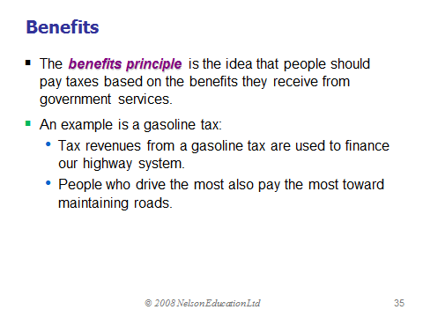
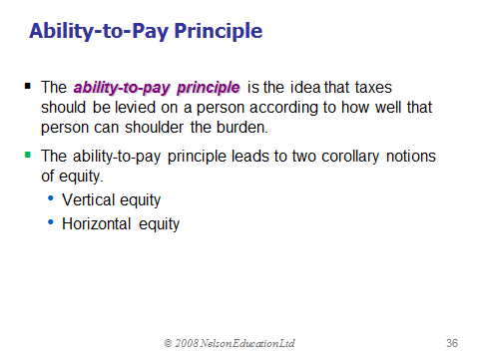

Vertical equity: idea that taxpayers with a greater ability to pay taxes should pay larger amounts.
Proportional tax: one for which high-income and low-income taxpayers pay the same fraction of income.
Regressive tax: One for which high-income taxpayers pay a smaller fraction of their income than do low-income taxpayers.
Progressive tax: One for which high-income taxpayers pay a larger fraction of their income than do low-income taxpayers.
Horizontal equity: idea that taxpayers with similar abilities to pay taxes should pay the same amounts.
*Equity and efficiency are the most important goals of the tax system.
Chapter 13
Profit = Total revenue – Total cost
Explicit costs: Require an outlay of money (paying wages to workers)
Implicit costs: Do not require a cash outlay (the opportunity cost of the owners time)
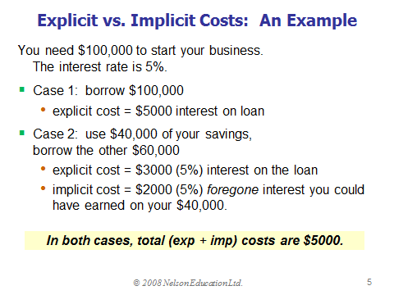
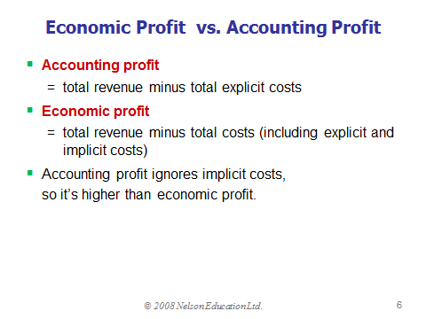
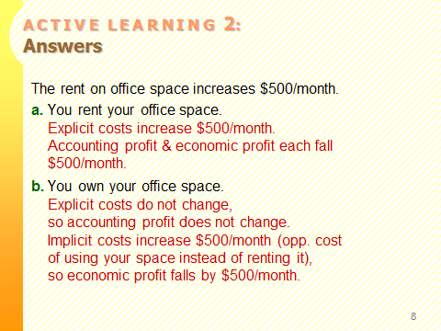
Production function: Shows the relationship between the quantity of inputs used to produce a good, and the quantity of output of that good.
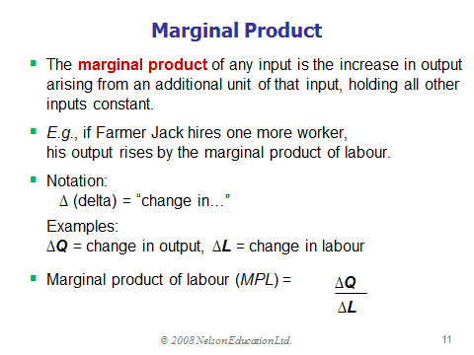
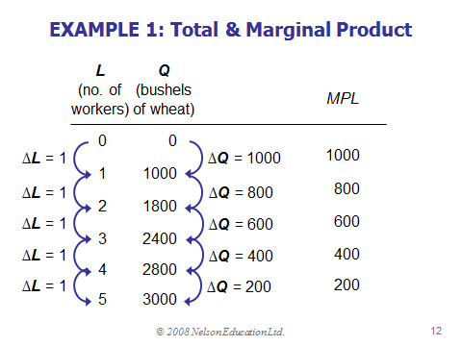
Marginal Cost = change in TC/change in Q
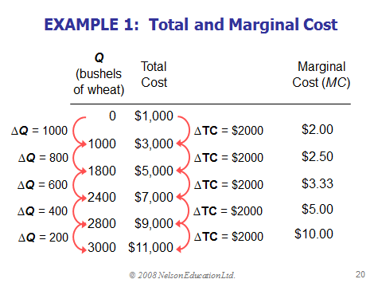
Fixed cost – do not vary with quantity of output produced.
Variable cost – vary with the quantity produced.
Total cost = FC + VC
Average fixed cost = FC/Q
Average variable cost = VC/Q
Average total cost = TC/Q OR ATC= AFC + AVC
*AFC ALWAYS FALLS AS OUTPUT INCREASES.
*ATC CURVE IS USUALLY USHAPED.
*WHEN MC < ATC, ATC FALLS AS Q RISES.
*WHEN MC > ATC, ATC RISES AS Q RISES.

