PSL300 – Dr. Tweed (Fall 2014)
Central Nervous System (CNS)
- The CNS is the brain (protected by the skull) and spinal cord (protected by the bones in the vertebral column)
Nephrons outside the CNS make up the peripheral nervous system
- The peripheral nervous system, or PNS, includes all neurons, and parts of neurons, outside the CNS
  - Parts of neurons because they are partly in the CNS and partly in the PNS (e.g. cell body in spinal cord but dendrites reach out to the muscles)
- The PNS comprises the somatic nervous system, for controlling voluntary action via skeletal muscle, and the autonomic nervous system, for visceral functions (tend to involve smooth muscles and glands) such as heart rate and breathing
  - via smooth muscles or glands
- Part of the autonomic system is the enteric nervous system, which controls digestion and movements of the gut. It gets input from spinal cord, but can also work independently
  - Contains lots of neurons
Most neurons are in the CNS
- The brain has ~88 billion neurons, and the spinal cord ~1 billion
- Estimates for the enteric nervous system range from 100-600 million, and the total for the PNS is likely not much more
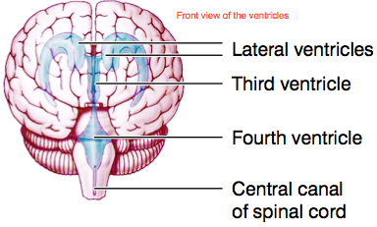
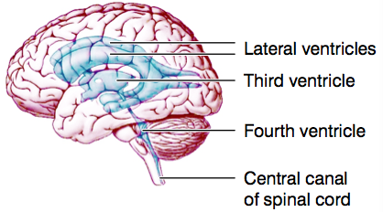
- CNS and PNS also have cells called glia, which support and protect neurons, and are about as numerous
The CNS contains ventricles filled with cerebrospinal fluid
The CNS includes gray and white matter
- Gray matter consists of nerve cell bodies, unmyelinated axons, and dendrites. The cell bodies are arranged either in layers (in parts of the brain) or in clusters called nuclei
- White matter consist of myelinated axons running in bundles called tracts
  - Note: white matter connects neurons from different parts of the CNS
- In the peripheral nervous system, clusters of neurons are called ganglia, and bundles of axons are nerves
  - Recall that clusters of neurons in CNS = tract
Compared to other organs, the CNS uses a lot of energy
- The brain has just about ~2% of the body’s mass, but gets 15% of the blood pumped by the heart
- It consumes half the body’s glucose
Compared to computers though, the CNS uses very little energy
- It runs on ~40 watts, like a light bulb, whereas computers that try to mimic it, such as IBM’s Jeopardy-playing computer Watson, need much more (~200,000 watts)
The CNS saves energy by limiting communication between neurons
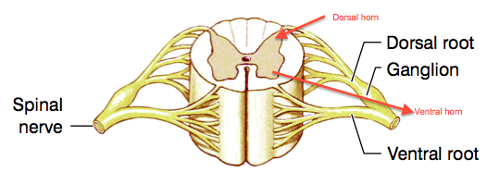
- Neurons communicate with each other by sending action potentials down their axons, but those action potentials take a lot of energy
- The energy supply to the CNS can support only a low rate of firing. At any moment, only ~4% of your neurons are firing
- That is, communication is expensive, and so the CNS has to use it sparingly
Spinal Cord – has 31 segments, each with a pair of spinal nerves
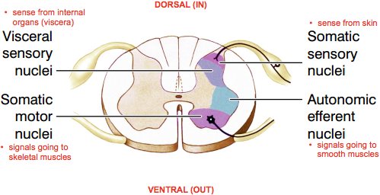
- Each spinal nerve has a dorsal root, which carries afferent (i.e. incoming, sensory) signals. The dorsal root ganglion contains cell bodies of sensory neurons
- The ventral root carries efferent (i.e. outgoding) signals from the CNS to the body, including motor signals (i.e. to muscles)
- Dorsal means toward the back; ventral means toward the belly
The gray matter is mainly in the middle of the cord
- It has a butterfly shape, with a dorsal and a ventral horn on each side (look at red arrows in the picture of spinal cord)
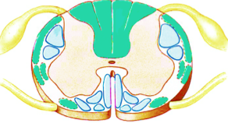
- Gray matter consists of sensory and motor nuclei
White matter consists of axon tracts
- Ascending tracts (green) carry sensory information to the brain
  - Dorsal because that’s where most of the incoming signals come in
- Descending tracts (pale blue) carry signals from the brain
  - Ventral because that’s where commands leave the CNS
- There are also propriospinal tracts (not shown in picture), which stay in the spinal cord
  - Can go up or down a few segments to let different parts of the spinal cord talk to each other but don’t go to the brain
In a spinal reflex, the cord responds to stimuli without consulting the brain
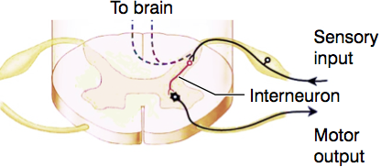
- An example is the knee-jerk reflex: the physician’s rubber hammer stretches a tendon below the kneecap. Sensory fibers carry the news of this unexpected stretch into the dorsal horn of the spinal cord
- These fibers send branches up to the brain (but doesn’t wait for the brain’s message), it also excites neurons in the ventral horn that send signals out to leg muscles to contract and counter the stretch
- Note: in daily life, if the upper muscles stretch it means your knees are bent; so the brain thinks to undo that which contracts the muscle = knee-jerk. Sends signals up to brain (because you were aware of the wack), but it doesn’t wait for message back from brain – it acts without consulting the brain
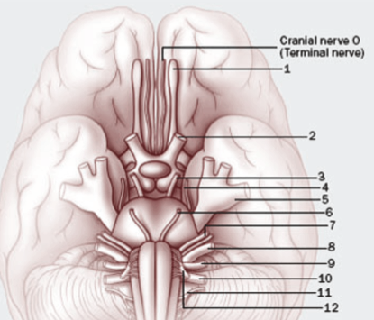
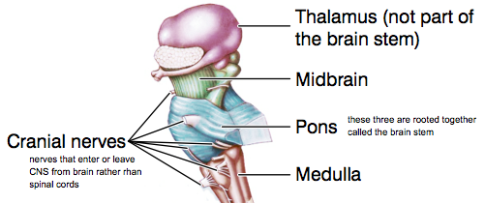
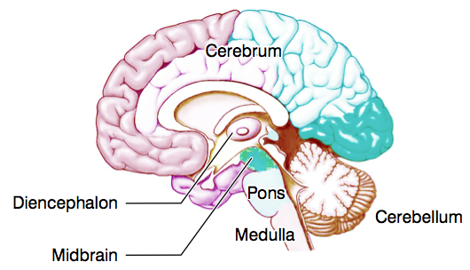
Brain: has 6 major divisions (refer to picture of brain)
Medulla, pons, and midbrain make up the brain stem
- The brain stem is involved in many autonomic functions and reflexes, such as breathing, swallowing, vomiting, and regulating blood pressure
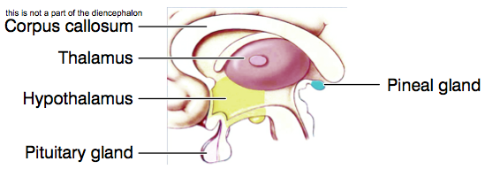
- Cranial nerves III-XII arise from the brain stem
  - Cranial nerves enter or leave the brain
  - Nerves that enter/leave the CNS from the brain (rather than from the spinal cord)
  - Traditionally 12 cranial nerves, but recently discovered cranial nerve 0 so overall 13 cranial nerves
The diencephalon is the thalamus, hypothalamus, pituitary and pineal
- The thalamus processes information going to and from the cerebral cortex
- The hypothalamus regulates behavioral (i.e. hunger/thirst) drives, and endocrine and autonomic homeostasis
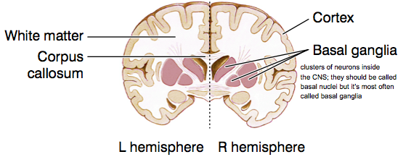
- Pituitary and pineal secrete hormones
The cerebrum has 2 hemispheres connected by the corpus callosum
- Note: cerebellum is important for motor control
- The cerebral gray matter includes the outer layer called the cortex, the limbic system, and the basal ganglia (which help control movement0)
- Corpus callosum is a large bundle of myelinated axons
  - Note: biggest bundle of nerve bundles – allows two parts of brain to communicate
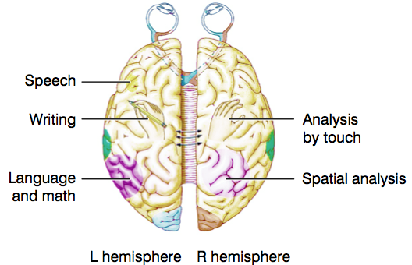
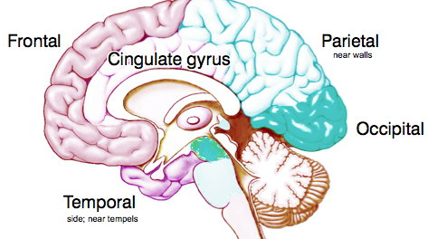
The 2 hemispheres’ functions differ, i.e. we have cerebral lateralization
- Each hemisphere has 4 lobes: frontal, temporal, parietal, occipital
- Each hemisphere has a cingulate gyrus, which is part of the limbic system
- The limbic system is an old group of brain region (primitive animals have it)
  - It includes the cingulate gyrus, amygdala, and hippocampus
  - It is concerned with motivation, emotion, and memory
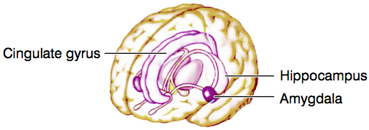
    - Side note: monkeys with amygdala lesions, unlike normal monkeys, are not frightened by snakes

Introduction to Senses
The senses carry information about the body and surroundings to the CNS
- 5 special senses – vision, hearing, equilibrium, taste, and smell
- 4 somatic senses – touch, temperature, proprioception, and nociception, i.e. pain and itch
- We are usually at least partly conscious of data from these 9 senses
- We are largely unconscious of other sense data such as blood pressure, lung inflation, blood-glucose concentration, internal body temperature, pH, etc.
Receptors and Neurons – every sensory system begins with receptors [cells]
- These are cells, which may or may not be neurons, and which convert stimuli such as light or sound into electrical signals. The conversion is called transduction (changing the form of energy)
- A receptor converts stimulus energy into a graded change in membrane potential called a receptor potential. If the receptor is a neuron, it may then fire action potentials. Or it may release neurotransmitter to affect a neuron
- Each receptor has an adequate stimulus: the form of energy to which it is most responsive (though it usually responds to other forms as well), e.g. thermoreceptors are more sensitive to temperature than to pressure (i.e. story about people seeing purple ghosts when it was actually the fan spinning at perfect frequency of eye…?)
  - Also respond to pressure, just aren’t as sensitive
Receptors are classed according to their adequate stimuli
- Chemoreceptors respond to SPECIFIC molecules or ions, e.g. to glucose, or oxygen, or H+
- Mechanoreceptors respond to mechanical energy such as pressure, vibration, gravity, and sound (vibrations in air which is mech.)
- Thermoreceptors respond to temperature
- Photoreceptors respond to light
Some receptors are very sensitive
- Any receptor has a threshold – the weakest stimulus it can detect
  - Some receptors have really low thresholds
- Some photoreceptors (on eyes) can detect a single photon of light (enough to activate receptors). Chemoreceptors (nose) for smell may respond to a single odorant molecule
- The perceptual threshold is different; it is the weakest stimulus you can consciously perceive
  - Even if photoreceptors can sense one photon of light, you might not see it (because too weak or lost along way)
Sensory systems involve series of neurons
- The first neurons in the system (either the receptors or the cells immediately downstream) [sometimes the receptor cells ARE neurons themselves, if they are not then the receptors signal neurons] are called primary sensory neurons
- Primary sensory neurons synapse onto secondary sensory neurons, and these synapse onto tertiaries, and so on
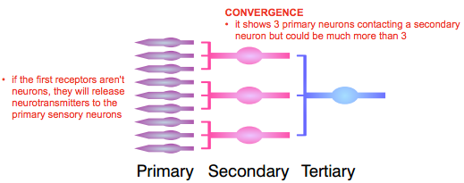
- At each stage, many presynaptic cells may contact any one post-synaptic cell. This convergence allows secondary and higher neurons to combine data from many receptors (pic: represents convergence – one secondary neuron gets info from three primary, tertiary get three secondary, etc.
  - Downstream neurons can collect & compare info. from diff. receptors for processing
Sensory neurons carry information about many aspects of the stimulus
- One aspect is the stimulus modality (modality = what it is), i.e. whether it is a light, a sound, a touch, etc.
- Sensory systems indicate modality by labeled lines (you know what it means based on what pathway it goes), e.g. activity on neurons in the visual pathway means light; in the auditory pathway it means sound
  - Very similar neurons go through different pathways to give different information
Groups of neurons can represent intensity in 2 ways
- Stronger stimuli may activate more neurons. This way of representing stimulus intensity, by the number of active neurons, is called population coding (more intense the stimulus, the more neurons fired)
- Stronger stimuli may make the individual neurons fire at a faster rate. This is frequency coding (the more intense a stimulus, the harder the neurons are fired, fire more APs in a given time)
  - Note: can have both situations occurring simultaneously (both types of coding are active so always a comb. of both)
Signaling Change
Receptors and neurons have dynamics
- Their activities may depend not only on the stimulus right now, but on how it changes through time
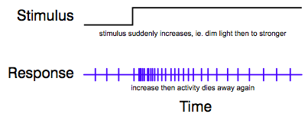
- E.g. when a stimulus suddenly increases or decreases, many receptors and neurons respond briefly and then return to a resting rate of activity
- So they signal changes in stimuli, they don’t steady levels
  - Not when you look at the picture – at the beginning of the response, the distances are the same as the distances near the end of the response, but the stimulus is higher near the end – thus the brain cannot detect level of stimulus
Different cells have different dynamics
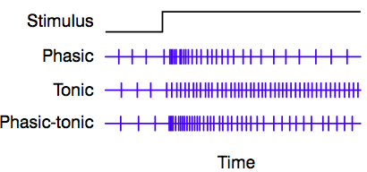
- Phasic cells respond briefly to any change in input and then return (not all the way) to their baseline activity. They signal change
- Tonic cells maintain their activity when the stimulus is not changing. They signal its current level
  - Not signaling change, they’re signaling the level of stimulus
- Phasic-tonic (or incompletely adapting) cells respond and then go partway back to the baseline (most cells are usually in this phase – mix of tonic and phasic)
- E.g. many retinal cells are phasic or phasic-tonic
  - Therefore they report changes in your visual world, as when something moves
    - That is why you wave your arms to catch a friend’s attention: your arm motion activates phasic or phasic-tonic cells in your friend’s retinas
  - Another example is the X and pink clouds illusion; the clouds “disappear” because with near-stationary eyes you have little change going on in your visual world so the phasic cells stop reporting (fade out) since it’s not interested anymore; this makes communication more efficient; reduces the amount of information that it MUST send
- Phasic signals can make communication more efficient
  - Because our world is fairly stable, it is more efficient to report changes than to repeat similar messages over and over
  - E.g. if you are gathering data from various weather stations, you don’t want them reporting “it is sunny… still sunny… still sunny”. More efficient to have them call only when there is a change in weather
  - These kinds of changes through time, between one moment and the next, are called temporal changes
  - It is also efficient to report spatial changes
  - Spatial changes (or edges) indicate differences between neighbouring regions in space, e.g. neighbouring patches of retina or skin
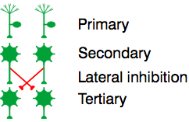
  - In the weather analogy, neighboring stations will usually have similar weather, and so it is more efficient for them to report to you only when they are on an edge between 2 kinds of weather
  - Sensory systems do this as well: they wire up many of their cells to accentuate (detect) edges
Edges are accentuated by lateral inhibition
- Lateral inhibition means that cells inhibit their neighbours (this is a direct process), or they inhibit the cells their neighbours excite (this is indirect)
  - Fight between neighbours (direct or indirect)
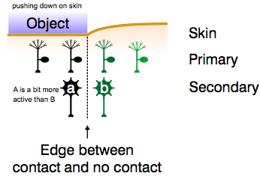
- E.g. in the picture, each secondary neuron inhibits the tertiary neuron that its neighbor excites (the inhibitory connections are drawn in red; all other connections are excitatory)
- Example of an edge detected by sensory neurons: suppose an object presses against the skin. Primary neurons in the area of contact are strongly activated, but the neuron just right of it also responds because of skin stretch (darker in the picture means more active); the same pattern is seen in the secondary neurons: cell “a” is slightly more active than b
- Secondary neurons laterally inhibit the tertiaries
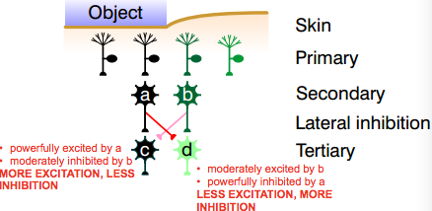
  - Cell ‘a’ powerfully excites c and powerfully inhibits d. Cell b is slightly less active than a, so its effects are weaker: it moderately excites d and moderately inhibits c. So c gets more excitation and less inhibition than d does. The net effect is that c is a lot more active than d
  - Note: looking at the picture: A is active thus it powers C but inhibits D; B is exciting D but only moderately active, and it inhibits C but not that strongly because it is not that strong – thus the difference from C and D is greater than difference between A and B
  - As a result, the edge is accentuated
    - Among the secondary neurons, there is only a slight difference in actively between neurons a and b
    - Among the tertiaries, the difference is larger, which means that these neurons represent the edge (between contact and no contact) more distinctly
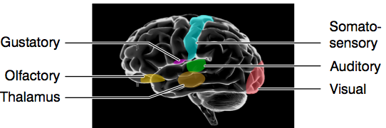
Higher Processing
Most sensory pathways run via thalamus to cortex (Make synapses with neurons in the thalamus, then these neurons project to the cerebrum cortex (surface of cerebrum)
- Most pathways run through thalamus, which is near the center of the brain, out to the sensory cortices on the surface of the cerebrum
  - Each sense has an area of the cortex it projects to, called the primary sensory cortex
- Olfactory (smell) pathways are an exception; they don’t project via thalamus (because smell is an ‘old’ sense)
- Equilibrium (sense of balance) pathways project mainly to cerebellum (partial exception bc it still does through thalamus a little)
Sensory processing is inference
- Our senses evolved to guide our behavior – to steer us away from danger and toward food, shelter, a mate. A big part of this guidance is deducing what is going on around us, e.g. identifying things
  - Goal of vision is not to produce a picture in the head, it’s to analyze the picture to identify good/bad things around you
- That is a hard job, because sense data are incomplete and ambiguous, so the brain has to infer.
Sensory processing is unconscious interference
- Identifying objects seems simple to us because we are good at it – we can identify things after seeing their images for 100ms – and we do it without conscious effort (hard to program artificial i.e. computers, we only recently got facial detection = artificial vision)
Since the brain has to guess/infer, it can be fooled
- The picture shows a flat 2D quadrilaterals, but you can see it as a 3D box because your brain thinks that interpretation is the most likely. The shapes and colours are just what you would expect from a 3D box. If it weren’t a 3D box, the n that means that the quadrilaterals would have had to been cleverly arranged and coloured, and your brain thinks that is unlikely
The brain mistrusts coincidences
- In the Kanizsa illusion, you see 2 overlapping triangles, but there is none in the image
- The brain mistrusts coincidences – the wedges perfectly aligned with each other and with the edges of the 3V’s – and explains them all by postulating a white triangle in front
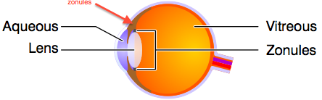
Lecture 3: Optics of the Eye
Eye is divided into 2 chambers by the lens
- The lens is a transparent disk that focuses light. It is suspended by ligaments called zonules
  - Which run all around the eye, suspending the lenses
- In front of the lens is the anterior chamber, filled with aqueous humor, a plasma-like fluid
- Behind is the vitreous chamber, filled with the vitreous body (aka vit. humor), a clear jelly that helps maintain the eyeball’s shape
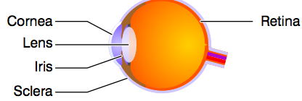
Light enters the eye through the cornea
- The cornea is a transparent [dome shaped] bulge at the front of the eye, continuous with the white of the eye, or sclera – the outer wall of the eyeball
- Cornea and lens focus light on the retina, the inner lining of the eye that contains the photoreceptors
- Light passes from the cornea to the lens through a hole in the iris called the pupil
Pupil size is controlled by the iris – a ring of smooth muscle
- In bright light the pupils shrink to 1.5mm across, reducing the amount of light reaching the lens. In the dark they dilate to 8mm, ~20 times bigger in the area, to let in more light (letting in about 20 times more light than when it’s restricted)
- But the eye operates over a 100-million-fold range of illumination, from starlight to sunlight, so the pupil contributes little to compensating for brightness
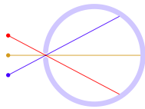
The pupil helps to focus light
- As in a pinhole camera, a small pupil ensures that each point on the retina receives light from just one direction in space – and that is what “focus” means
  - If from many directions, image is composed of all of them smeared together unfocused
  - All other beams never make it to the retina because they get blocked, only ones that go through the pupil get to the retina
- Note: that image in the retina is upside down (look at the red image, it’s from above but in the retina it’s at the bottom)
The pupil also controls depth of field
- When the pupil is tightly constricted, we have full depth of field, i.e. everything we see is equally in focus
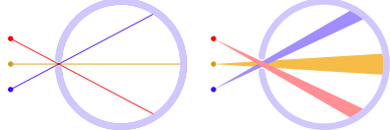
- When the pupil is dilated, we have shallow depth of field, i.e. only objects near one specific distance are in focus (that distance depends on the lens of the eye, as we will see)
There is a problem with using the pupil alone to focus light
- With pinhole-focusing, the retinal image is dim because the pinhole [is small so] doesn’t admit much light (“focused but dim”) –refer to first picture
- Enlarging the hole makes the image brighter but blurrier (look at second picture)
- How can we get a retinal image that is both bright and n focus> By using refraction
Refraction:
Light bends when it enters a medium with a different refractive index – when light passes from one medium to another with different refractive index, then light bends
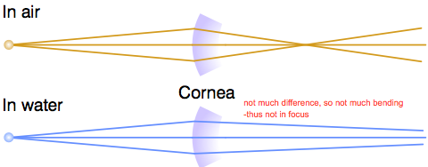
- E.g. our corneas are made of clear collagen. They bend light strongly because there is a big difference between the refractive indices of air and collagen. The bending of light is called refraction
- In water the refraction is much weaker because the refractive indices of collagen and water are similar thus blurry vision under water
- Side note: people who are good at seeing underwater, squeeze pupils very small= increase depth of field
Light is refracted by both the cornea and the lens
- The cornea is responsible for 2/3 of the eye’s refraction, and the lens for just 1/3
- But we will concentrate on the lens because it can accommodate (change shape) to adjust the focus
The lens is made of clear cells
- It is a mesh of long cells without nuclei, packed with clear proteins called crystallins, and “zippered” together in concentric layers for flexibility (so you can focus far and near) -to change shape to focus
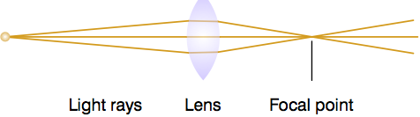
- It has no blood supply, but absorbs nutrients from the aqueous humor
  - blood vessels would impair its job to send light through
The lens is convex
- A convex lens is fatter in the middle and thinner at the edges. It makes light rays converge to a focal point. Another example of a convex lens is a magnifying glass (true for all convex lenses)
- Concave lenses are thinner in the middle and fatter at the edges. They disperse light, and are used in some spectacles
Refraction depends on the angle of incidence
- I.e. it depends on the angle at which the light ray hits the interface between the media; e.g. the angle at which it hits the lens surface
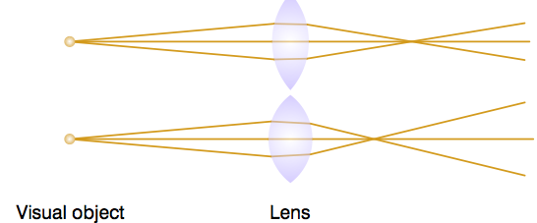
- That angle depends on the shape of the lens and the direction of the light ray; e.g. in the simplest cast, if a ray strikes the lens at right angles then it doesn’t bend at all
- By changing the shape of the lens we can alter these angles, and so bend the light more ore less
Accommodation
- A rounder lens bends light more, and so has a closer focal point
- For clear vision, the focal point must fall on the retina
- If the object draws closer but the lens stays flat (same lens), focus falls behind the retina which doesn’t do any good because no photoreceptors in the back. (note: beams are closer to the lens so they hit the lens at greater angles – beams aren’t focused onto retina – image smeared out so blurry vision)
  - To bring a closer object into focus, the lens gets rounder
    - We make the lens rounder (using a ring-shaped smooth muscle called the ciliary muscle) so the light rays bend more, and the focal point moves forward
      - Ciliary muscle is located up + around zonules (controls tension of zonules which controls shape of lens)
    - This rounding for near vision is accommodation. The closest point you can focus is your near point of accommodation. Accommodation weakens with age, a problem called presbyopia
    - Side note: near point gets weaker as you get older. When you’re a kid you can focus on things near your nose but as you get older you can’t even read a book that’s 30cm away
Accommodation is an unconscious reflex, but you can see it in action
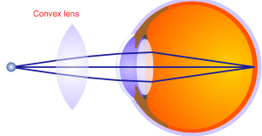
- Close one eye and hold up your hand, fingers spread ~20cm in front of your open eye; focus on a distant object between your fingers. Notice that the object is in focus but not your fingers. If you focus on fingers they are now in shape and object is fuzzy because your lens has accommodated
  - Note: if we only depend on the pupil for focusing, everything at every distance would be in focus; but since we use the lenses so there’s a depth of field problem – only things at certain distances can be brought into focus
Refractive Errors:
- In hyperopia (far-sightedness) the focal point falls behind the retina
  - The problem is solved by a convex lens in front of the eye
  - That is, the lens of the eye isn’t bending the light rays enough, and so the extra convex lens helps out
    - Convex lens starts bending the light rays so not much bending left for the lens of the eye to do
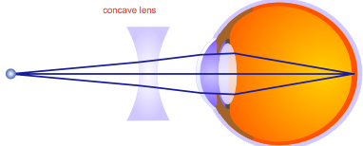
- In myopia (near-sightedness) the focal point falls in front of the retina
  - Solved by a concave lens in front of the eye
    - By dispersing the light rays, the angles at which the rays hit the lens are greater; since the lens bends the light rays too much, dispersing the rays (increasing the angles) allows the focal point to fall back onto the retina
  - The lens of the eye is bending the light rays too much, so the concave lens in front counteracts it by spreading the rays out slightly (disperses light rays)
    - Concave lens disperses light rays – these rays will hit the lens of the eye at greater angles than they would before going through the concave lens
Visual Processing
Photoreceptors are in the retina (which is lining at the back of the eye)
- They are light-sensitive neurons that convert light energy into electrical energy in cells (they respond to light energy)
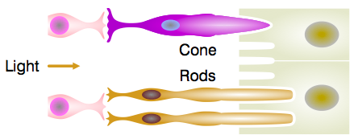
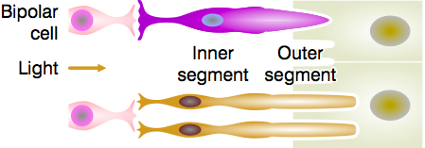
- The conversion is called phototransduction
  - “transduction”: converting stimulus energy into cell energy. “photo”: light (photons)
Our retinas have 2 main types of photoreceptor: cones and rods
- Each retina contains ~6 million cones and 120 million rods
Cones and rods have the same basic structure because one evolved from the other
-Note: (in the picture) – light has to pass through the layers (bipolar cells, basal layer, etc.) before gets to photoreceptors – wired backwards
- In the outer segment (towards back wall of eye), the membrane folds into disk-like layers. The disks contain membrane proteins called opsins that transduce light into changes in membrane potential
- In the inner segment are the nucleus and organelles for protein synthesis; and in a basal layer, a synapse that releases glutamate
- Both receptor types point toward the back of the eye
Cones are for bright light; rods are for dim
- Cones are less sensitive than rods; they are responsible for vision in bright light and for distinguishing colors, but they don’t operate in dim conditions (don’t help you see at night)
- Rods can detect single photons. But they operate only in low light: in daylight they are “bleached out”, i.e. their opsin, called rhodopsin, is broken down so they can’t sense light
- When the lights go dim the rods dark adapt, i.e. they rebuild their stores of rhodopsin over ~takes about 30 minutes
Each type of photoreceptor has one type of opsin
- Each photoreceptor contains millions of molecules of its [one type of] opsin: rhodopsin in rods, 3 other opsins in 3 types of cone
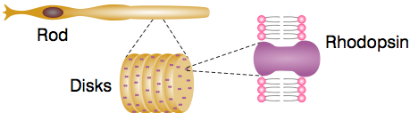
- When light hits them, opsin molecules change shape, starting a chemical cascade that hyperpolarizes the cell, reducing its release of glutamate (release of glutamate is greater in darkness)
- I.e. photoreceptors report darkness, not light (thus they should be called “scoot-receptors” because they respond to dark not light”
  - The release of glutamate is greater in the darkness
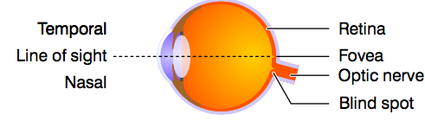
Photoreceptors are not distributed uniformly
- They are most densely packed in the macula, a central disk, and especially in its central pit called the fovea (2 degrees of visual angle – about as wide as 2 fingers viewed at arm’s length)
  - It’s not because things are out of focus, its because you don’t have the setup of photoreceptors and ganglion cells to have good acuity (things aren’t in very good focus though, but even if they were the periphery would still be pretty blurry)
- We use the fovea for detailed vision. 5 degrees off center, acuity is quartered; at 20degrees it falls below the standard for legal blindness
- There are no receptors in the blind spot – the hole where axons carrying visual information exit the eyeball to form the optic nerve
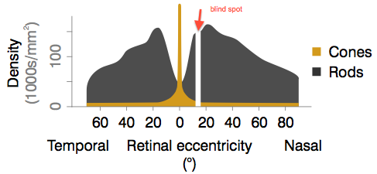
- Note: you can find your blind spot by looking at the blue circle from various distances, at a point it will seem that the yellow circle has banished because the image falls on the blind spot of your right eye (if you’ve closed your left eye); normally you don’t notice your blind spots because the brain fills in the gaps (in this case it fills the spot of where the yellow circle should be with checkers), and because objects in one eye’s blind spot aren’t in the other eye’s
Cones and rods are differently distributed
- The fovea contains almost exclusively cones. More-peripheral retina contains mainly rods
- That is one reason why your peripheral retina is more sensitive to light than your fovea is; e.g. you can see a dim star better by looking slightly away from it
  - Mainly rods (more sensitive than cones) in periphery
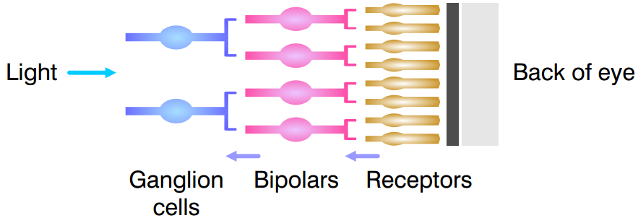
The 3 Layers of Neurons in the Retina
Photoreceptors contact bipolar cells, which contact ganglion cells
- Up to 45 photoreceptors may converge on a singly bipolar cell. Bipolars in turn converge on ganglion cells, so in each eye the signal from 126 million receptors is condensed into 1 million ganglion cells, whose axons (of ganglion cells) form the optic nerve (thus only about 1% of signals is sent from eye to brain – efficient condensed code)
- Convergence is greatest in the peripheral retina and least in the fovea, where some receptors project 1:1 to bipolars
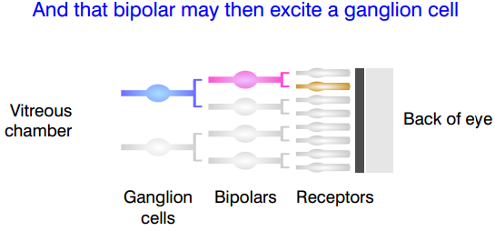
  - Periphery: many receptors converge on a bipolar cell
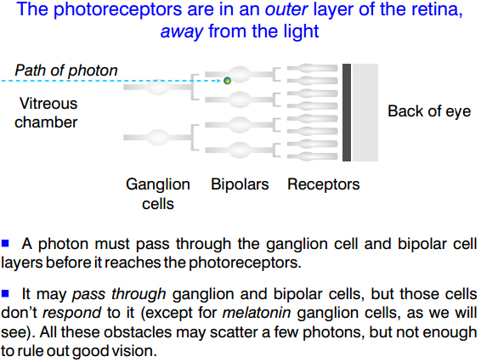
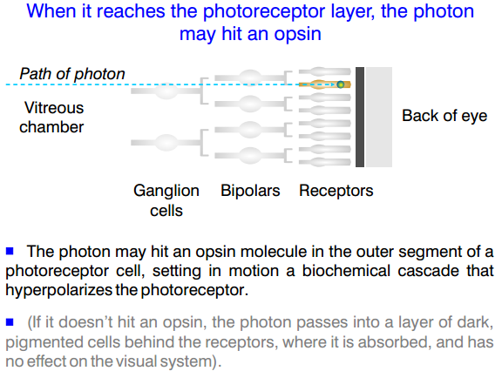
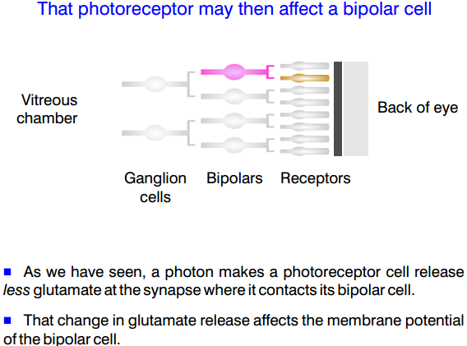
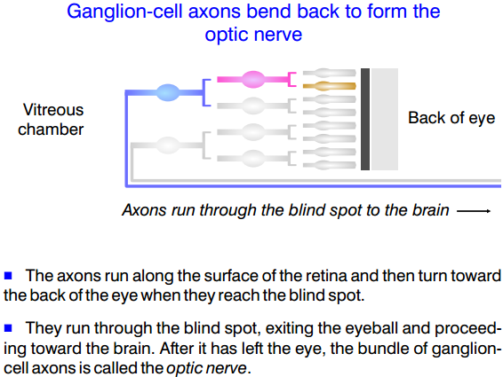

There are 2 types of bipolar cell (note: depolarized = active; hyperpolarized = inactive)
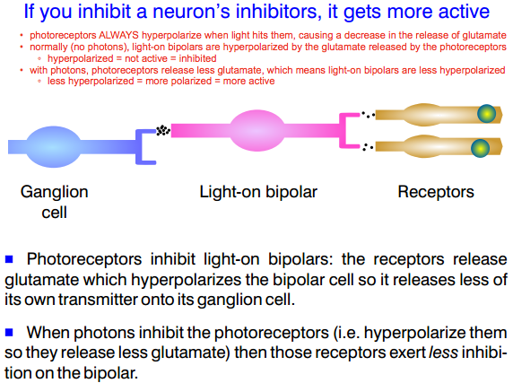
- Light-on bipolar cells hyperpolarize when they bind glutamate. So these cells are active in light, when less glutamate is released by photoreceptors (light comes along, hits photorepceptors, which causes less release of glutamate = less hyperpolarization = cell more active in light because it is considered depolarized)
    - Less hyperpolarization = more depolarized
- Light-off bipolar cells depolarize when they bind glutamate. So these cells are active in darkness
  - A light off bipolar cell is depolarized by glutamate. When light hits photoreceptors they release less glutamate, and so cause less depolarization in this type of bipolar, and so the bipolar becomes less active in light
    - Less depolarization = more hyperpolarized
- Both types of bipolar cell synapse onto the next processing layer, the retinal ganglion cells

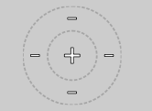
Retinal Ganglion Cells
Ganglion cells have center-surround receptive fields
- Every neuron in the visual system has a receptive field – a region of the retina where light affects the cell’s activity. Note that if light hits outside the receptive field then it has no effect
- Most retinal ganglion cells have center-surround fields,
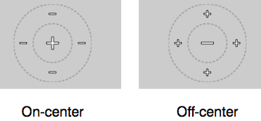
- E.g. they are excited by light in the center of the field (positive area), and inhibited by light everywhere in a ring around (negative area) the center (and unaffected by light anywhere else on the retina). If you have light in both positive and negative areas, they cancel each other out so no effect
Ganglion cell receptive fields can be on-center or off-center
- On-center cells act as just described: excited by light in the center of the field, and inhibited by light in a surrounding ring
- Off-center cells are inhibited by light in the center, and excited by light in a surrounding ring
Center-surrounded receptive fields arise from lateral inhibition
- E.g. consider an off-center ganglion cell. Suppose it gets input (via bipolars) from all these photoreceptors in this region of the retina – the central disk and surrounding ring
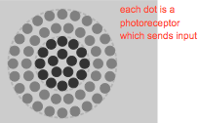
- The photoreceptors are in the central disk (colored dark in the picture) excite the ganglion cell, so when light hits them they hyperpolarizes, their excitation decreases (exert less excitation), so the ganglion cell becomes less active
  - i.e. that is why the ganglion cell is inhibited by light in the center of its field
  - less excitation in the excited area, so less active
- Receptors in the surround inhibit the ganglion cell, so when light hits them they hyperpolarize and so exert less inhibition, the ganglion cell gets more active
  - i.e. this explains why the ganglion cell is excited by light in its surround
  - less inhibition in the inhibited area, so more active
- Note that the photoreceptor cells in the surround inhibit the ganglion cell that their neighbors in the center excite, so this is indeed a case of lateral inhibition (lateral inhibition emphasizes edges)
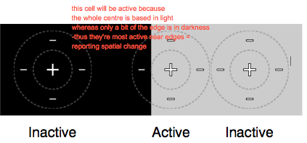
Center-surround fields emphasize edges – which allows for more efficient communication (helps condensing 126mill to 1mill)
- The ganglion cell in the middle, near the edge between dark and light, is active because it is strongly excited in its center and only weakly inhibited because only part of its surround is in the light
- The other 2 cells, away from the edge, are inactive (or near their baseline activity level) because their excitation and inhibition cancel
- So center-surround cells are most active near edges, i.e. they report spatial changes
This emphasis on edges likely explains Chevreul illusion
- The bands are each a uniform shade of gray, but they look “fluted”: they seem to be darker at their right-hand edges and lighter at their left-hand edges, i.e. brightness differences are accentuated near edges, like the activity of ganglion cells
- It may also explain the Hermann grid
- Counting the black dots when it seems like they’re moving around – but actually there are no black spots, it’s just “fluted”
Ganglion cells in different parts of the retina have different-sized receptive fields
- A ganglion cell near he fovea gets input from only a few photoreceptors, mostly cones. Farther out, each ganglion cell gets input from many receptors, mostly rods
- So in the periphery, each ganglion cell is very sensitive to light but not to spatial detail because it blends information from a wide swathe of receptors
  - Sensitive to light because it’s getting excitation from lots of rods (only need one rod to pick up light)
  - Not good spatial acuity (perception) because they don’t know where the light fell
    - Too many rods, don’t know which one picked up the photon
- And near the fovea, ganglion cells are less sensitive to light but have better resolution because each one gets input from just a few densely packed cones
  - less sensitive to light because getting input from cones (which are not sensitive), and only a few cones
    - not active until one of the very few cones gets enough photons to be activated
  - good spatial resolution because getting small number of closely packed cones, so if the ganglion cell gets activated, it has to have fallen on that little patch on the retina
Ganglion cells are classified based on how their signals are used in the brain
- Large, magnocellular ganglion cells, or M cells, provide information that is used by the brain to infer the movement of objects. These cells are phasic-tonic (respond to changes in time)
- Small, parvocellular ganglion cells, or P cells, provide information that is used to infer form and find detail, such as texture. About 80% of retinal ganglion cells are M or P
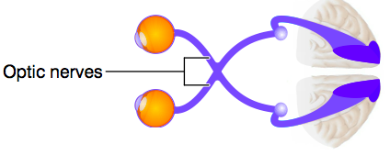
- A third group are melanopsin ganglion cells, which are photoreceptors: they contain their own kind of opsin, called melanospin. They project to the suprachiasmatic nucleus, a center for circadian rhythms
Visual Pathways
Visual information leaves the retinas in the optic nerves
- Each of the million ganglion cells in each retina sends its axon out the back of the eye through the blind spot
- These million fibers from each eye form its optic nerve, also known as cranial nerve II
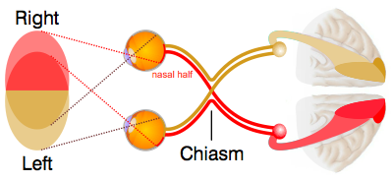
Half the optic-nerve fibers cross at the optic chiasm
- When each optic nerve reaches the optic chiasm, half its fibers cross to the other side of the brain
- Fibers from the nasal half of each retina cross; those from the temporal retinas don’t
Why do the fibers cross?
- In the eye, the right side of the scene (the right visual hemifield) projects onto the left side of each retina, i.e. onto the nasal side of the right retina and the temporal side of the right retina
- Because the nasal fibers cross, all the information from the right hemifield comes together in the left cerebral hemisphere, and vice versa
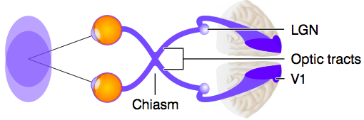
Information moves from chiasm to thalamus and then to cortex
- The 2 nerve bundles emerging from the chiasm are called the optic tracts. They terminate in the 2 lateral geniculate nuclei (LGN) in the thalamus, which project mainily to primary visual cortex, V1
- V1 is in the occipital lobe
Visual pathways are organized retinoptically
- Neurons close to each other in the brain get information from close-together parts of the visual field
- This arrangement is found in the lateral geniculate body (aka. LGN), V1, and many higher visual processing areas
- E.g. when light hits the central retina, shown in red, then the region shown in red in V1 is active; light in more-peripheral retina activates more-peripheral parts of V1
- Note: basically cortex is a warped map; when light hits the central part of retina, those projections go to the central part of V1, then information from concentric parts of the retina goes to concentric rings in V1
  - It’s a warped map
The retinoic map does not preserve areas
- The fovea, which covers only a small area of the retina, projects to large areas in V1 (and in other cortical regions and LGN)
- i.e. a large proportion of visual cells in the brain receive and process data from fovea photoreceptors
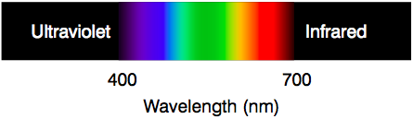
- The fovea gets a lot of space because it has many photoreceptors, and so carries a lot of information
  - many photoreceptors and ganglion cells, so high resolution
Color Vision
Color depends on wavelengths of light
- Light has a wavelength – the distance from one wave peak to the next – and different wavelengths correspond to different colors. The wavelengths we see range from 400nm for violet to 700 nm for red
  - Acuity (perception) drops gradually… its not like you can’t see ANYTHING at 701nm
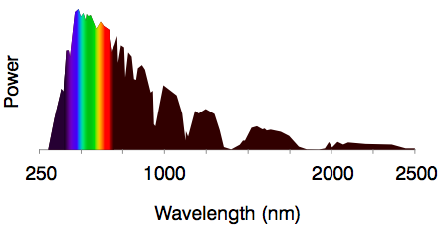
- People can see powerful infrared lights, and people who have had their lenses removed can see ultraviolet. But even so, the visible range is a tiny part of the electromagnetic spectrum
Why did evolution give us eyes that see 400-700nm?
- The power in sunlight peaks there (most powerful in that range). Also, Earth’s atmosphere is most transparent to these wavelengths
- Sea water, where eyes first evolved, is most transparent < 500 nm (particularly transparent to blue)
Different surfaces reflect different wavelengths
- The reflectance of a surface is its tendency to reflect certain wavelengths of light and absorb others, e.g. a yellow banana reflects yellow light more than other wavelengths; a green banana reflects green
- The reflectance of an object carries information about it, e.g. about ripeness
The visual system can infer refelectances
- The inference is hard because the wavelengths reaching the eye depend not only on reflectance but also on illumination. Yet the brain can disentangle the two factors
- E.g. if you put a ripe banana in greenish light then the banana’s reflectance doesn’t change (it is still yellow-colored object) but now it sends mainly green light to our eyes
  - E.g. shine red light onto a white piece of paper and the paper appears pink, but your brain can infer its true reflectance, which is white
- Yet our brains can infer its reflectance, so we see it as yellow. This ability is called color constancy
A demonstration of color constancy
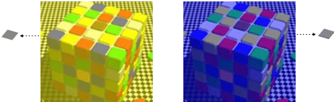
- The 2 pictures show the same cube in yellow and in blue light. You correctly see the blue facets in the left picture as blue, and the yellow facets in the right picture as yellow
- But the light these facets send to your eyes is the same, as you can see when I isolate one blue facet on the left and one yellow facet on the right brain infers their true colors)
Color and Photoreceptors
Most humans sense color with 3 kinds of cone
- The 3 types are called red, green, blue. In most people, ~63% of the cones are red, 31% are green, and just 6% are blue
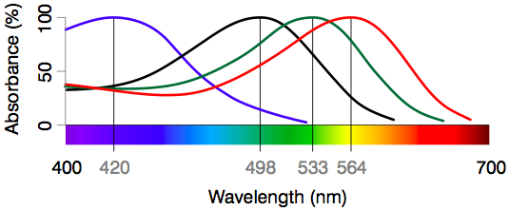
  - Not many blue cones; red to green cone ratio is ~2:1
- Because we have 3 types of cone, we are called trichomats (trichromatic vision – three colors)
Different photoreceptors prefer different wavelengths
- The plot shows how much light the rod and cone opsins absorb (as a percentage of the maximum for that opsin) at each wavelength. Note that red and green cones prefer yellow and yellow-green light
- Rhodopsin prefers blue-green light (498nm) and melanopsin (not shown) prefers blue (479nm)
  - Note: blue line favors 420nm bc it’s at 100% absorbance, likes the light blue moderately bc it’s at 50% absorbance, etc.
  - Side note: blue-enriched light they work better, sleep better, improve health/well-being; some say too much blue cause macular degeneration; also some say blue light at the night is bad (day is good) due to various effects relating to circadian rhythms
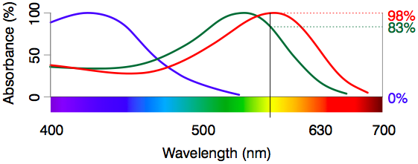
The brain infers color by comparing activities in the 3 types of cone
- E.g. if the red cones are slightly more active than the greens, and the blues are inactive, the brain infers that the color must be yellow
- Note: if you shine yellow – the red cones are going to be very hyperactive (at 98%), the green cone is quite a lot as well (83% absorbance), but blue not so much. The brain interprets this pattern and infers it as yellow. It can be fooled though: a red and a green light, with no yellow, can produce the same cone activates as a yellow light would, and so the brain sees yellow either way
We can produce any color by mixing 3 primary colors
- Any color we can experience corresponds to a pattern of activity in or 3 types of cone. It is possible to produce any such pattern by mixing just 3 colors of light, the primary colors red, green, and blue
- So TVs, computer screens, and projectors can show full color with just red, green, and blue lights – there is no yellow light coming from the slide with picture of lemon – its actually red and green lights
  - Note all mammals are trichromats, most are dichromats. Many birds are tetre- or pentrachromats – for them, color TV would need 4 or 5 kinds of light; so if they saw the lemon earlier, they would see the shape of a lemon but not yellow rather a mix of various colors
Not all our colors are in the rainbow
- Spectral colors are those that can be evoked by light of a single wavelength. They are the rainbow colors, from violet through blue, green, yellow and orange to red
- Extraspectral colors are evoked only by a mix of wavelengths, e.g. purple or white, or fusia, etc.
Processing Color
Ganglion cell color signals are combinations of cone signals
- Some ganglion cells are excited by red and green cones (R+G cells). They are called the yellow channel (because red and green make yellow)
- Some ganglion cells are excited by red and inhibited by green (R – G). Others are the opposite: inhibited by red and excited by green (G – R). These 2 types form the red-green opponent channel (fighting each other)

- Some are excited by blue and inhibited by red and green, (B – R – G, which is the same as B – (R+G), i.e. blue minus yellow). Others are the opposite: yellow minus blue. These 2 types form the blue-yellow opponent channel
- Note: some say the stupider the mammal the better the retina?? Because they have smaller brain,…
Opponent channels are thought to explain afterimages
- As you stare at something green, your G-R cells gradually fatigue. When you look away, those fatigued cells are less active than your R-G’s, and so you see red. And similarly for blue versus yellow
  - R-G cells are more active, so red is excited and green is inhibited
- We aren’t sure the responsible cells are in the retina, as there are color-opponent cells in LGN and visual cortex as well
The visual system infers reflectances by comparing parts of the image
- Edwin Land showed people “color Mondrians”: images with many patches of different colors. People saw full color even when the Mondrian was lit only by 2 [pure] yellow wavelengths because brain is figuring out reflectance of mondrians
- i.e. the viewers’ eyes received only yellow light, but their brains interred all the colors. They did it by comparing neighboring regions (with a single color swatch people can’t perceive its true reflectance)

  - People can compare when you have different colors. If you have only a single wavelength (one pure color) you can’t tell what color it is (can’t do much with only 1 wavelength)
These comparisons which underlie constancy give rise to illusions
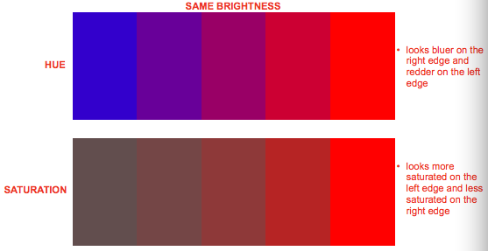
- In each vertical pair, the center squares are identical in color, but their surroundings affect our perception of brightness, hue, and saturation
  - Our visual system is constantly comparing brightness, hue, and saturation in different parts of the visual image
There are Chevreul illusions for hue and saturation as for brightness (recall ganglions detecting edges)
- This is referring to the picture of how the edges look different than the color itself
Color Blindness
The most common variant is red-green color blindness
- Daltonism is a name for a red-green color blindness, where people have trouble distinguishing those colors
Color blindness was the first human trait to be linked to a chromosome
- The heredity of Daltinism: color blind fathers have color-normal daughters who have color blind sons
- The genes for our red and green cone opsins lie on the X-chromosome. Problems at these loci underlie 95% of all variations in color vision. (The “blue” gene, on chromosome 7, is more stable).
- Women are seldom color blind because if one X-chromosome codes a faculty opsin then the other X-chromosome compensates. If her 2 X-chromosomes code, say, 2 different functional “red” opsins then a women may be a tetrachromat
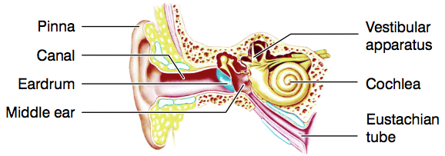
Hearing and Equilibrium
The ear is the organ of hearing and equilibrium
- The external ear consists of the prinna and the ear canal, sealed at its end by the tympanic membrane, or eardrum
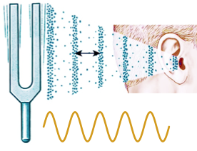
- Beyond the eardrum is the middle ear, an air-filled space connected to the pharynx by the Eustachian tube
- The inner ear contains the sensors: cochlea for hearing and the vestibular apparatus for equilibrium

Hearing
Sound is pressure waves – note: can hear through different mediums, i.e. ground, water, air, etc.
- At the peaks of the waves, the molecules are crowded together and the pressure is high; at the troughs the molecules are far apart and the pressure is low – vibrates + pushes molecules together, then springs back = troughs
Frequency is the number of wave peaks per second
- We perceive frequency as pitch: low frequencies as low-pitched sounds, high frequencies as high-pitched
- Frequency is measured in waves per second, i.e. in hertz (Hz)
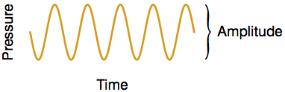
- Humans hear sounds in the range 16-20,000 Hz (extremes) --- ~10 octaves. Acuity is highest 1000-3000 Hz
Amplitude is the pressure difference between peak and trough (the size of wave)
- Amplitude is the main factor that determines our perception of loudness: the larger the amplitude, the louder the sound (for any one sound frequency)
- Loudness depends on frequency as well, e.g. a sound of 30,000 Hz is beyond the range of human hearing, so it won’t be loud no matter how large its amplitude
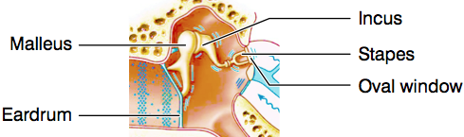
Sound waves vibrate the eardrum
- The eardrum separates the outer ear from the middle ear (refer to picture of ear)
- Note: sound comes along and gets funneled by pinna (some animals can move pinna, i.e. rabbits), it moves along the canal and vibrates eardrum
A chain of small bones conveys vibrations through the middle ear
- The eardrum vibrates the malleus (hammer) bone, which moves the incus (anvil), which moves the stapes (stirrup), which pushes like a piston against the oval window, a membrane between middle and inner ear (basically the eardrum moves the vibrations to a smaller apparatus)
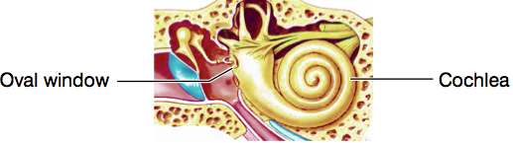
- These 3 bones, called ossicles, are the smallest in the body. They act as a lever system carrying vibratons from the eardrum to the much smaller oval window
  - tiny muscles are attached to the ossicles; tense up to block sound from getting trough – reflex that protects you from loud noises
The oval window leads into the cochlea, which contains the receptor cells (refer to picture)
Cochlea
Uncoiling the cochlea makes its anatomy clearer
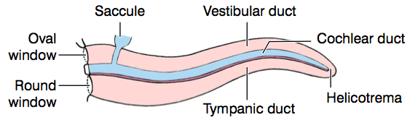
- The vestibular duct (or scala vestibule) and tympanic duct (scala tympani) contain perilymph (a fluid similar to plasma). These 2 ducts communicate at the helicotrema
- The cochlear duct (scala media) contains endolymph (similar to intracellular fluid) it is between the vestibular duct and tympanic duct, but sealed off from both ducts
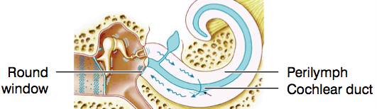
The oval window vibrates, setting up waves in the perilymph
-oval window: waves come in -round window: waves go out
- Wave energy enters the cochlea at the oval window and exits, eventually, back into the middle ear through (exists) another membrane called the round window
- En route, the waves shake the cochlear duct, which contains the auditory receptor cells (hair cells), though to see those cells we have to zoom in…
A cross section shows that the cochlear duct contains the organ of Corti
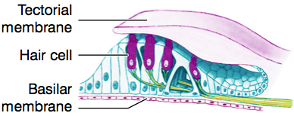
The organ of Corti sits on the basilar membrane and under the tectorial membrane
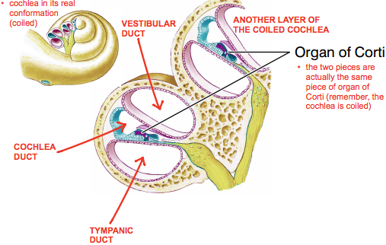
- The organ of Corti contains the auditory receptor cells – mechanoreceptors called hair cells. They are epithelial cells, not neurons, and #~20,000/ cochlea
- Each hair cell has 50-100 stiff “hairs” called stereocilia, which extend into the tectorial membrane. They bend when waves in the perilymph deform the basilar and tectorial membranes
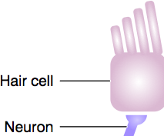
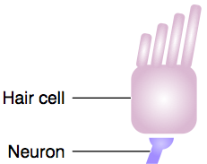
When its cilia bend toward the longest cilium, the hair cell excites its neuron
- The hair cell depolarizes and releases transmitter, activating a primary sensory neuron
- Axons of these neurons form the auditory nerve (also called the cochlear, or acoustic nerve), a branch of cranial nerve VIII
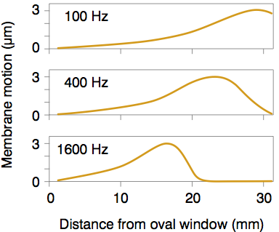
When its cilia bend away, the hair cell releases less transmitter (refer to picture with hair bending left)
- The hair cell hyperpolarizes, so it releases less transmitter and doesn’t excite its neuron as much
The basilar membrane responds to different frequencies at different points (because of its mechanical properties)
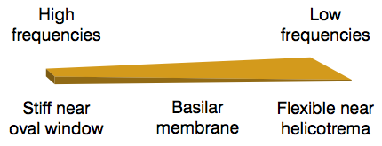
- The membrane is narrow and stiff near the round and oval windows, wider and more flexible at its other end
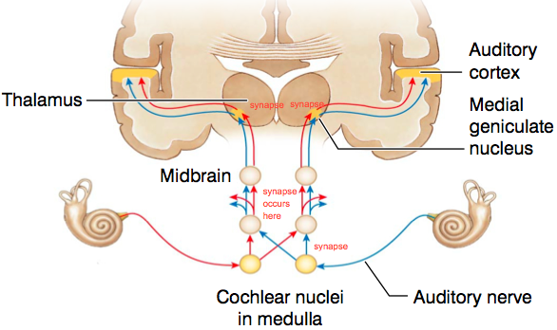
- High-frequncy waves maximally displace the membrane at the oval-window end; low frequency waves maximally displace the other send. So the brain can deduce the frequency by noting which hair cells are most active
The pattern of membrane motion pitch to the brain (refer to picture of graphs)
- If it’s 100Hz, the helicotrema area has more movement – low freq.
- Higher freq: somewhere in between helicotrema and oval window
- High freq: most of the motion moved to the oval window
Auditory Processing
Auditory signals pass from each ear to both sides of the brain (refer to picture of brain)
- At the cochlear nuclei there is a synapse; each side gets input from just one ear at this point
- Near the midbrain – info from both ears are sent to both sides of the brain
- For hearing it goes through the medial geniculate nucleus
Primary auditory cortex (A1) is in the temporal lobe
The auditory nerve represents sound intensity by frequency coding
- Larger-amplitude sound waves cause larger motions of the basilar membrane and hair cell cilia
- So the primary sensory neurons (whose axons form the auditory nerve) fire action potentials at a higher rate
- As a result, we experience a louder sound
The brain localizes sounds based on loudness in the 2 ears
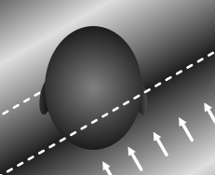
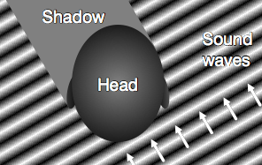
- If a sound comes from your right side then it is fainter in your left ear, because your head casts a sound shadow
- Your brain compares loudness in the 2 ears to infer where the sound came from
The brain also localizes sounds based on timing
- If a sound comes from your right side then it arrives at your right ear slightly before your left ear
- Your brain can measure interaural differences as small as 10 μs and use them to figure out the direction of the sound source
Hearing Loss
There are 3 kinds of hearing loss
- In conductive hearing loss, sound can’t be transmitted through the external or middle ear (i.e. fluid in middle ear, damaged, eardrum, etc.)
- In central hearing loss, there is damage to the cortex or the pathways from cochlea to cortex
- In sensorineural hearing loss, there is damage to the hair cells or elsewhere in the inner ear. Mammals can’t replace dead hair cells, though birds can. 90% of hearing loss in the elderly (presbycusis) is sensorineural
Clinical tests distinguish conductive from sensorineural loss
- In the Weber test you hold a tuning fork to the patient’s head (midline) and ask in which ear the sound is louder. Normally it is equal in the 2 ears
- In the Rinne test you hold the tuning fork against the mastoid bone and then beside the ear, and ask when the sound is louder. If it is louder through the bone, there is conductive loss (cant get to inner ear)
- If Rinne’s test is normal on both sides but Weber’s is asymmetric then there is sensorineural loss
  - Vibrations can reach the inner ear, so hair cells must be damaged
  - If problem in left ear
    - Sensorineural loss: louder in right ear because hair cells in left ear are damaged
    - Conductive loss: louder in left ear because bone conduction is equally good in both ear but sounds aren’t masked in left ear due to the problem
Equilibrium
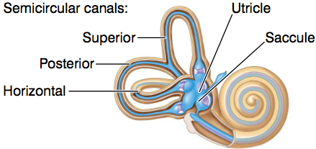
Different parts of the vestibular apparatus sense head position and motion
- The utricle and saccule contain hair cells that are activated when the head tilts relative to gravity
- The semicircular canals are fluid-filled hoops that detect head rotation, e.g. when your head turns rightward, the fluid in the tubes sloshes leftward, activating hair cells (same principles of Newton’s law of motion)
Equilibrium pathways project mainly to the cerebellum
- Vestibular hair cells activate primary sensory neurons of the vestibular nerve, which is a branch of cranial nerve VIII
  - Axons of the primary sensory neurons form the vestibular nerve
  - Second branch of cranial nerve VIII (auditory is the other branch)
- These neurons may either pass directly to cerebellum or synapse in the medulla, whence they proceed to the cerebellum or up through thalamus to cortex
  - Some neurons do go up through the thalamus to cortex, but mainly to cerebellum
- Your brain uses vestibular information to keep you upright
  - E.g. tilt your body brian gets signal from inner ear brain corrects body

Somatic Senses
There are 4 somatic senses: touch, temperature, proprioception, and nociception
- Receptors for the somatic senses are all neurons, and are located in the skin and viscera (internal organs)
- Proprioception is awareness of the position of body parts relative to each other; e.g. even with your eyes closed you can sense how much your elbow is flexed
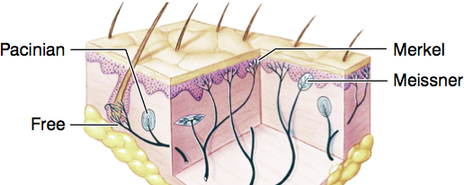
- Nociception detects tissue damage or the threat of it, and is perceived as pain or itch
Somatosensory Receptors
There are a variety of receptors in the skin
- Some receptors are free nerve endings; they detect mechanical stimuli, temperature, and chemicals
- The rest are encapsulated, i.e. sheathed in connective tissue. Examples are Merkel (Merkel is less encapsulated but still categorized as encapsulated), Meissner, and Pacinian receptors. They are all mechanoreceptors

At the bottom of the epidermis are saucer-shaped Merkel disks
- They are very sensitive to deformation of the skin, and are more tonic than phasic, i.e. they send a sustained message as long as the deformation persists
- They signal contact
Most mechanoreceptors are phasic
- Given a sustained, constant stimulus, the nerve ending’s membrane depolarizes but then returns to baseline – i.e. it registers changes, not steady levels
- So you don’t perceive much unless the stimulation is changing: if you run your hang along a surface, you get a vivid impression of its texture; after your hand stops, you sense far less
At the top of the dermis are egg-shaped Meissner corpuscles
- They are mainly in the tongue and hairless skin – erogenous zones, palms and fingertips – (sensitivity drops through life)
- Inside each corpuscle are many looping endings, like the coils of a spring mattress. They detect sideways shearing, as when you stroke a surface or lift something with your fingertips (because gravity causes slip which is sideways)
- They are phasic, so they sense changes in shear
Deep in the dermis are onion-shaped Pacinian corpuscles
- The nerve endings are sheathed in many layers
- They are phasic, and so they respond strongly to (small displacements?) vibration and other fast-changing stimuli
Receptors are not uniformly distributed over the body surface
- Palms, fingertips, and lips are the foveas of the somatosensory system: they have more densely packed receptors, and therefore higher acuity, than other areas
- The test of acuity is 2-point discrimination: if your skin is touched at 2 places simultaneously, can you tell whether there are one or 2 contact points?
- On your lips and fingertips you can distinguish points 2-4mm apart, but on your calves you need 40mm
Thermoreceptors are free nerve endings
- Cold receptors respond maximally at ~30°C (which is well below body temperature); warm receptors at ~45°C. Both are phasic-tonic which is why we get used to a hot bath or a cold lake
- Cold fibers also respond briefly to temperatures > 45°C, causing paradoxical cold: a hot object, touched briefly, may feel cold
- We have more cold receptors than warm, and few thermoreceptors in total – as few as 1000 fibers may carry temperature information up the spinal cord to the brain (precise localization isn’t crucial for temperature)
Nociceptors are free nerve endings that respond to noxious stimuli
- Some respond to damaging mechanical stimuli, others to damaging heat (some of these heat sensors also respond to capsaicin in chili peppers)
- Some respond to chemicals released from damaging cells (K+, histamine ,prostaglandins) and by serotonin released by platelets in response to injury

Pathways and Processing
Somatosensory afferents fall into 2 groups: small and large
- The small fibers, called C and Aδ, come mainly from free endings. C fibers are unmyelinated, and conduct spikes at speeds up to 2m/s. Aδ are thicker than C’s, myelinated, and conduct at up to 30m/s
- Small fibers respond to mechanical stimuli, chemicals, and temperature
- Large fibers, called Aβ, come from encapsulated mechanoreceptors such as Merkel disks, and Meissner and Pacinian corpuscles. They are myelinated, and conduct at 70m/s (use them for news that has to travel a long way and quickly)
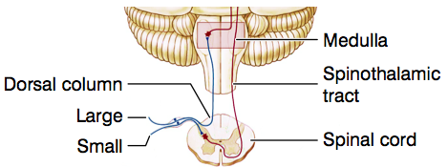
Large and small fibers project differently
- Large fibers turn upward on reaching the spinal cord, and run ipsilaterally up to the medulla in tracts called the dorsal columns. In the medulla they synapse on cells whose axons cross the midline
- Small fibers synapse directly or via interneurons on motoneurons (for reflex responses) or on cells whose axons cross the midline and run in the spinothalamic tracts
This anatomy reflects the fibers’ different functions
- Large fibers provide feedback to the brain, especially to motor cortex, as it manipulates objects. Their information has to travel a long way (up to the brain) quickly
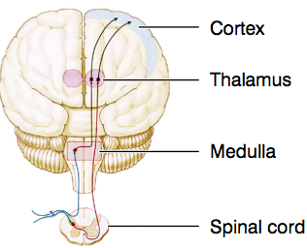
- Small fibers evoke simple responses to specific stimuli: with-drawing from pain, brushing away a bug, thermoregulatory and sexual responses. Many of these tasks can be handled in the spinal cord, without immediate input from the brain (spinal cord reflexes)
Signals travel via thalamus to cortex
- Signals from the spinal cord travel via the ventroposterolateral (VPL) nucleus of the thalamus. Signals from the head (not shown) travel via the ventroposteromedical nucleus (VPM)
- Both pass to the primary somatosensory cortex, S1
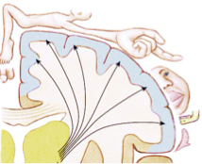
Primary somatosensory cortex is somatotopic
- Neighbouring areas of skin project to neighbouring cells in cortex, so S1 is a map of the contralateral body surface
- The map is distorted, as areas of high sensitivity and acuity (such as hands and lips) get a lot of cortical space, just as the foveas do in the visual system
  - Because there are more receptors there
Primary somatosensory cortex (S1) s in the parietal lobe
There is a lateral inhibition among somatosensory fibers
- As in the visual system, lateral inhibition enhances spatial differences, i.e. edges
- If you step into a very hot bath, you feel the most discomfort not in your foot but at the line formed by the water surface around your leg, because that is the temperature edge
- This is a somatosensory version of the Chevreul illusion
Pain
Pain indicates damage or danger
- People with congenital analgesia are susceptible to injury and infection, and usually die before they are 20
- We have 2 types of pain: fast and slow, e.g. when you stub your toe, you feel an immediate sharp pain, followed ~1s later by a duller sensation. Fast pain is carried by Aδ fibers, slow by C fibers
- The reason for the 2 types is likely that pain evokes 2 distinct responses: quick withdrawal (to get away from the painful thing) and prolonged immobilization – i.e. don’t move arm if you’ve broken it (to promote healing)
Nociceptive signals evoke responses from the CNS
- Nociceptive signals trigger withdrawal, e.g. pulling your hand back from a hot stove. This is a spinal reflex, and so it doesn’t need immediate input from the brain
- Nociceptive signals also reach the limbic system and hypothalamus, causing emotional distress, nausea, vomiting, and sweating
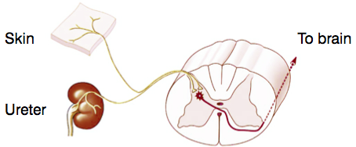
- Descending pathways through the thalamus can block nociceptive cells in the spinal cord, e.g. in emergencies where survival depends on ignoring pain (distractions)
Pain in an internal organ is often felt on the body surface – referred pain
- Nociceptors from different locations converge on a single ascending tract. So when the tract sends signals to the brain, the brain doesn’t know where the stimulus came from
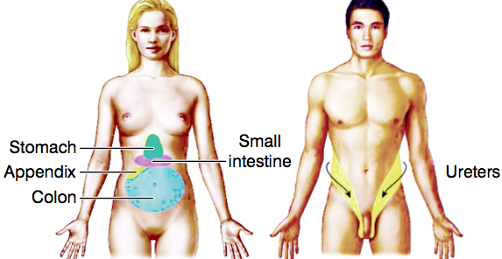
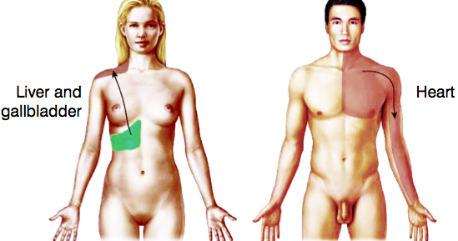
- As pain is more common in skin than in internal organs, the brain assumes the problem is on the body surface
Pains from different organs are referred to different regions on the body surface
- The woman feels pain on right shoulder, but internal organ is liver and gallbladder
- Male is having a heart attack though his left arm is in pain
Pain can be gated by Aβ activity (refer to picture)
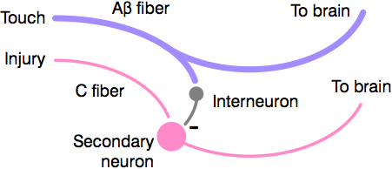
- In the dorsal horn, C fibers contact secondary neurons. Those secondaries are inhibited by Aβ fibers via interneurons
- So Aβ’s can block or dampen pain signals, e.g. if you rub a sore shoulder, it feels better
- Note: touch fibers can relieve pain ?
Analgesics work by various mechanisms
- Acetylsalicylic acid (aspirin) inhibits prostaglandins and inflammation, and slows transmission of pain signals
- Opioids (such as morphine and codeine) decrease transmitter release from primary sensory neurons and postsynaptically inhibit secondary sensory neurons
- The body makes natural painkillers such as endorphins, enkephalins, and dynorphins
Smell and Taste
Smell and taste are forms of chemoreception
- Chemoreception is evolutionarily old: bacteria use it to guide their movements; animals w/out brains use it to find food and mates
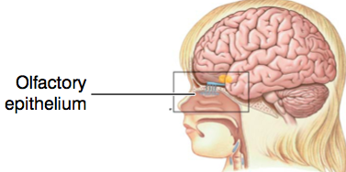
- Chemoreception may have evolved into chemical synaptic communication
Smell (oldest of special senses)
The olfactory receptors are in the olfactory epithelium
- This epithelium lies at the top of the nasal cavity, covering ~3cm² in each of the 2 sides. It contains ~10mill receptor cells in total
The receptor cells are ciliated neurons
- The cilia increase the surface area of the cell, so it has a greater chance of catching odorant molecules. These cilia “wave in the air like anemones on a coral reef”
- Each receptor cell has (many copies of) one type of odorant receptor molecule on its membrane. We have ~400 kinds of receptor cell, i.e. ~400 “primary odors” (in theory can mix these 400 receptors for different kinds of smell)
The receptor cells are sensitive
- Some of them can detect a single molecule of their preferred chemical, though ~40 cells must react before we experience a smell
The receptors have unusual properties
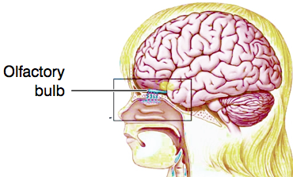
- They are pinocytotic, continually sipping in fluid and sending it along the nerves into the brain. We don’t know why
- They are short-lived, degenerating after a month or 2, to be replaced by new ones from below
- They send their axons into the brain through tiny holes in the cribriform (“sievelike”) plate – the bone at the base of the cranial cavity
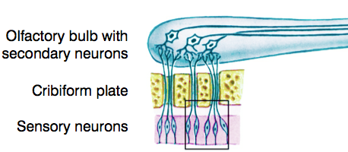
The receptors project to the olfactory bulb
- The bulb is an extension of the cerebrum, and lies on the underside of the frontal lobes
- The projection from the receptors to the bulb is called the olfactory nerve, or cranial nerve I
Many receptors converge on each bulb neuron
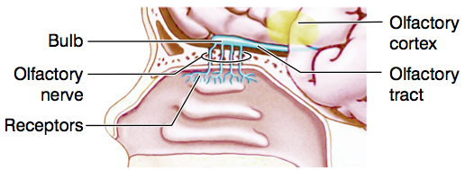
- As with rods converging on ganglion cells, this arrangement enhances sensitivity but discards spatial info.
The bulb projects directly to olfactory cortex, bypassing (not going thRugh) thalamus (refer to third picture)
Olfactory cortex is in the frontal and temporal lobes
The bulb also projects to the limbic system
- This is an old group of brain regions concerned with motivation and emotion. [Limbic and olfactory is linked because thought to be…] For early animals, motivation was tightly linked to smell: they used their noses to identify food and poisons, mates and predators
- Our emotions are no longer so smell-related (e.g. we like money) but they are still handled by these old olfactory areas. Maybe that is why odors call up emotional memories (e.g. Proust’s madeleines, Dicken’s label paste)
Olfaction adapts slowly but completely
- Sewer workers don’t notice anything objectionable, and people are unaware of their own body odors
- Food evaluators take steps to avoid adapting, e.g. wine tasters eat biscuits or cheese between sips, and Scottish cheese tasters sip whisky
Olfactory processing is mysterious
- Individual fibers may be excited by one chemical and inhibited by another that is very similar and smells almost identical, e.g. methanol and menthone
- A sign that we don’t understand olfaction is that we can’t predict how smells combine (e.g. coffee and iodoform have strong smells that unexpectedly cancel; raspberry scent comes from a mix of molecules, many of which smell bad on their own)
Rodents and maybe humans have pheromones
- Rodents have an olfactory structure in the nasal cavity called the vomersonasal organ (VMO), which is involved in their behavioral responses to sex pheromones
- In humans, the VMO disappears during fetal development, and there is little evidence for pheromones (we work with “visuomones” instead), but the question is still open
Cranial nerve zero may signal pheromones (refer to picture about 12 cranial nerves, - 13 if you add cranial nerve 0)

Taste
Our main taste receptor cells are clustered in taste buds
- We have ~5000 taste buds, mainly on the top of the tongue but also on the soft palate, epiglottis and upper esophagus. Babies have twice as many
- Each taste bud contains ~100 receptor cells, which are epithelial cells (not neurons) arranged like petals. A taste bud lives only ~10 days
Taste buds have at least 5 types of receptor cell
- All have clear biological roles: sweet and umami receptors detect sugar (energy) and the amino acid glutamate (indicating protein), respectively. Bitter receptors detect poison. Salty and sour receptors detect Na+ and H+ - 2 important ions
- The tongue may also have receptors for long-chain fatty acids
- Each taste bud has several kinds of receptor cell, i.e. buds aren’t specialized for sweet, salt, etc
We have receptors of all 5 types all over the top of the tongue
- For instance, it is not true that sweetness is sensed only by the top of the tongue
- But different areas of the tongue do vary slightly on their thresholds for different flavors
Our experience of food depends on other sensors as well
- It depends on smell, temperature, pain, texture, crunch, appearance and cognition – If I tell you some lousy food is a delicacy then you like it better
- We sense capsaicin (in chili peppers) by oral heat receptors. We also have an oral receptor that reacts to cold and to mint, which is why mint feels cool
- And chemoreceptors in our stomach and intestines monitor their contents; some of these receptors resemble ones on the tongue, e.g. for sweet and umami
Taste signals take several paths to the brain
- Receptor cells in the taste buds excite fibers of cranial nerves VII, IX, and X, the facial, glossopharyngeal, and vagus nerves. These pathways synapse in medulla and thalamus en route to the cortex
- Oral pain and temperature receptors excite cranial nerve V, the trigeminal

