MICROECONOMICS NOTES

CHAPTER 8

PERFECT COMPETITION

- PERFECT COMPETITION is a market structure in which:
- there are large number of firms
- firms sell identical products
- buyers and sellers have full information about prices charged by all firms
- transaction costs, the expenses of finding a trading partner and completing the trade above and beyond price, are low
- firms can freely enter and exit the market
- Examples:
- Agricultural/comodities markets like wheat and soybeans
- Building and construction

PERFECT COMPETITION: ASSUMPTIONS

- Large number of firms
- no single firms actions can raise or lower the price.
- Individual firms demand curve is a horizontal like at market price
- Identical ( homogeneous ) products
- if all firms are selling identical products, it is difficult for any firm to raise the price aboce the going market price charged by all firms
- Full Information
- Consumer knowledge of all firms prices makes it easy for consumers to buy elsewhere if any one firm raised its price above market price

- Negligible transaction Costs
- buyers and sellers waste little time or money finding each other.
- Free Entry and Exit
- leads to large number of firms and promotes price taking.

COMPETITIVE FIRMS DEMAND

- are perfectly competitive firms demand curves really flat?
- A firms RESIDUAL DEMAND CURVE, Dr ( p) , is the portion of the market demand that is no met by the other sellers at any given price.
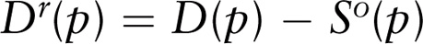

- D(p) = market demand
- S(p) = amount supplied b other firms
- If not perfectly horizontal, the residual demand curve of an individual firm is much flatter than market demand

PROFIT MAXIMIZATION

- PROFIT MAXIMIZATION in this class always refers to ECONOMIC PROFIT, which is revenue minus opportunity cost.
- Differs from business profit, which only subtracts off explicit costs from revenues
- Maximizing profit involves two important questions:
- OUTPUT DECSITION: if the firm produces, what output level (q*) maximizes its profit or minimizes its loss?
- SHUTDOWN DECISION: is it more profitable to produce q* or to shut down and produce no output?

PROFIT MAXIMIZATION: OUTPUT RULES

- A firm can use one of three equivalent OUTPUT RULES to choose how much output to produce:
- A firm set its output where its profit is maximized
- A firm sets its output where its marginal profit is zero.
- A firm sets its output where its marginal revenue equals its marginal cost.
- Output rules 1 and 2 are easily depicted in a single graph.
- Output rules 1 (maximum profit) and 2 (zero marginal profit) both point to q*.

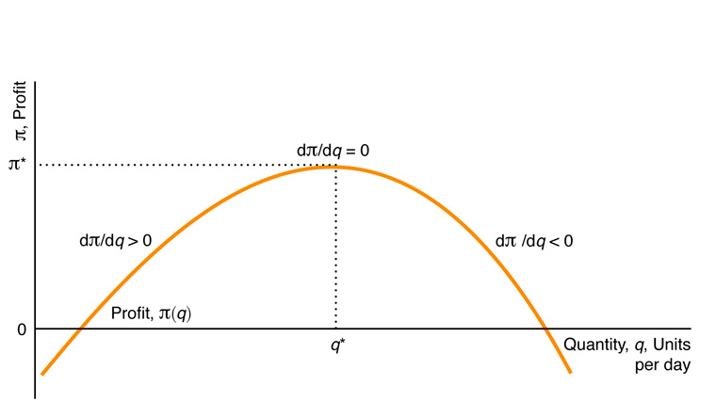

- Output rule 3 (marginal revenue = marginal cost) is less obvious on the previous graph.
- Mathematically, if we take the derivative of Total Revenue (q) = R(q) – C(q) with respect to output and set it equal to zero ( output rule 2), we find:

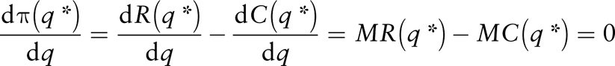

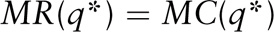

PROFIT MAXIMIZATION: SHUTDOWN RULE

- A firm shuts down only if it can reduce its loss by doing so:
- SHUTING DOWN means that the firm stops producing ( and thus stops receiving revenue) and stops paying avoidable costs.
- Only fixed costs are unavoidable because they are sunk costs.
- Firms compare revenue to variable costs when deciding whether to stop operating.
- Shutting down may be temporary.
- The shut down decision is a short run decision because, in the long run all costs are avoidable

COMPETITION IN THE SHORT RUN

- Given this general description of firms profit maximization decisions, how do perfectly competitive firms maximize profits in the SR.
- Because it faces a horizontal demand curve, a competitive firm can sell as many units of output as it wants at market price, p.
- Revenue is R(q) = pq, thus, q* satisfies:

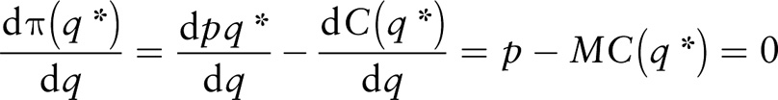

- Marginal cost equals the market price
- MC = p is equivalent to MC = MR because MR = p in perfect competition.
- Profit maximized at q where Revenue-Cost is greatest

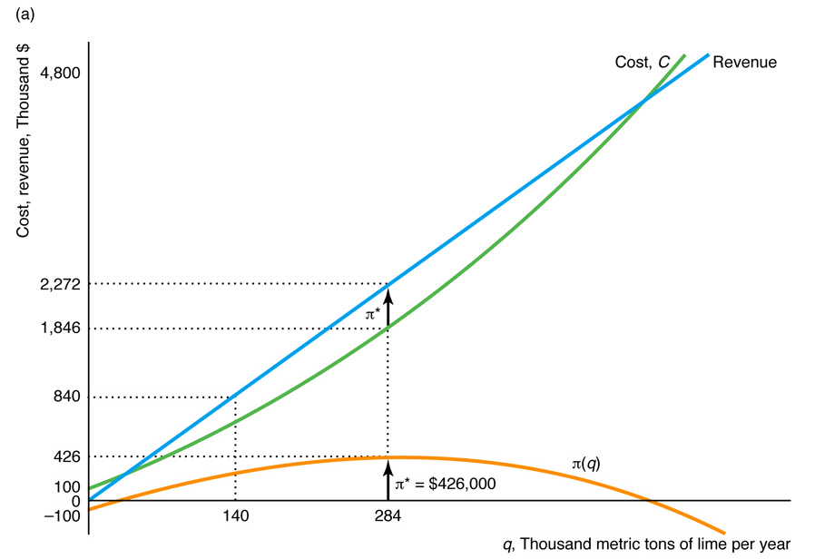
- Profit is the rectangle q*(p-AC(q*))

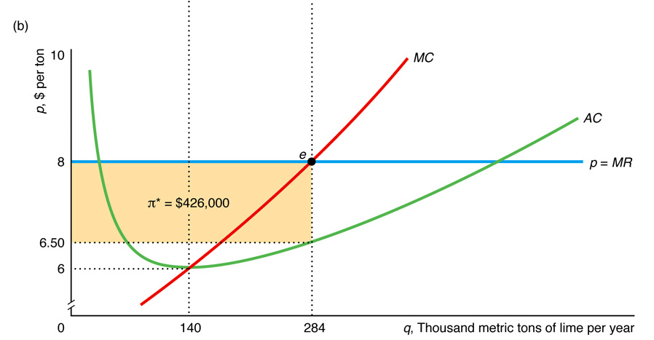

- The graph above does not allow us to address the firms shut down decision.
- Recall that firms compare revenues to variable costs to determine shutdown:

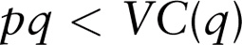

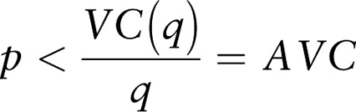

- Shut down if market price is less than the minimum of its SR average variable cost curve.
- Thus, our graphical analysis of firm profit maximization decisions required an AVC curve to address the shut down decision.

THE SHORT RUN SHUDOWN DECISION

- If AC( q*) >p>AVC(q*), then firm operates, but at a loss.
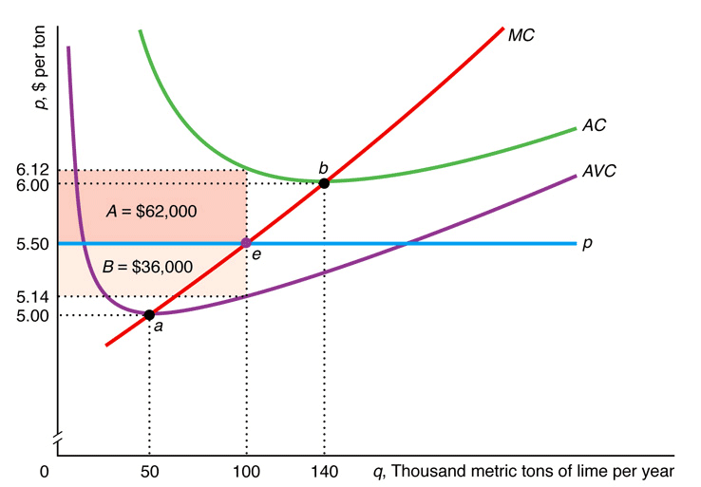

SHORT RUN FIRM SUPPLY CURVE

- S is the section of MC above min AVC.

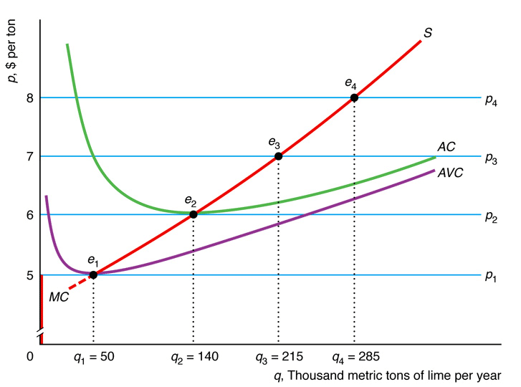

SHORT RUN MARKET SUPPLY (IDENTICAL FIRMS)

- The market supply curve is the horizontal sum of the firm supply curve.

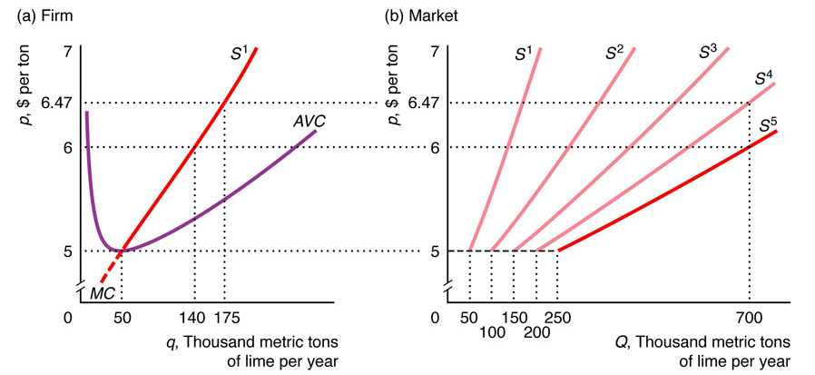
SHORT RUN MARKET SUPPLY (DIFFERENT FIRMS)

- The Market supply curve is the horizontal sum of the firm supply curves.

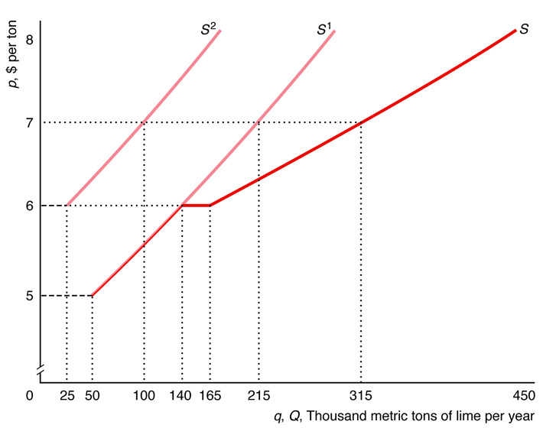

CHAPTER 13

An Overview of GAME THEORY

- Game theory is set of tools used by economists and may others to analyze players strategic decision making
- A game is an Interation between players ( such as individuals or Firms) Which players use Stratigies
- We concentrate on how oligopolistic firms behave with a game
- DEFINITIONS:
- The PAYOFFS of a game are the players valuation of the outcome of the game ( eg. Profits for firms, utilities for individuals)
- The RULES OF THE GAME determine the timing of playres moves and the actions players can make at each move.
- An ACTION is a move that a player makes at a specidfed stage of a game
- A STRATEGY is a battle plan that specifies the action that a players will make based on the information available at each move and for any possible contingency
- STRATEGIC INTERDEPENDNCE occurs when a players optimal strategy depends on the actions of others.

STATIC GAMES

- In a STATIC GAME each players acts simultaneously, only once and has complete information about the payoff functions but imperfect information about its rivals moves
- Examples: employer negotiations with a potential new employee, teenagers playing chicken in cars, street vendors choice of locations and prices
- Consider a NORMAL- FORM static game of complete information which specifies the palyers , their strategies, and the payoffs for each combination of strategies.
-Competitions between united and American airlines on the LA-Chicago route.

QUANTIT-SETTING GAME

- Quantities ( q) are in thousands of passengers per quarter, Profits are in millions per quarter

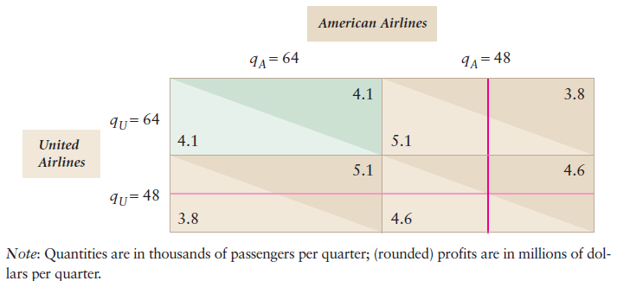

PREDICTING A GAMES OUTCOME

- Rational players will avoid strategies that are dominated by other strategies
- In fact , we can precisely predict the outcome of any game in which every player has a DOMINANT STRATEGY.
- A Strategy that produces a higher payoff than any other strategy for every possible combination of its rivals Strategy
- Airline Game:
- If united chooses high output, Americans high output strategy maximizes its profits
- If united chooses low output, Americans high output strategy still maximizes its profits.
- For American, High output is a dominant Stategy.
- The high output strategy is dominant for American and for united, This is a domninant strategy equalibirum.

- Players choose strategies that don’t maximize joint profits.
- Called a prisoners dilemma game; all players have dominant strategies that lea to a profit that is less than if they cooperated.

NASH EQUILIBIRUM

- When iterative elimination fials to predict a unique outcome, we can use a related approach.
- The BEST REPSONSE is a strategy that maximizes a players payoff given its belief about its rivals strategies
- A set of strategies is a NASH EQUILIBIRUM if, When all other playres use these strategies , no player can obtain a higher payoff by choosing a different strategy.
- no player has an incentive to deviate from NASH EQUILIBRIUM
- Every Game has at least one NASH EQUALIBRIUM and every dominant strategy equilibrium is a NASH EQUILIBRIUM

MULTIPLE EQUILIBRIA

- Many oligopoly games have more than one NASH EQUILIBRIUM

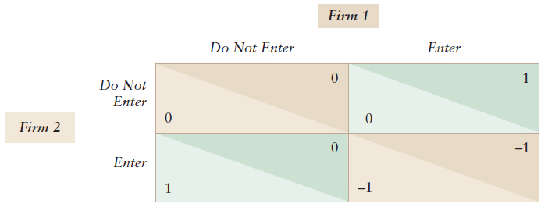

SIMULTANEOUS ENRY GAME

- This game has two NASH EQUILIBRIA in pure strategies and one mixed strategy NASH EQUILIBRIUM.

CHAPTER 14

COMPARISON OF MARKET STRUCTURES

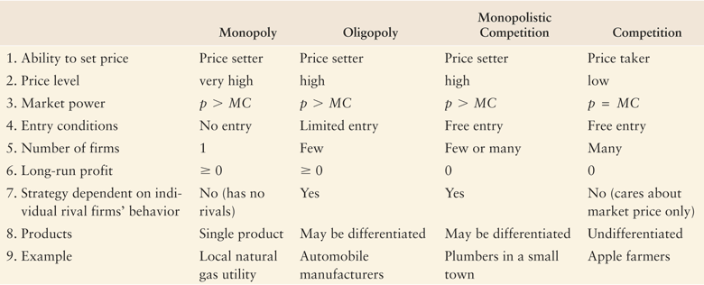

COURNOT OLIGOPOLY MODEL

- The COURNOT MODEL explains how oligopoly firms behave if they simultaneously choose how much they produce.
- Four main assumptions:
- There are tow firms and no others can enter the market
- The Firms have identical costs
- The Firms sell identical products
- The firms set their quantities simultaneously
- Example: Airline Market

COURNOT MODEL OF AN AIRLINE MARKET

DEMAND AND COST
- The quantity each airline chooses depends on the residual demand curve if faces and its marginal cost.
- Estimated airline market demand:

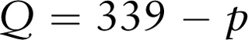

- P = dollar cost of a one way flight
- Q = total passengers flying one way on both airlines ( in thousands per quarter)
- Assume each airline has cost MC = 147 per passenger
- How does the monopoly outcome compare to duopoly ( Cournot with Two Firms)
- American airlines choice under monopoly and Duopoly
- In the duopoly American airlines faces residual demand

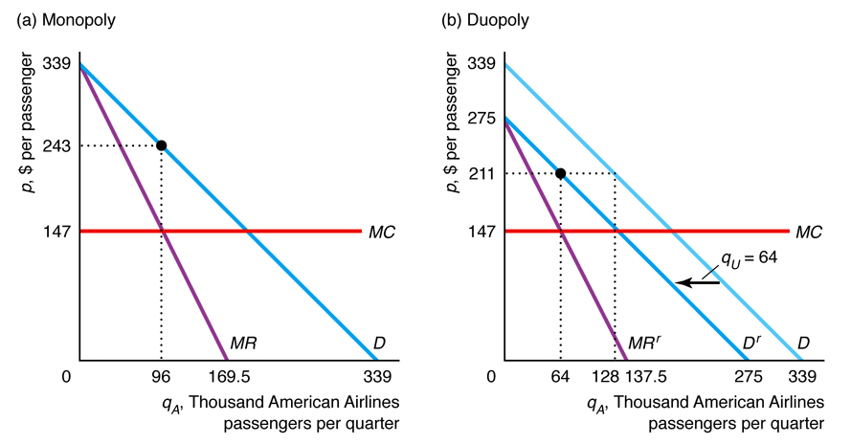

RESIDUAL DEMAND

- In a Duopoly if united flies qu passengers , American transports residual demand.
- Americans redisudual demand:

- What is Americans best Response , profit maximizing output if it believes united will fly qu passengers?
- American behaves as if it has a monopoly over people who don’t fly on united summarized by residual demand)
- Americans residual inverse demand:
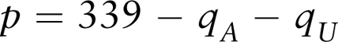

- Residual inverse demand function is useful for expressing revenue and MR in terms of rivals quantity.

RESIDUAL DEMAND

- Residual inverse demand function is useful for expressing revenue and MR in terms of rivals quantity.

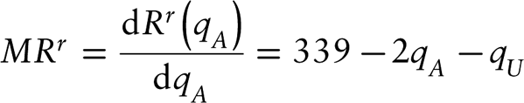

- Given MR = MC yields americans best response function;
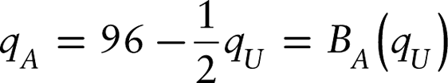

- Given our assumptions uniteds best response function is analogous:
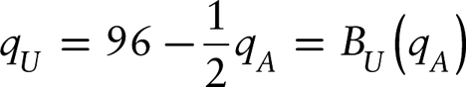

THE EQUILIBRIUM

- The NASH COURNOT EQUILIBRIUM IS THE POINT WHERE EST RESPONSE FUNCTIONS INTERSECT : qA = qU =64

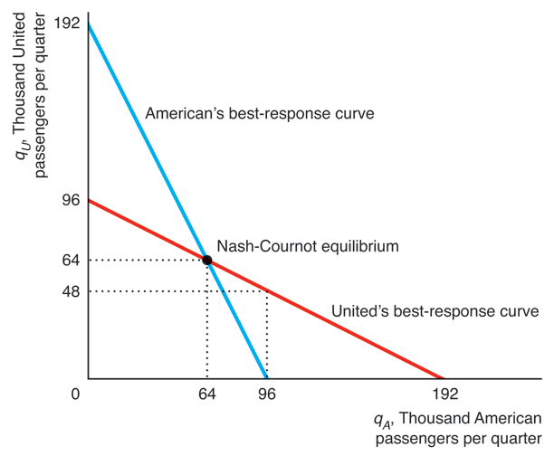

STACKELBERG OLIGOPOLY MODEL

- Suppose that one of the firms in our previous example was the LEADER and set its output before its rivals, the FOLLOWER
- Does the firm that acts first have an advantage?
- How does tis models outcome differ from the COURNOT OLIGOPOLY MODEL
- The STACKELBERG MODEL of oligopoly addresses these questions.
- Note that once the leader sets its output the rival firm will use its Cournot Best response curve to set its output

COMPARISON OF COLLUSIVE, COURNOT,STACKELBER, AND COMPETITIVE EQUILIBRIA

- Cournot and Stackelberg equilibrium outcomes ( quantities, prices , proftis) lie between Competition and collusion

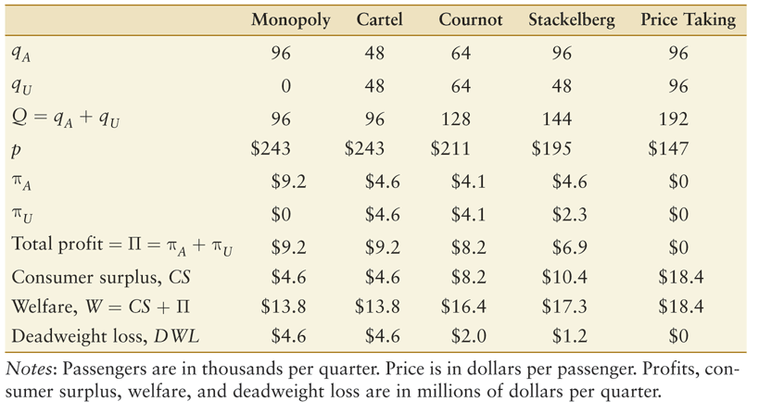

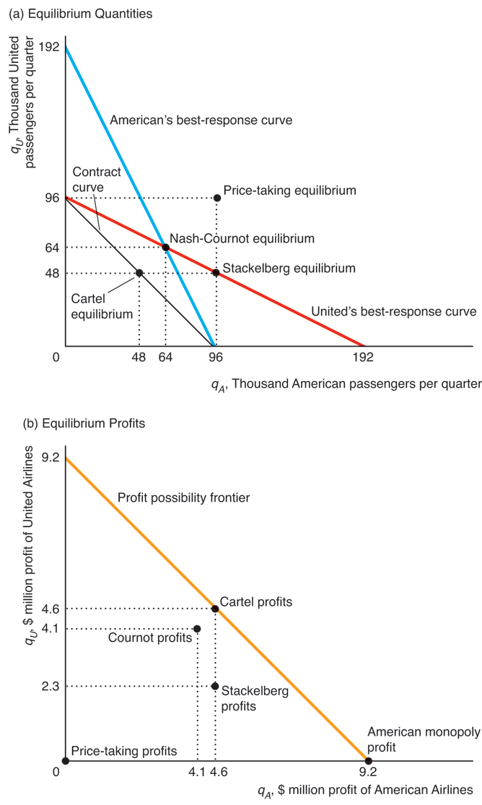
BERTRAND OLIGOPOLY MODEL

- What if, instead of setting quantities, firms set prices and allowed consumers to decide how much to buy?
- A BERTRAND EQUILIBRIUM ( or NASH BERTRAND EQUILIBRIUM) Is a set of prices such that no firm can obtain a higher profit by choosing a different price if the other firms continue to charge these prices.
- The BERTRAND EQUILIBRIUM is different than a quantity setting equilibrium in either the Cournot or Stackelberg Models
- BERTRAND EQUILIBRIUM price equals marginal cost ( as in Competition) because of incentive to undercut.
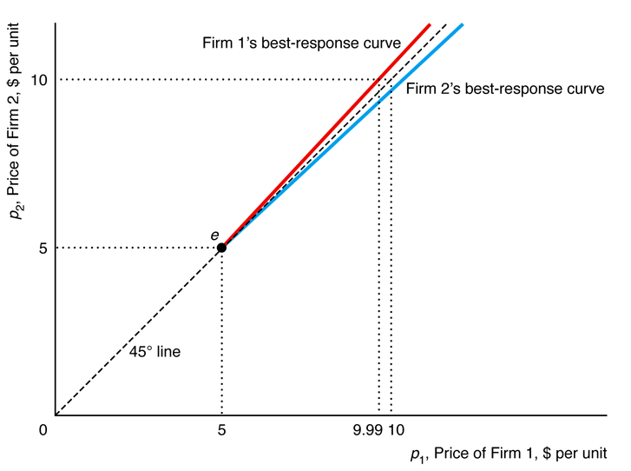

Chapter 15

Factor Markets

- Factor markets refer to the markets where labour L and Capital K are bought and sol or rented
- Factor markets are competitivie when there are many small selelrs and buyers
- Factor markets from earlier chapters:
- Labour supply determination via labor leisure model ch 5
- Firm input choices via profit maximization ch 6 and 7
- Competitive supply determination for general firm ch 8

Facktor Market Short run

- A firms SR production function can be expressed solely in terms of labour q = q(L) because capital is fixed in SR
- Reveneue is a function of production and the firms objectice is to maximize profit by choosing L in the SR

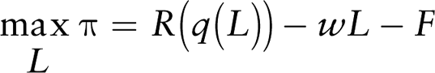
-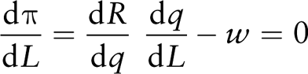
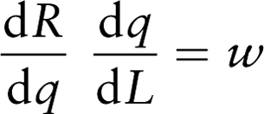

- the firms chooses L so additional revenue from emplying last woker equals wage paid to that last worker

Factor Market Short Run

- the marginal revene product of labour MRPL sometimes called the value of the marginal product is the additional revue gernereated by the last unit of labor.

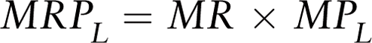

In a competitive market; 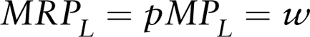

This is the firms SR labour demand Function

The MRPL shows the maximum wage that a firm is willing to pay to hire a given number of workers

FACTOR DEMAND IN THE LONG RUN

- in the LR firms are free to var all inputs so firms will adjust both L and K when input prices change.
- Objective Functions: 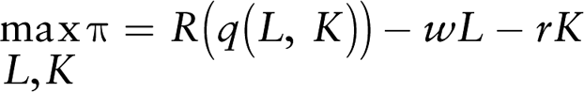
FOCs: 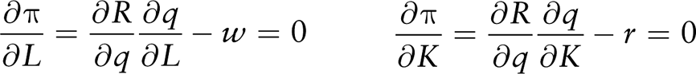

Rewriting:

Capital Markets an investing: When renting durable goods or workers services a firm chooses a quantity that equates current marginal cost and currgent marginal benefit.
If the Captial good must be bought or Built rather than rented then a firm must compare current cost of capital to future higher profits associated with the investment.
Such comparisons involce both stocks and flows.
A stock is measured independently of time E g Wealth
A flow is measured per unit of time eg Income

- an INTEREST RATE is the percentage more that must be repaid to borrow money for a fixed period of time.
- People value having a dollar today more than having a dollar in the future, so some future offering would have to be inflated:
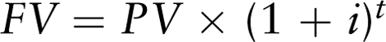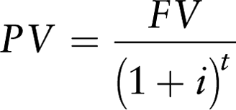

- A DISCOUNT RATE reflects the releative value an individual places on future consumption compared to current consumption.

Net Present Value Approach

A firm should make an investment only if a PV of the experected return exceeds the PC of the costs
If in year t of T years revenue is Rt and cost is Ct then firm should invest if:

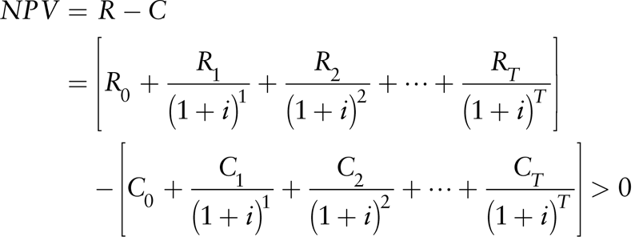

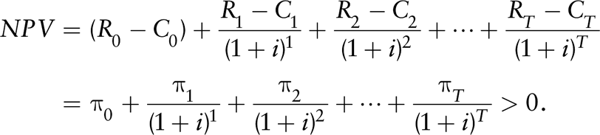

Individuals may choose to invest in education in order to raise their productivity and future earnings.



