ARTH 1200
History and Theory of Architecture 1:
Prehistory to ca.1600
Week 4

Athens, The Acropolis

- Ancient citadel located on a high outcrop above the city Athens.
- Containing the remains of several ancient buildings of great architectural and historical significance; the most famous being the Parthenon.
- While there is evidence that the hill was inhabited as far back as the fourth millennium BC.
- It was Pericles (c. 495 – 429 BC) in the fifth century BC who coordinated the construction of the site's most important buildings including the Parthenon, the Propylaia, the Erechtheion and the temple of Athena Nike.
- The Parthenon and the other buildings were seriously damaged during the 1687 siege by the Venetians in the Morean War when the Parthenon was being used for gunpowder storage and was hit by a cannonball.
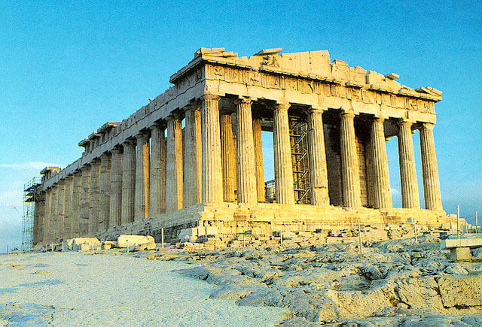

The Persian War
Greek Victory, 479 BCE

- Led by Athens and Sparta
- The Greek city-states were engaged in a great war with the Persian Empire at the beginning of the fifth century B.C.
- In 498 B.C., Greek forces sacked the Persian city of Sardis.
- In 490 B.C., the Persian king sent a naval expedition across the Aegean to attack Athenian troops at Marathon.
- Despite a resounding Athenian victory there, the Persians did not give up.
- In 480 B.C., the new Persian king sent a massive army across the Hellespont to Thermopylae, where 60,000 Persian troops defeated 5,000 Greeks.
- The year after that, however, the Greeks defeated the Persians for good at the battle of Salamis.
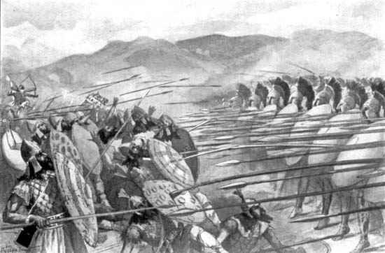
- This was leaded to peace, prosperity and health. Which leads to artistic patronage

The ‘Classical’ Period
Ca. 479-323 BCE

- Pericles, Alexander, Socrates, Plato, Aristotle, Sophocles, Aeschylus, Aristophanes.
- This is the period between the Persian wars at the beginning of the fifth century B.C and the rise of Alexandre the great in 323 B.C.E
- This period was an era of war and conflict – first between the Greek and the Persians, then between the Athenians and the Spartans.
- It was also an era of unprecedented political and cultural achievement.
- Besides the Parthenon and Greek tragedy, classical Greece brought us the historian Herodotus, the physician Hippokrates and the philosopher Socrates.
- It also brought us the political reforms that are ancient Greece’s most enduring contribution to the modern world: the system known as demokratia, or “rule by the people.”

The Propylaea
Ca. 437 BCE
Mnesikles

- Is a monumental gateway based on the original Propylaea that serves as the entrance to the Acropolis in Athens.
- the Propylaea was built under the general direction of the Athenian leader Pericles, but Phidias was given the responsibility for planning the rebuilding of the Acropolis as a whole at the conclusion of the Persian Wars.
- Construction began in 437 BC and was terminated in 432, when the building was still unfinished.

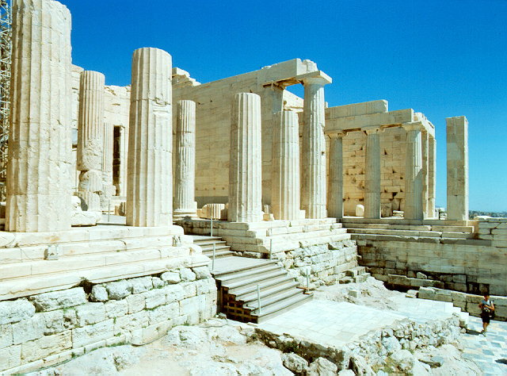

The Temple of Athena Nike
Ca. 425 BCE
Kallikrates

- The temple is the earliest fully Ionic temple on the Acropolis.
- It has a prominent position on a steep bastion at the south west corner of the Acropolis to the right of the entrance, the Propylaea.
- In contrast to the Acropolis proper, a walled sanctuary entered through the Propylaea, the Nike Sanctuary was open, entered from the Propylaea's southwest wing and from a narrow stair on the north.
- The sheer walls of its bastion were protected on the north, west, and south by the Nike Parapet, named for its frieze of Nikai celebrating victory and sacrificing to their patroness, Athena Nike.
- Nike means victory in Greek, and Athena was worshipped in this form, as goddess of victory in war and wisdom.
- The citizens worshipped the goddess in hope of a prosperous outcome in the long Peloponnesian War fought on land and sea against the Spartans and their allies.
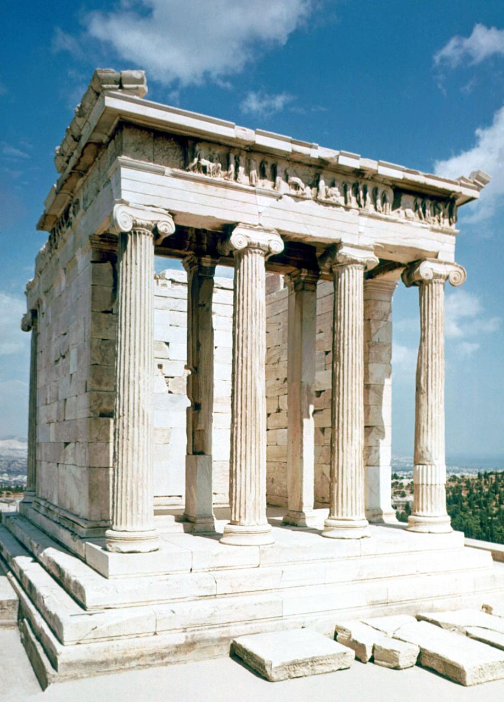

The Parthenon
Ca. 448 – 432 BCE

- It’s the biggest and most important temple.
- 8 Columns by 17 Columns
- Dedicated to the goddess Athena, whom the people of Athens considered their patron.
- Construction began in 447 BC when the Athenian Empire was at the height of its power.
- It was completed in 438 BC although decoration of the building continued until 432 BC.
- It is the most important surviving building of Classical Greece, generally considered the zenith of the Doric order.
- Its decorative sculptures are considered some of the high points of Greek art.
- The Parthenon is regarded as an enduring symbol of Ancient Greece, Athenian democracy and western civilization,
- The Parthenon itself replaced an older temple of Athena, which historians call the Pre-Parthenon or Older Parthenon, that was destroyed in the Persian invasion of 480 BC.
- Like most Greek temples, the Parthenon was used as a treasury.
- The Parthenon was converted into a Christian church dedicated to the Virgin Mary.

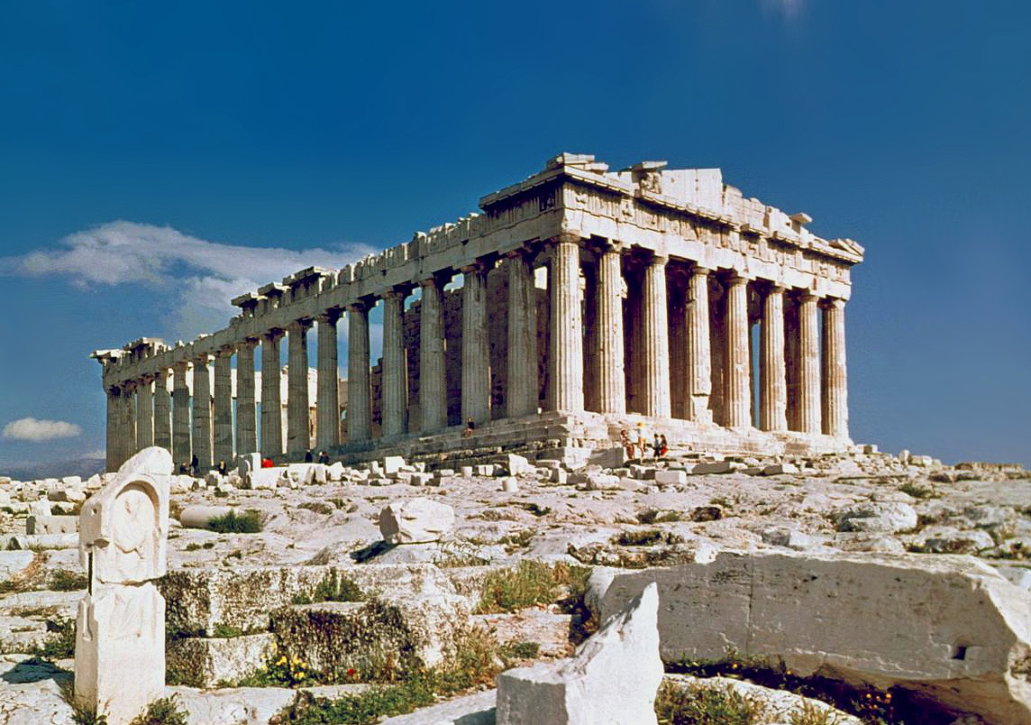

Erectheion, Athens
Ca. 420 BCE

- Ionic Temple
- The main structure consists of up to four compartments, the largest being the east cella, with an Ionic portico on its east end. Other current thinking would have the entire interior at the lower level and the East porch used for access to the great altar of Athena Polias via a balcony and stair and also as a public viewing platform.
- Porch of maidens
- Columns replaced with human figures (Relates to the orders and the personalities they reflect; Caryatids)

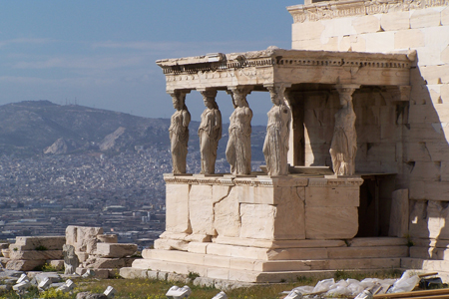

Monument of Lysikrates, Athens
Ca. 335 BCE

- Trophy for the victory of Lysicrates
- We do not honor people like this anymore, shows difference in culture
- This is the earliest monument that uses a Corinthian order.
  - Attached or Engaged columns to the wall surface

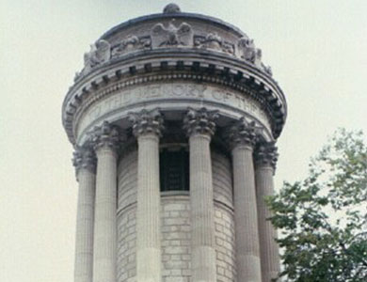

Theatre, Epidaurus
Ca. 350 BCE

- 55 rows of benches
- Provides unobstructed view of the stage
- Located for the healing purposes of the land
- Provide people with entertainment who pilgrimaged
- The circular part where people preformed was called the orchestra.
- Acoustics were very important and the architecture was designed so people at the back could hear stage whispers perfectly

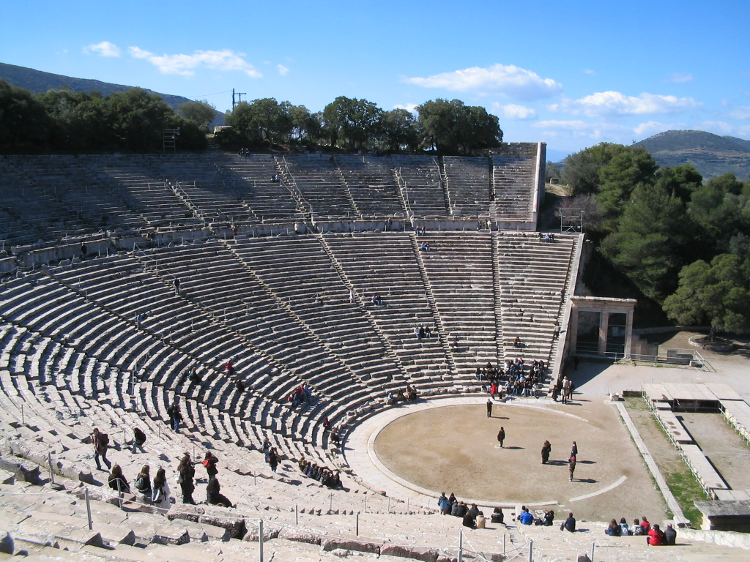

Pre-Rome

The Etruscans
Ca. 6th-4th century

- Have left us very little to study, not many monuments set foundation for Roman Civilization
- An example of an early Etruscan temples shares characteristics with Greece style temples ex. Columns, post & Lintel. Some differences are: It has walls

Tuscan

- A new order Tuscan.
- Which is most similar to the Doric order, but it much simpler then the Doric as the column has no fluting, considered the most simple and primitive order.

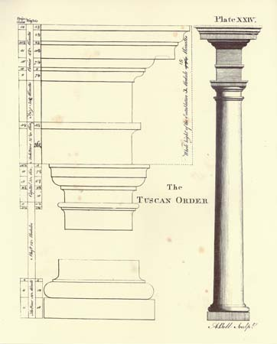

Arch of Augustus, Perugia
After 310 BCE

- One of seven gates in the Etruscan wall of Perugia.
- It was constructed in the second half of the 3rd century BC and was restored by Augustus in 40 BC after his victory in the Perusine War.
- Representing the best surviving and most monumental of the Etruscan city gates it opens on to the cardo maximus of the city, corresponding to the modern Ulisse Rocchi Road.
- The arch consists of an attractive facade with a single archway and two trapezoidal towers.
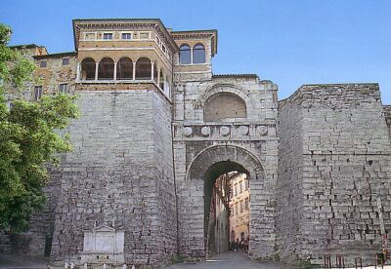
- Above the arch (in two concentric rows) there is an ornate frieze of metopes with round shields and triglyphs; above this is another arch between two pilasters.

Rome
2nd century BCE – 4th Century CE

Maison Carée, Nimes, France
Ca. 20 BCE

- Corinthian Order
- Romans added a lot of the idea and innovations to architecture, did not just steal ideas from Greece
- Has walls (Etruscan)
- Combines these two earlier eras.

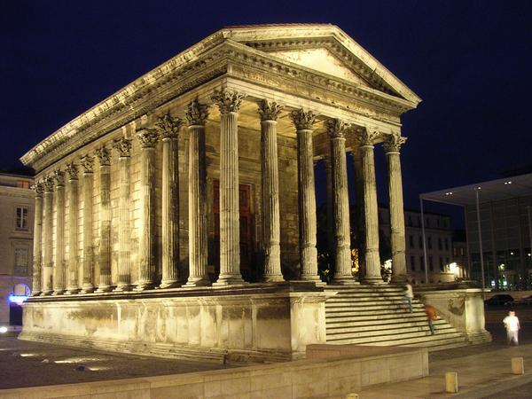

The limitations of Trabeation


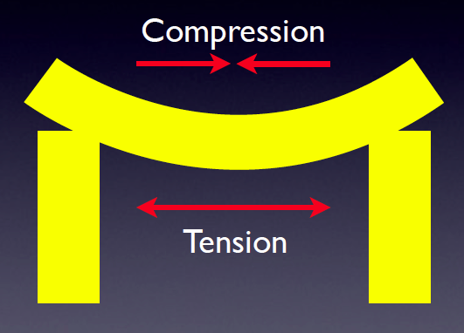


- The Lintel can start to droop in the center, the weight pulls it down, this causes a problem of compression, which causes tension, and the stone can snap.

The Arch

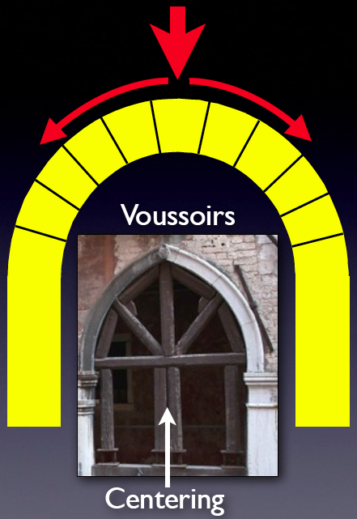
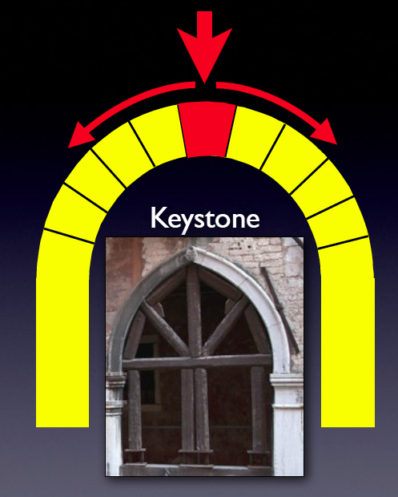
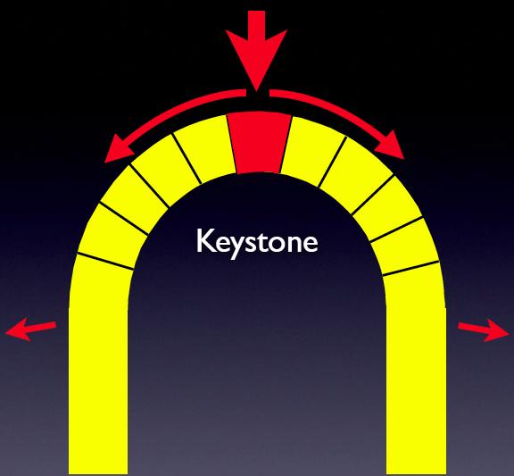
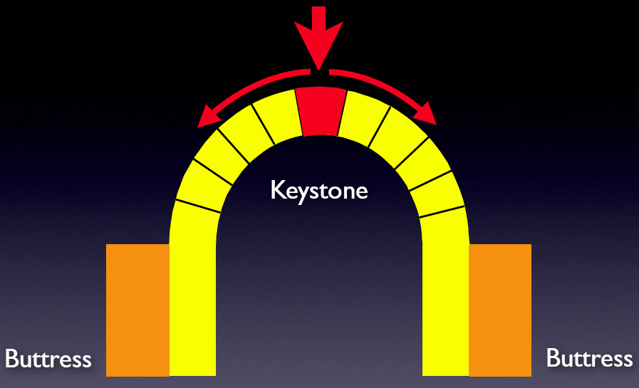

- The arch fixes this problem: it distributes the weight evenly, no more downward pressure.
- The arch is made from voussoirs which are under compression, but not tension which causes stone to snap
- The stone at the very top of the arch is called the keystone
- Arches cause a lot of lateral stress on the posts of the arch, but to fix this a buttress is added to take this stress away.
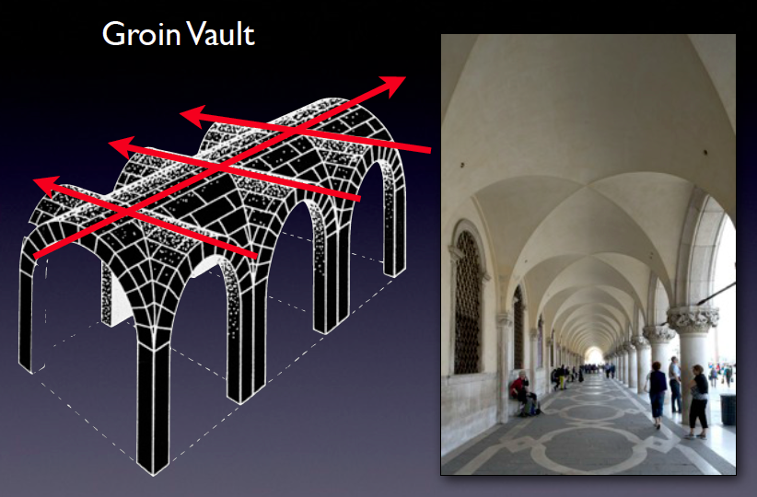
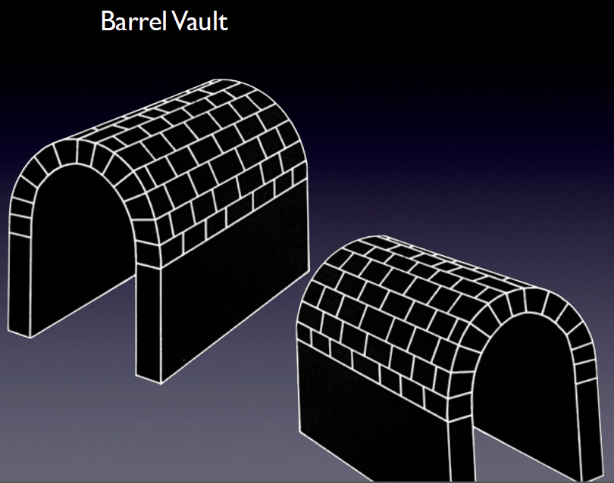
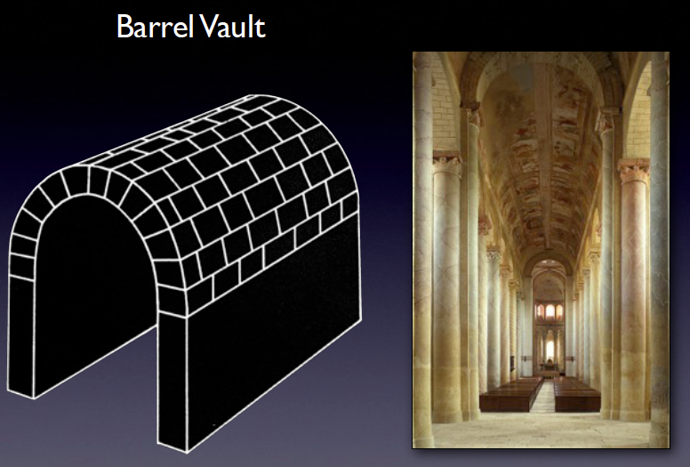


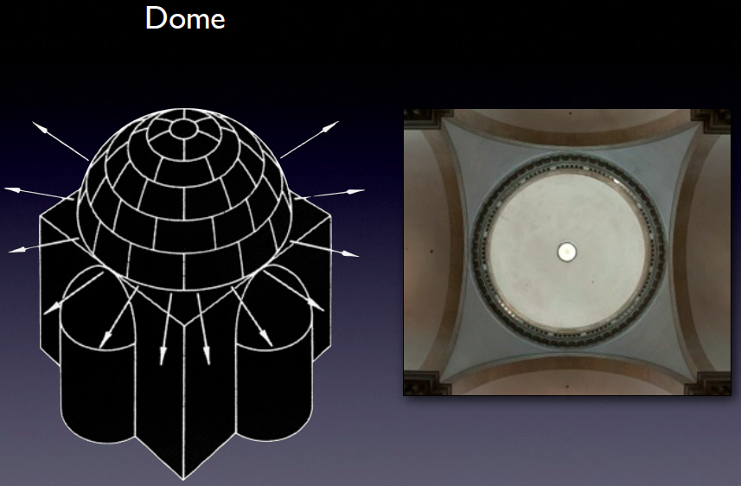
- If you take an arch and stretch is in 3 dimensions it is called a barrel vault (aka an arch stretched really long)
- Creates a tunnel like space that can be confined and gloomy sometimes, if you want to open up the space of a barrel vault laterally you add groin vaults by intersecting at 90 degrees (arches on all sides) and creates a very open space that is also structurally sound
- Dome is essentially an arch rotated 360 degrees
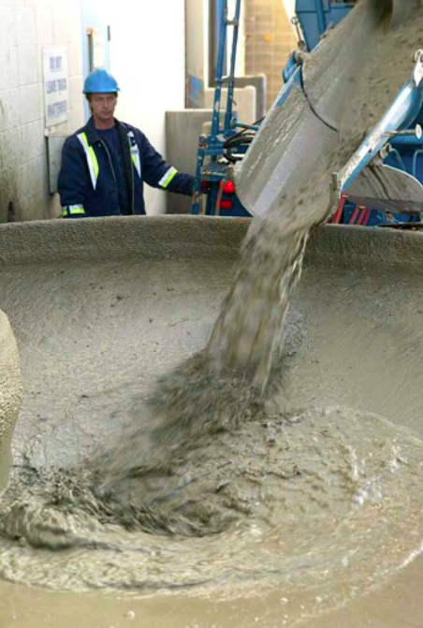


- Rome is one of the earliest users of brick, and becomes very common in Roman era, it is cheap and easily available, and a uniform shape
- The Romans used concrete, which is liquid and can be shaped into molds, offers great flexibility.

