ARTH 1200
History and Theory of Architecture 1:
Prehistory to ca.1600
Week 3

Quiz Next week:

- 1 slide identification
- 1 unknown slide
- 1 short-answer question

*Check the monument list!

Mycenae, ca. 1600 – 1100 BCE

- Greek World
- Its settlements located on the mainland of Greece date back to about 1600 BCE.
- Mycenae reached its period of greatness after about 1450 BCE
- The city is situated on high ground, protected by mountains on the north and south and flanked by two rivenes, allowing surveillance of a wide area down to the cost.
- The later Greek thought this impressively scale masonry to be the work of giants, the Cyclopes hence the adjective cyclopean to describe its construction.
- The principle entrance to Mycenae was made through the Lion Gate

Lion Gate, Mycenae, ca. 1300 BCE

- The gateway if considerable artistic interest.
- Single upright stone support a fourteen-ton lintel across the opening above, which is a corbeled arch.
- The space of the arch is filled by a triangular stone with relief sculpture of two lions with their forefeet on an altar bearing a column of tree cult.
- The lions head are missing they were carved separately and attached with dowels, the holes for which are still visible.
- The lion gate verifies contact by its creators with the Minoan world, for the columns of the tree cult is unmistakably the same as the columns used at Knossos.

“Classical Architecture”
(Greece and Rome)

- Formal Vocabulary
- Intellectual Values

Marcus Vitruvius Pollio ca. 75 BCE – ca. 15 BCE

- Proportion is a correspondence among the measures of the members of an entire work and of the whole to a certain part selected as standard
- Without symmetry and proportion there can be no principles in the design of any temple; that is, if there is no precise relation between its members, as in the case of a well shaped man.
- If a man be placed flat on his back, with his hands and feet extended and a pair of compasses centred at his navel, the fingers and toes of his two hands and feet will touch the circumference of a circle described therefrom.

The Orders
- According to Vitruvius
- Doric
“… Proportion, Soundness and attractiveness of male body”
- Ionic
“… A womanly slenderness, ornament, and proportion”
- Corinthian
“… Young girls… who obtain even more charming effects when they adorn themselves.”

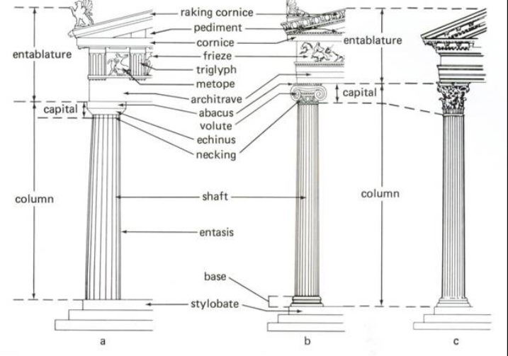

Doric
Temple of Hera, Paestum, ca. 550 BCE
- 9 Columns by 18 Columns (1:2 Rate)
- Articulation of elements that catches sunlight in an ever-changing play of shade and shadow across the caved surfaces. This may be one reason it has endured even to the presents as an expressive part of western architecture.
- The Doric temple usually uses Limestone for their orders, since it’s the local material available.
- This imposed structural limitations on the length of spans for lintels and the diameter of columns needed to support the heavy tile roof.

Ionic
Athens, The Acropolis
Erectheion Athens ca.420 BCE
- The Ionic has a base supporting its fluted column shaft
- A capital with Volutes (Scrolls)
- The Ionic temple used marble; a superior stone and thus had a more slender profile.
- The temple is usually found in the islands and on the coasts of Asia Minor, the areas settled by Greek who had fled from the Dorians.
- Its Columns are slimmer, lighter and more delicately sculpture and can be readily identified by volutes on the capitals that look like rams’ horns or a scroll.

Corinthian
Temple of Olympian Zeus, Athens, ca. 170 BCE
- The Corinthian capital, shaped like an upturned bell surrounded by serrated leaves, on the one hand evaded what had always been a problem with the corner pillar of the ionic.

Terms:

Columns In classical architecture, the upright structural element consisting of a base, shaft and capital.

Entasis The slight outward curve of a column, which then tapers toward the top of the shaft.

Intercolumniation The space between columns

Colonnade A linear series of columns with entablature

Elements in a capital:

- Abacus On a classical column, the stone set directly over the capital

- Echinus The curve cushion-like molding that, together with the abacus, forms he capital in the Doric order.

- Necking

- Fluting Vertical grooves incised in the shaft of a classical column
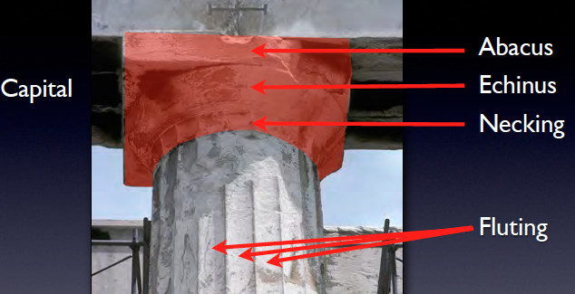

Architrave In classical architecture, the bottom portion of an entablature.

Frieze The horizontal element above the architrave and below the cornice in an entablature.

Triglyph A channeled block set between metopes in a Doric frieze

Metope An element of the Doric Frieze set alternately with triglyph. Metope panels contain low-relief carvings.
Cornice + Frieze + Architrave = Entablature

Pediment The gable end of a temple, framed by cornices.

