ARTH 1200
History and Theory of Architecture 1:
Prehistory to ca.1600
Week 2

Making Space meaning full
The Magdalenian Period, ca 15,000- 7,000 BCE

- The term “Magdalenian” refers to a late period of upper Paleolithic art and culture.
- Magdalenian tool culture is best known for its denticulated microliths, as well as its universal and biserial projectile points.
- An important influence on Magdalenian rock art was the climate.
- Magdalenian man lived as a hunter-gatherer, living off the herds of reindeer on the continental tundra, just outside the ice pack.
- Between 13000 and 10000 BCE, the ice age came to an end and period of global warming began.
- Around the start of the Holocene epoch (10,000 BCE), Magdalenian culture was superceded by two other microlithist cultures: the "Azilian" in Spain and southern France, and the "Sauveterrian", in northern France and Germany.

Lascaux Cave Paintings

- Chauvet Cave, France; Cave of the forgetten dreams
- Grotte de Niaux, Ariège, France
- The Lascaux cave contains some of the greatest examples of Paleolithic art and culture, from the Solutrean-Magdalenian era dating back to between 17,000 and 15,000 BCE.
- The paintings include a rare examples of a human figure, the largest simple image ever found in a prehistoric cave was the Great black bull.
- Lascaux is one of the few stone age caves in France to have been decorated with color painting.
- Its most famous chambers include the Hall of the Bulls
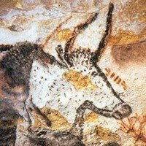

Painting of Auroch in "Hall of the Bulls" dating from about 17,000 BCE. Note the horns are painted from the front, while the body is depicted in profile.

Making meaningful space:
Neolithic Sites

- This is space made by human. It’s a human creation
- From the period ca. 9000 BCE – 2000 CBE
- “Stone Age”

Newgrange Passage Grave, Ireland, ca. 31000 BCE

- The kidney shaped mound covers an area of over one acre and is surrounded by 97 kerbstones,
- The 19 metre long inner passage leads to a cruciform chamber with a corbelled roof.
- It is estimated that the construction of the Passage Tomb at Newgrange would have taken a work force of 300 at least 20 years.
- The Gavrinis passage tomb in Brittany is remarkable similar to Newgrange. The cairn is about 5500 years old, it is 60 metres in diameter and covers a passage and chamber which is lined with elaborately engraved stones.
- In the passage and chamber 23 of the 29 upright stones are engraved with zig-zags, concentric circles, herring bones, axes, bows and arrows.

Loughcrew, Ireland, ca. 3000 BCE

- Also known as the Hills of the Witch, are a group of Neolithic passage tombs.
- The tombs are located on three different hills and Cairn T
- One of the largest tombs in the complex is situated on Cairnbane East.
- Inside this tomb lies a cruciform chamber, a corbelled roof and some of the most beautiful examples of Neolithic art in Ireland.
- During the Vernal and Autumn Equinox people gather at dawn in Cairn T to watch sunlight enter the chamber and illuminate the inside of the tomb.

Stonehenge, Wiltshire, England, Begun ca. 3000 BCE

- One of the most famous sites in the world.
- Stonehenge is the remains of a ring of standing stones set within earthworks.
- It is in the middle of the most dense complex of Neolithic and Bronze Age monuments in England, including several hundred burial mounds.

Historical/ Intellectual/Cultural Context

‘… The burial place of Uther pendragon’
‘… Built by the Romans’
‘… Build by the Druids’
‘… A great observatory for determining the solstices… and predicting lunar and solar eclipses…’

Egypt

Mastaba

- Earliest tomb.
- Were build as eternal houses for the departed and were in all likelihood based on the design of the dwellings of the living.
- Ordinary houses were constructed of reed, thatch and wood. Materials wholly unsuited for a permanent residence so that builders of mastaba tombs sought greater durability by using brick.
- The basic Mastaba was a blocklife structure above ground containing a small room for offerings and another chamber for the body and a statue of the deceased.
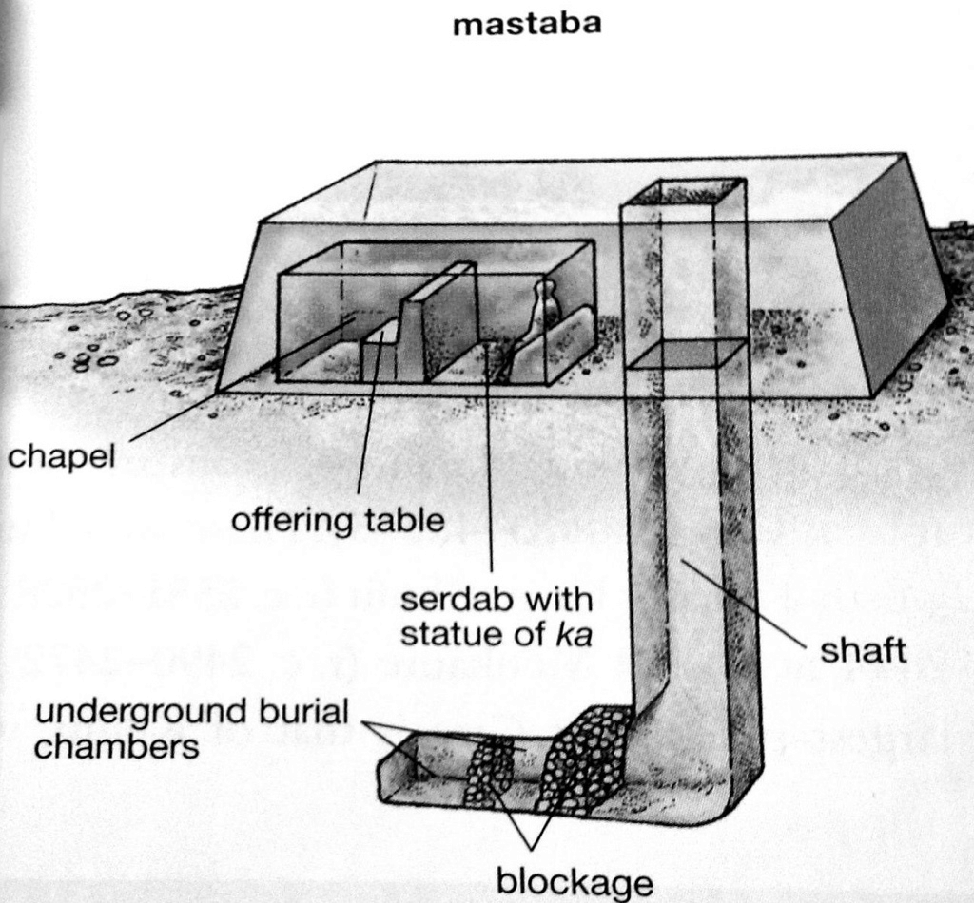

This aerial shows the burial chamber beneath the structures and small chamber, or serdabs, provided at ground level for offerings to the spirit of the decreased. It is though that these tombs, constructed a sun-dried brick or stone, were based on designs of actual dwellings constructed of less durable materials.

Funerary Complex of King Djoser. Saqqara, Egypt. Imhotep, Ca. 2630 BCE

- As the first monumental stone construction in Egypt, this tomb set the precedent for later pyramids of the pharaohs. Is architect, Imhotep was remembered for his genius and later revered as a deity.
- The step pyramid is the rectangular element in the center, dominating the great court, which is reached through the narrow processional hall at the lower left.
- The Egyptians provided the court’s two B-shaped stone blocks so that Djoser’s ka could continue to run the ceremonial race between them, symbolizing for eternity the governmental unity of upper and lower Egypt.
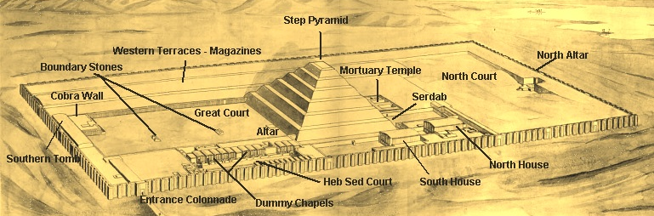

The First Pyramids

- As the religious ritual prescribed by the priesthood evolved to enhance further the significance of the pharaoh.
- The Mastaba was likewise enlarged, eventually producing the pyramid.
- At death the pharaoh accompanied the sun God on his daily journey across the sky, so he needed to be lifted skyward.
- The shape also makes a symbolic reference to the annual rebirth of nature, for as flood recrede, the first signs of plant life appear on small hillocks.
- The stepped and eventually the true pyramid’s form represented both daily and yearly rebirth throughout eternity.
- The pyramid was built up in several stages to attain its present shape, a mass rising in six steps.
- The exterior of the pyramid was faced with dressed limestone, while the courtyards and surrounding buildings are though to be representation of Djoser’s earthly palace in Memphis, rebuilt there to last for eternity.

Themes to see:
- Royal Patronage
- The Afterlife
- Religion

