ECON 1000A
Assignment #2
Pg. 250, #7
7. Four roommates are planning to spend the weekend in their dorm room watching old movies, and they are debating how many to watch. Here is their willingness to pay for each film:
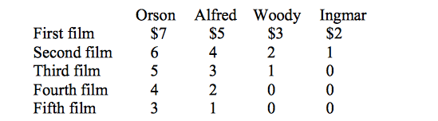

1. Q: Within the dorm room is the showing of a movie a public good? Why or why not?
A: In this situation the showing of a movie IS indeed a public good. This is said because none of the roommates can actually be excluded from watching the movie. The fact that one roommate’s viewing does not affect the ability of another roommate to view the movie, the good would also be seen as non-rival in terms of consumption.

2. Q: If it costs $8 to rent a video, how many videos should the roommates rent to maximize total
surplus?
A: The roommates should only rent 3 movies because the value of the fourth film is 6 dollars and that is less than the cost which is 8 dollars.

3. Q: If they choose the optimal number from part (b) and then split the cost of renting the videos
equally, how much surplus does each person obtain from watching the movies?
A: The total cost would be $24 ($8 × 3) If the cost were to be evenly divided between the roommates, each would pay $6. As for surpluses that depends on the willingness to pay (value)
-Orson values three movies at $18 so his surplus would be $12.
-Alfred values three movies at $12 so his surplus would be $6.
-Woody values three movies at $6, so his surplus would be $0.
-Ingmar values three movies at $3 (the least) therefore, Ingmar’s surplus is -$3.

The total, in terms of surplus among the three roommates (Orson, Alfred and Woody) would be $15.

4. Q: Is there any way to split the cost to ensure that everyone benefits? What practical problems does this solution raise?
A: Yes, the costs could be divided up based on the benefits they each receive. For instance, the one who values movies the most is Orson and as a result, he would pay the greatest share. The issue with this is that, each roommate is given a motivation to understate the value of the movies to him.

5. Q: Suppose they agree in advance to choose the efficient number and to split the cost of the videos equally. When Orson is asked his willingness to pay, will he have an incentive to tell the truth? If so, why? If not, what will he be tempted to say?
A: All roommates are going to pay equal shares. As a result, Orson has a motivation to tell the truth about the value he places on movies to make sure that the group rents 3 movies. Orson values each individual movie more than his cost per movie—which is two dollars.

6. Q: What does this example teach you about the optimal provision of public goods?
A: This example teaches me that, the optimal provision of public goods will take place if and when people DO NOT have an incentive or motivation to hide their perceived value or worth of a good. In other words, each individual’s cost cannot be related to his valuation.

Pg. 293, #5
5. Nimbus, Inc., makes brooms and then sells them door-to-door. The relationship between the number of workers and Nimbus's output in a given day is given in the following table:
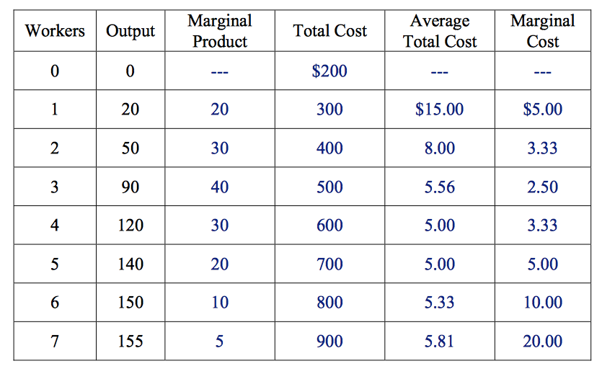

a. Fill in the column of marginal products. What pattern do you see?
A: Refer to table for Marginal products. At first, Marginal product rises, then it declines
Explanation:
This happens because of diminishing marginal product.

b. A worker costs $100 a day, and the firm has fixed costs of $200. Use this information to fill in the column for total cost.
A: Refer to table for total cost.

c. Fill in the column for average total cost. (Recall that ATC = TC / Q.) What pattern do you see?
A: Refer to table for average total cost. Average total cost is U-shaped (parabolic)
PATTERN: When quantity is low, ATC declines as quantity rises; when quantity is high, ATC rises as quantity rises.

c. Now fill in the column for marginal cost. (Recall that MC = ΔTC / ΔQ.) What pattern do you see?
A: Refer to table for marginal cost. Marginal cost is also U-shaped (parabolic)
PATTERN: Marginal cost rises steeply as output increases (Opposite and Skewed)
Reason: This is because of diminishing marginal product.

d. Compare the column for marginal product and the column for marginal cost. Explain the relationship.
A: As marginal product is rises, marginal cost falls.
And as marginal product falls, marginal cost rises
PATTERN: inversely proportioned.

e. Compare the column for average total cost and the column for marginal cost. Explain the relationship.
A: MC= Marginal Cost
ATC= Average Total Cost
When MC is less than ATC, ATC is falling.
As a result, the cost of the last unit produced pushes the average down.
However, when MC is greater than ATC, ATC is rising
And as a result, the cost of the last unit produced pushes the average up.

