
Department of Civil and Environmental Engineering

Course Notes for CIVE 3208

Geotechnical Mechanics

Instructor: M.T. Rayhani

Contents:
Chapter 10: Stress in Soil

References:
Soil Mechanics & Foundations, M. Budhu, John Wiley & Sons
Principles of Geotechnical Engineering, B. M. Das, Thompson Publishing
Fundamentals of Engineering Geology, Bell, F.G., Oxford University Press
An Introduction to Geotechnical Engineering, Holtz & Kovacs, Prentice Hall

10. Stress in Soil

Virtually all civil engineering structures impart loads onto the ground and those loads produce compressive, shear and possibly tensile stresses. These stresses might cause problems such as shear failure and excessive settlement. Many geotechnical problems depend on assessments of stresses in the ground.

Stress

• Intensity of the loading

• Force per unit area

Strain

• Change in length / original length

• Deformation per unit length

Normal stresses & normal strains

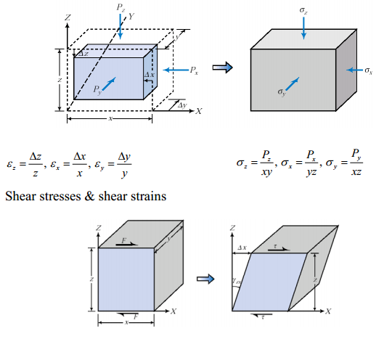

10.1. Geostatic Stress
Occur due to the weight above the point being evaluated
- Caused by gravity acting on the soil or rock
  - The direct result is the vertical normal stress
- This stress has a significant impact on engineering behaviour of soil
$$σ_{Z}=γH$$

Example 10.1 and 10.2:
Compute geostatic stress at point A, B, C
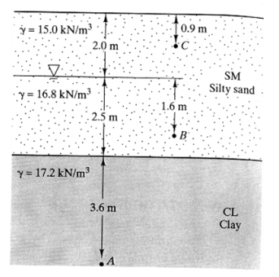

10.2. Effective Stress
The concept of effective stress or intergranular stress distinguishes between the forces transmitted through the soil skeleton and the forces transmitted through the pore water.
Applied normal loads (or stresses) in soils would be carried by both by solid particles, and pore water (in saturated soils). Effective stress is defined as follows;
$$σ=σ^{'}+u$$
Where:
- σ is the total normal stress
- σ′ is the effective stress
- u is the pore water pressure

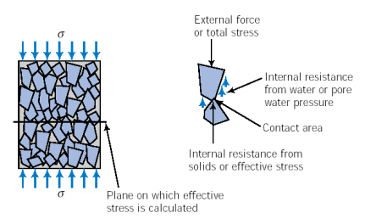
To determine the effective stress
- Determine the total stress
  - By considering the weight of the material above that point (plus any external forces)
- Determine the pore pressure
  - Static relationship: hρ_{w}g
  - Seepage/Flow velocity will influence “u”
The load carried by the solid particles is represented by “Effective stress” (σ’)
- Behaviour (volume change and shear strength characteristics) of soils is dependent on the effective stress, and NOT on the total stress
- Terzaghi (in 1920s) was the first person to recognize this.
What about shear stresses?
- Water cannot carry shear stresses. Therefore all shear stresses are carried by the soil particles
- i.e. Effective stress principle is ONLY applicable for normal stresses

Notes about effective stress:
- Effective stress is not the contact stress between soil particles, rather it is an average representation of the forces carried by the soil particles
    - Force carried by soil particles over the entire area
- Soils cannot carry tension, therefore effective stress is always positive (i.e. compression)
    - Note PWP may either be positive (pressure) or negative (suction)
- For unsaturated soils
$$σ^{'}=σ-u_{a}+X(u_{a}-u_{w})$$
- u_{a} : pore air pressure
- u_{w} : pore water pressure
- c : Factor representing the degree of saturation
      - c = 1 for saturated soil
      - c = 0 for dry soil
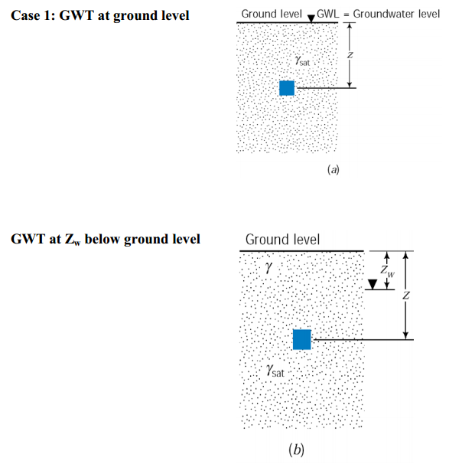

Example 10.3:
Given the soil distribution below, plot the total and effective stress distributions and the pore water pressure distribution for the soil.
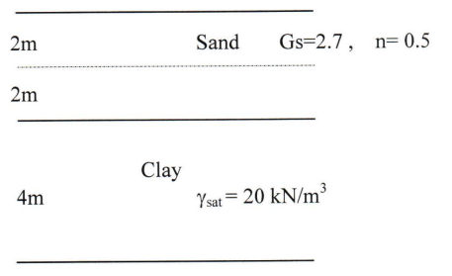
Effect of Capillary:
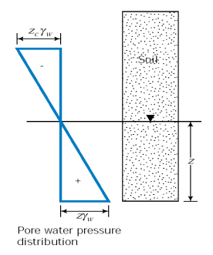
Example 10.4:
A layer of saturated clay 4m thick is overlain by sand 5m deep. The GWT is located at a depth of 3m below the ground surface. (saturated unit weight of the clay is 19 kN/m³, and that of sand is 19 kN/m³; unit weight of the sand above water table is 17 kN/m³).
Determine the total and effective stress distributions.
If the sand above water table is saturated to a height of 1m above GWT due to capillary rise, how will this affect the stress distributions? Sketch the variation of total, effective stresses under this scenario.
Note: In reality different pore diameters lead to a fully saturated zone, and a partially saturated zone above the GWT. But we will assume that the pore space has uniform diameter. (Therefore no partially saturated zone exists. The sand above 2m is dry. i.e, no PWP above 2m, but at 2m sudden drop to -9.8 kPa)

10.3 Changes in Effective Stress
Change in effective stress may result:
- Settlement
- Collapse/failure
- Instability of sheet piles
- Piping
Increase in effective stress
- Change in GWT
- Capillary fringe
- Seepage
- External loads

Influence of Seepage on the Effective Stress

As water flows through the soil, the total head decreases and energy losses due to friction occur (frictional drag). There is a transfer of energy from the moving water to the soil particles. This transfer of energy is referred to as the seepage force.

Consider an upward gradient or upward seepage adjacent to a sheet pile wall.

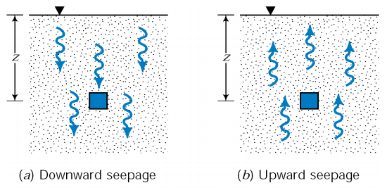
- As water flows through soil it exerts a frictional drag (resulting in head losses)
- Frictional drag “Seepage Force”
- Generally represented by the Seepage Force per unit Volume, j_{s} (recall, unit weight is the weight per unit volume)

$$j_{s}=\frac{seepage}{volume}=\frac{\left(Δhγ_{w}\right)A}{AL}=\frac{Δhγ_{w}}{L}=iγ_{w}$$
- For downward seepage: Seepage forces and Weight act in the same direction
$$σ_{Z}^{'}=γ^{'}z+izγ_{w}=γ^{'}z+j_{s}z$$
- For upward Seepage: Weight acts downwards, and Seepage Forces act upwards
$$σ_{Z}^{'}=γ^{'}z-izγ_{w}=γ^{'}z-j_{s}z$$

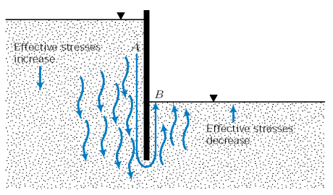
Seepage Forces play an important role in geotechnical design
- Left side of the wall
- effective stresses increase,
- as a result lateral forces on the wall increase
- Right side
- Effective stresses decrease, therefore, “Resistance” decreases
- Critical Hydraulic gradient
- The effective stress would decrease as the upward seepage velocity increase

$$σ_{Z}^{'}=γ^{'}z-\left(iγ_{w}\right)z$$
for $i=i_{cr}=\frac{γ^{'}}{γ_{w}}, σ_{Z}^{'}=0$
This is called the “quick” (or boiling) condition

Piping in Granular Soils
At the downstream, near the dam, the exit hydraulic gradient: $i_{exit}=\frac{Δh}{ΔL}$
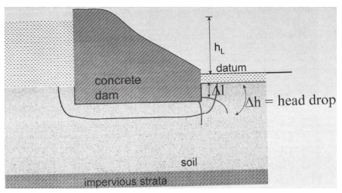
If i_{exit} exceeds the critical hydraulic gradient (i_{cr}), firstly the soil grains at exit get washed away. This phenomenon progresses towards the upstream, forming a free passage of water (“pipe”).
Piping is a very serious problem. It leads to downstream flooding which can result in loss of lives. Therefore, provide adequate safety factor against piping.
$$FS_{piping}=\frac{i_{cr}}{i_{exit}} 4<FS<6$$
Example 10.5:
The foundation soil at the toe of a masonry dam has a porosity of 0.41 and a G_{s} of 2.68. To assure safety against piping, the specifications state that the upward gradient must not exceed 25% of the gradient for quick condition.
What is the maximum permissible upward gradient?
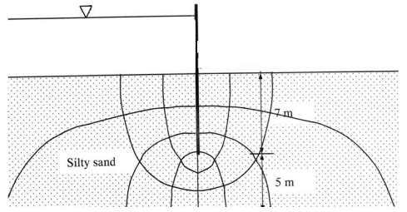
Example 10.6:
Compute factor of safety for piping in the following figure. ∆h=20 m and γ_{sat}=20 kN/m³.

10.4. Stress due to surface loads (Induced stress)

Soils are generally loaded at the surface (or just below the surface)
- Deformations would depend on the distribution of the applied load
- Theoretical solutions possible for specific loading scenarios (with appropriate assumptions of soil behaviour)
Stress distribution due to point load
Boussinesq (1885) solution
- For a homogeneous, isotropic, linear elastic, semi-infinite medium
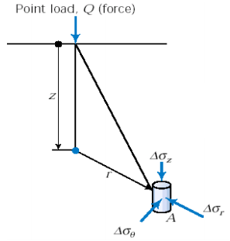
- Solutions for stress increments in the vertical, radial and the transverse directions yield lines
$$Δσ_{Z}=\frac{3Q}{2πz^{2}}{\left(\frac{1}{1+{\left(\frac{r}{z}\right)}^{2}}\right)}^{\frac{5}{2}}=\frac{3Qz^{3}}{2πL^{5}}=I\left(\frac{Q}{z^{2}}\right)$$

$$Δσ_{r}=\frac{Q}{2π}\left(\frac{3r^{2}z}{{\left(r^{2}+z^{2}\right)}^{\frac{5}{2}}}-\frac{1-2v}{r^{2}+z^{2}+z{\left(r^{2}+z^{2}\right)}^{\frac{1}{2}}}\right)$$

$Δσ_{θ}=-\frac{Q}{2π}\left(1-2v\right)\left(\frac{z}{{\left(r^{2}+z^{2}\right)}^{\frac{3}{2}}}-\frac{1}{r^{2}+z^{2}+z{\left(r^{2}+z^{2}\right)}^{\frac{1}{2}}}\right)$

$$Δτ_{rz}=\frac{3Q}{2π}\left[\frac{rz^{2}}{{\left(r^{2}+z^{2}\right)}^{\frac{5}{2}}}\right]$$
Mostly interested is the change in vertical stress, ∆σ_{z}
- Along the axis of loading, r = 0 $Δσ_{Z}=\frac{3Q}{2πz^{2}}$
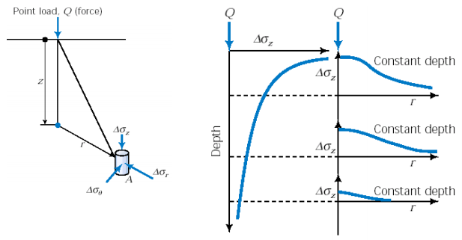
Line load:
- Line load: Load transmitted over an area of negligible width but infinite length
- A collection of point loads placed next to each other
- integrate along the line
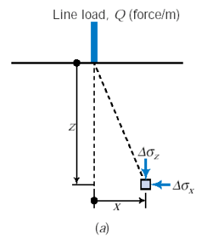
$$Δσ_{Z}=\frac{2Qz^{3}}{π{\left(x^{2}+z^{2}\right)}^{2}}$$

$$Δσ_{x}=\frac{2Qx^{2}z}{π{\left(x^{2}+z^{2}\right)}^{2}}$$

$$Δσ_{y}=\frac{2Qv}{π\left(x^{2}+z^{2}\right)}$$

$$Δτ_{XZ}=\frac{2Q}{π}*\frac{xz^{2}}{{\left(x^{2}+z^{2}\right)}^{2}}$$
• Effect of line load on a retaining wall
- By substituting x = aH₀ and z = bH₀ into the equation for ∆σ_{x},
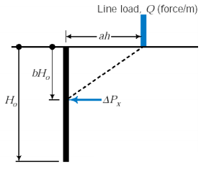
$$Δσ_{x}=\frac{2Qa^{2}b}{πH_{o}{\left(a^{2}+b^{2}\right)}^{2}}$$

Increase in lateral force:
$$ΔP_{x, total}=\int_{0}^{H_{o}}{{Δσ}_{x}dh}$$
$$= \int_{0}^{H_{o}}{\frac{2Qa^{2}b}{πH_{o}{\left(a^{2}+b^{2}\right)}^{2}}dh}$$
$$= \int_{0}^{1}{\frac{2Qa^{2}b}{πH_{o}{\left(a^{2}+b^{2}\right)}^{2}}db=\frac{2Q}{π\left(a^{2}+1\right)}}$$

Strip Loads:
- Strip load: Load transmitted over an area of finite width, but infinite length on a soil surface
- A collection of line loads placed together
    - Single integration of the line load results
    - Double integration of point load formulation

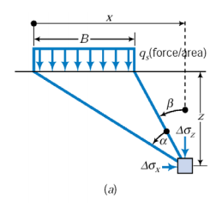
For uniform strip load:
$$Δσ_{Z}=\frac{q_{s}}{π}[α+\sin{α cos⁡(α+2β)]}$$

$$Δσ_{x}=\frac{q_{s}}{π}[α-\sin{α}\cos{(α+2β)]}$$

$$Δτ_{Zx}=\frac{q_{s}}{π}[\sin{α*\sin{(α+2β)] }}$$

Triangular loads
- Theoretical solutions can be obtained for other simple forms of loads as well.
- e.g. Triangular strip loads
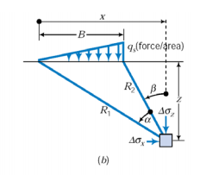
$$Δσ_{Z}=\frac{q_{s}}{π}\left[\frac{x}{B}α-\frac{1}{2}\sin{2β}\right]$$

$$Δσ_{x}=\frac{q_{s}}{π}\left[\frac{x}{B}α-\frac{z}{B}\ln{\frac{R_{1}^{2}}{R_{2}^{2}}+\frac{1}{2}\sin{2β}}\right]$$

$$Δτ_{Zx}=\frac{q_{s}}{2π}\left[1+\cos{2β}-2\frac{z}{B}α\right]$$

Uniformly loaded rectangular area
- Many foundations are rectangular in shape
- Boussinesq solution for point load: $Δσ_{Z}=\frac{3Qz^{3}}{2πR^{5}}=\frac{3Qz^{3}}{2π{\left(\sqrt{x^{2}+y^{2}+z^{2}}\right)}^{5}}$

- Increase in stress below the corner of a rectangular area
$$Δσ_{Z}= \int_{0}^{L}{\int_{0}^{B}{\frac{3\left(q_{s}dxdy\right)z^{3}}{2π{\left(\sqrt{x^{2}+y^{2}+z^{2}}\right)}^{5}}}}$$
$$=\frac{3q_{s}z^{3}}{2π}\int_{0}^{L}{\int_{0}^{B}{\frac{dxdy}{{\left(\sqrt{x^{2}+y^{2}+z^{2}}\right)}^{5}}}}=q_{s}I_{Z}$$

- Integration by Newmark (1935) to obtain I_{z} yielded
$$I_{Z}=\left(\frac{1}{4π}\right)\left[\frac{2mn\sqrt{m^{2}+n^{2}+1}}{m^{2}+n^{2}+m^{2}n^{2}+1}\left(\frac{m^{2}+n^{2}+1}{m^{2}+n^{2}+1}\right)\right]+\tan^{-1}\left(\frac{2mn\sqrt{m^{2}+n^{2}+1}}{m^{2}+n^{2}-m^{2}n^{2}+1}\right)$$
$$\left(for m^{2}+n^{2}-m^{2}n^{2}+1>0\right) where, m=\frac{B}{z}, \& n=\frac{L}{z}$$
Influence factor chart
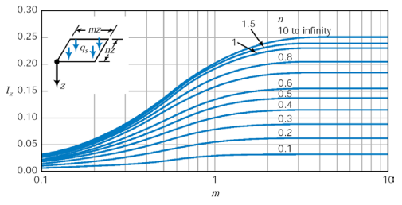
Stress increase beneath the centre of a rectangular foundation (or beneath any point)
- Newmark’s Chart
- To determine the vertical stress increment due to arbitrarily shaped surface loads
- Chart consists of concentric circles divided by radial lines
- Each chart is accompanied by a depth scale, and an influence factor I_{N}
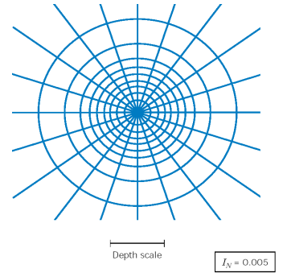

$$I_{N}=\frac{1}{\left(\#or radial zones\right)\left(\#of circular zones\right)}$$

Procedure for using Newmark’s chart
- Select a drawing scale, by equating the depth at which stress increment is required to the depth scale shown in the chart.
- Identify the point on the loaded area below which the stress is required. (Say point A).
- Plot the loaded area using the scale selected in (1) with point A at the center of the chart.
- Count the number of segment (Ns) covered by the scaled loaded area.
- If certain segments are not fully covered, you can estimate what fraction is covered.
- Calculate the increase in vertical stress as $Δσ_{Z}=q_{s}I_{N}N_{s}$
Pressure Isobars
- Pressure isobar: Contours showing the pressure increase due to applied load. Contours are shown as a fraction of the applied stress q at the surface in the above diagram
- Note that the stress increments decrease fairly rapidly with depth, why?
- Stress increments at a depth of z = 2B
- For square footing: about 10%
- For strip footing: about 30%
- Stress increments at a depth of z = 4B
- For square footing: about 3%
- For strip footing: about 15%

Approximate Method
- For preliminary analysis the “2:1 method” can be used
- The effective area on which the load acts increases with depth at a ratio of 2V:1H
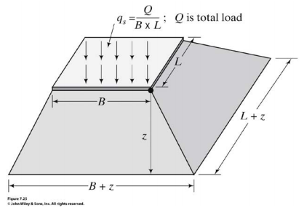
Example 10.7:
Compute ∆σ_{z} at a depth of 10 m below the edge of a square foundation with 25 m width. The structure and its contents have a total 6.1*10⁶ kg, which is uniformly distributed across its base.
Compute the stress increment below the centre of the foundation.

Example 10.8:
The footing shown below supports a vertical load of 475 kN. Compute the magnitude of σ_{z} at points A, B, and C considering both geostatic and induced stresses.
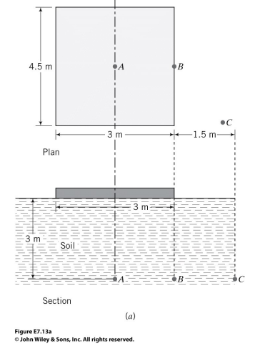
Example 10.9:
Compute ∆σ_{z} at a depth of 10 m below the centre of a square foundation with 25 m width. The structure and its contents have a total 6.1*10⁶ kg, which is uniformly distributed across its base.

Example 10.10:
Two meters of fill (ρ=2.04 Mg/m³) are compacted over a large area. On top of the compacted fill, a 3*4 m spread footing loaded with 1400 kN is placed. Assume that the average density of the soil prior to placement of the fill is 1.68 Mg/m³ and that the water table is very deep.
- What is the stress increment due to the fill?
- What is the stress increment at depth z=2 m measured from the footing base that is placed 1 m below the top of the filled ground?

10.5. Relationship between Horizontal and Vertical Stresses
Horizontal stresses in a soil mass are often expressed as a percent of the vertical stresses
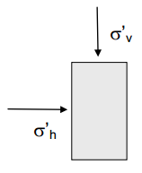
Recall from fluid mechanics that the pressure at a point in a fluid is the same in all directions. This is not applicable to soils.
$$σ_{h}=Kσ_{v}$$
where K is the earth pressure coefficient. However, the K will be dependent on the location of the water table. To remove the influence of a fluctuating water table, express the above equation in terms of effective stresses (effective stresses, not total stresses).
$$σ_{h}^{'}=K_{o}σ_{v}^{'}$$
where K_{o} is the coefficient of lateral earth pressure at rest.
- K_{o} is very sensitive to the geologic and engineering stress history and is dependent on the soil layers above the point or soil layer in question.
- It can vary from 0.5 for natural sedimentary soil deposits which have not been preloaded up to 3.0 or greater for a heavily overconsolidated or preloaded deposit.
- The value for K_{o} is very important in the stress and shear analyses. (e.g. dams, large retaining walls, foundations, etc.)
- The pore water pressure is hydrostatic and, at any given depth, the pore water pressures in all directions are equal.
- Empirical equation for K_{o}
- Jaky’s equation: $K_{o}=1-\sin{(ϕ)}$
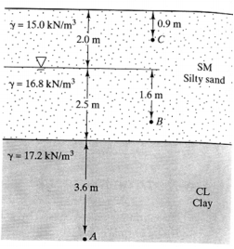
- Where φ is the “friction angle”.

Example 10.11:
Compute the lateral stress at point C.
(sand friction angle is 30°)

