
Department of Civil and Environmental Engineering

Course Notes for CIVE 3208

Geotechnical Mechanics

Instructor: M.T. Rayhani

Contents:
Chapter 12: Shear Strength

References:
Soil Mechanics & Foundations, M. Budhu, John Wiley & Sons
Principles of Geotechnical Engineering, B. M. Das, Thompson Publishing
Fundamentals of Engineering Geology, Bell, F.G., Oxford University Press
An Introduction to Geotechnical Engineering, Holtz & Kovacs, Prentice Hall

12. Shear Strength

The strength of a material is the greatest stress it can sustain. If the stress exceeds the strength, failure occurs.

Failure in Soil (from Coduto):
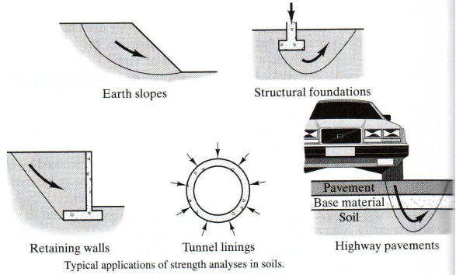
- Shear strength is the most important strength parameter in soils
  - Why not compressive or tensile strength?
Although the introduction of large compressive stresses may result in failure, the ground is actually failing in shear, not in compression. There are a few occasions where tensile failures occur, such as tensile crack near the top of landslides.
  - What is Shear Strength?
    - Difference between shear stress & shear strength
The shear strength of a soil is the shear stress on the failure plane at failure.
  - Shear strength is critical in
    - Slope stability
    - Foundation Capacity
    - Retaining structures, etc.
  - Focus of the Chapter:
    - Determine the shear strength of soils
    - Understand the differences between drained and undrained shear strength
    - Determine the type of shear test that best stimulates field conditions.
    - Interpret laboratory and field test results to obtain shear strength parameters.

12.1 Response of Soils to Shear Forces:
Stress – Strain Response
  - In most materials applied shear stress will ONLY induce a shear strain
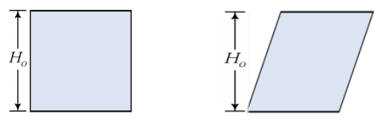
• In soils, applied shear stress will induce shear strain, and volumetric strain
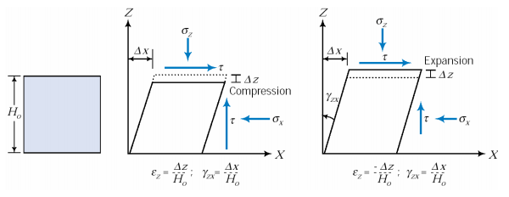
- Based on the “Shear – Volume Coupling” in soils, we have two kind of shear stress-strain curves:
      - Type 1: Contractive Soils (Ductile soil)
      - Type 2: Dilative Soils (Brittle soil)
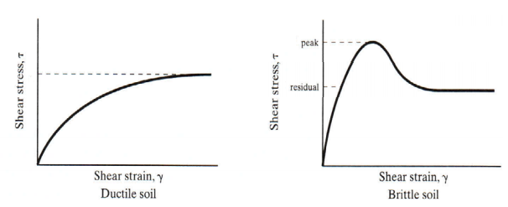
- Response depends on boundary conditions
  - Drained ?
    - High Permeability/Permeable boundaries (sands, gravels), or
    - Slow loading
  - Undrained
- Low permeability/Impermeable boundaries (silt, clay), or
- Rapid loading (e.g. Earthquake loading on Sands)
- In between (Partially Drained)

Drained and Undrained Stress – Strain Response
• Shear Stress vs Shear strain
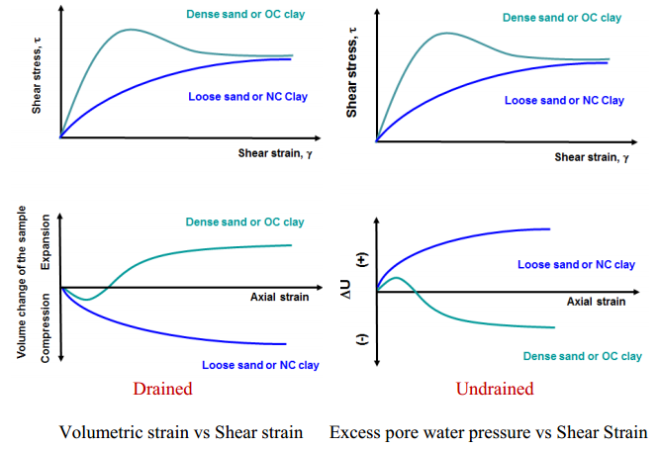
Type I Response
- Shear modulus gradually decreases and reaches an essential zero value.
  - “Strain Hardening” throughout
- Compressive volumetric strains but the rate gradually decreases and reaches close to zero
  - Compressive volumetric strains => Contraction
  - Soil gradually densifies and reaches an essentially constant void ratio at large strains
  - Generally called the “Critical Void Ratio”
- Soil Reaches a “Critical state” at large strains
  - Unlimited shear deformation occurs at constant volume and shear stress
• Critical state
  - The critical state is reached when no further changes in shear stress or volume occur with continued shearing. The shear strength and the void ratio at this state are called critical state shear strength $τ_{cs}$ and critical void ratio e_{cs}, respectively.
  - A conceptual idea, not always valid in practice
• Typical of
  - Loose sands
  - Normally consolidated clays
  - Lightly OC clays (OCR < ~2)
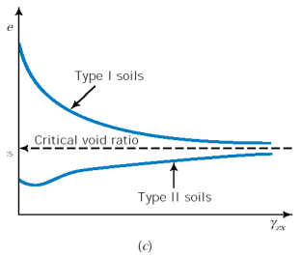
Type II Response
- Rapid increase in shear stress with strain during the early stages of the loading
  - i.e. Much higher initial shear modulus
- Shear modulus gradually decreases until peak shear stress state is realized (called the Peak strength)
- Strain softening following peak (increasing strain leads to a reduction in strength)
- Compressive volumetric strains initially, but mostly expansive strains afterwards
- Expansive strains => Dilation
- Soil initially densifies somewhat, but subsequently will loosen.
- Again, soil may reach an essentially constant void ratio at large strains (“Critical Void Ratio”)
- Typical of
    - Dense sands
    - Over consolidated clays
• Shear bands & localized failure

Effect of confining stress
- If the normal effective stress (commonly called the confining stress) increases
- Type I Soils:
  - Critical void ratio will decrease (i.e. the amount of compression will increase)
  - Shear stress at critical state will increase
- Type II Soils:
  - Critical void ratio will decrease (amount of dilation will decrease)
  - Shear stress at critical state will increase
  - The “sharpness” of the peak disappears
- Strength increasing with increasing confining stress indicates that shear strength is a function of normal stress
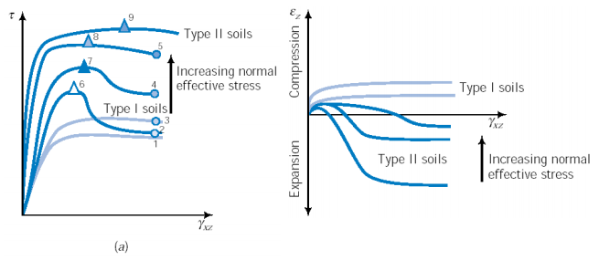

12.2. Mohr-Coulomb Failure Criterion
Mohr (1900) presented a theory for rupture in materials that a material fails because of a critical combination of normal stress and shear stress, and not from either maximum normal or shear stress alone.
- The functional relationship between normal and shear stress on a failure plane can be expressed in the form of
$$τ_{f}=f\left(σ\right)$$
- This, in general may be a non-linear relationship, but for most practical purposes we can approximate it with a linear relationship.
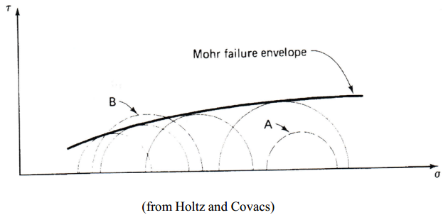
- Normally this dependency is approximated by
$$τ_{f}=c+σ\tan{(ϕ)}$$
Where $τ$_{f} is the shear strength at failure
c cohesion intercept or apparent
$σ_{f}$ is the normal stress at failure
φ angle of shear resistance (or internal friction)
- In soils the behaviour is govern by the effective stress, $σ'$ and not the total stress $σ$.
  - In terms of effective stress
$$τ_{f}=c^{'}+σ^{'}\tan{(ϕ^{'})}$$
• What is the basis of this?
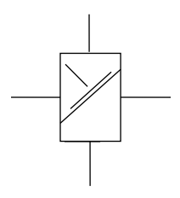
based on Terzaghi’s concept of effective stress where all the parameters are defined in terms of effective stress conventions
+ve stress compression
-ve stress tension
(soils not good in tension)

Stress and strain at a point:
- One intrinsic stress state
  - The stress state at a point is the set of stress vectors corresponding to all planes passing through that point
  - Described by different methods
    - Stresses in x, y, z planes (for simplicity just consider 2D case)
    - Instead of the traditional x, y, can have any two orthogonal directions
    - Principal planes
      - No shear stress on principal planes

Principal Stresses:
If the soil element is rotated to a certain angle, the shear stresses will be zero on all four sides. The planes on each side of this element are known as principal planes. The stresses acting on them are known as principal stresses.
- Major principle stress: the greatest normal stress that acts on any plane
- Minor principle stress: the smallest normal stress acting on any plane
- Intermediate principal stress: 3-D
$$σ_{1}=\frac{σ_{x}+σ_{z}}{2}+\sqrt{{\left(\frac{σ_{x}-σ_{z}}{2}\right)}^{2}+τ_{zx}^{2}}$$
$$σ_{3}=\frac{σ_{x}+σ_{z}}{2}-\sqrt{{\left(\frac{σ_{x}-σ_{z}}{2}\right)}^{2}+τ_{zx}^{2}}$$
$$θ_{z}=\frac{1}{2}\cos^{-1}\left[\frac{2σ_{z}-σ_{1}-σ_{3}}{σ_{1}-σ_{3}}\right]$$
Stresses Inclined at Angle θ
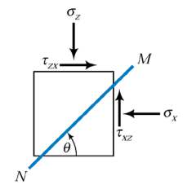
$σ_{θ}=\frac{σ_{1}+σ_{3}}{2}+\frac{σ_{1}-σ_{3}}{2}\cos{2θ}$
$$τ_{θ}=\frac{1}{2}\left(σ_{1}-σ_{3}\right)\sin{2θ}$$
$$τ_{max}=\frac{1}{2}(σ_{1}-σ_{3})$$

Maximum shear stress on planes at 45º to the principal planes

Mohr Circle:
- A graphical method of representing stresses at any plane, commonly adopted in soil mechanics.
- A plot showing the stresses at a given instant, but in different directions.
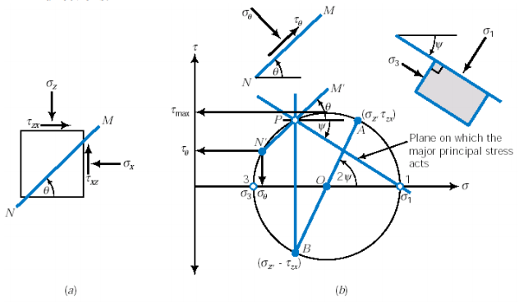
$$σ_{f}=\frac{σ_{1}+σ_{3}}{2}+\frac{σ_{1}-σ_{3}}{2}\cos{2θ}$$
$$τ_{f}=\frac{1}{2}\left(σ_{1}-σ_{3}\right)\sin{2θ}$$
$$τ_{max}=\frac{1}{2}\left(σ_{1}-σ_{3}\right)$$
$$θ=45°+\frac{ϕ^{'}}{2}$$
$$\sin{ϕ^{'}}=\frac{\frac{1}{2}\left(σ_{1}^{'}-σ_{3}^{'}\right)}{c^{'}\cot{ϕ^{'}}+\frac{1}{2}\left(σ_{1}^{'}+σ_{3}^{'}\right)}$$
Similar formulae exist if Mohr Circle is used to determine the effective stress $σ$’
Example 12.1:
The vertical and horizontal stresses at a certain point in a soil are as follow:
s_{x}=100 kPa
s_{z}=150 kPa
t_{zx}=20 kPa
- Determine the magnitudes and directions of major and minor principal stresses
- Determine the magnitude and directions of the maximum shear stress.
- Determine the normal and shear stress on a plane inclined at 35º clockwise from the x axis.

Mohr Circle and Failure Envelope
- The soil element does not fail if the Mohr circle is contained within the envelope
- Initially, Mohr circle is a point
- As loading progresses, Mohr circle becomes larger
- Finally failure occurs when Mohr circle touches the envelope
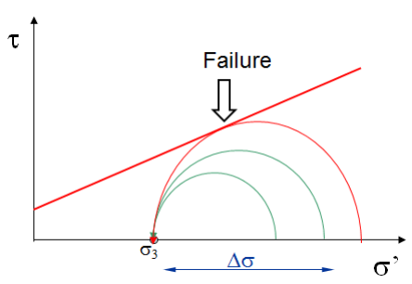
A consistent relationship exists between the shear strength on a plane and the effective normal stress that acts on that plane
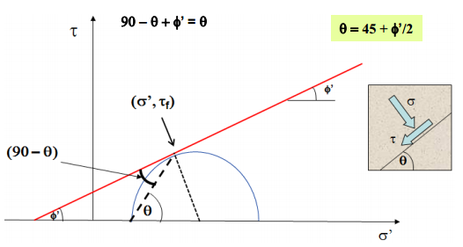
Mohr Coulomb Failure Criterion with Mohr Circle of Stress
Relationship between the effective principal stresses at failure and the shear strength parameters
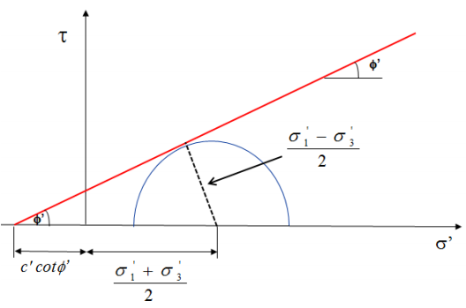
$$\left[\frac{σ_{1}^{'}-σ_{3}^{'}}{2}\right]=\left[c^{'}\cot{ϕ^{'}}+\left(\frac{σ_{1}^{'}+σ_{3}^{'}}{2}\right)\right]\sin{ϕ} \left(σ_{1}^{'}-σ_{3}^{'}\right)=\left(σ_{1}^{'}+σ_{3}^{'}\right)\sin{ϕ^{'}}+2c^{'}\cos{ϕ'}$$
$$σ_{1}^{'}=σ_{3}^{'}\tan^{2}\left(45+\frac{ϕ^{'}}{2}\right)+2c^{'}\tan\left(45+\frac{ϕ^{'}}{2}\right)$$
Example 12.2:
The major and minor principal stresses obtained from two triaxial tests are as follow:
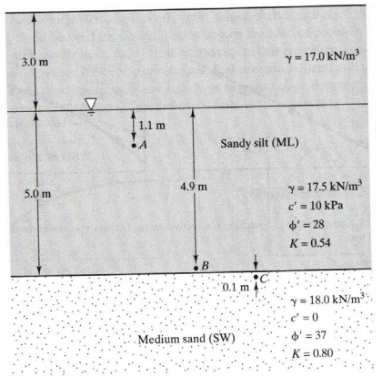
Test 1: $σ_{3}^{'}$=100 kPa, $σ_{1}^{'}$ =355 kPa
Test 2: $σ_{3}^{'}$=150 kPa, $σ_{1}^{'}$=520 kPa
Determine the shear strength parameters c’ and φ’

Example 12.3:
The shear strength parameters for two soil strata are given in Figure below.
a) Compute the shear strength at A, B, and C.
b) Draw the shear strength envelope for the ML stratum

12.4 Shear Strength of Soils: Cohesion and Friction
Cohesive Strength:
Some soils have shear strength even when the effective stress is zero, or appears to be zero. This strength is called cohesive strength.
Cohesive strength is the result of bonding between the soil particles. These bonds include:
- Cementation: chemical bonding due to the presence of cement agent
- Adhesion: primary valence bonding, type of cold welding in overconsolidated clays
- Negative excess pore pressure (apparent cohesion)

Frictional Strength:
The value of effective friction angle depends on both frictional properties of individual particles and the interlocking between particles. These are affected by many factors, including:
- Mineralogy
- Shape
- Gradation: well-graded have more interlocking
- Void ratio
- Organic materials
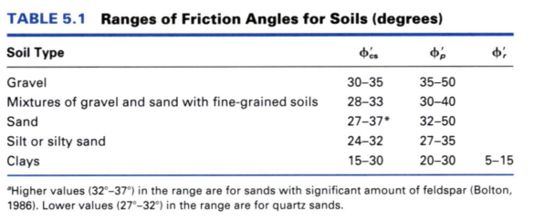

12.5. Shear Strength Measurements
In the Laboratory
- Direct shear test :sands
- Unconfined compression test: clay
- Triaxial compression test: used on important projects all soils
In the Field
- Vane shear test: clay
- Standard Penetration Test (SPT)
- Cone Penetration Test (CPT)
12.5.1 Direct Shear Test (see laboratory handout)
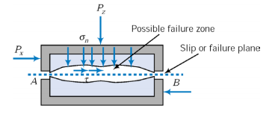
- Sample contained in a “box”
- Horizontal shear moves one half of the box relative to the other
- Horizontal load (shear stress at failure), vertical load (normal stress at failure), horizontal displacement & vertical displacement measured.
- Known sample area, height allows determination of σ, τ, γ, & ε_{a}
- Typically drained tests carried out (under constant vertical load)
- Several tests at different vertical stresses carried out

- Concerns:
- The failure plane is forced to be horizontal [it may not be the weakest plane]
- Serious stress concentrations at the sample boundaries and failure zone
- Not suitable for undrained tests

- Test several soil specimens at different vertical loadings and plot σ_{f} versus τ_{f}
- The best fit line gives the shear strength parameters c and φ.
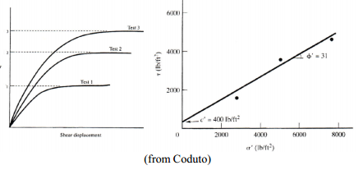
Example 12.4:
A series of three direct shear tests has been conducted on a saturated soil.
The test sample had a 60 mm length and 25 mm height. The test was performed slowly enough to produce drained conditions. Determine c’ and ϕ’
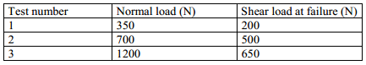
- Advantages
  - Easy to use and inexpensive
  - Fast measurement of shear strength parameters
  - Can be used to determine interface strength parameters
- Disadvantages
  - Rigid container (rigid boundary conditions)
  - Predefined shear zone
  - Difficult to do undrained tests
Direct Shear Tests on Coarse Grained Soil (sands)
- Direct shear tests are drained and pore water pressures are dissipated, hence u = 0
- φ’ = φ and c’ = c = 0, Sand is cohesionless hence c = 0
Direct Shear Tests on Clay
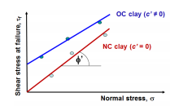
- Direct shear tests are drained and pore water pressures are dissipated, hence u = 0
- Shearing/loading should be applied at a very slow rate to allow dissipation of pore water pressure (long testing time, several days to finish)
- Failure envelopes for clay from drained direct shear tests:
Interface Direct Shear Tests
- In geotechnical engineering practice sometimes, it is required to determine the angle of internal friction between soil and other materials (concrete, steel, geomembrane, FRP, geotextile)
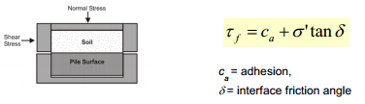
12.5.2 Unconfined compression tests
- ONLY for clays
- No lateral/radial stresses applied (stress in horizontal direction is zero)
- However, positive horizontal effective stress due to negative pore pressures in the sample
- Effective stress state is not determined in this test
- Loading carried out rapidly to ensure undrained response
- Plot Mohr circle in terms of total stress and determine the undrained shear strength S_{u}
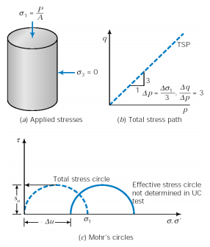
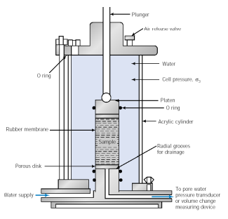
12.5.3 Triaxial Test
- Most commonly carried out soil test
- Sample contained in a rubber membrane
- All around cell pressure to provide confinement to the sample
- Shearing due to increasing vertical load (for compression tests)
- Extension tests carried out by decreasing the vertical stress
- Both drained and undrained tests can be carried out
- Achieved simply by closing/opening the drainage valve.
- Different types of tests carried out
- Uncosolidated Undrained (UU),
- Consolidated Undrained (CU) &
- Consolidated Drained (CD) tests

Soil Response under Loading:
- Two types of loading are possible from a practical perspective for engineering applications.
- Drained: (sand and gravel)
- Excess pore pressure dissipates immediately
- Pore pressure remains at hydrostatic value
- σ′ changes but can be calculated; s′ = s -u, tf = c’+ s′tanφ′
- Drained conditions occur when rate at which loads are applied are slow compared to rates at which soil material can drain
- Sands drain fast; therefore under most loading conditions drained conditions exist in sands
- Exceptions: pile driving, earthquake loading in fine sands
- Shear strength defined in terms of effective normal stresses is referred as “drained” or “effective” strength
- To use drained or effective strength, effective normal stresses need to be known which, in turn, requires that pore water pressures are known
- Undrained: (Clayey soils)
- Excess pore pressure pressure builds up as soil is loaded
- σ′ remains at initial value, therefore, use tf = c+ s’tanφ
- In some cases, such as at end of construction in fine-grained soils, where determination of pore pressures are difficult “undrained” or “total” strength is used for convenience
- where c = undrained cohesion and φ = undrained friction angle (zero for saturated soils), and σ = total normal stress
- In clays, drainage does not occur quickly; therefore excess pore water pressure does not dissipate quickly
- Therefore, in clays the short-term shear strength may correspond to undrained conditions
- Even in clays, long-term shear strength is estimated assuming drained conditions

1. Consolidated Drained test (CD)
- The sample is allowed to consolidate under applied confining stresses
- Volume (and void ratio change) during consolidation
- Sample is sheared after all consolidation is complete
- Drainage allowed during shear
- Void ratio (and volume) change during shear
- Effective stresses remain constant during shear
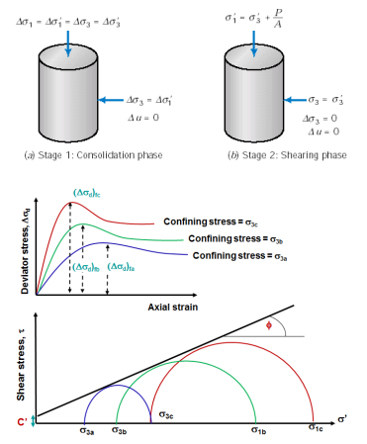
2. Consolidated Undrained test (CU)
- The sample is allowed to consolidate under applied confiningstresses
- Volume (and void ratio) change during consolidation
- Sample is sheared after all consolidation is complete
- Sample undrained during shear.
- Void ratio (and volume) constant during shear
- Effective stresses change during shear
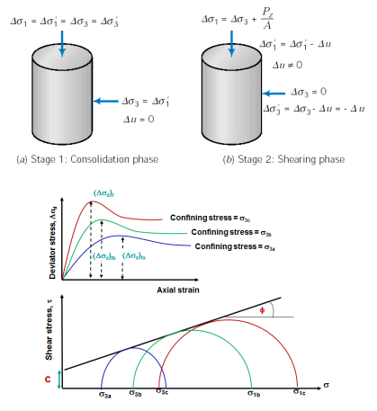
3. Unconsolidated Undrained Tests (UU)
- Similar to unconfined compression, but radial confinement applied through cell pressure
- When cell pressure is applied the pore pressure in the sample will increase by an equivalent amount
- No changes to the effective stresses since no consolidation allowed.
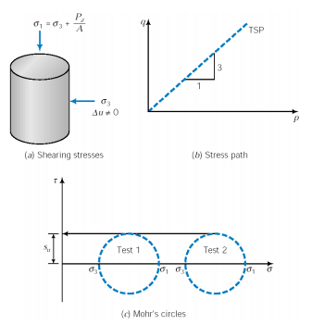
- Several tests may be carried out at different levels of cell pressure
- Plot Mohr circles (in terms of total stresses) and determine the undrained shear strength S_{u}

Example 12.5:
A series of CD tests were performed on silty sand soils. Each sample had a diameter of 50 mm and initial height of 120 mm. The condition of failure is presented in the following table. Determine the effective stress parameters c’ and ϕ’
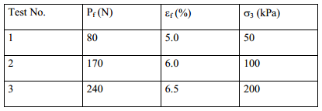
Example 12.6:
A series of CU tests were performed on clay soils. Each sample had a diameter of 50 mm and initial height of 120 mm. The condition of failure is presented in the following table. Determine the effective stress parameters c’ and ϕ’.
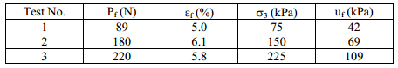
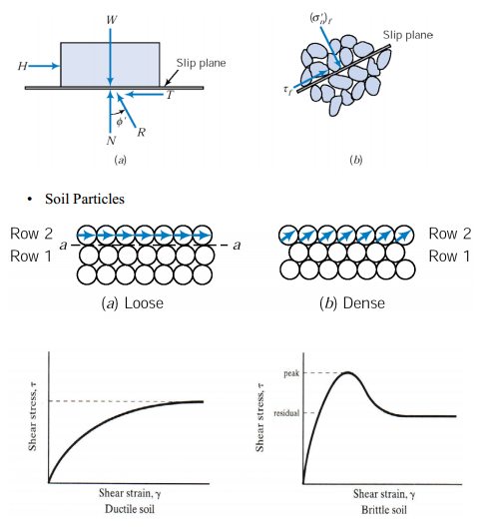

12.6. Shear Strength of Granular Soils
- For a purely frictional material with a “slip plane”

Shear Strength for Sands
- Shearing resistance derived from particle friction and interlocking
- High permeability assures drained conditions in all but dynamic loadings
τ_{f} = σ’ tan φ’ = (σ - u) tan φ’
- Friction angle, φ’ depends on
  - relative density (Dr),
  - grain shape (roundness), and
  - grain size distribution (size uniformity)
  - Pore pressure, u = uo for end-of-construction and long-term
- use drained triaxial test or a direct shear test
- Volume change in sand depends on density the particles are interlocked when compacted or in a dense formation, shear has to overcome the interlocking forces; along the shear plane the particles have move over adjacent particles
- Dilatency: increase in volume during shearing
Dilatency - concept describing the increase in volume during shearing dilation vs. compression
Rate of dilation is dε_{v}/dε_{a} (change in volumetric strain / change in axial strain)
(σ₁ - σ₃)_{max}
(σ₁ - σ₃)_{ult.}
φ′_{max}
φ′_{cv}
e_{c}
(e_{c} is a function of the confining pressure of the sand specimen (σ₃))
The critical void ratio is dependent on the consolidation or confining pressure

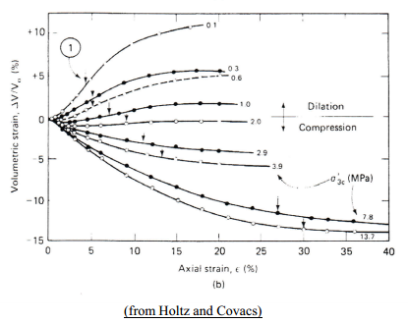
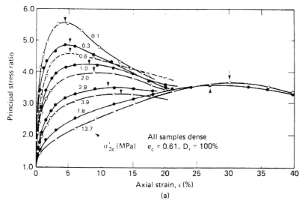
Typical behavior of sands:

12.7. Shear Strength of Clays

Consolidation of Clays

A clay consolidates (void ratio decreases) as the stress applied to the clay increases

A normally consolidated clay refers to a clay for which the current effective stress is the maximum effective stress to which the clay has been exposed.

An overconsolidated clay refers to a clay which has been exposed to aneffective stress greater than the current effective stress.

Overconsolidation ratio is the ratio of the maximum effective stress to the current effective stress.

An overconsolidation ratio of unity refers to a normally consolidated clay.

An overconsolidation ratio of greater than unity refers to a normally consolidated clay.

Undrained Response

Undrained implies no volume change (if the sample is saturated)

But, change in pore water pressure, and thus change of effective stresses

If the sample has a tendency to contract under drained loading then undrained shear will develop positive excess pore pressures (i.e. pore pressure within the sample will increase)

Excess pore pressure, ∆u = u – u₀

If the sample has a tendency to dilate under drained loading then undrained shear will develop negative excess pore pressures (i.e. pore pressure within the sample will decrease)
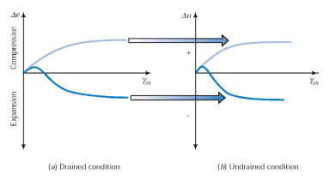
Undrained Strength of Clays
The UU and CU triaxial tests are used to determine the undrained soil strength of clay. The UU test will reflect in-situ conditions if the sample is removed and maintained at its in-situ pressure. If the volume of the sample increases, the sample can be consolidated in the triaxial apparatus to reflect the in-situ conditions. In all cases, you want to determine the strength of the clay based on the current and long term conditions it will be exposed to in the field.
- The undrained strength of the clay is also dependent upon the consolidation pressure.
- For normally consolidated clays, effective cohesion, c’= 0
- The angle of internal friction, φ’ for normally consolidated clays is higher compared to over consolidated clays
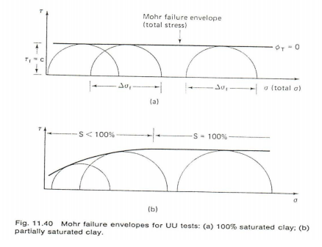
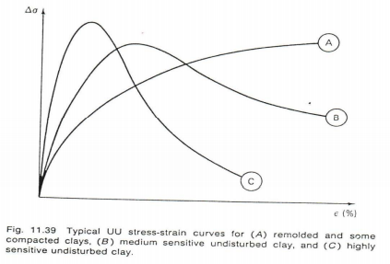
Strength in terms of Effective Stress (Clay)
The effective strength parameters can be determined using the CU and CD trixial tests. For the consolidated - undrained test, the pore water pressure must be measured to calculate the effective stress and the load must be applied slowly to allow equalization of the pore water pressure in the soil sample.

For the CU and CD tests, several tests are performed at different cell pressures to determine the Mohr-Coulomb Failure Envelope.

For a normally consolidated clay c′ will be zero and for overconsolidated clays a non-zero c′ value will exist.

Once the current stresses exceed the maximum stresses applied to the soil specimen in the past, the specimen is no longer overconsolidated and is considered normally consolidated.
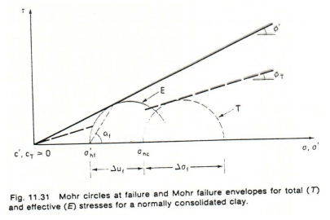
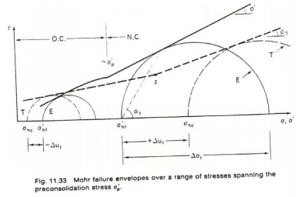

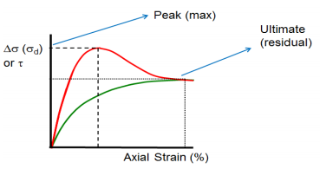
Peak vs Residual Strength
- Shear strength is sometimes interpreted based on peak shear strength values or ultimate or residual strength values
- Peak strength values are used are commonly used for coarse grained soils or soils that that are subjected to limited strains.
- Residual strength values are used for clays.

12.8. Analysis of Soil Shear Strength – Pore Pressure Parameters
- Based on the principle of effective stress, the shear strength of a soil is controlled by the effective stress which in turn is dependent on the magnitude of pore pressure for a given total stress.
- Knowledge of the mode of change in pore pressure due to a given stress change is essential for understanding the shear strength characteristics of soil.
- A pore pressure parameter is a dimensionless number that indicates the fraction of total stress increment that shows up an excess pore pressure when there is no drainage.

Pore Water Pressure Parameters in a UU Triaxial Test
- Immediately after sampling (∆u=0)
- After application of hydrostatic cell pressure
- ∆u_{c}: Increase of PWP due to increase of cell pressure (∆σ₃)
- B: Skempton’s pore water pressure parameter
- If S=1, B=1, then ∆u_{c} = ∆σ₃; B = 0 when S = 0 and under unsaturated conditions, 0 < B < 1. $Δu_{c}=BΔσ_{3}$
- During application of axial load
- ∆u_{d}: Increase of PWP due to increase of deviator stress (∆σ_{d})
- A: Skempton’s pore water pressure parameter $Δu_{d}=ABΔσ_{d}$
- Total pore water pressure increment at any stage, ∆u
$$Δu=B[Δσ_{3}+A\left(Δσ_{1}-Δσ_{3}\right)]$$
- Both B and A can be determined experimentally (using triaxial shear strength tests)
- For fully saturated condition (i.e., B = 1), Skempton’s equation can be written as below:
$$A=\frac{Δu}{σ_{1}-σ_{3}}$$
Typical values for parameter A
  - NC Clay (low sensitivity) (A = 0.5 – 1.0)
  - NC Clay (High sensitivity) (A > 1.0)
  - OC Clay (Lightly overconsolidated) (A = 0.0 – 0.5)
  - OC Clay (Heavily overconsolidated) (A = -0.5 - 0.0)
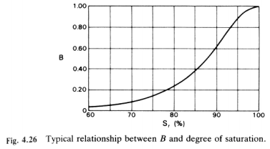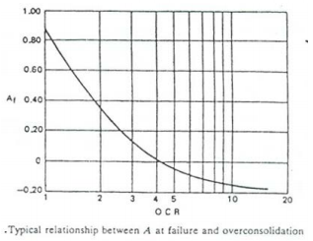
Example 12.7:
An embankment is being constructed of soil with c’= 50 kPa, φ’= 21° and ρ = 1.6 Mg/m³. The pore pressure parameters as found from triaxial tests are A = 0.5 and B = 0.9.
Find the shear strength of the soil at the base of the embankment just after the height of fill has been raised from 3 m to 6 m. Assume that the dissipation of pore pressure during the stage of construction is negligible, and that the lateral pressure at any point is one half of the vertical pressure.

12.9. The Other Shear Tests
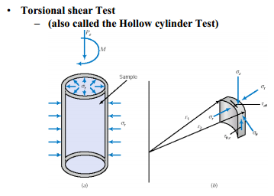
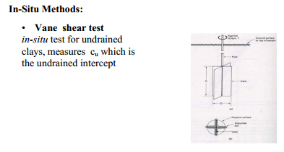
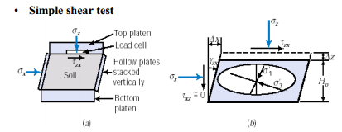

- Standard Penetration Test
- very common; main source of strength information for sand
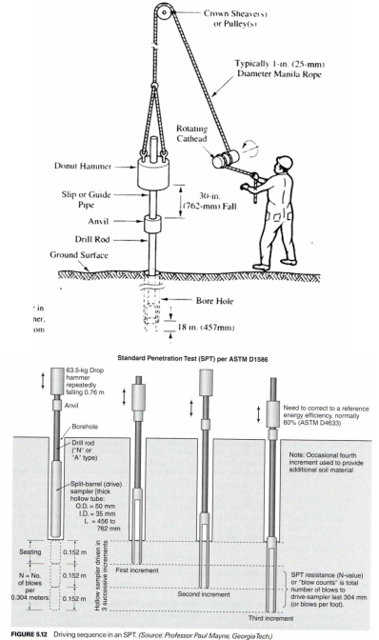

12.10. Stress Paths
Stress paths illustrate the stress path or history during a test (relationship between stress parameters during deformation).
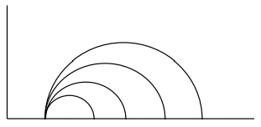
Often in geotechnical engineering, the stresses along the 45 degree plane are plotted and the coordinates of the stresses are defined as q and p. Note that it is assumed that σ₁= σ_{v} and σ₃= σ_{h} for the triaxial test.
$$q=\frac{ σ_{1}-σ_{3}}{2}$$
$$p=\frac{σ_{1}+σ_{3}}{2}$$
Stress Path - Typically plotted in p-q space:
- Plotting stresses in terms of q and p is useful is determining the stress path and how the soil approaches failure.
- q and p can be defined in terms of either total stresses (TSP) or Effective stresses (ESP) based
q′ = q
p′ = p – u
- Stress path- a plot showing the variation of two stress quantities (σ₁ vs σ₃, or p vs q, or …) with time
- Mohr’s circle – a plot showing the stresses at a given instant, but in different directions.
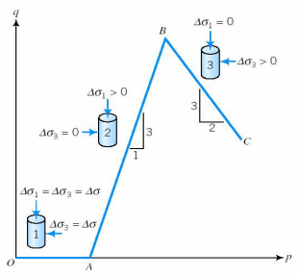
Stress path for axisymmetric loading
- Phase OA
  - Hydrostatic compression
- Phase AB
  - Axial compression
  - Constant Lateral Pressure
- Phase BC
  - Increasing Lateral Pressure
  - Constant Axial stress
The stress path will be a function of the stress history, normally consolidated clay versus an overconsolidated clay. (used in greater detail in advanced soil mechanics)
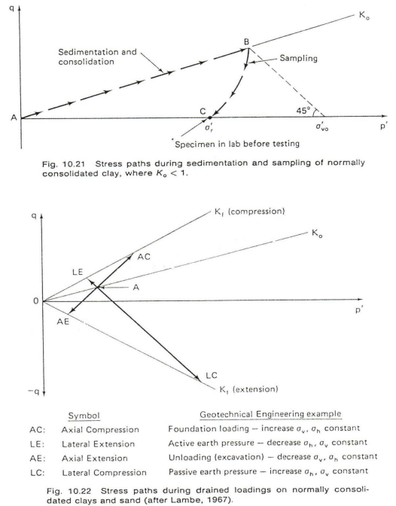
Example 12.8:
The levee shown in Figure below is to be built along the side of a river to protect a nearby town from flooding. As part of the design of this levee, the geotechnical engineer is considering the potential for a failure as shown in the figure. If the soils below the levee are clean sands with friction angle of 34º, and the shear stress at Point A is 20 kPa, compute the factor of safety against sliding at A.
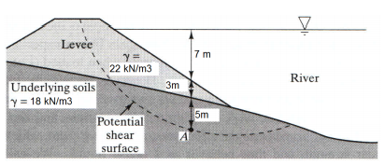
Example 12.9:
A cut is to be made in a clayey soil to permit construction of a new highway. A slope stability analysis is to be performed along the potential shear surface shown in Figure below. The soils are silty clays with C’=18kPa, ϕ’=20, and S_{u}=100 kPa. If the shear stress at point A is 60 kPa, compute the short-term and long-term factors of safety at this point.
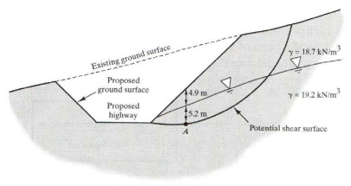
Summary
- introduced Mohr Circle, Shear strength, Mohr-Coulomb Failure
$$τ_{f}=c+σ_{f}\tan{ϕ}$$
$$τ_{f}=c^{'}+σ_{f}^{'}\tan{ϕ^{'}}$$
- introduced three methods to calculate shear and normal stresses
- Equations
- Mohr Circle
- introduced three test methods
- direct shear advantages - inexpensive, simple
disadvant. - difficult to control drainage
- horizontal plane may not be weakest
- stress concentration at boundaries
- principal stress orientation rotates during the test
- triaxial test
Unconsolidated-Undrained (UU)
Consolidated-Undrained (CU)
Consolidated-Drained (CD)
    - selected the test to reflect short term and long term field conditions
- shear vane test (in-situ)
Shear Strength for Sands
  - shear strength is dependent on the relative density and confining pressure
  - since the permeability of sands are generally high, use drained tests
  - shear box and triaxial tests (CD)
Shear Strength for Clays
  - shear strength is dependent on density, confining or consolidation pressure and the consolidation or stress history
  - normally consolidated clays, overconsolidated clays and an OCR
  - undrained shear strength parameters, φ_{u} and c_{u}
  - drained shear strength parameters φ′ and c′

Introduced Stress Paths
  - p-q plot (M.I.T. notation)
  - modified failure criterion expressed in terms of p′ and q′

Typical Shear Strength Parameters for a Sand
  - c′ is often close to zero (assume zero for a typical sand)
  - loose sand, angle of repose gives the minimum φ′ which is 30 to 35°
  - φ′ for a dense sand can be as high as 40 to 45°
  - for a normally consolidated sand K_{o} = 1 - sin φ′ (K_{o} = 0.3 to 0.5)
  - for an overconsolidated sand K_{o-oc} = K_{o} (OCR)^{h} where h = 0.4 to 0.5

Typical Shear Strength Parameters for a Clay
CD - φ′ for normally consolidated clays varies from 20(plastic) to 30°
- c′ is generally equal to zero for normally consolidated clays
- φ′ for compacted clays is generally 25 to 30° and occasionally 35°
- for overconsolidated clays φ′ decreases and c′ increases > 0
- the CD test is most important for long term, steady state seepage problems for slopes, embankments, dams, and excavations
CU - φ (total stress) is approx. 1/5 φ′ (effective stress) for normally consolidated clays and c is approx. zero
- for overconsolidated clays c > c′ and φ < φ′
UU - φ_{u} = 0 and c_{u} varies over a large range of values

Sensitivity of Clays
$$sensitivity=\frac{unconfined compressive strength \left(undisturbed\right)}{unconfined conpressive strength \left(remolded\right)}=\frac{τ_{f}\left(undisturbed\right)}{τ_{f}\left(remolded\right)}$$
Leda Clay (Ottawa River, St. Lawrence River, Kingston to Quebec City) sensitivity of approx. 15

