
Department of Civil and Environmental Engineering

Course Notes for CIVE 3208

Geotechnical Mechanics

Instructor: M.T. Rayhani

Contents:
Chapter 1: Index properties of soil Chapter 2: Compaction of soil
Chapter 3: Flow of water in soil
Chapter 4: Stress in soil
Chapter 5: Settlement and consolidation
Chapter 6: Shear strength

References:
Soil Mechanics & Foundations, M. Budhu, John Wiley & Sons
Principles of Geotechnical Engineering, B. M. Das, Thompson Publishing
Fundamentals of Engineering Geology, Bell, F.G., Oxford University Press
An Introduction to Geotechnical Engineering, Holtz & Kovacs, Prentice Hall

1. Introduction
Geotechnical Engineering is a sub discipline within Civil Engineering that has direct application to the solution of problems involving soils and rock. It embraces the topics of soil mechanics, rock mechanics, foundation engineering, and engineering geology. It also develops the bases for studying the interaction between the geological environment and man-made constructions whose large majority rest on, or below ground surface.

For civil engineers, soil generally refers to an accumulation of mineral particles found between the ground surface and the underlying bedrock. The size, type and arrangement of the particles or grains govern the behavior and properties of the soil.
The study of soil behavior is referred to Soil Mechanics.
Why study Soil Mechanics?
- Mechanics of a Material: Why another course?
– Most Engineering materials are manufactured
- Fairly homogeneous
- Typically elastic, & small strains
- Manufacturing process determines strength
- Strength can often be specified
- Soils are natural materials
  - Larger Variability (heterogeneity)
  - Strength cannot be specified
  - Elasto-plastic, possible large strains
  - The size, shape, and arrangement of the grains (or “soil particles”) govern the properties (and behaviour) of soils

  - I want to be a Structural, (or Transportation, or Environmental …) Engineer: Why me?

- Most Civil/Environmental Engineering projects involve a component dealing with soils
    - Soils are often used as construction material
    - foundations in soils, contaminant transport
- High probability for working with geotechnical engineers, and/or reading their reports as part of your work.
- Need to know how soils will behave in response to the change in stresses or fluid flow
Problems in soil mechanics:
Several engineering problems in civil and environment engineering require an engineer to have an understanding as to how a soil will behave in response to altering the forces or properties of the soil.
1) Bearing Capacity and Settlement of Foundations

Foundation is the term used to describe the material which supports any kind of engineering structure such as building, dams, highway embankments and treatment plants.

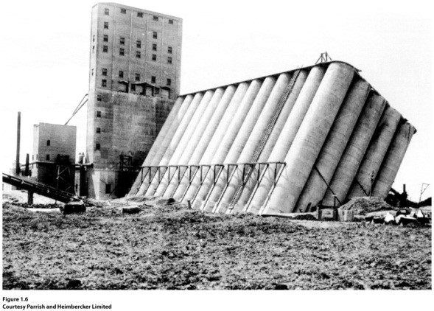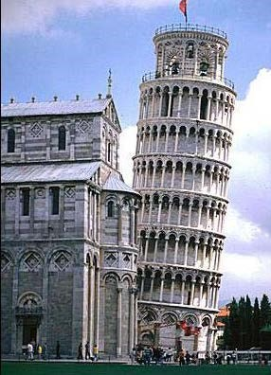

Bearing capacity of foundations total settlement vs.

differential settlement

- Slope Stability
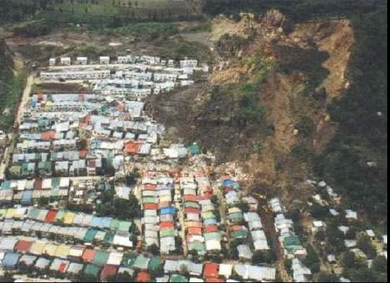
Determine if a slope is stable after an excavation for a road cut or along the boundaries of a landfill after the waste is placed and a cover is added. Check the stability of natural slopes and artificial slopes.

- Retaining Walls

- Dams

- Road Construction

Will the native material support the highway?
What is the strength of the Granular A subbase?
What soil compaction is required to support the traffic loads?
Backfill material above sanitary and storm sewers? Settlement?

- Flow and Transport in Soils

Porous soils can act as aquifers and provide water resources to communities and industry.
Contaminants can enter the subsurface and travel with the ground water. Clay soils are used as barriers to flow for landfill designs.

- Offshore structures: Artificial islands for offshore oil rigs.

2. Origin and Formation of Soil
Soils form as a result of an accumulation of mineral particles generated by the weathering of rocks. The void space between the particles contains water and/or air and/or other fluids (e.g. oil, brine).
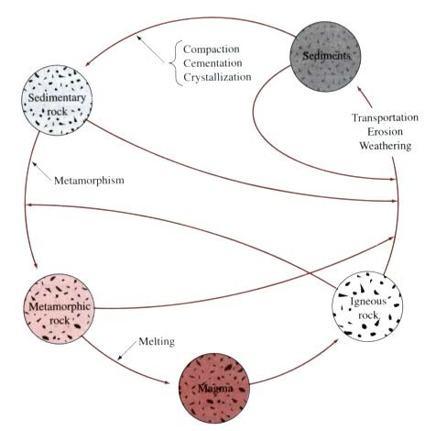
Geological Cycle

Uplift

lithification weathering
Igneous and

Sedimentary Soil Deposit Residual Soil

Metamorphic Rocks

Deposition Erosion
Transport

Igneous Rocks

- Formed by the solidification of molten magma ejected from deep within the earth’s mantle.
- The type of igneous rock is dependent on the original composition of the magma and the rate at which it is cooled
• Common minerals found in igneous rock
• quartz | SiO₂
• plagioclase - calcium feldspar | Ca(Al₂Si₂O₈)
sodium feldspar | Na(Al Si₃O₈)
• orthoclase - potassium feldspar | K(Al Si₃O₈)

- Common types of igneous rock
- granite - quartz, sodium and potassium feldspar
- basalt - calcium and sodium feldspar and ferromagnesian silicates
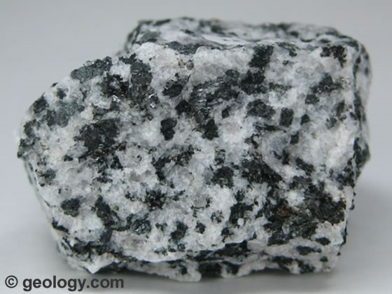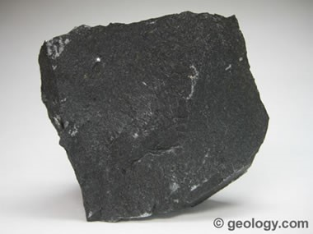
Granite Bazalt

Sedimentary Rocks

- Detrital sedimentary rock - the deposits of gravel, sand, silt and clay, formed by weathering, compact as a result of overburden pressure and with the presence of cementing agents like iron oxide, calcite, dolomite and quartz, form a rock. The cementing agents are generally carried to the void spaces by the ground water.
- e.g. shales, sandstone, limestone, conglomerate

- Chemical sedimentary rock - formed by chemical processes resulting in very small mineral particles
- limestone, chalk, dolomite, gypsum, anhydrite
- gypsum and anhydrite - CaSO₄ precipitated from sea water

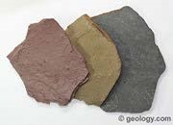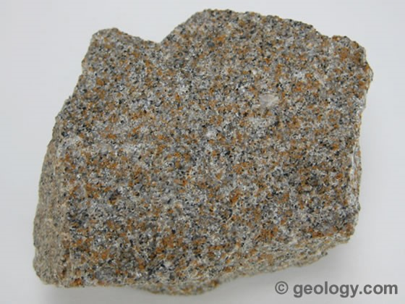

Shale Sandstone

Metamorphic Rocks

- Metamorphism is the process of changing the composition and texture of rocks as a result of heat and pressure
- granite ----> gneisses
- shale ----> slate
- calcite and dolomite ----> marble
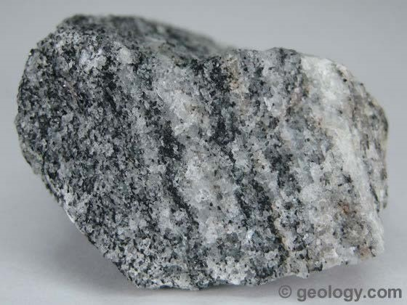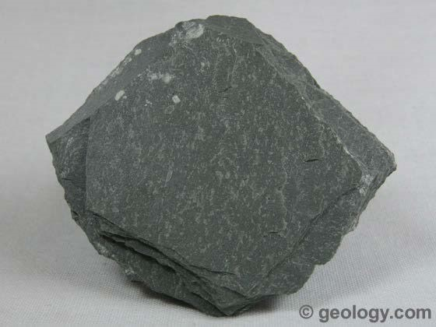

Gneisses Slate
Physical Weathering:
- Due to erosion (wind, water, glaciers), freezing & thawing, exfoliation (unloading)
- Breakdown the rock into smaller particles, rock flour to boulders
- No chemical change: No change in mineral composition, only a reduction in particle size
Chemical weathering
- Due to chemical reactions, such as hydration, oxidation, carbonation
- Both a reduction in particle size, and change in mineral composition Generally form small particles (e.g. clay minerals): (< 0.002 mm)
Soil Types:

Different descriptions used depending on the phenomenon looked at
– Two main categories by considering the transport mechanism

- Residual Soils - soils formed by weathering and remain in their place of origin

- Transported Soils - soils which are transported and deposited at a new location

- Alluvial Soils:
  - transported by water (rivers, streams etc)
  - typically consists of layers
  - much of our construction on alluvial soils
- Floodplains, stream beds etc

- Glacial Soils
  - transported and deposited by glaciers
- Mixed soils; rock debris sand, silt, clay
- Glacial clay: silt & clay; Till: mostly coarse particles

- Marine soils
- deposited in a marine environment
- Lacustrine soils: formed by deposition in quiet lakes

- Colluvial soils
  - soils accumulated at the base of slopes/hills due to gravity (e.g.
landslides
- Aeolian/Eolian soils:
  - transported and deposited by wind
- e.g. sand dunes, loess

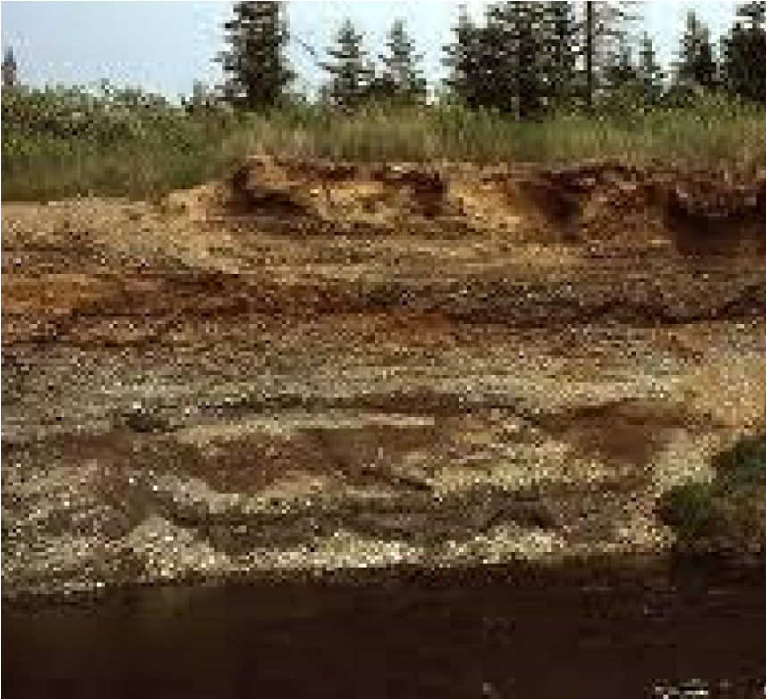 | 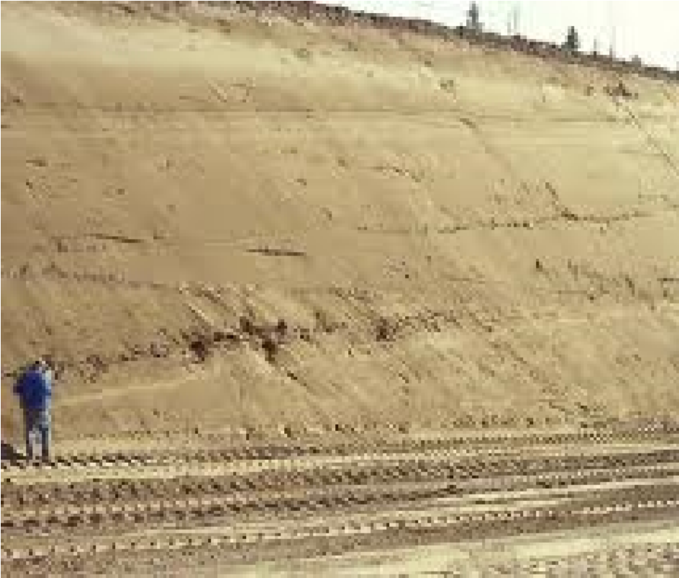
Alluvial soils | Marine soils
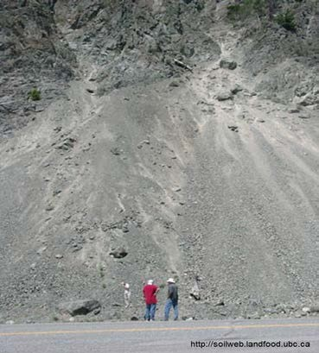 | 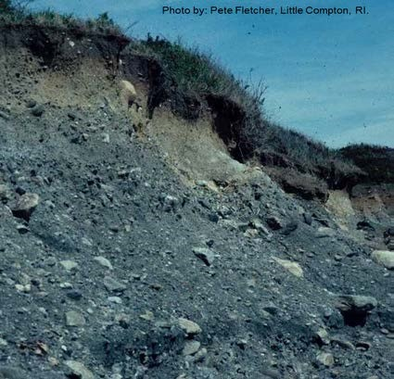
Colluvial Soils | Glacial Soils

3. Phase Relationships

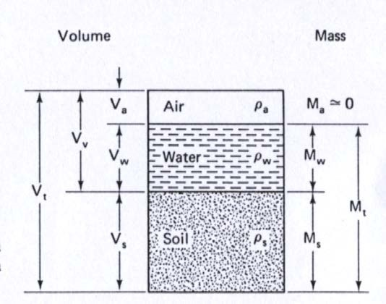
Soil is composed of solids (soil grains) & voids. The void space is often filled by water and/or air.

Volumetric Relationships:

- void ratio, e: e, is the ratio of the volume of void to the volume of solids expressed as a decimal quantity)

$$= \frac{Vy}{Vs}e$$

- porosity, n: is the ratio of the volume of voids to the total volume (expressed as a percentage)
$$n = \frac{Vv}{Vt} x 100(\%)$$

relationships which relate e and n
$$e = \frac{n}{1-n}$$ $n = \frac{e}{1-e}$
saturation, S: is the ratio of the volume of water to the volume of voids
S = Vw ×100(%) S = VVwv = eV.Vws
Vv
Mass Relationships:

- water content (w) or moisture content (m): is the ratio of the mass of water to the mass of solids (expressed as a percentage)
$$w = \frac{M_{w}}{M_{s}}$$
- density, ρ
$$ρ = \frac{M_{t}}{V_{t}}=\frac{M_{s}+ M_{w} }{V_{t}}$$

- density of solids, ρ_{s} $$ρ_{s} = \frac{M_{s}}{V_{s}}$$
- density of water, ρ_{w} $$ρ_{w} = \frac{M_{w}}{V_{w}}$$
- dry density, ρ_{d} $$ρ_{d} = \frac{M_{s}}{V_{t}}$$
- saturated density, ρ_{sat} $$ρ_{sat} = \frac{M_{s}+ M_{w} }{V_{t}}$$
- unit weight, _{γ}: is the weight of the soil per unit volume
$$γ = \frac{M_{t}}{V_{t}}=\frac{M_{t}g }{V_{t}}$$
- unit weight of water, $γ$ _{w} ${ γ}_{w} = \frac{W_{w}}{V_{t}}$

- specific gravity of a soil, G_{s}: is the ratio of the mass of the soil grains to the mass of water of equal volume
$$G_{s} = \frac{M_{s}}{V_{s}ρ_{w}}=\frac{ρ_{s}}{ρ_{w}}$$
- buoyant density, ρ’ $$ρ^{'}= ρ_{sat}- ρ_{w}$$
- buoyant weight, $γ'$ $$γ^{'}= γ_{sat}- γ_{w}$$
several of the definitions and formulae given above can be combined to give some of the following commonly used formulae

$γ = \frac{G_{s}+eS}{1+e}γ_{w}$ $γ = \frac{G_{s}(1+w)}{1+e}γ_{w}$ $S = \frac{V_{w}}{V_{v}} = \frac{wG_{s}}{e}$
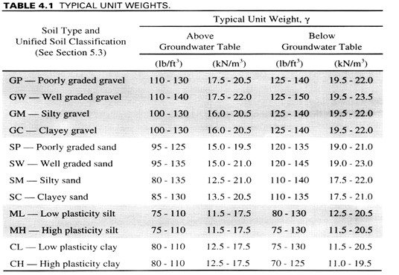

Special cases:
- Fully saturated soil:
Sr = 100% $saturated unit weight- γ_{sat} =\{\frac{G_{s}+e}{1+e}\}γ_{w}$
Dry Soil
- S = 0 $dry unit weight- γ_{dry} =\{\frac{G_{s}}{1+e}\}γ_{w}$
$also note-γ =(1+w)γ_{dry}$
- Maximum void ratio (emax) – Loosest state possible
  - Corresponds to the minimum density
  - Determined using standard test methods (ASTM D4254-00)

- Minimum void ratio (emin)
  - Densest state possible
  - Corresponds to the maximum density
  - Determined using standard test methods (ASTM D4253-00)

- Relative Density, D_{r}, is a measure of the current density with reference to the possible maximum and minimum density states.
$D_{r} = \frac{e_{max}-e}{e_{\max{- }}e_{min}} D_{r}=\frac{γ_{d}-{(γ_{d})}_{min}}{{(γ_{d})}_{max}- {(γ_{d})}_{min}}\{\frac{{\left(γ_{d}\right)}_{max}}{γ_{d}}\}$
- Relative density, obviously, is not an absolute scale. It’s possible to realize D_{r} values greater than 100%, (or less than zero) if you find a way to make samples looser (or denser) than the ASTM standard methods
Example 1.1:
Determine void ratio, porosity and degree of saturation of a soil sample
    - Mass of soil sample = 1013g
    - Vol. of soil sample = 585.0cm³
    - Specific Gravity, G_{s} = 2.65
    - Dry mass of soil = 904.0g
Example 1.2:
1870 g of wet soil compacted into a mold with a volume of 1000 cm³. The soil is put into the oven and dried to a constant mass of 1678 kg. Gs=2.66
Define: a) water content (w) b) dry unit wight
  - porosity
  - degree of saturation
  - saturated unit weight
Example 1.3:
Given: a saturated soil sample, Gs=2.67:
Mass of container + wet soil = 150.63 g
Mass of container + dry soil = 131.58 g
Mass of container = 26.48 g

Define: a) water content (w)
b) dry and saturated unit wight

Example 1.4:
Determine Gs, void ratio and saturated unit weight of a saturated soil sample if:
  - Dry unit weight = 16.2 kN/m3
  - Water content = 20%

Example 1.5:
Given _{γ}=17 kN/m³, and w=10%
Determine: γ_{d}, e, n, S, γ_{sat}

Example 1.6:
Given e=0.65, w=15%, and Gs=2.65
Determine: γ_{d}, γ, w for S=100%, γ_{sat}

Example 1.7:
Determine the mass of water to be added to 10 m³ of the following soil for saturation
  - Porosity = 0.45
  - Specific gravity of the soil solids = 2.68
  - Moisture content = 10%

Example 1.8:

The dry density of a soil is 1800 kg/m³. Given G_{s}=2.68, what would be the moisture content of the soil when saturated?

Example 1.9: Laboratory test results for a clean sand show that e_{max}=0.81, G_{s}=2.68. This sand was compacted in the field to a dry unit weight of 15.68 kN/m³. Estimate the relative density of compaction in the field.

Engineering Implications (e)
– Hydraulic conductivity
• Which packing (SC or CT) has higher hydraulic conductivity?
- Clogging:

Engineering Implications (S)
The slope stability is significantly affected by the surface water. (Au, 2001)
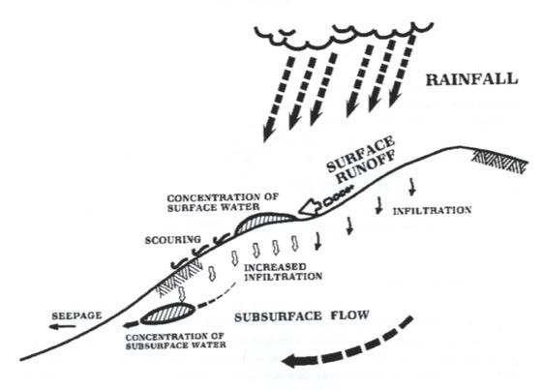

Determining the Specific Gravity

- Need to know the mass and the corresponding volume of the solids
  - Mass: Measure directly using a balance
  - Volume: Obtain indirectly by using the mass of water replaced
- Required equipment: A Pycnometer
- Essentially a Flask with a appropriate lid to give an accurate volume.
Example 1.10:
The following readings were taken during a Specific Gravity test of Fraser River sand (FRS).
- Mass of Flask: 173.7g
- Mass of Flask + Water: 671.3 g
- Mass of Flask + Water + Sand: 865.5g
- Temperature: 24 degrees
- Mass of Dry Sand: 308.0 g
- Determine the Specific gravity of the FRS.
Steps:
- Calculate the volume of the Flask
- Calculate the weight (& then volume) of water when the flask is filled with water and sands
- Obtain the volume of solids
- Calculate the density of the solids & then the specific gravity

- Answer: G_{s} = 2.70
4. Soil Particle Size:
- Soil particles exist in a range of sizes
  - Fairly large (several millimeters) to very small (just a fractions of a micrometer)

- Depending on the “average” particle size soils are generally divided into four categories.
  - Gravels (several mm to cm)
  - Sands (about a tenth of an mm to a few mm)
  - Silts (few to several micrometers)
  - Clays (smaller than about a micrometers)

GRAVEL SAND SILT CLAY

- Soils with “large” sized particles are called coarse grained soils
  - Gravels, sands

- Soils with particle sizes less than about tenth of a millimeter are termed fine grained soils
  - Silts, clays

Particle Size Distribution
- Gravels and sands are generally classified through a sieve analysis
  - Determined the percent (by weight) of the soil which passes through various standard sieves
  - Each sieve is made up of uniform mesh (square mesh with a given width)
  - Sieve size expressed either in terms of opening size or Mesh number

Sieve Sizes

ASTM No. Inches Metric

-- 0.750 19.00 mm
-- 0.625 16.00 mm
-- 0.500 12.70 mm -- 0.375 9.50 mm
-- 0.250 6.35 mm⁴ 0.187 4.75 mm
10 0.0787 2.00 mm
20 0.0331 850 µm
40 0.0165 425 µm
60 0.0098 250 µm 100 0.0059 150 µm
200 0.0030 75 µm

The ASTM standard for the sieve analysis is ASTM D 422 - 63 entitled Standard Test Method for Particle-size analysis of Soils.
ASTM, Annual Book of ASTM Standards, Philadelphia, copyright, American Society for Testing and Materials, 1916 Race Street, Philadelphia, PA 19103.
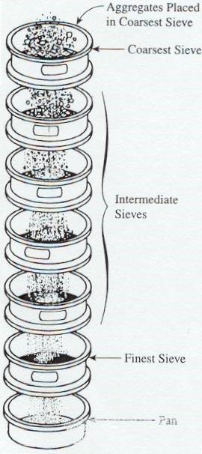
4.1 Sieve Analysis

- For coarse grained soils (i.e.
sands & gravels)

- A known weight of soil is screened through a stack of sieves (of progressively smaller opening sizes)

- A sieve shaker is used to shake the sieves

- Determine the mass of soil retained in each sieve

- Calculate the Cumulative Percentage passing each sieve, and plot on a semi log scale

Example:
A sieve analysis test was conducted on 650 gr of soil and the results are as follow:

Sieve #: 3/8” 4 10 20 40 100 200 pan

Mass 0 53 76 73 142 85 120.5 99.8

retained (g)

Plot the particle size distribution curve for this soil.

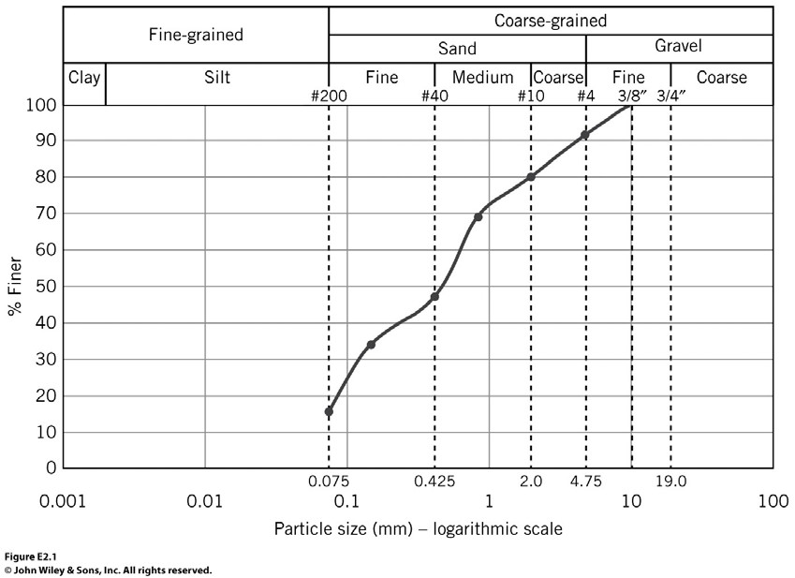

Silts and clays are classified by “equivalent grain size” (grain sizes defined as the diameter of a spherical grain which would fall in still water at the same velocity as the original particle).

• Determined using the Hydrometer Analysis

– Measure the time required for particles in a suspension to settle
– Use Stokes equation to find equivalent diameter of a spherical particle

4.2 Hydrometer Analysis

For the hydrometer test a sample of dry soil is placed into a cylinder of water. The soil-water solution is thoroughly mixed so that the particle size distribution is uniform everywhere in the column. After the column is thoroughly mixed, the column is placed vertically and the particles begin to settle out of solution. This represents the beginning of the test (t=0).

• Fine grained soil is mixed with water to form a uniform suspension

• Density of the soil would change as particles settle in the suspension
- Rate of settlement of soil particles in the suspension (i.e. density change with time) is measured
- Stoke’s Law is used to obtain the particle size distribution

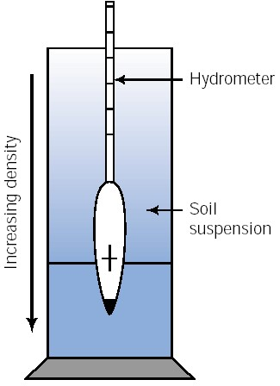

v: velocity $v=\frac{D^{2}\left(ρ_{s}- ρ_{w}\right)}{18η}$
ρs density of soil particles
ρ_{w}: density of water
η: viscosity of water $D\left(mm\right)=\sqrt{\frac{30η}{G_{s}-1}}\sqrt{\frac{L\left(cm\right)}{t\left(min\right)}}$
D: diameter of soil particles
Assuming density of water as 1 g/cm³: $D\left(mm\right)=K\sqrt{\frac{L\left(cm\right)}{t\left(min\right)}}$

K: function of G_{s} and η (temperature dependent)
L: distance
t: time
η: viscosity of water $K=\sqrt{\frac{30η}{G_{s}-1}}$
D: diameter of soil particles
G_{s}: specific gravity of soil
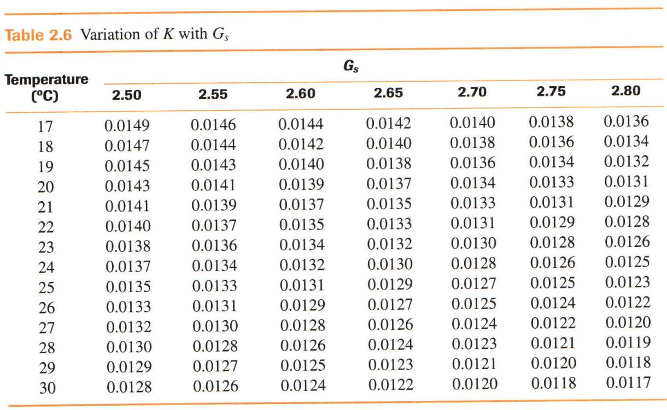
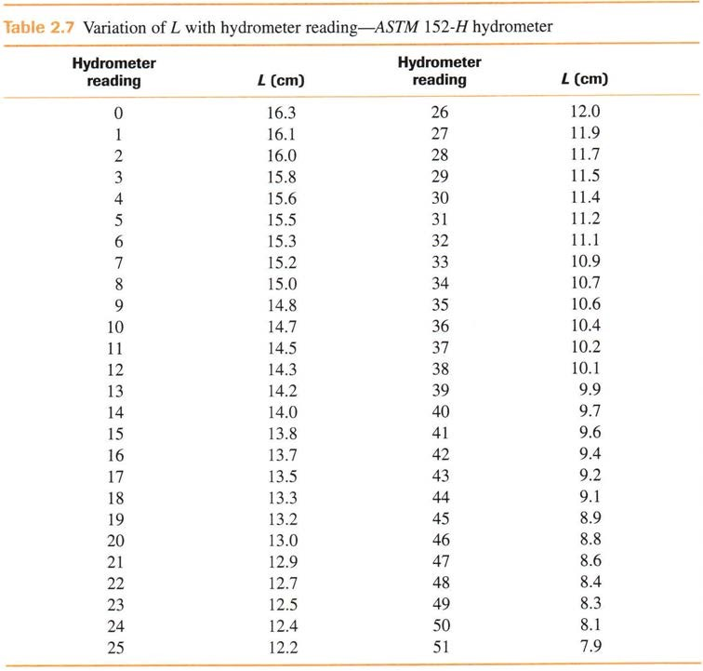

Example 1.11:
In a hydrometer test, the results are as follow: G_{s}=2.6
Temperature of water=24º
Hydrometer reading=43 at 60 min after the start of sedimentation

What is the diameter of the smallest-size particle that have settled beyond the zone of measurement at that time?

Hydrometer Analysis:
Particle size for each reading $D\left(mm\right)=K\sqrt{\frac{L\left(cm\right)}{t\left(min\right)}}$
- Percent passing of each reading
  - Hydrometer 151H $PP\left(\%\right)=\frac{1606\left(RC-1\right)a}{M_{s}}x100$
  - Hydrometer 152H $PP\left(\%\right)=\frac{RC*a}{M_{s}}x100$ $a=\frac{0.62G_{s}}{G_{s}-1}$
- RC is connected reading
  - R: hydrometer reading $RC=R+c_{t}+c_{d}$
  - c_{t}: temperature correction (c_{t} = 0 for T = 20ºC
  - c_{d}: Density correction for water (distilled water, additives)

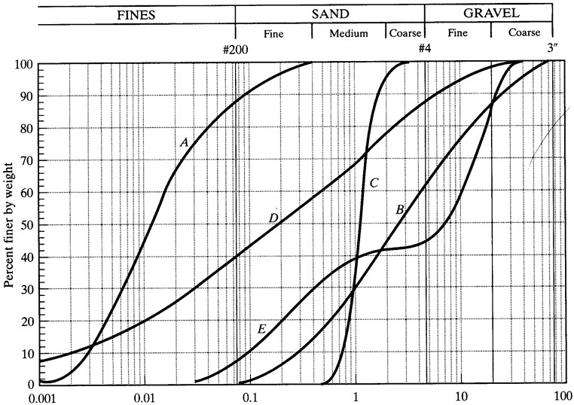

Example 1:12

Determine coefficient of uniformity and curvature for curve D.

4.3 Characterization of Soils Based on Particle Size
Soils in nature consist of a mixture of particles, and the grading curve is used for textural classification of soils

The selection of a soil for a particular use may depend on the assortment of particles it contains:
- well –graded (poorly sorted): flat curve
- poorly graded (well sorted): vertical curve
- gap-graded: absence of certain grain sizes

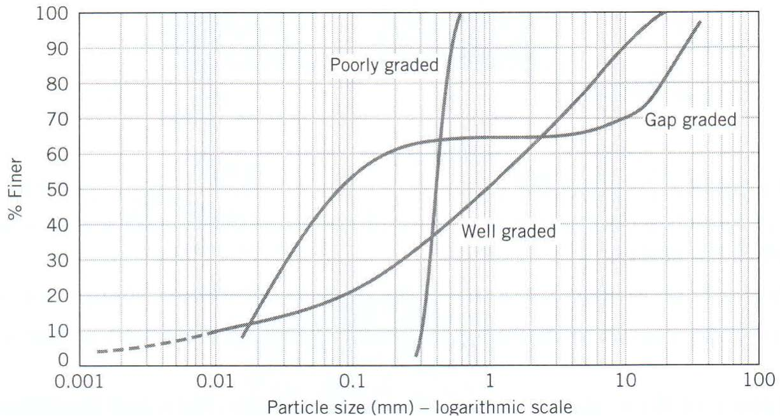

Gradation Parameters:
- Coefficient of uniformity, C_{u}: a numerical measure of uniformity
$$C_{u}=\frac{D_{80}}{D_{10}}$$

where D₆₀ = grain diameter corresponding to 60% by weight passing, and D₁₀ = grain diameter corresponding to 10% by weight passing.
- Coefficient of curvature, C_{c}:
$$C_{c}=\frac{D_{30}^{2}}{D_{10}D_{60}}$$
where D₃₀ = grain diameter corresponding to 30% by weight passing.

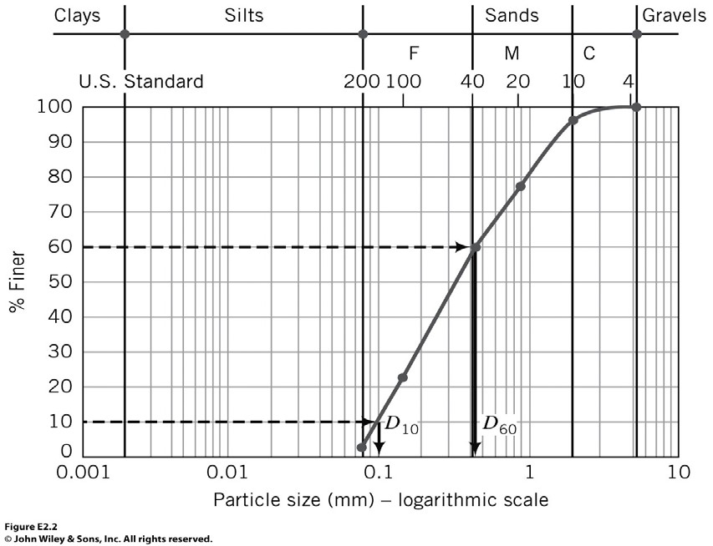

Well-graded soils:
Cu>4: Higher values of Cu (Cu>4) shows a wider assortment of particle sizes
Cc: 1-3
Produced by bulk transport process (e.g., glacial till) Poorly-graded soils:
Cu<4: contains particles of uniform size (approximately one size)
Sorted by water (e.g., beach sand) or by wind

D10: the effective size of the soil
Important in regulating the flow of water through soil (filter) The higher the D10 value, the coarser the soil, the better the drainage
Applications in engineering:
- Select aggregates for concrete
- Soils for construction of dams and highways
- Soils as filters
- Materials for grouting and chemical injection
- Soil classification
- Empirical relation between particle distribution and other physical properties of soils
Comparison of Coarse- & Fine-grained soils for engineering use

- Coarse-grained soils:
  - Eng. properties are mainly governed by grain size distribution
  - High strength and capacity (foundation, highway)
  - Good drainage quality (highway, filter)
- Fine-grained soils:
  - Eng. properties are controlled by soil mineralogy and moisture content changes
  - Lower strength and bearing capacity
  - Low permeability (earth dam, landfill)
  - High swelling and shrinkage potential (responsible for many failures)

5. Consistency of Soil (Atterberg Limits)

The properties of a soil (consistency) change with moisture content. For example, if a lot of water is added to a soil, the soil may be viscous and act like a liquid. A same soil when it is very dry may have a very high strength.
In engineering practice, soil plasticity is determined by observing the different physical states that a plastic soil passes through as the moisture conditions change. The boundaries between the different states, as described by the moisture content at the time of change, are called consistency limits or Atterberg limits.

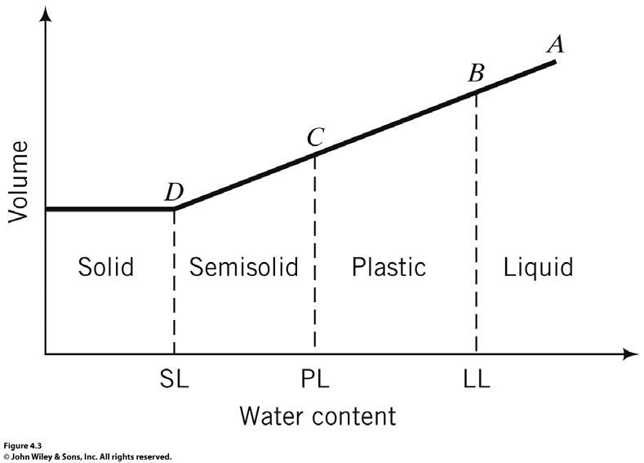

- Liquid Limit (LL)
  - The water content corresponding to the arbitrary limit between the liquid and plastic states of consistency of a soil. Above this value, the soil is presumed to be a liquid and behaves as such by flowing freely under its own weight. Below this value, it deforms under pressure without crumbling, provided the soil exhibits a plastic state.
  - Typical values: Silts : 30 to 40 %, Clays: 40 to 150 %
- Plastic Limit (PL)
  - The water content at an arbitrary limit between the plastic and semisolid state.
  - It is reached when the soil is no longer pliable and crumbles under pressure. Between the liquid and plastic limits is the plastic range.
- Shrinkage limit, SL
  - The water content is the boundary in moisture content between the solid and the semisolid states.
  - The solid state is reached when the soil sample, upon being dried, finally reaches a limiting or minimum volume.
  - Beyond this point, further drying does not reduce the volume but may cause cracking.
- Plasticity Index (PI)
  - The range during which the soil exhibits plastic response
PI = LL – PL
- liquidity index, LI:
$LI=\frac{w_{n}-PL}{PI}$
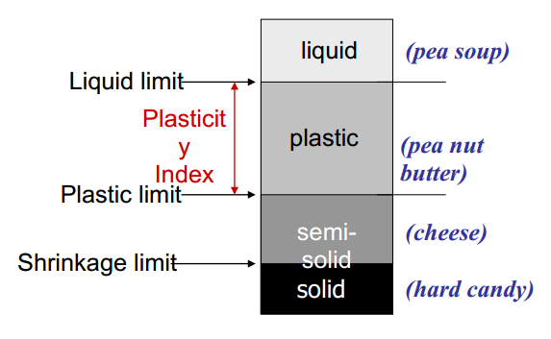

Engineering implication:
Effect of Moisture Content on the Stress-strain Response
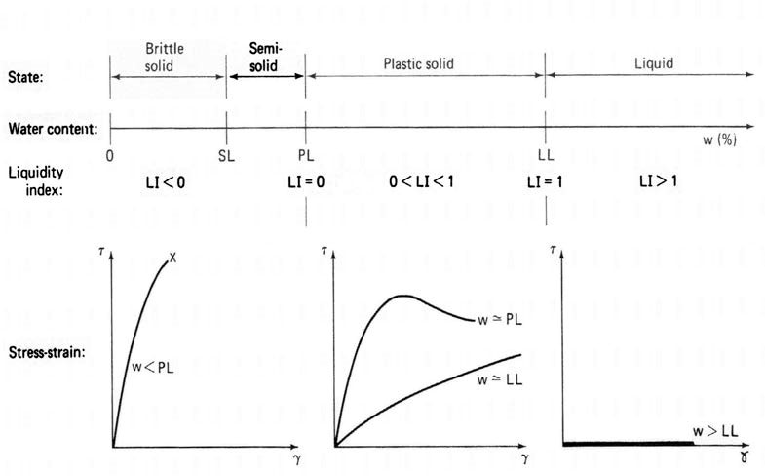
- Water content larger than L.L
– Viscous Flow
- Between L.L & P.L
– Plastic behaviour
- Water content lower than Shrinkage Limit
– Brittle response
5.1 Determination of Liquid Limit:
- Determined either by using
– Casagrande cup method
- Widely used in North America (ASTM)
- Developed by Arthur Casagrande (1932)
- We’ll use this method in the lab
– Fall cone method

popular in Europe & Asia (British Standard)
- Proposed by Hansbo (1957)
- Same apparatus used to determine plastic limit as well
- Considered a more accurate method

- Casagrande cup method
      - Semi spherical brass cup filled with soil, and a “standard” groove cut
      - Cup dropped onto a hard rubber base from a height of 10 mm at a rate of 2 drops per second
      - # of blows required to close the groove for a distance of half inch recorded
      - Liquid Limit is defined as the water content at which the groove will close in 25 blows.
      - Test carried out at different water contents, and LL obtained by interpolation (on a semi-log plot)
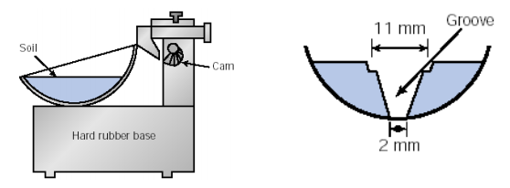

    - Multi Point Method

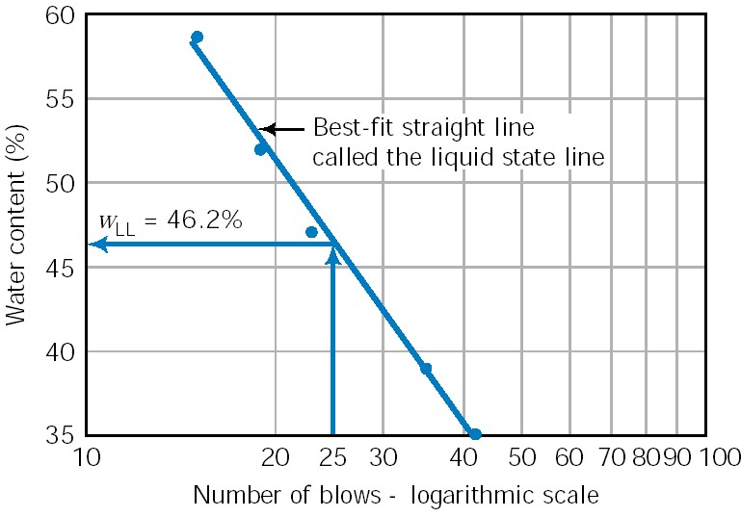
- Single Point Method
      - LL from one test (instead of the typical four).
      - How & Why?
        - For soils of similar geologic origin slopes of the liquid state line (b) are generally similar
          - $LL=w_{n}*{\left(\frac{n}{25}\right)}^{tanb}$
– Works fairly well if n is between 10 & 40

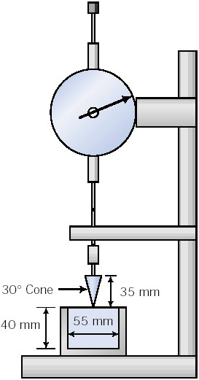
- Fall cone method
    - 80-g cone allowed to fall free for five seconds
    - Water content corresponding to 20mm penetration defines the LL
    - At least four tests carried out, and LL obtained by interpolation (on a semi-log plot of water content vs. penetration)
– Single point technique is also available
• Test repeated with a 240-g cone to determine the plastic limit
- Larger weight → more penetration at a given water content
- D → separation between the “liquid state lines” corresponding to 80 & 240g.

- $PL=LL-\left(\frac{2D}{\log\left(\frac{M_{2}}{M_{1}}\right)}\right)$

5.2 Determination of Plastic Limit:

      - Plastic limit is the lower level of the plastic range
      - The moisture content at which a thread of soil just begins to crack and crumble when rolled to a diameter of 1/8 inches
      - Typical values of Plastic Limits
          - Silts : 20 to 25 %
          - Clays: 25 to 50 %
      - As water content drops below PL soil cannot be molded without cracks
      - Roll a small clay sample into a thread
      - Water content at which threads of one eighth of an inch will just start to crumble is reported as PL

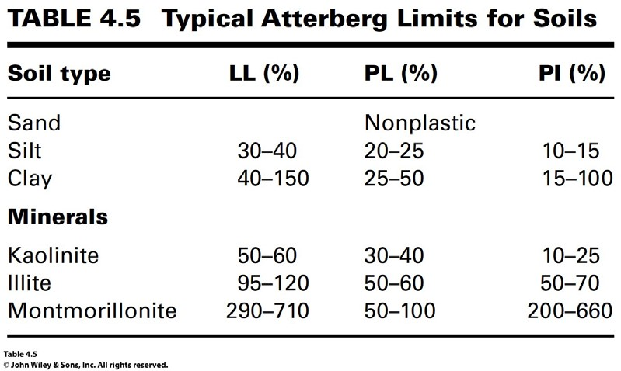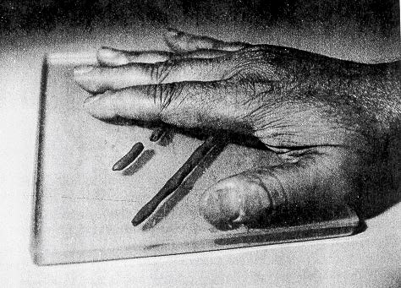

5.3 Determination of Shrinkage Limit:
      - Not commonly used nowadays
      - Difficult to determine accurately
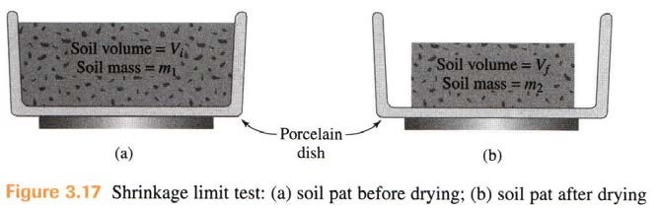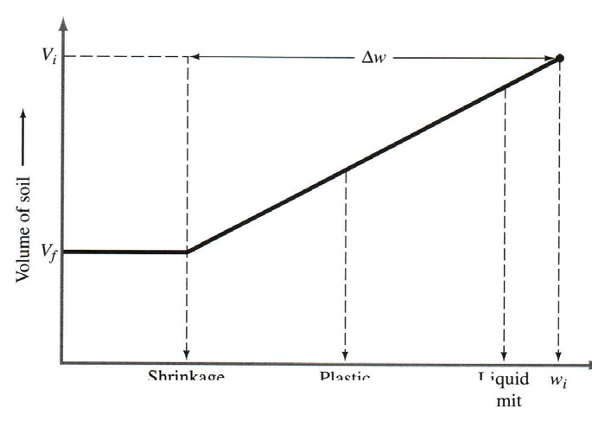

Skempton observed that the plasticity index of a cohesive soil increases linearly with the percentage of clay-size fraction particles present. The slope of the PI versus % finer than 2 _{µ}m is defined as the activity of the clay and is given above. Activity is used as an index for the swelling potential of clay soils.
$$A=\frac{PI}{\% finer than 2μm, by weight}$$
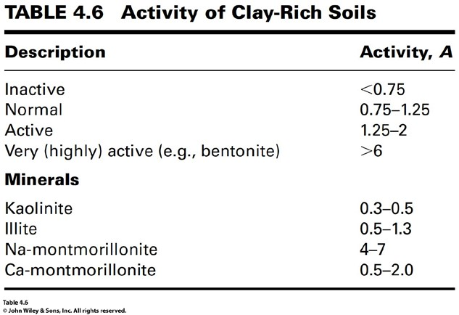
Example 1.13:
A fine-grained soil has an LL of 300% and PL of 55%. The natural moisture content of the soil is 80% and the clay content is 60%.
- Determine the PI, LI and the activity.
- What is the soil state in the field?
- What is the predominant mineral in the soil?
- If this soil were under a foundation for a building and water were to seep into it from watering of a lawn, what would you expect to happen to the foundation?
- If the soil were to be loaded to failure, would you expect a brittle failure?

Example 1.14:
A saturated soil has the following characteristics;
- Initial volume: 24.6 cm³
- Final volume: 15.9 cm³
- Mass of wet soil: 44 g
- Mass of dry soil: 30.1 g
Determine the shrinkage limit.

6. Soil Description and Classification
In soil mechanics we often need a standard consistent language to describe different soil types.
• description versus classification

- description - visual in-situ data as well as material and mass characteristics
- classification - soil is classified a specific soil type based on grain size distribution and plasticity

Soil classification is particularly useful if it is to be used as a construction material for backfilling, an embankment, landfill liners and leachate collection systems.

6.1 Soil Description
Soil structure:
- Particle shapes
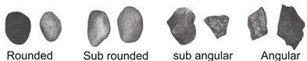

- Typically angular soil particles: Larger Friction angle, Higher Dilation Potential
- Particle arrangement depends on the density of the “packing”
- Loose, Dense – qualitative density descriptors
- Denser packing expected to be stronger

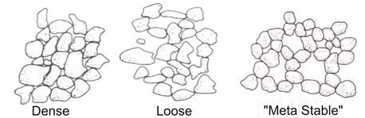

6.2 Soil Classification
The behaviour of a soil depends on grain size and plasticity. Therefore classification is often based on:
- Grain Size and Plasticity
- USCS: Particles smaller than 0.075 mm termed “fines” (both Silt & Clay).
- Further sub divisions based on Soil Plasticity
- Identification of soils in particular groups
  - Soils of a given group exhibit similar characteristics
  - a systematic way of categorizing soils
- Various schemes have been proposed, each with a specific use in mind
  - AASHTO: Classification to indicate the usefulness in roads and highways (commonly used for highway applications)
  - USCS: Unified Soil Classification System
- Unified Soil Classification System
- Proposed by Casagrande (1948) for air field construction
- Works well for Dams, foundations & other construction (WES, 1960)
- Widely used in geotechnical practice
- Symbols used to represent
- Particle Size
- Gradation
- Plasticity

Soil Classification Systems
- a systematic way of categorizing soils
- a consistent method a describing soils
- include grain size and soil characteristics

Unified Soil Classification System USCS
USCS contains four major division
1. coarse-grained soils
 | Gravel (G) Coarse | 75 mm to 19 mm
 | Fine | 19 mm to No. 4 sieve
 | Sand (S) Coarse | No. 4 to No. 10 sieve
 | Medium | No. 10 to No. 40 sieve
 | Fine | No. 40 to No. 200 sieve
2. fine-grained soils
Silt (M) | silts and clays are classified
 | based on their Atterberg Limits
Clay (C)  - organic soils (O)  - peat (Pt)  Boulders - diameter greater than 300 mm  Cobbles - diameter of 75 mm to 300 mm | (plastic limit, liquid limit, etc.)
Grain Size Symbols Gravel | G
Sand | S
Silt | M
Clay | C
Organic soil | O
Peat | Pt
Graduation Symbols Well-graded | W
Poorly-graded | P
Liquid Limit Symbols High LL | H
Low LL | L

• Each soil is given a 2 letter classification (e.g. SW). The following procedure is used.
- Coarse grained (>50% larger than 0.075 mm)
- Prefix S if > 50% of coarse is Sand
- Prefix G if > 50% of coarse is Gravel
- Suffix depends on %fines
- if %fines < 5% suffix is either W or P
- if %fines > 12% suffix is either M or C
- if 5% < %fines < 12% Dual symbols are used

Examples
SC -
CL -
GP -
GM -
CL-CH
CL-OL
GC-CL

Classification of Coarse Grained Soils
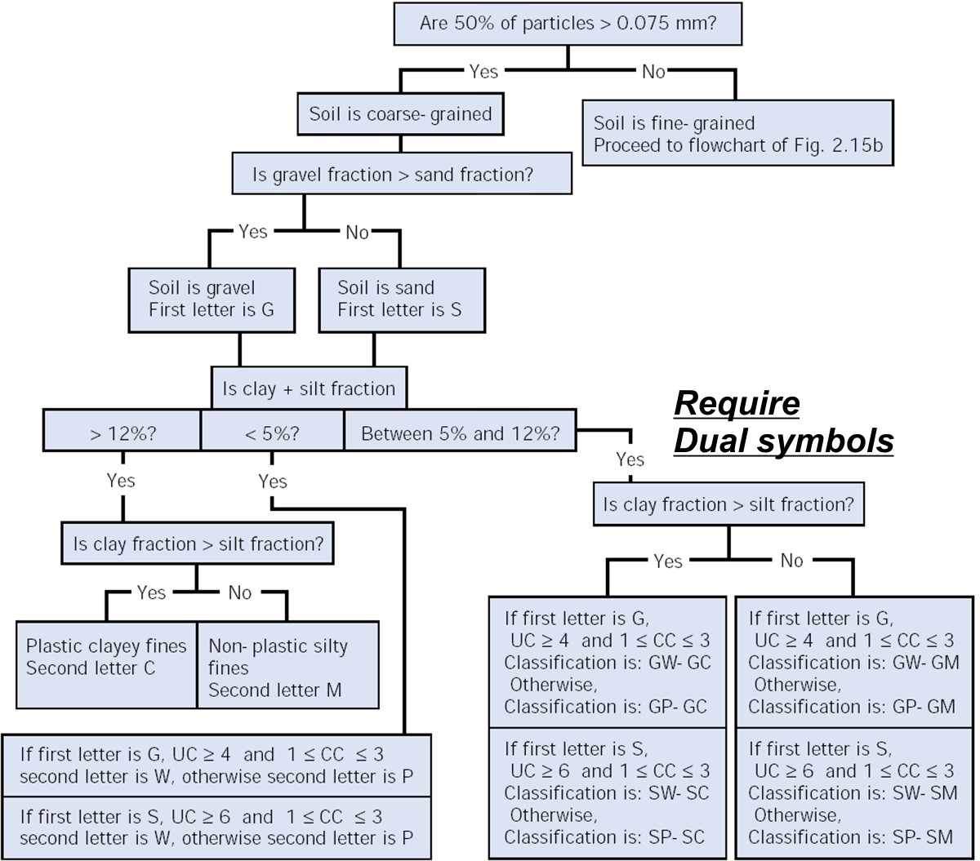
Classification of Fine Grained Soils
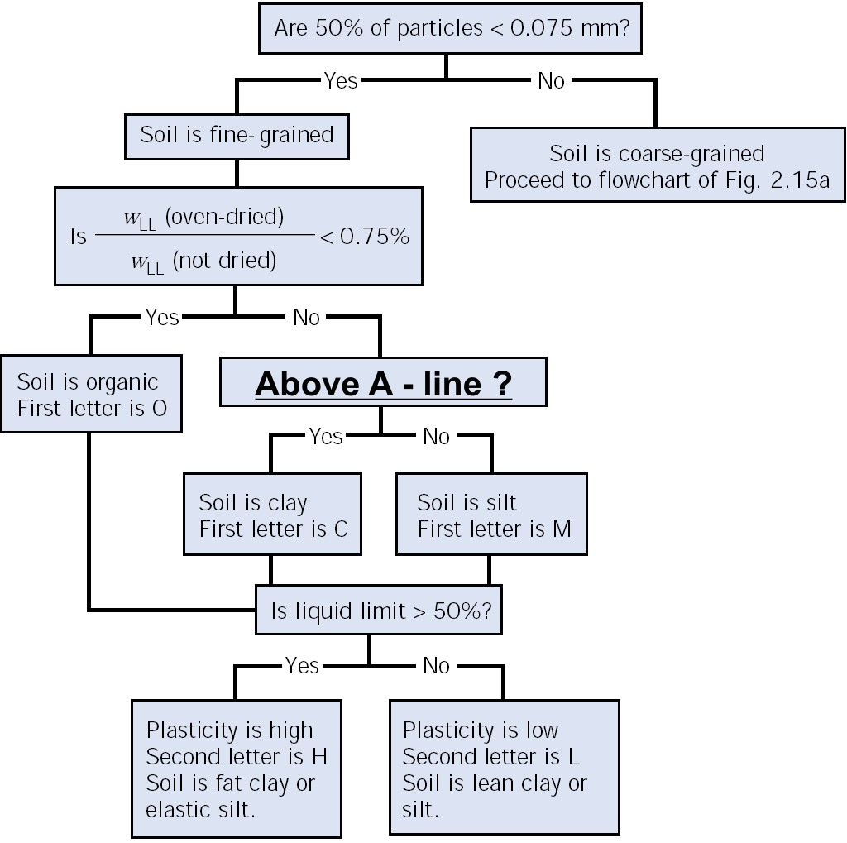

Plasticity Chart:
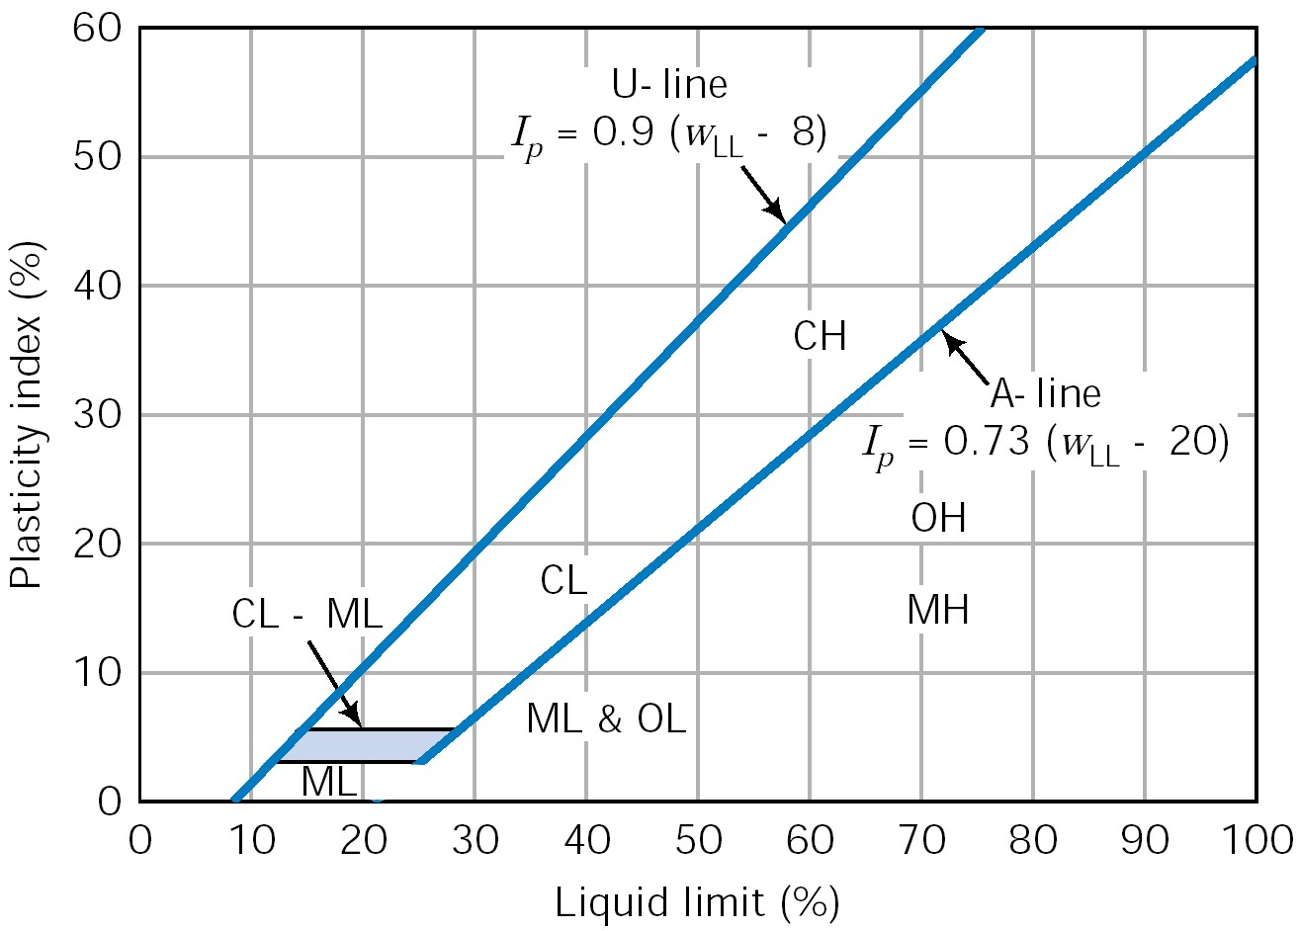

- Experimental results from different soils plotted
- A-line delineates the boundary between clays & silts
  - organic clays plot below the A-line
- All test data fall below the U-line (Upper limit line)

AASHTO Soil Classification System
- another system commonly used in the United States for road and highway design.
- explained in Holtz, section 3.3, pages 64-71.
- not a commonly used system in Canada
- you will not be require to classify a soil under the AASHTO system for this course

CFEM: Consistency Descriptions for Cohesive Soils

Consistency | Field Identification
Very Soft | Easily penetrated several centimeters by the fist
Soft | Easily penetrated several centimeters by the thumb
Firm | Can be penetrated several centimeters by the thumb with moderate effort
Stiff | Readily indented by the thumb, but penetrated only with great effort
Very Stiff | Readily indented by the thumbnail
Hard | Indented with difficulty by the thumbnail

• Organic Soil: Soil containing high natural organic content
– Readily identified by
- Color,
- Odor,
- Spongy Feel
- Fibrous texture
- Peat: Very high proportion of organic content

– Primary content: Decomposed tissues of vegetation
- Color: dark-brown to black
- Odor

Classification Example 1.15:
Passing No.200 sieve 30 %
Passing No.4 sieve 85 % Clay size particles 5%

USCS:

Classification Example 1.16:
Passing No.200 sieve 8 %
Passing No.4 sieve 100 %
D10 = 0.085 mm, D30 =0.12 mm, D60 = 0.135 mm
Clay size particles 5%

Classification Example 1.17:
Passing No.200 sieve 61%
LL=26%, PI=6%

Classification Example 1.18:
Passing No.200 sieve 45%
Passing No.4 sieve 100%
LL=36%, PI=22%

Classification Example 1.19:
Soil A: LL=36, PL=28
Soil B: Nonplastic

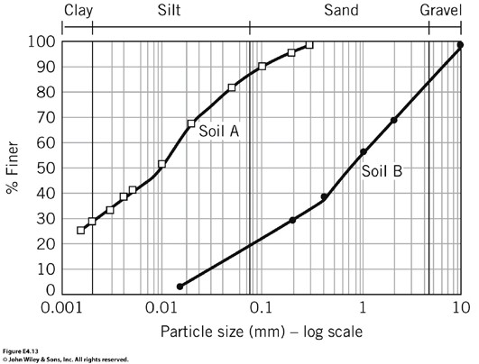

7. Fine Grained Soils
Silts and Clays both consist of very small particles, invisible to the naked eye. However, their properties vary significantly.

silts - non cohesive, non-plastic
clays - cohesive, plastic

- The physical properties of large grain soils, such as gravel and sand, are very dependent of the grain size distribution of the soil.

- The physical properties of clays are very dependent on the water content and electrochemical properties of each type of clay. Silts fall in between the coarse grain soils and clays.

Therefore, a gravel, sand or silt containing a small fraction of clay can have vastly different properties than a similar soil with no clay.

Clay Minerals
- very small, colloidal-sized crystals
- diameter < 2µm
- generally flat and form sheets

- tetrahedral sheet - silica tetrahedral
  - a single unit consists of 4-oxygen atoms surrounding a silicon atom
  - linked together to form a sheet

- octahedral sheet
- a single unit consists of 6-oxygen atoms and/or hydroxyl ions (OH) surrounding a single cation
  - Al, Mg, Fe
  - linked together to form a sheet

  - isomorphous substitution refers to the exchange of the cation within any sheet

Based on the cation contained in the octahedral units and based on how the tetrahedral and octahedral unit are linked or connected, different clay minerals arise. The different types of clay have different soil properties.

Classification according to chemical composition and structure:
(1) Kaolinite
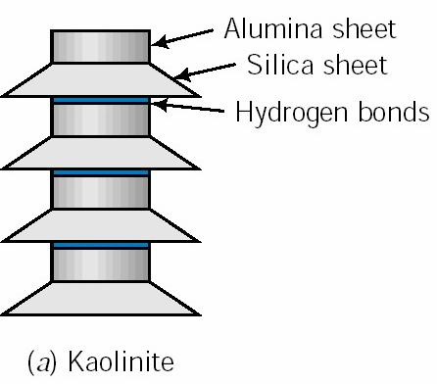

- repeating layers of tetrahedral sheets connected to octahedral sheets with largely Aluminum cations in the octahedral sheets
- the tetrahedral and octahedral sheets are bonded through sharing common atoms at the surface of the respective sheets (thickness approx. 0.72 nm)
- a kaolinite crystal is made up of several sheets up to 100 layers thick
- each layer is attached by a relatively strong hydrogen bond between OH unit of the octahedral sheet and the Oxygen atom of the tetrahedral sheet.

(2) Montmorillonite (Smectite)
- kaolinite is considered a 1:1 clay mineral and montmorillonite is a 2:1 clay mineral
- the layers are bonded by relatively weak van der Waals’ forces and a net negative charge exists on the surface of the octahedral sheet; this allows water and other exchangeable ions to enter between the sheets causing separation
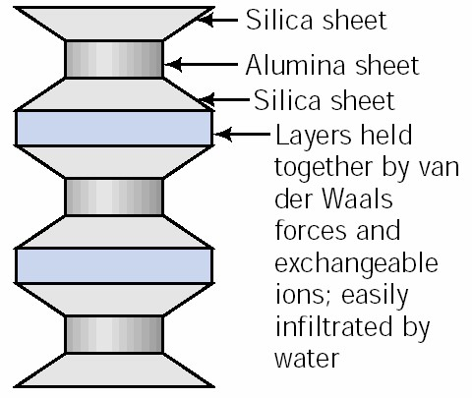
- since the water is drawn in by the negative charge, montmorillonite is very susceptible to swelling

(3) Illite
- similar to montmorillonite with a 2:1 structure
- bonded by a potassium ion, stronger bond than the van der Waals’ forces
- some isomorphous substitution of Si with Al in the silica sheet

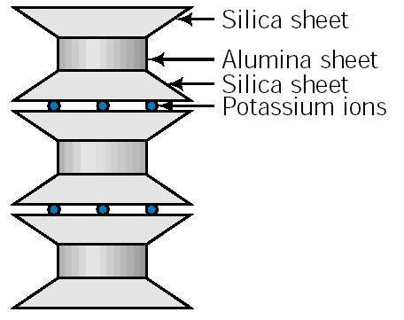

(4) Chlorite
• repeating layers of a silica sheet, an aluminum sheet, another silica sheet and then either a Al sheet (gibbsite) or a Mg sheet (brucite)

These are just a few of the more common clay minerals.
The properties of each varying as a result of their structure.

Clay Fabric:
The term fabric is used to describe the geometric arrangement of the clay particles. Flocculated and Dispersed are the two extreme cases.
Flocculated fabric gives higher strength and stiffness.
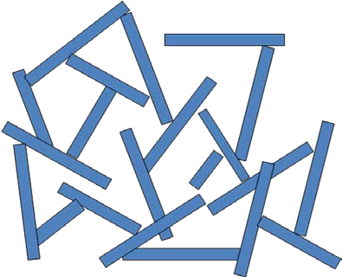
Dispersed: face-to-face contact Low k, lower strength

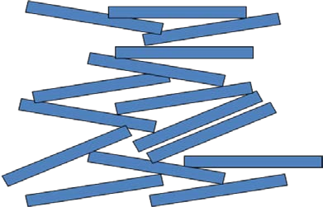

Why does water have a large effect on the properties of a clay soil?
Because most clay minerals have a net negative charge at their surface, a layer of water will tend to be adsorbed onto the surface of the clay mineral.

Adsorbed water: A thin layer of water tightly held to particle; like a skin
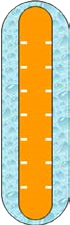
The negative charge at the surface of clay minerals is a result of isomorphous substitution and imperfections in the crystal lattice of a clay mineral (i.e. broken bonds).

Surface area plays a large role in the volume of water adsorbed in a clay soil.

Average values of relative sizes, thickness and specific surfaces for common clay minerals

Edge View Typical Thickness Typical Diameter Specific Surface
(nm) (nm) (km²/kg)

3 100-1000 0.8

30 10 000 0.08

30 10 000 0.08

50-2000 300-4000 0.015

Note: smaller the grain, higher the specific surface

Compare the volume of adsorbed water on a montmorillonite crystal versus a kaolinite crystal.

Isomorphous Substitution
The negatively charged faces of clay particles attract cations in the water. The concentration of the cations decreases exponentially with the increasing distance from the clay particle.
- exchange of cations within a octahedral or tetrahedral sheet
- during the formation of the clay
- due to the lack or excess of a given ion
- ions are substituted for other ions of the same or different valance
- the same structure is retained
- e.g. Al⁺³ is substituted for Si⁺⁴ in the silicon tetrahedral
- charge deficiency results in most clays being negatively charged (adsorbed water)
- absence of cations in the crystal lattice
- adsorption of anions

Cation Exchange
Most common cations Ca⁺⁺ Mg⁺⁺ Na⁺ K⁺
Most common anions SO₄⁻² Cl⁻¹ PO₄⁻³ NO₃⁻¹

Cation Exchange Capacity (CEC):
- capacity to attract cations from the water (i.e., measure of the net negative charge of the clay particle)
- measured in meq/100g (net negative charge per 100 g of clay)
- The replacement power is greater for higher valence and larger cations.

Replacement Order:
Al³⁺ > Ca²⁺ > Mg²⁺ >> NH⁴⁺ > K⁺ > H⁺ > Na⁺ > Li⁺

Replaceability criteria:
- the higher the valance, the more tightly held the ion is
- abundance
incoming Ca Na replaced

Na

Identification of Clay Minerals
- X-ray diffraction
- differential thermal analysis
- electron microscopy
- Casagrande’ plasticity chart

0
10
20
30
40
50
60
0
10
20
30
40
50
60
70
80
90
100
Liquid Limit
Plasticity Index
A-line
U-line
montmorillonite

kaolinite

chlorite

halloysite

illite

  - Montmorillonites have very high specific surface, cation exchange capacity, and affinity to water. They form reactive clays.
  - Montmorillonites have very high liquid limit (100+), plasticity index and activity (1-7).
  - Bentonite (a form of Montmorillonite) is frequently used as drilling mud.

