
Department of Civil and Environmental Engineering

Course Notes for CIVE 3208

Geotechnical Mechanics

Instructor: M.T. Rayhani

Contents:
Chapter 9: Flow of Water through Soil

References:
Soil Mechanics & Foundations, M. Budhu, John Wiley & Sons
Principles of Geotechnical Engineering, B. M. Das, Thompson Publishing
Fundamentals of Engineering Geology, Bell, F.G., Oxford University Press
An Introduction to Geotechnical Engineering, Holtz & Kovacs, Prentice Hall

8. Flow of Water through Soil

As a result of the pore spaces within the soil structure, a fluid (water) can flow through a soil.

Flow occurs from high energy state to low energy state

Energy ? (CIVE2101 Mechanics II)

Definition of terms

Pore water pressure: The water pressure within the soil $u=z_{w}γ_{w}$

Ground water table: The location of water level within the soil where pore water pressure is atmospheric

Aquifer: “A water bearing stratigraphic unit of relatively high permeability, such that water is readily extractable”

Aquitard: “A bed of low permeability along an aquifer

Head: An element of ground water contains energy in various forms, including:

Potential energy: due to its elevation above the datum

Strain energy: due to the pressure in the water

Kinetic energy: due to its velocity

“Head” is used to represent the mechanical energy (in fluid flow problems)

“Head” is the mechanical energy per unit weight

Total Mechanical Energy (total head) is made of three components

Pressure head: difference in elevation between the point and water level in a piezometer (hA)

Velocity component

Elevation component: difference in elevation between the datum and the point

Elevation head is measured with reference to an arbitrary datum

Total head “H” given by the following equation will be conserved if there are no energy losses.
$$H=Z+\frac{u}{γ_{w}}+\frac{v^{2}}{2g_{v}}=h_{z}+h_{p}+h_{v}$$
Where H = total head, u = pressure, v = velocity,
  - Z = elevation (with reference to datum)
  - g = acceleration due to gravity
  - γ_{w} = unit weight of water = (ρ_{w}g)
  - Z, P, v elevation, pressure & velocity heads
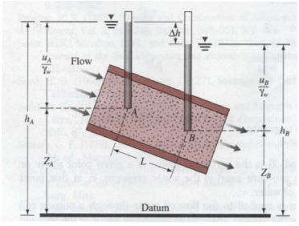
Example 9.1:
The pressure gage in figure below is 2 m at point A . Define the total head applies on top of the soil sample.
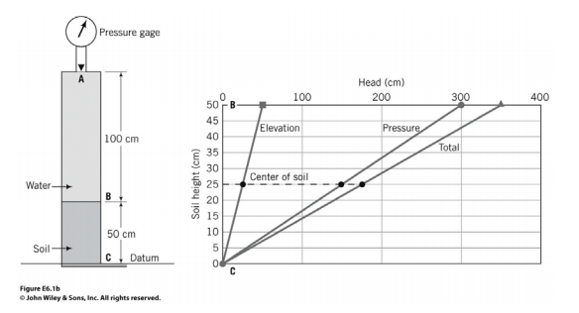
Darcy’s Law
Darcy (1856) proposed that average flow velocity through soil is proportional to the gradient of total head and hydraulic conductivity of the soil
$$v=ki$$
where v is the darcy velocity
  - k is the coefficient of permeability (or hydraulic conductivity)
  - i is the hydraulic gradient
The hydraulic gradient is the driving force causing the water to flow through the soil. The higher the hydraulic gradient, the greater the flow. If no hydraulic gradient is present, then no flow will occur and the system is under static conditions.
Hydraulic Gradient, i is defined as
$$i=\frac{dh}{dl}=\frac{Δh}{L}=head loss per unit length$$
• Both h and l are lengths, so i is dimensionless, and is always positive
Volume Flow rate, Q
$$Q=Av=\left(q_{v}in Budhu\right)=Ak\left(\frac{Δh}{L}\right)$$
Darcy’s Law is applicable only for laminar flows. (not valid if the flow is turbulent)
Recall from fluid mechanics two very important laws.
- Conservation of Mass (Continuity Equation)
- Conservation of Energy (Bernoulli Energy Equation)
Flow of water in soil depends on pressure head and length of flow (hydraulic gradient):
$$i=\frac{Δh}{L}$$
From Darcy’s Law: $v=ki$

9.1. Permeability

The ability of a soil to permit flow of water is quantified by its permeability (k)

Coarser soils

Larger pore spaces, therefore highly permeable

Finer Soils

Pore space small. Not as permeable

State of flow within the soil may vary with time. But we’ll study only about “Steady state” flow.

Conditions at a given point do not change with time

But, conditions change among points

Coefficient of Permeability (hydraulic conductivity) depends on several factors

Average particle size

Particle size distribution

Void ratio (or density)

Fabric/structure of the soil, layering, fissuring

The coefficient of permeability may be “direction dependent” for natural deposited soils

K_{Horizontal} ≠ K_{Vertical}

When permeability values are noted without the direction, it’s implied that they correspond to the permeability in the vertical direction

Coefficient of Permeability: Typical values

Budhu Table 2.7
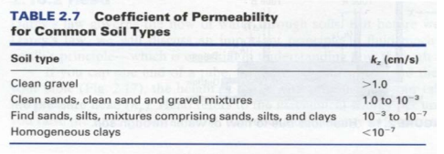
Note boundaries in the chart:
• 1 cm/s: approx boundary between laminar & turbulent flow
• 10⁻⁴cm/s: boundary between “pervious” &”poorly drained soils”
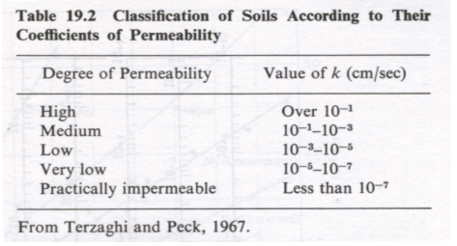
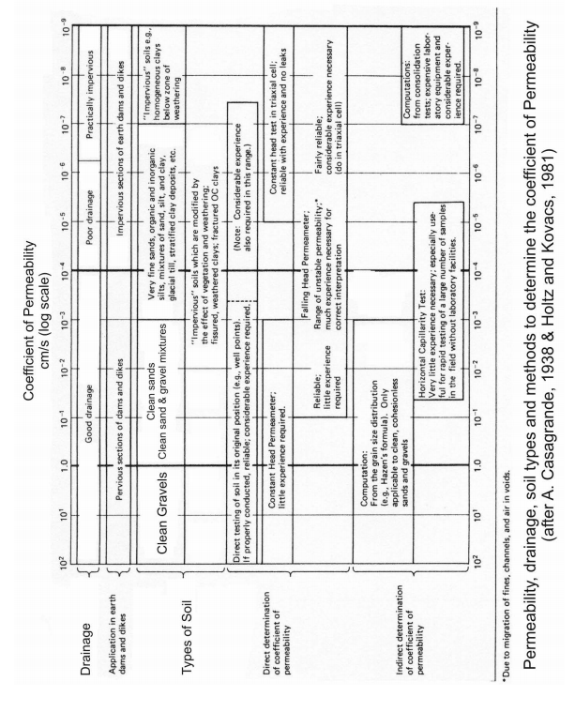

Example 9.2: 1-D Flow
A 0.3 m thick gravel layer (S=100%) sits above a 3m thick clay of hydraulic conductivity (k) = 0.005 m/a, which is on top of an aquifer. Plot the total head and calculate the flow through the clay layer.

Example 9.3 (6.2 of the text book):
A permeable soil layer is underlain by an impervious layer. With k=4.8×10⁻³cm/sec for the [permeable layer, calculate the rate of flow through it in m³/hr/m width if H=3 m.

9.2. Measurements of Permeability
In order to experimentally determine K, we need to know
  - Darcy’s velocity & hydraulic gradient
- Obtain Darcy velocity from the measured Flow rate (Q), and cross sectional area of the specimen
- Hydraulic gradient obtained from the head difference and length.
- Flow rate drastically different between coarse grained soils (gravels, sands) and fine grained soils (clays, clayey silts)
  - Different tests used depending of the soil type
Laboratory Methods
- Constant Head Test
- Falling Head Test
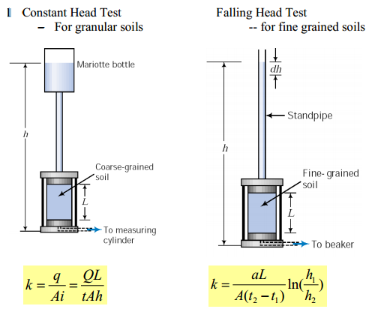

In-situ Field Methods
The permeability of a soil unit in the field is determined using a pumping well or a pumping well in conjunction with a series of observation wells.
The principle behind the in-situ tests are to pump water from an aquifer and back out the permeability based on the flow rate and the decrease in head at the pumped and observation wells. An aquifer is a soil unit which will conduct water and is more permeable than the soil layer above and below. A permeable aquifer can supply a small town or city with water for drinking and industry.
Water is pumped out at a constant flow rate, and the resulting reduction in ground water levels at observation wells is recorded.
By considering the head at two observation wells (h₁ and h₂) at distances r₁ and r₂ from the pumping well, it can be shown that (for radial laminar flow towards the pumping well in an isotropic, homogeneous infinite soil medium)
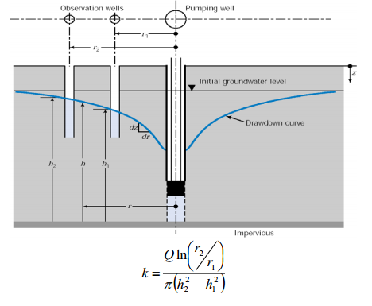
- Empirical relationship for K
  - If all particles in a granular soils are of the same size spheres then permeability to be proportional to the square of the particle size
  - In reality a range of particle sizes exist, and the coefficient of permeability is proportional to the effective grain size
  - Hanzen (1911) proposed K = (C) D₁₀²cm/s
- For granular soils
- Constant C varies between 0.4 to 1.0
  - Other propositions available in the literature
Extreme caution required if using empirical relationships

Examples
9.4: A constant head k-testing was performed on a coarse grained sample with diameter of 15cm and height of 30cm. The head of water was kept on 50cm for 300s, and flow rate was measured as 350cm³. Define the hydraulic conductivity of the soil.

9.5. A falling head permeability test was conducted on a soil with following data. Determine the hydraulic conductivity:
A=12cm², L=15cm, a=0.5cm², T=5min, h₁=40cm, h₂=20cm

9.6. A pumping test was carried out in a well and the flow rate was estimated about 0.2m³/s. The ground water level was observed constant during the test at the distance of 400m. Define the level of water in the well. K=0.0002 m/s

Flow Velocity:
Darcy Velocity is the average velocity of the groundwater.
- Actual velocity would be different because water has to travel through the pore space
- Seepage or pore water velocity is the average velocity of a water molecule through the actual pore
  - But, it’s difficult to measure the interstitial velocity
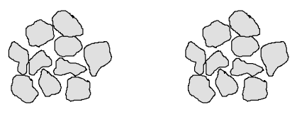
- Pore water (seepage) velocity is computed by dividing the average velocity by the area of the void cross section (note, Darcy velocity is obtained by dividing the flow rate by the area of the soil specimen; both solids plus voids)
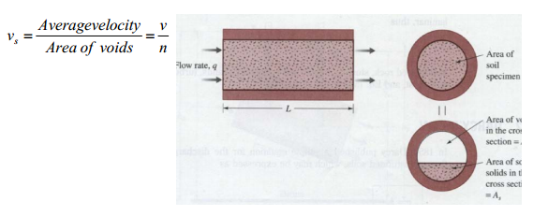

Example 9.7(6.1 of textbook):
For a constant head permeability test on a fine sand (void ratio is 0.46):
- length of specimen = 300 mm
- diameter of sample = 150 mm
- head difference = 500 mm
- water collected in 5 min = 350 cm³.
Determine
- Hydraulic conductivity
- Discharge velocity
- Seepage velocity

Flow in layered soils
1. Flow Parallel to Soil Layers: 2. Flow Normal to Soil Layers:

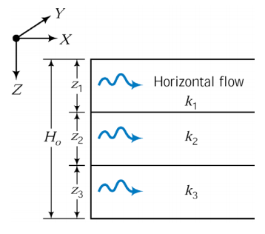

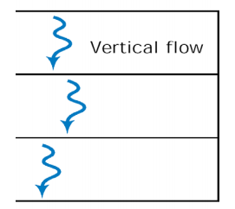

Example 9.8:
Define equivalent hydraulic conductivity in X and Z directions in figure below.

Example 9.9:
Define equivalent hydraulic conductivity and flow rate in figure below.

Pore water pressure in flow:
Water pressure at any point (no flow): $u=z*γ_{w}$
During the flow there will be a loss in the total head (due to friction), which will affect the pore water pressure.
From Bernoulli’s equation in soil: $H=Z+\frac{u}{γ_{w}}$
$$u=γ_{w}(H-Z)$$

9.3 Multidimensional Flow
Most groundwater flow problems are two- or three dimensional flow:
- Excavation
- Multiple wells
- Inhomogeneous soils
Definitions:
Isotropic -
Anisotropic -
Homogeneous -
Heterogeneous –
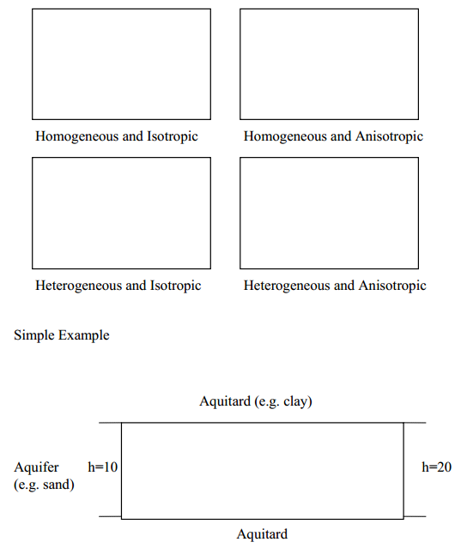

Development of the Laplace Equation
Assumptions:
- Soil is homogeneous and isotropic
- The soil element remains unchanged

Continuity gives: $q_{in}=q_{out}$
From Darcy’s Law:
$$\frac{∂^{2}h}{∂^{2}x}+\frac{∂^{2}h}{∂^{2}y}=0$$
Solutions to the LaPlace Equation
- Exact Solution
- Graphical Solution (flow net)
- Approximate Solutions
- Numerical Solution - Finite Difference
- Finite Elements
- Finite Volumes
Flow Nets
flow net - graphical solution of the Laplace equation in two dimensions
$$\frac{∂^{2}h}{∂^{2}x}+\frac{∂^{2}h}{∂^{2}y}=0$$
flow lines

equipotential lines

flow channels

Constructing Flow Net:
Criteria:
- flow lines and equipotentials are normal to one another at their intersection
- for isotropic soils, the areas confined by the flow lines and equipotentials are equal in width and height
- Flow lines must not intersect each other
- No two equipotential lines entersect
Drawing steps:
- Draw cross-section to scale
- Identify the boundary conditions
- Select an integer value for Nf
- Sketch the initial flow lines
- Add equipotential lines
- Refine the flow net

Flow Rate for 2D Flow
Flow through the flow net can be calculated using: $q=kL_{D}Δh\left(\frac{N_{F}}{N_{D}}\right)$
- q = Total Flow rate
- k = Hydraulic conductivity (Keq)
- L_{D} = Length of dam (aquifer) perpendicular to the cross-section
- ∆h = Total head loss through the flow net
- N_{F} = Number of flow channels
- N_{D} = Number of equipotential drops

Example 9.10:
Compute the total flow under the dam shown below in m³/day. Assume k=10⁻²cm/s, the length of the dam
the dam perpendicular to the section, L_{D}=150 m, and the total head change from the reservoir to the tail water, ∆h=8m.
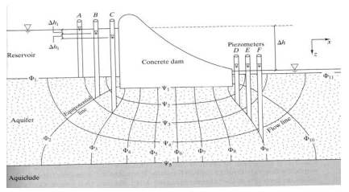
Example 9.11:
For the flow net given below, compute the flow net under the dam per unit length of the dam if the permeability is 3.5*10⁻⁴cm/s. Compute the uplift pressure along the base of the dam.
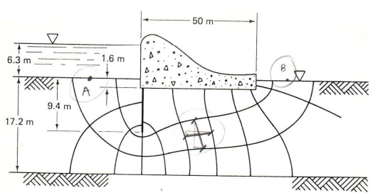
Example 9.12:
Compute the total flow under the sheet pile if the permeability is 3.5*10⁻⁴cm/s and total head is 8m. The length of the sheet pile is 10 m. Compute the uplift pressure under the sheet pile.
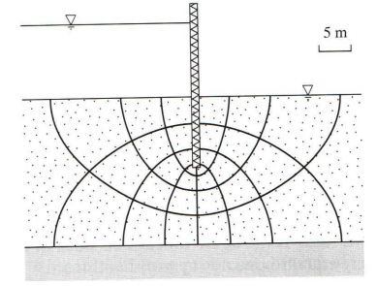

9.4. Capillarity
Water level rises within the pore space on account of surface tension that
  - Occurs at the interface of different fluids and soilds
  - In soil: solid, water and air interfaces
The capillary tube is an ideal representation of the pore space in soils
The height of capillary rise is inversely proportional to the diameter of the tubing. (introduced in fluid mechanics course)
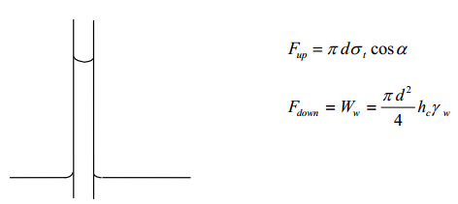
- consider the water pressure within the capillary tube
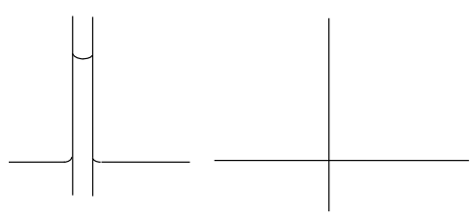
- the water is held under negative pressure of tension
- the capillary tube is an ideal representation of the pore structure in soil
- therefore, water within the soil is held in tension
Water table - is the surface in an unconfined aquifer or confining bed at which the pore water pressure is zero or atmospheric (phreatic surface)
The location of the water table can be determined by drilling a well until water is reached. The water level in the well corresponds to the location of the water table.
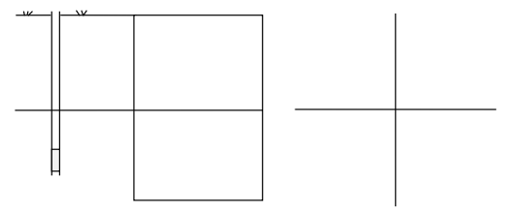
- Below the water table the saturation is 100% and the water pressure is positive above the water table,
- Above the water table, the saturation can still be 100% if the water is held there by capillarity or surface tension, result in negative water pressure
- The tension saturation zone above the water table is called the capillary fringe
- Above the capillary fringe water is still held in place by increasingly negative water pressures and the water saturation decreases as the pressure becomes more negative and decreases.
- The height of the capillary fringe ≅ 20% of the effective grain size (D₁₀)
- In coarse grain soils (gravel) there will be little to no capillary fringe
- In fine grained soils (sand, silts and clays) the capillary fringe can vary in height from a few centimeters to several meters.
Approximate Height of the Capillary Rise in Different Soils
Height of Capillary Fringe
Coarse Sand 0.3 - 0.15 m
Medium Sand 0.12 - 1.0 m
Fine Sand 0.3 - 3.0 m
Silt 1.5 - 10.0 m
Clay > 10 m
For the Soil Science and Soil Mechanics fields, the plot of saturation versus the height above the water table or the pore water pressure is called the Soil Moisture Retention Curve. The fluid saturation is plotted along the ordinate axis.
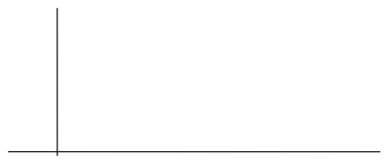
In the Hydrogeology and Groundwater Fields, the axes are reversed and the curve is called the Capillary Pressure - Saturation Curve. The capillary pressure in the unsaturated equalling the negative of the pore water pressure.

As a result of capillarity, the soil grains are held together by the surface tension forces within the water and the soil will has an apparent cohesion.
The reason why shallow trenches and excavations do not collapse is due to the presence of the water and the capillary fringe.
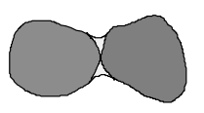
Shrinkage
Shrinkage in a clays and other fine grained soils occurs as a result of capillary forces. If a saturated clay is exposed to the atmosphere, water within the clay will evaporate. Due to the surface tension forces, air will not penetrate the clay and therefore the volume of the clay will reduce or shrink.
As evaporation continues, the pore water pressures become more strongly negative and eventually cracks can start to form.
- Agriculture (honeycone pattern in fields)
- Landfill liners
- Top of clay units below the ground

Importance of Shrinkage and Swelling
Shrinkage will cause cracks to form in the soil, reducing the strength of the soil. It was estimated by Jones and Holtz (1973) that the United States spends 2.3 billion dollars annually in repairing damage due to swelling and shrinkage. Swelling of soils occurs as a result of the increase in water pressure which reduces the interparticle forces and allows the soil to swell.
The degree to which a soil swells is a function of the types of clays present.
swelling in montmorillonite > illite > kaolinite
Potential Problems
e.g. - excavate for the structure exposing the foundation soil
- the moist soil shrinks and dries due to evaporation
- place the foundation
- the water is replaced with time and swelling occurs
Possible Solutions to Problems
- for compacted fill material, compact wet of optimum; this will cause less swelling, however, the strength of the soil is also effected
- periodically wet exposed soils so that they maintain a relatively constant water content until the foundation is placed
- chemical stabilization of the soil
Frost Action
Frost Action in the spring is a result of the pore water freezing over the winter months. When water freezes, the volume increases by about 10 %.
This however, is not the sole reason for the frost heave seen in the spring.
During the spring thaw, the pore water near the surface and the snow above the surface melt and infiltrate downward. The pore water lower in the ground is still frozen and as the infiltrating water reaches the frozen water an ice lens forms and pushes the soil above causing it to lift.
Similarly, if a foundation or any structure is not located below the frost line, water may flow along its surface to the base and form an ice lens causing the foundation of structure to lift.

Frost Thaw
Thawing of frozen ground: Thawing ice in frozen ground (coating soil particles and lenses)
- Seasonal Thaw: due to melting near surface permafrost
  - Loss of strength
- Increase in mean ground temperature
  - Climate change and global warming
  - Volume change, loss of strength, thaw settlement
  - Impact on foundations, embankments and pipelines

