
Department of Civil and Environmental Engineering

Course Notes for CIVE 3208

Geotechnical Mechanics

Instructor: M.T. Rayhani

Contents:
Chapter 11: Consolidation

References:
Soil Mechanics & Foundations, M. Budhu, John Wiley & Sons
Principles of Geotechnical Engineering, B. M. Das, Thompson Publishing
Fundamentals of Engineering Geology, Bell, F.G., Oxford University Press
An Introduction to Geotechnical Engineering, Holtz & Kovacs, Prentice Hall

11. Consolidation

11.1 Settlement

Many engineering projects include placing loads onto the ground, which produce increase in the vertical effective stress. This increase in effective stress induces vertical stress in the soil, and thus cause ground surface to move down. This downward movement is called settlement.

Changes in vertical effective stress:

• Stress change due to an external load (structural foundations, placement of a fill)

• Stress change due to changes in GWT elevation

• Settlement requirements often control the design of foundations

• Response of the ground to loading is of importance for all structures: cracks in dams, structures, road

• Settlement must be within acceptable limits …..

Compressibility of Soils
When a soil is loaded it can compress as a result of
- Deformation of the soil grains
- Compression of the air and water in the void space
- Time dependent movement of the water and air from the soils voids
The soil grains are generally very rigid and compression is negligible. Generally we are evaluating soils below the water table and water in relatively incompressible. Therefore, the compressibility of the soil will be dependent on how quickly the water can be displaced from the void space.

Compression and Settlement of Granular Materials (Sand and Gravels)
- Due to change in pore volume
- Very high K:
- No change in pore water pressure
Compression and Settlement of Clay Soils (Consolidation)
- Due to change in pore volume
- Very low K: water takes a long time to squeeze from clay
- This time dependent compression of clay is referred to as consolidation.
Types of Settlement:
- Distortion Settlement (Immediate)
- Consolidation (Time Dependent)
- Secondary Compression
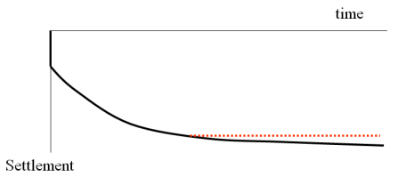
$$S_{t}=S_{i}+S_{c}+S_{s}$$
where S_{t} is the total settlement
S_{i} is the immediate settlement
S_{c} is the consolidation settlement (clay soils)
S_{s} is referred to as the secondary compression (creep)

Prediction of Settlement:
- Displacement of soil mass due to applied loads:
- Approached to predict deformation (settlement) caused by loads:
- Elasticity theory
- Spring model
- 1-D consolidation (oedometer) test

11.2 Immediate settlement:
Depends on elastic modulus, Poisson’s ratio and area of the loading.
$$S_{i}=\frac{qB}{E}I_{s}$$
which B is the width or diameter of structure, q is pressure, E is elastic modulus, and Is is the shape factor defined in the following table:
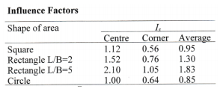
Example 11.1:
The design column (1m*2m) loads for a new building will be about 900 kN.
The soil consists of alluvial sand with unit weight of 20 kN/m³, elastic modulus of 68000 kPa, and GWT is at a depth of 70m. Determine settlement for this foundation.

11.3. Consolidation
Consolidation is a time dependent process. Initially when a load is applied to a clay layer, the soil (grain) structure of the clay layer will want to compress; however, it cannot compress until the water contained in the void space is forced out of the void space.
The flow of the water is a function of the soil permeability. Therefore the initial increase in total stress is taken by the water in the voids. As excess pore water pressure dissipates with time and the clay layer is compressed (consolidation), the effective stress increases and ultimately the change in the effective stress will equal to the applied load and the excess pore water pressure will approach zero. For a low permeability clay layer, the total consolidation settlement may take several years to reach equilibrium conditions.
- Consolidation is the process of settlement (or compression) of soils due to the expulsion of pore water from the voids.
- The void space becomes smaller during consolidation (i.e. void ratio decreases)
    - Similar result during compaction, but fundamental differences between the two processes.
- Consolidation is
    - A Time dependent process
    - Associated with increasing effective stresses (permanent)
    - Caused by outflow of pore water (from the control volume)
- We will only consider (fully) saturated soils (note soils are not fully saturated during compaction)
Consolidation process:
- When a load is applied to a saturated soil
    - The load carried by the soil skeleton can change ONLY if the soil skeleton undergoes deformation
    - The pore water pressure (PWP) increases instantaneously to support the extra load
- Generate Excess PWP
    - With time, the excess PWP dissipates (i.e. water flows out) and the PWP will return to its original value after a “long” time
    - As the PWP dissipates, the effective stress on the soil increases, (soil skeleton undergoes deformation) and the soil “consolidates”.
- PWP dissipation is time dependent, therefore consolidation is time dependent
    - Percentage Consolidation (or degree of consolidation) refers to current state with reference to the final state
- Either in terms of effective stress increment in the soil, or in terms of the dissipated excess PWP.
- Spring analogy to show percentage consolidation
Consider the spring analogy
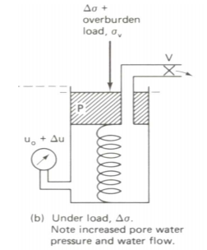
- System initially in equilibrium under overburden stress
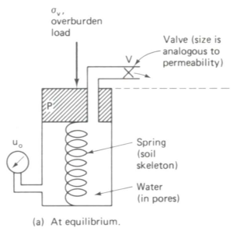

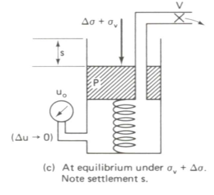
Add an extra load ∆σ at time t =0
- Two possibilities
- (a) Valve is closed (b) Valve is open (c) After adequate time

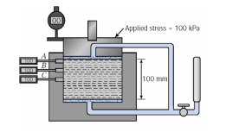
When a clay undergoes loading, the initial load is taken by the pore water pressure and ∆u = ∆σ and there is no change in the effective stress. With time the water drains and the load is transferred to the soil skeleton and the effective stress increases by the amount of the loading (∆σ′ = ∆σ_{t}, ∆u = 0).
- Initially in equilibrium.
  - Make Undrained (valve closed)
  - Apply 100 kPa stress increment
- PWP increases by an equivalent amount at the instant the load is applied.
(If ∆σ = 100 kPa then ∆u = 100 kPa throughout)
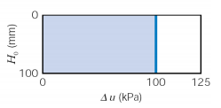
- If the drainage value is opened
- PWP at the drainage boundaries will be equal to the applied back pressure in the pipette.
- Excess PWP at the drainage boundaries is zero.
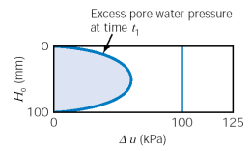
- Water will flow out through the soil: Pressure gradient within the soil (i.e. Seepage induced head loss)
- Symmetry,
- Non linear PWP distribution
- Zero Excess PWP after a “long” time.
  - Dependent on the permeability of the soil.

11.3.1 Consolidation Testing (Oedometer):
Objective: to measure stress-strain properties of soil in 1-D compression
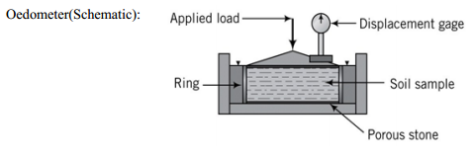
- 1D consolidation test used in the laboratory to determine the consolidation characteristics of the soil
- Lab handout gives the details
- Loads are applied in sequence (typically with an LIR=1)
  - Deformation – time response recorded during each load increment until all excess PWP is dissipated
  - Typically less than 24 hours for the specimens used in the lab
- May include unloading (and/or reloading) sequences.
- Allow sufficient time for excess PWP dissipation in each case
11.4 Settlement Calculations

11.4.1 Settlement calculation based on phase relations:

Change in volume due to consolidation, ∆V

Caused by a change in void space (no change in volume of solids)

Volumetric strain: $ϵ_{v}=\frac{Δv}{v} ϵ_{v}=A*ϵ_{z}$
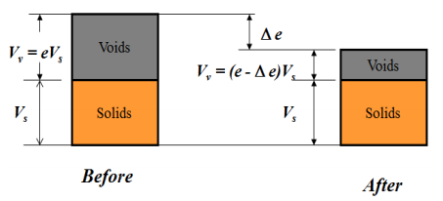
- For one dimensional consolidation
  - Settlement only in vertical direction
  - Constant cross sectional area
$$ϵ_{v}=A*ϵ_{z} ϵ_{z}=\frac{ΔH}{H_{o}}=\frac{s}{H_{o}}=\frac{Δe}{1+e_{o}}$$
therefore settlement, s, is given by $s=\frac{Δe}{1+e_{o}}H_{o}$

11.4.2 Settlement prediction of clay soils based on consolidation test:
If we obtain σ’ vs e relationship of a clay soil via consolidation tests, we can predict the soil settlement, knowing the applied load and soil layer thickness:
Void ratio – Pressure Relationship
There are two different conventions of presenting consolidation settlement data:
Plot the void ratio at the end of each loading increment against the effective stress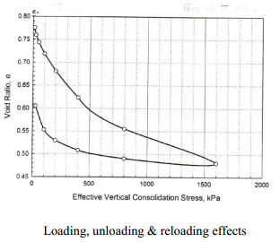
a) Coefficient of compressibility, a_{v} $a_{v}=\frac{Δe}{Δσ_{v}^{'}} (e vs. σ_{v}^{'})$
Note: e - σ curve is non-linear, so you must break up the stress change into increments.
b) Coefficient of volume change, m_{v} $m_{v}=\frac{Δϵ_{v}}{Δσ_{v}^{'}}=\frac{a_{v}}{1+e_{o}}=\frac{1}{D} (e vs. σ_{v}^{'})$
where $D=\frac{1+e_{o}}{a_{v}}$ strained or oedometric modulus
Settlement calculation based on:
  - Coefficient of compressibility
  - Coefficient of volume change
$$s=\frac{Δe}{1+e_{o}}H_{o} s_{c}=m_{v}Δσ^{'}H_{o}$$
Example 11.2:
Compute settlement for a clay layer with thickness of 5m if the GWT drops from ground level to a depth of 2.5mm (γ =18 kN/m³ and γ_{sat} = 20 kN/m³).
From consolidation test: m_{v}=8*10⁻⁴m²/kN

- Plot the void ratio at the end of each loading increment against the logarithm of the effective stress.
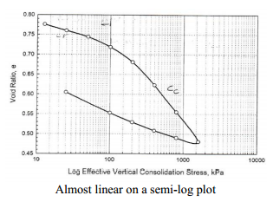
c) Compression index, C_{c} $C_{c}=\frac{Δe}{Δ\log{σ_{v}^{'}}} (e vs.\log{σ_{v}^{'}})$
d) Recompression index, C_{r} $C_{r}= \frac{Δe}{Δ\log{σ_{v}^{'}}}$ (normally much smaller than C_{c})
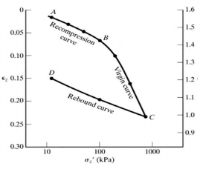
Example 11.3:
Given the following compression curve, calculate:
- a_{v} and m_{v} for the stress increment from 20-40 kPa.
- C_{c} and C_{r}.
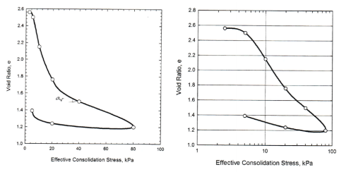
e) Preconsolidation Pressure:
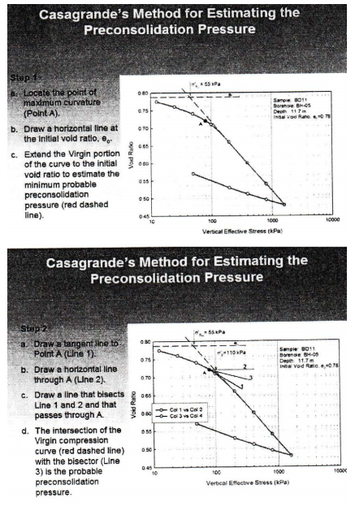
f) NC, OC, UC, OCR:
These terms describe the relationship between the existing effective stress in soil (overburden pressure σ_{v}’) and its preconsolidation pressure σ_{v}’
NC: Normally consolidated $σ_{vo}^{'}=σ_{p}^{'}$
OC: Over consolidated $σ_{vo}^{'}<σ_{p}^{'}$
UC: Under consolidated $σ_{vo}^{'}>σ_{p}^{'}$
OCR: Over consolidation ratio $OCR=\frac{σ_{p}^{'}}{σ_{vo}^{'}}$
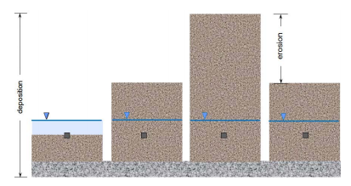
Example 11.4:
Figure below shows the results of an oedometer test performed on a sample of Windsor Clay. The sample was taken from a depth of 4.6 m.
- Estimate the probable preconsolidation pressure using Casagrande procedure.
- What is the minimum preconsolidation pressure?
- Determine the over-consolidation ratio (OCR).

Soil information: w=54% γ_{sat}=17.4 kN/m³ GS=2.7
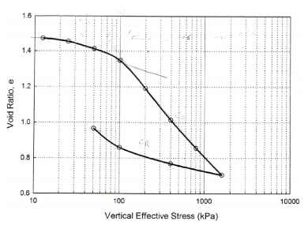

1-D Settlement Calculation (from consolidation test):
- We use parameters obtained from consolidation tests (a_{v} or m_{v}, C_{c}, C_{r} and σ_{p}’)
- Soil layer thickness (H₀)
- Initial effective stress of the layer before loading (σ_{v0}’)
- Surface loading pressure (p)
- Increment of vertical stress of the layer (∆σ_{v})

Case 1, NC Soil (σ_{v0}’ = σ_{p}’):
The initial stress is the maximum stress the soil has ever seen (σ_{v0}’=σ_{p}’).
The final stress exceeds the preconsolidation pressure. Settlement is due to virgin compression only and we use C_{c}.
$$s=\frac{Δe}{1+e_{o}}H_{o} s_{c}=C_{c}\frac{H_{o}}{1+e_{o}}\log{\frac{σ_{vo}^{'}+Δσ^{'}}{σ_{vo}^{'}}}$$
$$Δe=C_{c}[\log\left(σ_{o}^{'}+Δσ^{'}\right)-\log{σ_{o}^{'}]}$$

Case 2, OC Soil (σ_{zo}′ + ∆σ′ ≤ σ_{p}′):
The initial stress and final stress are both less than the preconsolidation pressure
(σ_{vo}′ + ∆σ_{v}′ ≤ σ_{p}′). Settlement is due to recompression only and we use C_{r}
$$s=\frac{Δe}{1+e_{o}}H_{o} s_{c}=C_{r}\frac{H_{o}}{1+e_{o}}\log{\frac{σ_{vo}^{'}+Δσ^{'}}{σ_{vo}^{'}}}$$
$$Δe=C_{r}[\log\left(σ_{o}^{'}+Δσ^{'}\right)-\log{σ_{o}^{'}]}$$
Note: Cr is typically one order of magnitude lower than C_{c}. Therefore, settlement due to recompression is much less than that due to virgin compression.

Case 3, OC Soil becomes NC due to loading:
If initially σ_{vo}′ ≤ σ_{p}′ and after consolidation σ_{vo}′ + ∆σ_{v}′ > σ_{p}′ then combine the normally consolidated and overconsolidated settlement equations as follows
$$s_{c}=C_{r}\frac{H_{o}}{1+e_{o}}\log{\frac{σ_{vo}^{'}+(σ_{p}^{'}- σ_{vo}^{'})}{σ_{vo1}^{'}}}+ C_{c}\frac{H_{o}}{1+e_{o}}\log{\frac{σ_{p}^{'}+(σ_{vo}^{'}+Δσ_{v}^{'}- σ_{p}^{'})}{σ_{p}^{'}}}$$
which reduces to
$$s_{c}=C_{r}\frac{H_{o}}{1+e_{o}}\log{\frac{σ_{p}^{'}}{σ_{vo1}^{'}}}+ C_{c}\frac{H_{o}}{1+e_{o}}\log{\frac{σ_{vo}^{'}+Δσ_{v}^{'}}{σ_{p}^{'}}}$$
Therefore, in order to determine the settlement due to a clay soil, C_{c} and C_{r} and σ_{p}′ should be determined.

Example 11.5:
Given: Clay layer, H₀=5 m
γ_{sat} = 22 kN/m³
From consolidation test:
σ_{p}′ = 130 kPa e₀= 0.84
C_{c} =0.15 C_{r} =0.03
If the lead geotechnical engineer tells you that 1-D loading will generate the vertical stress increase of 35 kPa, estimate the consolidation settlement.
Example 11.6:
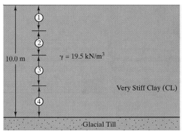
A 2*2 m² column with 1000 kN load will be placed over a clay layer of 10m. Compute the final settlement of the clay:
σ_{p}′ = 300 kPa
e₀= 0.6
C_{c} =0.20
C_{r} =0.08

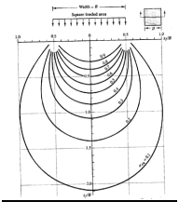
How deep the analysis should be?

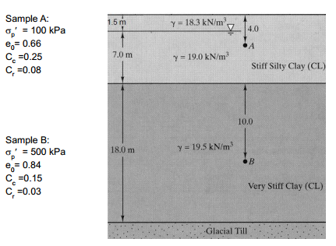
Example 11.7:
A square column (B=2.5m) with 1200 kN load will be placed over the following soil. Compute the final settlement of the clay:

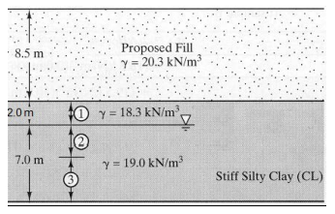
Example 11.8:
Determine consolidation settlement for figure below under the fill load.
σ_{p}′ = 300 kPa
e₀= 0.6
C_{c} =0.3
C_{r} =0.05

11.5. Rate of Consolidation
When static loads are applied to a structure element like beams or columns, the resulting deformations occur as fast as the loads are applied. However, deformations in soil occur much more slowly, especially in saturated clays.
- Consolidation is a Time dependent process
- For a low permeability clay layer, the total consolidation settlement may take several years to reach equilibrium conditions.
- It is important to estimate the rate of consolidation and predict the time required for final settlement
Terzaghi’s One-Dimensional Consolidation Theory (1925)
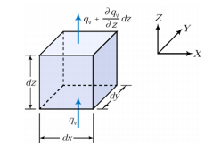
Assumptions
- homogeneous, water saturated soil layer
- Darcy’s law applies to the flow of water out of the layer
- soil particles and the water are incompressible
- a_{v} and k are constant during consolidation
- no secondary compression during this consolidation period
- layer is freely draining above and below

$$Volume inflow=v_{z}\left(dxdy\right)$$
$$Volume outflow=\left(v_{z}+\frac{δv_{z}}{δz}dz\right)\left(dxdy\right)$$
$$Change in flow=\frac{δv_{z}}{δz}\left(dxdydz\right)$$
$$Time rate of change in volume of the soil=\frac{δV}{δt}$$
$$=\frac{δ\left(V_{s}+V_{v}\right)}{δt}=\frac{δV_{s}}{δt}+\frac{δV_{v}}{δt}=\frac{δV_{v}}{δt}=V_{s}\left(\frac{δe}{δt}\right)$$
$$=\frac{V}{1+e_{o}}\left(\frac{δe}{δt}\right)=\frac{dxdydz}{1+e_{o}}\left(\frac{δe}{δt}\right)$$

Change in Flow should be equal to the Time Rate of Change of Volume
$$\frac{δv_{z}}{δz}=\frac{1}{1+e_{o}}\left(\frac{δe}{δt}\right)$$
From Darcy’s Law: $v_{z}=k_{z}i= -k_{z}\left(\frac{δh}{δz}\right)$
$$-k_{z}\left(\frac{δ^{2}h}{δz^{2}}\right)=\frac{1}{1+e_{o}}\left(\frac{δe}{δt}\right)$$
$$Let a_{v}=\frac{δe}{δσ^{'}} since Δσ^{'}= -Δu → a_{v}= -\frac{δe}{δu}$$
$$Also h=\frac{u}{γ_{w}}$$
$$\frac{k_{z}}{γ_{w}}\left(\frac{δ^{2}u}{δz^{2}}\right)= -\frac{1}{1+e_{o}}a_{v}\left(\frac{δu}{δt}\right)= -m_{v}\left(\frac{δu}{δt}\right)$$
$$\frac{δu}{δt}=\left[\frac{k_{z}}{m_{v}γ_{w}}\right]\left(\frac{δ^{2}u}{δz^{2}}\right)$$
Governing equation for 1D consolidation:
$$\frac{δu}{δt}=c_{v}\left(\frac{δ^{2}u}{δz^{2}}\right)$$
Solution to the Governing Equation
$$\frac{δu}{δt}=c_{v}\left(\frac{δ^{2}u}{δz^{2}}\right)$$
- Solution will depend on the boundary conditions
- Typically:
  - Top boundary free draining,
    - at z = 0, ∆u = 0
  - If bottom boundary is also free draining then
    - At z=2H_{dr}, ∆u = 0 where H_{dr} is the length of the drainage path.
  - At the instant the load is applied all the load is carried by the pore water
    - At t =0, ∆u = ∆u0 = ∆σ
- A solution that satisfies the above boundary conditions is:
$$Δu\left(z,t\right)=\sum_{m=0}^{m=∞}{\frac{2Δu_{o}}{M}\frac{sinMz}{H_{dr}}exp⁡(-M^{2}T_{v})}$$
- Where m is a positive integer, $M=\frac{\left(2m+1\right)p}{2}$ and the non-dimensional time factor, TV is given by:
$$T_{v}=\frac{C_{v}t}{H_{dr}^{2}}$$
where T = time factor, t = time and H_{dr} = longest drainage path

Degree of consolidation (rate)
- Degree of consolidation, U_{t} $U_{t}=\frac{e_{o}-e_{t}}{e_{o}-e_{f}}$
$$U_{t}=\frac{\left(Δu_{o}-Δu_{z}\right)}{Δu_{o}}= 1-\left(\frac{Δu_{z}}{Δu_{o}}\right)=1- \sum_{m=0}^{∞}{\frac{2}{M}\left[\frac{\sin{Mz}}{H_{dr}}\right]\exp\left(-M^{2}T_{v}\right)}$$
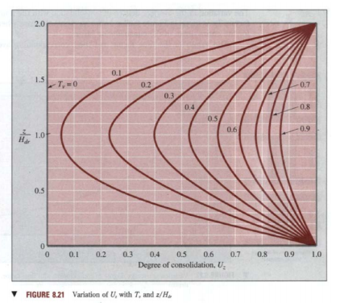
Therefore, you can determine the time factor (T) and then use this graph to determine Ut at a point or depth.
- Average degree of consolidation
  - If U_{t} is integrated over the depth of the layer, the average degree of % consolidation can be determined.
$$U=\frac{\int_{0}^{2h_{dr}}{Δu_{z}dz}}{2H_{dr}}=1- \sum_{m=0}^{∞}{\frac{2}{M^{2}}\exp\left(-M^{2}T_{v}\right)} =\left(\frac{S_{t}}{S_{cf}}\right)\frac{Average Settlement at Time t}{Total Settlement}$$

Therefore the settlement at time, t, is given by: $s\left(t\right)=U_{avg}S_{cf}$
For a given degree of consolidation U, T_{v} may be approximated by:
$$T_{v}=1.781-\log\left(100-U\right) for U≥60\%$$
$$T_{v}=\frac{π}{4}{\left(\frac{U}{100}\right)}^{2} for U<60\%$$
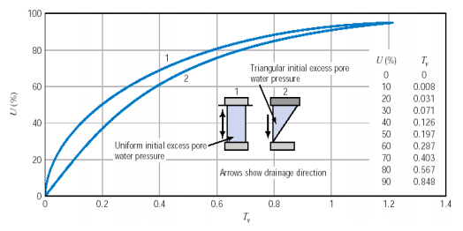
The same plots can be used if the layer is only drained on the top or bottom.
Assume the layer thickness is half that of a double-drained layer.

Determination of the Coefficient of Consolidation (Cv)
  - Two methods available
- Casagrande’s Logarithm of Time Fitting Method
- Plot the recorded displacement (within one load increment) against the logarithm of time determine t₅₀ from the graph and use
$$C_{v}=\frac{T_{50}H_{dr}^{2}}{t_{50}}$$
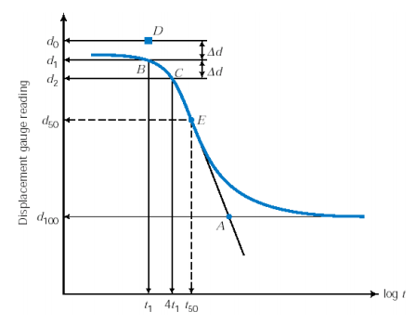

- Taylor’s Square Root of Time Fitting Method determine t₉₀ from the graph and use
$$C_{v}=\frac{T_{90}H_{dr}^{2}}{t_{90}}$$
- Plot the recorded displacement (within one load increment) against the square root of time
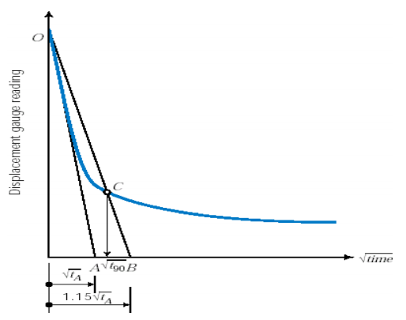
Example 11.9:
The following readings were taken for an increment of vertical stress of 20kPa in an oedometer test on a saturated clay sample, 75 mm in diameter and 20 mm thick. Drainage was permitted from the top and bottom boundaries.
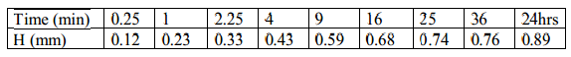
Determine the coefficient of consolidation using the root time method.

Example 11.10:
A sample 75mm in diameter and 20 mm height taken from a clay layer 10 m thick was tested in an oedometer with drainage at the upper and lower boundaries. It took the laboratory sample 15 min to reach 50% consolidation.
  - If the clay layer in the field has the same drainage condition as the laboratory sample, calculate how long it will take the 10 m clay to achieve 50% consolidation.
  - How much more time would it take the 10 m clay layer to achieve 50% consolidation if drainage existed only on one boundary

Example 11.11:
The coefficient of consolidation of a clay for a given pressure range was obtained as
8 x 10⁻³mm²/s on the basis of 1-D consolidation test results.
In the field, there is a 2 m thick layer of the same clay located over a layer of sand. Based on the assumption that a uniform surcharge of 70 kPa was to be applied instantaneously, the total consolidation settlement was estimated to be 150 mm. However, during construction, the loading was gradual.
Estimate the settlement at t = 60 and t = 120 days after the beginning of construction.

Determining k from the Oedometer Test
Once you have determined a_{v} and c_{v} from the oedometer test, you can rearrange the equation for c_{v} to determine k
$$c_{v}=\frac{k}{ρ_{w}g}\left(\frac{1+e_{o}}{a_{v}}\right)→k= \frac{c_{v}ρ_{w}ga_{v}}{1+e_{o}}$$

Determination of the Consolidation Parameters
The oedometer or consolidation test is used to determine the consolidation parameters for a soil sample in the laboratory (m_{v}, a_{v}, C_{c}, C_{r}, etc.)
However, the consolidation curve for an undisturbed clay in the field can be significantly different than the laboratory consolidation curve. Likewise, a well prepared undisturbed clay sample will have a significantly different consolidation curve than a remolded clay sample.
The same problems are encountered when determining C_{r} and C_{re}. The slope of the initial recompression or reconsolidation measured in the lab is generally too steep and therefore these values may not reflect the values in the field. Leonards (1976) suggested that the sample be exposed to a stress less than the preconsolidation value and then allowed to rebound before the stress is again increased. The average of the two values is often used to represent the in-situ values.
Factors Affecting the Determination of σ_{p}′
- sample disturbance
- load increment ratio (LIR) for consistency in testing
$$LIR=\frac{Δσ}{σ_{previous}}=1.0$$
- duration of the load increment for consistency, generally = 24 hours

Soil Profile and Typical Values for Consolidation Parameters:
The amount a foundation will settle will be dependent on the soil properties below the foundation. The total settlement will be the result of the settlement of each individual layer below the foundation. The soil parameters and stress history will vary with depth. Hence, the formation should be divided into a series of layers and the total final settlement will be the sum of the settlements of each individual layer.
Typical values for the compression indices are given below. Several empirical relationships have been developed for different types of clay based on the LL and PI. All relations contain values for clay soils since clays are generally responsible for settlement problems.
- C_{c}: 0.1 to 0.8
- C_{r} : about 10 ~ 20% of C_{c}
- Empirical Relationship for C_{c}: C_{c} = 0.009(LL-10)
- K_{o,ocr} = (1-sinφ)(OCR)^{0.5}
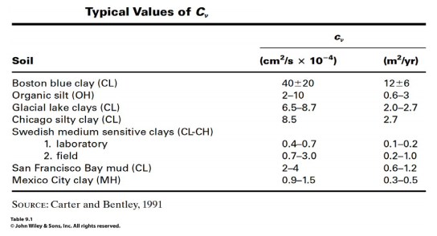

11.6. Secondary Consolidation
- Experimental Observation:
  - Clearly seen in a logarithimic time plot:
  - Compression under constant load. (no change in effective stress)
  - Therefore not consolidation.
  - Called secondary compression or Creep.
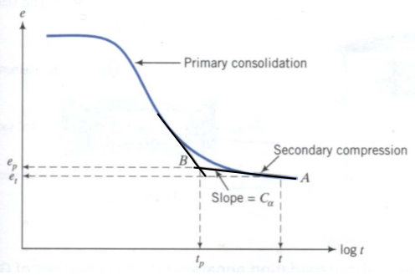
No concise, clear explanation for secondary compression exists, therefore the following assumptions are often made when estimating the secondary settlement
- C_{α} is independent of time (i.e. linear ???)
- C_{α} is independent of layer thickness
- C_{α} is independent of the LIR
- C_{α}/C_{c} is approximately constant for normally consolidated clays

