
Department of Civil and Environmental Engineering

Course Notes for CIVE 3208

Geotechnical Mechanics

Instructor: M.T. Rayhani

Contents:
Chapter 8: Soil Compaction

References:
Soil Mechanics & Foundations, M. Budhu, John Wiley & Sons
Principles of Geotechnical Engineering, B. M. Das, Thompson Publishing
Fundamentals of Engineering Geology, Bell, F.G., Oxford University Press
An Introduction to Geotechnical Engineering, Holtz & Kovacs, Prentice Hall

8. Soil Compaction

Compaction is the process of increasing the density of the soil by packing the particles closer together with a reduction in the volume of the voids.

Generally load carrying capacity of a soil increases with increasing density

– Loose: Weak soils, susceptible to failure

– Dense: particles tightly packed, results in stronger, competent soils

Loose => Dense

– Achieve by re-arranging particles (“compacting”) such that the void space decreases

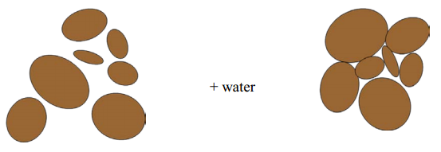
- Typical objectives of Compaction
– Increase shear strength, bearing capacity
– Decrease settlement (subsequent to construction)
– Decrease permeability
- Compaction is a “Soil Improvement” technique

Soil compaction is performed to increase the strength properties of the soil and to reduce its compressibility. The degree of compaction is measured in terms of dry density (or dry unit weight).

$$ρ_{d}=\frac{ρ}{1+w}$$
The degree to which a soil is compacted is dependent upon:
- the compaction energy and
- the water content.
The water content is important for two reasons.
- At very low water contents the soil is sticky and not easily compacted. As the water content is increased, the water acts as a lubricant allowing the grains to move over one another as the volume of the voids is reduced.
- Secondly, if the water content is too high, the water becomes trapped in the pore space and since it relatively incompressible, further compaction is restricted unless the water can flow out of the pore structure. In comparison, the air space within the pore volumes can be expelled and/or compressed more easily than the water phase.
The optimum water content for compaction is the water content at which the dry density is greatest for a given compaction energy.

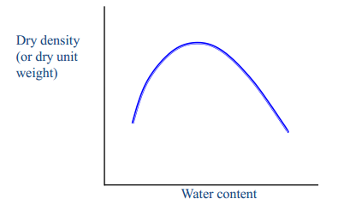
Several advantages occur through compaction:
- detrimental settlements can be reduced or prevented
- soil strength increases and slope stability can be improved
- bearing capacity of pavement subgrades can be improved
- reduce the permeability of a clay landfill liner
Different tests have been developed to determine the optimum water content for a given compaction energy.

8.1. Standard Proctor Test

Originally proposed by Proctor (in early 1930s), and hence called the Proctor Compaction Test. The procedure is given in the lab handout.

Standard hammer (5.5 lb), dropped a distance of 12 inches

Compact three soil layers (V_{mold}=943.3 cm³), each receiving 25 blows,

Repeat on several soil specimens with different soil moisture contents.

Determine the dry density of each compacted specimen

Plot dry density versus water content, and determine optimum water content, and maximum density

The compaction energy is a measure of the mechanical energy applied to the soil to reduce its volume. The optimum water content will vary depending on the compaction energy used.

Improved field compaction techniques are capable of producing densities higher than standard Proctor maximum density.

Originally encountered in air-field construction

Require a different test method in Lab to properly assess the degree of compaction

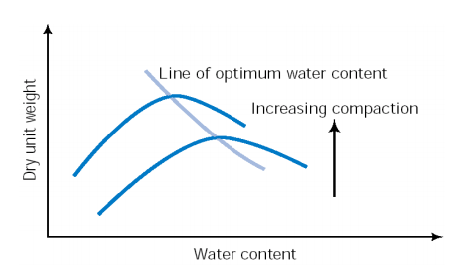
Example 8.1:
The laboratory test data for a standard Proctor test are given below. Find the maximum dry unit weight and the optimum moisture content.

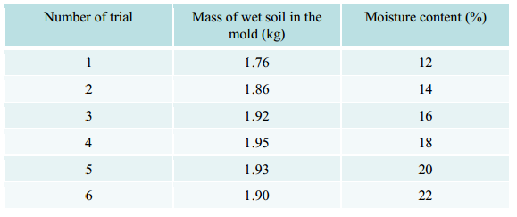
Effect of Compaction Energy
The compaction energy is a measure of the mechanical energy applied to the soil to reduce its volume.
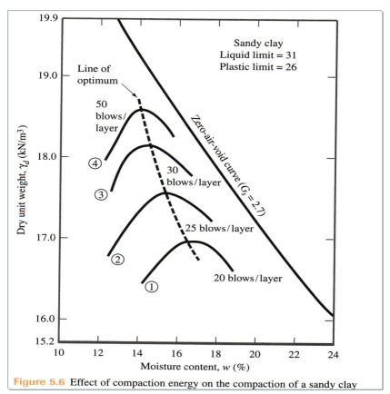

8.2. Modified Proctor Test
The modified Proctor test is similar to the standard Proctor test except the compaction energy is increased and soil is compacted in five layers. Similar to Standard Proctor, but different amount of energy input (About 4.5 times more energy input):
- 10 lb hammer
- 18 inch drop height
- 25 blows per layer, but five layers
- Modified Proctor Compaction Test
  - More energy input => Higher Maximum density
  - Lower optimum water content
  - Degree of saturation corresponding to max. density is lower
- Why these Lab Tests?
  - Information for efficient soil improvement in the field
    - Optimum water content
  - Specification for soil improvements in the field
    - Typically 95% of the Proctor Max. dry density specified
    - Compaction preferred at the lower (of the two possible) water contents except for swelling clays
Zero Air Voids Curve
For given water content, the theoretical maximum dry unit weight is obtained when there is no air left in the void space (S = 100%). The zero air voids (ZAV) curve represents the dry density when the saturation is 100%.
- Dry density corresponding to full (100%) saturation (i.e. zero air voids)
- Proctor densities always below ZAV line
- Can find the degree of saturation at Proctor Maximum density
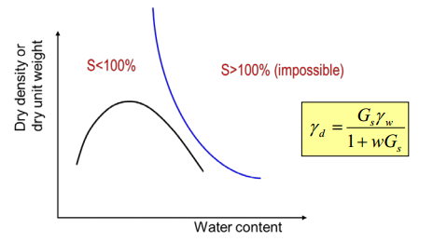
Note that a dry density-water content curve will never intersect the ZAV curve.
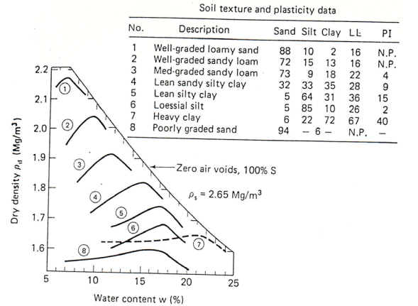
8.3 Effects of Compaction on Cohesive Soils

In dealing with the compaction of a soil, three terms are used to describe the water content

dry of optimum - water content < optimum water content

at or near optimum

wet of optimum - water content > optimum water content

Structure/fabric of the clay will be influence by the water content during compaction

random distribution if compacted dry of optimum

more “oriented” if compacted wet of optimum
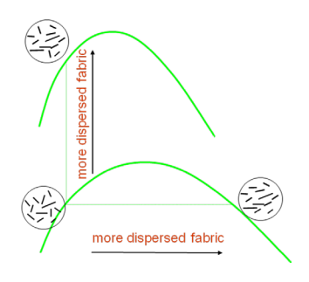

8.3.1. Permeability of Compacted Clays
Permeability is a measure of the soil’s ability to conduct water. A gravel has a significantly greater permeability than a clay.
The permeability of the clay decreased as the optimum water content is reached. The optimum water content corresponds to the greatest dry density and the lowest porosity. As the water content is increased beyond the optimum value, the permeability of the soil increases slightly.
If a clay is compacted under dry of optimum conditions, the permeability is significantly greater than the permeability under wet of optimum conditions due to the orientation of the soil grains. Under dry of optimum conditions the more random orientation of the clay particles results in larger void spaces and an increase in the permeability of the soil. If the clay is compacted wet of optimum, the clay particles are more aligned and oriented such that the void spaces are smaller and the permeability less.
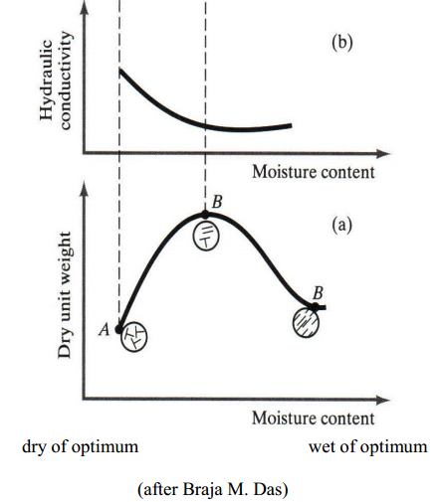

8.3.2. Strength of Compacted Clays
The strength of compacted clay soils decreases with molding moisture content. The strength of a soil drops off rapidly as the optimum water content is reached. i.e. clay soils compacted dry of optimum have a greater strength than clay soils compacted wet of optimum. Therefore, a remolded clay soil (wet of optimum) with the same dry density as an undisturbed clay soil (dry of optimum) will have a significantly lower strength than the undisturbed sample.
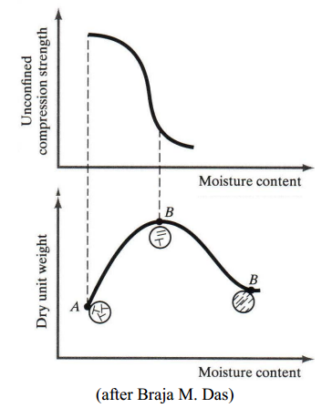
This becomes very important when a clay soil is used as a construction material for barrier systems since often the clay is remolded as it is compacted. Also, when testing the properties of clay in the laboratory, it is important to understand how the properties a remolded clay soil sample will vary from those of undistributed clay in the field.

Example 8.2:
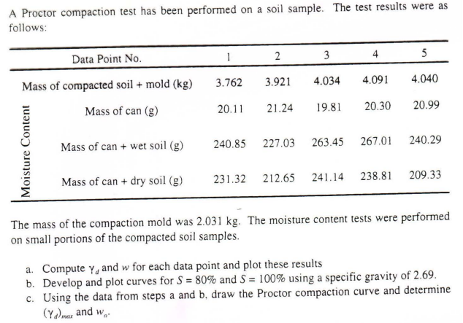

8.4. Field Compaction: Why?
- In Geotechnical design (e.g, earth dams, slopes, landfills, roadways etc.) it is imperative that the design strength for the soils used in the construction reflect the conditions under which the soil is placed.
- Difficult to directly measure strength and permeability in the field.
Density easily measured.
- Often required density specified
- Control compaction (compacting effort and moisture content) to ensure that the specifications are met).
- Road construction
  - Concern: Strength & Settlement of the sub base65
  - Specify maximum thickness of layers, and density required
(typically 90% to 95% of the Standard or Modified Proctor Density)
- Landfill leachate collection system
  - Concern: Permeability
  - The clay must be compacted to the required density to ensure that the permeability of the clay is reduced sufficiently to prevent the flow of water and/or leachate.
- Backfill material
  - Concern: Strength & Settlement of the fill
  - Often use native soil excavated from the site or off-site. These materials are mixed and placed under different conditions than the original (native) material.
- Compaction carried out in the filed using different types of rollers

Several different rollers are used in the field to achieve the desired compaction.
Smooth-wheeled of smooth drum rollers
- large steel cylinders filled with water or sand or any other material to increase the weight of the roller
- results in a smooth surface, smooth surfaces result in a very little bonding between surfaces
- generally used to finish surfaces and for proof rolling subgrades for asphalt or concrete
- used to compact relatively thin soil layers
Pneumatic rubber-tired roller
- can be used for a wide range of coarse and fine grained materials
- series of closely spaced tires over which the load is distributed
- compaction through pressure and kneading action66
- produces a relatively smooth surface resulting in poor layer bonding unless the surface is roughened or scarified between layers
Sheepsfoot roller
- steel drum with numerous tapered or club-shaped feet projecting from the surface of the drum, the feet are usually 200 to 250 mm in length with an end surface area of 40 to 60 cm²
- the feet impart a large pressure over a small area
- suitable for fine grains soils, both plastic and non-plastic
- the feet mix the soil and break up any lumps to improve the homogeneity of the material
- compacts the lower portion of the layer more effectively
- provides a rough surface for the next layer, therefore improving the bond or contact between layers
Grid rollers
- surface consists of a network of steel bars forming a square grid
- suitable for coarse grained soils
Vibratory rollers
- very efficient in compacting granular material
- added force of vibration, smooth-wheeled, pneumatic-tired, and sheepsfoot rollers
- one of the more efficient rollers for higher moisture contents near or above optimum
- variety of sizes and types (hand held vibrating plate compactors)

8.4.1. Specifications for Field Compaction
The design specifications are usually developed after a particular soil has been selected.
- Initial soil samples are tested in the lab to determine the soil strength, etc. 67
- Based on the design and soil parameters, a set of specifications are written to ensure that the selected soil will be placed at a compaction level that will provide the necessary properties to support the design.
There are two categories for earthwork specifications,
- End-product specifications
- The specifications state the specified relative compaction, how the contractor reaches those specifications is left up to the contractor.
- Method specifications
- The specifications state the method that must be used by the contractor
e.g. place granular A in two 6-inch lifts, compacting each lift using a certain weight smooth-wheeled roller, allowing three passes at a specified rate
- If the contractor meets these requirements and the soil is tested and does not meet the desired specifications, the engineer can ask the contractor to conduct additional passes with the roller as an extra for the contract.
A combination of the both categories can be used. Field quality control tests are performed for both specifications to ensure the desired result is achieved.
End-product specifications are generally more common. Field specifications are generally given as a relative compaction (R.C.) in comparison to a laboratory sample tested using a specified standard test procedure.
e.g. 90 % of the Modified Proctor Density
95 % of the Standard Proctor Density
$$RC\left(\%\right)=\frac{γ_{d}(field)}{γ_{d}(\max{lab)}} x 100\%$$
The denominator, γ_{d} (max. lab), is the maximum unit dry weight determined in the lab using the specified test (e.g. Standard of Modified Proctor Tests).
An alternative method is to specify the degree of compaction in terms of a relative density D_{r}.
$$D_{r}=\frac{γ_{d}\left(field\right)- γ_{d}(min)}{γ_{d}(\max{)}- γ_{d}(min)} x \frac{γ_{d}(max)}{γ_{d}(min)}$$

8.4.2. Quality Control in the Field
- Determine the soil compaction of a sample in the field.
- Destructive and non-destructive tests exist.
Destructive testing requires that some of the compacted fill material be removed for testing.
- Excavate a hole in the compacted fill.
- Determine the mass of the excavated soil.
- Place a soil sample in a sealed container for a moisture content analysis.
- Measure the volume of the excavated material using
- sand cone method
- balloon method
- water or oil method
- Determine the soil density and the dry density.
- Compare the results to the required specifications
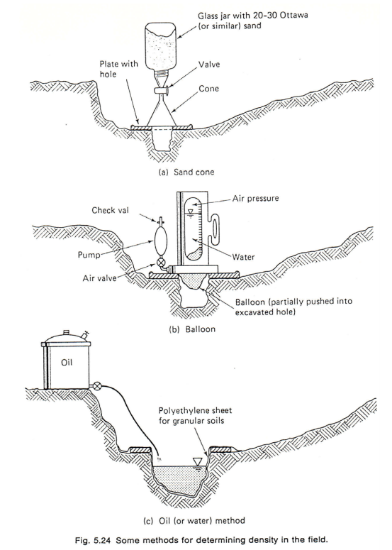

Nuclear Test Method
The advantages of the nuclear test methods are
- non-destructive
- test is conducted quickly with preliminary results within minutes
The disadvantages of the nuclear test methods are
- initial cost
- risk of radioactive exposure
The basic concept of a nuclear density device is to calibrate the scatter of gamma radiation to the soil density and the scatter from a neutron source to the water content. The unit consists of a source and a detector. The gamma source (radioactive material, radium or a radioactive isotope of cesium) releases gamma radiation which is scattered by the soil and the amount of scatter is recorded at the detector. The neutron source (americium-beryllium isotopes) released neutrons which are scattered as a result of the detector. The nuclear density unit must be calibrated prior to use in the field. Once calibrated for the particular soil, it is an effective way to determine the density and water content at a construction site.
Three standard setups are used;
  - direct transmission
  - backscatter
  - air-gap
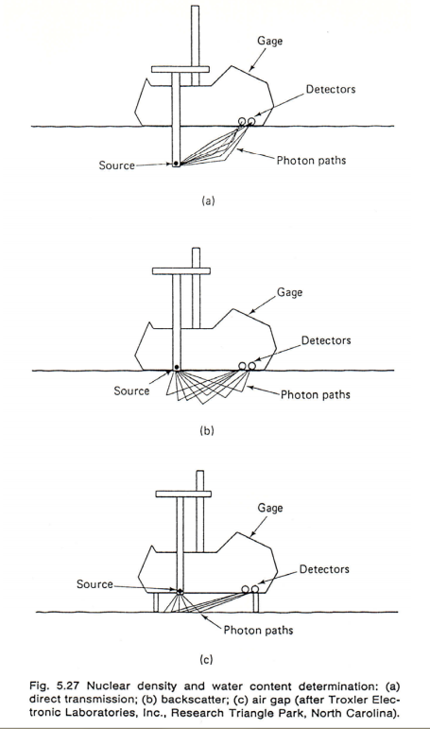
Example 8.3:
A sand cone test has been performed in a compacted fill and test results were as follow
(γ_{d}(max) =18kN/m³):
- Initial mass of sand cone: 5.912 kg
- Final mass of sand cone: 2.378 kg
- Mass of soil from hole: 2.883 kg
- Moisture content of soil from hole: 7.0%
- Density of sand: 1300 kg/m³
- Volume of cone below valve: 1.114*10⁻³ m³
The project specifications require a relative compaction of 90%.
Compute dry unit weight and relative compaction and determine whether the project specifications have been met. If not suggest a course of action.

Field Data: Effect of Vibrating Frequency:
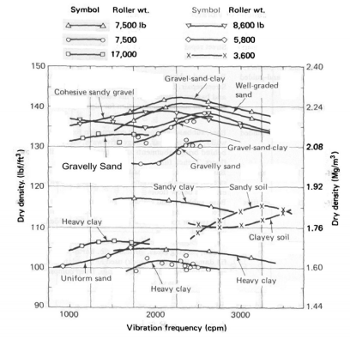

Field Data: Effect of roller travel speed
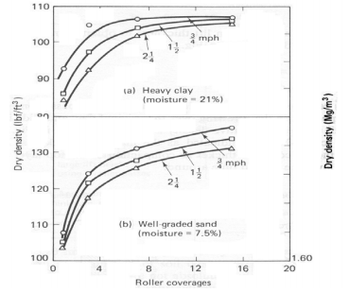
Field Data: Effect of Number of Passes
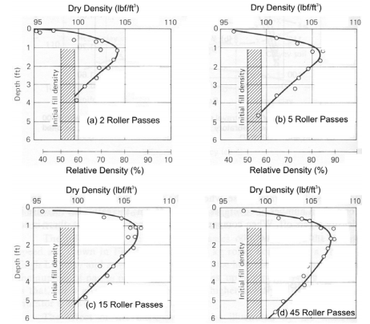

Field Design: Lift Height
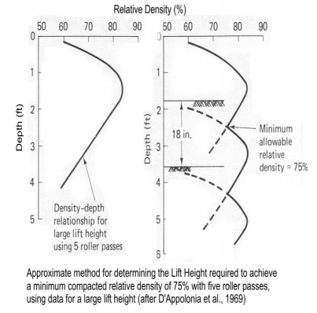
Example 8.4:
A Field density test was performed by using the balloon method. The following data were obtained from the test
- Mass of soil removed + pan: 1690 g
- Mass of pan: 225 g
- Initial Balloon Reading: 200 cm3
- Final Balloon Reading: 950 cm3
- Water content information:
  - Mass of wet soil + container: 504.9g
  - Mass of Dry soil + container: 465.9 g
  - Mass of container: 222.0 g
Compute
- Dry density and water content of the soil
- The Relative compaction, if the maximum modified proctor density of this soil is 1.78 Mg/m³

