Project Management
Table of Contents
Introduction 5
The Project Manager’s Job 7
Project Planning 8
Risk Management Planning 9
Work Breakdown Schedule 11
Project Scheduling 11
Gantt Chart 12
PERT/CPM Technique 14
Precedence Network 14
Deterministic Activity Durations 16
Solution Technique 17
Calculating Activity Slack Times 24
Probablistic Activity Durations 26
Determining Path Probabilities 28
Project Crashing 30
Project Execution and Control 34
Project Management Software 36

Learning Objectives
- Introduction
  - Project Manager’s Job
- Project Planning
  - Risk management planning
  - Work breakdown structure
- Project Scheduling (lo3)
  - Gantt chart
  - PERT/CPM Technique
  - Precedence Network
    - Precedence network
      - Diagram of project activities and their sequential relationships by use of arrows and nodes
    - Ativity on arrow (AOA)
      - Network in which arrows designate activities
    - Acitivity-and-node (AON)
      - Network in which nodes designate activities
    - Path
      - A sequenceof activities that leads from the start ndoe to the end node
    - Critical path
      - The longest ath from start to end
      - Determines the epected project duration
    - Critical activities
      - Activities on the critical (longest) path
    - Path slack time
      - Allowable slippage for a path
      - The difference between the length of the path and the length of critical (longest) path
- Deterministic Activity Duration (LO4)
  - Vocab
    - Deterministic durations
      - Durations that are fairly certain
    - Probabilistic durations
      - Durations that allow for variation
  - Solution technique
    - Calculating activity slack times
  - Rules for PERT/CPM Solution Technique
    - Forward pass
    - Backward pass
- Probablistic Activity Durations (LO5)
  - Vocab
    - 3-point estimates method
      - PERt/CRM when the activity durations are vaiable and are determined using three estimates
        - Optimistic
        - Most likely
        - Pessimistic
    - Opimistic duration
      - The length of time under the best conditions (to)
    - Pessimistic durations
      - The length of time under the worst conditions (Tp)
    - Most likely duratiosn
      - The most probable length of time (Tm)
    - Beta distribution
      - A family of continuous positive distributions used to describe the inherent variability in activity duration
  - Determining Path Probabilities
    - Using simulations
- Project Crashing (LO6)
- Project Execution and Control
  - Vocab
    - Project execution
      - Involves performance of activities planned
    - Project control
      - Comparing a project’s progress against plans and taking corrective action if necessary
- Project Management Software
  - Using Microsoft project
  - Deltek (Welcom)

Learning Objectives
- Describe what a project is and discuss the nature of the managers job
  - Project: unique, large, one-time job requiring special activities to accomplish a specific objective in a limited time frame
  - Work
    - The work so that all of the neccssary activities are accomplished in the desired sequence and performance goals are met
  - Human resourcs
    - So that those working on the project have direction and motivation
  - Communication
    - So that everybody has the information they need to do their work (usually through regular meetings), and th customer sonsor is well informed
    - Logs of actions, issues and risk should be kpt to manage the projct and to have as project history
  - Quality
    - So that the specific objective is realized
  - Time
    - So that the project is completed on schedule
  - Costs
    - So that the projct is completed within budgt
- Manager’s skills include ability to
  - Motivate and direct team members
  - Build a team
  - Make trad-off dcisions in project performance goals
  - Expedite th work when necessary
  - Deal with obstacles and team conflicts
  - Handle failure, fear of failure
  - Monitor time, budgt and techniqical details
  - Strong leadership skills
    - Adapt to changing circumstances that may involve changes to project performance goals, technical requirements and project team composition
    - Recognize need for change
    - Decide what changes are necessary
    - Accomplish them
- Explain what is involved in project planning, how to manage project risk and what work breakdown structure is
  - Breaking down the project into smaller componenets
    - Delieverables, subprojects, work packages, and activities
  - Risk management planning: Identification, analysis and response plans to what may go wrong
  - Estimating the required resources for the activities: Employees, equipment, material
  - Cost estimation for each activity
  - Budgetting: Calculating total cost per time, including subcontracting costs
  - Human resource planning: Including assigning team member roles and responsibilities
  - Project scheduling: Estimating activity durations, sequencing, and scheduling
  - Quality planning: involves determing how product quality is to e assured and controlled; It incudes: deciding the quality policy, objectives, responsibilities, metrics, tools (i.e.: checklists)
  - Communications planning: Involves determining the nature of information needed by stakeholders and how to satisfy these needs ; It includes: plans for information collection/storage, the tech and media used, nature of info distributed (i.e.: project performance reports)
  - Purchase planning: Involves: determining what to purchase, the statement of work or the specification of the item, supplier evaluation, selection and the award of contract , The actual delivery and monitoring/controlling of supplier performance are part of execution and control of the project
- Explain what project scheduling is, how schedule/control Gantt charts can be used in project scheduling, and wat PERT/COM and precedence networks are
- Use PERT/CPM technique with deterministic activity durations to schedule projecs and solve typical problems
- Schedule activities with probabilistic activity durations and solve typical problems
- Describe what is involved in project execution and what the earned value is
- Be able to use Microsoft project

Vocab
- 3-point estimates method
  - PERt/CPM when the activity durations are variable and are determined using three estimates
    - Optimistic
    - Most likely
    - Pessimistic
- Activity-on-arrow (AOA)
  - Network in which arrows designate activities
- Activity-n-nodes (AON)
  - Network in which nodes designate activities
- Beta distribution
  - A family of continuous positive distributions used to descrive the inheret variability in activity durations
- CPM
  - Critical path method, used for scheduling and control of large projects
- Critical activities
  - Activities on the critical (longest) path
- Critical path
  - The longest path from start to end, determines the expected project durations
- Deterministic durations
  - Durations that are fairly certain
- Matrix organizations
  - An organizational structure that temporarily groups together specialists from different departments to work on special projects
- Most likely distribution
  - The most probable length of time under the best conditions (To)
- Optimistic durations
  - The length of time under the best condition (to)
- Path
  - A sequence of activities that leads from the start node to the end node
- Path slack system
  - Allowable slippage for a path
  - The difference between the length of the path and the length of the critical longest path
- Performance goals for a project
  - For a project, keeping the project within
    - Schedule
    - Budget
    - Quality guidelines
- PERT
  - Program evaluation and reviw technique, used for scheduling and control of large projects
- Pessimistic durations
  - The length of time under the worst conditions (Tp)
- Precedence network
  - Diagram of project activities and their subquential relationships by use of arrows and nodes
- Probabilistic durations
  - Durations that allow for variations
- Project
  - Unique, large, one-time jb requiring special activities to accomplish a specific objective in a limited time frame
- Project control
  - Comparing a project’s progress against plans and taking corrective action if necessary
- Project execution
  - Involves performance of activities planned
- Project manager
  - The person responsible for planning, scheduling, executing, and controlling a projet from iceptoin to completion, meeting the project’s requirements and ensuring completion on time, within budget and to the required quality standards
- Project planning
  - Analyzing the project into work packages and activities, estimating resources needed and durations, scheduling
- Project scheduling
  - Determining the timing of activities of the project
- Work breakdown structure (WBS)
  - A hierarchial listing of what must be done during a project

Summary
- Project
  - Unique, one-time, job requiring special activities by different people, established to realize a specific objective in a limited time span
  - Projects go through a life cycle that involves
    - Initiation
    - Planning and scheduling
    - Execution
    - Control
    - Closeout
- Most organizations are structured as a matrix
  - With memers working for both projects and a functional department
- Project manager
  - Responsible for all project activities from inception to close-out, including meting the project performance goals f being on time and within quality specifications and budgets
- Project planning
  - Involves finalizing the project scope
  - Create the work breakdown structure
  - Risk management planning
    - Risk identification
    - Assessment
    - Response planning
  - Scheduling
  - Cost estimations and budgeting
  - Quality
  - Communications
  - Purchase planning
- Schedule/control Gantt charts are used to schedule simple projects
- PERT/CPM
  - Used to schedule complex projects
- Precedence network
  - Depicts the sequential relationships that exist among activities
  - The solution reveals the largest (critical) path and the critical activities (i.e.: those activities that must be completed on time to achieve timely project completion)
- For projects iwht variable activitiy durations, the 3-point estimates method can be used
- It is possible to shorten (crash) the length of a project by shortening one or more of the critical activities
  - Such gains are achieved by the use of additional resources but shortening will save indirect project costs
- Project execution
  - Involves putting the project plans into actions, buying materials, and assigning team members, or subcontracting the work
- Project control
  - Means taking measurements of project performance and takng corrective action if necessary
- Project management software
  - Microsoft project
  - Deltek’s (Welco) EPM suite

Introduction
- Learning Objectives
  - Describe what a project is and discuss the nature of a project manager’s job?
- Program
  - Set of projects
- All projects are expected to achieve the following performance goals
  - To be completed within
    - time/schedule
    - cost/budget
    - quality guidelines
  - To accomplish this
    - Projects must be authorized
    - Their objectives and scope must be established
    - A project manager should be appointed
    - Prject must be planned
    - Activities/tasj must be identified and time estimates made
    - Resource requirements must also be estimated and budgets prepared
    - Project’s progress must be monitored to ensure that project’s performance goals will be achieved
- Project life cucle
  - Project initiation (conception, feasibility study/selection)
  - Planning and scheduling
  - Execution
  - Control
  - Closeout
- Steps
  - Initialll an idea is presented and its feasibility is assessed
  - Plans must be drawn up by an architect
  - Approved by the owner and possibly a town’s building permits department
  - Succession of activities occurs
    - Each with its own skill requirements
      - Start with site preparation, lay foundation, erect frame, roofing ealls, wiring/plumbing, installing, interior finishing, painting and carpeting
- In a company
  - The project initiator/sponser is usually a senior manager/VP
  - Project output or deliverable is a good such as a building/software or service such as emerging 2 databases
  - Project is influenced by company’s strategies and policies and “environment| (culture, info systems, HR)
    - The major document used is the project scope 9the work that needs to be accomplished to deliver a good or service, the specified objective)
- Project portfolio selection
  - Involves factors
    - Budget
    - Availability of personnel with appropriate knowledge and skill
    - Cost-benefit consideration
    - Financial benefits
      - Return on investment
      - Net present value
      - How the project will contribute to the company’s strategy
  - Steps to project selection
    - Establish project council
      - i.e.: the executive committee
    - identify some project categories (i.e.: long v. short term, minor v. major ) and criteria (i.e.: business value, customer satisfaction, process effectiveness, employee satisfaction)
    - Collect project data
    - Assess resources (i.e.: labour, dollars) availability
    - Prioritize the projects within categories
    - Select projects within categories
    - Select project to be funded
    - Communicate the result to stakeholders and provide the reasons for selection or non0selection of each project
- Project planning
  - Determines how the project is undertaken
    - Including breaking down the job into saller components (Work Breakdown Structure) determining
      - the resource needed and estimating their costs
      - scheduling the activities involved or subcontracting the work
      - planning risk management
      - panning material purchases
- Project execution
  - Involves purchasing material and using team members and subcontractors to perform activities/tasks
- Project control
  - Involves observing the project’s progress, issuing performance reports on scope/schedule/cost/quality/risk and making any neccesay changes to project
- Project
  - Brings various people together
    - Stakeholders include the project tesam who perform the activities/tasks, project sponser/initator who initiates and gets approval afor the project, and customer/users
    - The project is headed by a project manager, guided by the project sponser
      - Initiates and gets approval for the project
    - Customers/users
  - The project is headed by the project managers and guided by the project sponsr
- Matrix organizations
  - Temporary groups together specialists from different departments to work on special project
  - Staff members
    - A structural engineer or an accountant, works on one or more projects part-time but permanently belonging to his department
  - Project manager and functional manger
    - Share the authority of assigning priorities and directing the work

The Project Manager’s Job
- Project manager is responsible for
  - Work
    - The work so that all of the neccssary activities are accomplished in the desired sequence and performance goals are met
  - Human resourcs
    - So that those working on the project have direction and motivation
  - Communication
    - So that everybody has the information they need to do their work (usually through regular meetings), and th customer sonsor is well informed
    - Logs of actions, issues and risk should be kpt to manage the projct and to have as project history
  - Quality
    - So that the specific objective is realized
  - Time
    - So that the project is completed on schedule
  - Costs
    - So that the projct is completed within budgt
- Manager’s skills include ability to
  - Motivate and direct team members
  - Build a team
  - Make trad-off dcisions in project performance goals
  - Expedite th work when necessary
  - Deal with obstacles and team conflicts
  - Handle failure, fear of failure
  - Monitor time, budgt and techniqical details
  - Strong leadership skills
    - Adapt to changing circumstances that may involve changes to project performance goals, technical requirements and project team composition
    - Recognize need for change
    - Decide what changes are necessary
    - Accomplish them
- Ethical issues
  - Temptation to understate costs
  - Withhold information in order to get a project approved
  - Pressure to alter or make misleading statements on status erports
  - Falsifying records
  - Compromising workers’ safety
  - Approving substandard work

Project Planning
- Further elaboration of the scope (the work to be done)
  - Breaking down the project into smaller componenets
    - Delieverables, subprojects, work packages, and activities
  - Risk management planning
    - Identification, analysis and response plans to what may go wrong
  - Estimating the required resources for the activities
    - Employees, equipment, material
  - Cost estimation
    - For each activity
  - Budgetting
    - Calculating total cost per time, including subcontracting costs
  - Human resource planning
    - Including assigning team member roles and responsibilities
  - Project scheduling
    - Estimating activity durations, sequencing, and scheduling
  - Quality planning
    - Involves determing how product quality is to e assured and controlled
    - It incudes
      - Deciding the quality policy
      - Objectives
      - Responsibilities
      - Metrics
      - Tools (i.e.: checklists)
  - Communications planning
    - Involves determining the nature of information needed by stakeholders and how to satisfy these needs
    - It includes
      - plans for information collection/storage
      - the tech and media used
      - nature of info distributed (i.e.: project performance reports)
  - Purchase planning
    - Involves
      - determining what to purchase
      - the statement of work or the specification of the item
      - supplier evaluation
      - selection and the award of contract
    - The actual delivery and monitoring/controlling of supplier performance are part of execution and control of the project

Risk Management Planning
- Risks relate to the occerence of events that have undesirable consequences
  - Delays
  - Increased costs
  - Inability to meet technical specifications (quality/performance)
- Good risk management
  - Identify as many possible risks as possible
    - Use brainstorming and questionnaires to involve everyone
    - Review documents, analue assumptions, look for inaccuracies, inconsistencies and incompleteness
    - List risks in a risk register
  - Analyze and assess risks
    - Evaluate probability of occurrence and potential consequence
    - Use tools ike scenario analysis, simulation, decision trees and sensitivity analysis
  - Plan a response to avoid/transfer/mitigate the risk
    - Risk response can take many forms depending on the nature and scope of project
    - Steps
      - Identify root cause of risk
      - Categorize their source
      - Risk response
        - Redundant (backup) systems
          - An emergency generator could supply power in the event of an electrical fire
        - Using a less complex process or a more stable supplier
        - Frequent monitoring of critical project aspects with the goal of catching and eliminating problems in their early stages, before they cause extensive damage
        - Transferring risks, say by outsourcing a particular component of a project and requiring performance bonds
        - Risk-sharing, for example, as in oil and gas consortium
        - Extending the schedule, creating contingency funds, reducing project scope, clarifying the requirements, obtaining information and improving communication

Work Breakdown Schedule
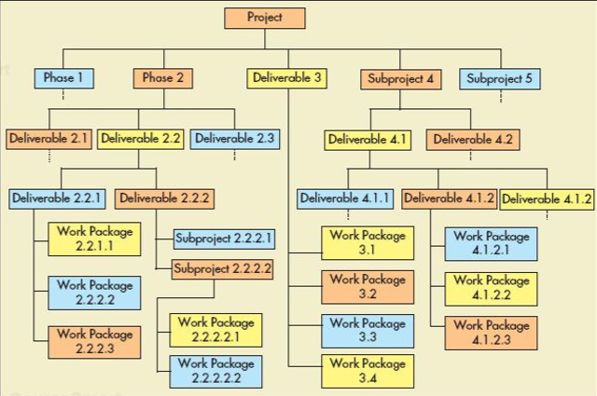
- Steps
  - Develop a work breakdown structure is to identify the major components of te project
    - These could be the phase of project, deliverables or subprojects
  - Identify major subcomponents is decomposed into work packages
    - A work package can be performed by a worker, team or subcontracter
    - Each work package, possible with assistance from the worker, team or subcontractor is broken down into a list of activities that will be needed to accomplish it

Project Scheduling
- Steps to project scheduling
  - Indemnify the activities of WBS
    - Including attributes and whether it is a milestone activity
  - Any sequential dependencies of every part of activities should be identified
    - If he needed resources cannot be identified, the activity should be further decomposed
  - The duration of each activity can be estimated using information on the availability of resources
    - The risk register could possibly add contingency time to the duration
    - As work is undertain, more accurate estimates of costs and times become available
  - Schedule is developed using the activity duration estimates and the sequential dependencies of activities by the PERT/COM technique
    - For one-point estimate (deterministic times)
    - For 3-point estimate (probabilistic times)
    - If project is late, schedule comptession methods such as project craching (accelerating activities) and fast tracking (overlapping predecessor-successor activities) will be performed
    - The schedule ewill be displayed via a
      - Gantt chart for simple scheduling/controlling
      - PERT/CPM technique using both
        - deterministic and probabilistic times
        - project crashing

Gantt Chart
- popular tool for scheduling and control of the activities of simple projects
- enables managers to schedule the activities and then to monitor their progress over time by comparing their planned to actual progress
  - 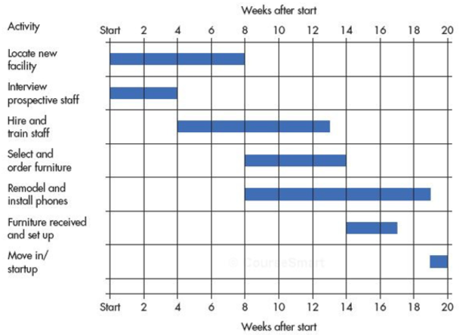

- Chart indicates
  - When activites are to occur
  - Their planned duration
  - When they are to occur
- The manger is able to see which activities are head of schedule and which are behild
  - Enables manager to direct attention
- Advantage
  - Simple
- Disadvantage
  - Fails to reveal relationships among activities that can be crucial to effective project management
    - If one of the early activities in a projects suffers a delay, it would be important for the manager to be able to easily determine which later activies are affected
    - Some activities may be safely delying without affecting the overall project completion time

PERT/CPM Technique
- By using PERT/COM
  - A graphical display of project activities and their sequential relationship
  - An estimate of how long the project will take
  - An indication of which activities are most critical to timely project completion
  - An indication of how long any activity can be delayed without delaying the project
- PERT and CPM are the same

Precedence Network
- Main feature of PERT/CPM
  - Depicts the project activities and their sequential relationships by use of arrows and nodes
  - Two slightly different conventions for constructing these networks
    - Activity on arrow -- Arrows designate activities
      - Arrows represent both activities and the sequence in which they must be performed
    - Activity on node -- Nodes designate activities
      - Arrows show only the sequence in which activities must be performed while the nodes represent the activities
      - Start at node S, not activity but is added in order to have a single stating node … also has one end node
  - Types of relationships
    - Start to start
      - An activity can only start after the other has started
    - Finish to finish
    - Start to finish
    - Finish to start
  - Possible to require a pre-specified minimum delay (time buffer) in any of these relationships
  - Some dependencies may be discretionary
  - There may be external dependencies (an externally determined start or finish time for an activity
  - We will consider only finish to start
  - 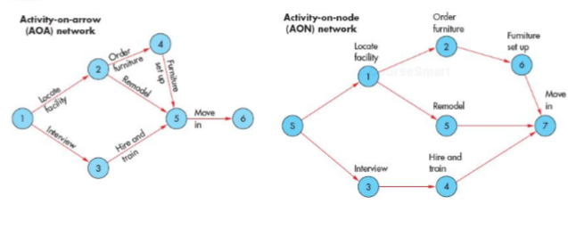
  - 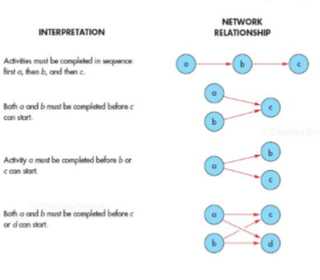

- One reason for the importance of paths is that they reveal sequential relationships
  - If one activity in a sequence is delayed or done incorrecty, all the following activities on that path will be delayed
- Important aspect of path is its length
  - Determined by summing the expected duration of the activities on it
  - Path of largest duration governs the project completion time
    - Expected project duration equals the expected duration of the longest path
  - If there are any delays along the longest path, the corresponding delays in the project completion time
  - Attempts to shorten project completion must be focused on the longest path
  - Called the critical path
    - Its activities are referred to as critical activities
  - Path slack time
    - Reflects the difference between the length of the path and the length of the critical path, then, has zero path slack time

Deterministic Activity Durations
- PERT/CPM networks determine whether activity durations are
  - Probabilistic
    - Include an indication of the extent of probable variations
  - Deterministic
    - Fairly certain

- 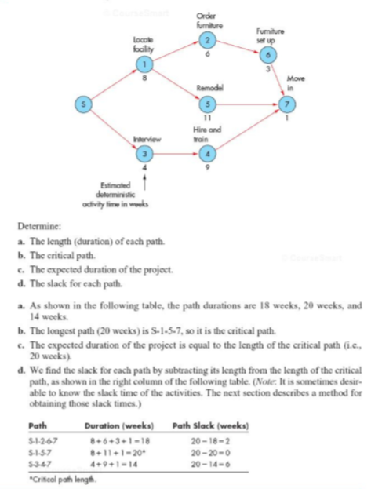

Solution Technique
- Necessary calculations can be exceedingly time consuming, large networks are analyzed by a computer program and a solution technique that develops four values for each activity
  - ES … the earliest time the activity can start
  - EF … the earliest time the activity can finish
  - LS … the latest time the activity can start and not delay the project
  - LF … the latest time the activity can finish and not delay the project
- Once the values have been determined, find
  - Expected project duration
  - Activity slack times
  - The critical path
- Steps to calculating the earliest start and finish times (left, the start, moving to right) using the following two simple rules
  - The earliest finish time for any activity is equal to its earliest start time plus its expected duration, t
    - EF = ES + t
  - ES for an activity with one immediate predessor is equal to the EF of that node. ES for an activity with multiple immediate predecessor is equal to the largest EF of those nodes. Let ES of the start node be 0.
- 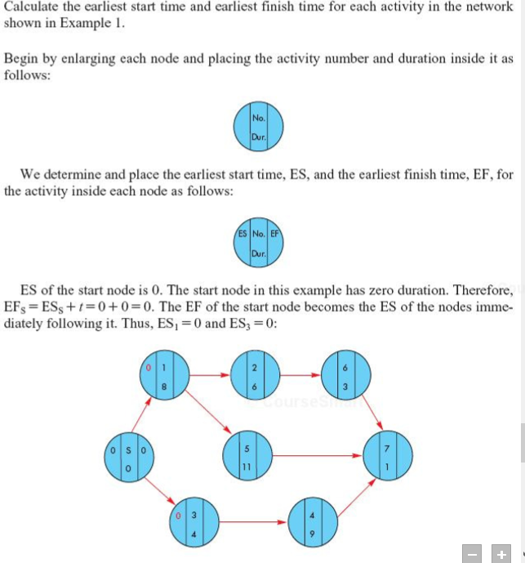
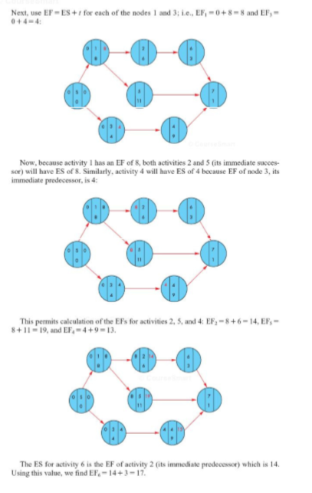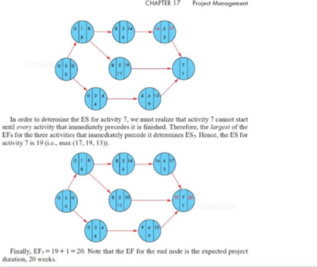

- We calculate the latest start and finish time, starting from the right and moving to the left of the precedence network (backward pass) using the following two simple rules
  - The latest start for any activity is equal to its latest finish time minus its expected duration
    - LS = LF – t
  - For a node with one immediate successor, LF equals the LS of that node. For the node with multiple immediate successors, LF equals the smallest LS of those nodes. Let LC of the end node equals its EF
- 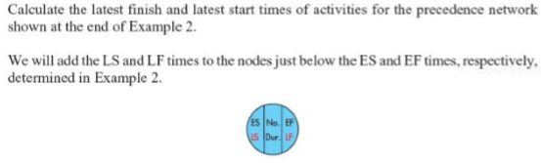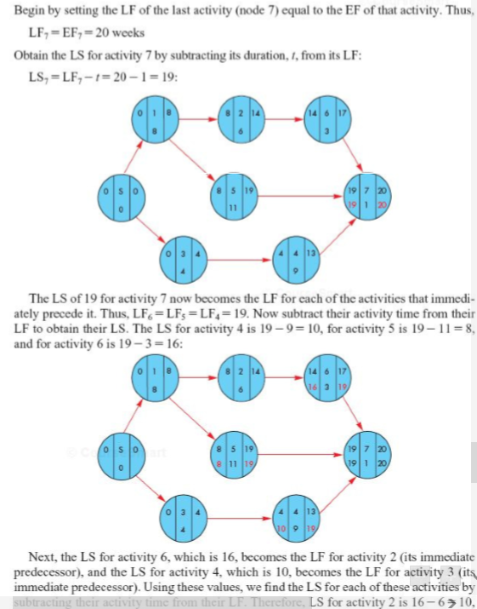
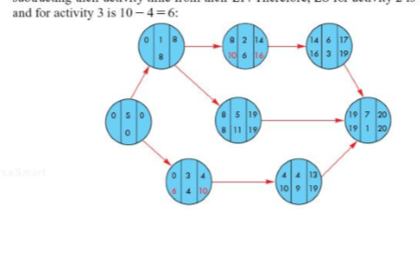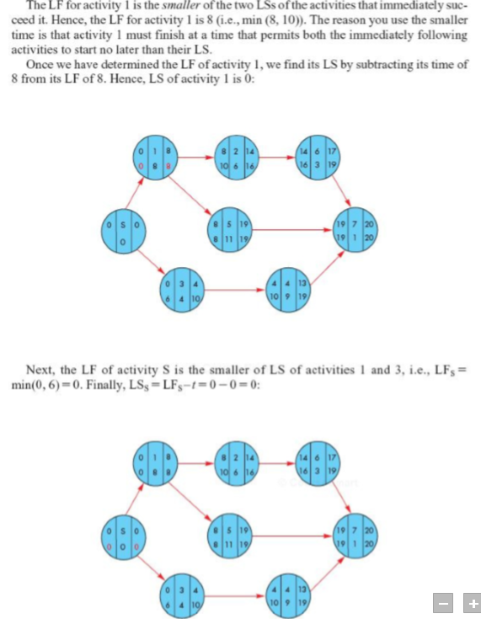

Calculating Activity Slack Times
- Activity slack times can be calculated 2 ways
  - Slack = LS – ES
  - Slack = LF – EF
- Rules for the PERT/CPM solution technique
  - Forward pass
    - Start at the left side of the precedence network (i.e.: from the start node) and work toward the right side
    - For the start activity, ES = 0
    - For each activity, ES + Activity Duration = EF
    - If ny activity has a unique immediate predessor; ES = EF of that activity
    - If any activity has multiple immediate predeccors, set its ES equal to the largest EF of its immediate predecessors
  - Backward Pass
    - Start at the right side of the precedence network (i.e.: the end node) and work toward the left side
    - Use the EF as the LF for the end activity
    - For each activity, LS = LF – Activity time
    - If any activity has an immediate follower, LF = LS of that activity
    - If an activity has multiple immediate followers, set the activity’s LF equal to the smallest LS of the immediate followers
    - 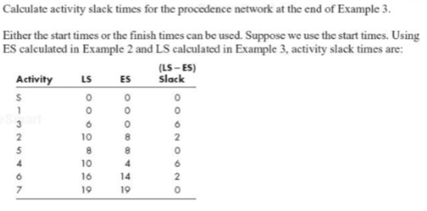

      - Therefore, S 1,5,7 are all critical activities (which agrees with the result of the intuitive approach)
      - Knowledge of activity slacktimes provide managers wit information for planning the allocation of scarce resource and for directing control efforts otwoard those activities that are most susceptible to delaying the project
        - It is important to recognize that activity slack times are based on the assumption that all of the activities on the same path will be started as early as possible and not exceed there expected times
        - If two activities are both on the same path (i.e.: activities 2, 6 in the preceeding example) and have the same slack time (2 weeks), this will be the total slack available to both
          - The activities have shared slack
          - If the first activity uses all the lack, there will be 0 slack for the following activities on the path

Probablistic Activity Durations
- The probabilistic PERT/CPM approach is called the 3-point estimates method and involves 3 duration estimates
  - Optimistic duration
    - Length of time under the best conditions (To)
  - Pessimistic duration
    - Length of time under the worst conditions (Tp)
  - Most likely duration
    - The most probable length of time
- Of interest is the average or expected duration for each activitiy and the variance
  - $t_{e}= \frac{t_{o }+4t_{m}+ t_{p}}{6}$
  - Expected average duration of a path equal to the sum of the expected duration
    - $Path Mean= \sum{(Expected duration of activities of the path)}$
  - The standard deviation is estimated to be one-sixth of the difference between pessimistic and optimistic
    - $σ_{Act}^{2}={[\frac{\left(t_{p }- t_{o}\right)}{6}]}^{2}$
      - The larger the variance, the more uncertain
  - Standard deviation on the duration of the path
    - $σ_{path}= √\sum{(variances of activity durations on path)}$
- 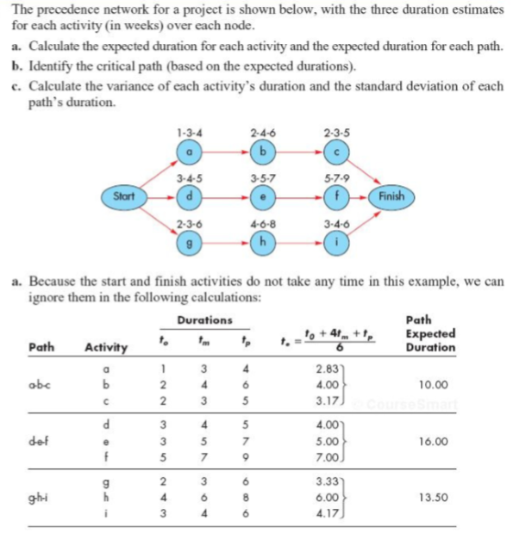
- 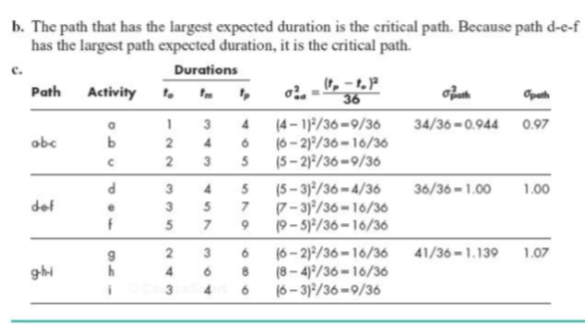

- Knowledge of the path’s expected duration and standard deviation of duration enables managers to calculate probabilistic estimates of the project completion time

  - The probability that the project wil be completed by a specified time
  - The probability that the project will take longer tat its scheduled completion time

Determining Path Probabilities
- The probability of a given path will be completed in a specified length of time can be determined by
  - $z=\frac{\left(specified length of time-Expected path duration\right)}{Standard deviation of path duration }$
  - $how many standard deviations on the paths duration of specified length is$$$beyond the expected path$$
    - negative value indicates that specified time is earlier than expected
    - positive value indicaes that it is after

- project is not completed until all of its activities have been completed
  - risky to focus exclusively on the critical path, requires determining the probability that each path will finish by a specified time and then multiply those probabilities
- result is the probability that the project will be completed by a specified time
  - assumes independence in path durations … which requires 2 conditions
    - that the activity durations are independent of each other
    - that each activity is on only one path
- 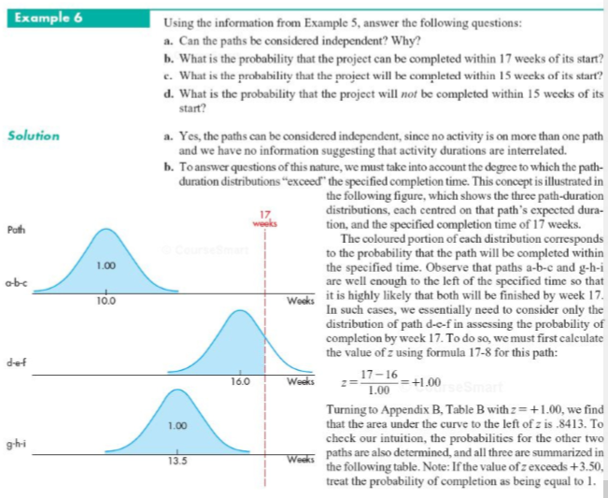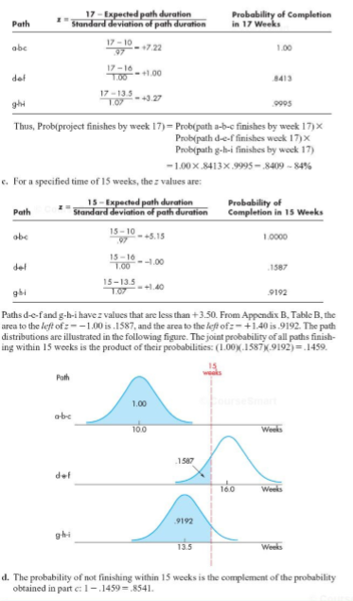

Project Crashing
- Estimate of an activities suration is usually made for a given evel of resouurces
- Reduce length of project (crash) by using additional resources .. may reflect efforts to
  - Avoid late penalty
  - Take advantage of monetary incentives for timely or early completion of a project
  - Free resources for another project
  - With a new prodocut, you may be beating the market
- May also reflect an attempt to reduce indirect costs associated with running projets 9i.e.; facilities, equipment)
- Project manager may be able to shorten a project by increasing direct costs to speed up, thereby realizing savings on indirect project cost
- Time-cost trade off
  - Used to identify those activities that will reduce the sum of the indirect and direct project cost
- Only those activities on the critical path are potential candiates
  - Critical activities should be crashed according to crashing cost per period
    - Crash those with the lower crash cost per period first
  - Crashing should continue as long as the cost to crash is less than the benefits derived from crashing
- Assume that indirect costs are a linear function of project durations
  - We assume (direct) crashing costs per period increase faster, the more you crash a project
- General procedure for crashing
  - Obtain estimates of regular and crash durations and crash cost per period for each activity and indirect project costs per period
  - Determine the lengths of all paths
  - Determine the critical activities
  - Crash critical activities, starting from cheapest, as long as crashing period does not exceed benefit of crashing
    - Note that 2 or more paths may become ctiical as the orginal critical path becomes shorter so that subsequent improvements will require simultaneous shortenings of two or more paths
    - It will be more economical to shorten an activity that is one two or more of the critical paths than 2 or more activities on each critical path
- Costs related to crashing acivities; crashing activites reduce the indirect project cost but increase direct costs; the optimum amount of crashing results in minimum of the sum of these two types of costs
  - 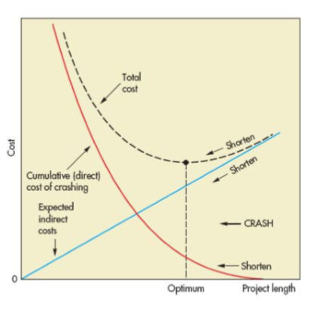
- 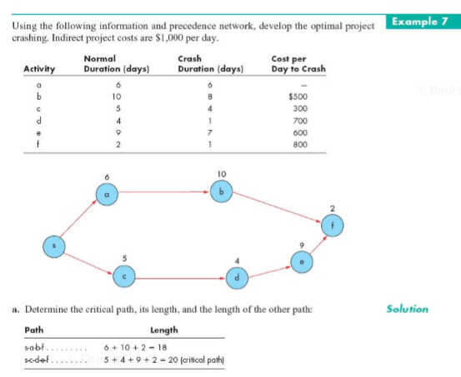
- 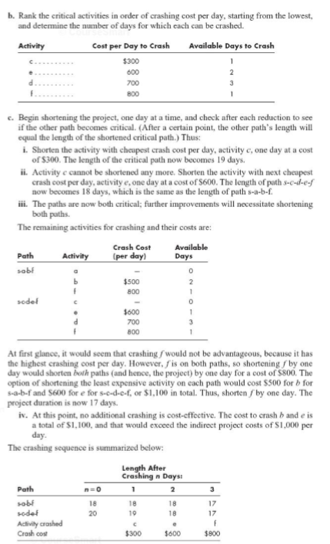

Project Execution and Control
- Approach to project execution is the critical chain
  - Based on 2 psychological principals
    - Student’s syndrome = student’s tendency to delay the start of an assignment until the last possible time
    - Parkinson’s law
      - Work expands to fill the time available for its completion
  - The comination of the two results in late projects
  - What is done
    - Activities are prioritized, scheduled accordingly and done as soon as possible
    - Estimates of activity duration are examined to ensure that they are not being padded with safety time
      - Safety time is added to the end of the critical chain and the end of each feeder chain feeding the critical chain
    - Activities and chain prioprities are determined on the daily based on percentage of buffer time
- Project control
  - Involves controlling the changes of a project
  - Replanning should be kept to a minimum
  - Common problem
    - Customer/sponsers tends to frequently demand changes in work required
  - Problem of uncontrolled changes is the scope creep
- To control projects costs/schedule
  - Various measures are used
    - Work performance
  - Common technique: earned value analusis
    - After project’s time and costs are planned, the progress of the project is measured, not by the budget cost of work schedulated, but by budgeted cost of work performed
    - Schedule time overrun is measured by schedule “variance” (=PV – EV)
    - The cost overrun is measure by cost “variance” (=Actual cost – EV)
    - For over budgeted project that is behind schedule
      - 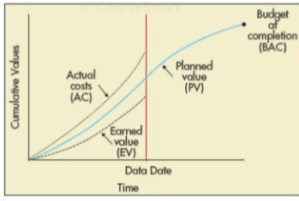
      - Forecasts cost estimates to completion (ETC) and cost estimate at completion (EAC)
  - Quality control
    - Involves quality tools (control charts, cause and effect)
  - Project team
    - Managed by measuring team performance, providing feedback, resolving issues, and recognizing good performance
    - Communication with project stakeholders is well managed
    - Risks are tracked
    - Contracts are managed
    - Project completed, and closed out
    - Important to review the project for lessons learned and docs for future reference

Project Management Software
- Types of software
  - Microsoft project
  - Deltek’s (Welcom) EPM suite
- Advantages to using project management software
  - Imposes a methodology and common project management terminology
  - Provides a logical planning structure
  - Enhances communication among team members
  - Flags the occurrence of a problem
  - Automatically formats reports
  - Generates multiple levls of summary reports and detailed reports
  - Enables what-if scenarios
  - Generates various charts, including basic schedule/control Gantt chart

