Materials Requirement Planning and Enterprise Resource Planning
- Describe materials requirements planning (MRP) and the conditions under which it is most appropriate
  - Overview of MRP systems
    - MRP computer program
      - Inputs
        - Committed order forecasts: master production schedule
        - Design: bills of material
        - Open ordered: inventory levels
      - Outputs
        - Primary reports
          - Planned order releases
          - Immediate order releases
          - Changes
        - Secondary reports
          - Demand history reports
          - Performance control reports
          - Inventory transaction
  - Dependent demand
    - Demand for subassembly parts or raw materials that are derived fro the plan for production of finished goods
    - Example: the parts, materials and sub-assemblies that go into the production of a particular model of automobile have dependent demand because the amounts need are a function of the number of cars that is planned to be produced
      - Conversely, the demand for the finished car is independent; the customer demand is unknown and must be forecasted
  - Independent demand
    - Fairly steady one allowance are made up for seasonal variations
      - Unlike dependent demand where it can be seen to be sporadic or lumpy (large quantities are ised at specific points in time with little or no usage)
      - Example; a company that produces lawn mowers and tractors generally make them in batches. Suppose that the products are produced as follows
        - One month – push mowers
        - Two months – small mowers
        - Third – tractors
      - Components may be used most of the time (i.e.: nuts and screws)
      - It makes sense to have a continual inventory of these parts bcasue they arer alwys needed
        - On the other hand, some parts might be only used for one item
        - Demand for such parts is lumpy and, because of these tendancies,
        - Independent-demand items must be carried on a continual basis (dependent demand items only need to be stocked prior to a job
          - Predictability of usage of dependant demand items implies that there is little to no need for safety stock
- Descrive the inputs to MRP
  - Committed order forecasts: master production schedule
    - The anticipated build schedule stating which end items are to be produced, when and in what uantites for the next 12 weeks or so
  - Design: bills of material
    - Listing of all the raw materials, parts, and subassemblies needed o produce one unit of a product
  - Open ordered: inventory levels
- Describe the calculation of MRP and solve typical problems
  - Thus one x will require: 2 B’s, 1 C, 6(2*3) D’s, 28 (2*3*4 = 24+ 2 + 2) E’s, 2 F’s
  - Thus 10 x’s (keeping in mind, inventory on hand), will require:
    - B: 2 * 10 = 20 … 20 – 4 = 16
    - C: 1*10 = 10 – 10 = 0 … closes of the (E, F components requirements)
    - D = 6 *10 = 60 – 8 = 52
    - E = 24*10 = 240 – 60 = 116?????????
    - F= 0 ?????????????????
- Describe lot sizing methods, capacity requirements planning and MRP II
  - Lot sizing
    - Choosign a lot size for a purchase or production order
  - Capacity requirements planning
    - The process of determining short-term capacity requirements of MRP
  - Manufacturing resource planning (MRPII)
    - Expaned sstem for production planning and scheduling, involving sales and operations planning, MPS, MRP, CRP and detailed scheduling
- Describe enterprise resource planning
  - Enterprise resource planning (ERP)
    - Used to manage and coordinate all the resources, information and functions of an organization from a shared data base

Table of Contents
Materials Requirement Planning and Enterprise Resource Planning 1
Introduction 1
Dependent Demand 1
Overview of MRP 2
Special Types of BOM 6
Inventory Levels, Lead Time and Open Orders 6
MRP Processing, Updating and Outputs 7
MRP Processing 7
Updating the System 15
MRP Outputs 15
Primary Reports 15
Secondary Reports 15
Other Considerations 16
Safety Stock 16
Lot Sizing 16
Fixed Interval Ordering 17
Past-Period Method 17
Capacity Requirements Planning 19
MRP II 21
ERP 21
The ABC of ERP^2 21
How Can ERP Improve a Company’s Business Performance 22
Willl ERP Fir the Ways a Company Does Business 22
What Does ERP Cost 22
Hidden Costs of ERP 22
How DO you Configure ERP Software? 23
Summary 23

Introduction
- This chapter describes MRP and ERP
  - MRP is a planning and scheduling technique primarily used for batch product of the components of assembled items
    - Components refer to raw materials, part or sub-assembly
  - ERP is used to manage and coordinate all of the resources, info, and dunctions of an organization from a shared datavase
- First, we willshow why plans for compenents of products require a different treatment than plans for finished goods, supplies or spare parts

Dependent Demand
- Dependent demand
  - Demand for subassembly parts or raw materials that are derived fro the plan for production of finished goods
  - Example: the parts, materials and sub-assemblies that go into the production of a particular model of automobile have dependent demand because the amounts need are a function of the number of cars that is planned to be produced
    - Conversely, the demand for the finished car is independent; the customer demand is unknown and must be forecasted
- Independent demand
  - Fairly steady one allowance are made up for seasonal variations
    - Unlike dependent demand where it can be seen to be sporadic or lumpy (large quantities are ised at specific points in time with little or no usage)
    - Example; a company that produces lawn mowers and tractors generally make them in batches. Suppose that the products are produced as follows
      - One month – push mowers
      - Two months – small mowers
      - Third – tractors
    - Components may be used most of the time (i.e.: nuts and screws)
    - It makes sense to have a continual inventory of these parts bcasue they arer alwys needed
      - On the other hand, some parts might be only used for one item
      - Demand for such parts is lumpy and, because of these tendancies,
      - Independent-demand items must be carried on a continual basis (dependent demand items only need to be stocked prior to a job
        - Predictability of usage of dependant demand items implies that there is little to no need for safety stock
- Key differences between independent and dependent demand and inventory levels resulting from using inventory control models
  - 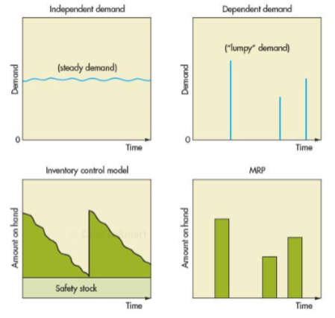

Overview of MRP
- Materials Requirements Planning (MRP)
  - The activity that determines the plans for purchasing and production of dependant demand compenents
- Product plan for a specified number of each product is coverted into requirements for its sub-assemblies, parts and raw materials, working backward from the due date of the product, sing lead times and inventories on hand
  - This determines when and how muh to order of each component
- Historically, planning purchasing and production of compnents for assembled products suffered two difficulty
  - The enormous task of setting up production schedules for a product, keeping track of large number of raw materials and coping with plan changes
  - Lack of differentiation between independent demand and dependant demand items
- Techniques designed for independent demand iterms were used to handle dependent demand items which resulted in excessive inventories
- The primary inputs to MRP are
  - The bills of material which tell us the composition of products
  - A master schedule which tells u how many finished products are desired and when
  - Inventory levels, lead time and open shop or purchase orders
- Outputs of MRP
  - Immediate and planned order releases and various reports
- Overview of MRP syste,s
  - MRP computer program
    - Inputs
      - Committed order forecasts: master production schedule
      - Design: bills of material
      - Open ordered: inventory levels
    - Outputs
      - Primary reports
        - Planned order releases
        - Immediate order releases
        - Changes
      - Secondary reports
        - Demand history reports
        - Performance control reports
        - Inventory transaction
- MPS are determined to satisfy customers orders and forecasts
  - Separate the planning horizon into a series of time periods or time buckets (expressed in weeks or days)
  - Plans for those more distant time periods are more tentative than near term requirements
- Cumulative (stacked) lead time
  - Amount to the sum of the lead times that sequential phases of purchasing and production process require
- 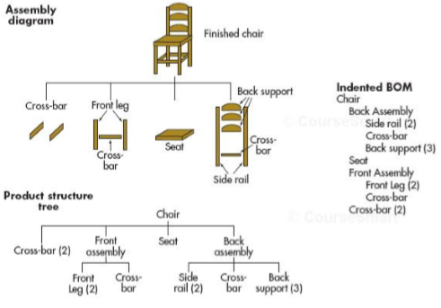
  - Bil of Materials
    - Listing of all of the raw materials, parts and subassemblies needed to produce one unit of a product
  - Product structure tree
    - A hierarchial diagram of the compenents needed to assemble a product
  - End item (chair) is shown at the top
    - Just beneath end item are are the back and front subassemblies that must be put together with the two cross bars and a seat to make up the end item
      - Beneath each subassembly are the parts
  - Note: wuantities of each item in the product structure tree refer to the amounts needed to complete one unit of the parent at the next higher level
    - Three back supports are needed for one back assembly
- 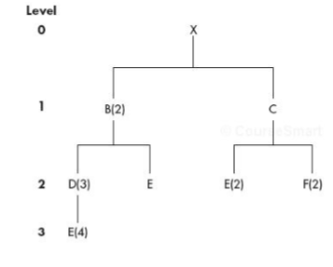
  - End item X is composed of 2 B’s and one C
    - Each B consists of 3 D’s and one E
      - Each D consists of 4 E’s
    - Each C consists of 2 E’s and 2 F’s
  - These requirements are listed by level (beginning at 0 and ending in the third)
    - Items at each level are compenents of the next up level
    - Items above components are referred to as their parents
- Example:
  - Determine the quantity of B, C, D, E, F needed to assemble one X
  - Determine the quantities of these compenets that will be required to assemble 10 x’s taking into account the following inventories on hand of various components
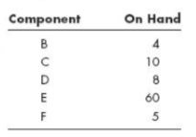
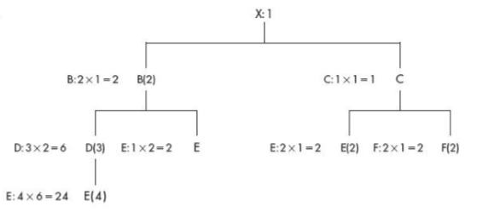
  - Thus one x will require: 2 B’s, 1 C, 6(2*3) D’s, 28 (2*3*4 = 24+ 2 + 2) E’s, 2 F’s
  - Thus 10 x’s (keeping in mind, inventory on hand), will require:
    - B: 2 * 10 = 20 … 20 – 4 = 16
    - C: 1*10 = 10 – 10 = 0 … closes of the (E, F components requirements)
    - D = 6 *10 = 60 – 8 = 52
    - E = 24*10 = 240 – 60 = 116?????????
    - F= 0 ?????????????????
  - Note
    - The amount on hand for each component is neeted out before determine the requirements of its children
    - Determining net requirements is more complicated when involving the issue of timing (when must the compnents be purchased ot made) must be incuded in analysis

Special Types of BOM
- Planning Bill
  - Also called pseudo bill or a kit is a combination of several BOMS
  - While it does not relate to the real product, we will result in the calculations of the right number of components purchased or produced
  - Used to reduce the number of BOMs necessary for the planning section
- Modular bill
  - BOM for a module
  - Modular bills are used to reduce the number of bOM’s when a product consists of various modules, each with few options
  - Example: if there are 10 modules with 2 options, the number of product condfigurations is 2^10 = 1,024
    - Whereas, there are only 10(2)= 20 options
    - Thus a company will use 20 modular bills to plan purchases and later will assemble the final prouct to order
- Phantom bill
  - Also called a transient bill
  - For an item that is not usually kept in inventory but may be needed
    - A spare part for WIP in the assembly line
  - A phantom item has zero lead time and special stock code so it will not regular be ordered
  - Make planning easier
- Comment
  - Important that the bill of material is accurate and reflects the composition of the product
  - Since errors at one level can become magnified by the multiplication process to determine quanity requirements of its componenets
  - Obviously it makes it impossible to effectively determine material requirements,
    - The task of correct records may be complex and time consuming
    - Accurate records are a prerequisite for effective MRP

Inventory Levels, Lead Time and Open Orders
- each item in stock should have a separate description file that contains information about the item and, if purchased, the purchase lead time
- the quantity on hand (inventory balance) of each item should be updated continuously as transaction (receipts and issues) occur
  - used to net the requirements
- each manufactured or assembled items will have a configuration file that shows the operations necessary and the components used
- each operation will have a standard time for set up and per unti operation time
- using these and the number of itesm to be producted, the total manufacturing lead time for the batch of the item can be computed
- lead time will be used for timing orders
- each open shop order and open purchase order (called scheduled receipt in MRP) has a quantity and due date and will be considered projected on-heand inventory on its due date (and used to net the requirements)

MRP Processing, Updating and Outputs

MRP Processing
- MRP process takes the end items requirements specified by the MPS and explodes them into time-phased requirements for assembly of subassemblies a
- You can see the time-phasing requirements in the assembly time chart
  - D, F and I must be purchased at the start of week 2
  - Part C at the sart if week 4
  - Part H at the start of week 5 in order to order 1000 units of the end item to be available for delivery at the start times of other items
- 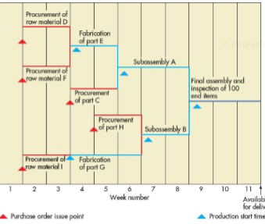
  - Note that the length of horizontal ines represent the lead time
    - For example, the purchase lead time for raw material D is two weeks and the manufacturing lead times for 100 units of part E
  - The quantities that are generated by exploding the bills of materials are gross requirements; they do not take into account any inventory that is currently on hand or is due to be received (scedued receipt)
  - The materials that a company must actually acquire to meet the demand generate by the MPS are the net requirements
- The determination of net requiremetns (netting) is the dcore of MRP processing
  - One accomplishes this by subtracting from gross requirements the sum of inventory on hand and any scheduled receipts and then adding the safety stock requirements
  - Equation
    - Net requirements in period, t = gross requirements n period, t – Projected inventory at the start of period, t – Scheduled receipts + Safety stock
  - If the formula gives a negative value, then there is no net requirement (it is 0)
    - For simplicity, we wil omit safety stock from the alculations in the examples and most problems
    - Net requirements are sometimes adhusted to include an allowance for waste but for simplicity, this too will not be includd in the examples or most problems
  - The timing and size of ordrs are determined by planned order realises
    - The timing of the receipts of these quantities is indicated by planned-order receupts
      - Depending on ordering policy, the planned order releases may
        - have a minimum level
        - be multiples of a specified quantity
        - be equal to the quantity needed at that time (called lot-for-lot ordering)
  - Important terms
    - Gross requirement
      - The demand for an item during a time period (a week or a day) without regard to the amount on hand
      - For an end item, this is shown in the MPS
      - For a compnenet, this is rqual to the planned order release of its immediate parent multiplied by the number of item in one parent
    - Scheduled receipt
      - Open order scheduled to arrive from a vendor or shop floor in the beginning of a period
    - Projected on-hand
      - The amount of inventory that is expected to be on hand at the beginning of a time period:
        - It equals the scheduled receipt this period plus any ending inventory expected from the last period
    - net requirement
      - the actual amount needed in a time period
    - planned-order receipt
      - the quantity planned to be received in the beginning of a period
        - under lot for lot ordering, it will equal net requirements
        - under lot-sizing ordering, it may exceed net requirements
      - we assume that any excess is added to a available inventory in the beginning of the next time period
    - planned-order release
      - the quantity planned to be released in the beginning of a period
      - it equals planned-order receipt offset by lead time
      - this amount generates gross requirement(s) at the next level down in BOM
      - when an order is executed, it is removed from the planned order releases and receipts row and is entering in the scheduled receipts rpw
- these quantities are used in a time-phased plan in the following format

  - 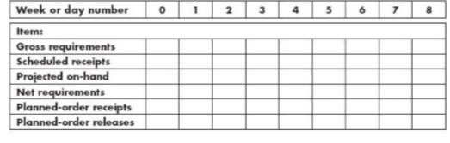
- Example
  - A company produces wood shutter
    - Receives 2 orders
      - 100 units due for delivery at the start of week 4
      - 150 units due for delivery at the start of week 8
    - Each shutter contains
      - 2 frames
        - Purchase lead time: 2 weeks
      - 4 slated wood section
        - Purchase lead time: one week
    - Assembly of the shutters require one week for lot sizes of 100 – 200 shutters
      - There is a scheduled receipt of 70 wood section from the vendor at the beginning of week 1
    - There is no inventory on-and
    - Determine the size and timing of planned-order releases necessary to meet delivery requirements under each condition
      - Lot for lot ordering (order sizes equal to net requirements)
      - Lot-size ordering with a minimum lot size of 320 units for frames and multiples of 70 units for wood section
  - Solutoin
    - Develop a production schedule for shutters
      - Week number: 1, 2, 3, 4 , 5, 6, 7, 8
      - Quantity: 100 150
    - Develop a product structure tree
      - Shutter
        - Frames (2)
        - Wood sections (4)
    - Using lot-for-lot ordering
      - At the start of week 4, the production schedule calls for 100 shutters to be ready for delivery and no shutters are projected to be on hand
        - The net requirements are 100 shutters
        - Planned order receipt for week 4 equals 100 shitters
        - Shutter assembly for 100 units requires one week (plannd order release at the start of week 3)
        - 150 shutters must be assembled during week 7 in order to abailable for delivery at the start of week 8
      - Planned order release of 100 shutters at the start of week 3 means that 200 frames (gross requirement) must be available at that time
        - None are expected to be on hand
        - Generates net requirement of 200 frames and necessitates planned-rder receipt of 200 frames by the start of week 3
        - With a 2 week purchase lead time, this mean that company must order 200 frames at the start of week 1
      - The planned order release of 150 shutters at the start of week 7 generates gross and net requirements of 300 frames for week 7 as well as planned-order receipt for that time
        - The two week purchase time means that the company must order grames at the start of week 5
      - The planned order release of 100 shutters at the start of week 3 also generates gross requirement of 400 wood sections at that time
        - Because 70 wood section are expected to be received at the start of week 1 and will be on hand;
        - The net requirement is 400 – 70 = 330 for week 3, therefore, the planned purchase order must be issued at the start of week 3
        - Since purchase lead time is one week, the order must be placed in week 2
      - The planned order release of 150 shutters in week 7 generates gross requirements of 600 (150*4) wood sections
        - No on-hand inventory of wood sections is projected for week 7, net requirements is also 600 and planned order receipt is 600 units at the start of week 7
        - The one week purchase lead time means that the order for 600 should be placed in week 6
    - 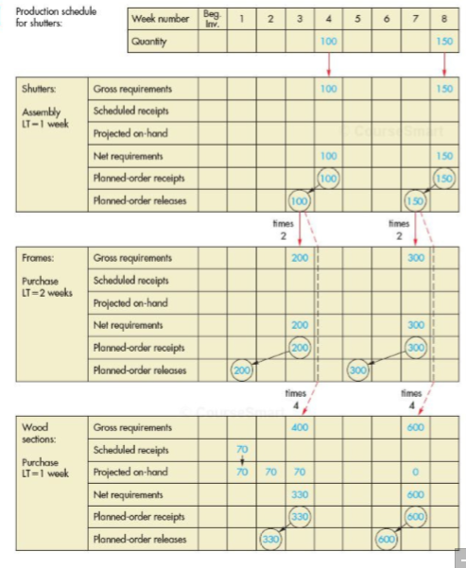
    - Under lot-size ordering, the only difference is the possibility that planned receipts will exceed net requirements
      - The excess is recorded as projected on-hand inventory in the beginning of the following week
      - Example: the beginning of the following week
        - The minimum order size for frames is 320 units but net requirement for week 3 is 300; thus 320 units are ordered resulting in an excess of 320 – 200 = 120 units
      - Net grame requirements is 300 – 120 = 180 units in week 7
        - Thus, 320 units are ordered
        - Excess of 320 – 180 = 140 units become projected on hand inventory in the start of week 8
      - The same thing happens to the wood sections
        - The excess of planned order receipts in weeks 3 and 7 is added to project-on-hand in the start of weeks 4 and 8
        - Note that the order size for wood sections must be multiples of 70
          - For week 3: it is 5 times 70 because 350 is the firmst multiple of 70 larger than 330
          - For week 7: it is 9 times 70 because 630 is the first multiple of 70 larger than 580
    - 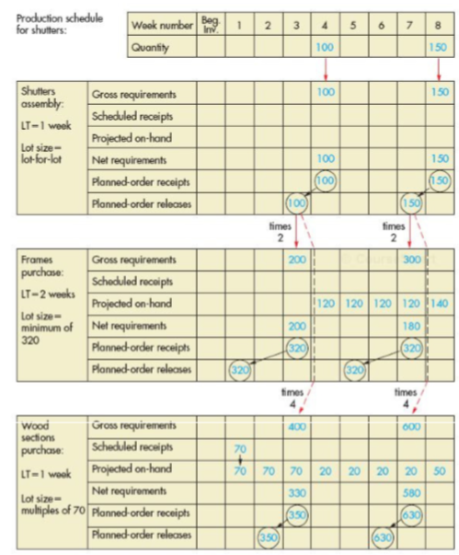
      - Example is useful for describing some of the main features of MRP processing
        - It understates the enormousness of the task of keeping track of material requirements especially in situations where the same subassembliesm parts, raw materials are used in a number of different products
        - Differences in timing of demands, revisions caused by late deliveries, high scrap rates, and cancelled orders all have an impact on processing
- Consider the two product structure tree
  - A
    - B
    - D
  - C
    - D (2)
    - E
  - Note:
    - Both products A and C have D as a component
    - Suppose we want to deveop a MRP for D given the additional information:
      - The demand for A is 80 units at the start of week 4 and the demand for C is 50 units at the start of week 5
      - There is a beginning inventory of 110 units of D on hand
      - All items have manufacturing or purchase lead times of one week
      - We order D using lot-for-lot ordering
  - Note
    - The requirements for B and E are not shown because they are not a parent of D
  - 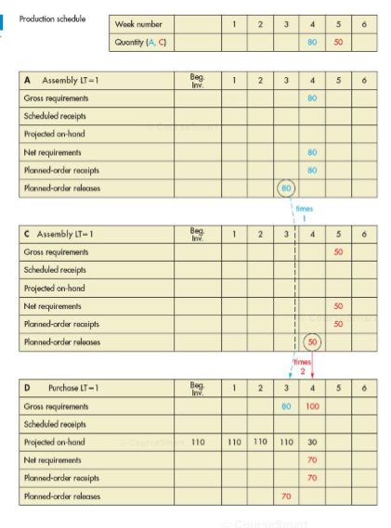
- Pegging
  - Denotes working the MRP processing in reverse
  - Identifying the parent items that have generated a given set of requirements for some item such a sF
  - Althiught this may appear simple enough given the product structure trees and tables shown in this chapter
    - When multiple products are involve, it is more complex
  - Allows managers to determine which product(s) will be affected if an order for an items such as D is late
- the importance of the computer is vital when you consider the layers

Updating the System
- two types of approaches used to update MRP tables
  - regenerative MRP
    - essentially a batch type approach. All inputs to MRP are updated, the MRP quantities are blanked and the MRP is process again
  - net change MRP
    - immediately updates the MRP to reflect the changes as they occur
      - if some defective purchased pars had to be returned to a vendor, the manager can enter this info into the system as soon as it becomes known
      - only the changes are exploded through the system, level by level, the entire plan will regenerated
- regenerative MRP is best suited for fairly stable situations, whereas, net change MRP is best suited for situations that have frequent changes
  - the obvious disadvantage
    - potention amount of lag between the time information becomes available and the time it can be incorporated into te materials requirements plan
  - one way around this is to use a day as the time bucket
- processing costs are typically less uing regenative MRP
  - changes that occur in a given time period could ulramitely cancel each other, thereby avoiding the need to modify and then remodify the plan
- nervousness refers to changes in requirements of an item having large effects;
  - problem if it results in changes in purchase or shop orders
- MRP system nervousness is similar to the bullwhip effect in supply chains
- Backflushing
  - Exploding an end item’s BOM periodically to determine the quantities of the various components that must have been used to make the item and updating the inventory on hand quantities for te components
  - This eliminates the need to collect detailed usage information on the production floor

MRP Outputs

Primary Reports
- Immediate order releases, planned-order releases, and changes are part of primary reports
  - Immediate order releases – authorize the execution of week 1 planned-order releases
  - Planned order releases indicate the amount of timing of future orders
  - Changes to open order: revision to due dates and quantities, e.g.: expedite, de-expedite, move-forward and move backward

Secondary Reports
- Performance control and demand history reports belong to a secondary reports
  - Performance-control reports
    - Evaluate system operation
    - They aid managers by measuring standard deviations from plans, including missed deliveries and stock outs
    - By providing information that can be used to asses cost performance
  - Demand history reports
    - Useful in forecasting future inventory requirements
    - They include net requirements and other data that can be used to forecast future material requirements

Other Considerations

Safety Stock
- Main advantage of MRP: theoretically, inventory ssytems with dependant demand should not require safety stock below the end-item level
  - Supposedly, safety stock is not needed because the manager can project the requirements once the MPS has been established
  - Expections:
    - bottleneck process or one varying scrap rates can casue shortages in downstream operations
    - Shortages may occur if orders are late or delayed
  - MRP deals with issues
    - Identify activities or operations that are subject to variability
    - Determine the extent of that variability
      - When lead times are variable, the concept of safety time instead of safety stock is often used
      - It schedules orders for arrival or completion sufficiently ahead of the time they are neeed in order to eliminate or substantially reduce the element of chance in waiting for those items
    - It is important in general to make sure that lead times are accyrate
      - If safety stock is needed because of possible quality problems resulting in scrap, planned order release amounts can be increased by a percentage

Lot Sizing
- Lot sizing
  - Determining a lot size to purchase for both independent and dependant demnd
    - For independent demand: managers often use economic order quantity
    - For dependant demand: wider variety of models is used to determine lot sizes (mainly because no single model has a clear advantage over the oter)
- Primary goal:
  - Minimize the annual ordering and holding costs
    - Independent demand: demand is frequently unifFixorm
    - Dependant demand: lump
- Managers can usually realize economies by grouping consecutive orders
  - This would be the case if the additional cost incurred by holding the exta untils until they were used led to a savings in set up or ordering costs
  - Determination can be very complex
    - Combining the demands for some of the periods into a single order has a cascading effect trough the product structure tree
    - In order to achieve this grouping, you must also group items at lower levels in the tree and incorporate teir setup and holding costs into the decision
  - The uneven period demands and the relatively short planning horizon require contunial recalculation and updating lot sizes
- Choice of lot sizing techniques must be taken into account:
  - The nature of demand (degree of uniformity)
  - The relatigve importance of holding cost versus ordering (setup) costs

Fixed Interval Ordering
- Provides coverage for some predetermined number of periods
  - In some cases, the span is simply arbitrary, in others, a review of historical demand patterns should be conducted
- The rule can be modified when common sense suggests a better way
  - Take a look at the demand; using two period intervals, an order size of 120 units would cover the first two periods
  - However, the demand in period 3 is so small that it would make sense to combine it with the demand during the first two periods
  - Order 121 units for the first 3 periods
- Example of lumpy demand for a part
  - Period 1:
    - Demand: 70; Cumulative Demand: 70
  - Period 2
    - Demand: 50; Cumulative Demand: 120
  - Period 3:
    - Demand: 1; Cumulative Demand: 121
  - Period 4:
    - Demand: 80; Cumulative Demand: 201
  - Period 5
    - Demand: 4; Cumuative Demand: 205

Past-Period Method
- This method provides a better way to determine the number od periods to order for at the same time
- Like the EOQ, it attempts to balance setup (ordering) and holding costs
- Term part period refers to holding a part or parts over a number of periods
  - Example: if 10 parts were held for 2 periods; this would be 10 * 2 part periods
- The economic part period (EPP) can be calculated as
  - The ratio of set up (ordering) costs to the cost to hold a unit for one period
  - $EPP=\frac{Setup \left(Ordering\right)Costs}{Unit holding cost per period}$
- To determine an order size that is consistent with the EPP, various order sizes equal to various cumulative demands are examined and each one’s number of part periods is determined
  - The one which comes closest to EPP is selected as best lot size
- Example
  - Use the part period method to determine production run sizes for the following demands
    - Period 1
      - Demand: 60; Cumulative demand: 60
    - Period 2
      - Demand: 40; Cumulative demand: 100
    - Period 3
      - Demand: 20; Cumulative demand: 120
    - Period 4
      - Demand: 2; Cumulative demand: 122
    - Period 5
      - Demand: 30; Cumulative demand: 152
    - Period 6
      - Demand: 0; Cumulative demand: 152
    - Period 7
      - Demand: 70; Cumulative demand: 222
    - Period 8
      - Demand: 50; Cumulative demand: 272
    - Setup cost is $80 per production run for this item
    - Unit holding cost $0.95/period
  - Steps
    - Calculate the EPP
      - EPP is 80/0.95 = 84.21 (rounds to 84 part periods)
    - Try cumulative lot sizes, beginning with 60, until the part periods approximate the EPP
      - The calculations of part periods indicate that 122 units should be ordered to be available at period 1 to cover the demand for the first 4 periods
      - Repeat this process starting at period 5 (which results in 100 units to be available at period 5 to cover periods 5 to 7)
      - The next lot size will be ordered for period 8 but there is insufficient info now to determine its size
    - 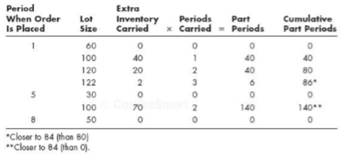

Capacity Requirements Planning
- Capacity requirements planning (CRP)
  - The process of determining the short term capacity requirements of MRP
  - The inputs to CRP are planned order releases of MRP for manufactured or assembled items
- A company usually generates mPS initially (which may/may not be feasible given the capacities of the production system)
  - It is often necessary to run it through MRP and then CRP in order to obtain a clearer picture of actual requriements
    - Often necessary to run it through MRP and then CRP in order to obtain a clearer picture of actual requirements
- Capacity Requirements Planning (CRP)
  - Develop a tentative production schedule
  - Use MRP to determine material requirements
  - Use CRP to covert the material requirements to resource requirements (load report)
    - Is the shop capacity adequate?
      - If yes
        - Firm up a portion of the MPS
      - If no
        - Can capacity (or requirement) be changed to meet requirement (or capacity)?
          - If yes: change capacity
          - If no: revise tentative master production schedule
- Load reports
  - Department or work centre reports that compare known and expected future capacity requirements with projected capacity available
- It shows ecpected resource requirements for jobs currently being worked on and the future planned-order releases
  - Managers are better able to determine whether capcity is sufficient to satisfy these requirements
- 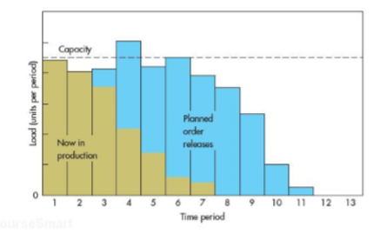
  - Load reports
    - Department or work centre reports that compare known and expected future capacity requirements with projected capacity availability
    - Allows managers to easily determine whether capacity is sufficient to satisfy these requirements
      - Time period 4 would cause an overlead, however, it appears possible to accommodate demand by shifting some orders to adjacent periods
      - Managers may be able to increase capacity by scheduling overtime or transferring personnel from other areas if this possible and economical or else revise the master production schedule and repeat the process until an acceptable master production schedule is pbtained
    - If the master production schedule must be revised, tis means that managers must assign priorites to orders if some orders will be finished later than originally planned
    - One note of causation
      - The load reports are only approximations and they may not give a true picture because the oading does not take into accound scheduling and queuing delays
      - It is possible to experience systems backups even troug a load report implies sufficient capacity to handle projected loads
- An important aspect of capacity requirements planning is the conversion of quantity requirements into time requirements
  - Accomplished by multiplying ach periods quantity requirements by standard time per unit plis a setup time per production run
  - For instance, if 10 units of product A are scheudlled in the fabrication department and each unit has a standard time of 2 hours plus a set-up time of 8 hours for the batch, then 10 units
    - Converts: 10 units * 2 hours/units + 8 = 28 hours

MRP II
- Manufacturing resource planning (MRP II)
  - Expaned system for production planning and scheduling, onvolving sales and operations planning, MPS, MRP, CRP and detailed scheduling
  - Closed-loop MRP which means tat it involves the whole production planning process stating with sales and operations planning
- Overview
  - Market demand
    - Marketing
    - Manufacturing
  - Sales and operations
  - Roughly cut capacity
  - Problems?
    - Yes: may adjust production plan
    - No: continue
  - Master production schedule
  - MRP
  - Capacity requirements planning
  - Problems?
    - Yes: may adjust master schedule
    - No: continue
  - Detailed schedules
  - Execution
  - Problems
    - Yes: may adjust detailed schedule
    - No

ERP
- Enterprise resource planning (ERP)
  - Or enterprise software, is sued to manage and coordinate all the resources, information, and functions of an organization from a shared database
  - Involves standardized records keeping that will permit information sharing

The ABC of ERP^2
- ERP attempts to integrate all departments and functions of a company onto a single computer system that can serve all those different departments particular needs
- ERP combines all of the departments integrated software to
  - run on a single database
  - it contributes to more info sharing and communication
  - reduces redundant data entry
- integrated approach can have tremendous payback if company installs the software correctly

How Can ERP Improve a Company’s Business Performance
- ERP automates the tasks involved in performing a business process which involves taking an order from a customer, making it, shipping it and billing it
- With ERP, it is simplier to find out where the orders is at any time, one needs only to long on to the ERP system and track it down
  - Customers get their order faster and with fewer mistakes than before
  - ERP can apply the same magic to the other major business process
- ERP requires lower level employees to ake more responsiblilty because there is more information available

Willl ERP Fir the Ways a Company Does Business
- Common reason that companies walk away from multi-million dollar ERP projets is that they discover that the shoftware does not support one of their important business processes
- Two things they do
  - They can change the business process to accommodate the software which will mean deep changes in long-established ways of doing business and shaking up important people’s roles and responsibilities
  - They can modify the software to fit the process, which will slow down the project, introduce dangerous bugs into the system and make upgrading the software difficult

What Does ERP Cost
- Total cost of ownership of ERP include
  - Hardware
  - Software
  - Professional services
  - Internal staff costs
- Usually ranges between $50,000 to a few million depending on amount of licenses (seats) and the software (tier)

Hidden Costs of ERP
- Training
  - Training expenses are high because the workers almost invariabily have to learn a new set of processes, not just a new software
- Integration and testing
  - A typical manufacturing company may have add-on applications for logistics, production planning and bar coding. If the laundry list also includes customization of the core ERP package, expect the cost of integrating, testing and maintaining the system to sky rocket
- Data concersion
  - It costs money to move corporate info from old systems to new ERP
- Data analysis
  - ERP needs to be combined with data from exernal systems for analysis purpose
  - Users with heavy analysis needs sould nclude the cost of data warehouse in the ERP budget—and they should expect to do quite a bit of work to make it run smoothly
- Consultants
  - When user fails to plan disengagement, consultanting fees run wild

How DO you Configure ERP Software?
- The packages are built from database tables
- Most ERP systesm are preconfigured, allowing just hundred- rather than thousands- of procedural settings made by customers

Summary
- Materials requirement planning (MRP ) is the activity that determines the ordering of dependant demand items
- The planning process that begins with a amster production schedule
  - The end items are exploded using bills of material, inventory-on-hands are netted, and planned order releases are developed by offsetting for lead times
  - These show the quantity and timing for purchasing or producing compnenets
- A small number of safety stocks are used in MRP
- Various lot sizing methods are used in MRP but the main one is lot-fot-lot ordering
  - Capacity requriements planning (CRP) uses the MRP shop order releases and standard operations time to determine the capcity requirements from each work center
- MRP II a second generation MRP that adds a broader scope to planning
  - Links sales and operation plannings
  - MPS, MRP, CRP and detailed scheduling
  - ERP systems build on these likages even further by integrating all funcions of business on a single common database
- EPP (economic part period) = Setup costs / holding costs

Vocab
- Blackflushing
  - Exploding an end items BOM to determine the quantites of the components that must have been used to make the item
- Bill of materials
  - A listing of all the raw materials, parts, subassemblies needed to produce one unit of a product
- Capacity requirements planning
  - The process of determining short-term capacity requirements of MRP
- Cumulative lead times
  - The sum of the lead times that sequential phases of a process require, from ordering of components to completion of final assembly
- Demand history reports
  - Data useful for forecasting future material requirements
- Dependent demand
  - Demand for subassemblies part that are derived from the plan for production of finished goods
- Enterprise resource planning
  - Used to manage and coordinate all the resources information and functions of an organization from a shared database
- Gross requirement
  - The demand for an item during a time period
- Immediate order releases
  - Authorization for the execution of week 1 planned order releases
- Load reports
  - Department or work centre reportst that compare known and expected future capacity requirements with projected capacity and availability
- Lot sizing
  - Choosing a lot size for purchase or production order
- Manufacturing resource planning (MRP II)
  - Expanded system for production planning and scheduling, involving sales and operations planning, MPS, MRP, CRP and detailed scheduling
- Master production schedule
  - The anticipated build schedule stating which end items are to be produced, when, and in what quantities for the next 12 weeks or so
- Material requirements panning
  - The activity that determines the plans for purchasing and production of dependent demand components
- Modular bill
  - A BOM for a module
- Net requirement
  - The actual amount needed in a time period
- Net change MRP
  - Immediately updates onkly MRP tables affected by a change
- Pegging
  - Identifying the partent items that have generated a given set of requirements for an item
- Performance control reports
  - Evaluation of system operations including eviations from plans and costs
- Phantom bill
  - Also called a transient bill is for an item that is usually not kept in inventory
- Plannet order receipt
  - Quantity planned to be received in the beginning of a period
- Panned order release
  - Quantity planned to be releasesd (ordered) in the beginning of the period, that is, planned-order receipt offset by lead time
- Planning bill
  - Also alled a pseudo bill or a kit is a combination of several BOMs
- Product structure tree
  - A hierarchial diagram the component needed to assemble a product
- Projected on-hand
  - Expected amount of inventory that will be on hand at the beginning of a time period
- Regenerative MRP
  - Recalculates all the MRP quantities periodically
- Scheduled receipts
  - Open order scheduled to arrive from a vendor or shop floor

