Inventory Management
Learning Objectives
- Define the term inventory, list major reasons for holding inventory, and discuss the objectives of inventory management
- List the main requirements for effective inventory management, and describe A-B-C classification and perform it
- Describe the basic EQQ model, the economic quantity model, the quantity discount model and the planned shortage model, and solve typical problems
- Describe how to determine the reorder point and solve typical problems
- Describe the fixed order interval model and solve typical problems
- Describe the single period model and solve typical problems
Table of Contents
Introduction 1
Importance of Inventories 2
Functions (Purpose) of Inventories 2
Importance and Objectives of Inventory Management 3
Requirements for Effective Inventory Management 4
Safely Storing and Using Inventories 4
Tracking Inventories and Using Inventory Control Models 5
Periodic counting 5
Perpetual Tracking (continual tracking) 6
Forecasting Demands and Lead Times 7
Estimating Inventory Costs 7
Holding Costs 7
Ordering Costs 8
Set up 8
Shortage costs 9
Fixed Oder Quantity/Reorder Point Model; Determining the Economic Order Quantity 10
Basic Economic Order Quantity 10
Economic Production Quantity (EPQ) 14
EOQ with Quantity Discounts 16
EOQ with Planned Shortages 19
Fixed Order Quantity/Reorder Point Model: Determining the Reorder Point 20
ROP Using Annual Service Level 24
Other Related Models 25
Fixed Order Interval/Order up to Level Model 25
Determining the Order Interval 26
Single Period Model 31
Continuous Stocking Levels 32
Discrete Stocking Levels 34

Overview:
- Bad inventory management can lead to
  - Hampering of operations
  - Diminishes customer satisfaction
  - Increases operating costs
- Chapter describes
  - Independent demand items
    - finished goods, some raw materials, spare parts, retail items
      - Discuss
        - Material requirements planning
        - Just-in-time
  - Dependent demand items
    - Demand for manufactured parts, components depend on production schedule for the finished goods
      - Functions of inventory
      - Objectives
      - Requirements for effective inventory management
      - Models determining
        - how much to order,
        - when to order

Introduction
- Vocabulary
  - Inventory
    - An idle material or product, usually in a warehouse or storeroom
  - Inventory Management
    - Planning and controlling the inventories
- Manufacturing companies carry supplies of
  - Raw materials
  - Purchased manufacturing parts and components
  - Partially finished items (i.e.: WIP)
  - Finished goods
  - Spare parts for machines, tools, other supplies

Importance of Inventories
- Widely used measure of business performance is return of investment (ROI)
  - Profit after tax divided by total assets
  - Inventories may represent a significant portion of total assets, a reduction of inventories can result in a significant increase in ROI
- Major revenue source
  - Retail, wholesales
    - Sale of inventories
    - The inventory of goods held for sale is one of the largest assets of a merchandising business
- Service companies
  - Don’t carry as many inventories but do carry supplies and equipment

Functions (Purpose) of Inventories
- To wait while being transported
  - Usually transported by
    - Ship
    - Rail
    - Truck
    - Planes
  - Type of transportation and freight could take up to reach a destination
  - There may be long waits at distribution centers, terminals, borders
  - Items being transported are called in-transit inventory
- To protect against stock outs
  - Delayed deliveries and unexpected increases in demand increase the risk of stock-outs or shortages
  - Delays can occur because of
    - Weather conditions
    - Quality problem, etc.
  - The risk of shortage can be reduced by holding safety stocks
    - Stocks in excess of average demand to compensate for variabilities in demand and delivery lead time
- To take advantage of economic lot size and quantity
  - To minimize … A company often buys quantities that exceed their minimum requirements
    - Purchasing
    - Receiving
    - Material handlings
    - Accounts payable costs
  - Excess amount must be stored for later use
  - It is usually economical to produce in larger quantities than smaller
    - Excess output must then be stored for greater use
  - Inventory storage enables organizations to buy or produce in economic lot sizes
    - This results in consecutive orders occurring after some interval of time (order or replenishment cycles)
    - The resulting inventory is hence known as cycle stock (or lot or batch inventory)
    - The ability to store extra goods also allows a company to take advantage of price discounts for larger order
- To smooth seasonal demand or production
  - Seasonal Demand
    - Manufacturers who experience seasonal demand often build up inventories during off-season periods to meet high requirements during peak seasons.
- To decouple operations
  - Manufacturers have used inventories as buffers between successive operations to
    - maintain continuity of production that would otherwise be disrupted by events such as breakdowns and accidence that may cause operations to temporarily shut down
  - Work-in-process buffers
    - permit other operations to continue to operation while the problem is being resolved
- To hedge against price increases
  - Anticipation inventory
    - Occasionally a buy or manager will suspect that a substantial price increase is about to occur and will purchase larger-than-normal amounts to avoid the price increase

Importance and Objectives of Inventory Management
- Under stocking
  - Results in
    - Missed deliveries
    - Lost sales
    - Dissatisfied customers
    - Production stoppage
- Overstocking
  - High price tag
    - Takes up storage space
    - Ties up funds that may be more productive elsewhere
- Inventory management has 2 main concerns
  - Level of customer service (availability)
    - To have the right goods, in sufficient quantities, in the right place and at the right time
  - Cost of ordering or holding inventories
- Overall objective of inventory management
  - Achieve satisfactory levels of customer service (availability) while keeping inventory costs within reasonable bounds
- Buyer or inventory analyst must make 2 fundamental decision
  - Timing of order
  - Size of order
- Measure of performance to judge the effectiveness of their inventory management
  - Customer satisfaction
    - In-stock/fill rate
      - Percentage of demand filled from stock on hand
    - Inventory costs
    - Inventory turnover
      - Ratio of annual costs of goods to average inventory investment
      - Indicates how many times a year inventory issold or used
      - Generally, the higher the ratio, the best
      - Benefit of this measure that it can be used to compare other companies of a different size in the same industry
    - Days of inventory
      - Number that indicated the expected number of days or usage that can be supplied from existing inventory

Requirements for Effective Inventory Management

Safely Storing and Using Inventories
- Inventories are usually stored indoors, in a warehouse or storeroom
  - Depends on nature of how they are stored, i.e.:
    - Racks
    - Shelves
    - Bins
  - Heavy items/fast-moving items are usually stored on the floor
- To save moving items long distances, warehouses are usually a vertical space (they are as tall as 3-4 storey building
  - Forklifts and high-reach industrial trucks are sued to access top locations
- Warehouse/storerooms should be uncluttered so that items can be stored/retrieved easily
- Depending on the flow of items, the right level of automation should be used
  - Forklifts to carry piled on pallets
  - Carousels or conveyor belts
- Vocabulary
  - Warehouse management system
    - Computer software that controls the movement and storage of materials within a warehouse and process the associated transactions
      - Include
        - Receiving
        - Put-away
        - Replenishment
        - Picking and shipping
      - Applications in Textbook
        - Eli Lilly Canada
        - B.C. Hot House
- Warehouses/storerooms may needed added security
  - Building should be controlled
  - Items that are prone to theft are seured
- Safety is an important issue in warehouses
- Common problem in warehouses
  - The existence of considerable amount of obsolete items, tehse parts include
    - Machines that no longer exist
    - Wrong parts
    - Excess materials
    - Used machines, etc.
  - To be efficient, outdated items should be either
    - sent back to the supplier (to be restocked by the supplier)
    - sold at a discount (salvage)
  - Obsolete items are a drag on company’s assets and take space in the warehouse

Tracking Inventories and Using Inventory Control Models

Periodic counting
- Vocabulary
  - Periodic counting
    - Physical count of items in inventory made at periodic intervals (e.g., weekly, monthly)
- Used in many small retailers
  - Manager periodically checks the shelves and stockroom to determine the quantities on hand
  - The manager then estimates how much of it will be demanded prior to the next delivery and bases the order quantity on this information
- This replenishment model is called the fixed order interval model
- Advantage of this method
  - Orders from the same supplier can be issued at the same time, which can result in economies in process and shipping
- Several disadvantages of periodic review
    - Stock-out between review
      - Protect against by carrying extra stock
    - Time and cost of a physical count

Perpetual Tracking (continual tracking)
- Vocabulary
  - Perpertual tracking
    - Keeps track of removals from and additions to inventory continuously, thus providing the current inventory level of each item
  - Fixed order quantity/reorder point model
    - An order of a fixed size in placed when the amount on hand drops to or below a minimum quantity called the reorder point
- Advantage
  - Shortages can be avoided
  - Order quantity is fixed
    - Management can determine an optimal order quantity and use it for every order (provided that demand is not seasonal nor has a trend)
- Disadvantage
  - Added cost of continual record keeping
  - Bank accounts are kept using this method
    - Transactions (such as customer deposits and withdrawals) are instantly recorded and balance is determined continually
Two-Bin System
- Vocabulary
  - Two-bin system
    - Reorder when the first bin is empty,
    - use the second bin until the order arrives;
    - top off the second bin and leave the rest in the first bin,
    - start drawing inventory from the first bin until it is empty again and repeat
- Two bin system
  - Second bin contains enough stock to satisfy expected demand until the order is filled plus an extra cushion of safety stock that will reduce
- Advantage
  - No need to record each withdrawal from inventory or keep track of inventory on hand
- Disadvantage
  - The reorder card may not be turned in
- Barcodes
- Vocabulary
  - A number assigned to an item or location, made of a group of vertical bars of different thickness that are readable by a scanner
- Five different types of barcode
  - UPC (Universal Product Code)
    - Zero on the left identifies this as a groery item
    - The next 5 indicate the manufacturer
    - Last 5 numbers indicates the specific item
- Barcodes have added
  - Increased speed
  - Increased accuracy
- Radio Frequency Identification (RFID)
  - Technology which uses radio waves to identify items
  - Done through the use of an RFID rg attached to the item
    - Tag has an RFID reader using radios waves
  - Use of RFID has been increases and it is expected that RFID tags will replace barcodes
- Textbook
  - Air Canada’s RFID

Forecasting Demands and Lead Times
- Vocabulary
  - Purchase lead time
    - Time interval between ordering and receiving the order
  - Point-of-Sale (POS) system
    - Software for electronically recording sales at the time and location of sale
- Inventories are used to satisfy future demand requirements
  - Essential to have reliable estimates of the amount and timing of future demand
- Essential to know purchase lead time
- Manufacturing lead time is the time it will take for a batch of a product to be manufacturered
- Managers need to know the extent to which demand and lead time might vary
  - The greater the potential variability, the greater the need for additional safety stock to reduce the risk of a shortage between deliveries
  - Crucial link between forecasting and inventory management
- Point of Sale (POS) system
  - Electronically record actual sales at the time and location of sale. After accumulation into daily or weekly or monthly sales for each stock-keeping unit (SKU) are used in forecast
- Given the large number of items kept in inventory of a typical organization, a simple time-series forecasting technique such as exponential smoothing (and its variants) is commonly used to forecast demand of items kept in inventory

Estimating Inventory Costs
- Three basic costs are associated with inventories
  - Holding
  - Ordering
  - Shortage

Holding Costs
- Vocabulary
  - Holding or carrying cost
    - Related to physically having items in store
    - Cost includes warehousing costs
      - Rent or building depreciation, labour, material-handling equipment depreciation, heating/cooling, light, etc.)
      - The opportunity cost associated with having funds tied up in inventory
    - Other holding cost include
      - Insurance
      - Obsolescence
      - Spoilage
      - Pilferage
      - Breakage
- The significance of some of the components of holding costs depend on the type of item involved
  - Items that are easily concealed or are fairly expensive are prone to theft and need to be locked up
  - Items such as meant and dairy are subject to rapid spoilage and need freezing/cooking
- Holding costs are stated in either 2 ways
  - A percentage of unit costs
  - A dollar amount per unit
- Typically annual hold costs rates range from 20-40% of the cost of the item

Ordering Costs
- Vocabulary
  - Cost of the actual placement of an order (not including the purchase cost)
- This includes
  - Time of purchasing/inventory control staff determining how much is needed
    - Periodically re-evaualting sources of supply
    - Preparing purchase orders
    - Fixed-cost portion of transportation, receiving, inspecting and moving of goods to storage
    - Cost of time spent paying the invoice
- Generally expressed as a fixed dollar amount, regardless of size

Set up
- Vocabulary
  - Set up
    - Involves preparing the machine for the job by adjusting it, changing cutting tools, etc.
- When a company produces its own inventory instead of ordering it from a supplier, the cost of machine set up is analogous to order cost
  - Fixed charge per production per run

Shortage costs
- Vocabulary
  - Shortage cost
    - Cost of demand exceeding supply of inventory on hand, includes unrealized profits per unit, losses of goodwill, etc.

Performing A-B-C Classification
- Items held in inventory come at opportunity costs
  - Example: a produce rof electrical equipment might have electrical generators, coils of wire, and miscellaneous nuts and bolts in inventory
    - It would be inefficient to devote equal attention to each of these items
    - A more reasonable approach would be allocate control effects according to the relative importance of various items in inventory
- Vocabulary
  - A-B-C classification
    - Grouping inventory items into 3 classes to some measure of importance and allocating inventory control efforts accordingly
      - A being the most important
        - 15-20% of t
      - B being moderately important
      - C being least important
    - 80-20 rule/Pareto Analysis
- Cycle Counting
  - Vocab
    - Cycle counting
      - Regular actual count of the items in inventory on a cyclic schedule
  - Purpose
    - Reduce discrepancies between inventory records and the actual quantities of inventory on hand
    - Investigate the causes of inaccuracy and fizx them
  - Accuracy is important because inaccurate records can lead to wrong inventory control decisions which leads to
    - Disruptions in production
    - Poor customer service
    - Unnecessarily high inventory carrying cost
  - Key questions concerning cycle counting
    - How much accuracy is needed?
    - What kind of counting cycle should be used?
    - Who should do it?
- APICS, American Production and Inventory Control Society recommend
  - +-0.2% for C
  - +-1% for B
  - +-5% for A

Fixed Oder Quantity/Reorder Point Model; Determining the Economic Order Quantity
- Vocabulary
  - Economic order quantity
    - The order size that minimizes total inventory control cost
- Types of EOQ models
  - Basic economic order quantity
  - Economic production quantity
  - EOQ with quantity discounts
  - EOQ with planned shortages

Basic Economic Order Quantity
- Used to
  - Identify the order size for an item that will minimize the costs of holding or ordering inventory
    - Annual purchase price is unaffected by the order size
- Basic Assumptions
  - Only one product is involved
  - Annual demand requirements are known
  - Demand is spread evenly throughout the year so that the demand rate is constant
  - Lead time does not vary
  - Each oder is received in a single delivery
  - There are no quantity discounts
    - This includes the assumptions that transportations coss per unit is fixed and does not depend on order size
  - Shortages are not allowed
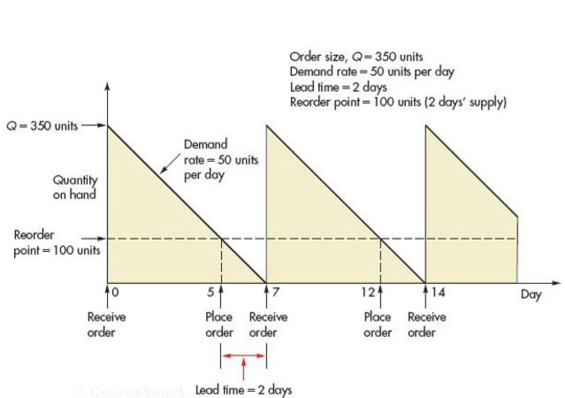

- Annual holding, ordering, and total inventory cost cuves
  - Annual holding cost is linearly related to order quantity
    - 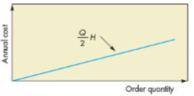
  - Annual ordering cost is inversely and non-linearly related to order quantity
    - 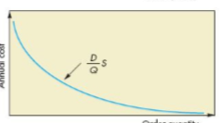
  - The total annual inventory cost curve is U shaped and it’s minimum annual holding cost is equal to annual ordering cost
    - 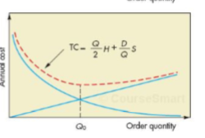
- Calculating annual holding cost
  - Multiplying the average amount of inventory on hand by the cost to hold one unit for one year
  - The average inventory is simply half of the order quantity
  - The amount on hand descreases steadily from Q to 0 (for an aveage of (Q+0)/2 or Q/2)
  - Annual holding cost
    - (Q/2)H
      - Q is the order quantity, units per order
      - H is the holding (or carrying) cost per unit per year
  - Annual holding cost is a linear quntion of Q
    - It increases or decreases in direct proportion to hanges in order quantity Q
- Annual Ordering Costs
  - Annual ordering cost will decrease as order quantity increases because for a given annual demand,
    - the larger the order quantity,
    - the fewer number of orders needed
  - Demo of Ordering Costs
  - if annual demand is 12,000 units and the order quantity is 1000 units per order, there will be 12 orders per year
    - but if Q=2,000 units, unlt six order will be needed
    - at Q = 3000, only 4 orders will be needed
  - Calculating Annual Ordering Costs
    - Annual ordering cost = (D/Q)S
      - D, Demand (units per year)
      - S, Ordering costs per order
  - Because the number of order per year (D/Q) decrease as Q increases, annual ordering cost is inversely and nonlinearly related to order quantity
- Total Inventory Costs
  - The total annual inventory costs of holding and ordering inventory when Q units are order
    - Total inventory Cost = Annual Holding Cost + Annual Ordering Cost
    - Total Inventory cost = ((Q/2)H) + ((D/Q)S)
  - Total cost curve is U shaped (convex with one minimum) and that it reaches its minimum at the quantity where annual holding and annual order costs are equal
  - Calculating Optimal Order Quantity (Q_{o}) can be obtained using calculus
    - $EOQ= Q_{0}=\frac{\sqrt{2DS}}{H}$
    - The minimum total cost is found by substituting Qo for Q (total inventory costs formula)
  - Calculating the length of order cycles (time between orders if Qo is used)
    - Length of order cycles (in yeas) = Qo/D
  - Example
    - A tire store sells 100 steel-belted radial tires
      - holding cost, H: $16/unit/year
      - ordering cost, S: $20/order
      - Demand, D: 100
      - Store operates 360 days a year
    - Optimal Quantity
      - Qo = √2DS/H = √(2)(100)(20)/16 = 15.8 (round to 16)
    - Number of orders per year
      - D/Qo = 100 tires per year /16 tires each time = 6.25 times per year
    - Length of order cycle
      - Qo/D = 16 tires / 100 tires per year = 0.16 year (which is 0.16*360 = 57.6 workdays)
    - Total Inventory Cost
      - Annual holding cost + annual ordering cost
      - (Qo/2)H + (D/Qo)S = (16/2)6 + (100/16)20 = 128 + 125 = $253
  - Holding cost is usually stated as a percent, I, of the purchase pice (or unit cost) of an item rather than as a dollar amount per unit H. However, as long as this percent is converted to a dollar amounts by multiplying it by unit cost, R< the EOQ formula is still appropriate
  - Example
    - A distributor of security monitors purchases 3,600 black-and-white monitors a year from the manufacturer at the cost of $65 each. Ordering cost is $30 per order, and annual holding cost rate is 20% of the unit cost
    - Calculate the optimal order quantity and the total annual cost of ordering and holding inventory
      - D = 3,600
      - S = $30 per order
      - I = holding cost rate per year = 20%
      - R = unit cost = $65
      - H = iR = 0.2*$65 = $13
    - Optimal Quantity
      - Qo = √2DS/H = √(2*3,600*30)/13 = 128.9 (round to 129 monitors)
    - Total Inventory Cost
      - Annual holding cost + Annual ordering cost
      - (Qo/2)H + (D/Qo)S = (129/2)2 + (3600/129)30 = 838.50 + 837.21 = 1,675.71

Economic Production Quantity (EPQ)
- The equivalent of EOQ in production is the Economic Production Quantity (EPQ)
- Used to
  - Determine the optimal batch or lot size in a batch process
- Batch Production
  - Widely used
  - The capacity to produce a part on a machine/equipment exceeds the part’s usage or demand rate
  - As long as production continues, inventory will grow
- Assumptions of EPQ model
  - Similar to EOQ
    - instead of orders being received in a single delivery, units are received incrementally
- How inventory levels are affected when a batch of an item is produced periodically
  - 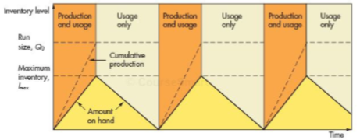
- During the production phase of the cycle, inventory builds up at a rate equal to the difference between production and usage rate
  - Example: the daily production rate is 20 units and the daily usage rate is 5 units,
  - inventory levels will build up at a rate of 20 – 5 = 15 units per day
- As long as production continues, inventory will grow
  - When production cases, the inventory level will begin to decrease
  - The inventory will be max, denoted Imax, when production ceases
  - When the amount of inventory is exusted, production resumes and the cycle repeats itself
- Because the company makes the product itself, there are no ordering cost
- Every production run has a set-up cost
  - Cost to prepare equipment (adjusting, changing tools, etc.)
- Set up costs are analogous to ordering costs and are treated the same way with the same symbol, S
  - Independent of the lot (run) quantity
- The larger the run quantity, the fewer the number of runs/batchs per year (D/Q) and the annual setup cost is equal to the number of runs per year times the setup cost per run (D/Q)S
- Total Annual Inventory Cost
  - Annual honding cost + Annual setup cost
  - (Imax/2)H + (D/Q)S
    - Imax = Maximum Inventory
    - Q = Production run quantity
    - S = Setup cost per production run
  - To calculate Imax, let
    - P = production rate (i.e.: Units per Day)
    - d = usage or demand rate (units per day)
  - The production run quantity Q is consumed at the rate of d during the entire cycle length (= the time between the beginnings of 2 consecutive production runs) therefore
    - Cycle length = Q/d
  - The production run quantity Q is produced at the rate of p during the production run length (the production phase cycle
    - Production run length = Q/P
  - therefore, the max inventory level is
    - Imax = Q – d(Q/P) = Q/P(p-d)
  - Substituting max inventory level and total inventory cost, taking the derivative with respect to Q setting it to zero and solving for Q
    - Q = √2DS/H √p/p-d
- Example
  - Toy manufacturer uses 48,000 rubber wheels per year. The company produces wheels at 800 units per day. Holding costs are $1, setup costs is $45 and the company operates 240 days a year
    - Optimal production run quantity
    - Minimum total annual cost for holding and setup
    - Cycle length for optimal production run quantity
    - Production run length for the optimal production run quantity
  - Given
    - D = 48,000 wheels per year
    - S = $45 per production run
    - H = $1 per wheel per year
    - P = 800 wheels per day
    - d = 48,000 wheels in 240 days OR 200 wheels per day
  - Optimal production run quantity
    - Qo = √2DS/H √p/p-d = √(2*48,000*45)/1 √800/800-200 = 2,400 wheels
  - Minimum total annual costs for holding and setup
    - TCmin = Annual holding cost + Annual setup cost
    - TCmin = (Imax/2)H + (D/Qo)S
    - TCmin = 1800/2 * 1 + 48,000/2,400 * 45 = 900+900 = $1,800
  - Cycle length for optimal production run quantity
    - Q/D
    - 2,400/200 = 12 days
  - Production run length for the optimal production run quantity
    - Q/P
    - 2400/800 = 3 days

EOQ with Quantity Discounts
- Quantity discounts
  - Price reductions for large orders
- Example
  - Surgical supply company publishes pice lists where price per box decreases as quantity increases
  - Consider all-unit discount case where the price of every unit given for order quantity
  - i.e. for 60 boxes
    - 44($2.00) + 16 ($1.70) = 115.20
- If quantity discounts re offered, the buyer must weigh the benefits
  - Large quantity and cheaper
  - Smaller quantity but more expensive
- Buyer’s goal is to select quantity that will minimize total annual cost
- Total annual cost is the sum of annual holding cost, ordering cost and purchasing cost
  - TC = Annual holding cost + annual ordering cost + annual purchase cost
  - TC = (Q/2)H + (D/Q)S + RD
    - Where R is the unit price
- Recall that the basic EOQ model does not include purchase cost
  - The rationale
    - Under the assumption that no quantity discounts is that annual purchase cost is not affected by order quantity
    - 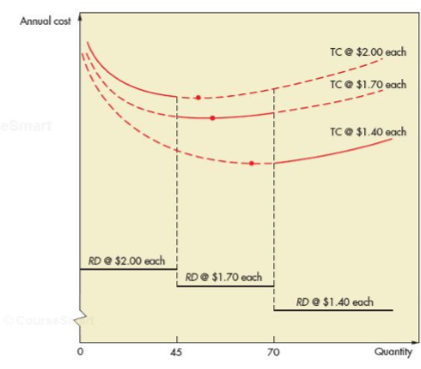
- When quantity discounts are offered, there is a separate U shape for each unit price
  - Including annual purchase price merely raises each curve at a constant amount
  - However, because the unit prices are all different, each curve is raised by a different amount
    - Smaller unit prices will raise the total cost curve less than larger unit prices
  - The annual total cost curve is denoted by solid lines only
- The objective of the quantity discount model
  - Identify an order quantity that will represent the lowest total cost for the solid lines
- Note:
  - Holding cost is a percentage of price
    - Lower prices mean lower holding costs which will result in larger EOQs
    - Price decreases, each curve minimum point will be to the right of the purchase quantity with the following procedures
- Determine the best purchasing price by
  - Beginning with the lowest unit price,
    - Calculate the EOQ for each price until you find a feasible EOQ (until an EOQ falls in the quantiy
    - If the EOQ for the lowest unit prie is feasible, it is the optimal order quantity
      - If not, compare the total cost at all break quantities larger than te feasible EOQ with the total cost of the feasible EOQ
      - The quantity that yields the lowest total cost among these is optimum
- Example
  - A factory uses 4,000 light bulbs a year,
    - 1-499.90 cents each
    - 500-999.85 centss
    - 1000 or more
  - The cost is $30 to prepare the purchase order and the holding cost is 40% of the purchase price per year
  - Determine optimal order quantity and the total annual cost
  - 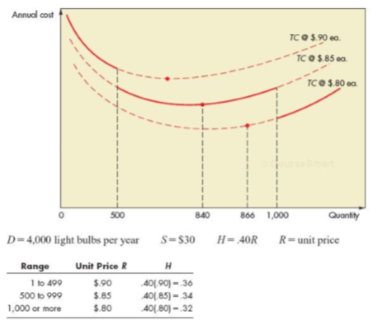
  - Find EOQ for each price until you locate feasible EOQ
    - EOQ0.80 = √2DS/H = √2*4000*30/0.32 = 866 light bulbs
      - Not feasible because it is less than 1000
    - EOQ0.85 = √2(4000)30/0.34 = 840 light bulbs
      - Feasible; fall in the 0.85 per light bulb range (500 – 999)
  - Find total inventory costs
    - Annual holding cost + annual ordering costs + annual purchase cost
    - (Q/2)H + (D/Q)S + RD
  - Find total inventory: 840 units
    - 840/2(0.34) + 4000/840(30) + 0.85*4000 = $3,686
  - Find total inventory: 1000 units
    - 1000/2(0.32) + 4000/1000 (30) + 0.08 (4000) = $3,480
  - Because $3,480 < $,686, the minimum cost order quantity is 1000 light bulbs

EOQ with Planned Shortages
- When holding cost is large, demand can wait, a company may allow shortages intentionally
- We assume that all shorted demand will be back-ordered (customers wait)
  - The back-ordered demand will incur shortage cost
  - This cost will be proportional to the length of the time a unit is back ordered
- We represent this cost, number of units back-ordered as
  - B = back-order cost per unit per year
  - Qb = Quantity back-ordered per order cycle
- Assumptions
  - Same as EOQ except we allow shortages
    - T is order interval and the length of an order cycle
    - t is the time period when inventory level is non-negative
    - tb is time period when inventory level is negative
- When the next order arrives, the back-ordered demand is satisfied first (I.E.: THE INVENTORY LEVELS JUST FATER AN ORDER ARRIVAL WILL BE q – Qo
  - Recall that d = demand rate per day
- Because Q – Qo is used up at a rate of d units per day then
  - Q –Qb= d * t
  - t = Q – Qb/d
  - tb = Qb/d
  - T = t + tb = (Qb/d)/(Q/d)
  - t/T = ((Q – Qb)/d) / Q/d = Q – Qb/ Q
  - tb/T = Qb/d / Qd = Qb/Q
- therefore, average level of inventory furing the year
  - Q – Qb/1 * t/T + 0(t/T) = ((Q-Qb)^2/2Q)
- Average level of back orders during the year
  - Qb/2 * tb/T + 0(t/T) = Qb^2/2Q
- Total annual inventory control cost
  - TC = annual ordering cost + annual holding cost + annual back-order cost
  - (D/S) S + ((Q – Qb)^2/2Q) H + (Qb^2/2Q) B
- Taking derivative of TC with respect to Qb, setting it equal to zero and solving for Qb
  - Qb = Q (H/H+B)
- Taking derivative of TC with respect to Q setting it equal to zero and multiplying it by 2Q^2 and rearranging it
  - -2DS + Q^2H – Qb^2 (H+B) = 0
- Substituting the derivative of TC in respect to Qb and Q
  - Q = √2DS/H(H+B/B)
- Example
  - Annual demand for a fridge is 50 units. The holding cost per unit per year is $200. The backorder cost is estimated to be $5000. Ordering costs from the manufacturer is $10 per order
  - Determine the optimal order quantity and the back-order quantity per cycle
    - D is 50 unit per year
    - H is $200 per unit per year
    - B is $500 per unit per year
    - S is $10 per order
  - Q = √2DS / H (H+B/B)
    - Q = √2*50*10 / 200 (200 + 500/500) = 2.65, round to 3
  - Qb = Q (H/H+B)
    - Qb = 3 (200/200+500) = 0.86, round to 1
- This model has the following practical implications
  - Allow the inventory level to drop to zero
  - Then when there is a customer demand for a unit, place an order for 3 fridges

Fixed Order Quantity/Reorder Point Model: Determining the Reorder Point
- Reorder point (ROP)
  - When the inventory level drops to this amount, the item should be reordered
- ROP
  - ROP = d * LT
    - d is demand rate (units per day or week or month)
    - LT is leadtime in (days, weeks, or months)
- Example
  - A patient takes 2 special tablets per day, which are delivered to his home is 7 days after an order, at what point should the patient reorder
    - Usage is 2 tablet a day
    - Lead time is 7 days
    - ROP is the usage * lead time
      - 2 * 7 =14 tablets
  - Thus, the patient should reorder when there are 14 tablets left
- Note: demand and lead times must have the same time units
- When variability is present in demand/lead time, it creates the possibility that actual demand during a leadtime will exceed expected demand during the leadtime.
  - It becomes necessary to carry additional inventory called safety stock toreduce risk of running out of inventory
- The reorder point then increase by the amount of safety stock
  - ROP = Expected demand during a lead time + safety stock
- Example
  - If the expected demand during a lead time is 100 unit ,
    - The desired amount of safety stock is 10 units
    - Then the ROP would be 110 units
  - 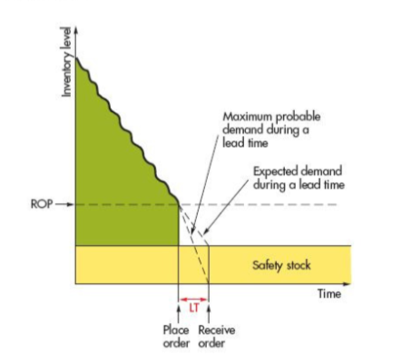
    - Demo of how supply stocks can reduce shortage or risk of stock-out during a lead time (LT)
    - Note that for the fixed order quantity/ROP model,
      - Shortage/stock-out protection is needed only during lead times
  - the amount of safety stock that is appropriate is determined by
    - demand and lea time variability
    - desired service level
  - there are two ways to define service level
    - lead time service level
      - probability that demand will not exceed supply during a lead time
    - annual service level
      - the percentage of annual demand filled
  - the formula commonly used to determine safety stock assumes lead time is normally distributed
    - Safety stock = zϬ_{dlt}
  - 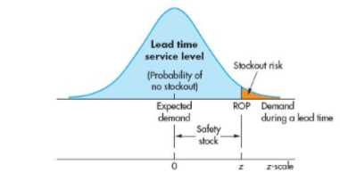
    - Where z is the safety factor
      - Number of deviations above expected demand
      - Where Ϭ_{dlt} is the stand deviation of demand during a lead time
    - Exact relationship depends on
      - Type of service used
        - Lead time
        - Annual
ROP Using Lead Time Service Level
- Given a desired lead time service level,
  - The value of z can be directly determined rom the (standard) normal probability table (appendix B, table b)
  - Note that stock out risk is
    - 1 – Lead Time Service Level
      - Example
        - If the desired lead time service clevel is 0.95 (95%), stock out would be 0.05 (5%)
  - Note that the small the stock-out risk the manager is willing to accept, the greater the value of z
- Example
  - The manger of a store says its lead time can be described through normal distribution that has a mean of 50 bags and a standard deviation of 5 bags
  - Assume that the manager is willing to accept a stock-out risk of no more than 3% during a lead time
  - Questions
    - What value of z is appropriate
    - How many safety stock should be held
    - What reorder point should be used
  - Given
    - Expected demand during lead time = 50 bags
    - Ϭ_{dlt} = 5 bags
    - Stock out risk = 3%
  - Answers
    - What value of z is appropriate?
      - From the table
        - 1 – 0.03 = 0.97
        - Z (of 0.97) is 1.88
    - How many safety stocks should be held?
      - zϬ_{dlt} = 1.88 (5) = 9.40 bags
    - What is the reorder point
      - ROP = Expected demand during a lead time + safety stock
      - ROP = 50 + 9.40 = 59.40 bags
- When data on demand during a lead time are not readily available, than the safety stock formula cannot be used
- If only demand is variable, then Ϭ_{dlt =} √LT Ϭ_{d} and the reorder point is
  - ROP = dbar * LT + _{z}√LT _{Ϭd}
    - Where
      - Dbar is the average daily/weekly/monthly demnd
      - Ϭ_{d} = Standard deviation of daily/weekly/monthly demand
      - LT = Lead time in days/weeks/months
- If both demand and lead time are variable, then
  - Ϭ_{dlt} = √$\sqrt{(\overline{LT }}σ_{d}^{2}+ {\overline{d}}^{2}σ_{LT}^{2})$
- Reorder point
  - $ROP= \overline{d}\overline{LT}+z√\overline{LT}σ^{2}{{\overline{d}}^{2}σ}_{LT}^{2}$
  - $where \overline{LT } is the average lead time ( day/ week/ month)$
  - Where $σ_{LT} is the standard deciation of the lead time (days / weeks / months)$
- Note
  - Each of these models assume that demands and lead time are independent
- Example
  - Restaurant uses 50 jars. The weekly usage has a standard deviation of 3 jars. The manager is willing to accept no more than 10% risk of stock-out during lead time (2 weeks). Assume normal distribution.
  - Questions
    - Which of the above formulas is appropriate for this situation? Why?
    - Determine the value of z
    - Determine the ROP
  - Given
    - Demand, $\overline{d}=50 jars per week$
    - LT is 2 weeks
    - $σ_{d}=3 jars per week$
    - Acceptable stock out risk is 10%
      - Lead time service level is 0.90
  - Solutions
    - Which of the above formulas is appropriate for this situation? Why?
      - Because only the demand is variable, than the reorder point formula is most appropriate
    - Determine the value of z
      - From the table, using service level 0.90, we obtain z = 1.28
    - Determine the ROP
      - ROP = $\overline{d LT+z √{LTσ}_{d}}$
      - ROP = 50* 2 + 1.28√2*3
- Example
  - Daily demand is normally distributed with a mean of 3 units and a standard deviation of 1 unit and a lead time of 2 days, then demand during a lead time will be normally distributed with a mean of 6 units and a standard deviation of $\sqrt{1^{2}{+1}^{2}}=1.41 units$
  - 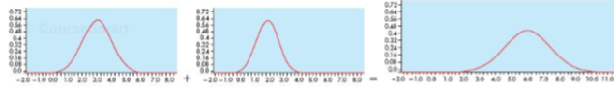
    - The graph on the left is day 1
    - The graph in the middle is day 2
    - The graph on the right is the distribution of the sum of day 1 and day 1 demands
  - We assumed that the manager has a desired service level from which z, then safefy stocks and ROP, were determined
  - Alternative method to determine the ROP
    - Based on cost of overstock and cost of shortages
    - This analysis will be similar to the single period model

ROP Using Annual Service Level
- Given a desired amout of annual service level (i.e.: the percentage of demand filled directly from inventory during the whole year, fill rate)
- To find the required ROP, a 3-step procedure should be used
  - Calculate
    - $E\left(z\right)=\frac{Q\left(1-SL_{Annual}\right)}{σ_{dLT}}$
  - Take E(z) to z-value table, determine z value
  - Use the z value in the following general ROP formula or a specific ROP formula (12-15, 12-16)
- ROP is the expected demand during lead time + $zσ_{dLT}$
  - Where SLannual is the annual service level
  - E(z) is the standardized expected number of units short during an order cycle
  - The derivation of the formula for E(z) in step 1 is rather long and complicated
- Example
  - Inventory item has order quantity Q = 250 expected demand during lead time is 50 and standard deviation of demand during a lead time $σ_{dLT}$is 16.
  - Given
    - Q = 250
    - $σ_{dLT},$Standard deviation of 16
    - $Lead time is 50$
  - Question
    - Determine the ROP if the desired annual service level is
      - 0.997
      - 0.98
  - Solution
    - Calculate E(z) (0.0997, 0.98)
      - $E\left(z\right)=\frac{Q\left(1-SL_{Annual}\right)}{σ_{dLT}}$
        - $E\left(z\right)=\frac{250\left(1-0.0997\right)}{16}=0.047$
        - $E\left(z\right)=\frac{250\left(1-0.098\right)}{16}=0.3125$
    - Calculate Z value
      - E(z) = 0.047, z = 1.28
      - E(z)=0.3125, z = 0.19
    - ROP
      - 50 + 0.19(16) = 53.04 units
- It is important that variations in demand and lead times (with the cooperation of the suppliers) be reduced as much as possible
  - This will reduce the need for safety stock

Other Related Models
- A commonly used variation of the fixed order quantity/reorder point model is the min/ma model
  - The determination of min and max is complicated but min can be approximated by ROP and max by ROP + EOQ
- Another common model is the base stock model
  - When the on hand inventory level back up to the base stock (i.e. max) level
- Another variation of the Min/Max model is the Can Order model
  - In the model, when an items’ on-hand inventory level drops to or below Min. all related items (e.g. those bought from the same supplier) are investigated to see if their on-hand inventory level is at or below their can order level
  - If so, they are ordered too (to bring inventories to max)

Fixed Order Interval/Order up to Level Model
- Vocabulary
  - Orders are placed at fixed time intervals to bring the inventory level up to level
- The model is widely used by wholesalers and retailers who buy their supplies from the same supplier
- If demand is variable, the order size tends to vary from interval to interval
  - Quite different from the EOQ/ROP model in which the order size remains fixed from cycle to cycle while the length of the cycle varies (shorter if demand is above average, and longer if demand is below average)
- Grouping orders can save ordering and shipping costs
- Some situations may not readily lend themselves to an inventory count
  - Example: Many retail operations
- The alternative for them is to use fixed interval ordering, which requires only periodic checks of inventory levels
- Two decisions are needed to apply this model for a group of items from the same supplier
  - The order interval
  - The order up to level for each item

Determining the Order Interval
- The order interval can be determined by minimizing total annual holding and ordering costs of all the SKUs received from a particular supplier
- The complications is that there are two components to ordering costs
  - The cost of issuing a purchase order
  - The cost of ordering each line item (SKU) in it
- In the basic model
  - Assume that every SKU is ordered at every order time no matter how small its order quantity is.
- Let
  - OI be the order interval (fraction of a year)
  - S be the fixed ordering cost per purchase order
  - s be the variable ordering cost per SKU included in the purchase order (line item)
    - For simplicity, we assume s is the same for every SKU
  - n be the number of SKUs purchased from the supplier
  - R_{j} be the unit cost of SKU_{j}, j = 1, …, n
  - I be the annual holding cost rate
  - D_{j} be the demand for SKU_{j}, j = 1, …, n
- For each SKUj from this supplier, we will purchase enough to last until next order
  - i.e.: Q = Dj * OI
- Total Annual Inventory Control Cost
  - Total Annual Inventory Control Cost (TC) = $\sum{(\frac{D_{j}*OI}{2} }) R_{j}*i+\left(S+ns\right) (\frac{1}{OI})$
- Taking derivative of TC with respect to OI, setting it equal to 0 and solving for OI, we get the optimal order interval
  - $OI* = \sqrt{\frac{2(S+ns)}{i\sum{D_{j}R_{j}}}}$
- Example
  - Three parts are purchased from the same supplier. The basic cost of placing an order for one of the SKUs is $1.50. The inclusion of each additional SKU costs $0.50 more. The annual carrying cost rate is 24% of the unit cost. The annual demand and unit prices are given below. Assume that the buying company works 250 days a year.
  - Question
    - Calculate the optimal order interval
  - Given
    - SKU 1, Demand/Year is 12,000 and the price/unit is $0.50
    - SKU 2, demand/year is 8,000 and the price/unit is 0.30
    - SKU 3, demand/year is 700 and the price/unit is 0.10
    - S = $1.50 – 0.50 = $1.00
    - s = 0.50
    - i = 0.24
  - Solution; optimal order interval
    - $OI* = \sqrt{\frac{2(S+ns)}{i\sum{D_{j}R_{j}}}}$
    - OI* $= \sqrt{\frac{2*(1.00+3*0.50)}{0.24\left(12000*0.50+8000*0.30+700*0.10\right)}}$
    - OI* = 0.0496 year = 12.4 days

Determining the Order up to Level
- The order up to level for an item should be enough so that items last unti the next arrives (i.e.: after an order interval plus a lead time
  - This fact illustrated in the below chart also contracts the fixed order interval model with the order quantity (EOQ/ROP) model
  - 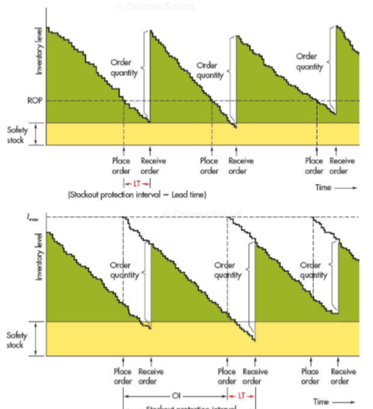
- Note
  - The order quantity (the difference between order up to level and on hand inventory level) for the fixed order interval model will vary from one order time to another (depending on size of demand during the past interval)
- Safety Stocks
  - Need for safety stocks
    - In the presence of demand and lead time variability stocks
    - The two models also differ in terms of safety stocks
      - The fixed order interval model must have stock-out protections until the next order arrives
      - The fixed order quantity (EOQ/ROP) model needs protection only during lead time
      - Therefore, the fixed interval model necessitates a larger amount of safety stock for a given service level
      - Therefore, order up to level or Imax can be determined by
        - Imax = Expected demand during an order interval plus a lead time + safety stock
      - Like the fixed order quantity model
        - The fixed order interval model can have variations in demand and/or lead time
        - For the sake of simplicity and because it is the most frequently encountered situation, the discussion will focus only on variable demand and constant lead time case
          - As in the fixed order quantity model, we assume that demand during an order interval and a lead time is normally distributed
- Example
  - Given the following information for a SKU, determine its order up to level and amount to order (optimal order quantity)
  - Given
    - $\overline{d}=30 units per day$
    - $σ_{d}=3 units per day$
    - Desired service level = 99 percent
    - Amount on hand at reorder time = 71 units (safety stocks)
    - Lt is 2 days
    - OI is 7 days
  - Solution
    - Calculate Z Score
      - 99% is z =2.33
    - Calculate order up to level (Imax)
      - Imax = $\overline{d}\left(OI+LT\right)+zσ_{d }\sqrt{OI+LT}$
      - Imax = 30(7+2) + 2.33(3) √7+2
      - Imax = 291
    - Amount to order
      - Order up to level (max) – safety stocks
      - 291 – 71 = 220 units
- Note
  - The average demand is usually estimated using forecast of demand, and the standard deviation of demand is usually estimated using standard deviation of the forecast error

Coordinated Periodic Review Model
- In the fixed order
  - It might cost less to order some items every 2, 3 or more order intervals than ordering them at every interval,
    - Their holding cost may be less than the line-item ordering cost
- The periodic review model
  - Accommodates this by determining an order interval OI for reviewing every SKU and a multiple modates this by determining an order interval OI for reviewing every SKU and a multiple Mi of OU for ordering SKUi (determines the order up to level SKUi)
- After planning the model (i.e.: determing OI and Mis) during operation and control of the model (in the presence ofd demand variation),
  - the on-hand inventory level of each SKU should be compared with its forecast demand for the next OI plus lead time plus SKU should be compared with its forecast demand for the next OI plus lead time plus safety stock (just like ROP) and if on hand inventory level level up to the SKU’s order up to level should be ordered
- the order up level for SKUi should cover its forecast demand during the next mi order intervals (OI) plus lead time plus safety stocks only for the next OI + LT
- the determination of optimal values for OI and Mis is complicated, we will use a simple heuristic
  - find the SKU with largest annual dollar value DjRj, Suppose, it is SKU, Let mi =1
  - for every other SKUj, calculate
    - $Mj= \sqrt{(\frac{s}{D_{j}R_{j} }\frac{D_{j}R_{j}}{S+s }} (round it to the nearest interget greater than 1)$
  - Calculate Order Interval OI
    - $OI* = \sqrt{\frac{2(S+s\sum{\frac{1}{m_{j}}))}}{\sum{m_{j}D_{j}R_{j}}}}$
  - Rationale
    - Thatb oth purchase order cost (S) and line item ordering cost (s) are charged to the SKU because SKU will be ordered T EVERY ORDER INTERVAL
    - Mj for other SKUs re determined using formula for $OI* = \sqrt{\frac{2(S+s\sum{\frac{1}{m_{j}}))}}{\sum{m_{j}D_{j}R_{j}}}}$relative to mk
    - OI is calculated using the formula for order interval is very similar to formula $OI* = \sqrt{\frac{2(S+ns)}{i\sum{D_{j}R_{j}}}}$ but uses mjDj as the order quantity for SKU
- Example
  - We use the same data as previous eample to compare periodic review model with the fied order interval model
  - Given
    - S = $1.00
    - s = 0.50
    - i = 0.24
  - The annual demand and unit price
    - SKU 1, demandyear = 1
    - 12,000; price/unit 0.50, DiRi $6,000
    - SKU 2, demand/year 8,000, price/unit 0.30. DiRi $2,400
    - SKU 3, demand/year 700, price/unit 010, DiRi $70
  - SKU with largest DiRi is Sku
    - M1 = 1
    - M2 = $\sqrt{\frac{0.50}{2,4000}\frac{\$6,000}{1+0.5}}=0.91;round to 1$
      - M2 =1
    - M3 = $\sqrt{\frac{0.50}{70}\frac{\$6,000}{1+0.5}}=5.35;round to 5$
  - Order Interval
    - $OI= √ \frac{2(1.00+0.4)(1+1+20)}{0.24 (1*6000+1*2400+5*70)}$ = 0.447 year = 11/2 days (Ibecause the buyer works 250 days a year)
- Thus, OI is only slightly smaller, but the plan for SKU3, because of its smsall small annual dollar usage, is to order it every five 5 order times
- Suppose,
  - OI is 11 work days
  - LT and safety stocks ar negligible, demand for SKU3 during the next 11 work days = 700(11)/250 = 30.8 units
  - Therefore, the order up to level for SKU3 should set 5(30.8) = 154 units

Single Period Model
- Vocab
  - Single period model
    - Model for ordering of perishables and other items with limited useful lives
- Period for spare parts is the life of the equipment, assuming that the parts cannot be used for ther equipment
- What sets unsold/unused goods apart is that they are not typically carried over from one period to the next, at least not without penalty
  - Day old bread is sold at reduction
  - Unsold seafood is thrown out
- There may even be some cost associated with disposal of leftover good
- Analysis of single period model generally focuses on 2 costs
  - Shortage
  - Excess
- Shortage cost may include a charge for loss of customers goodwill as well as the opportunity cost of the lost sale
  - Cshortage = Cs = Revenue per unit – Cost per unit
- We assume Ci>0
  - If a shorage or stock-out relates to an item used in production or to a spare part for machine, then shortage is the cost of lost production
- Excess cost
  - Difference between purchase cost and salvage value of an item left at the end of the period
  - Cexcess = Ce = Cost per unit – salvage value per unit
- If there is a cost associated with disposing of excess items, then the salvage value wil be negative and will therefore increase the excess cost per unit
If the salvage value os ;arger than the original cost, then C will be negative
However, in this case, we must have Cs + Ce > 0
  - Because the salvage value per unit must be less than revenue per unit
- Goal of thesingle period model
  - Identify that order quantity or stocking level that wil minimiz the long-run total excess and shortage cost
- Two categories of problems that we will consider
  - Those for which demand can be approzimated by a continuous distribution (uniform/normal)
  - Those for which demand be approximated by a discrete distribution (say, hisctorical frequencies or Poisson)
- The nature of item can indicate which type of model might be appropriate
  - Example: demand for liquids and items whose individual units are small but whose demand is large (i.e. muffins, newspaper) tend tovary over some continuous scale
    - Thus lending itself to the description by continuous distribution
- Demand for spare parts, flowers, etc/ can be expressed it terms of the number of units demanded
  - Lends itself to discrete distribution

Continuous Stocking Levels
- Concept of identifying an optimal stocking level (i.e.: order quantity) is perhaps easiest to visualize when demand is uniform
- Choosing the stocking level is similar to balancing a seesaw
  - Instead of person on each end of the seesaw, we have excess cost per unit (Ce) on one end of the distribution and the shortage cost per unit (Cs) on the other
- The optimal stocking level is analogous to the fulerum of the seesaw
  - The stocking level equalizes the cost weights
  - If actual demand exceeds the balance point So, there is shortage
    - Here C is on the right end of the distribution
- Similarily,
  - If demand is less that So, there is excess, so C is on the left of the distribution
  - When Ce = Cs
  - The optimal stocking level is halfway between the endpoint of the distribution
  - If one cost is greater than the other
    - S will be closer the larger cost
  - 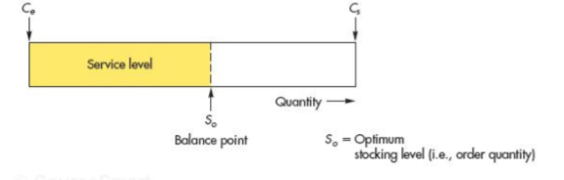
- Service level
  - The probability that demand will not exceed the stocking level
- Calculation of the service level
  - Key to determining the distribtuipns optimal stocking level So
  - Service Level SL = Cs / Cs+ Ce
    - Cs is the shortage cost per unit
    - Ce is the excess cost per unit
  - Optimal stocking level, So
    - Determined from the demand distribution
- Example
  - Muffins are delivered daily to the caf, demand can vary from 30 -50 nuffins per day. The caf spends 20 cents of a muffin and charge 80 cents. Unsold muffins have no salvage value and cannot be carried)
  - Question
    - Find the optimal stocking level
    - The stock-out risk for that quantity
  - Cost of excess stock
    - Cost per unit – Salvage value per unit
    - 0.2 – 0
    - 0.20 per unit
  - Cost of surplus stock
    - Revenue per unit – Cost per unit
    - 0.8 – 0.20
    - 0.60 per unit
  - Service Level
    - Cs/Cs+Ce
    - 0.60/0.6+0.2
    - 0.75
  - The optimal stocking level (i.e.L order quantity) must satisfy 75% of demand
  - For uniform distribution
    - This will be at a point qual to the minimum demand plus 75% of the difference between maximum and minimum demands
    - So = 30 + 0.75*50-30) = 45 muffins
    - Stock out risk is 1 - 0.75 = 0.25
- Example
  - Suppose the distribution of demand for muffins in the previous example was approximately normal with mean of 40 muffins per day and a standard deviation of 5 muffins per day
  - Question
    - Find the optimal stocking level for the muffins
  - Solution
    - Recall that Cs - $0.60, Ce =$0.20 and SL = 0.75
  - This indicates that 75% of the normal curve must be to the left of the stock level
  - The z value is between 0.67, 0.68 so .675
    - So = 40 + 0.675 (5) = 43.374 or 43 muffins
  - 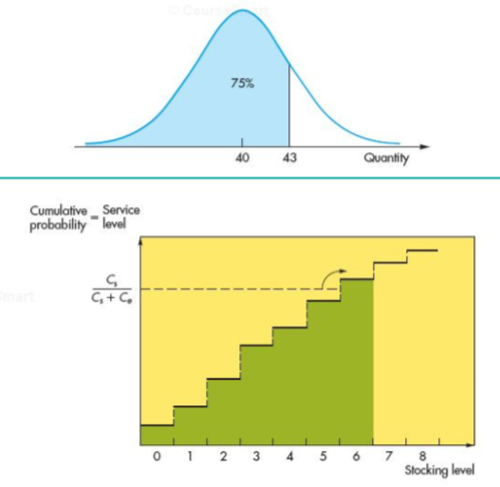

Discrete Stocking Levels
- When stocking levels are discrete rather than continuous, the service level calculated using the ratio Cs/(Cs+Ce) usually does not coincide with a feasible stocking level (.g. optimal amount may be between 5 and 6 units
- The optimal solution in this case is the higher level (i.e. 6 units)
  - In other words, choose the stocking level so that the desired service level is equalled or just exceeded
- the service level in this case is compared with the cumulative probability of demand (above)
- Example
  - Historical records on the use of spare parts as an estimate of usage for the spare part in a similar but new press
  - Stock out costs involve downtime expenses and special ordering cost. These average $4,200 per unit short)
  - The spare parts cost $1,200 each and unused part has $400 salvage value
- Question
  - Determine the optimal stocking level
    - Number of spare used 0, probability 0.20, cumulative probability 0.2
    - Number of spare parts used 1, probability is 0.3 and cumulative probability is 0.6
    - Number of spare parts is 2 than 0.30, 0.9
    - Number of spare parts 3, than 0.1 and 1
    - Number of parts 4 or more than 0, 0
  - Given
    - Cs = 4,200
    - Ce = 1,200 – 400 = 800
    - Stocking level
      - Cs/Cs+Ce = 4200/4200+800 = 0.84
      - Percentage of time that demand was equal to or less than some amount
        - Example: demand<one part occurred 60% of the time but demand < 2 parts occurred 90% of the time
- Example
  - Demand for long stemmed red roses is approximated by poisson distribution has a mean of 4 dozens of roses per day. The profit on the roses is $3 per dozen. Leftover flowers are marked down and sold the next day at a loss of $2
  - Question
    - What are the optimal stocking level?
  - Given
    - Cs = 3
    - Ce = 3
    - SL = 3/3+3 = 0.60
  - Table
    - Demand, cumulative probability
      - 0, 0.018
      - 1, 0.092
      - 2, 0.238
      - 3, 0.434
      - 4, 0.629
      - 5, 0.785

