Chapter 7 Design of Work Systems
Table of Contents
Job Design 1
Efficiency School 1
Behavioural School 1
Specialization: 1
Advantages 1
Disadvantages 1
Introduction to Job Design 2
What does Job Design Involve 2
Objectives 2
Approaches 2
Job Design Decisions 2
Trends in Job Design 3
Physical Considerations in Job Design 3
Behavioural Approach 3
Teams 4
Benefits of teams 4
Methods Analysis 4
Worker-Machine Chart 5
Motion Study 5
Working Conditions: Government Regulation 5
Working Conditions 6
Noise and Vibrations 6
Work Breaks 6
Levels of Illumination 6
Safety: Protection Against Hazards 7
Safety 7
Ergonomics 7
Work Measurement 8
Work Measurement 8
Standard time 8
Stopwatch Time Study 8
Number of cycles 8
Solved Problem #2 9
Normal Time 9
Standard Time 10
Time Study Example 10
Cautions on Time Studies 10
Predetermined Element Times 11
Work Sampling 11
Compensation 11
Output-based (piece rate) pay 12
Question 12
Question 12
Question 13

Job Design
- Job design involves specifying the content and methods of job
  - What will be done
  - Who will do the job
  - How the job will bob will be done
  - Where the job will be done
  - Ergonomics

Efficiency School
  - A refinement of Taylor’s scientific management concepts
  - Systematic, logical approach to job design
  - Labour cost reduction

Behavioural School
  - Emerged during the 1950s
  - Emphasizes satisfaction of wants and needs
  - Reminded managers of the complexity of human beings

Specialization:

Advantages
- For company
  - Simplifies training
  - High productivity
  - Low wage cost
- For worker
  - Low education and skill requirement
  - Minimum responsibilities
  - Little mental effort needed

Disadvantages
- For Company
  - Difficult to motivate quality
  - Worker dissatisfaction
    - Absenteeism
    - High turnover
    - Disruptive tactics
- For Workers
  - Monotonous work
  - Limited opportunitiy for afvancement
  - Little control over work
  - Little opportunity for self-fulfillment

Introduction to Job Design

What does Job Design Involve
- Job design involves specifying the content and methods of job
  - What will be done
  - How the job will be done

Objectives
- Objectives of job design
  - Productivity
  - Safety
  - Quality of work life

Approaches
- Two approaches to job design
  - Efficiency school
  - Behavioral school

Job Design Decisions
- Ultimate Job Structure
  - Who
    - Mental and physical characteristics of the workforce
  - What
    - What tasks will be performed
  - Where
    - Geographic locale of the organization;
    - Locations of work areas
  - When
    - Time of day
    - Time of occurrence in workflow
  - Why
    - Organizational rationale for the job
    - Objectives and motivation of the workforce
  - How
    - Method of performance and motivation

Trends in Job Design
  - Quality control as a part of workers job
  - Cross-training workers to perform multi-skilled jobs
  - Employee involvement and team approaches to designing and organizing
  - Extensive use of temporary workers
  - Automation of heavy manual work
  - Creating alternative workplaces
  - Organizational commitment to providing meaningful and rewarding jobs for all employees

Physical Considerations in Job Design
- Work physiology
  - sets work-rest cycles according to the energy expended in various parts of the job. The harder the work, the more the need for rest periods.
- Ergonomics
  - is a term used to describe the study of the physical arrangement of the work space together with tools used to perform a task. Fit the work to the body rather than forcing the body to conform to the work.

Behavioural Approach
- Job Enlargement
  - Giving a worker a larger portion of the total task by horizontal loading
- Job Rotation
  - Workers periodically exchange jobs
- Job Enrichment
  - Increasing responsibility for planning and coordination tasks, by vertical loading

Teams
- Self-directed teams
  - Groups who perform the same function and are empowered to make certain decisions and changes in their work.

Benefits of teams
  - Fewer managers are necessary
  - Higher quality
  - Higher productivity
  - Greater worker satisfaction

Methods Analysis
- Methods analysis
  - breaks down the job into sequence of tasks and elements and improves it.
  - Basic Procedures
    - Identify the job to be studied and gather information
    - Discuss the job with the operator and supervisor
    - Study and document the present method
    - Question the present method and propose a new one
- Process Charts
    - Chart used to examine the overall sequence of an operation by focusing on movements of the operator or flow of materials
    - Ask:
      - Why is there a delay or shortage at this point?
      - How can travel distances be shortened/avoided?
      - Can an operation be eliminated?
      - Can the sequence be changes?
      - Can similar activities be grouped?
      - Would additional or better equipment help?
  - Process Chart: Example
    - 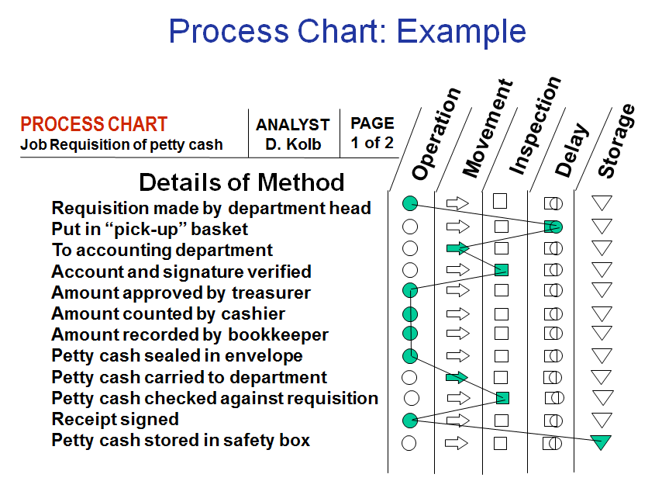

Worker-Machine Chart
- Helps to see portions of work cycle during which an operator and equipment are busy or idle.
- Can help to determine how many machines one operator can manage.
- See Figure 7-2

Motion Study
- Motion study is the systematic study of the human motions used to perform an operation.
- Motion economy principles:
  - guidelines for designing motion - efficient work procedures
- Analysis of elemental motions (therbligs):
  - basic elemental motions into which a job can be broken down
- Micro motion study:
  - use of motion pictures and slow motion to study motions that otherwise would be too rapid to analyze
- Simultaneous hand motion chart:
  - a chart that shows the elements performed by each hand, side by side, over time

Working Conditions: Government Regulation
- Canadian Labour Code
  - safety and other work standards (e.g.. min wage)
  - Workers have rights to:
    - refuse dangerous work,
    - participate in improving health & safety,
    - know about hazards in the workplace.
- Canadian Centre for Occupational Health and Safety
- Workplace Hazardous Materials Information System (WHMIS),
    - mandates proper labeling of hazardous material
    - making available material safety data sheets.

Working Conditions
- Working conditions
  - Termperature and humidity
  - Ventilation
  - Illumination
  - Ergonomics
  - Noise and vibrations
  - Work breaks
  - Safety
  - Cause of accidents

Noise and Vibrations
  - Noise:
    - Selection and placement of equipment
    - Acoustical walls and ceilings or baffles
    - Provide earplugs or protective devices
  - Vibration:
    - Padding, stabilizers, shock absorbers, cushioning or rubber mountings

Work Breaks
  - Efficiency declines as day wears on
  - Work breaks can cause an upward shift
  - Depends on amount of physical/mental efforts

Levels of Illumination
Task condition | Type of task or area | Illumination level | Type of illumination
Small detail, extremely accurate | Sewing, inspecting dark materials | 100 | Overhead ceiling lights and desk lamps
Normal detail, prolonged periods | Reading, part assembly, general office work | 20-50 | Overhead ceiling lights
Good contrast, fairly large objects | Recreational facilities | 5-10 | Overhead ceiling lights
Large objects | Restaurant, stairway, warehouse | 2-5 | Overhead ceiling lights

Safety: Protection Against Hazards
  - Proper lighting
  - Clearly marked danger zones
  - Protective equipment
  - Safety devices
  - Emergency equipment
  - Housekeeping
  - Thorough training
  - Enforcement of procedures

Safety
  - Requires constant attention
  - Occupational Safety and Health Standards
  - WHMIS training required
  - Two main causes of accidents:
    - carelessness
    - hazards

Ergonomics
  - Involves fitting the job to the worker’s capability and size.
    - Design of equipment, work methods, work space
    - Remove awkward movement
    - Try to prevent common workplace injuries (e.g. back injuries, repetitive motion injuries)

Work Measurement

Work Measurement
  - Determine how long it should take
to do a job.
    - Stopwatch time study
    - Predetermined element times
    - Work Sampling

Standard time
  - The amount of time it should take a qualified worker to complete a specific task
    - working at a sustainable rate,
    - using given methods, tools and equipment, raw materials, and workplace arrangement.

Stopwatch Time Study
  - Development of a time standard based on observations of one worker taken over a number of cycles.
  - The basic steps in a time study:
    - Define the task to be studied
    - Determine the number of cycles to observe
    - Time the job
    - Compute the standard time

Number of cycles
  - Number of cycles depends on:
    - variability of observed times,
    - desired accuracy, and
    - desired level of confidence for the estimated job time
  - Formulas
  - Notation
    - z =Number of Normal standard deviations needed for desired confidence
    - s =Sample standard deviation
    - a =Desired accuracy proportion (= percentage/100)
    - =Sample mean
    - e =Accuracy amount or maximum acceptable error amount
    - n = number of observations (= sample size)

Solved Problem #2
  - Determine number of observations needed to achieve a specified maximum error, with a confidence of 95.5 percent.
    - mean = 5.2 minutes
    - standard deviation = 1.1 minutes
  - Determine:
a. A maximum error of +/- 6% of the sample mean.
b. A maximum error of .40 minute.
- Given
  - x-bar = 5.2 minutes
  - z = 2.00 for 95.5%
  - s = 1.1 minutes
  - a = .06
  - e = .40
- Solution

Normal Time
  - Normal time (NT) = Observed time x Performance rating
    - Observed Time is an average of recorded times
    - The Performance Rating expressed as a decimal. Performance Rating of a person working 10% faster than normal = 1.10 or 110% of normal time. Working 10% slower = 0.90 or 90% of normal.
    - Performance rating is subjectively assigned
    - Can sum normal times for several elements

Standard Time
  - Standard Time = Normal Time * Allowance Factor
    - Standard time = NT x (1 + Allowance % )
based on job time
    - used when different tasks have different allowances
- Standard Time = Normal time * Allowance Factor
  - Standard time = NT .
1 – Allowance %
based on time in workday
    - used when different tasks have similar allowances

Time Study Example
  - You want to determine the standard time for a job. A worker produced 20 items in an 8 hour day. As the worker was nervous under observation, it was estimated that the employee worked about 10% faster than normal. Allowances for the job are 25% of the normal time.
  - What are the normal and standard times for this job?
- Normal time = Observed Time x (Perf. rating)
= (480 minutes/20) x (1.10)
= 26.4 minutes

Cautions on Time Studies
  - Analyst must be familiar with task
    - Workers may attempt to shorten times
    - Abnormally short times should be discarded
    - Abnormally long times should be investigated
  - Jobs need to be broken down into basic motions
    - Many jobs can’t be observed like this
  - Costly and disruptive: benefits must outweigh cost
    - Can also use historical or published elemental times to determine times for a task
    - Need high skill to describe task in basic elements

Predetermined Element Times
  - Published data based on extensive research on element times
    - Methods Time Measurement (MTM) tables
    - Time Measurement Unit (TMU)
    - Many tables for a variety of moves and conditions
      - distance, difficulty, weight, degree of turn, etc.
    - Requires much time and skill

Work Sampling
  - technique for estimating the proportion of time that a worker or machine spends on each activity or is idle.
  - Reason
    - Make brief observations of a worker or machine at random intervals
    - Does not require
      - Timing an activity
      - Continuous observation
  - Steps
    - Identify worker to be studied
    - Notify workers and supervisors to avoid arousing suspections
    - Compute initial estimate of sample size
    - Determine estimated proportion of time spent on specified activity
    - Begin taking observations. Re-compute required sample size periodically
    - Develop random observation schedule

Compensation
  - Time-based pay
    - Compensation based on time an employee has worked during a pay period
  - Output-based (piece rate) pay
    - Compensation based on the amount of output an employee produces during a pay period
  - Group Incentive Plans
    - Sharing of productivity gains with employees
      - Output and cost reduction (gain-sharing)
      - Increases in profit (profit-sharing)
- Skill/Knowledge-Based Bonus Plans
    - reward workers who undergo training
to increase their skills/knowledge

Output-based (piece rate) pay
  - Compensation system should be:
    - Accurate
    - Easy to apply
    - Consistent
    - Easy to understand
    - Fair

Question
- A job is said to be enlarged vertically if the employee is involved with which of the following?
  - The job’s planning
  - The job’s organizing
  - The job’s inspecting
  - All of the above
  - None of the above

Question
- Which of the following is the Normal Time for a job whose observed performance time is 10 minutes with a performance rating of 90%?
  - 90 minutes
  - 9 minutes (10 * 0.9 = 9)
  - 1.10 minutes
  - 11.111 minutes
  - None of the above

Question
- Which of the following is the Standard Time for a job whose Normal Time is 20 minutes and whose Allowances are 5% of Normal Time?
  - 19.05 minutes
  - 21 minutes
    - St = nt (1+allowances) = 20 (1.05) = 21
  - 400 minutes
  - 450 minutes
  - None of the above

