Chapter 7: Design of Work Systems

Table of Contents
Introduction and Job Design 1
Efficiency Approach 1
Behavioural Approach 2
Methods Analysis 2
Motion Study 3
Working Conditions 6
Brief History of Government Regulations in the Workplace 6
Temperature and Humidity 6
Ventilation 6
Illumination 6
Noise and Vibrations 6
Work Breaks 6
Safety 6
Ergonomics 6
Workers’ Well-Being and a Healthy Workplace 6
Work Measurement 6
Stopwatch Study 7
Observed Time 8

Learning Objectives
- Briefly describe efficiency and behavioural approaches to job design
  - Efficiency Approach
    - Specialization: focusing the job to a narrow scope
- Advantages
  - For the company
    - Simplifies training
    - High productivity
    - Low wage cost
  - For the worker
    - Low education and skill requirements
    - Minimum responsibilities
    - Little mental effort needed
- Disadvantages
  - For the company
    - Difficult to motivate quality
    - Worker dissatisfaction, possibility of resulting in absenteeism, high turnover, disruptive tactics
  - For the worker
    - Monotonous/boring work
    - Limited opportunities for advancement
    - Little control over work
    - Little opportunity for self-fulfillment
  - Behavioural Approach
    - Job enlargement
      - Giving a worker a larger portion of the total task
    - Job rotation
      - Workers periodically exchange jobs
    - Job enrichment
      - Increasing responsibility for planning and coordination
    - Self-directed teams
      - Groups who perform the same function and are empowered to make certain decisions and changes in their work

- Explain the purpose of methods analysis and describe how methods analysis is performed
  - Methods analysis; breaks down the job into sequences of tasks and elements and improves it
    - Identify the job to be studied and gather all pertinent facts about its operations, machines, equipment, materials and so on
    - Discussthe job with the operator and supervisor
    - Analyze the document the present method of performing the job
    - Question the present method and propose a new method
  - Elements
    - Process chart
    - Worker machine chart
  - Motion study: systemic study of the human motions used to perform an operation or task
  - Tools
    - Motion economy principles
    - Analysis of elementary motions
    - Micro motions
    - Sumultaneous hand motion chart
- Discuss the impact of working conditions on job design
  - Government regulation
  - Temperature and humidity
  - Ventilation
  - Illumination
  - Noise and vibrations
  - Work breaks
  - Safety
- Describe the time study methods and perform calculations
  - Stop watch study: development of standard time based on observation of one worker taken over a number of cycles
    - Define the job to be studied and inform the worker
    - Determine number of cycles
      - N = (Z value * Standard deviation / max error * mean) ^ 2
      - N = (Z*s/e); e being the accuracy amount error amount
    - Time the job and rate performance
    - Calculate standard time
      - Observed time: average of recorded times
        - OT = sum of recorded times / number of observations
      - Normal time: workers performance
        - NT = Observed time * Performance rating
      - Standard time (performed job; accounts for delays)
        - ST = Normal time * allowance factor
  - Work sampling: technique for estimating the proportion of time that a worker spends on each activity or is idle
    - A (acceptable error) = zvalue√(p(1-p)/n)
    - N = (z value/acceptable error)^2 p(1-p)
- Describe various compensation methods
  - Time based pay: compensation based on time an employee has worked
  - Output based pay (piece rate): compensation based on the amount of output an employee produces
  - Group bonuses
  - Skill/knowledge bonus plan

Introduction and Job Design
  - Briefly describe efficiency and behavioural approaches to job design
- Vocabulary
  - Job design
    - Specifying the content and method of a job

Efficiency Approach
- Vocabulary
  - Specialization
    - Focusing the job to a narrow scope
- Assembly line specialization
  - Advantages
    - For the company
      - Simplifies training
      - High productivity
      - Low wage cost
    - For the worker
      - Low education and skill requirements
      - Minimum responsibilities
      - Little mental effort needed
  - Disadvantages
    - For the company
      - Difficult to motivate quality
      - Worker dissatisfaction, possibility of resulting in absenteeism, high turnover, disruptive tactics
    - For the worker
      - Monotonous/boring work
      - Limited opportunities for advancement
      - Little control over work
      - Little opportunity for self-fulfillment

Behavioural Approach
- Vocabulary
  - Job enlargement
    - Giving a worker a larger portion of the total task
  - Job rotation
    - Workers periodically exchange jobs
  - Job enrichment
    - Increasing responsibility for planning and coordination
  - Self-directed teams
    - Groups who perform the same function and are empowered to make certain decisions and changes in their work

Methods Analysis
- Vocabulary
  - Methods analysis
    - Breaks down the job into a sequence of tasks and elements and improves it
  - Process chart
    - Chart used to examine the overall sequence of an operations by focusing on movements of the operator or flow of material
  - Worker-Machine chart
    - Used to determine portions of a work cycle during which an operator and equipment are busy or idle
- Method for job analysis
  - Identify the job to be studied and gather all pertinent facts about its
    - Operations
    - Machines
    - Equipment
    - Materials, etc.
  - Discuss the job with the operator and supervisor
  - Analyze and document the present method of performing the job
  - Question the present method and propose a new method
- Questions that experienced analysts ask when developing checklist to generate ideas for improvement
  - Why is there a delay, storage, or inspection at this point?
  - How can travel distances be shortened or avoided?
  - Can an operation be eliminated?
  - Can the sequence of operations be changed?
  - Can similar activities be grouped?
  - Would the use of additional or improved equipment be helpful?
- Example of a process chart
  - 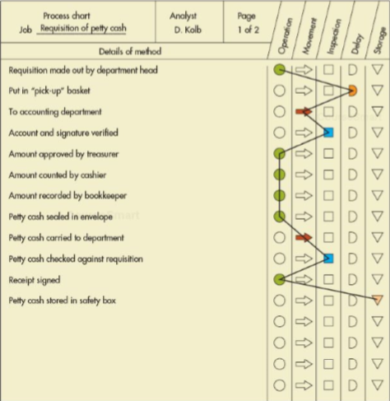
- Example of a worker-machine chart
  - 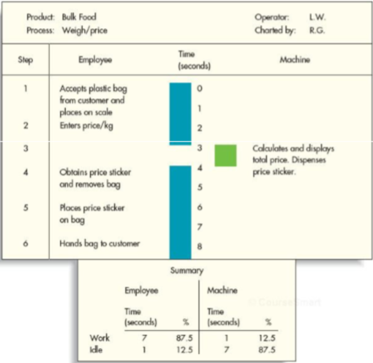

Motion Study
- Vocabulary
  - Motion study
    - Systematic study of the human motions used to perform an operation or task
  - Motion economy principles
    - Guidelines for designing motion-efficient work procedures
  - Micro-motion study
    - Use of motion pictures and slow motion to study motions that otherwise would be too rigid to analyze
  - Simo chart
    - A chart that shows the elementary motions performed by each hand, side-by-side, over time
- Most used techniques/tool to develop efficient procedures
  - Motion economy principles
  - Analysis of elementary motions
  - Micro-motion (slow-motion video) study
  - Simultaneous hands motion chart
- Example of motion economy principles
  - The use of arms and body
    - Both hands should begin and end their acivity simultaneously and should not be idle at the same instant, expect during frequent but short rest periods
    - The motions made by the hands should be minimal and symettrical
    - Momentum should assist workers wherever possible and should be minimized if it must be overcome by muscular effort
    - Continuous natural curved motions are preferable to straight-line motions involving sudden and sharp changes in direction
    - Strength requirements should be much less than the maximum available. Avoid lifting heavy objects. Use slow motions for maximum muscle strength.
    - Eliminate bend and rise, awkward postions, and make the task easier to reduce fatigue
    - Eliminate eye travel and avoid losing eye focus
  - The arrangement of the workplace
    - Fixed locations for all tools and materials should be provided to permit the best sequence and eliminate or reduce search and selection
    - Gavity bins and drop delievery should reduce reach and move times, whenever possible, ejectors should remove finished parts automatically
    - All materials and tools should be located within easy reach
    - Provide a chair or stool if possible
  - The design of tools and equipment
    - Where possible, power tools should replace hand tools
    - All levers, handles, wheels and other control devices should be readily accessible to the operator and designed to give the best possible mechanical advantage and to utilize the strongest available muscle group
    - Parts should be held in position by fixtures
- Example of a simultaneous hands motion chart
  - 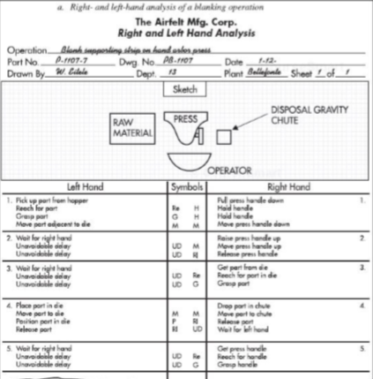
  - 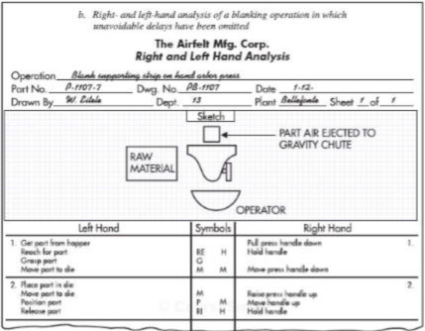

Working Conditions

Brief History of Government Regulations in the Workplace

Temperature and Humidity

Ventilation

Illumination

Noise and Vibrations
- 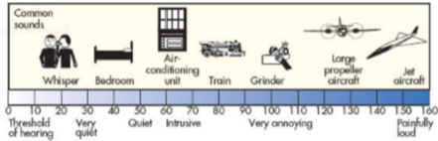

Work Breaks
- 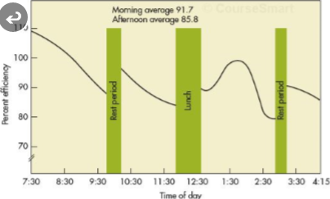

Safety

Ergonomics
- Vocabulary
  - Ergonomics
    - Fitting the job to the worker’s capability and size

Workers’ Well-Being and a Healthy Workplace

Work Measurement
- Vocabulary
  - Work measurement
    - Determine how long it should take to do a job
  - Standard time
    - The amount of time it should take a qualified worker to complete a specified task, working at a sustainable rate and using given methods, tools, equipment, raw materials, and workplace arrangement
- Most common methods to develop standard time

Stopwatch Study
- Vocabulary
  - Stopwatch study
    - Development of standard time based on observations of one worker taken over by a number of cycles
- Basic steps in a stopwatch time study
  - Define the job to be studied and inform the worker who will be studied
  - Determine the number of cycles to observe
  - Time the job and rate the worker’s performance
  - Calculate the standard time, allowing for rest periods
- Determining number of cycles
  - The sample size needed to achieve the goal can be determined using
    - $n={\left(\frac{zs}{a\overline{x}}\right)}^{2}$
  - Alternative formula used when the desired amount of accuracy is stated as an amount (i.e.: within one minute of the true mean) instead of a proportion
    - $n= {\left(\frac{zs}{e}\right)}^{2}$
    - $where e is accuracy amount or maximum acceptable error amount$
  - $Where$
    - Z is the number of normal standard deviations needed for desired confidence
    - s is the sample standard deviation
    - a is maximum acceptable error proportion ( = percentage / 100)
    - Xbar is the sample mean
    - N is the number of observations (sample size)
  - Typical values
    - 90% confidence, z is 1.65
    - 95% confidence, z is 1.96
    - 95.5% confidence, z is 2.00
    - 98% confidence, z is 2.33
    - 99% confidence, z is 2.58
- Example: Determine sample size
  - Yield a mean of 6.4 minutes with a standard deviation of 2.1 minutes and a confidence level of 95%
  - How many observations will she need if the maximum acceptable error is
    - $± 10\% of sample mean$
      - $Given$
        - s = 2.1 minutes
        - xbar = 6.4 minutes
        - z = 1.96
        - a = 0.10
      - Input
        - $n={\left(\frac{zs}{a\overline{x}}\right)}^{2}$
        - $n={\left(\frac{1.96*2.}{0.1*1.96}\right)}^{2}$
        - $n=41.26$
      - Therefore, sample size is 42
    - 0.5 minutes
      - Given
        - E = 0.5
        - s = 2.1 minutes
        - z = 1.96
      - Input
        - $n= {\left(\frac{zs}{e}\right)}^{2}$
        - $n= {\left(\frac{1.96*2.1}{0.5}\right)}^{2}$
        - $N=67.77$
      - Therefore, sample size is 68

Observed Time
- The observed time is simple the average of the recorded time
  - $OT=\frac{\sum{x_{i} }}{n}$
  - Where
    - OT is observed time
    - $\sum{x_{i} } is the um of the recorded times$
    - N is the number of observations
  - Note
    - If a task does not occur during each cycle, its average time should be determined separately

