Process Design, Facility Layout
Contents
Introduction and Process Types 1
Definitions 1
Process Design 1
Make or Buy 1
Classify Processes in 4 Categories 1
Job Shop 1
Batch Process 2
Repetitive/Assembly line 2
Continuous 2
Automation 4
Fixed Automation 4
Programmable Automatoin 4
Flexible Automation 5
Process Design 6
Methodology 6
Example 5 8
Service Process Fail-Safeing 9
Customer Perception in Service Process Design 9
Types of Layout 10
Product Line Layout 10
Process (Function) Layout 10
Cellular Layout 11
Warehouse Layout 12
Retail Layout 12
Office Layout 12
Layout Design Steps 12

Introduction and Process Types

Definitions

Process Design
- Determining the form and function of how goods and services will be produced

Make or Buy
- Decide whether to make or buy a part
- Often a strategic decision
- Fctors
  - Existing/desired core capabilities
  - Available capacity
  - Quality
  - Whether demand is steady or temporary
  - Secrecy of technology
  - Costs

Classify Processes in 4 Categories
- Depends on
  - Variety of products
  - Flexibility of products

Job Shop
- Definition
  - Process type used when a low quantity of high-variety customized goods or services is needed
- Characteristics
  - Process is intermittent
    - Work shifts from one small job to the next; each slightly different requirements
  - Highly flexible machines
  - Skilled workers
- Example
  - Tool and die shop which makes one-of-a-kind tool and die
- Managerial Challenge
  - Scheduling jobs so due dates are met
  - Resources are used as much as possible

Batch Process
- Definition
  - A type of process used when a moderate volume and variety of a goods or service is desired
- Characteristics
  - Equipment is not as flexible as job shop
  - Workers are not as skilled as job shops
  - Intermittent process
- Example
  - Bakeries bake/sell cookies in batches
- Managerial Challenge
  - Scheduling batches in order to meet planned production and demand while utilizing the resources at a high level

Repetitive/Assembly line
- Definition
  - A type of process used when higher quantities of more standardized good or services are needed
    - Production line
      - A sequence of machines/workstations that perform operations on a part/product
    - Assembly line
      - A production line where parts are added to a product sequentially
- Characteristics
  - Low level of skilled workers
  - Slight flexibility in equipment
  - Lines can be either
    - Machine paced (same speed)
    - Human paced (variable speed)
- Example
  - Automobiles
- Managerial Challenges
  - Capacity balance
  - Technology management
  - Quality
  - Materials management

Continuous
- Definition
  - Used when a high volume of highly standardized output it required
- Characteristics
  - No variety in output
  - No need for flexible equipment
  - Low skill wokers
  - Product is unable to be counted
- Example
  - Sugar
- Managerial Considerations
  - Same as assembly line
    - Capacity balance
    - Technology management
    - Quality
    - Materials management
  - But because of faster production speed
    - Greater care required for automated control of flow
    - Start/stop production is challenging

 | Job Shop | Batch | Repetitive | Continuous
Product variety | Customized | SEMI-Standard | Standardized | Highly Standardized
Volume | Low | Low-Moderate | High | Very High
Equipment  Flexibility | Very High | Moderate | Low | Very Low

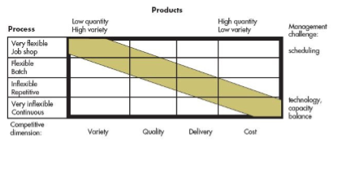
- ABOVE MATRIX DEPICTS: Ideal to have the production process capabilities, i.e equipment, to match the requirements (i.e. product variety)
- Consider
  - Products often go through lifecycles, requiring a switch in production process
- Hybrid Process
  - Process with elements of other process types embedded in them, i.e.:
    - Job shop may evolve to repetitive; having part of the process run as a job shop while the other acts in a repetitive fashion
- Focused factories
  - Handle both high quantity and high variety;
- Choice of operation process
  - Nature
  - Shape
  - Size
  - Quantity
  - Variety
  - Other materials

Automation
- Definition
  - Using machinery and equipment with sensing andcontrolling devices that enable it to operate automatically
- Disadvantages
  - Costly
  - Less flexible
  - Adverse effect on productivity (morale)

Fixed Automation
- Most rigid
- Perfected by Ford Motor Company
- Characteristics
  - High cost, specialty
- Advantages
  - Low unit cost
  - High volume
- Limitations
  - Minimal variety
  - High cost of making maor changes

Programmable Automatoin
- Characteristics
  - High cost, general purpose equipment controlled via a computer program which provides
    - Sequence of ops
    - Details of each ops
  - As easy to change process as it is easy to change software
  - Type of automation has capability of economically providing a fairly wide variety of low volume products (i.e.: batch)
- Numerically controlled machines
  - Machine whih perform ops by following mathematical processing instructions
  - Best used whenL
    - Parts are processed in frequent, small batch
    - Parts geometry are complex
    - Close tolerance is required
    - Mistakes are costly
    - The possibility of making changes is high
  - Disadvantages
    - Higher cost
- Robot
  - Machine consisting of a mechanical arm, a power supply, and a controller
  - Advantage
    - Can handle a variety of tasks
    - Level low robots
      - Low: follows fixed instruction
      - Programmable
      - High: can recognie objects, make simple decisions
    - Robots can be powered
      - Via aire (pneumatically)
      - Via water (hydraulically)
      - Via electricity

Flexible Automation
- Uses equipmenttt thhhat is more customized than programmable
- Key difference
  - Flexible automation requires less change, thereby being almost continuous and batch
- Machine center
  - Machine capable for performing a variety of ops
- Flexible manufacturing system (FMS)
  - A group of machine centers controlled by a computer with automatic material handling and robots or other automated equipment
  - Advantages
    - Offers reduced labour costs
    - More consistent quality
    - Lower capital investment
    - Higher flexibility
    - Relatively quick change over
  - Limitations
    - Systems can handle relatively narrow range of part variety
    - Must be used for family/similar parts
    - Longer planning and development times of increased complexity and cost
  - Suitability depends on
    - Variety
    - Quantity
- Computer Integrated Manufacturing
  - A system for linking a broad range of manufacturing, other activities through computer systems
  - Able to
    - Orders
    - Schedules
    - Purchasing
    - Control inventory
    - Shop controls
    - Distribution in manufacturing

Process Design
- Determine
  - Form and untion of how production of g/s is to occur
- Involves
  - Identifying activities and their sequences, resources, controls directly needed in production

Methodology
- Define production process;
  - Determine how complete inputs should be; these are make or buy decisions
  - Set production process objectives
    - Capacity, flexibility
    - Type of process
      - Job shop
      - Assembly
      - Repetitive
      - Continuous
    - Technology and extent of automation, production start date
  - Determine the nature of the process
- Production Process Development
  - Conceptualize the Design
    - Answers:
      - How do you get from input to output
      - What is the sequence of major operations?
        - Develop a few alternative concepts
          - Incremental
            - Do one step at a time
          - Hierarchal (top down)
            - Divided into 2 operations, then divided into subsystems
        - Usually follow a process flow design to show process and materials going through
        - Evaluate each alternative
  - Make an embodiment of the design
    - Choose one process concept and comlete the design
    - Build a prototype process and test,
      - Determine resources needed
      - Estimate cost, quality
    - Refine process, re-evaluate
  - Create a detailed design
    - Finalize the process specifications
      - Determine the specific machine
      - Design plant layout
      - Design the work centers
- Buy machines, recruit workers and start trail runs

- Process flow diagram
  - Shows the operations and movement of materials through ops
  - 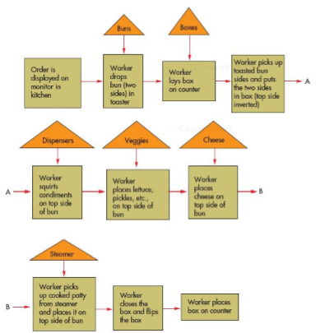
  - Triangle
    - Storage
  - Rectangle
    - Operation

Example 5
- Recipe
  - Mix flour, yeast, salt
  - Knead the dough
  - Shape the dough
  - Bake in over
  - Let rise in pan
  - Bake in over
  - Let bread cool
- Machine
  - Mixes, knreads
  - Automatically shapes,
  - Drops in pan
  - Bakes
  - Sliced and bagged
- Process flow diagram
  - 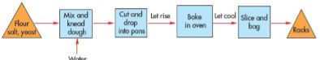

Service Process Fail-Safeing
- Services are vulnerable to quality and delivery problems
  - Usually during delivery, when difficult to fix problems before customer notices
- Company’s must identify points of failure
- Example
  - 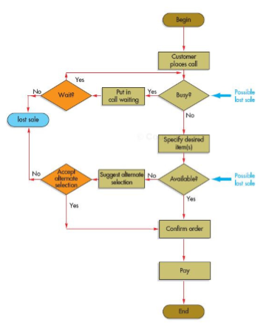

Customer Perception in Service Process Design
- Don’t raise customers expectations too high in the beginning
- End the service positively
- If pleasurable, divide into segments
- If painful, keep as one trip
- Let customer control part of the process
- Communicate the evidence to customers

Types of Layout
- Layout refers to the location of
  - Departments
  - Work centers
  - Equipment in facility
- Common reasons for redesign
  - Inefficient operations (excessive handling)
  - Change in design of product
  - Change in quantity mix of output
  - Change of methods, equipment

Product Line Layout
- Arranges production resources linearly according to the progressive steps by which a product is made
- Since one, very few items, involved, it is possible to arrange entire layout to correspond to production requirements of a product
- Certain compromises may be made
  - Automatic car wash dispenses same amout regardless of level of dirt
- Efficiency
  - Product layouts achieve high degree of labour and equipment utilization (tends to offset cost)
- Preventive maintenance
  - Periodic inspections and replacement of worn parts or those with high failure ates
  - Reduce probability of breakdowns during ops
- Advantages
  - Low cost production
  - Simplified accounting
  - Purchasing
  - Inventory controls
- Disadvantages
  - Equipment cost
  - Dull, repetitive jobs
  - Repetitive stress injuries
  - Inflexible response to change in quantity of output or in a product mix

Process (Function) Layout
- Definition
  - Arranges production resources together according to similarity of function
    - Intermittent process
      - Discontinuus work flow
- Batch require movement of batch quantity may require equipment like forklift
- Use of general purpose equipment
  - Provides the flexibility necessary to handle a wide range of production range of production sequence
  - Often has skilled workers
- Advantages
  - System is much less vulnerable to shutdown caused by mechanical failure
  - Idle equipment usually available
  - Lower maintenance costs
  - Personnel become more skilled in specific area
  - Reduce necessary investment of spare parts
- Disadvantages
  - Routing, scheduling must be done continuously
  - Material handling is inefficient
  - Unit cost is generally higher
  - In process inventories can be sustained
  - Not uncommon to have equipment utilization under 50%

Cellular Layout
- Definition
  - Layout in which different machines areee arrrranged in a cell thhhat can process items that have similar processing equipment
    - Group technology
      - Grouping items together with similar design of manufacturing characteristics into part families
- Observe
  - Arranged to handle ops necessary for group (family) of similar arts
  - Thus, all parts flow through the same route with minor variations
  - Cell often in the shape “U”
    - Permitting teamwork via communication
    - Increasing flexibility because worker can work at 1 station and quickly another
- Benefits
  - Faster processing time
  - Increased capacity
  - Less material handling
  - Less work in process inventory
  - Reduced set up lines
- Design Characteristics
  - Size
  - Shape
  - Material
  - Features
  - Function
- Manufacturing characteristics
  - Type of service
  - Tolerance/precision
- Once items that are similar are collected
  - Form families
  - System developed to store, retrieve specific info on familis
  - Allows for a part to be manufactured for a family, alleviated the individual specification frustrations
- Disadvantages
  - Time consuming
  - Considerable amount of data
- Primary methods
  - Visual inspections
  - Examination of design
  - Production delay
  - Production flow sequence and routing analysis

Warehouse Layout
- Factors affecting warehouse
  - Cold storage
  - Size, frequency of order
    - High frequency placed near docks
    - Low frequency at front
  - Correlated items together
  - Consider cost, time of shipping while placing

Retail Layout
- Objective
  - Cost minimization
  - Product flow
  - Customer flow
  - Sales influencing

Office Layout
- Less need for paper works allows for open offices

Layout Design Steps
- Determine the location of receiving and shipping
- For product layout
  - Fit the process flow diagram onto a sketch of the factory floor; determine the approximate location of each part of the process
- For process layouts
  - Determine the expected work flow between each pair of department and place the two departments with the highest workflows closest toether
- Continue until all departments are located
- Keep special requirements of machine in mine (i.e.: heavy press needs strong foundation)
- Allow space for machines, in-feeds, out-feeds, workers and carts
- Keep rearranging the plan using feedback from workers until you find what works best
- On the factory floor, paint outlines of machines in-/out-feeds
- Walk through the normal sequence of activities
- Run the electricity through

