Reliability

- Learning Objectives
  - Describe the basic production process types
    - Job shop
    - Batch
    - Repetitive
    - Continuous process
  - Discuss automated production technologies
    - Fixed automation: Most rigid; uses high cost, specialized equipment for a fixed sequence
    - Programmable automation: uses high cost, general purpose equipment controlled by a computer program that provides the sequence of operations and specified details about each operation
      - N/C (numerically controlled) machine
      - Robot
    - Flexible manufacturing: group of machine centres controlled by a computer, with automatic material handling and robots or other automated
  - Describe steps of production process design and learn to draw process flow diagrams
    - Define production process
      - Determine how completed the input materials should be
      - Set production process objectives: capacity, type of process, cost, tech
      - Determine the nature of process in general
    - Production development
      - Conceptualize the design
        - Develop a few alternative process concepts (incremental/hierarchial)
        - Usually a process flow diagram
        - Evaluate alternative process concept
      - Make an embodiment of the design
        - Choose one process concept and complete the design
        - Build a prototype (Determine resources, estimate costs)
        - Refine process and re-evaluate
      - Create a detailed design
        - Finalize the process specidication
          - Determine specific machines, equipment (capacities and make) and labout
          - Design the plant layout
          - Design the work centres
    - Buy the machine and equipment, recruit workers and start trial runs
  - Describe the basic plant/facility layout types
    - Product layout: arranges production resources linearly accourding to the progressive steps by which a product in made
    - Process (functional) layout
      - Process layout: arranges production resources together according to similarity function
      - Cellular layout: layout in which different machines are arranged in a cell that can process items that have similar processing requirements
      - Warehouse layout
      - Retail layout
      - Office layout
  - Solve simple assembly line balancing problems
    - Cycle time: max time allowed at each workstation to complete its set of tasks on a unit
      - CT = Operating time per day/Desired output per day
    - Number of workstations
      - N = Sum of task times / Cycle times
    - Precendence network: diagram that shows the tasks and their precedence requirements
      - Assign the tasks with
        - Longest time
        - Most followers
    - Procedure
      - Identify the cucle time and determine the maximum number of workstations
      - Make assignments to workstations in order, beginning with workstation
        - Tasks are assigned to moving from left to right through the precedence etwork
        - Start each workstation with time left – cyce time
      - Before each assignment use the following criteria to determine which tasks are eligible and will fit
        - All its preceding task in the network have been assigned
        - The task timedoes not exceed the time left at the workstation
      - Assign tasks andbreak ties using one of the heuristic rules
        - Assign the task with the longest time
        - Assign the task with the most followers
      - After each task assignment, update the time left on the workstation by subtracting the time of assigned task from time left
      - Continue until al tasks how have been assigned to workstationc and calculate total idle time
  - Develop simple process (functional) layouts
    - Minimize total transportation costs or distances
    - Heuristic
    - Closeness rating
      - Use same equipment
      - Share same personnel
      - Sequence of work flow
      - Ease of communication
      - Unsafe or unpleasant conditions
      - Similar work performed

- Reliability
  - The ability of a product, part, or system to perform its intended function under a prescribed set of conditions
- Failure
  - Situation in which a product, part, or system does not perform as intended
- Normal Operating
  - The set of conditions under which an item’s reliability is specified

Strategic Importance of Reliability
- Failure has a far reaching effect on a firm;
  - Operation
  - Reputation
  - Profitability
  - Dissatisfied customers
  - Idle employees
  - Profits becoming losses
  - Reduced value of investment in plant and equipment

Elements of Reliability
- Improvement of individual components
- Providing Redundancy

Improving Reliability
- Component design
- Production/assembly techniques
- Testing
- Redundancy/backup
- Preventive maintenance procedures
- User education
- System design

Quantifying Reliability
- Reliability is probability that the product or system will:
  - Function when activated -- instantaneous reliability
  - Function for a given length of time – continuous reliability
- Independent Events
  - Vents whose occurrence or non-occurence do not influence each other
- Redundacy
  - The use of backup components to increase reliability

Rules of Reliability
- If two or more events are independent and the success is defined as the probability that all of the events occur, than the probability of success is equal to the product of the probabilities of the events occurring
  - i.e. : Ps = P1 * P2 * P3 … *PN
  - Example
    - There are two lamps that require the other to work for it to work.
      - The probability of lamp 1 working, p = 0.90
      - The probability of lamp 2 working, p = 0.80
    - The probability of both lamps working
      - P = 0.9*0.8 = 0.72 OR 72%
      - 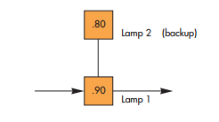
  - Redundancy
    - The use of backup components to increase reliability
- If two events are independent and success is defined as the probability that at least one of the events will occur, the probability of success is equal to the probability of either one plus (1 – probability is none of the events occurs
  - i.e.: 1 – (1-P1) (1-P2) (1-P3) , simplifying:
    - Ps = P1 + (1-P1)(P2) + (1-P2)(P3) ….
  - Example
    - There are two lamps in a room. When on,
      - Lamp 1 probability: 0.9
      - Lamp 2 probability: 0.8
    - Only one lamp is needed for success,
    - Probability of success
      - Ps = 1 – (1-0.9)(1-0.8) = 0.98
    - Conceptually, think of as a backup; if one fails, the other is turned on
    - 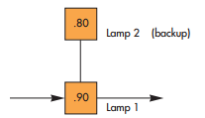
- If three events are involvement, and success is defined as the probability that at least one of the events will occur,
  - The probability of success is equal to the probability of one of the events (any of the events),
      - Plus the product of (1 – that probability)
      - Plus the probability of the second event (any of the remaining events) ,
      - Plus the product of (1 – the first probability) and (1 – second probability) and the probability of the first event
        - Probability of success = P1 + s
  - Example
    - Three lights have probabilitys of 0.9, 0.8, 0.7 of lighting when turned on. Only one lighted lamp is needed for success.
      - Ps = 1 – (1-0.9)(1-0.8)(1-0.7) = 0.994
    - Conceptually, we can think of this system as a backup with a backup
    - The probability of success, Ps, is the probability that the first lamp operates + if the first fails, that the second will turn on, and then if that fails, a third
      - #1 operates + [#1 fails][#2 operates] – [#2 fails][#3 operates]
    - 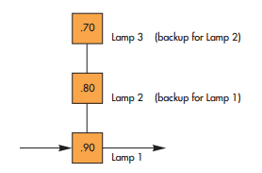

Example S!:
- Determine the reliability of the system shown below
  - Made up of three components
    - Component 1, no backup = 0.98
      - P = .98
    - Component 2, 1 backup = 0.90 + 0.9(1-0.9) = 0.99
      - P1 = 0.9
      - Pb = 0.9
    - Component 3, 1 backup 0.95+0.92(1-0.95) = 0.996
      - P1 = 0.95
      - Pb = 0.92
  - Reliability
    - 0.98 * 0.99 * 0.996 = 0.966
  - 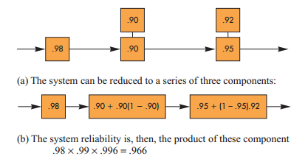

Finding Probability of Functioning for a Given Length of Time
- Reliability considering a use factor, usually time dimension:
  - Probabilities are determined relative to a specified length of time
    - i.e.: Product warranties
- In this case,
  - Failure rate per hour
    - Defined as the number of failures divided by total operating hours
- Example S-2
  - Two hundred units of a particular compent were subject to accelerated life testing equivalent to 2,500 hours of normal use.
  - One unit failed after 1,000 hours an another after 2,000 hours
  - All other units were still working at the conclusion of the test
    - Failure rate per hour
      - 2/[200-2(2,500)+1,000+2,000] = 0.000004016
  - Note: formula assumes constant failure over time
- Time-quantity transposition is applicable (i.e.: one can reduce the test time for a proportionate increase to amount of items) if failure rate is constant, i.e.:
  - Instead of 200 items for 2,5000 hours
  - 400 items for 1,250 hours
- Typical profile of failure over time
  - Bathtub curve
    - A number of products fail shortly after they are released to the market.
    - Second phase is after quirks have been worked out, failures bottom out
    - Third phase involves parts breaking due to wear over time
    - 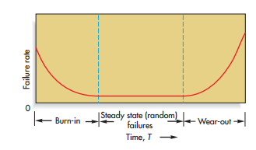
  - Mean time to failure (MTTF)
    - The average length of itme before failure of a product
  - Mean time between failures (MTBF)
    - The average time from the up time after the repair following a failure to the next failure
  - 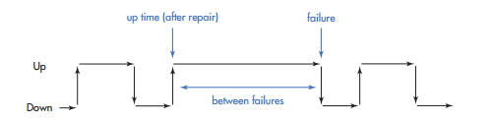

Probability that Failure Will Not Occur before t, exponential
- Reliability of the item is the probability that it will last at least until time T; therefore,
  - Reliability is equal to the area under the curve beyond t
- Observe,
  - The specified length of service increases the area under the curve to the right of that point
- Mean Time to Failure/Between Failure
  - Exponential distribution
  - Using t to represent length of service
  - The reliability or probability that failure will not occur before T
    - Reliaility = P(no failure before T) = 1 – e^{-t/MTTF}
    - 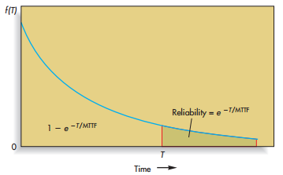

Example S-3
- Particular vacuum cleaner has an expected life expenctency that is exponsential with a mean of 4 year and an insignificant burn-in phase
  - Find the probability that one of these vacuum cleaners will have a life that ends
    - After the initial 4 years
    - Before 4 years
    - Not before 6 years
  - After initial 4 years; t = 4
    - T/MTTF = 4 years/4 years = 1.00
    - From table, e⁻¹ = 0.3679
  - The probability of failure before 4 years; P_{1-4t}
    - 1 – t(4)
    - 1 – 0.3679 = 0.6321
  - Not before 6, t = 6
    - T/MTTF = 6 years / 4 years = 1.50
    - From table, e^{-1.50} = 0.2231

Item Failure Due to Wear Out, Normal Distribution
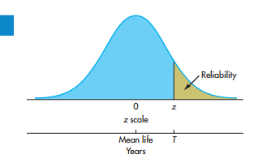
- Involves standard normal table
  - The table provides the areas under a normal curve up to a specified point, z
    - Where z is a standardized value calclulated via
    - $z=\frac{T-Mean wearout Time}{Standard Deviation of Wearout Time}$
    - The area is the probability that service life will not exceed some value T
    - To find the reliability
      - Subtract probability by 1
    - To obtain the result of T
      - Work in reverse
        - Locate nearest probability,
        - Pick up the associated z value
        - Insert the z value in the above formula
        - Solve for t

Example S-4
- The mean life of a certain ball bearing can be modelled using a normal distribution with a mean of 6 years and a standard deiation of 1 year, determine
  - The probability that a ball bearing will fail before 7 years of service
  - The probability that a ball bearing will fail after 7 years of service (find its reliability)
  - The service life that will provide a failure probability of 10%
    - Wear-out mean : 6 years
    - Wearout Standard deviation: 1 year
    - Wear-out is normally distributed
- The probability that a ball bearing will fail before 7 years of service
  - Calculate z using the above formula
    - $z=\frac{T-Mean wearout Time}{Standard Deviation of Wearout Time}$
    - Z = (7 – 6)/1 = 1/1
    - P(T<T) = P(z<1) = 0.8413
    - 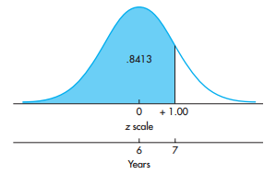
- The probability that a ball bearing will fail after 7 years
  - 1 – (before 7 years)
  - 1 – 0.8413
  - 0.1587
  - 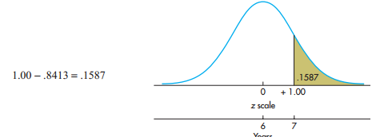
- That service life will provide a failure rate of 10%
  - $z=\frac{T-Mean wearout Time}{Standard Deviation of Wearout Time}$
  - $where 0.1 is z=1.28$
  - $1.28=\frac{t-6}{1}$
  - T = 4.72
  - 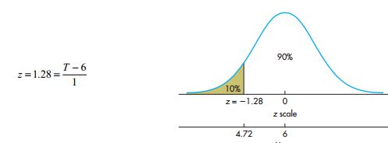

Weilbull Distribution
- Weilbull is identical to the exponential distribution
- If k>1 failure rate increases overtime
- Because of flexibility
  - Weilbull distribution is commonly used to model the time to failure during the burn-in (k<1) and wear out (k>1) phases

Availiability
- Availability
  - The faction of time a piece of equipment or a repairable product is expect to be available for operation
- Mean time to repair
  - The average length of time to repair a failed item
- Availability
  - $\frac{MTBF}{MTBF+MTTR}$
  - Where
    - MTBF
      - Mean time between failures
    - MTTR
      - Mean time to repair

Example S-5
- A copier is expected t operate for 200 hours after repair and the mean repair time is expected to be 2 hours
  - MTBF : 200 H
  - MTTD: 2
- $\frac{MTBF}{MTBF+MTTR}$
  - 200/(200+2)
  - 0.99

Note (availability):
- To increase availability
  - Increase MTBF
  - Decrease MTTR
- i.e.: easier to replace cartridges

