Language processing and the brain – October 10th 2014

Mako believes that neural basis of word processing needs more research. She said she thinks what happens is they worked on words but then as soon as they could they moved onto sentences and now they are starting to move back to words.

First we have to understand that conceptual knowledge does not equal word knowledge.

Lexical decision task – when we ask people to name items with words. How they react depends on properties of words (how complex they are) and properties of tasks.

-Mako is going to add in some extra slides on line about experiments-

You should know how to identify frontal, temporal and occipital lobe.
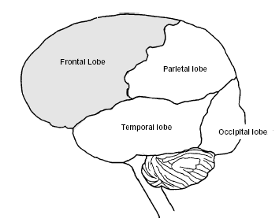

In the experiment on slide 34 – different parts of the brain were being activated when people saw pictures of animals vs. pictures of tools. The language area was activated when they saw tools but not when they saw animals.

Task effects on neural response
-Semantic task would be when the researchers show people a picture or name an animal and say is this animal in danger or no?
-Action task would be they are given a tool and told what action it can do. An example is hammer pound
-What they found was there was action in the left frontal lobe for both

Dorsal Ventral Hypothesis

The hypothesis that was made popular by David Milner and Melvyn A. Goodale in 1992, argues that humans possess two distinct visual systems. As visual information exits the occipital lobe, it follows two main pathways, or "streams". The ventral stream (also known as the "what pathway") travels to the temporal lobe and is involved with object identification and recognition. The dorsal stream (or, "where pathway") terminates in the parietal lobe and is involved with processing the object's spatial location relevant to the viewer.

Chapter 3 Review
1-words have parts
2-words meanings may be represented as a set of associated symbols; those representations may be supplemented by embodied knowledge (perceptual symbols)
3-lexical access is harder than it seems
-Models differ with respect to the targets of perception
4-lexical knowledge and access processes call on distributes networks of neurons.

Sentence Processing

Lexical ambiguity - two or more possible meanings within a single word.
Example – bank
Within lexical ambiguity you access both meanings but you just ignore one in your brain because you know it doesn’t make sense. It gets inhibited.

Parsing (or syntactic analysis) is the process of analyzing a string of words according to the rules of their formal grammar.

Garden Path Theory
An example of garden path theory is the sentence we learned about “the horse raced passed the barn as it fell”
Garden path theory – we only build one tree at a time and then if it doesn’t work we start over. 30% of people at makos meetings support this. Mako supports this.

Constrained satisfaction model – we build many trees and see which one is the best. Computing all the possibilities at the same time. 70% of linguistics at makes meeting support this.

Global Ambiguity – you get to the end of the sentence and still don’t understand.
Local Ambiguity – you don’t understand until you read one word and then it makes sense.

