Ch. 1
Strategic competitiveness: achieved when a firm successfully formulates and implements a value-creating strategy
Strategy: an integrated and coordinated set of commitments and actions designed to exploit core competencies and gain a competitive advantage
Strategic Management Process: the full set of commitment, decisions, and actions required for a firm to achieve strategic competitiveness and earn above-average returns.
Hypercompetition: the realities of the competitive land-scape. Under conditions of hypercompetition, assumptions of market stability are replaced by notions of inherent instability and change. Hypercompetition results from the dynamics of strategic maneuvering among global and innovative combatants.

Perpetual innovation: describe how rapidly and consistently new, information-intensive technologies replace older ones. The shorter product life cycles resulting from these rapid diffusions of new technologies place a competitive premium on being able to quickly introduce new, innovative goods and services into the marketplace

Disruptive technologies—technologies that destroy the value of an existing technology and create new markets

Strategic flexibility: a set of capabilities used to respond to various demands and opportunities existing in a dynamic and uncertain competitive environment.

I/O Model of Above-Average Returns:
- Four assumptions:
- External environment is assumed to impose pressures and constraints that determine the strategies that would result in above-average returns.
- Most firms competing within an industry or within a segment of that industry are assumed to control similar strategically relevant resources and to pursue similar strategies in light of those resources.
- Resources used to implement strategies are assumed to be highly mobile across firms, so any resource differences that might develop between firms will be short-lived.
- Organizational decision makers are assumed to be rational and committed to acting in the firm’s best interests, as shown by their profit-maximizing behaviors

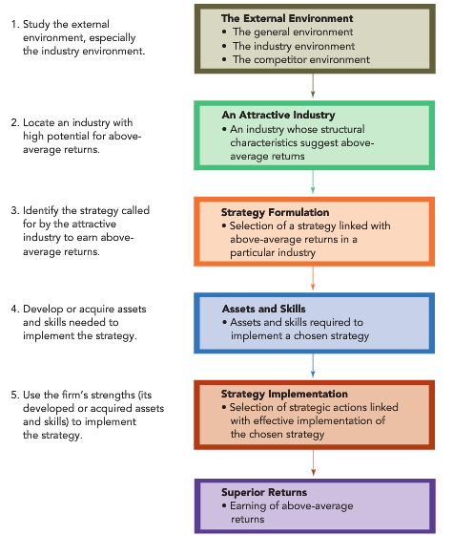

The Resource-Based Model of Above-Average Returns:
- Assumes that each organization is a collection of unique resources and capabilities. The uniqueness of its resources and capabilities is the basis of a firm’s strategy and its ability to earn above-average returns
- Resources are inputs into a firm’s production process, such as capital equipment, the skills of individual employees, patents, finances, and talented managers. In general, a firm’s resources are classified into three categories: physical, human, and organizational capital.
- A capability is the capacity for a set of resources to perform a task or an activity in an integrative manner.
- Core competencies are resources and capabilities that serve as a source of competitive advantage for a firm over its rivals.

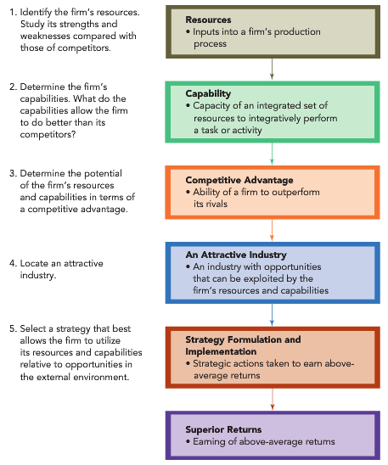

Vision: a picture of what the firm wants to be and, in broad terms, what it wants to ultimately achieve

Mission: specifies the business or businesses in which the firm intends to compete and the customers it intends to serve

Stakeholders are the individuals, groups, and organizations who can affect the firm’s vision and mission, are affected by the strategic outcomes achieved, and have enforceable claims on the firm’s performance

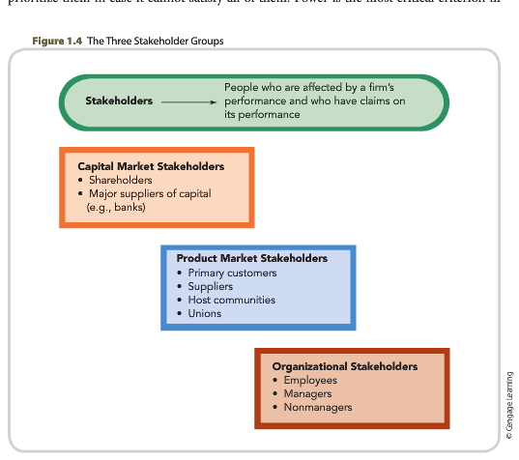

Strategic leaders are people located in different areas and levels of the firm using the strategic management process to select strategic actions that help the firm achieve its vision and fulfill its mission.

Organizational Culture: the complex set of ideologies, symbols, and core values that are shared throughout the firm and that influence how the firm conducts business.

Strategic Management Process: A-S-P (Analyze, Strategies, Performance)

Ch. 2

General Environment is composed of dimensions in the broader society that influence an industry and the firms within it.
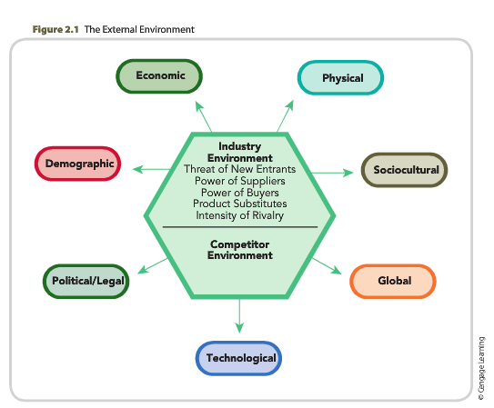

Industry Environment: is the set of factors that directly influences a firm and its competitive actions and responses: the threat of new entrants, the power of suppliers, the power of buyers, the threat of product substitutes, and the intensity of rivalry among competing firms.

How companies gather and interpret information about their competitors is called competitor analysis.

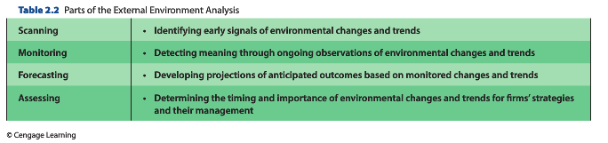

- Demographic segment is concerned with a population’s size, age structure, geographic distribution, ethnic mix, and income distribution
- Economic Environment refers to the nature and direction of the economy in which a firm competes or may compete
- Political/legal segment is the arena in which organizations and interest groups compete for attention, resources, and a voice in overseeing the body of laws and regulations guiding interactions among nations as well as between firms and various local governmental agencies.

- Sociocultural segment is concerned with a society’s attitudes and cultural values. Because attitudes and values form the cornerstone of a society, they often drive demographic, economic, political/legal, and technological conditions and changes

- Technological segment includes the institutions and activities involved in creating new knowledge and translating that knowledge into new outputs, products, processes, and materials.

- Physical Environment segment refers to potential and actual changes in the physical environment and business practices that are intended to positively respond to and deal with those changes.

- Global segment includes relevant new global markets, existing markets that are changing, important international political events, and critical cultural and institutional characteristics of global markets

- Globalfocusing often is used by firms with moderate levels of international operations who increase their internationalization by focusing on global niche markets.

Porter’s Five Forces:

1. Threat of New Entrants:
Barriers to entry: economies of scale, product differentiation, capital requirements, switching costs, access to distribution channels, cost disadvantages independent of scale, gov’t policy

2. Bargaining Power of Suppliers:
A supplier group is powerful when
It is dominated by a few large companies and is more concentrated than the industry to which it sells.
Satisfactory substitute products are not available to industry firms.
Industry firms are not a significant customer for the supplier group.
Suppliers’ goods are critical to buyers’ marketplace success.
The effectiveness of suppliers’ products has created high switching costs for industry firms.
It poses a credible threat to integrate forward into the buyers’ industry. Credibility is enhanced when suppliers have substantial resources and provide a highly differentiated product.

3. Bargaining Power of Buyers
Customers (buyer groups) are powerful when
They purchase a large portion of an industry’s total output.
The sales of the product being purchased account for a significant portion of the seller’s annual revenues.
They could switch to another product at little, if any, cost.
The industry’s products are undifferentiated or standardized, and the buyers pose a credible threat if they were to integrate backward into the sellers’ industry.

4. Threat of Substitutes
Product substitutes present a strong threat to a firm when customers face few if any switching costs and when the substitute product’s price is lower or its quality and performance capabilities are equal to or greater than those of the competing product. Differentiating a product along dimensions that are valuable to customers (such as quality, service after the sale, and location) reduces a substitute’s attractiveness.

5. Intensity of Rivalry
High when:
- Numerous or Equally Balanced Competitors
- Slow industry growth
- High fixed costs of storage costs
- Lack of differentiation or low switching costs
- High strategic stakes
- High exit barriers

Competitor Analysis:
The firm seeks to understand the following:
What drives the competitor, as shown by its future objectives
What the competitor is doing and can do, as revealed by its current strategy
What the competitor believes about the industry, as shown by its assumptions
 What the competitor’s capabilities are, as shown by its strengths and weaknesses.

Ch. 3

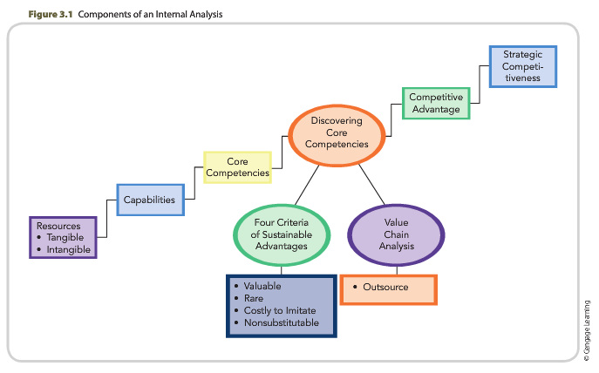

Value is measured by a product’s performance characteristics and by its attributes for which customers are willing to pay. Firms create value by innovatively bundling and leveraging their resources to form capabilities and core competencies.

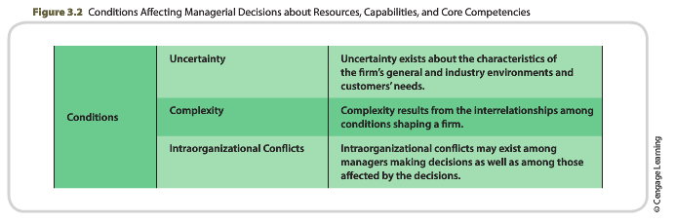

Resources, capabilities, and core competencies are the foundation of competitive advantage.

Tangible resources are assets that can be observed and quantified. Production equipment, manufacturing facilities, distribution centers, and formal reporting structures are examples of tangible resources.
Intangible resources are assets that are rooted deeply in the firm’s history and have accumulated over time. Because they are embedded in unique patterns of routines, intangible resources are difficult for
competitors to analyze and imitate.

Capabilities: used to complete the organizational tasks required to produce, distribute, and service the goods or services the firm provides to customers for the purpose of creating value for them. As a foundation for building core competencies and hopefully competitive advantages, capabilities are often based on developing, carrying, and exchanging information and knowledge through the firm’s human capital.

- Core competencies are capabilities that serve as a source of competitive advantage for a firm over its rivals.

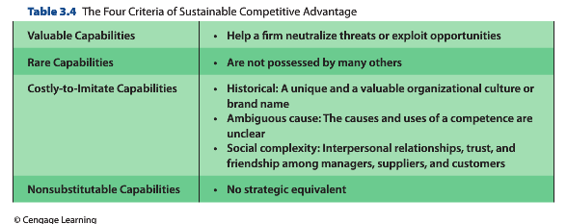

Value chain analysis allows the firm to understand the parts of its operations that create value and those that do not.
- Value Chain activities are activities or tasks the firm completes in order to produce products and then sell, distribute, and service those products in ways that create value for customers.
- Support functions include the activities or tasks the firm completes in order to support the work being done to produce, sell, distribute, and service the products the firm is producing

Ch. 4

Business-level Strategy is an integrated and coordinated set of commitments and actions the firm uses to gain a competitive advantage by exploiting core competencies in specific product markets.

Reach, Richness, and Affliation with customers:
- Reach: the firm’s access and connection to customers
- Richness: the depth and detail of the two-way flow of information between the firm and the customer
- Affiliation: facilitating useful interactions with customers

- Determine who to serve (Who)

- Determining what customer needs to satisfy (What)

- Determining Core Competencies Necessary to Satisy Customer Needs (How)

The purpose of a business-level strategy is to create differences between the firm’s position and those of its competitors. To position itself differently from competitors, a firm must decide whether it intends to perform activities differently or to perform different activities.

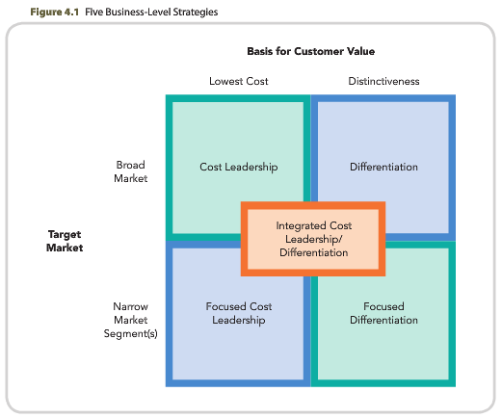

- Cost leadership strategy is an integrated set of actions taken to produce goods or services with features that are acceptable to customers at the lowest cost, relative to those of competitors
- Risks: a loss of competitive advantage to newer technologies, a failure to detect changes in customers’ needs, and the ability of competitors to imitate the cost leader’s competitive advantage through their own distinct strategic actions.

- Differentiation Strategy is an integrated set of actions taken to produce goods or services (at an acceptable cost) that customers perceive as being different in ways that are important to them.
- Risks: a customer group’s decision that the unique features provided in by the differentiated product over the cost leader’s goods or services are no longer worth a premium price, the inability of a differentiated product to create the type of value for which customers are willing to pay a premium price, the ability of competitors to provide customers with products that have similar features, but at a lower cost, and the threat of counterfeiting.

- Focus Strategy is an integrated set of actions taken to produce goods or services that serve the needs of a particular competitive segment
- Risks: a competitor’s ability to use its core competencies to “outfocus” the focuser by serving an even more narrowly defined market segment, decisions by industry-wide competitors to focus on a customer group’s specialized needs, and a reduction in differences of the needs between customers in a narrow market segment and the industry-wide market.

- Integrated cost leadership/differentiation strategy, firms engage in primary value chain activities and support functions that allow them to simultaneously pursue low cost and differentiation

Total quality management (TQM) is a managerial process that emphasizes an organization’s
commitment to the customer and to continuous improvement of all processes through
problem-solving approaches based on empowerment of employees.
- Firms develop and use TQM systems to (1) increase customer satisfaction, (2) cut costs, and (3) reduce the amount of time required to introduce innovative products to the marketplace.

Ch. 5

Competitive rivalry is the ongoing set of competitive actions and competitive responses that occur among firms as they maneuver for an advantageous market position.

Competitive behavior is the set of competitive actions and responses a given firm takes to build or defend its competitive advantages and to improve its market position.

Multimarket competition: occurs when firms compete against each other in several product or geographic markets.

Competitive dynamics refer to all competitive behaviorsthat is, the total set of actions and responses taken by all firms competing within a market.

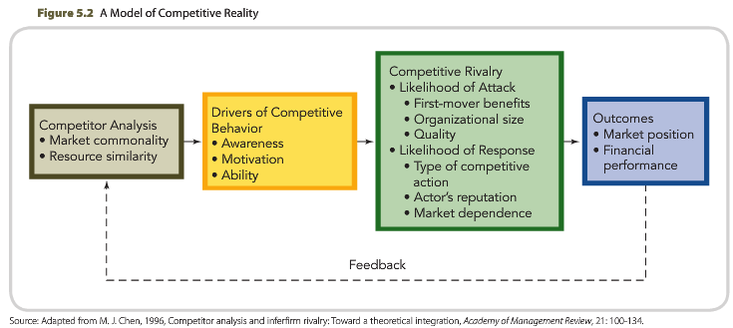

- Market commonality is concerned with the number of markets with which the firm and a competitor are jointly involved and the degree of importance of the individual markets to each.
- Resource similarity is the extent to which the firm's tangible and intangible resources are comparable to a competitor's in terms of both type and amount.

- Awareness refers to the extent to which competitors recognize the degree of their mutual interdependence that results from market commonality and resource similarity
- Motivation, which concerns the firm’s incentive to take action or to respond to a competitor’s attack, relates to perceived gains and losses
- Ability relates to each firm’s resources and the flexibility they provide.

A competitive action is a strategic or tactical action the firm takes to build or defend its competitive advantages or improve its market position.

A competitive response is a strategic or tactical action the firm takes to counter the effects of a competitor’s competitive action. A strategic action or a strategic response is a market-based move that involves a significant commitment of organizational resources and is difficult to implement and reverse. A tactical action or a tactical response is a market-based move that is taken to fine-tune a strategy; it involves fewer resources and is relatively easy to implement and reverse.

Slow-cycle markets are markets in which the firm's competitive advantages are shielded from imitation, commonly for long periods of time, and where imitation is costly.

Standard-cycle markets are markets in which the firm's competitive advantages are partially shielded from imitation and imitation is moderately costly.

Fast-cycle markets are markets in which the firm's capabilities that contribute to competitive advantages aren't shielded from imitation and where imitation is often rapid and inexpensive.

Ch. 6

A corporate-level strategy specifies actions a firm takes to gain a competitive advantage by selecting and managing a group of different businesses competing in different product markets.

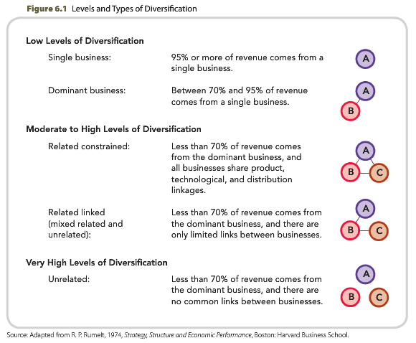

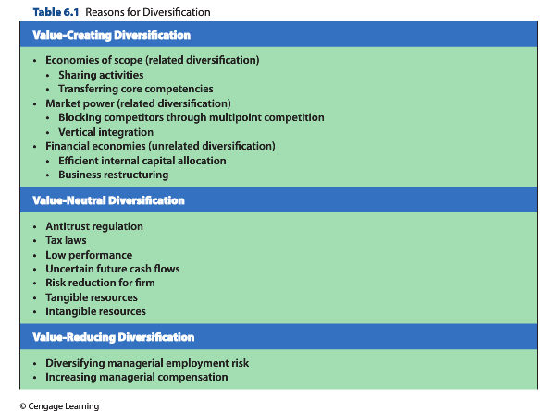

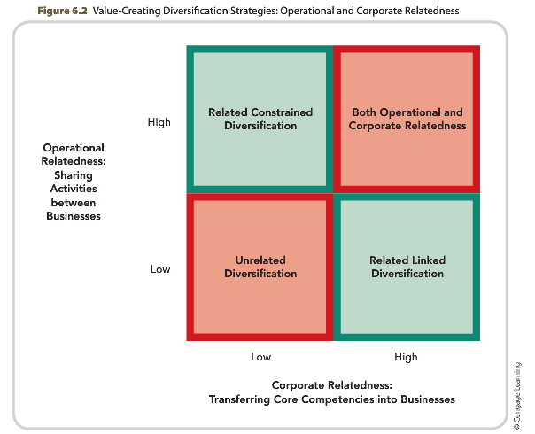

Economies of scope are cost savings that the firm creates by successfully sharing some of its resources and capabilities or transferring one or more corporate-level core competencies that were developed in one of its businesses to another of its businesses.

Corporate-level core competencies are complex sets of resources and capabilities that link different businesses, primarily through managerial and technological knowledge, experience, and expertise.

Market power exists when a firm is able to sell its products above the existing competitive level or to reduce the costs of its primary and support activities below the competitive level, or both.

Multipoint competition exists when two or more diversified firms simultaneously compete in the same product areas or geographical markets

Vertical Integration exists when a company produces its own inputs (backward integration) or owns its own source of output distribution (forward integration).

Financial economies are cost savings realized through improved allocations of financial resources based on investments inside or outside the firm

Ch. 7

A merger is a strategy through which two firms agree to integrate their operations on a relatively coequal basis

An acquisition is a strategy through which one firm buys a controlling, or 100 percent, interest in another firm with the intent of making the acquired firm a subsidiary business within its portfolio.

A takeover is a special type of acquisition wherein the target firm does not solicit the acquiring firm's bid; thus, takeovers are unfriendly acquisitions.

Reasons for Acquisition:
- Increased market power
- Overcoming entry barriers
- Cost of New Product Development and Increased Speed to Market
- Lower Risk Compared to Developing New Products
- Increased diversification
- Reshaping the Firm’s Competitive Scope
- Learning and Developing New Capabilities

Problems in achieving Acquisition success:
- Integration difficulties
- Inadequate evaluation of target
- Large debt
- Inability to achieve synergy
- Too much diversification
- Managers overly focused on acquisitions
- Too large

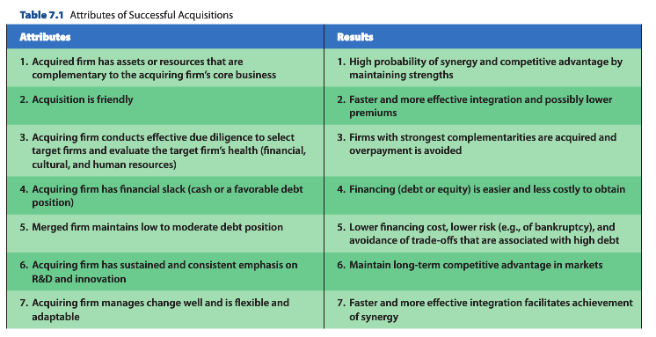

Restructuring is a strategy through which a firm changes its set of businesses or its financial structure.

Three types of Restructuring strategies:

1. Downsizing: a reduction in the number of a firm’s employees and, sometimes, in the number of its operating units, but it may or may not change the composition of businesses in
the company’s portfolio.

2. Downscoping: divestiture, spin-off, or some other means of eliminating businesses that are unrelated to a firm’s core businesses.

3. Leveraged buyout: a party (typically a private equity firm) buys all of a firm’s assets in order to take the firm private.

Chapter 8
global strategy | A global strategyis an international strategy in which a firm's home office determines the strategies business units are to use in each country or region.
greenfield venture | A greenfield ventureis an entry mode through which a firm invests directly in another country or market by establishing a new wholly owned subsidiary.
international diversification strategy | An international diversification strategyis a strategy through which a firm expands the sales of its goods or services across the borders of global regions and countries into a potentially large number of geographic locations or markets.
international strategy | An international strategyis a strategy through which the firm sells its goods or services outside its domestic market.
multidomestic strategy | is an international strategy in which strategic and operating decisions are decentralized to the strategic business units in individual countries or regions for the purpose of allowing each unit the opportunity to tailor products to the local market.
transnational strategy | is an international strategy through which the firm seeks to achieve both global efficiency and local responsiveness.

Chapter 9
business-level cooperative strategy | A business-level cooperative strategyis a strategy through which firms combine some of their resources and capabilities for the purpose of creating a competitive advantage by competing in one or more product markets.
Complementary strategic alliances | Complementary strategic alliancesare business-level alliances in which firms share some of their resources and capabilities in complementary ways for the purpose of creating a competitive advantage.
cooperative strategy | is a means by which firms collaborate for the purpose of working together to achieve a shared objective.
corporate-level cooperative strategy | A corporate-level cooperative strategyis a strategy through which a firm collaborates with one or more companies for the purpose of expanding its operations.
cross-border strategic alliance | is a strategy in which firms with headquarters in different countries decide to combine some of their resources and capabilities for the purpose of creating a competitive advantage.
diversifying strategic alliance | A diversifying strategic allianceis a strategy in which firms share some of their resources and capabilities to engage in product and/or geographic diversification.
equity strategic alliance | An equity strategic allianceis an alliance in which two or more firms own different percentages of the company they have formed by combining some of their resources and capabilities for the purpose of creating a competitive advantage.
Franchising | Franchisingis a strategy in which a firm (the franchisor) uses a franchise as a contractual relationship to describe and control the sharing of its resources and capabilities with its partners (the franchisees).
joint venture | A joint ventureis a strategic alliance in which two or more firms create a legally independent company to share some of their resources and capabilities for the purpose of developing a competitive advantage.
network cooperative strategy | A network cooperative strategyis a strategy wherein several firms agree to form multiple partnerships for the purpose of achieving shared objectives.
nonequity strategic alliance | A nonequity strategic allianceis an alliance in which two or more firms develop a contractual relationship to share some of their resources and capabilities for the purpose of creating a competitive advantage.
strategic alliance | A strategic allianceis a cooperative strategy in which firms combine some of their resources and capabilities for the purpose of creating a competitive advantage.
synergistic strategic alliance | A synergistic strategic allianceis a strategy in which firms share some of their resources and capabilities to create economies of scope.

