Introduction
As an engineer it’s important to pay attention to units, because forgetting to make one simple conversion may endanger multiple people. This danger became a reality to the passengers on an Air Canada flight in 1983 that was forced to make a dangerous emergency landing because it ran out of fuel. It was later discovered that a miss calculation due to a unit conversion was the cause. In this report you will see the results to three separate problems. The first part of this lab is dedicated to making multiple unit conversions in order to discover which one of three pumps is the most efficient. Part 2 of this lab is to calculate the surface area of 3 parts so that data can be used to calculate the cost of the surface coating that will be applied to the parts, while also calculating the volume of each figure. Finally, part 3 was to create an image in your textbook² using IntelliCAD.

Materials and Methods
Using the values found in part 1 (II – Problem Statement¹) in “Laboratory 2¹ – Units, Dimensions & Significant Figures” and the equation 𝜂= (𝑄Δ𝑃) / (input power) calculation where made to convert all the units into S.I units, followed by calculations to find the efficiency of 3 different pumps (Appendix, pg. 3). Also, using the precise dimensions given for figures 1, 2, and 3 in part 2 (II – Problem Statement¹), by dividing each figure into multiple sections the total surface area and volume of each component was calculated (Appendix, pg. 5-7). Finally, to familiarize oneself with IntelliCAD operations, the instructions offered in chapter 15 of the textbook¹ were used to create Figure 15.25 in the textbook².

Results
Results are summarized in Table 1 (Part 1), Table 2 (Part 2) and Figure 4 (Part 3), Appendix.

Discussion
In part 1, it is clear that pump 1 is more efficient than pump 2 and 3, however the difference between pump 1 and 2 is marginal (between 4-9% difference) followed by a large decrease of efficiency for pump 3 (around 30.5% difference). The efficiency of each pump was only easily discovered once every factor was taking into account and every unit was converted into SI units. In part 2, the total surface area of the parts is crucial to being able to predict the cost of the coating, and although the volume seems useless it could be very useful to determine the amount of material needed to fabricate each part, and therefore the cost of each part. Once the calculations where made it became clear that a total of 923.7508 cm² of coating would be needed to fully cover all the parts.

Conclusions
In conclusion, pump 1 is the most efficient pump. The total amount of surface area for figures 1, 2, 3 is 923.7508 cm² and the combined volume is 601.8073 cm³. Also, the figure 15.25 found in the textbook² was successfully recreated (appendix, page 8 of the report).

¹ McCrae, G. (2014). Laboratory 2 – Units, Dimensions & Significant Figures. Ottawa : Carleton University
² Hayes, J.B., Brassard, D., Aziz, T. (2009). Introduction to Engineering Seventh Edition. Upper Saddle River : Prentice Hall

APPENDIces- Figures and Tables
Part 1
Calculations :

Pump 1
Input Power = 16 HP = 16 HP * 0.7457 kW/HP = 11.9312 kW = 11 931.2 W
Δ𝑃 = 33 IBF/In² = 33 PSI x 6.894757 kPa/PSI = 227.526981 kPa = 227 526.981 Pa
Q = 2.165 m³/min = (2.165 m³/min) / (60 s/min.) = 0.03608333 m³/s
𝜂 = (0.03608333 m³/s * 227 526.981 Pa) / 11 931.2 W
= 0.68810606974
= 69% (2 sig. figures in 33 IBF/In² and 16 HP)

Pump 2
Input Power = 265 kW = 265 000 W
Δ𝑃 = 913 mm of Hg - 760 mm of Hg = 153 mm of Hg = 153 mm of Hg * 0.1333 kPa/mm of Hg = 20.3949 kPa = 20 394.9 Pa
V_{n} = 11 811 in/min
A = 1 m * 1 m
Q = V_{n}A = ((11 811 in * 2.54 cm/in) / (1 min * 60 s/min)) * (1 m * 1 m) = 4.99999 m³/s
𝜂 = (4.99999 m³/s * 20 394.9 Pa) / 265 000 W
= 0.384808664
= 38.5% (3 sig. figures in 153 mm of Hg)

Pump 3
Input Power = 29 065 Btu/hr = (29 065 Btu * 1.055056 kJ) / (1 hr * 60 min/hr * 60 sec/min) = 8.518111844 kJ/s = 0.0085181 W
Δ𝑃 = 2 atm – 16 psi = (2 atm * 101.325 kPa/atm) – (16 PSI * 6.894757 kPa/PSI) = 92.333888 kPa = 0.092333888 Pa
Q = 55 061 US gal/hr = (55 061 US gal * 0.0037854 m³/US gal) / (1 hr * 60 min/hr * 60 sec/min) = 0.057896641 m³/s
𝜂 = (0.057896641 m³/s * 0.092333888 Pa) / 0.0085181 W
= 0.627575668
= 6 * 10¹ % (1 sig. figure in 2 atm)

Part 2
Figures 1, 2 and 3

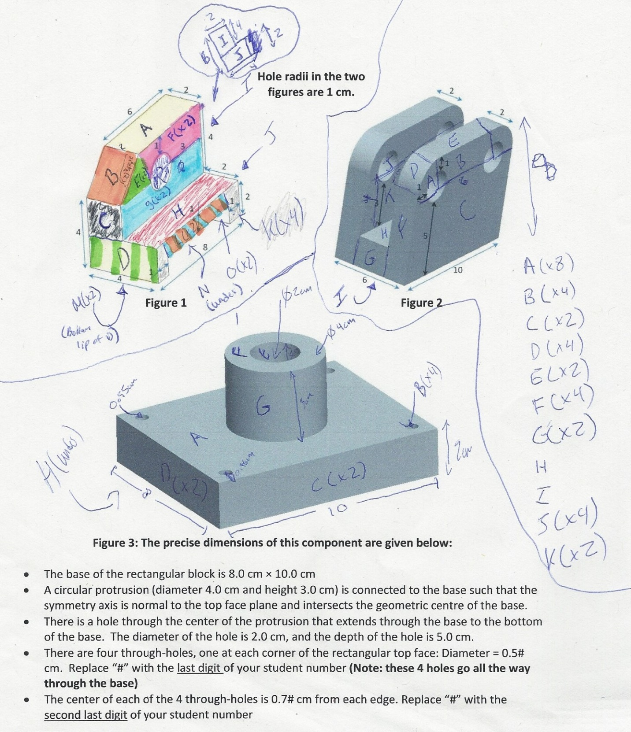

*Note:
Here you can see into what part the figure was divided into during my calculations. If a part was multiplied it means there where x (x being the number multiplied by) many of identical sides on the figure. There are many different ways to separate the figure, the way it’s done is not important as long as you don’t forget any areas.
Calculations :

Figure 1:

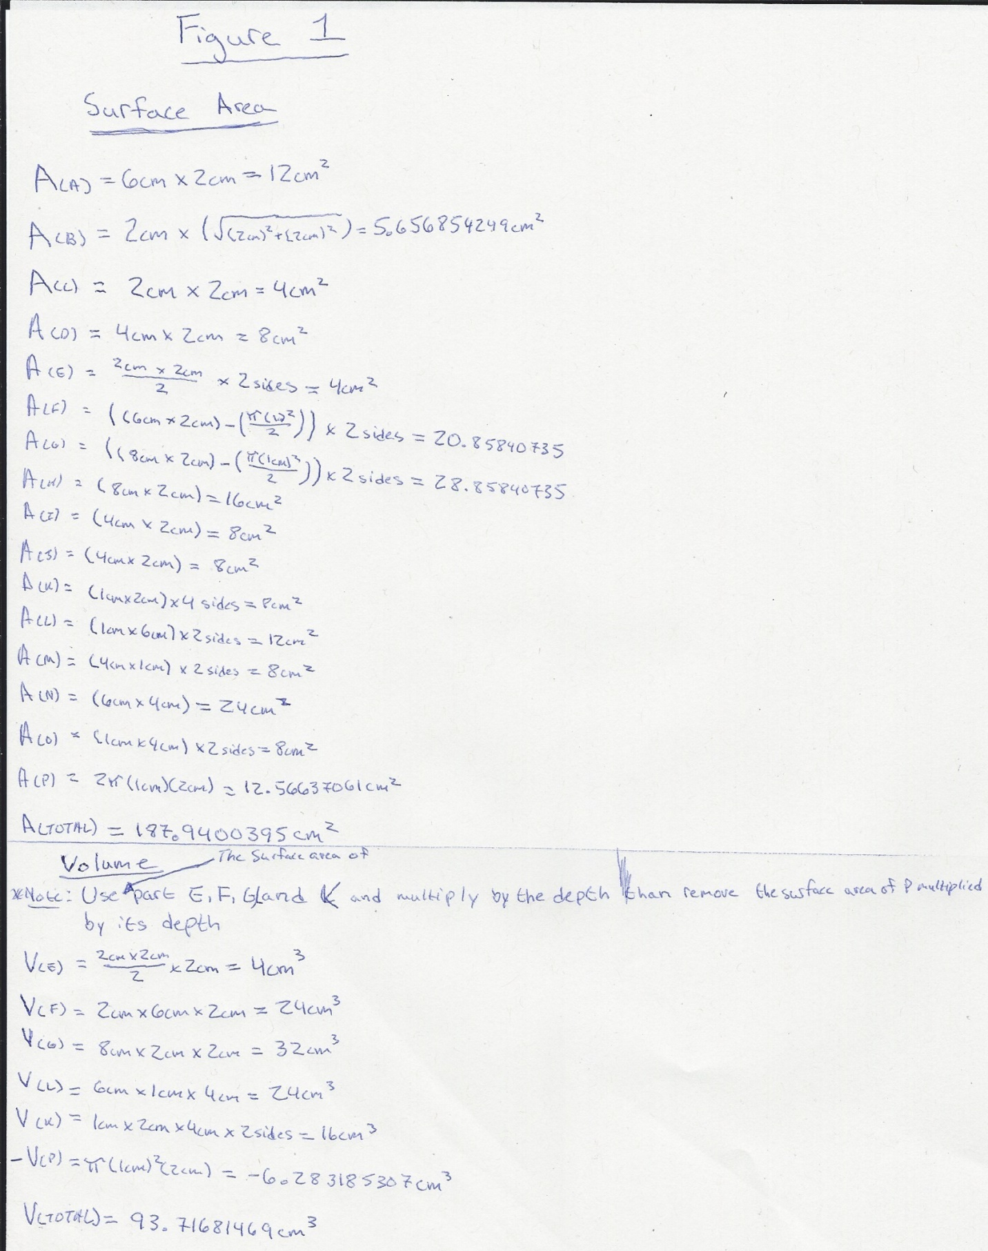
Figure 2:
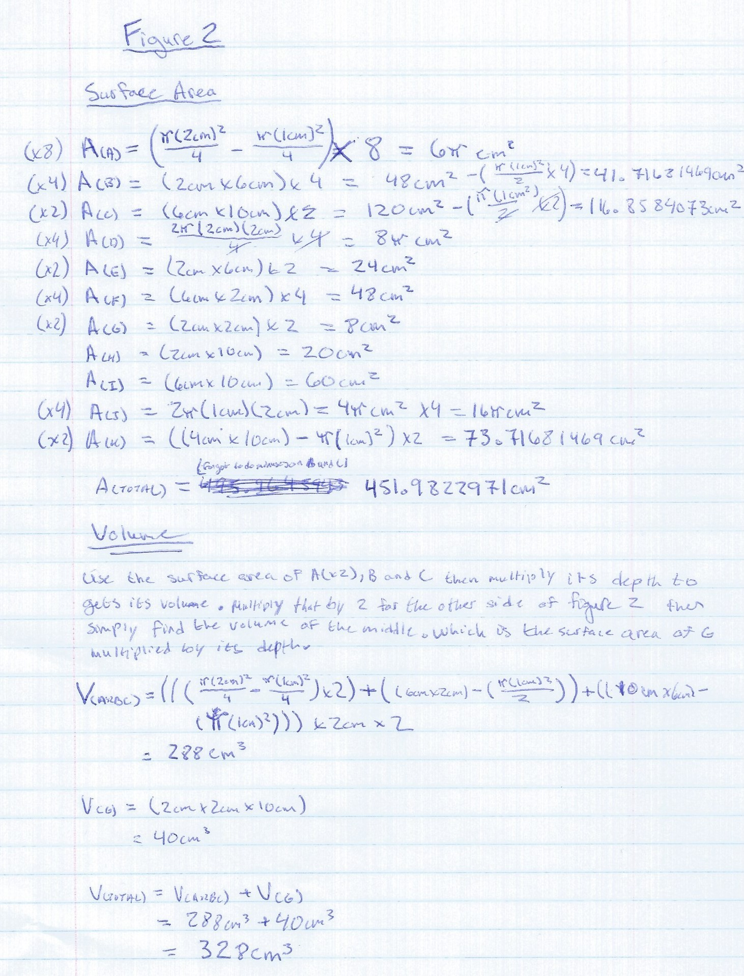

Figure 3:
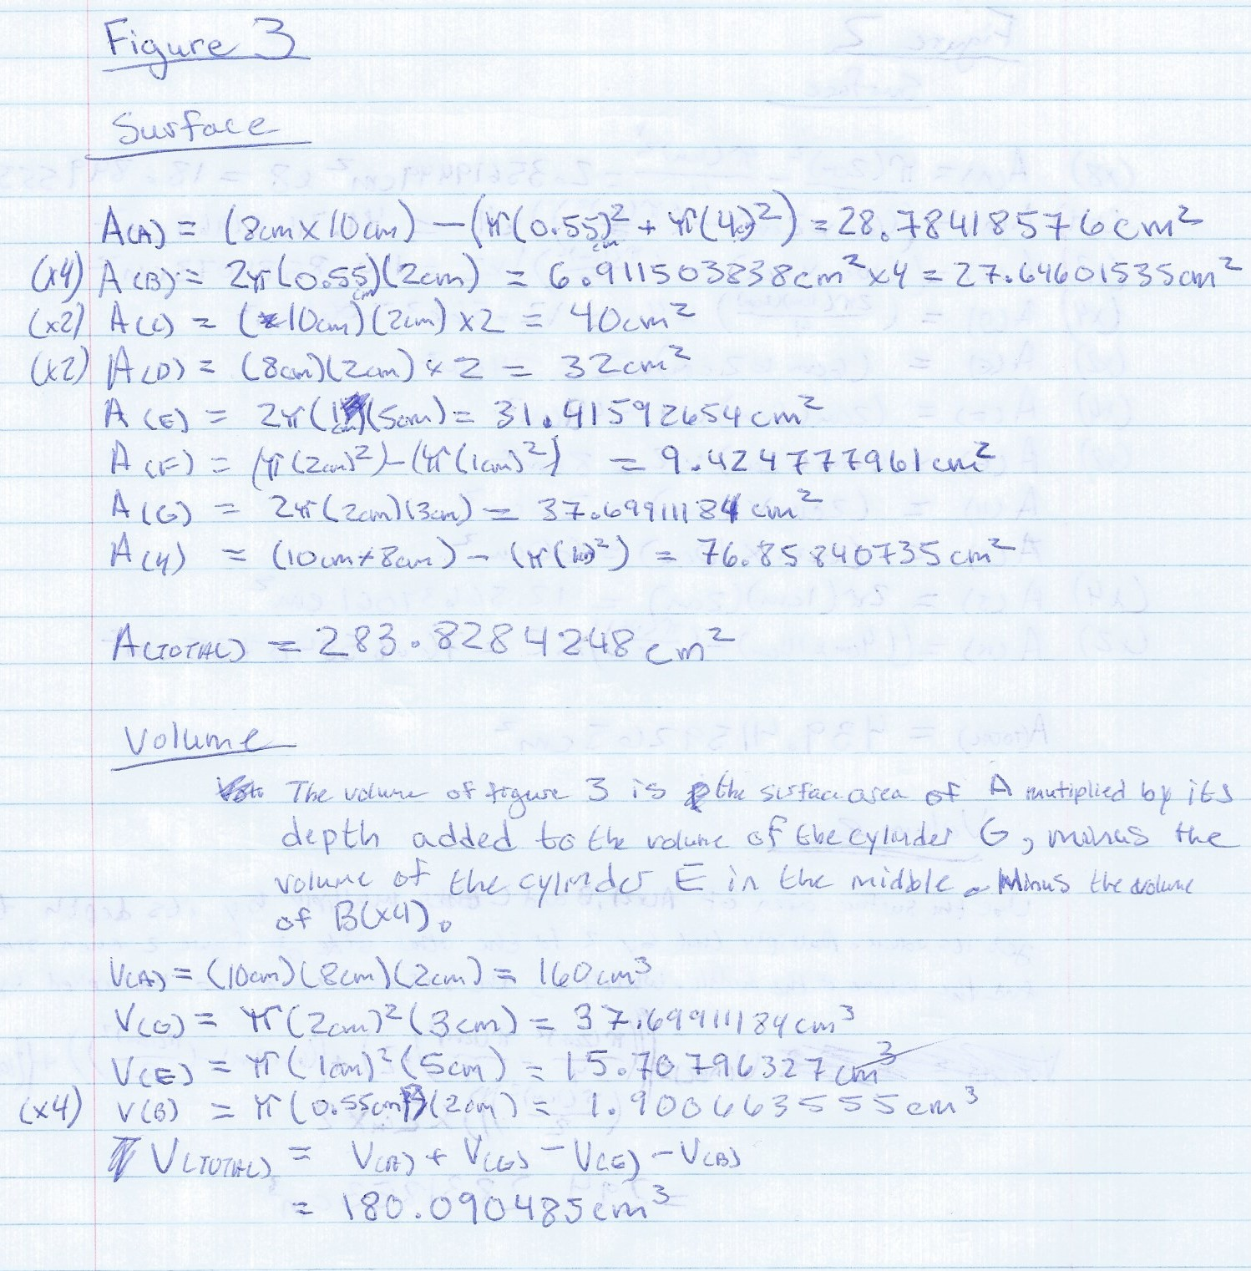

Part 3

Figure 4 : Results for part 3
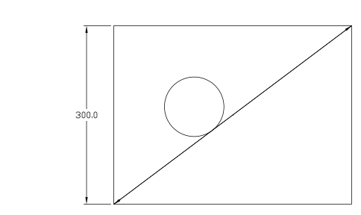

Table 1 : Efficiency of the pumps
Rank | Pump | Efficiency (%)
1 | Pump 1 | 69
2 | Pump 3 | 6 * 10¹
3 | Pump 2 | 38.5

Table 2 : Surface air of the figures
Figure | Surface Area | Volume
Figure 1 | 187.9400 cm^{˛2} | 93.7168 cm³
Figure 2 | 451.9823 cm² | 328.0000 cm³
Figure 3 | 283.8284 cm² | 180.0905 cm³
 | 923.7508 cm² | 601.8073 cm³

