Midterm is on Lectures 1 -9 and TSE 1-4
LECTURE 2
What is engineering?
- Problem solving & critical thinking (applied analysis)
- Design (Synthesis)
- Professionalism (formal organization)

Definition of an Engineer
A person who uses science, mathematics, experience, and judgement to create, operate, manage…Does this in a rational and economic way with human, societal, and natural resources and environmental constraints.

Role of engineers
- Engineering is a team activity
  - Engineering teams involve individuals with widely different abilities, interests and education who cooperate to advance the project.
  - A typical technical team might consist of
    - Engineers
    - Scientists
    - Technologists
    - Technicians
    - Social workers
    - Skilled workers
Engineer
- Provides the key link between theory and practical applications
  - Has theoretical knowledge
  - Thinks creatively
  - Leads a team towards a common goal (motivation)
  - Knack for obtaining practical skills
- Education
  - Basic requirement is a bachelor's degree
  - Master's or PhD is useful and sometimes preferred

Professional Engineer
In Canada, the title "professional engineer" is restricted by law.
- Only people that can be called "professional engineer" if they have:
  - Demonstrated competence
  - Been licensed by a provincial professional engineering association (PEO in Ontario)

Canadian Engineering Accreditation Board (CEAB)
- Provincial/territorial associations rely on CEAB to evaluate and accredit engineering programs in Canada
- CEAB conducts rigorous and regular reviews of engineering programs across Canada
- They publish a list of accredited programs in Canada
Why Conform to CEAB?
If you want to be a professional engineer, one of the principal requirements is to graduate from a CEAB accredited program.
CEAB requirements?
Practical Experience (4 Years)
Professional Practice Examination
Character attested to by references
***No longer required to be a Canadian Citizen or Permanent Resident***

Technologist
- Works under the direction of an engineers
  - They apply engineering principles and methods to complex technical problems
- Required Education:
  - 3 Year technology program from community college
- Often supervises work of others and is encouraged to have qualifications recognized by technical society.
- Engineer Vs Technologist
  - Engineering education typically provides greater theoretical depth
  - The technology diploma is more hands-on experience

Skilled Worker
- Skilled in a trade like electrician, welder, plumber, carpenter, machinist, etc
  - Typically carries out the designs and plans of others
- Has great expertise acquired thru apprenticeship or years of experience in the trade
- Most trades have a trade organization and certification procedure

Technician
- Works under the supervision of an engineer or technologist in the practical aspects of engineering
  - Ex. Of Work: Making tests and maintaining equipment.
- Education
  - Completion of two year technician program in a community college
- Association may confer to the title of Certified Engineer Technician
  - Although, Certification is not necessary to work as a technician

Open-Ended Problems
Most Engineering Problems are open-ended
- Meaning they don't have a single solution
Also just because there isn't just one answer, doesn't mean the problem is easier to solve
- What skills are needed to solve open-ended problems?
  - Broad base of engineering knowledge
  - Critical thinking
  - Innovation
  - Perseverance

Engineering Skills
- How to represent a design problem
- How to make assumptions
- How to generate ideas for designs
- How to conduct effective research to solve a problem
- How to plan and schedule activities
- How to make efficient use of resources
- How to organize components and activities of a team design project (Teamwork)

Ingenuity
- Engineers can find clever ways to solve problems
- Innovation
- Critical thinking
- Problem solving

Canadian Engineering Accomplishments
- Transcontinental Railway - links coast to coast
- De Havilland Beaver 1947 - Water landing plane
- Very High Voltage Transmission - Transmission lines at very long distances with very high voltage
- St Lawrence Seaway - Connects Ocean and great lakes
- Nuclear Power - CANDU Reactor
- Athabasca Oil Sands - Recovering Oil from the Oilsands
- Winnipeg Floodway - Diverts flood water around city
- Alouette Satellite - 3rd Satilite in space
- CanadaARM
- Trans Canada phone Network
- Pacemaker
- Confederation Bridge
- CN Tower
- IMAX

LECTURE 3
Measurements
- Physical quantity that can be observed
  - Measurement compared to a standard quantity
- A measurement consists of two parts
  - A numerical magnitude
  - A name, symbol, or combination of symbols that define the reference standard

Base and Derived Units
- Derived in terms of base units
  - Ex. 1 Newton = 1 Kilogram x 1 Metre / Second squared
- Base Units
  - Are fundamental units from which all other units are derived from

Systeme International d'Unites (SI Units)
- Adopted by almost all countries
  - Notably the United States is an exception
- Metric system introduced as measurement system "for all people, for all time"

7 Base Units in SI
- Metre for length
- Kilogram for mass
- Second for time
- Ampere for electric current
- Kelvin for temperature
- Candela for liminous intensity
- Mol for the amount of a substance

Absolute and Gravitational Unit Systems
SI Unit system
- Absolute System
  - Mass is a fundamental unit
  - Newton's second law (force=mass x acceleration) is invoked to derive force due to gravity
FPS unit system
- Gravitational system
  - Force is a fundamental unit
  - Mass is derived from Newton's second law.
  - Distance, force and time are all fundamental dimensions, measured in units of feet, seconds and pounds.

Forces and Gravity
- The application of gravity in Newton's Second Law (F=ma) presents several problems.
- It's treated differently in each system of units
- SI: 1N=1kg x 1m/s^2
- American: 1lbf doesn’t not equal 1lbm x 1ft/sec^2
- For American system you have to re-write Newton's 2nd law: F=ma/gravitational constant gc=32.17

Read Chapter 10 for Lecture 3

Lecture 4 - Measurements, Units and Errors
SI Magnitude Prefixes
A Unit may be proceded by a magnitude prefix:
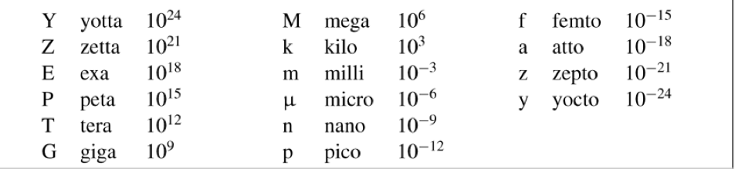

Writing Quantities With Units
- Standardized rules for correctly representing quantities with units:
Number or Formula (italic typed)proceded by a half or full space then SI unit symbols ( Roman typed)

Rules for writing with Units
- Always put a space between numeric value and unit
- Unit symbols are treated like algebraic factors that can be multiplied or divided with numbers or other unit symbols:
  - Multiplication between units is indicated by a centred dot or a half space
  - Division between units is indicated by a slash or a negative superscript
- Unit symbols are not modified with subscripts:
  - -Vmax=200v NOT V= 200 Vmax
- Relation between numerical quantity and unit symbols must be clear:
  - 3.7 km x 2.8 km for an area, NOT 3.7 km x 2.8
- Unit symbols not mixed with unit names in sentences:
  - Use kg/m^2 or kilogram per metre squared NOT kilogram/m^2
- Long numbers, written in groups of 3, the groups should be seperated by a non-breaking half space rather than a comma or period:
  - 930 000 000 miles NOT 930,000,000 miles
  - 21 298.046 83 miles NOT 21298.04683 miles

Fixed, Scientific and Engineering Notation
- Fixed Notation
  - Ordinary decimal notation
    - Ex. 30 140.0
- Scientific Notation
  - Ex. 3.014 x10^4
- Engineering Notation
  - Exponent of 10 is a multiple of 3 to correspond to SI prefixes
    - Ex. 30.14x10^3

Dimensions
- Dimensions differ slightly from units
  - Ex. Speed
    - Dimensions = distance/time
    - Units are known as km/hr, or mm/s, etc.
- Fundamental dimensions
  - Distance, time, mass, etc.

Measurement
Property of a physical object that can be represented using a real number
- Not like counting, measurement is not exact
Quantities are usually measured with an instrument
- Calipers, scale, measuring cup, etc.

Uncertainty
- Measuring instruments are not perfect

True Value - Measured Value = Measurement Error

Systematic Errors
- Constant deviation from the true value, is called a bias or offset.
- Error has the same measurement and sign when repeated measurements are made under the same conditions
- Systematic Errors can be detected by
  - Calibration
  - Comparison with results obtained with an independent method
Lecture 5
How do engineers Communicate?
- The 3 ways Engineers convey information:
  - Written Documents
  - Oral Presentations
  - Graphically
- Sometimes a combination of ways is used

Engineering Graphics
- The majority of engineering information is transmitted by graphical means
- But written and verbal communication is also important to engineering communication
Advantages of Graphical Communication
- Clear
- Concise
- Efficent
- Reduced Ambuiguity
Engineering Graphics
- Graphics is a universal language
- Engineering graphics are directed towards graphical problem solving
- A good engineering Graphic is worth a thousand words

Technical Illustration
- Technical Illustrations are used to describe products in cataloagues, user and maintenance manuals.
- Pictorial sketching is an important engineering communication tool
- Helpful to describe difficult to visualize components or assemblies
- How to put components together, NOT how to make them
- There common types of Technical Illustration:
  - Perspective
  - Oblique
  - Isometric

Oblique Projection
- Front face of the object is parallel to the viewer, therefore the face is true size
- The projection lines do not converge into a vanishing point
- 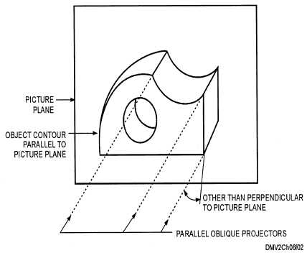
Isometric Projection
- Parallel lines remain parallel instead of converging to a vanishing point
- Axes are 120 degrees apart
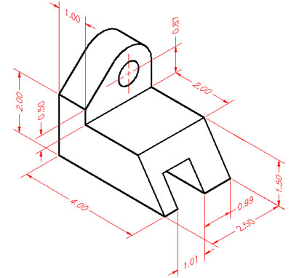

Orthographic Projection
- Most important graphical drawing method
- 2D representations of a 3D figure
- Extensively used in engineering
- Useful when technical information is needed
- Enable parts to be made
- Sometimes the isometric view is included into the Orthographic Projection
- Geometric backbone of a technical drawing

Third Angle Projection
- The object is placed in the third quadrant and then view from the first quadrant
- Projection planes are between the observer and the object
- Used in Canada, US and Britian
- Top view over the front view, then to the right of that is the right view
First Angle Projection
- The object is placed in the first quadrant and then viewed from the third quadrant
- The object is between the observer and projection planes
- Used in most of the world
- Right view, to the right of that is the Front view then below is Top view

Selection of views
- The most descriptive view is usually selected to be the front view
- The remaining views are selected to be the ones with the least hidden lines
- If a tie occurs, we use the conventional view (right and top)

Read Chapters 12-14

Lecture 6 - Engineering Graphics
Standard Drawing Layout
- Three-view orthographic projection
  - Top view located above the front view
  - Right view located to the right of the front view
  - The views must be aligned

Orthographic Projection - Lines
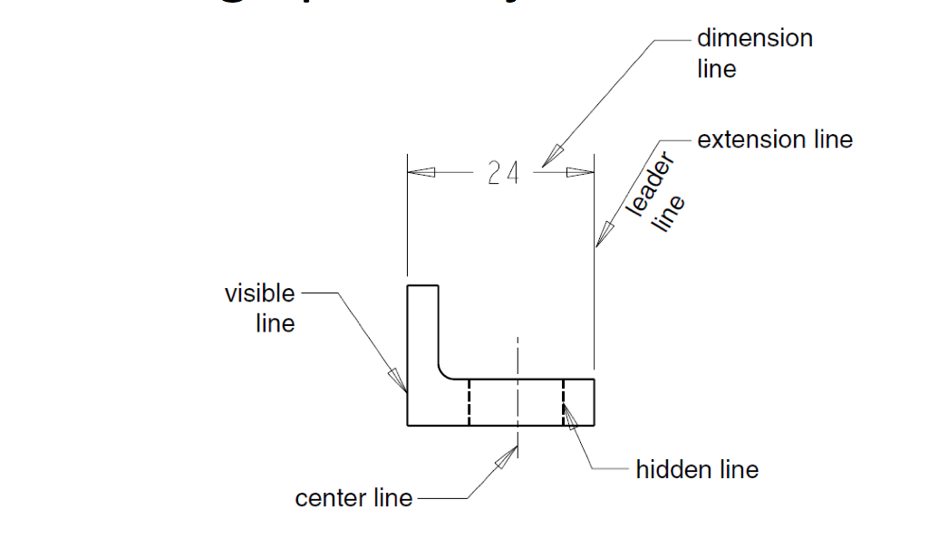

- When two or more lines concide, there is a convention called 'precedence of lines' to establish which is visible:
  - Visible Object Lines
  - Hidden Object Lines & Cutting plane lines
  - Centre Lines
  - Extension & Leader Lines

- Line Types:
  - Object Lines: indicate all visible edges of an object; must stand out and be apparent to the eye
  - Hidden Lines: shows object likes that are hidden from the view
  - Cutting Plane Lines: indicated edge view of an imaginary cutting plane (Section views)
  - Centre Lines: indicates centres of holes and symmetrical features of an object
- 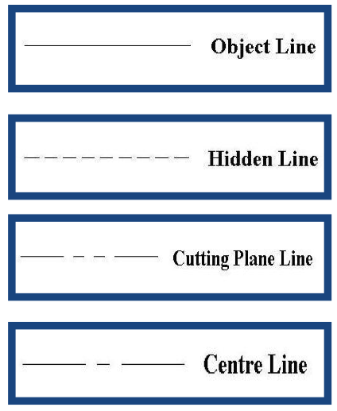

Dimensions
- Two fundamental rules for dimensioning:
  - Dimensions must be describe the complete geometry of the part
  - Redundant dimensions should be avoided
- More specific rules apply to the geometry, the placement and style of the dimension
  - Dimensions must be from visible lines, not hidden features
  - Repeated regular identical features may be dimensioned only once, along with a small note indicating quantity, etc.
  - The designer should be able to locate dimensions in a way to indicate how tolerances accumulate
- Dimensioning Circles
  - Radii are dimensioned using a leader line with an arrow at he end of the line
    - Capital "R" indicates radius
    - Dimension rounds and fillets with their radii
  - Similarly, a diameter has a leader line with an arrow
    - The diameter symbol indicates diameter
    - Never dimensions holes or cylinders with radius, use diameter
  - Angles
    - Fractional degree measurements can be represented with decimals or minutes and seconds
    - Dimensional lines are drawn as arcs
- Rule Zero
  - When dimensioning a drawing, set the dimensions size to a readable size for when it's printed in it’s final size
- Rule One
  - The first dimension height should be three times the letter height, from the object.
  - Successive dimensions should be two times the letter height apart
- Rule 2
  - Place dimensions between the views sharing the same dimensions
- Rule 3
  - Dimension the most descriptive view
- Rule 4
  - Dimension from visible (object) features, and not hidden features
- Rule 5
  - Give an overall dimension, omitting the last in a chain of dimensions
- Rule 6
  - Organize the dimensions to reduce the clutter in the drawings
- Rule 7
  - To avoid errors and confusion, do not duplicate dimensions
- Rule 8
  - Dimension lines never cross any other lines, unless absolutely necessary
- Rule 9
  - Extension lines may cross other extension lines, or object lines, if necessary
- Rule 10
  - Do not leave gaps where extension lines cross object lines or other object lines
- Rule 11
  - Where possible, place object lines outside the objects
- Rule 12
  - Dimension Cylinders in the RECTANGULAR view, not CIRCULAR
  - Only Diameter, NOT Radii
  - BUT dimension inside of circular holes in view where they look like holes, in the circular view
  - Dimension circular holes in the view where they look like holes ie If model is not a cylinder
Orthographic Projections
- Advantages
  - Able to contain a high degree of detail
  - Angle and length measurements can be made on all views (exceptions do exist)'
- Disadvantages
  - Effort is needed to interpret the object
  - Many conventions must be followed - not as easy as the other three
Read Chapter 13

LECTURE 6 - Engineering Graphics
Nomographs
- Also called an alignment chart, is a calculating chart with scales that contain values of three or more mathematical variables
  - Widely used in engineering, industry, and the natural and physical sciences
Why do we need CAD?
- CAD is an effective way to communicate your ideas and designs
  - Used to produce working drawings
- Manufacturing is becoming more integrated, more global
- Systems are becoming more complex
- Working drawings are needed in all disciplines
  - Electrical, Civil, Mechanical, Aerospace, Manufacturing & Architecture

CAD Advantages
- Increased accuracy
- Increased Speed
- Easy Revision
- Better Design analysis
- Better presentation
- Libraries of drawing aids
- Improved filing

Solid Modeling
- The software creates 3D virtual objects
- The virtual objects appear as axonometric projections
- The models can be virtually manipulated, just like a physical object
- Ex. Products:
  - Pro/ENGINEER
  - Solid Edge

LECTURE 8 - Introduction to Design
What is design?
- Design is a creative process
- Incorporates all areas of engineering education
- Design is basically what engineers do
- Almost always involves a team effort
- An iterative process
- Open-ended problems, often with many possible solutions
- Usually, only a handful of good solutions

Engineering Design
- Identifying problems, solving them, and implementing the solutions.

Good Design Requires:
- Organization
- Teamwork
- Communication
In addition, it requires, creativity and critism is essential
The key is knowing when to criticize and when to be creative

- Before a problem can be solved, it has to be identified
- Needs should be categorized and defined in a Statement of Requirements
- Most design problems can be categorized as:
  - Systems Problem
  - Product Problem
Design Loop
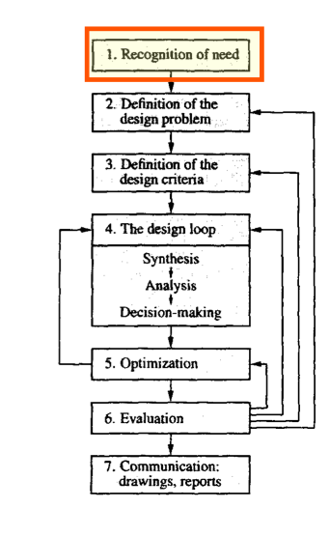
Method of Design
- Recognition of Need
  - A need can be either very obvious or hidden
  - Usually very vague
  - The vagueness of the need can cause the design process to become open-ended
  - Often the need is written in a Statement of Requirements

- Definition of the design problem
  - Critical for a good design
  - May require the gathering of information of the topic (research)
  - Must define the problem correctly in order to provide a solution

- Definition of the design criteria
  - Design criteria are performance standards to be met by the design
  - Design constraints are limitations placed on the designer
  - The design criteria and constraints must be quantitative values
- The design loop
  - Synthesis
    - Suggesting ideas or methods to solve the problem
  - Analysis
    - Calculating the expected result of each idea or method
  - Decision-making
    - Deciding which alternative is best
- Optimization
  - Optimum implies a compromise between cost and benefits - the best design at a reasonable cost
  - If the design is not optimum, the design loop may be needed to be reiterated
- Evaluation
  - Once the design is completed, it must be reviewed
  - The senior engineer and "others" have to approve of the design before they finalize it
  - If the design is flawed, it must be iterated and send back to step 2
- Communication
  - Once the design is approved, it can be built or manufactured
  - The final design must be communicated effectively
    - Reports
    - Technical Drawings
Creativity and Innovation
- Are required for the design process
  - Brainstorming
Read Chapter 16-17

LECTURE 9 - Rapid Prototyping with 3D Printing
- Ideal to complement to CAD
- Process to build concept and working models from 3D CAD Data
  - Several different techniques available
- Used for
  - Communication/collaboration
  - Time reduction
  - Cost reduction
Additive and Subtractive RP
- There are two main methods of Rapid prototyping, which are derived from similar approaches in sculpture
  - Additive Rapid Prototyping (ARP)
  - Subtractive Rapid Prototyping (SRP)

3D Printing
- 3D printing is a variation of rapid prototyping
- A 3D printer is less expensive, easier to use and usually faster then a RP System
- 3D printer is small and can fit in an office environment

Read Chapters 12-17

