ITM 102 Review

Chapter 1, 1
- Information System Basics
IS , computer-based systems that individuals use to work with and process information for an organization.
IT , acquisition, processing, storage, and dissemination of vocal, textual, and numerical information by a microelectronics based combination of computing and telecommunications.
MIS ,holds the function of developing, implementing, and maintaining IT hardware, software, and application.
- Roles and responsibilities within IS
Chief Information Officer: Oversees uses of IT, and ensure strategic alignment with business goals.
Chief Knowledge Officer: Collects , maintains, and distributes organization’s knowledge.
Chief Privacy Officer: Ensure ethical and legal use of information.
Chief Security Officer: Ensure safety in use of IT resources.
Chief Technology Officer: Responsible for ensuring the throughput, speed, accuracy, availability, and reliability of IT
Chapter 1, 2
- Porter’s 5 Forces Model
Buyer Power, Supplier Power, Threat of Substitute,Threat of New Entrants, and Rivalry Among Competitors.
Buyer Power: High number of suppliers means buyers have options to choose from. They have power over the suppliers. Buyer power can be translated with high # of suppliers for organizations or a high number of sellers for customers.
Supplier Power: Opposite of buyer power, where few supplies for buyers.
Threat of substitute: # of possible substitutes within a single market. Switching costs, makes it so it becomes more expensive to switch to another service or product. Offering discounts or services that make it more expensive to switch makes an organization more competitive.
Threat of New Entrants: High when it’s easy for new corporations to enter the market and low when there exists many barriers for new corporations.
Rivalry Among Existing Competitors: High/competition is fierce, and Low/complacent.
- 3 Generic Strategie’s
Differentiation, Cost Leadership, and Focused Strategy
Narrow Market, Broad Market/Low Cost, High Cost
 | Low Cost | High Cost
Broad Market | Cost Leadership | Diffrentiation
Narrow Market | Focused Strategy | Focused Strategy

Value Chain Analysis
Business process – A standardized set of activities that accomplish a specific task, such as a specific process
Value Chain Analysis – Views a firm as a series of business processes that each add value to the product or service
Business-Driven Information Systems and Business Strategy
Porter’s 5 forces , 3 generic strategies, and value chain analysis allows corporation to asses competitive advantage. IS collects data that allows corporations to behave in a way creates a better competitive advantage for them. This information is driven by the need of the business for quick, accurate and insightful information.

Chapter 2, 1
- Decision Making
Corporation use IS to make critical decisions for growth and competitive advantage
IS allows corporations to analyze large quantities of information that they otherwise would not be able to and be able to analyze said information quicker than ever before.
Good decision making asks for individuals to use sophisticated analysis techniques such as modelling and forecasting. IS is much more efficient in preforming such tasks.
IS systems offer security to keep organizational information safe as a corporate asset.
Operational -> Managerial -> Strategic
3 Levels of management that offer different challenges that require different decision making abilities and procedures.
Operational: Day to day operation, very well established decisions for well known situations. They are very structured decisions.
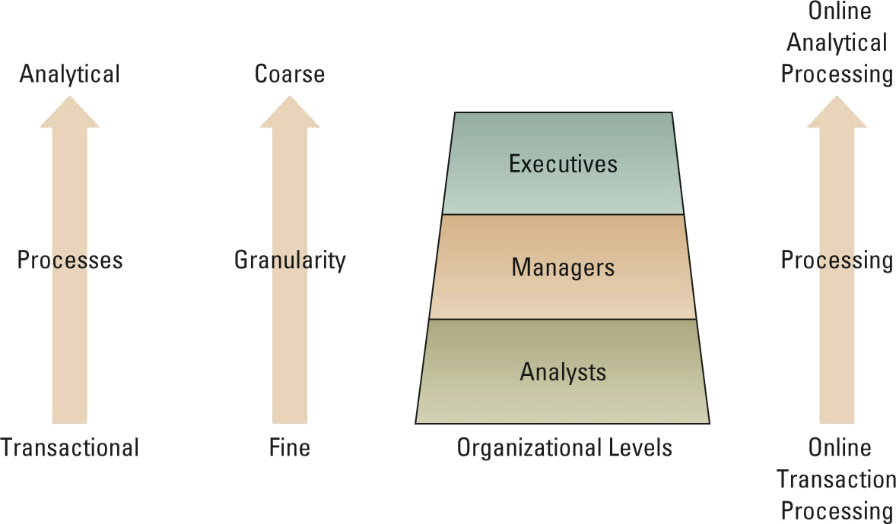
Managerial: Cover short-medium dance plans, and objectives. Allocate resources, and monitor performance of organizational units. Semi-structured decision : few established processes exist but not enough to lead to a definite decision.
Strategic: Development of long term business strategies, and goals/objectives as a part of the organization’s strategic plan. Highly Unstructured: no rules or guidelines in place for decision making.
- Transactional Data vs Analytical Data
TD: raw facts within a single unit of work in an organization. Primary purpose is to support daily operations within an organization.
AD: summarized TD, purpose is to assist in decision making, and support analytical tasks.

- Measuring Decisions Success
Efficiency/Effectiveness, and Benchmarking Metrics
Efficiency measures the performance of the information system itself, throughput , speed, and widespread availability.
Effectiveness measures the impact IS has on business processes and activities.
Benchmarking is the process of continuously measuring results in comparison to optimal system performance.
- Business Process

A standardized set of activities that accomplish a specific task, such as processing a customer’s order

Business process re-engineering (BPR) — the analysis and redesign of workflow within and between enterprises

Chapter 3,1

