ECOR 1010 – Introduction to Engineering

Jasdeep Sekhon
Lab #4
Assignment Title: – Creo Parametric (Bearing Solid Model)
TO Marking TA:
Name: Ali Tarabay
Email: alitarabay@cmail.carleton.ca

Lab Section: A1
Room: ME2556 – Carleton University

FROM: Jasdeep Sekhon
Email: jasdeepsekhon@cmail.carleton.ca
Student Number: 100980887

Number of Figures and Tables (Including handwritten ones): 4
Last Date and Time of Revision: 13 October 2014 7:00

APPENDIces- Figures and Tables
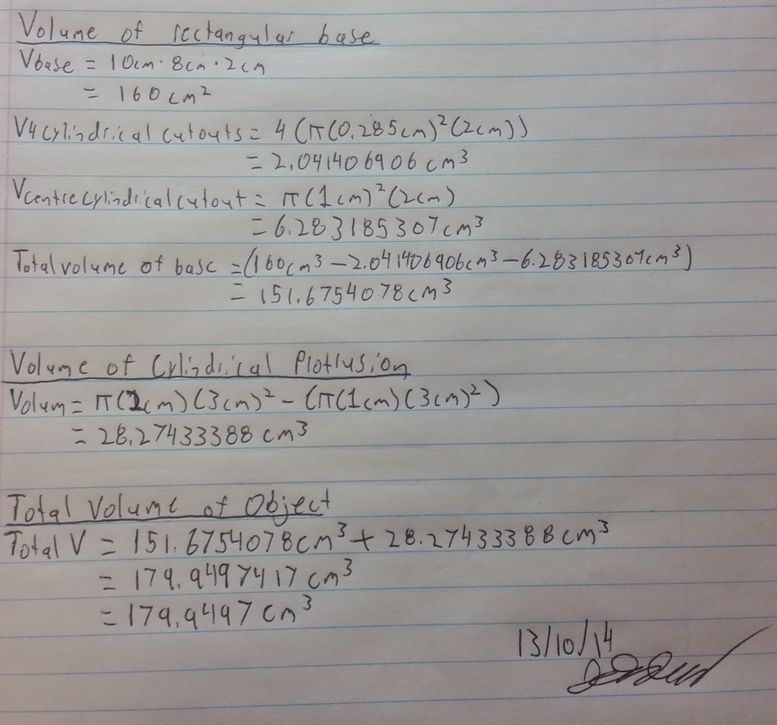
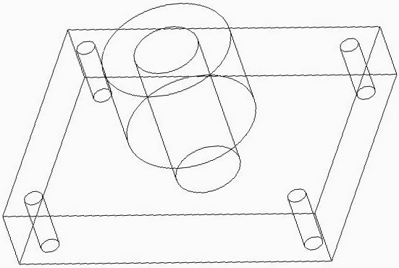

Figure 2: Handwritten calculations of volume

Figure 1: 3D wireframe isometric view of the bearing

APPENDIces- Figures and Tables

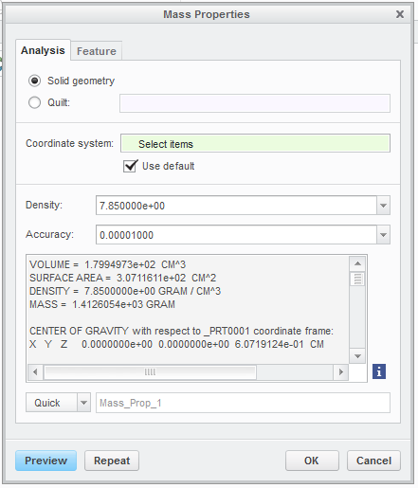
APPENDIces- Figures and Tables

Figure 3: Mass properties as calculated through Creo

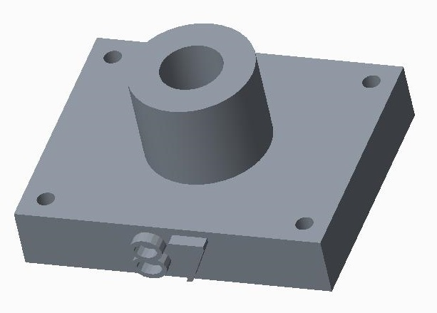

Figure 4: Creo rendered 3D opaque solid model of bearing

