ECOR 1010 – Introduction to Engineering
Jasdeep Sekhon
Lab #5
Assignment Title: – Unvariate Data
TO Marking TA:
Name: Ali Tarabay
Email: alitarabay@cmail.carleton.ca

Lab Section: A1
Room: ME2556 – Carleton University

FROM: Jasdeep Sekhon
Email: jasdeepsekhon@cmail.carleton.ca
Student Number: 100980887

Number of Figures and Tables (Including handwritten ones): 4
Last Date and Time of Revision: 13 October 2014 7:0

Introduction
The company is producing a plastic knob in which a metal insert will be placed. The acceptable range for the width of the knob is 0.137”≤knob≤0.143”. The process by which these plastic knobs are being produced is being tested for its efficiency.

Results AND dISCUSSION
The shape of the obtained distribution is right-skewed. This shows that the mode is near the left hand side, which is the most common measurement. There are no obvious outliers.
Sample Statistic | Results via equations | Result vis MS Excel | Random Normal Distribution using Excel with seed = 887 (Calculated using Excel)
Sample Mean | 0.1398” | 0.1398” | 0.1391”
Sample Variance | 0.00001303” | 0.00001303” | 0.00008492”
Standard Deviation | 0.003611” | 0.003611” | 0.002914”
Standard Error | 0.0005382” | 0.0005382” | 0.0004344”
Population Mean with 90% Confidence Interval | 0.1398” ± 0.0008854” | 0.1398” ± 0.0009045” | 0.1391” ± 0.0008755”

If the dimension of one sample had been recorded as 0.113”, it can be questioned whether or not there was an error of measurement, which is probable as this measurement is an outlier, it is not within in the range, and it. The measurement is .020” less than the smallest measurement, which is greater than the 0.16” range, so it is highly unlikely that this measurement is a valid extreme value.

Figure 1. Sample statistics using production sheet and random number generator values

The differences between the statistics measured through Excel and the equations are not significant. The values for the sample mean, variance, standard deviation, and standard error are the same. The population mean with 90% confidence interval is not exactly the same, although they are both valid. This can be due to the process by which the confidence interval was calculated (plugging the sample mean and standard error equations directly into the confidence interval equation by the computer)

An estimate for the proportion of acceptable knobs is 71%, since 32 out of the 45 knobs in the sample set were in the acceptable range. With a 95% confidence interval, this comes out to 71.11% ± 0.003%. If the distribution is normal, and there is a 99% confidence range, the estimate is 71.11% ± 0.002%.

The differences between the randomly generated numbers and the knob measurements are noticeable. This is due to the randomness of the generated numbers, there were many possibilities for various outcomes, and this outcome created noticeable differences between the statistics. Although there are differences, they correlate with one another, which is due to the fact that the range and count of the numbers was the same, so sum of all numbers is expected to be similar.

The process is not very efficient. Although there are an acceptable number of knobs that are valid, the number can be much greater. There is a chance of losing money by producing knobs. The process can be altered to produce a greater proportion of acceptable knobs.

Appendices – Figures and Tables
Bin(in) | Frequency
≤0.133 | 1
≤0.135 | 2
≤0.137 | 10
≤0.139 | 12
≤0.141 | 8
≤0.143 | 5
≤0.145 | 3
≤0.147 | 2
≤0.149 | 2

Figure 2. Relative Frequency Table of Production Sheet Measurements

Figure 3. Relative Frequency Histogram for Part #1285 Production

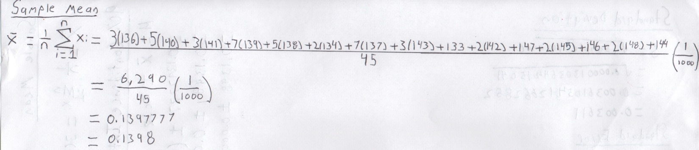
Figure 4. Sample Mean Calculation Using Equation

APPENDIces- Figures and Tables

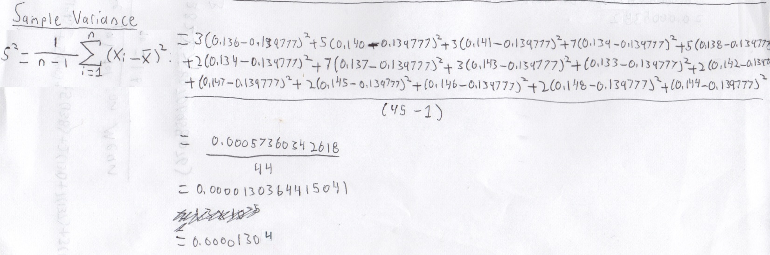
Figure 5. Sample Variance Calculation Using Equation

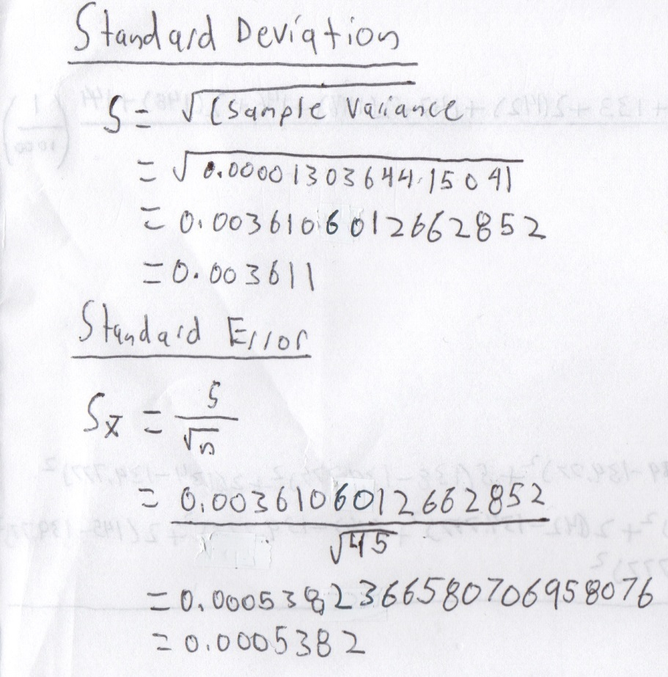

Figure 6. Standard Deviation and Standard Error Calculations Using Equations

APPENDIces- Figures and Tables

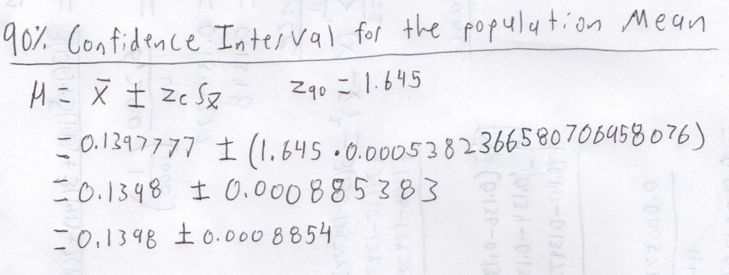
Figure 7. 90% Confidence Interval Calculations Using Equation

APPENDIces- Figures and Tables

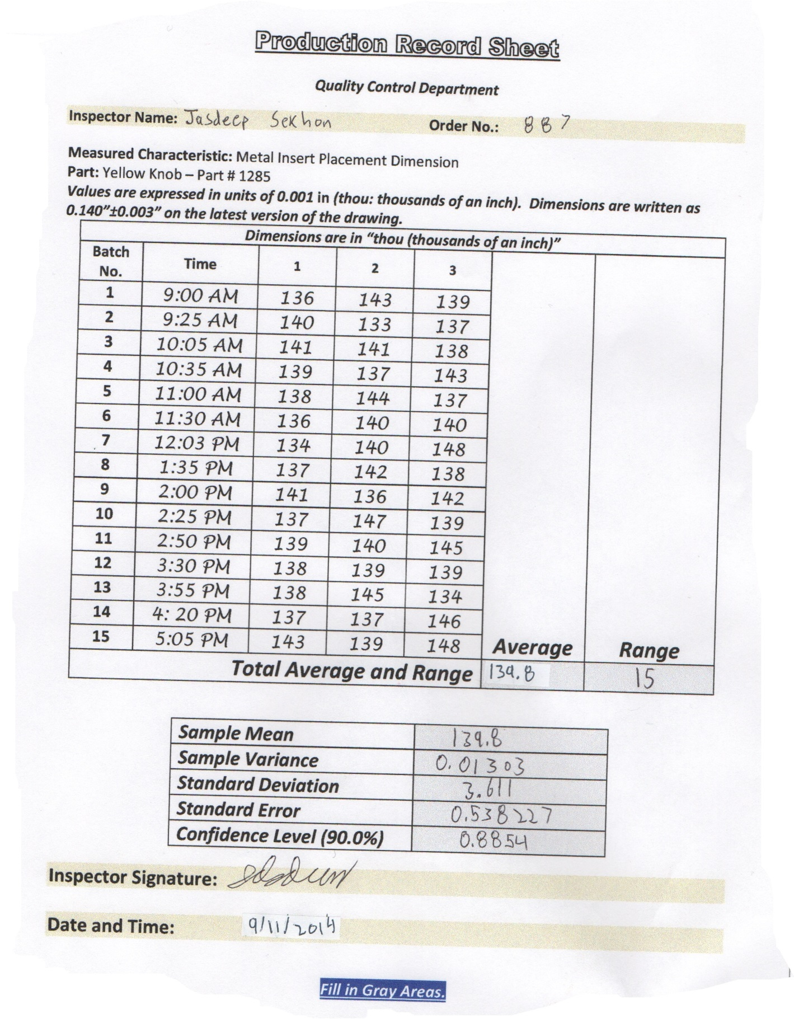
Figure. 8 Production Record Sheet

APPENDIces- Figures and Tables

0.135 | 0.143 | 0.138
0.137 | 0.137 | 0.136
0.137 | 0.140 | 0.136
0.139 | 0.141 | 0.142
0.140 | 0.137 | 0.139
0.141 | 0.141 | 0.143
0.140 | 0.133 | 0.139
0.142 | 0.135 | 0.142
0.138 | 0.141 | 0.138
0.140 | 0.144 | 0.139
0.136 | 0.139 | 0.139
0.134 | 0.142 | 0.140
0.138 | 0.134 | 0.142
0.144 | 0.143 | 0.140
0.138 | 0.143 | 0.134

Figure 9. Random Number Generator Values

Bin | Frequency
0.133 | 1
0.135 | 4
0.137 | 7
0.139 | 9
0.141 | 9
0.143 | 13
0.145 | 2
0.147 | 0
0.149 | 0

Figure 9. Relative Frequency Histogram for Random Numbers
Figure 11. Relative Frequency Table for Random Numbers

