UNWTO (United Nations World Tourism Organization)
The activities of person traveling to and staying in places outside their usual environment for not more than one consecutive year for leisure, business and other purposes. (Non-routine travel)

Tourism has interaction between
- The tourist
- The business
- The government
- And the host community
Visitor: anyone who is engaged as a consumer in tourism
Tourist: a visitor who stays overnight
Same-day visitor: a visitor who does not stay overnight
Business: Meetings, conferences, conventions, trade shows, incentive travels

Pleasure: Vacation, Shopping, festivals

Visiting Friends and relatives (VFR)

Domestic Tourism: Visitors travelling in their nations (Canadians in Canada)
International tourism: all travel crossing borders (travel by foreigners into Canada)
Inbound Tourism: Visitors coming to another nation/ destination (foreigners coming into Canada, other Canadians coming into Ontario)

Outbound tourism: Visitors leaving for another nation (Canadians going to Jamaica)
The temporary movement of people to destinations outside their normal places of work and residence, the activities undertake during their stay in these destinations and the facilities created to cater to their needs.
(Mathieson and Wall, 1982)

TOURISM TODAY:
- 9% of global GDP
- 1 in 11 jobs
- US$1.4 Trillion in exports
- 6% of global exports
- 1950=25m, 2013=1,087m, 2030=1,800m
- 5 to 6 billion domestic tourists
Tourism contributions in Canada
- 1.6 million jobs; 9.2% of all jobs in Canada (2010)
- As an industry, tourism has the ability to create more jobs at a faster pace than any other industry in Canada.
- Exceeded only by retail trade (2 million) and healthcare and social assistance (1.7 million)
- CTRHC/TSA
Tourism arrivals in 1995 Europe had 60%, in 2020 it will be 46%
Tourism motivation: state of arousal of a drive or need which impels people to activity in pursuit of goals (Seaton, 1997)

Why do we want to know what motivates tourist?
- Industry must strive to meet or exceed the needs and expectations of the tourist.
- Satisfaction; repeat business/ visitation; eWOM

- Motivation and its association with destination selection plays a critical role in predicting future travel patterns and demand.
Push
- Internal
  - Social- psychological
  - Unrelated to destination
  - Intangible forces
- Escape, relaxation, kinship, adventure
- Needs for relaxation, exploration, social interaction and enhancement of kinship relationships.
Pull
- External
- Related to destination, attractiveness, characteristics, hotels, cultural resources
- Aroused by the destination and include factors like scenic attractions, historical sites.
Anomie
- Feeling of isolation from the routine of daily life drives need to become socially interactive.
- Vacation primarily to satisfy social needs
- Need to meet local people, mix with other fellow tourist and spend time with people whom they care about (Dann, 1977)
Ego- enhancement
- The need to be recognized and have a status which is attained as a result of travel experiences
- Satisfy personality needs
- For example: some may like to visit places their friends have been to or places that they have never been to before (Dann, 1977)
Why People Travel:
2 cultural motives:
- Novelty
- Education
7 Social Psychological motives
- Escape
- Relaxation
- Social interaction
- Kinship
- Self-exploration
- prestige
- regression
Most travel and travellers are not just one type, but mixture of motives
I can go to a resort in winter, cultural day trip, but travel to France for culinary tour
Also can change overtime

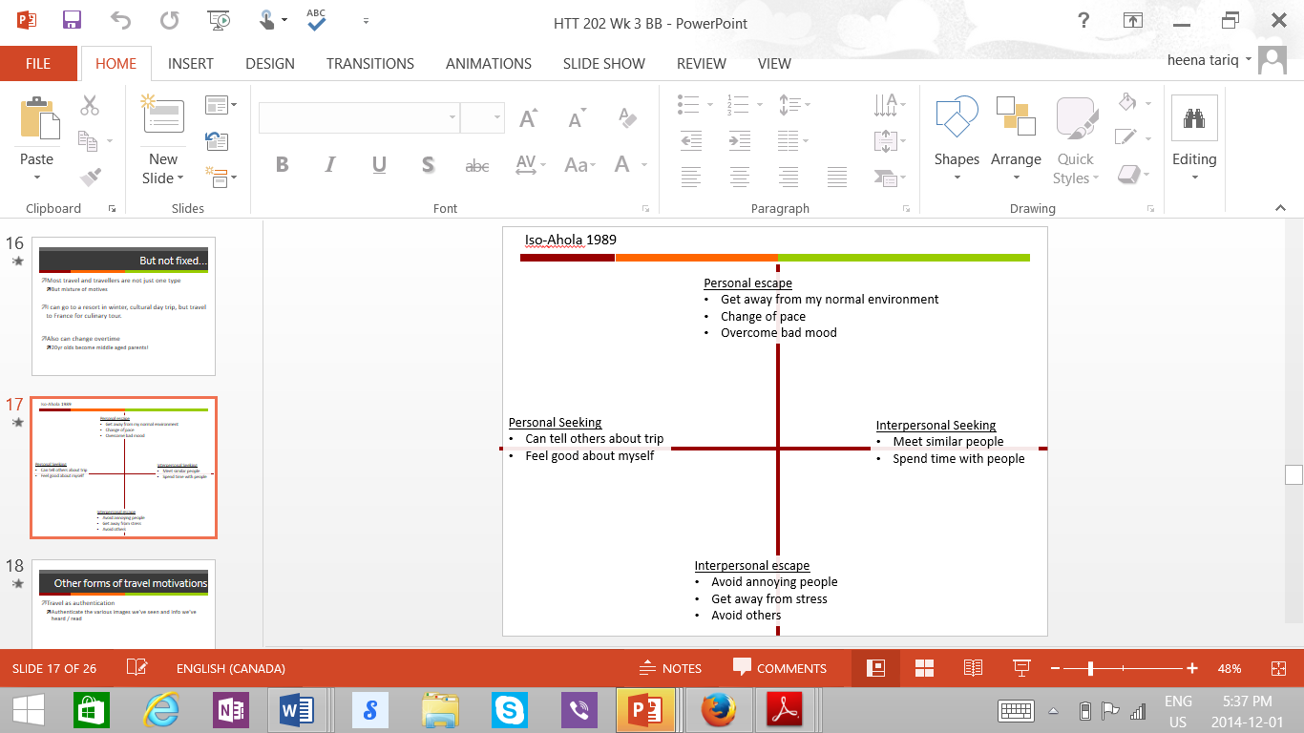

Iso Ahola, 1989
Personal Escape
- Get away from my normal environment
- Change of pace
- Overcome bad mood
Interpersonal Seeking
- Meet similar people
- Spend time with people
Interpersonal escape
- Avoid annoying people
- Get away from stress
- Avoid others
Personal Seeking
- Can tell others about trip
- Feel good about myself
Travel Motivations:
Travel as authentication: Authenticate the various images we’ve seen and info we’ve heard/ read
Travel as a form of imperialism:
- Most tourists are from economically advantageous countries
- Some guest flaunt their wealth and prestige
Socio – Demographics
- Age
- Gender
- Sexual orientation
- Education
- Income
- Marital status; life course
- Place of residence
- Culture ethnicity
Psychographics
- Personal beliefs, social values and view of the world

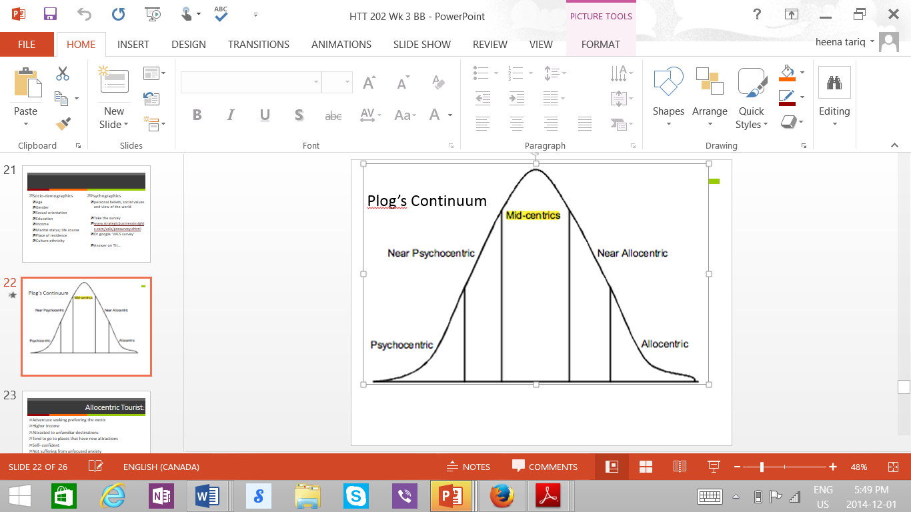

Allocentric tourist
- Adventure seeking preferring the exotic
- Higher income
- Attracted to unfamiliar destinations
- Tend to go places that have new attraction
- Self-confident
- Not suffering from unfocused anxiety
- Like to travel
- Higher preference for air travel
- Prefers to meet local people
Psychocentric tourist:
- Safety seeking, preferring the familiar destinations
- Like good facilities
- Travel less and spends less
- Prefer to travel to familiar places
- A non-flyer
- Insecurity in daily life and sense of powerlessness
- Prefers sun, fun and relaxation
Plog’s Model Critique
- Incorrectly assumes a person will be interested in only one type of destination
- Us- centred view of the world
- Ignores “style” of travel e.g. independent vs group; types of activities
- Predicts destinations will tend to decline as they become too touristy
Importance of attractions:
- Without attractions, demand for other tourism services would be much smaller
- Also add to quality of life for residents
- Often draw on local context, environment, history
Definition of attraction
- Provide entertainment , education, recreational activities as core products at a fixed site
- Draws visitors as well as locals
- Open to public
- Admission is controlled or could be controlled

Types of attraction:
- Cultural
- Natural
- Event
- Recreation
- Entertainment

Cultural Attraction:
- Often reflect local culture
  - Often help form it too
- A way for local community to coalesce who they are, and what others should think of them

Museums
- Art, History, science
Historic Sites
- Place (specific)
- Parks, buildings, homes
Heritage
- History and entertainment
- Often based on perception of tourist of belonging there ( where I am from? What is my own history?)
- Valued objects and qualities such as historic buildings and cultural traditions that have been passed down from previous generations
- E.g. NYC Tenement Museum, Historical site, Museum, Heritage-links to personal experiences, develops local community
  - Increased business for specific neighbourhood
Natural Attraction

Events
- Activities that provide an opportunity for leisure, social, or cultural experiences that last anywhere from a half day to a year
- Events, like attraction, provide motivation for travel
  - Also add to quality of life for residents
  - Often draw on local context, environment, history
- Local economic activity
  - Painters, carpenters, audio-visual, etc.
- Two main groups
  - Events (leisure) and meetings (business)

Leisure – Event characteristics
- Open to public
  - But private corporate functions are also sometimes called “special events”
- Celebration or display of specific theme
- Takes place annually or less frequently
- Fixed opening and closing dates
- Usually multiple activities
- All activites take place in same are
  - But can be very broad area
Types of events
- Festivals
  - Public celebration that centre on themes of local, regional, or national interest
- Bradford West Gwilimbury carrot festival
- Started as pat of revitalisation efforts in ‘98
  - Combined existing events
- Heart of vegetable country
  - 70% of Canada carrots
- 2006 – 11, 000 people
- 2012 – 40,000+
Mega Event
- Connotes “ big”, but not precisely defined
- Often implies worldwide publicity
Roles of festivals and events
- As an image – maker
  - Hallmark events
  - Destination theme/brand
- As a development catalyst
  - Urban renewal
  - Infrastructure
  - Economic and business development
- As community development
  - Add to community life
  - Maintain authentic traditions
  - Bring hosts and guest together
  - Tourism benefits without physical development
Meetings industry
- Commonly referred to in the industry as MC & IT
  - Meetings, conventions and incentives travel
Why are they important?
For attendees
- Reaping the rewards of gathering professional in one place to pursue common objectives
- Progress and development in field
- Creating knowledge
- Networking
- Training
- Meet clients and suppliers

For host community
- Economic development
- Employment
- Regeneration
In Canada
- They generated 32.2 billion in direct spending in 2006.
  - Foreign tourist spend 15.1 billion
- 70.2 million total participants and 235, 000 full – year jobs.
  - 34, 000 in auto manufacturing
- Over 673, 000 meetings were attended in 2008
Recreation
- Golf, biking, snow sports, other such activities
- Adventure tourism
  - Bungee jumping, hiking
Parks Canada
- 1911 Parks Canada was formed
  - On behalf of the people of Canada, we protect and present nationally significant examples of canada’s nature and cultural heritage and foster public understading, appreciation and enjoyment in ways that ensure ecological and commemorative integrity of these places for present and future generations
  - Now there are 42 national parks
  - 4 national marine conservation areas
Entertaining attractions
- Theme parks
- Amusement park
- Live entertainment
- Casinos
- Shopping
- Not necessarily linked to culture, nature or heritage
4 components of tourism supply
- Natural resources
  - For beauty as an attraction (mountains, waterfalls)
  - Survival (water, land)

- Built environment
  - Infrastructure (roads, communications, sewage)
  - Superstructure (Buildings – hotels, restaurants, terminals

- Operating secotrs (events, attractions, entertainment, rec, transport, F&B, travel, trade, accommodation

- Hospitality
- The friendly and generous reception and entertainment of guest, visitors, or strangers (oxford dictionary)
- Politics, culture, resident willingness
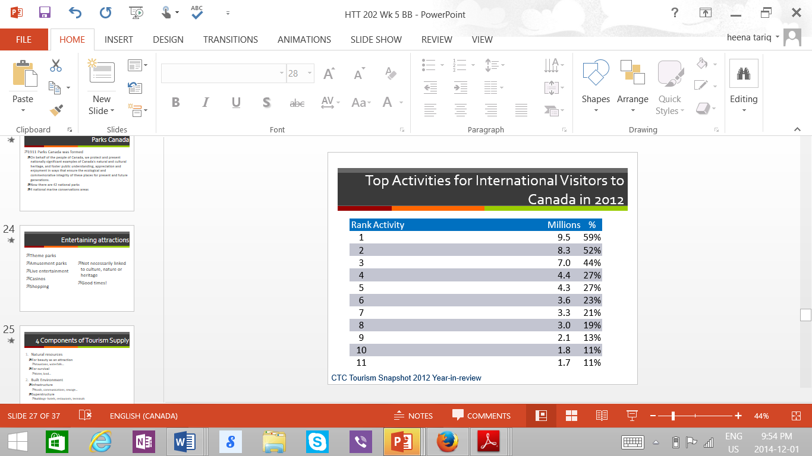

What is demand?
- The amount of any products or service that people are willing and able to buy during a specified period of time
- Strongly limited and influenced by quantity and quality of supply components

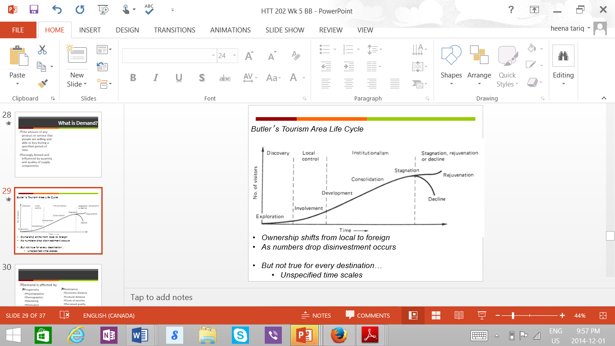

Demand is affected by:
- Propensity
  - Psychographics
  - Demographics
  - Marketing
  - Motivation
- Resistance
  - Economic distance
  - Cultural distance
  - Costs of services
  - Perceived quality
  - Seasonality
Quality of service
- For first time visitors must be perceived
  - Tourism is intangible
  - Based on personal preference, marketing, WOM
Seasonality
- Diversification
- Multiple activities
- Different markets
- Different pricing
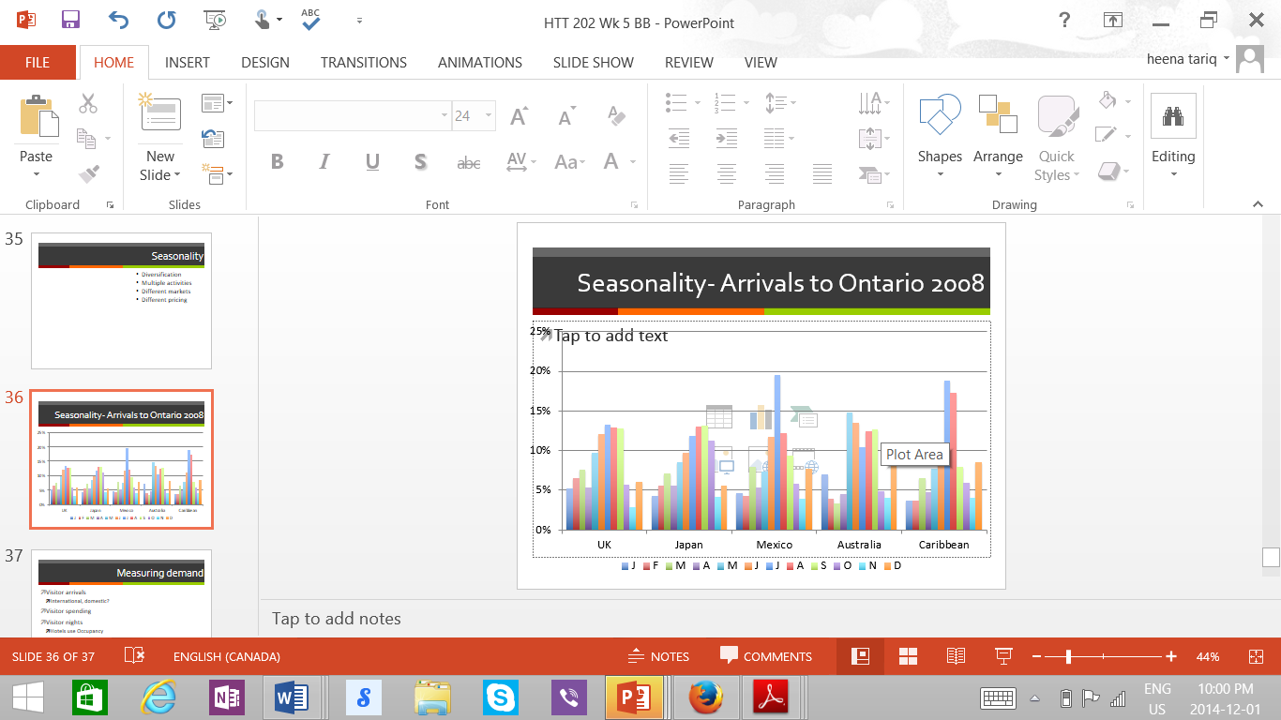

Measuring demand

- Visitor arrivals
  - International, domestic
- Visitor spending
- Visitor nights
  - Hotels use occupancy
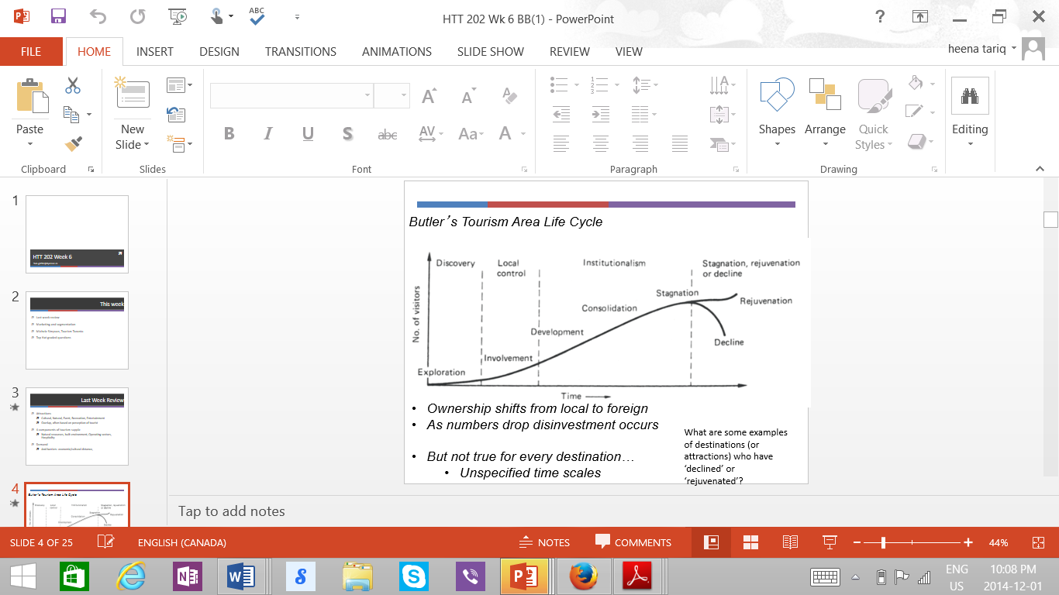

Tourism
- is intangible (hard to sell)
- perishable (if not brought this week it cannot be sold)
- heterogeneous (potentially inconsistent)
- fixed supply ( A limit to how much can be sold, but can increase the price)
- often beyond one supplier’s control
Marketing Mix
- segmentation helps identify who the supply side’s target market is
- we also need to understand how we are going to market ourselves
- supply side controls 4p’s
Product
- object, service, idea
Tourism product?
- Transport, accommodations, restaurants
- Culture, markets, temples, sports
- Environment, beaches, old town, mountains
- Entertainment, theatre, festivals
- An overall destination with a combined mix of products

Price
- The amount charged for a good or service
- What is lost in order to consume the good or service (includes time, opportunities)
Affected by
- Cost of production
- Competition
- Perceived value
Pricing Strategies
- Market skimming
  - High price for fewer more profitable sales

  - Market penetration

    - Low price for large market share
  - Based on timing of purchase
    - Advance bookings, seasonality
  - Volume
    - Discount for greater purchases

  - Segmented pricing
    - Charging the right customer right amount at the right time

Distribution
How is the tourism distributed?
- Travel agents
- Online
- Direct sales
Promotion
- Communication by marketers that informs, persuades, and reminds potential buyers of a product or service in order to influence an opinion of elicit a response
Advertising
- Expensive, mass, one way communication
Sales promotion
- Hotels, airlines, specific service providers

Public Relations
- Using public interest to attract attention
Segmentation:

- Post Modern ( uniqueness, authentic, consumption for status
- Segmentation necessary for efficient marketing and delivery of services
- Match specific product with specific visitor
- Increased niche product
  - Activities based
  - Appeal to social values
- Groups of consumers who share certain common characteristics that may be useful in reaching them with marketing campaigns, or in designing new products for them
  - Members of groups are similar to each other and are different from non-members
- Purpose of travel
  - Pleasure, business, VFR
  - Easily understood
  - Better is purpose is very precise( going to play golf)
- Self- selected not always what industry is looking for
  - What is the main reason for your trip?
- Travel behaviors
  - Frequency of purchase
  - Package versus independent travel
  - Mode of transportation
- Demographics
  - (fixed characteristics)
    - Age, education, ethnicity
  - Popular, easily understood
  - Often limited value or usefulness
- Psychographics
  - Interest, values, intrinsic motivation, travel philosophy
- Segmentation models are often unique for destination
- Same product can be marketed to different segments
- Draw on various models to find perfect target market
  - Many destinations must consider consumers
    - Transportation (islands)
    - Geography (volume)
    - Age (Cancun at spring break)
The Canadian tourism commission (CTC)
Crown Corporation
- Mandate is to
  - Sustain a vibrant and profitable Canadian tourism industry
  - Market Canada as a desirable tourism destination
  - Support a cooperative relationship between the private sector and the government of Canada
- Promote a strong and consistent image of our country to the world
- Primary focus on international tourism
- Marketing
  - Social media
  - Joint marketing
- Sales efforts
- Toolkits for businesses
- Research and intelligence
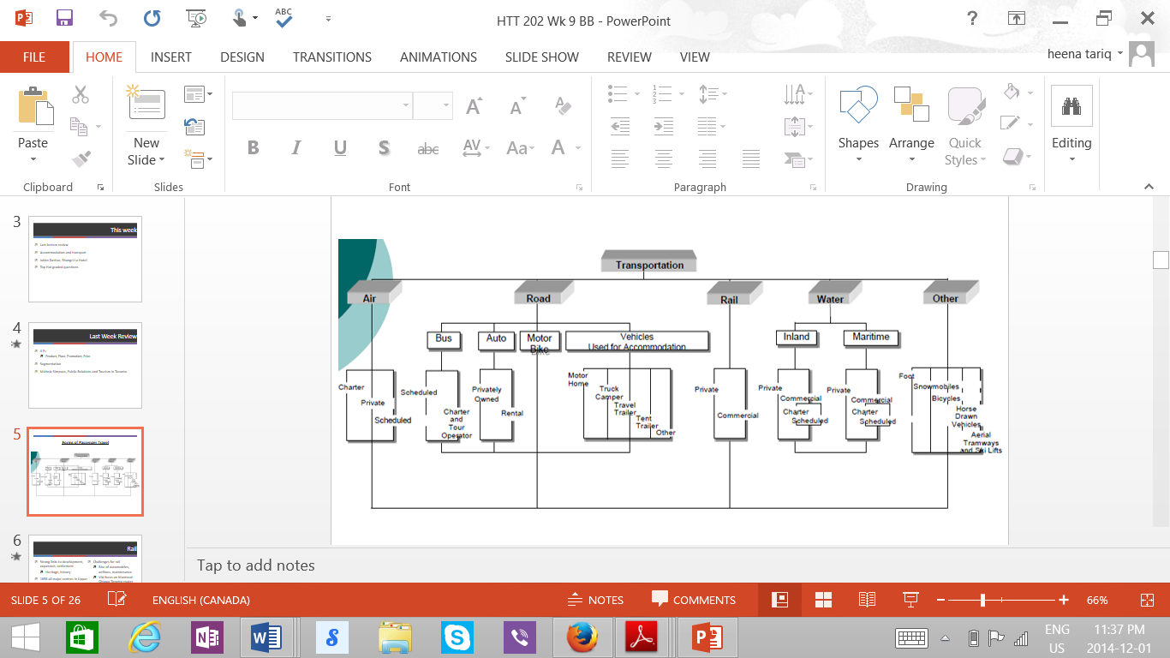

Rail
- Strong links to development, expansion, settlement
  - Heritage, History
- In 1856 all major centres in upper and lower Canada connected
Advantages
- Pleasant way to travel
- Convenient location of stations
Challenges for rail
- Rise of automobiles, airlines, maintenance
- Via focus on Montreal – Ottawa – Toronto routes
  - Can compete
- But in other countries high speed trains are built

Automobiles
- Democratised travel
  - Convenient
  - Affordable
  - Flexible
- Opened up national parks as attractions
Cruises
- Combine transport with accommodation, f&b, entertainment
- One of the fastest growing forms of tourism
Motor coach industry
- Charter, tour,
- Regular route
Airline Industry
- Vital component of modern tourism
  - Without it, hotel rooms go empty, rentl cars unrented
  - 1,715 airlines and 3,670 airports
- Carries over 2.4 billio passengers per year
- US alone, commercial aviation generates more than $150 billion in annual revenue
- Employs 550,000 people
Expanded tourism peripheries
- We can travel to more places
  - In less time
  - For less money, than ever before
- Think about where
  - Your grandparents generation would vacation
  - Your parents
  - You and peers

Airline Impact
- High energy consumption
  - Emissions/ oil consumption
  - Energy use at airports
  - Space and impact or airport development
  - Leads to global environmental impacts
    - That can affect tourism specifically
  - Efforts to make plans more efficient
    - Lighter, better engines

Deregulation
- In 1978 in US led to
  - Significant consolidations
  - Hub systems
  - Low airfares in competitive situations
  - High airfares where competition is lacking

Air transportation

- Challenges include
  - High taxation and fees
  - Security, air improvements fees, congestion fees,
  - US $20,885 to land an airbus A330 at Pearson
    - Approx. $40 per persp
  - Changing and rising fuel costs
- Bilateral agreements
  - Between 2 countries
  - How many flights, types of planes, discounted fees
- Open skies 1995
  - US – Canada

Ryanair
- Based in Ireland
- Over 1,500 flights per day
- From 51 bases
- On 1.500 low fare routes
- Across 28 countries
- Fleet of over 290 new Boeing 737-800 aircraft
- Carry of more than 8500 people
  - Air Canada 33 million
Hyperloop (future)
- Elon Musk (tesla, Paypal)
- LA to San Francisco
  - Car = 5 ½ hours
  - Flight = 60 mins
  - Hyperloop = 30 mins
- High speed train = 200 mph (320 kph) at $70
- Hyperloop= 750 mph (1200 kph) at 7.5 b
Accommodation History
- As transport develops
  - So does touris
  - Need for accommodation increases
- Accommodation changes with times
  - Used to need stables
  - Or be accessible by trains
- Automobile changed that
  - Fairmount bath springs
    - First ‘ pleasure’ hotel
Hotels – rooms within multi-story buildings, accessible from interior only, offer a range of amenities
Resorts – extensive indoor or outdoor leisure activities, usually year – round; usually non- urban’ full service, often including conference facilities

Motels – short – stay by motorist; usually one or two story; exterior access to rooms, ample parking, and limited services
Housekeeping cottages – Vacation stays in rural areas; typically includes access to beaches and fishing

Bed and breakfast – Guest rooms in private homes or small businesses converted to this use; often unique or historic value; highly personalized service; but usually only breakfast is served

RV (recreational vehicle) parks and campgrounds – serviced or unserviced sites to accommodate campers and their equipment (usually brought by campers) may offer washrooms, laundry, recreation halls, store/snack bar, possibly beach and outdoor recreation facilities

Occupancy
- Occupancy is the percentage of available rooms that were sold during a specified period of time. Occupancy is calculated by =

dividing the # of rooms sold / # of rooms available

Occ = rooms sold/ rooms available

Occ = 100/200
= 50%

Trends in hotel pricing

- Hotwire
  - Customers pays upfront for product. Cheap price for limited information
    - Avoids competition with other sights (owned by expedia)
    - Only deal with brand names
      - Decrease customer risk
  - Priceline
    - Name your own price and wait for response
    - Sometimes worse than rack rates
  - Dealangle
    - Track prices and markets
    - Give consumers more info
  - Airbnb
    - The seeds for a significant transformation within the tourism accommodation sector were laid in 2007 in the form of three air mattresses on the floor of a san Francisco aprtament. A major conference was in town and two recent university graduates had used a simple website to successfully advertise their apartment as an airbed & breakfast for conference delegates looking to avoid the city’s high hotel rpices

