ECOR 1010 – Introduction to Engineering

Nathan shane
Assignment #4
Assignment Title: Creo Parametric (Bearing Solid Model)
TO Marking TA:
Name: Yamer Yusuf
Email: yameryusuf@cmail.carleton.ca

Lab Section: A6
Room: ME2556 – Carleton University

FROM:
Email: nathanshane@cmail.carleton.ca
Student Number: 100976026

Number of Figures and Tables (Including handwritten ones): 3
Last Date and Time of Revision: 16/10/2014 @ 8:55 PM

Figure 1: Creo wireframe rendering of bearing
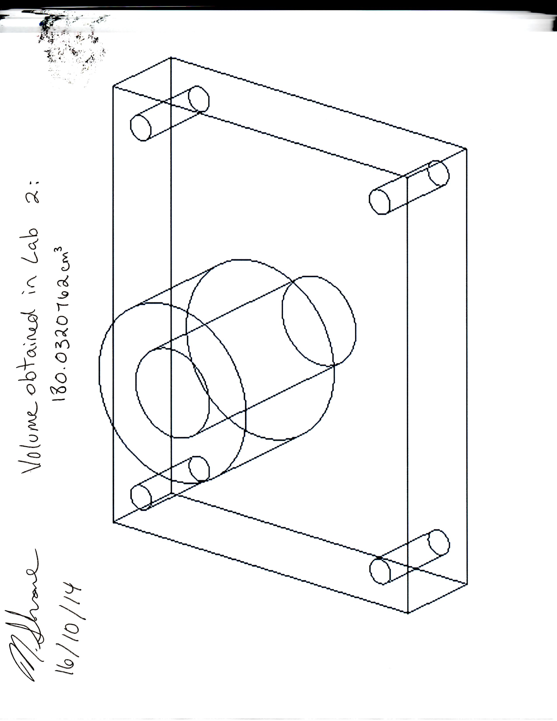

Figure 2: Volume, Surface Area and Mass of figure 1

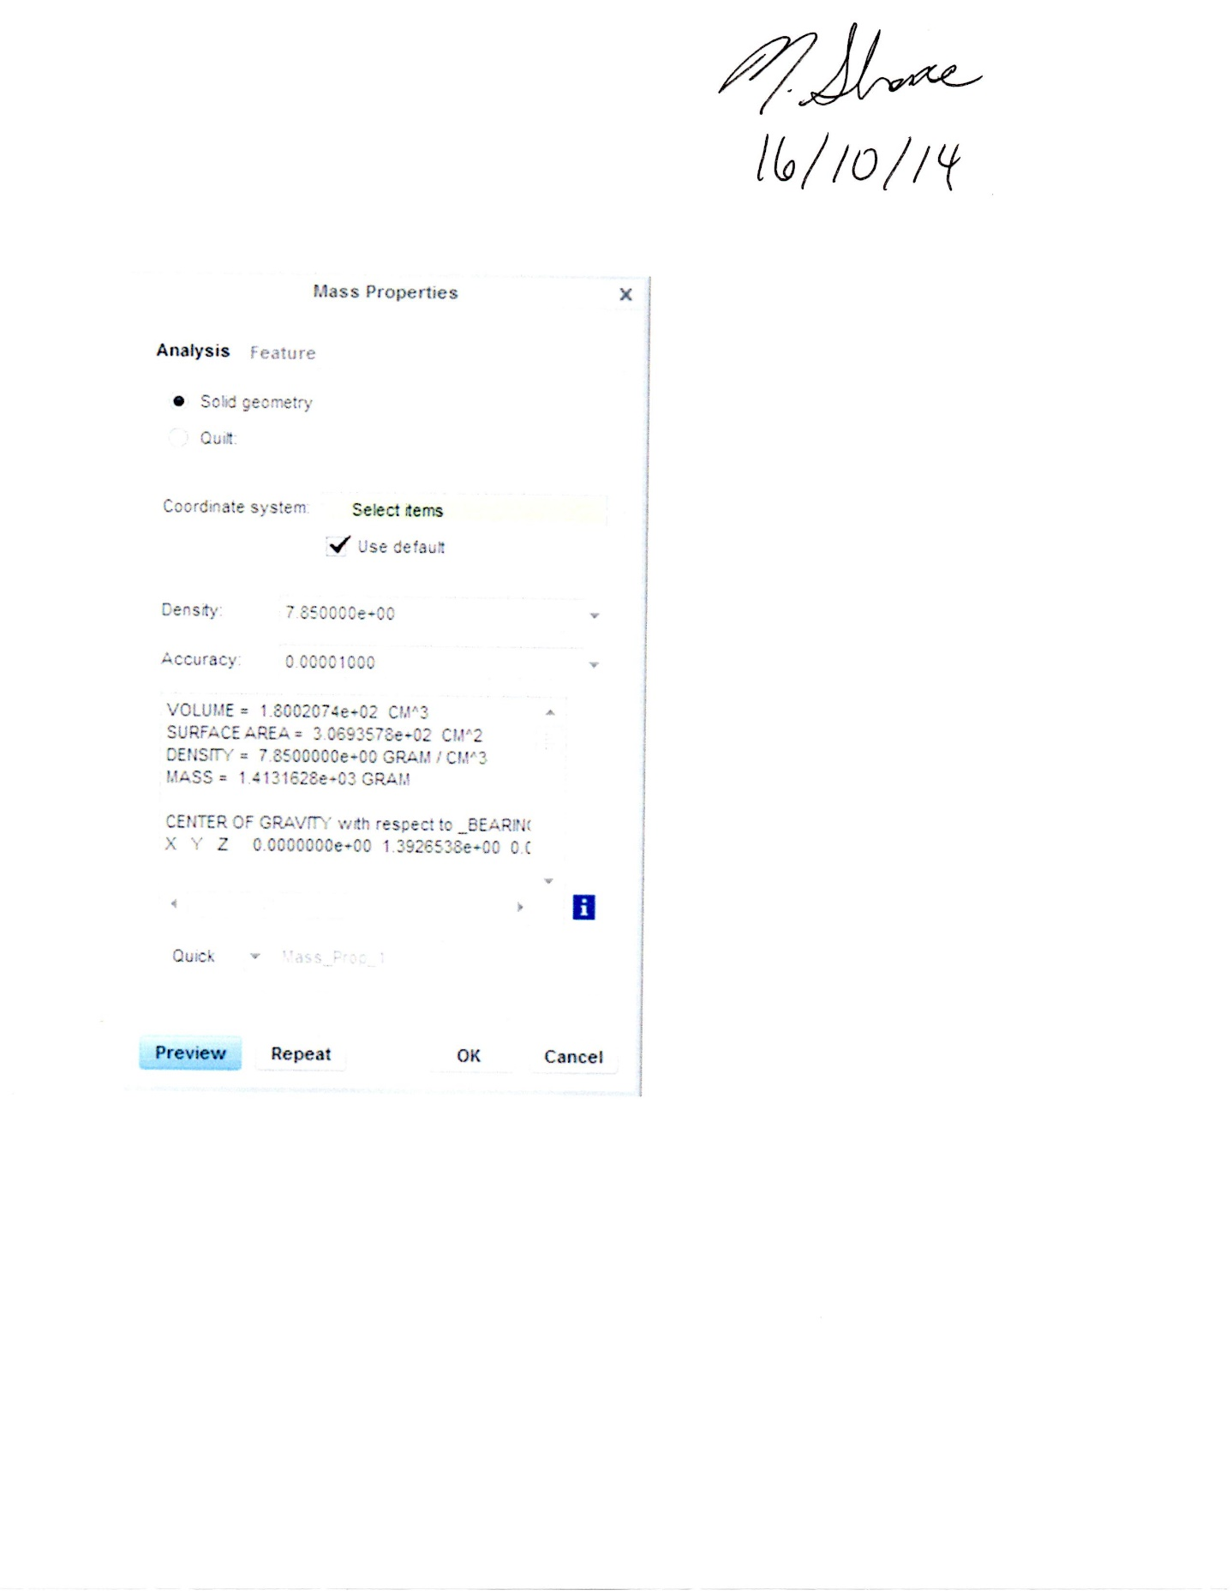

Figure 3:Creo rendered opaque solid model of bearing with text protrusion


