ECOR 1010 – Introduction to Engineering

Ashish Maharaj
Creo Parametric (Bearing Solid Model)
TO Marking TA:
Brent Cameron
brent_cameron@carleton.ca

Lab Section: B5
Room: MC5010 – Carleton University

FROM:
ashishmaharaj@cmail.carleton.ca
100978902

3 Figures
Last Date and Time of Revision: 16 October 2014

Creo wireframe rendering of bearing

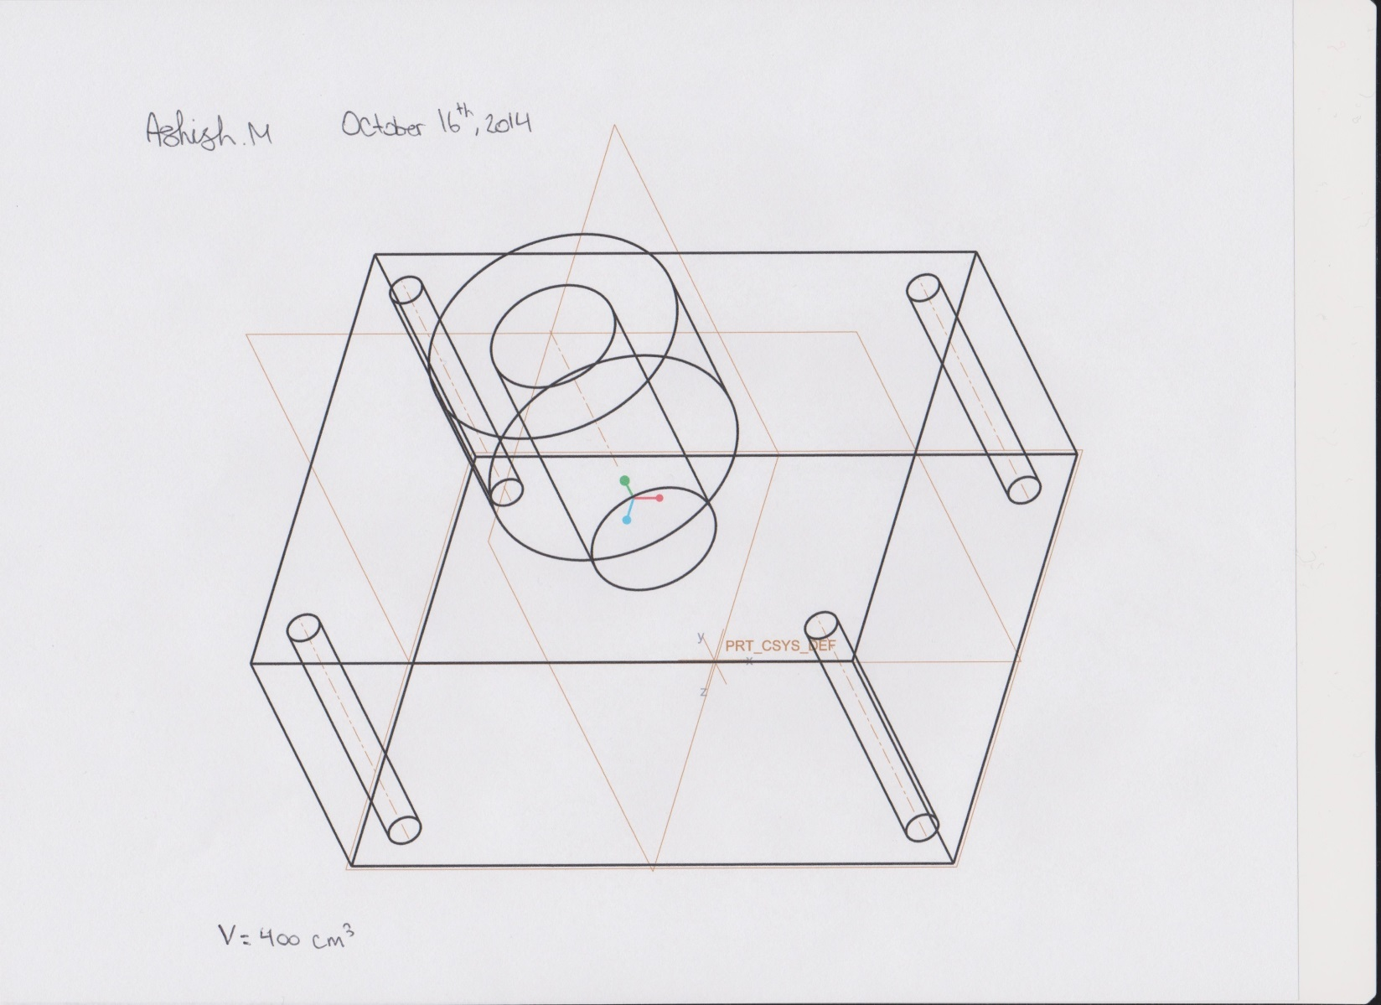

Mass Properties

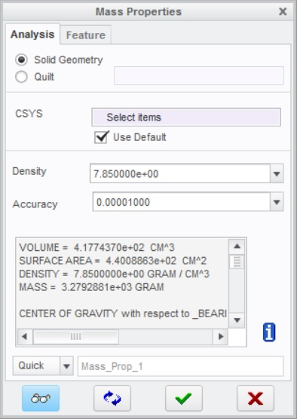

Creo opaque solid model of bearing with text protrusion



