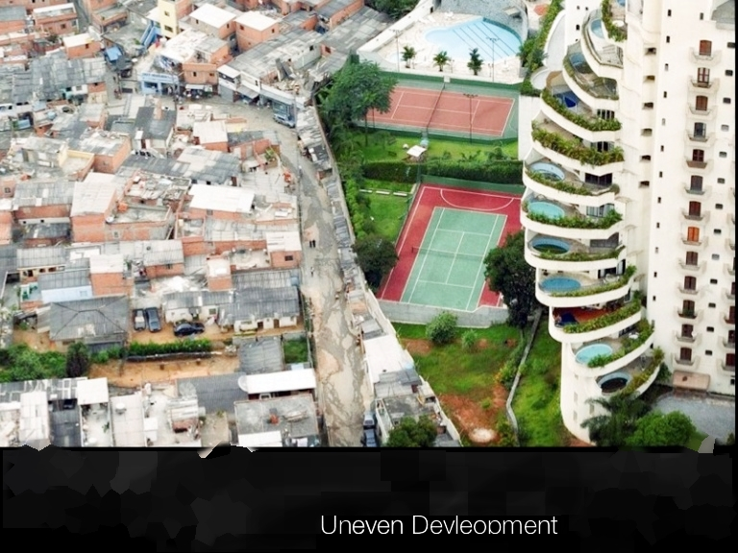 | Submitted by:  To:  Niloofar Alavi-Shoushtari  Professor:  Paul B. Williams  Date of Submission: October 8, 2014

Assignment No. 1
- Uneven Development-

- Explain one weakness of using GDP (PPP) per capita as an indicator of a country’s standard of living or quality of life.

GDP is the measurement of a country’s economic status by measuring the total exports, imports, money spent and earned by government, businesses and consumers etc. The weaknesses of using GDP per capita as an indicator of a country’s standard of living or quality of life is that it does not measure the change in quality of life, surroundings and goods ; unevenness of the distribution of wealth throughout the country; economic health and well-being; literacy rate; etc. All these factors are necessary to indicate that a person leads a decent life.
- Outline the key features of the Human Development Index (HDI). Explain why it is considered a better indicator of quality of life than GDP (PPP) per capita.

Human Development Index (HDI) is the measurement of an overall well-being of an individual in the country. It takes various factors into accounts such as national literacy rate of an adult and enrollment in schools, life expectancy at birth, and the standard of living by measuring the gross national income (GNI).
Measuring a country’s wealth (GDP) solely cannot be regarded as a good indicator of the standard of living as it depends on the developments initiated by the government for its country using the wealth it possesses. If the developments that are made does not improve the standard of living or well-being of a human being, then the development is considered as an economic growth. Thus HDI is considered as a better indicator of quality of life than GDP as it takes into account many other factors as mentioned above.

Country/state | Life Expectancy | Literacy rate |  | HDI Rank^ | Income Inequality Indicator* | GDP (PPP)  per capita
 |  | National | For women
INDIA | 65.4 years | 61.0% | 47.8% | .619 | 7.0 | 3,104
Bihar | -- | -- | -- | -- | -- | 2,162
Kerala | -- | -- | -- | -- | -- | 5,263
NIGERIA | 51.9 years | 61.3% | 50.4% | .470 | 24.9 | 2,276
Abia | -- | -- | -- | -- | -- | 407
FTC Abuja | -- | -- | -- | -- | -- | 10,208

One of the Social disparities in India can be observed in the section of literacy rate. The average literacy rate for women is less than the average national literacy rate.
Spatial disparity in India can be compared between the two given regions, Bihar and Kerala. When comparing the GDP of these two states, Kerala has a better GDP than Bihar with a 41.76% increase or 3101 (PPP) increase.
A social disparity that is common for both India and Nigeria are the average literacy rate of women and the average national literacy rate. This can be observed as the average national literacy rate in India and Nigeria are 61.0% and 61.3% respectively whereas literacy rate for women is 47.8% and 50.4% respectively. As we can see, both the literacy rate of women in Nigeria as well as in India is less than the national literacy rate in both the countries with an average difference of 13%.
The national-level data or indexes usually tend to hide the information rather than revealing. In the case of literacy rate for women, the figures are most likely to be less than that being shown in the table. In a country like India where female foeticides and child marriage of girls are still prevalent in a widely scaled manner, the literacy rate shown in the table should be much lower.
- “Interdependence means that individual places are tied into wider processes of change that are reflected in broader geographical patterns” (Knox et al. 2013, p. 10).

From the early ages itself China’s market had a prominent place in the world economy. The membership to the world trade organization in 2001 made China gain an increase of 10% in the production level. As a result, in 2010 china was ranked as the world’s third largest economy.
Today, China is an emerging power with most of its investment coming from the foreign countries. This has created many opportunities throughout the country increasing the investment, growth of industries as well as real estates. At the same time, unevenness of economy can be seen throughout the country as the northwestern parts of the Gansu province and southwestern part of Sichuan province still cannot accommodate the economic transformation and has a high level of poverty.
Even though the production sector and the economy grew, the wages of the labourers remained the same with an average of 60 cents per hour. This paved the way for a pattern of deflation and competition in the world economy which caused deindustrialization in many parts of the world. The main countries that has undergone deindustrialization are the East Asian countries such as Taiwan, South Korea, and Japan. As their neighboring country China emerged as a marketing typhoon of low cost productions, these countries had to face hard competitions that forced them to shift their production to China. This caused unemployment as well as a steep drop in the economic growth of these countries.

