MGTA01 Midterm Notes (Ch.1-5) CHAPTER 1
LECTURE 1 - Understanding the Canadian Business System
Focus: Business, Profit and Loss, Factors of Production, Economic Systems
Business
- An organization that seeks to earn profits by providing goods and services
- Not all organisations are business (e.g. hospitals, universities, churches). They provide services but not intended for profit
Terminology
- Expenses (costs): the money a business spends producing its goods and services and generally running the business.
- Revenues (sales): the money a business earns selling its products and services.
Profit
- The money that remains (if any) after a business' expenses are subtracted from its revenues.
- Fundamental reason for a business to exist
- It is called a loss when the expenses are more than the sales
Economics
- Study of how business and people make choices about
- what things to produce/consume
- how best to produce things
- how best to distribute wealth
Factors of Production
- Basic building blocks used to produce anything
- Natural resources: raw materials harvested from nature (e.g. coal ,wheat, water, wood)
- Labour: people that business need (e.g. human beings, workers)
- Capital: money or machines and technology that can money can buy (e.g. computers, phones, hammers, tractors)
- Entrepreneurs: the people who assemble and organize the other factors of production; the individual who makes it all happen
- Information resources: information such as market forecasts, economic data, and specialized knowledge of employees, that is useful to a business and that help it achieve its goals.
Economic Systems
- The way different countries answer basic economic questions
- who should own and control the factors of production
- what should be produced, with the factors?
Economic System - 2 types
- Command or Planned Economies
- Governments own/control factors of production
- Governments make all / most of decisions
- Market Economies
- Individuals own/control factors of production
- Individuals make all / most of decisions

Command or Planned Economies - 2 types

- Communist economies
- Government controls all factors of production + makes 100% of economic decisions
- E.g. North Korea
- Socialist economies
- Government controls majority of factors of production + most economic decisions
- E.g. Cuba
Market Economies - 2 types
- Capitalist economies
- Individual owns/control all factors of production + makes 100% economic decision
- Mixed Market economies
- Individual owns/control majority factors of production + most economic decision
- A system featuring both characteristics of both command and market economies:
- Privatization: process of converting government enterprises into the public sector
- Deregulation: a reduction in the number of laws affecting business activity
- E.g. Canada, USA, UK, France
How Government influences Business
- Customer: Government buys thousands of different products and services from business firms, including office supplies, office buildings, computers, battleships, helicopters, highways, and management and engineering consulting services.
- Competitor: Government also competes with business through Crown corporations which are accountable to a minister of parliament for their conduct.
- Regulator: Provincial and federal government regulates business through many administrative boards, tribunals, or commissions. These regulations protect competition, protect consumers, achieve social goals, and protect the environment.
- Taxation Agent: Taxes are imposed and collected by the federal, provincial, and local governments.
- Revenue taxes: funds various government services and programs.
- Progressive taxes: levied at a higher rate on higher-income taxpayers and at a lower rate on lower-income taxpayers.
- Regressive taxes: levied at the same rate regardless of a person's income.
- Restrictive taxes: levied to control certain activities that legislators believed should be controlled (e.g. alcohol, gasoline, tobacco)
- Provider of Incentives: Federal, provincial, and municipal government offer incentive programs that help stimulate economic development.
- Provider of Essential Services: Federal, provincial, and municipal government facilitate business activity through the wide variety of services they supply (highways, postal service, police and fire departments, utilities, hospitals, education, etc). These activities create stability that encourages business activity.

LECTURE 2 - Understanding the Canadian Business System (Part 2)
Focus: Economic Systems (continued), Command economies, Market economies, Supply and Demand, Four Degrees of Competition

Market Economy - How they work
- Market: exchanges between buyers and sellers
- Laws of Supply and Demand
- The Law of Supply: Producers will offer more of a product as its prices increases, less as it drops.
- The Law of Demand: Consumers will purchase more of a product as its price drops, less as its rises.
- The Demand and Supply Schedule: Obtained from marketing research that helps managers better understand the relationships among different levels of demand supply and different price levels.
- Demand and Supply Curves:
- Demand curve: Graph showing how many units of a product will be demanded (bought) at different prices.
- Supply curve: Graph showing how many units of a product will be supplied (offered for sale) at different prices.
- Market price: The price at which the quantity of goods demanded and the quantity of goods supplied are equal. and different price levels.
- Surpluses and Shortages:
- Surplus: quantity supplied exceeds quantity demanded
- Shortage: quality demanded exceeds quantity supplied

Private Enterprise
Market economies rely on a private enterprise- an economic system that allows individuals to pursue their own interests with minimal government restriction. In turn, private enterprise requires the presence of four elements:
- Private property rights: ownership of the resourced used to create wealth is in the hands of the individual.
- Freedom of choice: you can sell your labour to any employer of your choice and choose which products to buy and whom to hire and what to produce.
- Profits: anticipated profits influence individual's choices of which goods/services to produce.
- Competition: forces all businesses to make products better or cheaper to gain advantage over competitors.

Degrees of Competition
Not all markets are the same. Ability of buyers to negotiate "good" prices depends on the number of sellers in the market. Some markets have lots, few, or only one seller.

- Perfect Competition
A market characterized by a large number of firms supplying an identical product so that none of the firms has any ability to influence price.
- lots of suppliers, all are small
- approx. the same, must sell at the same price
- e.g. milk

- Monopolistic Competition
A market characterized by a large number of firms supplying products that are similar but distinctive enough from one to give firms some ability to influence price.
- most all small, most are approx. the same
- some are big, can differentiate themselves
- most sell at the same price, but big suppliers can chart extra
- e.g. coffee shops vs. Starbucks

- Oligopoly
A market characterized by a small number of very large firms that have the power to influence the price of their product or resources
- small number of suppliers (e.g. 4 or 5), all are large
- each tries to differentiate themselves
- industry hard to enter, hard to exit
- they watch and follow each other
- e.g. Canadian banking industries

- Monopoly
A market with only one producer who can set the price of its product/resourced
- only one supplier, 100% market share, can set whatever price it likes
- e.g. LCBO
- Natural monopoly: a market in which having only one producer is the most efficient because it can meet all of the consumer's demand for the product.

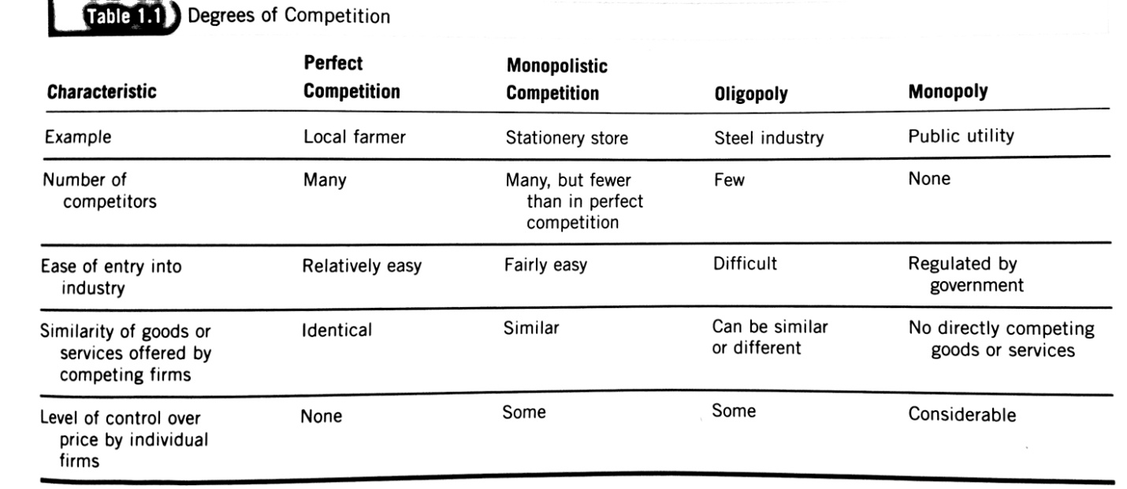
CHAPTER 2
LECTURE 3 - Understanding the Environment of Business
Focus: Measures of economic performance →Gross Domestic Product, GDP/capita, Productivity, Unemployment, Inflation
Purpose of an Economic System
- Assemble/organise resources
- Make thing people want so people will buy them
- Creative profits for business
- So everyone will be better off
Economic Environment
- External environment: everything outside an organization's boundaries that might affect it.
- Economic environment: conditions of the economic system in which an organization operates.
Measuring Economic Performance
Is the economic system producing:
- lots of things that people want?
- more things every year?
- quickly and efficiently?
- using all available resources at reasonable prices?
Economic Growth
- Business Cycle
- Economic growth is measured by the business cycle which is a pattern of short term ups and downs in an economy. It has four phases.
    - Peak
    - Recession: Period during which aggregate output declines. Prolonged period of severe recession is called a depression.
    - Trough
    - Recovery
- Aggregate Output and the Standard of Living
- Aggregate output: Main measure of growth in Business. Total quantity of goods and services produced by an economic system during a given period.
- Standard of Living: Total quantity and quality of goods and services that a country's citizens can purchase with the currency used in their economic system. Growing economic system = improving standard of living.

Gross Domestic Product (GDP) Growth
Total value of all goods and services produced within a given period by a nation economy through domestic factors of production.
- GDP is the preferred method over GNP
- Growth depends on output increasing at faster rate than population
- Growing GDP → more people making more stuff, Falling GDP → fewer people making less stuff (this is called recession)
- Real GDP: GDP calculated to adjust and account for changes in currency values and price changes
- Nominal GDP: GDP measured in current dollars or with all components valued at current prices (not adjusted).
- Purchasing Power Parity: principle that exchange rates are set so that the prices of similar products in different countries are about the same. Give better sense of standards of living around the world.
- GDP per Capita: GDP = total size of an economy, GDP per capita = relative wealth

Gross Nation Product (GNP)
Total values of all goods and services produced by a national economy within a given period regardless of where the factors of production are located.
- Profits earned by a Canadian company abroad are included in GNP, but not in GDP. Conversely, profits earned by foreign firms in Canada are included in GDP.
- GDP and GDP are useful measures of economic growth because they allow us to track an economy's performance over time.
- Genuine Process Indicator (GPI) is a more realistic measure proposed by an organization called Redefining Process to asses economic activities. It treats activities that harm the environment or our quality of life as costs and gives them negative values.
Productivity
- Ability to make things quickly and efficiently
- Some countries are more richer than others because they are more productive
- Ratio of inputs (time/money) and outputs (products/services)
- Balance of trade: total of country's exports (sales to other countries) minus its imports (purchases from other countries).
- Positive trade of balance = more exports than imports.
- National debt: total amount of money the government owes its creditors
- Budget deficit: result of the government spending more in one year than it takes in during that year.

Economic Stability:
- Stability: conditions in an economic system which the amount of money available and quantity of goods and services produced are growing at about the same rate.
- Factors that threaten stability: inflation, deflation, and unemployment
Unemployment
- Labour (a key factor of production) is under-utilised
- People would like to work - but can't find work and are actively looking for work
Inflation
- Prices for goods going up → People buying less
- Consumer Price Index (CPI): Measure of the prices of typical products purchased by consumers living in urban areas
- Deflation (Consumer Prices): During recession, when demand falls, some prices can fall
- Refer to textbook for further detail
Managing the Canadian Economy
The government manages the economic system through two sets of policies
- Fiscal policies: Policies by means of which government collect and spend revenues.
- Monetary policies: Policies by means of which the government controls the size of the nation's money supply.
- Stabilization policy: Government policy embracing both fiscal and monetary policies whose goal is to smooth out fluctuations in output and unemployment and to stabilize prices.
The Business Environment
- Three important elements of business environment: taxation, the value of the Canadian dollar, the need for educated/skilled workforce.
- The Industry Environment: Managers analyze 5 important sources of competitive pressure which help them make up their competitive strategy.
- Rivalry among existing competitors: competition in price, advertising, customer service.
- Threat of potential entrants: easy for new competition to enter market
- Suppliers: bargaining power is influenced by number of substitute products available
- Buyers: only few buyers and many suppliers
- Substitutes: many substitute products are available
Emerging Challenges and Opportunities in the Business Environment
- Most businesses are dealing with challenges and opportunities by focusing on their Core competency: Skills and resources with which an organization competes best and creates most value for owner
- Outsourcing: Strategy of paying suppliers and distributors to perform certain business processes or to provide needed materials or services.
- E.g. Museum, who main line of business is their exhibits, will hire a catering company to run the cafeteria because it is their main line of expertise.

CHAPTER 3
LECTURE 4 - Entrepreneurship and Small Businesses
Focus: Small businesses → scale/importance in Canada, failure and success | Entrepreneurs → psychological and demographic characteristics
Intro
Canada is a market economy which means
- Anyone may start a business with no fees, no government permission
- 380 new business are created everyday
- New venture/firm: a recently formed commercial organization that provides goods/and or services for sale.
Small Businesses
- Textbook definition: owner-managed business with less than 100 employees
- Tricky to define because it's impossible to know how many
- Failure rates: It's easy to start a business, but easy for a business to fail.
- Private sectors: the part of the economy that is made up of companies and organizations that are not owned of controlled by the government
- Refer to textbook for further detail on rates in Canada
Entrepreneurs
Personality traits: High "need for achievement, "Internal" Locus of Control, Risk Tolerance, Self Confident.
- Need for Achievement
Three basic human motivations for entrepreneurs
- Seek challenges
- Set goals
- Take risks
- Refer to slides for "needs motivation" theory

- Locus of Control
A person's belief about what causes good or bad results in their life.
- Internals: Believe that events result from their own behaviour and actions
- Externals: Believe that powerful others, fate, or chance determine events

- Risk Tolerance
- Entrepreneurs recognize opportunities, assemble and mobilize resources, and assume risks to realize rewards.
Identifying Opportunities
Identifying opportunities involves generated new ideas, screen those ideas, and then developing the opportunity.
- Idea generation:
- Abandoning traditional assumptions of how things should work and seeing what others do not.
- Most new ventures do not emerge from deliberate search for a viable business idea. Instead most idea comes from work experiences and personal hobbies.
- Screening:
- Weeding out the dead-end ideas and devoting more time and effort into the ones that remain.
- The opportunity is greater when the idea:
- creates or adds value for the customer that solves a significant problem.
- provides a competitive advantage that can be sustained.
- marketable and financially viable for customers to be willing enough to buy product (sale forecasts help by estimating how much of a product or service will be purchased by prospective customers of a specific period).
- has low exist costs so the venture can shut down without a significant loss of time, money, and reputation.
- Developing the Idea:
- After dead-end venture ideas are weeded out, a business plan is developed; a document that described the entrepreneur's proposed business venture; explains why it is an opportunity; and outlines its marketing plan, its operational and financial details, and its managers skills and abilities.
- New ventures use one of three main entry strategies; they introduce a totally new product/service, they introduce an existed product/service with a new twist, or they franchise
Financial Resources
There are 2 main types of financing- debt and equity.
- Debt financing is money that is borrowed
- to obtain this financing, the entrepreneur must have collateral - assets that a borrower uses to secure a loan or other credit, and that are subject to seizure by the lender if the loan isn't repaid according to the specified repayment terms.
- the most common sources of debt financing include:
- Financial institutions: banks are usually the main provider but are risky to get loans from.
- Suppliers: suppliers provide goods/services to the entrepreneur with an agreement to bill them later (trade credit).

- Equity financing is money that the entrepreneur invests in a business in return for an ownership interest.
- Most common sourced of equity include
- Personal savings: personal finances saved up by entrepreneur.
- Love money: investments from friends, relatives, and business associates.
- Private investors: wealthy business entrepreneurs, also known as angels, who with to recycle their wealth by investing in a new business.
- Venture capitalists: Venture capitalists, the most difficult to be financed by, invests money and owns equity in the companies it invests in.
Buying an existing business vs. Buying a franchise
- Buying a existing business:
- odds of success are better since an existing business has already proven its ability to attract customers
- a special case of buying an existing business is taking over a family business. Family business often has a strong reputation and employee loyalty that results in important community and business relationships
- Buying a franchise:
- an arrangement that gives franchisees (buyer) the right to sell the product/service of the franchiser (seller)
- a franchising agreement stipulates the duties and responsibilities of the franchisee and franchise
- 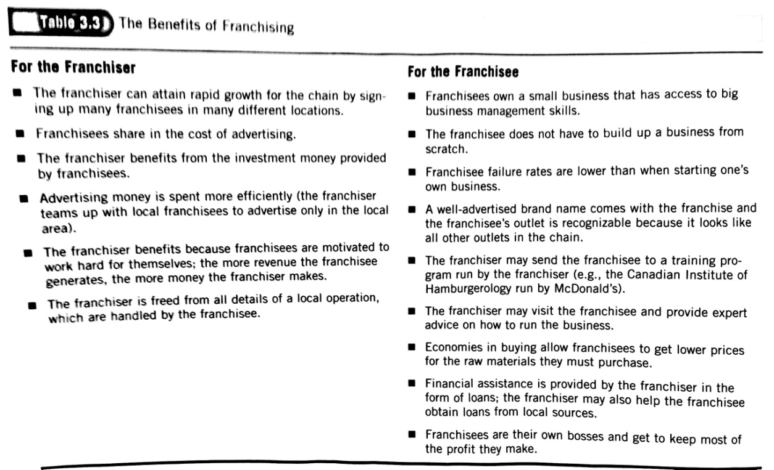

Success and Failure In Small Business
Reasons for Success
- Hard work, drive, and dedication: owners must put in the time and effort to make it happen.
- Market demand for product/service: careful analysis of market conditions can help owners asses the probable reception of their products.
- Managerial competence: owners must have solid understanding of how to manage a business through training, experience, or expertise of others.
- Luck: can also play a role in the success of some firms,
Reasons for Failure
- Managerial incompetence or inexperience: some entrepreneurs put their faith in common sense, overestimate their own managerial skills, or believe the hard work alone ensures success. Mangers must know how to make basic business decisions and principles to succeed in the long run.
- Neglect: Entrepreneurs try to launch ventures in the spare time or limited time. Starting a business damans an overwhelming time commitment.
- Weak control systems: managers need to be alerted of potential problems in order to keep a business on track.
- Insufficient capital: some entrepreneurs are overly optimistic about how soon they'll start earning profits that they don't have enough capital to operate after a few months.

CHAPTER 4
LECTURE 5 - Form of Business Organization
Focus: 3 main forms of organization → Sole proprietorship, Partnership, Corporations
Sole Proprietorship
- A business owned/operated by one person
- Easiest way to form a business and most common form of ownership
- Sole proprietor: makes all decisions, keeps all profits, responsible for all debts
- Advantages vs. Disadvantages
- Advantages:
        - Easy and cheap to set up
- Disadvantages:
- Limits to owner's skills and resources
- Hard to get financed
- Personal and unlimited liability
Terminology
- Personal Liability
- Personally responsible to pay any bills, settle any law suits, and pick up all the pieces if things go wrong
- Unlimited Liability
- Person liability for all debts of business
- Financial responsibility is not limited to the value of the job or assets used on job
- If things go wrong, you can be sued for money and lose your house, car, life savings, etc.
- Joint and Several Liability
- Each partner is responsible for debts of partnership, even when inccured by another partner
Partnership
- A business owner/operated by two or more people acting together
- Advantages vs. Disadvantage
- Advantages:
- Two or more heads are better than one
- More resources (human and financial)
- More credibility (more than one owner)
- More contacts (potential customers)
- Disadvantages:
- Conflict (more than one owner)
- Personal liability and unlimited liability
- Joint and several liability
- Partnership Agreements:
- how much money each partner contributed
- what each partner must do
- how the partners paid
- how profits are distributed
- between partners only → not binding on others
- Two types of Partnership:
- General Partnership
- All partners share in ownership and management
- All partners have unlimited and personal liability for debts
- Limited Partnership
- Partnership with partners who take no part in management
- Limited partners supply money only
- Have limited liability (can only lose their investment)
Corporations
- A legal entity, authorized to operate a business that is responsible for its own debts
- Owned by shareholders with limited liability
- Types of corporations
- Public corporation: a business whose shares a widely held and available for sale to the general public.
- Private corporation: a business whose shares are held by a small group of individuals and is not usually available for the sale to the general public.
- Most new corporations start off ass private because few investors are willing to buy an unknown stock. As the corporation develops, it may issue a share to the public as a way of raising additional money - this is called IPO.
- Initial Public Offering (IPO): Sale of shares in a company for the first time to the general investing public.
- Formation of corporation
- Founders of business ("incorporators") must complete all necessary legal documents
- Names of corporations must include: Limited/Limitée, Ltd/ Ltée, Incorporated (Inc), or Corporation (corp) to signify business as a corporation
- Owners and management are now the same
- Owner's liability is limited
- Shares
- The corporation now sells shares to anyone who wants to invest in it →the shareholders own the corporation
- Investor pays for share and receives piece paper that shows evidence of ownership
- Managing
- Shareholders elect the board of directors to represent them and they run the corporation for the owners.
- Inside directors: members of corporation board of directors who are also full-time employees of the corporation.
- Outside directors: members of a corporation's board of directors who are not also employees of corporation.
- Chief executive officer: person responsible for the firm's overall performance.
- Advantages and Disadvantages
- Advantages:
- limited liability
- continuity: since corporation's life is independent of its founders and owners, a corporation can, in theory, continue forever.
- shares expand the number of investors and amount of available funds.
- Disadvantages:
- very costly
- needs legal help in meeting government regulations because they are far more heavily regulated than proprietorships and or partnerships.
- Redrawing Corporate Boundaries
Successful companies are redrawing traditional organizational boundaries by joining with other companies to develop new goods and services.
- Acquisitions and Mergers:
- Acquisition: one firm buys another firm and absorbs it into its operations.
- Friendly takeover: management of the acquired company welcomes the firm's buyout by another company.
- Hostile takeover: management of the acquired company fights the firm's buyout by another company.
- Merger: the union of two companies to a single new business (more collaborative than acquisition).
- Horizontal merger: union of two firms that have been previously been direct competitors in the same industry.
- Vertical merger: union of two firms that have previously had a buyer-seller relationship (supplier/customer).
- Conglomerate merger: union of two firms in completely unrelated business.
- Divestitures and Spinoffs:
- Divestiture: occurs when a company sells part of existing business operations to another company.
- (e.g. Unilever- maker of close up tooth paste, dove soap, Vaseline, and q-tips- at one time owned several speciality chemical business that made ingredients for its consumer products and the company decided to put its focus on consumer products so they sold the chemical business to another chemical company.)
- Spin off: strategy of setting up one or more corporate units as new, independent corporations because a business unit might be more valuable as a separate company.
- (e.g. PepsiCo spun off pizza hut, taco bell, and kfc into a new separate corporation called Yum! Brands Inc.)

CHAPTER 5
LECTURE 6 - International Business
Focus: International Trade, Open Economy, Importance of Trade in Canada, NAFTA, Competitive Advantage, Imports and Exports
International Business
- Business activities that involve exchanges across national boundaries
- Canada is an "open economy" because it raises living standards
- open to trade
- open to flow of goods and services across border2
Importance of Trade
Globalization: the integration of markets globally
- Competitive advantage
- No country can make everything quickly, cheaply, and well
- Some countries are better equipped than others to make particular products
- Forms of Competitive Advantage:
- Absolute Advantage: a nation can produce some goods or services more cheaply or better than in any other countries (e.g. maple syrup in Canada)
- Comparative Advantage: a nation chooses to specialize - It makes some products more cheaply or better than other products that it could make - but doesn't (e.g. Canada chooses to specialize in hockey players)
- National Competitive Advantage: a country will be inclined to engage in international trade when four conditions are favourable:
- Factor conditions (factors of production)
- Demand conditions: reflect a large domestic consumer base that promotes strong demand for innovative products/
- Related and supporting industries: include strong local or regional suppliers and/or industrials customers.
- Strategies. structures, and rivalries: refer to firms and industries that stress cost reduction, product quality, higher productivity, and innovate new products.
- International Competitiveness: ability of country to generate more wealth than its competitors in world markets.
- Import
- Products that are made or grown abroad and sold in Canada
- We import because it's faster, cheaper, and easier to buy other things from elsewhere
- This creates jobs, investments, and profits for another country
- Export
- Products are that made or grown in Canada that are sold abroad
- We export because it's faster, cheaper, and easier to make some things here
- This creates jobs, investments, and profits in Canada
Import-Export Balances
- Balance of trade: difference in value between a country's total exports and it's total imports.
- Trade surplus: occurs when a country exports more than it imports.
- Trade deficit: occurs when a country imports more than exports.
- Balance of payments: flow of money in or out of a country
- An unfavourable balance means more money is flowing out than in
- For Canada to have a favourite balance, the total of our exports, foreign tourists spend in the country, foreign investments here, and earnings from overseas investments must be greater than the total of our imports, Canadian tourist spending overseas, our foreign aid grants, our military spending abroad, the investments made by Canadian firms abroad, and the earnings of foreigners from their investments in Canada.
Exchange Rates
- The balance of imports and exports between two countries is affected by the rate of exchange between their currencies.
- An exchange rate is ratio of one currency to another.
- A currency is said to be "strong" if when demand for it is high.
- Fluctuation in exchange rates can have an impact of the balance of trade.
- (e.g. if Canadian dollar is stronger in relation to British pound, all prices of all Canadian-made products would rise in England while all English-made products would fall in Canada. As a result, English would buy fewer Canadian-made products while Canadians would be prompted to spend more on English-made products → A Canadian trade deficit with England)
- One of the most significant development in foreign exchange has been the introduction of the euro- a common currency amongst most of members of the European Union.
International Organizational Structure
- Different levels of involvement in international business requires different kinds of organizational structure.
- Independent agents: a foreign individual, an organization, who agrees to represent an exporter's interests n foreign markets.
- Licensing arrangement: an arrangement by an owner of a process or product to allow another business to produce, distribute, or market it for a fee or royalty.
- Branch offices: a location that an exporting firm establishes in a foreign country in order to sell in products more effectively.
- Strategic alliances: an enterprise in which 2 or more persons or companies temporarily join forces to undertake a particular project.
- Foreign Direct Investments (FDI): buying or establishing tangible assets in another country.
Barriers to International Trade
Social, cultural, economic, legal, and political differences act as barriers to international trade.
- Social and cultural differences:
- Any firm involved in international business needs to understand something about the society and culture of the countries in which it plans to operate.
- Language barriers can cause inappropriate naming of products, physical stature of different ethnicities, and differences in the average age of the local population can also have effects for product development and marketing.
- Knowledge of do's and don'ts is important in international business activity.
- Economic differences:
- A foreign firm doing business in a command economy must understand the unfamiliar relationship of the government to business, including a host of the individual's unique practices.
- Legal and Political Differences:
- Quotas: a restriction by one nation on the total number of products of a certain type that can be imported from another nation.
- Embargo: a government order forbidding exportation and/or importation of a particular product (ultimate form of quota).
- Tariff: a tax levied on imported products.
- A revenue tariff is imposed strictly to raise money for the government.
- Subsidy: a government payment to help domestic business compete with foreign firms.
- Protectionism: protecting domestic business at the expense of free market competition.
- Local-Context Laws: laws requiring that products sold in particular country be at least partly made in that country.
- Business-Practice laws: laws or regulations governing business practices in given countries.
- Cartels and Dumping:
- Cartels: an association of producers whose purpose is to control the supply and price of a given product.
- Dumping: selling a product of less abroad than in the producing national; illegal in Canada.
Free Trade Agreements
- The European Union (EU) : Agreement among major Western European nations to ultimate or make uniform most trade barriers affecting group members.
- North American Free Trade Agreement (NAFTA)
- Agreement to gradually eliminate tariffs and other barriers among the US, Canada, and Mexico. Took effect in 1989.
- Promotes trade between Canada, USA, and Mexico
- Majority of Canadians were opposed to free trade prior to its introduction. They feared:
- Jobs would be lost to other countries.
- Canada would be flooded with products manufactured in lower-wage countries like Mexico.
- Canada would lose the right to control its own environmental standards.
- The US might take out natural resourced.
- Canadian cultural authority to govern itself would be lost.
- Supporters of free trade argued:
- Access to US markets would be guaranteed and would protect Canadian employment.
- Canadian exports would increase.
- Environment was not covered in free trade agreements.
- There was nothing in the free trade agreement that threatened Canada's control over tariffs.
- The free trade agreement was about trade and tariffs, not cultural sovereignty.
- Actual noticeable effects after NAFTA took effect include:
- NAFTA has created much more active North American market.
- Direct foreign investments has increased in Canada.
- U.S. imports from (and exports to) Mexico have increased.
- Canada has become an exporting powerhouse.
- Trade between US and Canada has risen sharply and Canada enjoys a large trade surplus with the US.

