MAAE 2300: Fluid Mechanics I

Lab Experiment #1
“Flow Through a Venturi Meter”

Katelynn Bolster
100878176
katelynnbolster@cmail.carleton.ca
October 21, 2014

Group L2B:
William Zorratto
Sagar Rash
Jonah Veenendaal
Wael Daas
Summary:
This experiment was performed to aid in our understanding of pressure and flow rates as discussed in class, using Bernoulli’s equation with simplifying assumptions to determine/calculate these parameters. This experiment made use of a Venturi meter to allow for the comparison of real flow behavior and simplified flow behavior. It also helped us understand the physical meaning of the terms static, stagnation, and dynamic pressures.

Nomenclature:
Given constants
g = gravitational acceleration = 9.81 m/s²
P_{atm} = standard atmospheric pressure = 101325 Pa
ρ_{water} = density of water = 1000 kg/m³
ρ_{air} = density of air = 1.23 kg/m³
D_{in} = intake diameter = 1.045 in
D_{th} = throat diameter = 0.707 in

Other symbols
P = gauge pressure
P_{s} = static pressure (Pa)
P_{d} = dynamic pressure (Pa)
P_{stag} = stagnation pressure (Pa)
C_{v} = Venturi coefficient
A_{in} = cross sectional area of intake (m²)
A_{th} = cross sectional area of throat (m²)
V_{in} = velocity at intake (m/s)
V_{th} = velocity at throat (m/s)
Q_{actual} = actual volume flow rate (m³/s)
Q_{ideal} = ideal volume flow rate (m³/s)
h = height of water in the Pitot taps (m)
y = ideal radius of Venturi (cm)
x = distance from beginning of slope of the Venturi (cm)

Flow Analysis:
We start with Bernoulli’s Equation:
$P_{atm}+\frac{1}{2}ρ_{water}v_{in}^{2}+ρ_{water}gh=P_{th}+\frac{1}{2}ρ_{air}v_{th}^{2}+ρ_{water}gh$ (1)

And since all the static taps are at the same height (h = 0), we can say that
$P_{atm}-P_{th}=\frac{1}{2}ρ_{air}v_{th}^{2}-\frac{1}{2}ρ_{water}v_{in}^{2}$ (2)

Then to find the pressure at the point of each Pitot tube, we use
$P_{atm}-P_{th}=ρ_{water}gh$ (3)

Putting equations 2 and 3 together, and since v_{in} = 0, we get:
$ρ_{water}gh=\frac{1}{2}ρ_{air}v_{th}^{2}$ (4)

Rearranging Equation 4, we can solve for the velocity at any tap, v_{i}:
v_{i} = $\sqrt{\frac{2ρ_{water}gh_{i}}{ρ_{air}}}$ (5)

To obtain Q_{actual} we use the formula:
$Q_{actual}=A_{in}v_{in}$ (6)

To obtain Q_{ideal} we start with a rearranged continuity equation:
$v_{in}= \frac{A_{th}v_{th}}{A_{in}}$ (7)

Then substituting v_{in} from Equation 7 into Equation 2, we get:
(8)

And solving Equation 8 for v_{th} and substituting in Equation 3:
$v_{th}=\sqrt{\frac{2ρ_{water}gh}{ρ_{air}\left(1-\frac{A_{th}^{2}}{A_{in}^{2}}\right)}}$ (9)

The following formula can be derived to find the ideal flow rate:
Q_{ideal} = A_{th}v_{th} (10)

And finally, this equation was used to find the Venturi Coefficient:
$C_{V}=\frac{Q_{actual}}{Q_{ideal}}$ (11)

To find the actual pressure at each Pitot tap:
$P_{i}=P_{atm}-\frac{1}{2}ρ_{air}{\left[\frac{Q_{actual}}{A_{i}}\right]}^{2}$ (12)

The following equations calculate Static Pressure, Dynamic Pressure and Stagnation Pressure, respectively:
$P_{s}=P_{atm}-ρ_{water}gh$ (13)
$P_{d}=\frac{1}{2}ρ_{air}v_{th}^{2}$ (14)
(15)

The slope of the Venturi, starting from the beginning of the taper through tap 9 (the throat), is assumed to be linear and follow the below relationship:
$y=2.6543-0.09133x$ (16)

The slope of the Venturi, between tap 10 and the end of the tapering of the Venturi, is assumed to be linear and follow the below relationship:
$y=1.79578+0.06707x$ (17)

And subbing y into the area of a circle equation, we get the Venturi Area at any tap, where $Δx$ is in cm, measured from the beginning of the tapering of the Venturi:
$A(taps 1-9)=π\left[{\left(2.6543-0.09133Δx\right)}^{2}x{10}^{-4}\right]$ (18)
$A(taps 10-16)=π\left[{\left(2.6543-0.09133Δx\right)}^{2}x{10}^{-4}\right]$ (19)

Experimental Setup and Procedure:
This experiment was conducted in accordance with the instructions outlined for Experiment 1 in the lab manual (“MAAE 2300: Fluid Mechanics I, Course Manual”, S.A. Sjolander, 2014), with no major deviations. The set-up for this experiment is illustrated below:
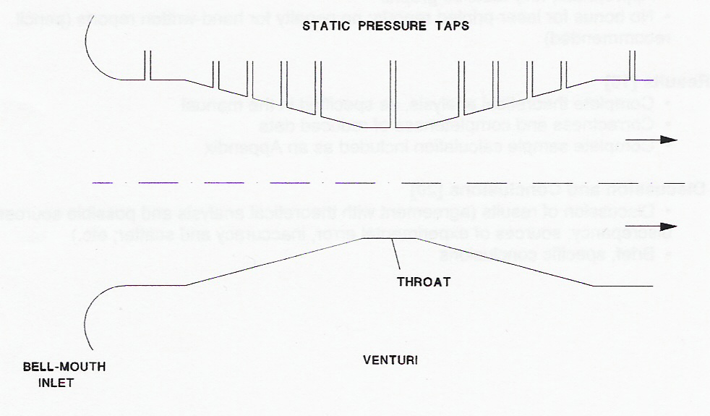

y

Δx

Results and Discussion:
The experiment was conducted with two different flows, named Flow 1 and Flow 2 accordingly. Example calculations will be shown for Flow 1 only, with the results for Flow 2 being listed as well.

1) Firstly we want to find the Venturi Coefficient for each of the flows. The sample calculations are as follows.
Steps to find C_{v} for the flow 1:
We use eqn (5) at tap 1 to find the inlet velocity, v_{in}:
v_{in} = $\sqrt{\frac{2ρ_{water}gh}{ρ_{air}}}=\sqrt{\frac{2(1000)(9.81)(0.044)}{1.23}}=26.493 m/s$

We use eqn (18) at tap 1 to find the inlet area, A_{in}:
$A_{(tap 1)}=π\left[{\left(2.6543-0.09133(1.32715)\right)}^{2}x{10}^{-4}\right]=5.53337x{10}^{-4} m^{2}$

We use eqn (18) again, this time at tap 9, to find the area of the throat, A_{th}:
$A_{\left(tap 9\right)}=π\left[{\left(2.6543-0.09133\left(0.897899\right)\right)}^{2}x{10}^{-4}\right]=2.5328x{10}^{-4} m^{2}$

Using eqn (5) again, this time at tap 9, we can find the velocity at the throat, v_{th}:
v_{th}= $\sqrt{\frac{2ρ_{water}gh}{ρ_{air}}}=\sqrt{\frac{2(1000)(9.81)(0.221)}{1.23}}=59.3736 m/s$

The using eqns (6) and (10) we can calculate Q_{actual} and Q_{ideal}, respectively:
$Q_{actual}=A_{in}v_{in}=\left(5.53337\right)\left(26.493\right)=0.0146596 m^{3}/s$
$Q_{ideal}=A_{th}v_{th}=\left(2.5328\right)\left(59.3736\right)=0.015038 m^{3}/s$

And then finally using eqn (11), we can solve for the Venturi Coefficient:
$C_{V}=\frac{Q_{actual}}{Q_{ideal}}=\frac{0.0146596}{0.015038}=0.97482$

The value of the C_{v} for Flow 2 was: 0.95897

The Cv rates for both flows were very close to 1, meaning that our calculations using Bernoulli’s equation are a very accurate estimation. We know that the simplifying assumptions that we made in using Bernoulli’s equation (i.e. 1-D, frictionless, incompressible flow) do not perfectly accurately represent the flow, but we can see from this experiment that they do provide us with a fairly accurate way to analyze flows.
Tables of values recorded for Flow 1 and Flow 2, as well as distances between each of the Pitot taps taken during the experiment can be found in Appendix A.
Tables of values calculated for Flow 1 and Flow 2 can be found in Appendix B.

2) Graphs

4) Using equations (13), (14), and (15), we can calculate the static, dynamic, and stagnation pressures for flows 1 and 2. An example calculation is done for Flow 1:
$P_{s}=P_{atm}-ρ_{water}gh=101325-\left(1000\right)\left(9.81\right)\left(0.313\right)$
$=9.825447e+04 Pa$
$P_{d}=\frac{1}{2}ρ_{air}v_{th}^{2}=\frac{1}{2}\left(1.23\right){\left(59.3736\right)}^{2}$
$=3.07053e+03 Pa$
$P_{stag}=P_{s}+P_{d}=101325 Pa$

For Flow 1:
Static P: 98254.47 Pa
Dynamic P: 3070.53 Pa
Stagnation P: 101325 Pa

For Flow 2:
Static P: 96449.43 Pa
Dynamic P: 3070.53 Pa
Stagnation P: 99519.96 Pa
4) The flow through the Venturi meter linearly increases in velocity as the Venturi meter decreases in area approaching the throat (Pitot tube 9), and reaches a maximum velocity at tube 9; then it linearly decreases as the Venturi meter increases in area. The pressure in the Venturi meter behaves in an opposite manner, linearly decreasing with the decrease in area of the Venturi meter, to a minimum at the throat, and then increases linearly as the area of the Venturi meter increases again after the throat.
The trends in actual and ideal static pressures shown in graphs 2 and 3, for Flow 1 and Flow 2 respectively, are in accordance with the Venturi coefficient calculated in Part 1. The actual static pressure for each of the flows very closely matches the ideal static pressure for the flow. Because our Venturi coefficients for Flow 1 and Flow 2 were very close to 1, the actual static pressures for each of the two flows very closely match the ideal static pressures for their respective flows.
Below are three approximate velocity profiles for the flow through the Venturi meter. The first figure, (i), is the velocity profile at the upstream end of the venturi; (ii) is the velocity profile at the throat of the Venturi; and (iii) is the velocity profile near the downstream end of the Venturi.

Conclusions:
The Venturi coefficients for Flow 1 and Flow 2 were $0.97482$ and 0.95897, respectively. As these values are both close to 1, we can observe that Bernoulli’s equation gave us a good approximation of our calculations for both flows, however we see that for Flow 1, the slow flow, our calculations were more accurate than for Flow 2, the faster flow, because C_{v(1)} is closer to 1. We know that using Bernoulli’s equation will not give us perfectly accurate results because of the simplifying assumptions that need to be made to use the equation, such as assuming a 1-D, frictionless, incompressible flow in the Venturi meter. We also found that the static, dynamic, and stagnation pressures for Flow 1 were 98254.47 Pa, 3070.53 Pa, and 101325 Pa, respectively; and for Flow 2 they were 96449.43 Pa, 3070.53 Pa, and 99519.96 Pa, respectively. This lab experiment gave us a good insight into how Bernoulli’s equation can be applied using simplifying assumptions for a real flow, and the physical meanings of static, dynamic and stagnation pressures. Accuracy of this experiment could be improved by taking multiple measurements for many different flows and taking temperature measurements to determine whether there’s a change in density of the fluid.
Appendix B – Tables of Values for Flow 1 and Flow 2:

The below data was calculated/analyzed using Matlab.
The results from the sample calculations shown in the “Results and Discussion” section were calculated by hand.
As a result, the below values are more accurate than those previously shown in this report.

FLOW 1 (all pressures in Pa)
--------------------
Tube h (m head) x (cm) y (cm) A (m^2) V (m/s^2) Gauge Pressure Actual Pressure Ideal Pressure
1 0.1360 0.0000 1.3272 0.000553337 46.576451707 -431.6556 100893.3444 100870.7703
2 0.1360 0.0000 1.3272 0.000553337 46.576451707 -431.6556 100893.3444 100870.7703
3 0.1370 1.0000 1.2815 0.000515914 46.747375040 -496.5504 100828.4496 100802.4818
4 0.1470 2.5000 1.2130 0.000462235 48.423437180 -618.5746 100706.4254 100674.0761
5 0.1580 3.5000 1.1673 0.000428087 50.202516699 -721.1971 100603.8029 100566.0868
6 0.1780 5.0000 1.0988 0.000379321 53.285242546 -918.5510 100406.4490 100358.4120
7 0.2010 6.0000 1.0532 0.000348448 56.623273677 -1088.5290 100236.4710 100179.5448
8 0.2360 7.2000 0.9984 0.000313131 61.355421968 -1347.9235 99977.0765 99906.5848
9 0.3130 9.4000 0.8979 0.000253282 70.659264837 -2060.1909 99264.8091 99157.0684
10 0.3050 11.6000 0.9717 0.000296611 69.750426172 -1502.2501 99822.7499 99744.1875
11 0.2370 12.8000 1.0119 0.000321687 61.485274858 -1277.1734 100047.8266 99981.0349
12 0.2220 13.8000 1.0454 0.000343362 59.507736738 -1121.0182 100203.9818 100145.3565
13 0.1920 15.2000 1.0924 0.000374895 55.341071062 -940.3697 100384.6303 100335.4523
14 0.1800 16.4000 1.1326 0.000403023 53.583761647 -813.6872 100511.3128 100468.7598
15 0.1700 17.5000 1.1695 0.000429704 52.074056084 -715.7797 100609.2203 100571.7875
16 0.1610 20.2000 1.2605 0.000499171 50.676881726 -530.4182 100794.5818 100766.8428

Static Pressure: 9.825447000000000e+04 Pa
Dynamic Pressure: 3.070530000000001e+03 Pa
Stagnation Pressure: 101325 Pa

FLOW 2 (all pressures in Pa)
--------------------
Tube h (m head) x (cm) y (cm) A (m^2) V (m/s^2) Gauge Pressure Actual Pressure Ideal Pressure
1 0.1660 0.0000 1.3272 0.000553337 51.457773359 -774.7798 100550.2202 100482.5285
2 0.1650 0.0000 1.3272 0.000553337 51.302545936 -774.7798 100550.2202 100482.5285
3 0.1660 1.0000 1.2815 0.000515914 51.457773359 -891.2596 100433.7404 100355.8719
4 0.1860 2.5000 1.2130 0.000462235 54.469503663 -1110.2813 100214.7187 100117.7145
5 0.2040 3.5000 1.1673 0.000428087 57.044270356 -1294.4787 100030.5213 99917.4240
6 0.2420 5.0000 1.0988 0.000379321 62.130468548 -1648.7098 99676.2902 99532.2442
7 0.2870 6.0000 1.0532 0.000348448 67.660919296 -1953.8036 99371.1964 99200.4945
8 0.3530 7.2000 0.9984 0.000313131 75.038526690 -2419.3916 98905.6084 98694.2286
9 0.4970 9.4000 0.8979 0.000253282 89.037947514 -3697.8423 97627.1577 97304.0810
10 0.4700 11.6000 0.9717 0.000296611 86.585640673 -2696.3928 98628.6072 98393.0261
11 0.3520 12.8000 1.0119 0.000321687 74.932164444 -2292.4020 99032.5980 98832.3131
12 0.3170 13.8000 1.0454 0.000343362 71.109328399 -2012.1186 99312.8814 99137.0846
13 0.2650 15.2000 1.0924 0.000374895 65.015945511 -1687.8721 99637.1279 99489.6603
14 0.2410 16.4000 1.1326 0.000403023 62.001966924 -1460.4895 99864.5105 99736.9091
15 0.2250 17.5000 1.1695 0.000429704 59.908466766 -1284.7549 100040.2451 99927.9973
16 0.2090 20.2000 1.2605 0.000499171 57.739110472 -952.0492 100372.9508 100289.7713
Static Pressure: 9.644942999999999e+04
Dynamic Pressure: 3.070530000000001e+03
Stagnation Pressure: 9.951995999999999e+04

