Chapter 13-Information and decision making
Johari Window
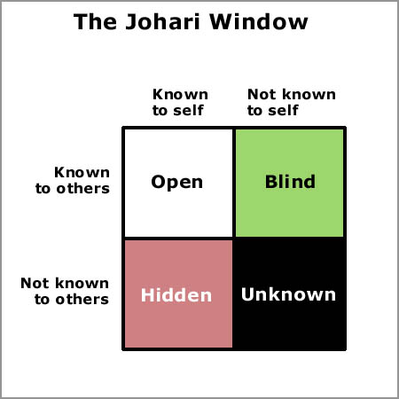
Concepts
Intellectual capital= Competency x Commitment

Globalization- Worldwide interdependence of resource flow, markets, and business economies

-Stakeholders and firms have a bilateral relationship- both need each other to make money.
-Ethics is intertwined with business success
Slent or Pestel
-A framework to look at an organization
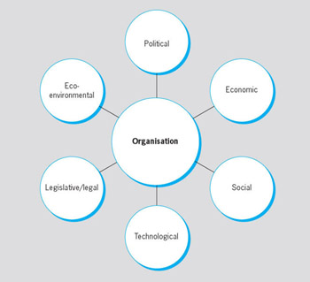

Social -cultural – Norms customs and certain values Legal political-philosophy/ objectives of the political party running Economic Environment- nature and conditions Technological- development of technology and availability of technology
POLK- Management process and advantages of IT
Planning- set objectives and how to accomplish them- more timely access to info
Organizing- assign tasks, allocate resources- all parts informed and together
Leading- build enthusiasm, inspire to achieve goals – frequent, better communication with stakeholders
Controlling- measure performance take action – timely performance info for criteria

Data does not = Information; Data is used to make information, they are not the same
5 criteria for useful Information
- Timely – Be sure of deadlines
- High quality- use with confidence
- Complete- current and up to date
- Relevant- appropriate for the task
- Understandable- clear
Ways of thinking
- Systematic- rational step by step, breaks problems down into small components, usually plans before action
- Intuitive- flexible, creative, quick, many different courses of action, willing to deal with many aspects of a problem at the same time. Also very spontaneous, best way of managing when there are limited facts
- Multi-dimensional – view many problems at once in relationship to each other, across short and long horizons. They are able to make decisions and take actions in the short run that benefit longer-run objectives
Thinkers
- Sensation Thinkers tend to emphasize the impersonal rather than the personal and take a realistic look at problem solving, they like hard "facts;' clear goals, certainty, and situations of high control. (Impersonal)
- Sensation feelers tend to both analysis and human relations; they tend to be realistic and prefer facts; they are open communicators and sensitive to feelings and values. Open communicators
- Intuitive Thinkers are comfortable with abstraction and unstructured situations. They tend to be idealistic and prone toward intellectual and theoretical positions. They are logical and impersonal but they avoid details.
- Intuitive Feelers prefer broad and global Issues. They are insightful and tend to avoid details, being comfortable with intangibles; they value flexibility and human relationships.
The Decision making process
- Find the problem
- Generate and evaluate different solutions
- Make decision and conduct ethics double check
- Implement the decision
- Evaluate results
Issues in managerial decision making
Decision errors and traps
-Heuristics are strategies for simplifying decision making
-The availability bias occurs when people use information that is "readily available" The availability heuristic from memory as a basis for assessing a current event or situation.
-Representation bias- similar to stereotypes
-The anchoring and adjustment heuristic occurs when decisions are biased by inappropriate allegiance to a previously existing value or starting point. An example is a manager who sets a decision on new salary level for an employee by simply raising her prior year's salary by a small percentage
-Framing error- This is spinning data/politics, the way it’s presented
Confirmation error- justification by seeking out confirmatory evidence and ignoring contradictory evidence
Advantages of team decisions
-Diversity – more info, expands the options
-Prevents tunnel vision
-Increases commitment

Disadvantages
-Social pressure
-There may be minority domination, where some members feel forced or "railroaded" to accept a decision advocated by one vocal individual or a small coalition

Ethical decisions
1. Utility-Does the decision satisfy all constituents or stakeholders?
3. Justice-Is the decision consistent with the canons of justice?
2. Rights-Does the decision respect the rights and duties of everyone?
4. Caring-Is the decision consistent with my responsibility to care?

Chapter 3- International Business
Licensing- A licensing agreement occurs when a firm pays a fee for rights to make or sell another companies products in a specified region.
Franchising- Involves buying the rights to use another companies and operating methods
FDI- Foreign direct investment: Building, buying part or all ownership of a business in another county
A Joint venture operates in a foreign country through co ownership; both parties share the risk and control of business operations
Foreign Subsidiary: An extension of a company in a foreign country
NAFTA- North American Free Trade Agreement: Free trade between Mexico, America, and Canada
The European Union is a political economic alliance of 28 European countries that have agreed to support mutual economic growth by removing barriers that previously limited cross-border trade and business development
When MNC’s enter other countries to do business (multi-national corporations)
Problems- Excessive profits, economic domination, interference with government, hire best local talent, disrespect for local customs
Benefits-Larger tax bases, increased employment opportunities, technology transfers the introduction of new industries and the development of local resources
MNCs complaints about host countries
Profit limitations, overpriced resources, exploitative rules, foreign exchange restrictions, failure to uphold contracts

Chapter 2 & 16
3 Assumptions on Management
Scientific approach- Frederick Taylor
- Deveop for every a job a science that includes rules of motion
- Carefully train workers
- Select workers with the right abilities for the web
- Support workers
Henri Fayol identified 14 administrative principles of management that he felt should be taught to all aspiring managers, things like:
1.Division of Labour-Specialization of work will result in continuous improvements in skills and methods.
2. Authority-Managers and workers need to understand that managers have the right to give
orders.
3. Discipline-Behaviour needs to be grounded in obedience and' derived from respect There
will be no slacking or bending of rules.
- Unity of Command-Each employee should have one, and only one, manager.
Max Webers theory- A bureaucracy Is a rational and efficient form of organization founded on logic, order, and legitimate authority. (Fairness)

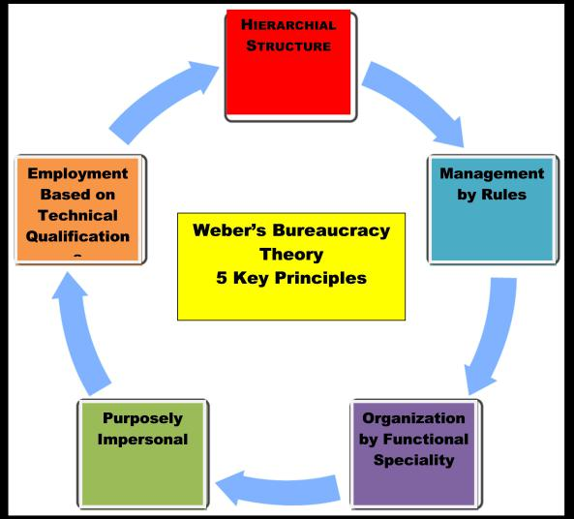

SESSP- Maslow's hierarchy of human needs
Self-actualization- Esteem needs- Social needs- Safety needs- physiological needs

McGregors theory of X and Y
Managerial assumptions
Theory x assumes that people don’t like work, they are lazy and lack ambition they like to be led
Theory y assumes that people like to work; they like responsibility and are self-dedicated

A self-fulfilling prophecy occurs when a person acts in ways that confirm another's expectations.

Management
A system is a collection of interrelated parts that function together to achieve a higher purpose
A subsystem is a smaller component of a larger system

An open system interacts with its environment in a continual process of transforming inputs from suppliers to outputs
Operations management is how organizations produce goods and services
Quality management is managing with an organization wide commitment to continuous improvement, product quality, and customer needs.

Contingency Thinking
-Tries to match managerial responses with the problems and opportunities specific to different situations
-there is no one best way to manage
-Understand situational differences and deal with them appropriately
Knowledge Management-> the process of using intellectual capital for competitive advantage
Evidence-based management Involves making decisions based on hard facts about what really works.

Continuous improvement -> Always wanting to be better
1. Mental models-everyone sets aside old ways of thinking.
2. Personal mastery-everyone becomes self-aware and open to others.
3. Systems thinking-everyone learns how the whole organization works.
4. Shared vision-everyone understands and agrees to a plan of action.
5. Team learning-everyone works together to accomplish the plan.

