Chapter 1
- Individual Choice: The decision by an individual of what to do, which necessarily involves a decision of what not to do. Basic principles behind the individual choices:
Principle #1: Resources are scarce
- A resource is anything that can be used to produce something else
- Land, labour, capital, human capital
- Resources are scarce: The quantity available isn’t large enough to satisfy all productive uses
- Ex. Petroleum, lumber, intelligence, time
Principle #2: Opportunity Cost
- The real cost of an item is its opportunity cost: what you must give up in order to get it
Principle #3: “How much?” is a decision at the margin
- You make a trade-off when you compare the costs with the benefits of doing something
- Decisions about whether to do a bit more or a bit less of an activity are marginal decisions
- Marginal analysis Ex. Hiring one more worker or studying for one more hour, etc.
Principle #4: People usually take advantage of opportunities to make themselves better off
- An incentive is anything that offers rewards to people who change their behaviour
- Ex. Well-paid jobs for economic degree graduates -> more students major in economics

- Interaction of choices- My choices affect your choices, and vice versa. Principles that underlie the interaction of individual choices:
Principle #5: There are gains from trade
- Each person specializes in the task that he or she is good at performing. The economy can produce more when each person specializes in a task and trades with others
Principle #6: Markets move towards equilibrium
- An economic situation is in equilibrium when no individual would be better off doing something different
Principle #7: Resources should be used as efficiently as possible to achieve society’s goals
- An economy is efficient if it takes all opportunities to make some people better off without making other people worse off
Principle #8: Markets usually lead to efficiency
- The incentives built into a market economy already ensure that resources are usually put to good use.
Principle #9: When markets don’t achieve effiency, government intervention can improve society’s welfare
- Individual actions have side effects not taken into account by the market
Principle # 10: One person’s spending is another person’s income
Principle # 11: Over spending sometimes gets out of line with the economy’s productive capacity
Principle #12: Government policies can change spending
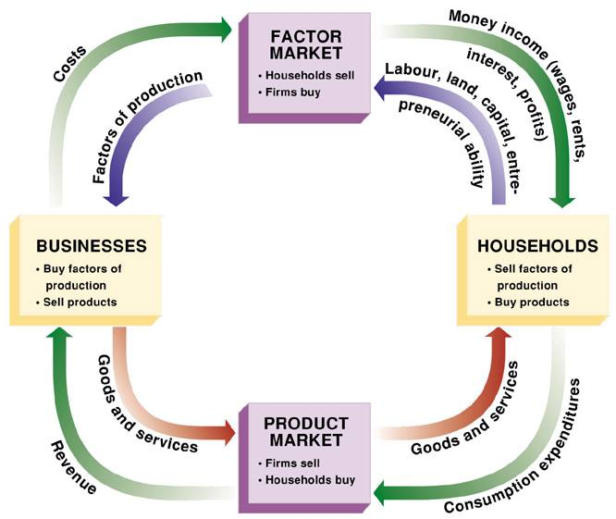

Chapter 2: Trade-Offs
- Model: is a simplified representation of a real situation that is used to better understand real-life situations. How? By…
- Creating a real but simplified economy (Ex. Cigarettes in World War ll prison camps)
- Simulating an economy on a computer (Ex. Tax models, money models, etc)
- The “Other things equal” assumption means that all other relevant factors remain unchanged
- The production possibility frontier (PPF) is a graph that we use to illustrate the trade-offs facing an economy that produces only two goods.
- An individual has a comparative advantage in producing a good or service if the opportunity cost of producing the good is lower for that individual than for other people
- An individual has an absolute advantage in an activity if he or she can do it better than other people
- The circular-flow diagram is a model that represents the transactions in an economy by flows around a circle
- Positive economics: is the branch of economic analysis that describes the way the economy actually works
- Normative economics: makes prescriptions about the way the economy should work
- A forecast: is a simple prediction of the future

Chapter 3: Supply and Demand
- A competitive market: Includes many buyers and sellers, and same good or service
- The supply and demand model: is a model of how a competitive market works
- Five key elements:
- Demand curve: is the graphical representation of the demand schedule
- Supply curve: shows graphically how much of a good or service people are willing to sell at any given price
- Demand and supply curve shifts
- Market equilibrium
- Changes in the market equilibrium
- Substitutes: Two goods are substitutes if a fall in the price of one of the goods makes consumers less willing to buy the other good
- Complements: Two goods are complements if a fall in the price of one good makes people more willing to buy the other good
- Changes in Income:
- Normal Goods: When a rise in income increases the demand for a good
- Inferior Goods: When a rise in income decreases the demand for a good
- An input: is a good that is used to produce another good
- Equilibrium in a competitive market: when the quantity demanded of a good equals the quantity supplied of that good
- Surplus: when the quantity supplied exceeds the quantity demanded. Surpluses occur when the price is about its equilibrium level
- Shortage: when the quantity demanded exceeds the quantity supplied. Shortages occur when the price is below its equilibrium level

Chapter 4: Consumer and Producer Surplus
- A consumer’s willingness to pay for a good is the maximum price at which he or she would buy that good
- Individual consumer surplus: is the net gain to an individual buyer from the purchase of a good
- It is equal to the difference between the buyer’s willingness to pay and the price paid
- Total consumer surplus (individual and total): is the sum of the individual consumer surpluses of all the buyers of a good
- The total consumer surplus generated by purchases of a good at a given price is equal to the area below the demand curve but above that price
- A fall in the price of a good increases consumer surplus through two channels:
- A gain to consumers who would have bought at the original price
- A game to consumers who are persuaded to buy by the lower price
- A potential seller’s cost is the lowest price at which he or she is willing to sell a good
- Individual producer surplus: is the net gain to a seller from selling a good. It is equal to the difference between the price received and the seller’s cost
- Total producer surplus: in a market is the sum of the individual producer surpluses of all the sellers of a good
- The total producer surplus from sales of a good at a given price is the area above the supply curve but below that price
- When the price of a good rises, producer surplus increases through two channels:
- The gain of those who would have supplied the good even at the original, lower price
- The gains of those who are induced to supply the good by the higher price
- The total surplus: generated in a market is the total net gain to consumers and producers from trading in the market. It is the sum of the producer and the consumer surplus
- Claim: The maximum possible total surplus is achieved at market equilibrium
- Property rights: are the rights of owners of valuable items, whether resources or goods, to dispose of those items as they choose
- An economic signal: is any piece of information that helps people make better economic decisions
- The three principle sources of market failure are:
- Attempts to capture more resources that produce inefficiencies
- Side effects from certain transactions, and
- Problems in the nature of the goods themselves

Chapter 5: Price Controls and Quotas
- Price Controls: Legal restrictions on how high or low a market price may go
- Price ceiling: is the maximum price sellers are allowed to charge for a good or service
- Price floor: is the minimum price buyers are required to pay for a good or service
- How price ceilings cause inefficiency:
- Inefficiently low quantity
- Deadweight loss: is the loss in total surplus that occurs whenever an action or a policy reduces the quantity transacted below the efficient market equilibrium quantity
- Inefficient allocation to customers
- Wasted resources
- Inefficiently low quality
- Black markets
- Price floor: a minimum market price above the equilibrium price, benefits successful sellers but creates persistent surplus
- Minimum wage: is a legal floor on the wage rate, which is the market price of labour
- A quantity control (or quota): is an upper limit on the quanity of some good that can be bought or sold. The total amount of the good that can be legally transacted is the quota limit
- A licence: gives its owner the right to supply a good
- The demand price: of a given quantity is the price at which consumers will demand that quantity
- The supply price: of a given quantity is the price at which produces will supply that quantity
- A quantity control, or quota, drives a wedge between the demand price and the supply price of a good; that is, the price paid by buyers end up being higher than that received by sellers
- The difference between the demand and supply price at the quota limit is the quota rent, the earnings that accrue to the licence-holder from the ownership of the right to sell the good

Chapter 6: Elasticity
- The price elasticity of demand: is the ratio of the percent change in the quantity demanded to the percent change in the price as we move along the demand curve (dropping the minus sign)
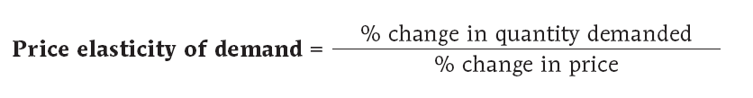
- Demand is perfectly inelastic: when the quantity demanded does not respond at all to changes in the price. When demand is perfectly inelastic, the demand curve is a vertical line
- Demand is perfectly elastic: when any price increase will cause the quantity demanded to drop to zero. When demand is perfectly elastic, the demand curve is a horizontal line
- Demand is elastic if the price elasticity of demand is greater than 1
- Demand is inelastic if the price elasticity of demand is less than 1
- Demand unit-elastic if the price elasticity of demand is exactly 1
- Total Revenue: Price X Quantity Sold
- A price effect: After a price increase, each unit sold sells at a higher price, which tends to raise revenue
- A quantity effect: After a price increase, fewer units are sold, which tends to lower revenue
- The cross-price elasticity of demand between two goods measures the effect of the change in one good’s price on the quantity demanded of the other good
The Cross-Price Elasticity of Demand between Goods A and B
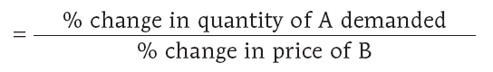
- Goods are substitutes when the cross-price elasticity of demand is positive
- Goods are complements when the cross-price elasticity of demand is negative
- The income elasticity of demand is the percent change in the quantity of a good demanded when a consumer’s income changes divided by the percent change in the consumer’s income
- When the income elasticity of demand is positive, the good is a normal good; that is, the quantity demanded at any given price increases as income increases
- When the income elasticity of demand is negative, the good is an inferior good; that is, the quantity demanded at any given price decreases as income increases
- The price elasticity of supply is a measure of the responsiveness of the quantity of a good supplied to the price of that good.
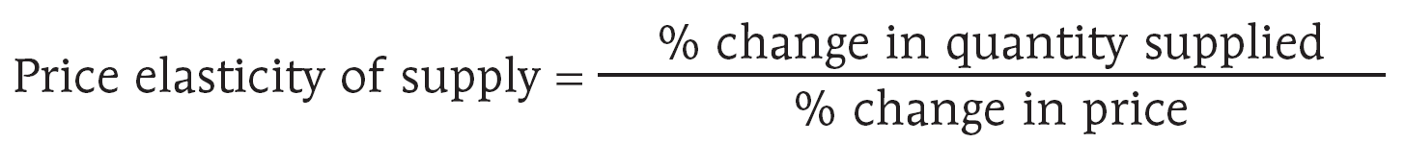
- There is perfectly inelastic supply when the price elasticity of supply is zero, so that changes in the price of the good have no effect on the quantity supplied. A perfectly inelastic supply curve is a vertical line
- There is perfectly elastic supply when even a tiny increase or reduction in the price will lead to very large changes in the quantity supplied, so that the price elasticity of supply is infinite. A perfectly elastic supply curve is a horizontal line.
- The Availability of Inputs: The price elasticity of supply tends to be large when inputs are readily available and can be shifted into and out of production at a relatively low cost. It tends to be small when inputs are difficult to obtain
- Time: The price elasticity of supply tends to grow larger as producers have more time to respond to a price change. This means that the long-run price elasticity of supply is often higher than the short-run elasticity

Chapter 7: Taxes
- An excise tax is a per-unit tax on sales of good or service
- Raise the price paid by buyers
- Reduce the price received by sellers
- Excise taxes also drive a wedge between the two prices
- The incidence of a tax is a measure of who really pays it.
- The wedge between the demand price and supply price becomes the government’s tax revenue.
- When the price elasticity of demand is low and the price elasticity of supply is high, the burden of an excise tax falls mainly on consumers.
- When the price elasticity of demand is high and the price elasticity of supply is low, the burden of an excise tax falls mainly on producers.
- The general principle is: The revenue collected by an excise tax is equal to the area of the rectangle whose height is the tax wedge between the supply and demand curves and whose width is the quantity transacted under the tax
- A tax rate is the amount of tax people are required to pay per unit of whatever is being taxed
- The administrative costs of a tax are the resources used by government to collect the tax, and by taxpayers to pay it, over and above the amount of the tax, as well as to evade it.
- Two major principles of tax fairness:
- According to the benefits principle of tax fairness, those who benefit from public spending should bear the burden of the tax that pays for that spending
- According to the ability-to-pay principle of tax fairness, those with greater ability to pay a tax should pay more tax
- A lump-sum tax is the same for everyone, regardless of any actions people take
- trade-off between equity and efficiency: the system can be made more efficient only by making it less fair, and vice versa
- The tax base is the measure or value, such as income or property value, that determines how much tax an individual or firm pays
- The tax structure specifies how the tax depends on the tax base
- Income tax: a tax that depends on the income of an individual or a family from wages and investments
- Payroll tax: a tax that depends on the earnings an employer pays to an employee
- Sales tax: a tax that depends on the value of goods sold (also known as an excise tax)
- Profits tax: a tax that depends on a firm’s profits
- Property tax: a tax that depends on the value of property, such as the value of a home
- Wealth tax: a tax that depends on an individual’s wealth
- The simplest tax structure is a proportional tax, also sometimes called a flat tax, which is the same percentage of the base regardless of the taxpayer’s income or wealth.
- A progressive tax takes a larger share of the income of high-income taxpayers than of low-income taxpayers
- A regressive tax takes a smaller share of the income of high-income taxpayers than of low-income taxpayers
- The marginal tax rate is the percentage of an increase in income that is taxed away

Chapter 8: International Trade
- Imports: Goods and services purchased from other countries
- Exports: Goods and services sold to other countries are exports
- Globalization is the phenomenon of growing economic linkages among countries
- The Ricardian model of international trade analyzes international trade under the assumption that opportunity costs are constant
- Autarky is a situation in which a country cannot trade with other countries
- The main sources of comparative advantage are: Differences in cimate, technology, and factor endowments
- According to the Heckscher-Ohlin model, a country has a comparative advantage in a good whose production is intensive in the factors that are abundantly available in that country
- The factor intensity of production of a good is a measure of which factor is used in relatively greater quantities than other factors in production
The Effects of Imports:
- The domestic demand curve shows how the quantity of a good demanded by domestic consumers depends on the price of that good
- The domestic supply curve shows how the quantity of a good supplied by domestic producers depends on the price of that good
- The world price of a good is the price at which that good can be bought or sold abroad
-
- Exporting industries produce goods and services that are sold abroad
- Import-competing industries produce goods and services that are also imported
- A tariff is a tax levied on imports
- An import quota is a legal limit on the quantity of a good that can be imported
- Offshore outsourcing takes place when businesses hire people in another country to perform various tasks

