Lab 1 Q3Question 3 [4 points]
Your solution to the question was:
During 2013 Benson Inc. had sales of $350,000. Cost of goods sold, administrative and selling expenses, and depreciation expenses were $210,000, $59,000, and $31,000 respectively. In addition, the company had an interest expense of $26,000, and a tax rate of 20 percent. (Ignore any tax loss carry-back or carry-forward provisions.)
a) What is Benson Inc.'s net income for 2013?
Net income = $63,600
Marking:
Your answer was: $63,600.00
The correct answer was: $19,200.00
To calculate net income, we want to prepare an income statement :
Net Sales |  | $350,000
Cost of goods sold |  | (210,000)
Administrative and selling expenses |  | (59,000)
Depreciation |  | (31,000)
Earnings before interest and taxes |  | 50,000
Interest paid |  | (26,000)
Income before taxes |  | 24,000
Taxes (20%) |  | (4,800)
Net income |  | $19,200
You will lose 2 marks for this part.
b) What is the operating cash flow?
Operating cash flow = $120,600
Marking:
Your answer was: $120,600.00
The correct answer was: $76,200.00
You have correctly deduced this from your earlier answers; however, at least one of your earlier answers was incorrect, causing your answer for this part to be incorrect.
You will not lose any further marks for this.
 | SPREADSHEET  PRINT  HELP

Lab 5 (Question 3)
Name: Lily Tran
Date: 2014-06-22 16:48

Question 3 [2 points]
Your solution to the question was:
Barton Corporation offers you a $45,000, 5-year term loan at 9 percent annual interest. What will your annual loan payment be?
Annual loan payment = $6,554
Marking:
Your answer was: $6,554.00
The correct answer was: $11,569.16
PVA: Present value of an annuity
C: Cash flow
r: Interest rate
t: Period
PVIFA_{(r,t)} =
  1 - [1 ÷ (1 + r)^{t}]
  r

PVIFA_{(9%,5)} = |  | = 3.889651
  1 - [1 ÷ (1 + 0.09)⁵]
  0.09
PVA = C × PVIFA_{(9%,5)}
Therefore, solving for C:
C | = | PVA ÷ PVIFA_{(9%,5)}
 | = | $45,000 ÷ 3.889651
 | = | $11,569.16
You will lose 2 marks for this question.
Total marks for this question: 0

Overall Mark: 0/2

Your mark of 0/2 has been recorded.

Question 4 [7 points]  Your solution to the question was:  You are planning to save for retirement over the next 35 years. To do this, you will invest $550 a month in a stock account and $350 a month in a bond account. The returns for both stock and bonds are quoted as a rate per year compounded monthly. The stock account will pay 16 percent, and the bond account will pay 13 percent.  Note: Please round your answers to two decimal places.  a) What is the annuity future value of your stock account at retirement?  FVA of your stock account = $123,213  Marking  Your answer was: $123,213.00  The correct answer was: $10,708,592.13  FVA: Annuity future value  C: Payment per period  r: Interest rate in percent per period  t: Number of periods  = $10,708,592.13  You will lose 2 marks for this part.  b) What is the annuity future value of your bond account at retirement?  FVA of your bond account = $123  Marking  Your answer was: $123.00  The correct answer was: $2,951,143.67  FVA: Annuity future value  C: Payment per period  r: Interest rate in percent per period  t: Number of periods  = $2,951,143.67  You will lose 2 marks for this part.  c) What is the total amount saved at retirement?  The total amount saved at retirement = $232,131  Marking  Your answer was: $232,131.00  The correct answer was: $13,659,735.80  We add the FVA of the stock account and the FVA of the bond account to get the total amount saved at retirement. So:  You will lose 1 mark for this part.  d) When you retire, you will combine your money into an account with a 15 percent return, which is also quoted as a rate per year compounded monthly. How much can you withdraw each month from your account, assuming in a 30-year withdraw period?  Withdrawal per month = $123,213  Marking  Your answer was: $123,213.00  The correct answer was: $172,719.71  Our retirement savings ends and the retirement withdrawals begin, so the PV of the retirement withdrawals will be the FV of the retirement savings. Solving for the withdrawal amount in retirement using the PVA equation gives us:  Annuity present value (PVA) = C × PVIFA_{(r,t)}  = 79.0861  Therefore, solving for the C (the withdrawal per month):  You will lose 2 marks for this part.  Total marks for this question: 0  Overall Mark: 0/7  Your mark of 0/7 has been recorded. | Top of Form  Bottom of Form
  SPREADSHEET
  PRINT
  HELP
  Lab 5 (Question 4)
  Name: Lily Tran
  Date: 2014-06-22 16:54
  FVA = C ×
    [(1 + r)^{t} - 1]
    r
  = $550 ×
    [(1 + 0.16 ÷ 12)^{35 × 12} - 1]
    0.16 ÷ 12
  FVA = C ×
    [(1 + r)^{t} - 1]
    r
  = $350 ×
    [(1 + 0.13 ÷ 12)^{35 × 12} - 1]
    0.13 ÷ 12
  Total amount saved at retirement | = | FVA of stock account + FVA of bond account
   | = | $10,708,592.13 + $2,951,143.67
   | = | $13,659,735.80
  PVIFA_{(r,t)} =
    [1 - 1 ÷ (1 + r)^{t}]
    r
  =
    [1 - 1 ÷ (1 + 0.15 ÷ 12)^{30× 12}]
    0.15 ÷ 12
  C | = | PVA ÷ PVIFA
   | = | $13,659,735.80 ÷ 79.0861
   | = | $172,719.71
  Top of Form
  Bottom of Form
SPREADSHEET
PRINT
HELP

Lab 5 (Question 5)
Name: Lily Tran
Date: 2014-06-22 17:20

Question 5 [2 points]
Your solution to the question was:
An investment will pay you $18,000 in 3 years. If the appropriate discount rate is 21.9 percent compounded daily, what is the present value?
Present value = $7,753
Marking:
Your answer was: $7,753.00
The correct answer was: $9,333.11
To find the present value with daily compounding, we use the formula:
Present value =
  Future value
  (1 + discount rate/365)^{number of periods×365}

=
  $18,000
  (1 + 0.219/365)^{1,095}
= $9,333.11
You will lose 2 marks for this question.
Total marks for this question: 0

Overall Mark: 0/2

Your mark of 0/2 has been recorded.

Top of Form
Bottom of Form
SPREADSHEET
PRINT
HELP

Lab 5 (Question 6)
Name: Lily Tran
Date: 2014-06-22 17:28

Question 6 [4 points]
Your solution to the question was:
Susan Huang has received a job offer from a large investment bank as an assistant to the vice president. Her base salary will be $89,000. She will receive her first annual salary payment one year from the day she begins to work. In addition, she will get an immediate $11,000 bonus for joining the company. Her salary will grow at 3 percent each year. Each year she will receive a bonus equal to 14 percent of her salary. Susan Huang is expected to work for 10 years.
What is the value of this offer if the discount rate is 12 percent?
Note: Please make sure your final answer is accurate to the nearest dollar.
Value = $233,424
Marking:
Your answer was: $233,424
The correct answer was: $650,530
To answer this question we need to use the formula for the present value of a growing annuity, which is:
PV = |  | × [1 - (
  C
  r - g

 |  | )^{t}]
  1 + g
  1 + r
where: r = discount rate = 12 percent
g = rate of growth per period = 3 percent
t = number of periods for the annuity = 10 years
C = payment to occur at the end of the first period = [Based salary] + [Bonus each year] = $89,000 + $12,460 = $101,460
Furthermore, we also have to add the $11,000 Susan Huang received immediately when she joined the company. Therefore:
PV = $11,000 + |  | × [1 - (
  $101,460
  0.12 - 0.03

 |  | )¹⁰] = $650,530
  1 + 0.03
  1 + 0.12
You will lose 4 marks for this question.
Total marks for this question: 0

Overall Mark: 0/4

Your mark of 0/4 has been recorded.

Top of Form
dBottom of Form

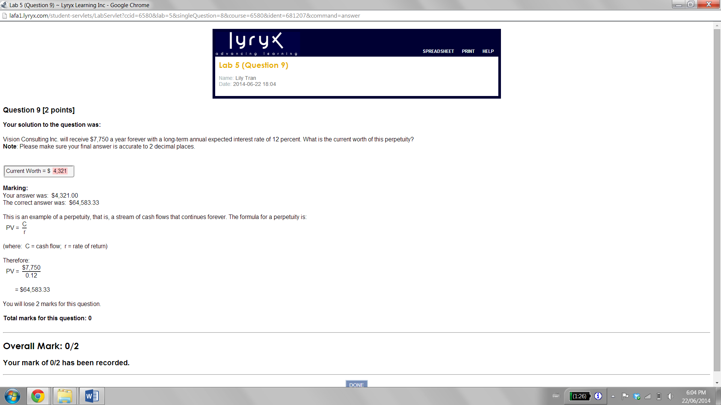
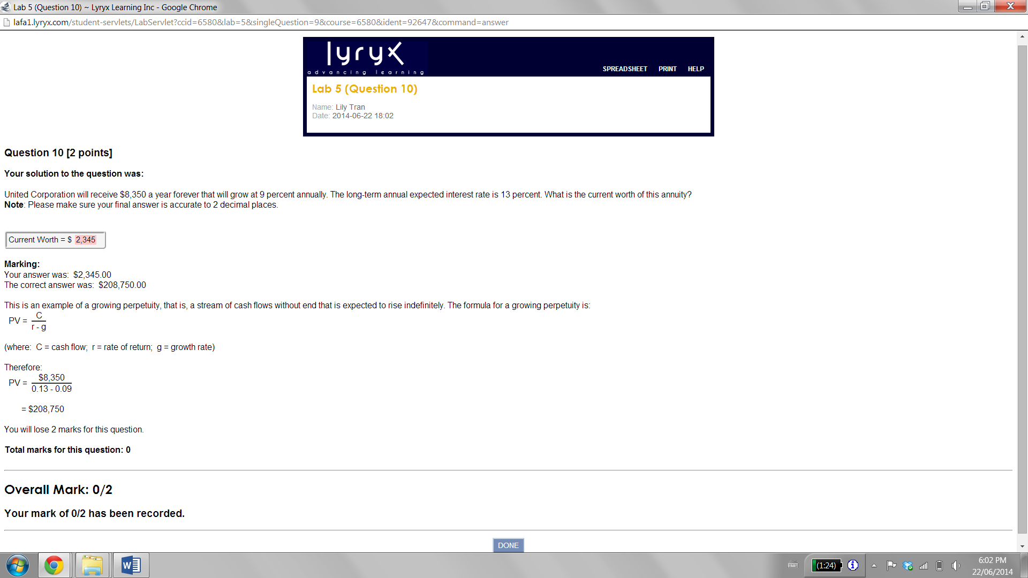ssssssdfadsf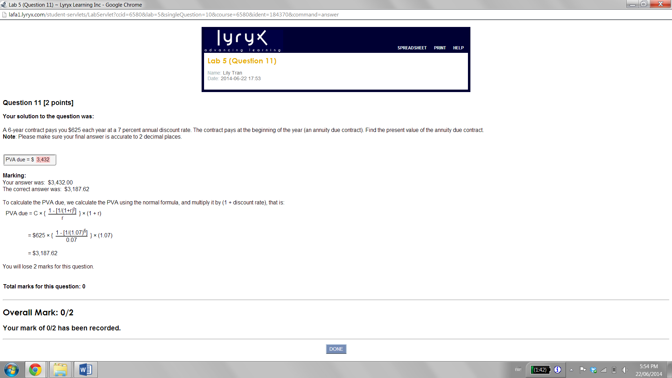

Question 8 [6 points]
Your solution to the question was:
A local finance company quotes a 10 percent interest rate on one-year loans. So, if you borrow $30,000, the interest for the year will be $3,000. As you must repay a total of $33,000 in one year, the finance company requires you to pay $33,000/12, or $2,750, per month over the next 12 months.
Note: Please make sure your final answers are in percentage form and is accurate to 2 decimal places. (For example: 34.56%)
a) This is not really a 10 percent loan. Instead, what is the effective monthly rate?
Effective Monthly Rate =2%
Marking:
Your answer was: 2.00%
The correct answer was: 1.50%
Let's denote r as the effective monthly rate you need to find.
From the $30,000 loan and $2,750 monthly payment over the next 12 months, we have:
PVA = $30,000 = $2,750 ×
  1 - [1/(1+r)¹²]
  r
Solving on a financial calculator, or using a spreadsheet, gives r = 1.5%
You will lose 2 marks for this part.
b) What rate would legally have to be quoted?
APR =5%
Marking:
Your answer was: 5.00%
The correct answer was: 18.00%
The APR is the interest rate charged per period (for our case, months) multiplied by the number of periods per year, therefore:
APR = 12 × 1.5% = 18%
You will lose 2 marks for this part.
c) What is the effective annual rate?
EAR =3%
Marking:
Your answer was: 3.00%
The correct answer was: 19.56%
To find the effective annual rate, we use the formula: (note that APR/12 = Effective monthly rate)
EAR = [1 + APR/12]¹² - 1= 1.015¹² - 1 = 0.1956 = 19.56%
You will lose 2 marks for this part.
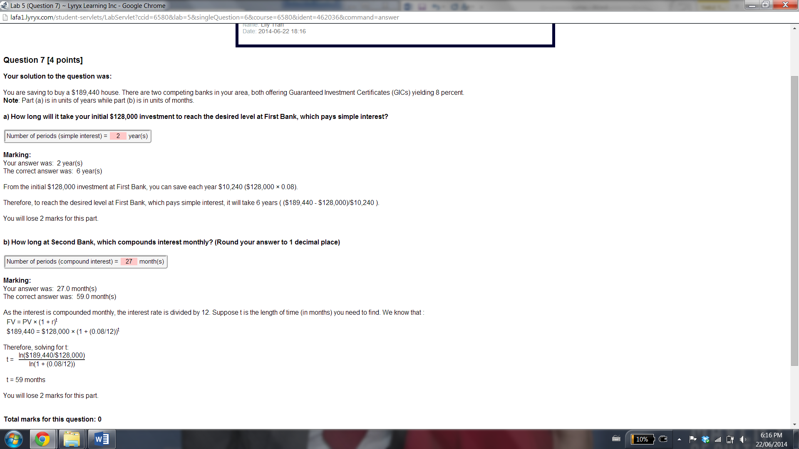
SPREADSHEET
PRINT
HELP

Lab 6 (Question 5)
Name: Lily Tran
Date: 2014-06-29 23:54

Question 5 [2 points]
Your solution to the question was:
Suppose the real rate is 3 percent and the inflation rate is 5 percent. What rate would you expect to see on a Treasury Bill?
Note: Please make sure your final answer is accurate to 2 decimal places and in percentage form. (For example: 34.56%)
Nominal Rate =2%
Marking:
Your answer was: 2.00%
The correct answer was: 8.15%
The Fisher Effect tells us that the relationship between nominal rates (R), real rates (r) and inflation (h) can be written as:
1 + R = (1 + r) × (1 + h)
Therefore, in this case to find the nominal rate:
R | = (1 + r) × (1 + h) - 1
 | = (1.03) × (1.05) - 1
 | = 0.0815
 | = 8.15%
You will lose 2 marks for this question.
Total marks for this question: 0

Overall Mark: 0/2

Your mark of 0/2 has been recorded.

Top of Form
Bottom of Form
s

