Final
April 21, 2014
9:20 PM

Week 1: Introduction
Key topics:
- What is geomatics?
- The power of maps
Geomatics - What is it?
- Consists of products, services and tools involved in collection, integration and management of geographic data
- Geographic information can be retrieved from various sources, including earth-orbiting satellites, ground based instruments and airborne and seaborne
- An academic and professional field that involves:
  - Collection and analysis of spatial information
  - Discovery of geographic patterns and processes
  - Communication of geographic knowledge, often as part of a broader effort to resolve environmental and social problems
  - Ongoing development of new technologies, methods and other innovations
The power of maps
- European colonization
  - Allowed for early explorers to navigate
  - Allowed for a visual representation of colonization
- War
  - Can provide information on enemy armies and the conflict area
  - Allowed pilots to learn routes and the area
- Flooding
  - Can map flooding and help to defend against it
- Humanitarian aid
  - Maps can help aid workers respond
    - Provides information of the area and the people
- Disasters
  - Before and after shots
- Emergency response and network analysis
  - Can help emergency services find the fastest way to and from a location
  - Can allow for alterations to traffic flow to alleviate congestion
- Business and marketing
  - Businesses and marketing can analyze customer behaviour, census data, city maps and other information to improve better suit customers as well as their own business
What is geospatial revolution?
- Geospatial technologies are becoming more powerful
- Geospatial technologies are affecting people's lives in more ways
- More people, organizations and agencies are using geospatial tools
- Geospatial Revolution (part 1) video
  - http://geospatialrevolution.psu.edu/episode1/complete

Week 2: Thinking spatially
Key topics:
- Spatial thinking
- Spatial relationships and spatial analysis
- Key concepts – location, distance, spatial patterns,
- movement and connectivity, scale
- Spatial data
- Basic spatial statistics

Thinking spatially
- Humans have an innate ability to think spatially and make mental maps
  - Mental maps
    - 2 categories
      - Uses landmarks of various sorts (spatial)
      - Use of cues (stimulus)
    - Affected by perception and interaction with the world around us
Spatial analysis: Cholera outbreak in London, 1853-1854
- John Snow was able to map the disease outbreak and the location of public water pumps
  - His map showed the cholera deaths were based around a water pump
Spatial relationships
- What geographic features are connected?
  - e.g. bike paths
- What geographic features are adjacent or contiguous to each other?
  - e.g. a landfill and a lake
- What is contained within an area?
  - e.g. high rises within a particular neighbourhood
- What geographic features overlap?
  - e.g. a city and a geological fault line
- What features are near others (in close proximity)?
  - e.g. an offshore oil drilling platform and a fishing zone
- What is the difference in elevation of geographic features
  - e.g. along a hiking trail
- What features are along another feature?
  - e.g. a restaurant along a highway
Location
- Communicating location
  - Nominal (e.g. "Confederation Park")
Absolute (e.g. "45⁰ 40' 15'' North 75⁰ 51' 28'' West")
Relative (e.g. "halfway between Regina and Saskatoon")
Distance
- Why is distance important?
  - First law of geography: “Everything is related to
everything else, but near things are more related than
distant things.”
- Even in an increasingly globalized economy, distance matters (e.g. for goods that are heavy or perishable)
- Measuring distance
  - Absolute, straight line distance (e.g. kilometers)
  - Distance along a path or route
  - Time
  - Timemaps (e.g. measuring the distance between Ottawa to Montreal)
  - Cost
  - Greenhouse gas emissions
- Scales of analysis
  - Local
  - Regional
  - National
  - International
  - Global
- Map scale
  - Ratio of the distance on the map to the distance on the earth
    - e.g. at a 1:50,000 scale, anything measured on the map is equal to 50,000 in real life
- Map generalization
  - A reduction in level of detail on a map covering a larger area
- Spatial data
  - Along with qualitative and quantitative data, there is also spatial data
    - Unique geographic coordinates or other spatial identifiers that allow the data to be located in geographic space
  - Types of spatial data
    - Discrete
      - Discontinuous, have definite boundaries
      - Types
        - Points
          - e.g. mailboxes, trees, lamp posts
        - Lines
          - e.g. roads, rivers, power lines
        - Areas
          - More detail than points
          - e.g. field, building, lake
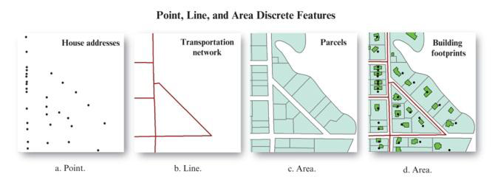
- Continuous
  - Transition is gradual, not abrupt
    - e.g. elevation, temperature
Spatial distribution
Point patterns
- Random
  - Influence of boundaries
    - Random can be a cluster based on boundaries

- Clustered
- Regular
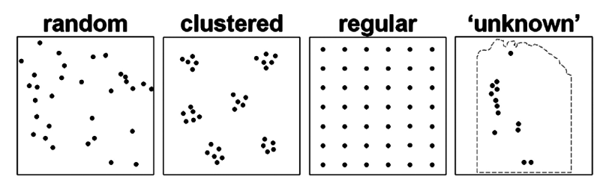
Accuracy and precision
- Not the same thing
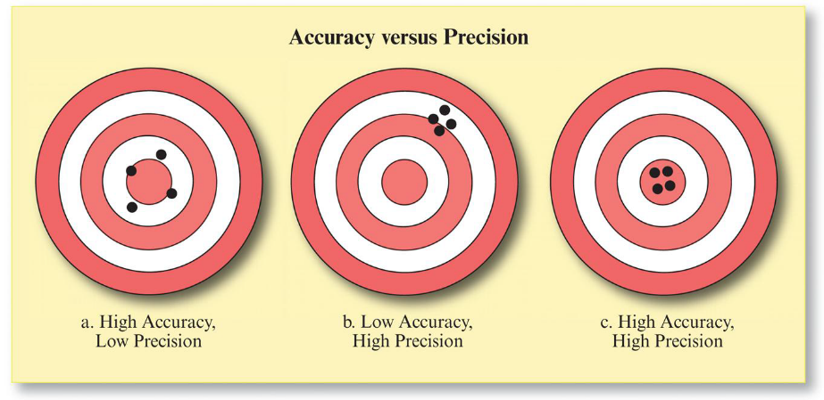
Mean centre
- A measure of central tendency that can determine the center of a distribution
- Standard distance
  - Measures how dispersed a distribution is around a mean centre, 2/3rds of the points will be located within a standard distance

Week 3: Georeferencing
Key topics:
- Global Positioning System (GPS)
  - Components and how it works, including differential GPS
- Earth Models
  - Datums
  - Ellipsoid vs Geoid
- Coordinate Systems
  - Global or Spherical
  - Rhumb lines vs great circles
  - Calculation of distance along a parallel
  - Projected: UTM
  - DD to DMS conversions
  - Universal Transverse Mercator

Global Positioning System (GPS)
- How it works
  - Basis of GPS is triangulation (trilateration since angles are involved)
    - Trilateration - determining position based on geometry of triangles
  - Signal from satellite directly overhead is ~0.06 s
  - Even with VERY precise clocks, timing errors are a BIG problem
- Components
  - Space segment (satellites)
  - Control segment (global network of ground facilities that track and monitor GPS satellites and help key functions)
  - User segment (GPS receiver)
- Differential GPS (DGPS)
  - Two receivers can be used to increase position accuracy
  - One receiver is the base receiver, logging timing and position information constantly
  - Base receiver information is used to correct moving GPS
Earth models
- Datums
  - Set of physical reference points on earth's surface that are used to make position measurements against
  - 2 main North American Datums
    - Horizontal Control Datum (NAD83)
    - Vertical Control Datum (NAVD88)
- Ellipsoid and geoids
  - Earth is not a perfect sphere
    - Earth is an oblate ellipsoid (spheroid)
    - The geoid is the surface of the earth's gravity field, approx. mean sea level
      - Runs perpendicular to the direction of gravity pull
      - The mass of the earth is not uniform at all points, meaning that the magnitude of gravity varies, making the shape of the geoid irregular
Coordinate systems
- Global or spherical coordinate systems
  - Latitude φ
    - Angular distance between plane of equator and a line passing through the point being investigated and the center of the earth
  - Longitude λ
    - Angular distance between the Prime Meridian (0°) and meridian of point being investigated
    - Distance between 1 degree of latitude is always 111 km.
      - 1° of longitude = 111 km x cos (latitude)
      - e.g. What is the distance of 1° of longitude along the 60th parallel?
        - distance = 111 x cos(60) = 111 x 0.5 = 55.5 km
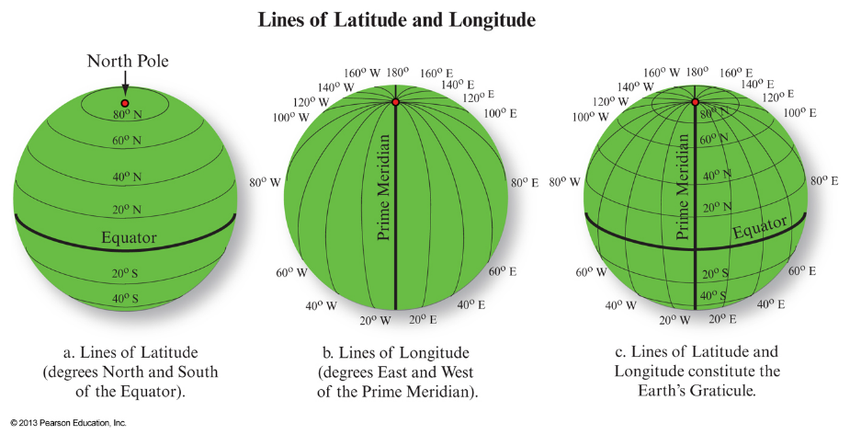

- Decimal Degrees to Degrees-Minutes-Seconds conversion
  - e.g
45.38205° N
0.38205 degrees x 60 minutes/degree = 22.92300
0.923 degrees x 60 seconds/minutes = 55.38"
45°22'55.38"N
- DMS to DD conversion
  - e.g.
45°23'2.47"N
2.47 / 60 seconds/minutes = 0.04117
23 + 0.04117 = 23.04117 / 60 minutes/degree = 0.38402
45.38402°N
- Projected coordinate systems
  - Map projection - a systematic transformation of the 3-dimensional earth into a 2-dimensional flat map
  - A projected flat map or parts of a map can have some, but never all of the following characteristics:
    - True angles/shapes
      - Prioritizes angles at the expense of angles
    - True areas
      - Prioritizes area (at expense of angles)
    - True directions
      - Prioritizes directions around a single point
    - True distances
      - Prioritizes distance around a single point
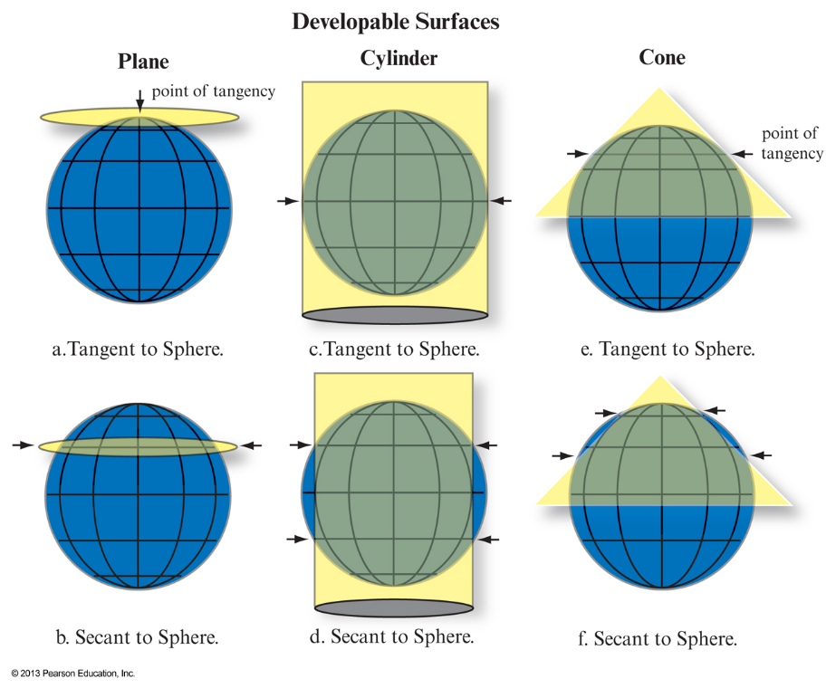

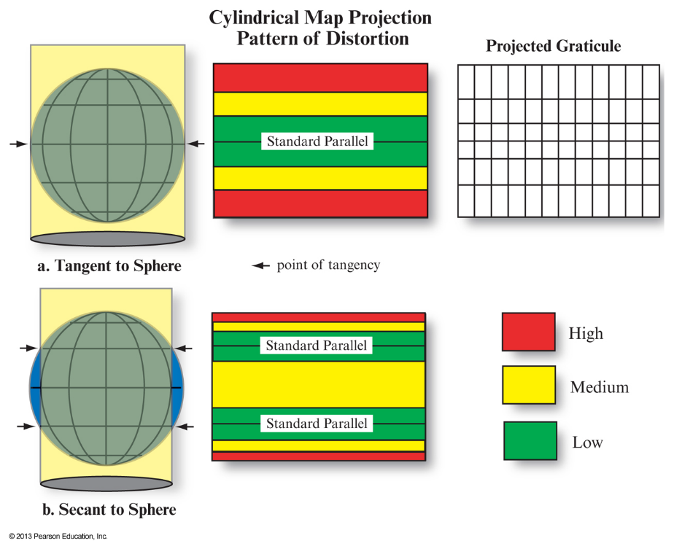

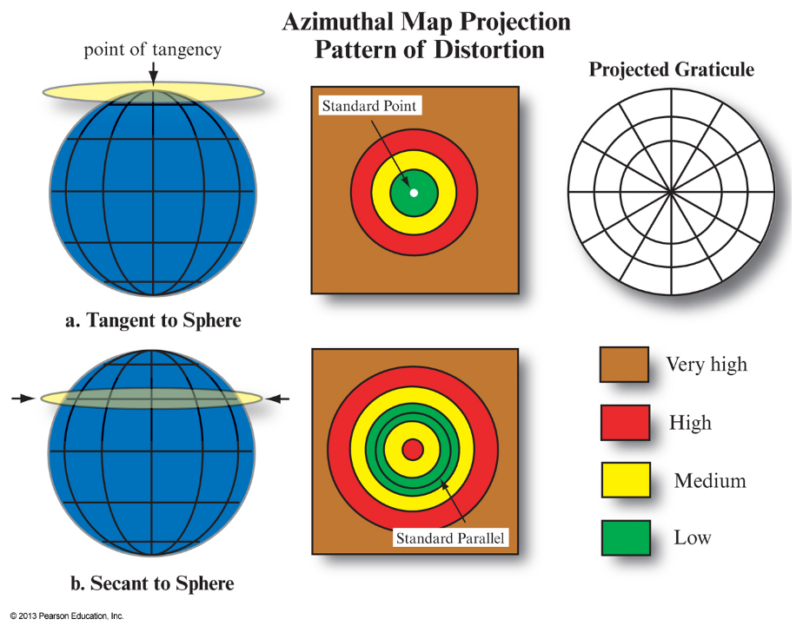

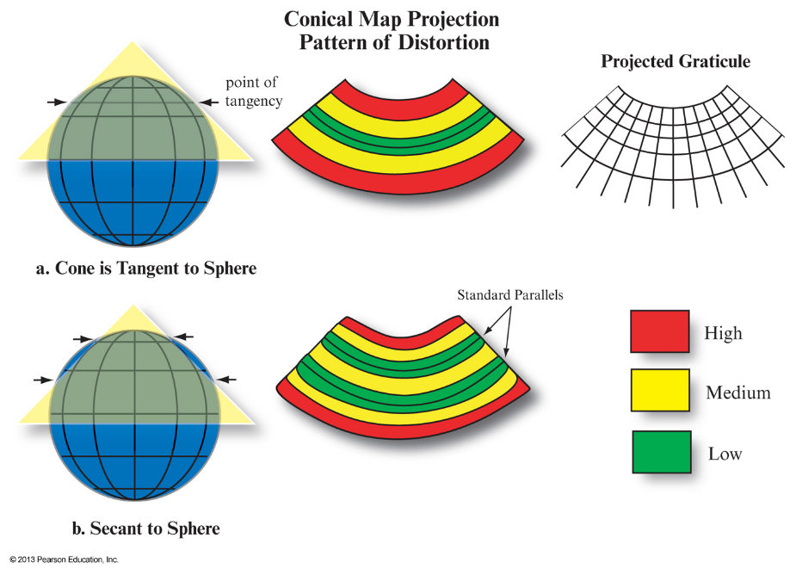
- Universal Transverse Mercator (UTM)
  - Advantages
    - High accuracy conformal projection for large scale applications
    - Coordinates easy to work with
    - Truly universal
      - Works anywhere in world except poles
  - Disadvantages
    - Hard to work with in areas that straddle multiple UTM zones
    - Not suitable for high latitudes

Week 4: An introduction to cartography
Key topics:
- What is a map?
- What are maps used for?
- A very brief history of cartography
- Types of maps
What are maps and what are they used for?
- A thematic representation of spatial or geographic info, usually on a plane surface of a region of the earth or heavens
- Maps can present enormous amounts of information very effectively, and can be used to establish theories and solve problems
- Maps are not objective, scientific representations of reality
  - Socially and historically subject to change, and have political dimensions
- What are maps used for?
  - Communication and understanding
    - Raising public awareness
  - Finding patterns
  - Deriving new information through analysis
    - Environmental conservation
  - To get status reports
  - To compile geographic information
  - Communicate ideas, concepts, plans and designs
    - Uneven development
  - Exert control over spaces, places and people
    - Lie with maps
A brief history of cartography
- 15th and 16th century cartography made major advantages through exploration
  - Provided much more accurate maps with coastlines, islands, rivers and harbours
    - Maps were highly valued for economic, military and diplomatic purposes, often treated as national or commercial secrets
Types of maps
- Topographic
  - Represent the earth's features accurately and to scale on a 2 dimensional surface
- Thematic
  - Represents a theme in a specific geographic area
Cartographic design: how to make a good map
- Smaller than the real world it represents
- Must depict curved surface of earth on a flat plane
- Must contain symbols to convey the info so the reader can interpret the map

Week 6: Geographic Information Systems
Key topics:
- Definitions of GIS and common misconceptions
- How is spatial data represented/stored in a GIS?
- How is attributed data represented/stored in a GIS?

- Map projections
  - “A map projection is a systematic transformation of the 3-dimensional Earth into a 2-dimensional flat map.”
  - Tangent
  - Secant
  - Properties
    - Can have some properties, but not all
      - True angles/shapes - prioritizes angles
      - True areas - prioritize area
      - True directions - prioritizes direction around single point
      - True distance - prioritizes distance around single point
  - UTM
    - Advantages
      - High accuracy conformal projection for large-scale applications
      - Coordinates easy to work with
      - Truly universal - works everywhere except poles
    - Disadvantages
      - Hard to work with in areas that straddle multiple UTM zones
- Roger Tomlinson and The "Canadian Geographic Information System"
  - Canadian geographer
  - Coined "Geographic Information Systems" in ~1961
  - Father of modern GIS
- Geographic Information System (GIS)
  - "information system used to manipulate, summarize, query, edit and visualize spatial and non-spatial information stored in a computer database”
  - “An automated system for the capture, storage, retrieval, analysis and display of spatial data”
  - Common misconceptions about GIS
    - GIS is only cartographic software/form of "computer mapping"
    - GIS is a type of graphic design or CAD software
    - GIS is only software
  - Trends
    - Faster paced hardware and software tech development (Moore's Law)
    - Improvements in computer networking and sharing of spatial data via internet
    - Increase in open source GIS software
    - GIS data and algorithms work together
  - Moore's Law
    - # of transistors on circuits double ~ every 2 years
  - Components of a GIS
    - Hardware
      - CPU - controls operations (more = faster)
      - Arithmetic Co-processer - increases calculation speed
      - Memory - performs system operations (>6GB, >1TB VRAM)
      - Mass Storage - >1TB
      - Display - goal is to view as much geographic space as possible at highest resolution
      - Peripheral input and output devices (HQ printers, plotters, possible requirement to digitize physical maps
      - Networking - enables sharing spatial data, GIS processing and distribution
    - Software
      - OS - widely adopted, reputable OS
      - Database Management System (DBMS) - stores and accesses attribute data
      - Functions - GIS software must be able to perform geospatial tasks
      - Network - data sharing and processing between computers
    - Cloud GIS
      - Distributed computing typically involving remote connected computers
      - Efficient for sharing data, distribution and collection; flexible; increased availability
      - e.g. Amazon's EC2 (Elastic Compute Cloud)
- GIS Data Models
  - Data models
    - Objects represented by a computer system together with their properties and relationships
    - In GIS, defines how real world spatial features are represented within a GIS
    - Manner in which spatial data are represented dictates the way their associated, non-spatial information (attribute data) are represented
  - Spatial Data Representation: raster vs vector
    - Raster data model - stores features in a user defined grid of pixels
      - Header information
        - # rows and columns
        - Geographic or projected coordinates of reference corner
        - Cellsize (same unit as coordinate system
        - No data value
        - Projection info often in other file
    - Vector data model - stores features as points, lines or polygons; more suitable for "discrete" (distinct) geographic phenomena
    - Spatial data describes locations of geographic features
      - Can be discrete or continuous
        - Discrete features - individually distinguishable features that do not exist between observations
        - Continuous features - features that exist spatially between observations
  - Attribute data storage and retrieval
    - Describes properties of spatial data, is stored and accessed differently depending on data model used
    - Raster - attribute stored as grid of values, separate grid for each attribute
    - Vector - attribute data stored as separate data table, each row relates to discrete geographic feature (point, line or polygon), each column represents a property of interest (e.g. "geo-relational data model")

Week 7: Mapping Spatial Patterns
Key topics:
- Cartographic design
- Mapping spatial patterns
  - points, lines, areas and surfaces
  - measurement levels
  - classification and symbolization
  - issues related to boundaries
  - geovisualization

- Cartographic design
  - Review of key points
    - Maps are incomplete, selective representations of geographic areas
    - Maps use symbols to give reader information
    - Good maps depend on good spatial data
    - Maps typically show a curved surface on a flat plane
    - Well-established principles of cartographic design
      - Map composition
      - Title
      - Typography
      - Thematic content
      - Geographic reference material (lat-long)
      - Scale
      - Symbology and map legend
      - Orientation
      - "metadata"

- Mapping spatial patterns
  - Point data
    - Simple dot maps
    - Graduated symbols
  - Lines
    - Basically transportation (roads, rivers, train tracks, etc.)
  - Areas
    - Type of area (desert, water, forest, etc.)
    - Problems
      - Sharp boundaries may not exist on the ground
      - Boundaries can be arbitrary or poor match for what's being mappped
      - Differences in size of units can favour certain areas
  - Surfaces
    - Contour lines and other isolines (line on map connecting points sharing features)
    - Interpolation (discrete set of data)
- Geovisualization
  - Development and use of methods to facilitate visual exploration, analysis and presentation of spatial data
  - e.g. 3D maps, map animations
  - Interactive digital maps and spatial databases

Week 8: GIS Operations and Analysis
Key topics:
- Raster vs Vector analysis with GIS: various types and their definitions and explanations
- Various examples of problem solving with raster and vector GIS analysis

- Basic GIS Querying and Operations
  - Basic querying
    - On-screen querying
    - Spatial querying
    - Attribute querying
  - Buffering (Vector or Raster operation)
  - Creation of polygon that is a specific distance around a point, line or area feature.
  - Vector GIS operations
    - Vector operations
      - Intersect
      - Union
      - Erase
      - Symmetrical difference
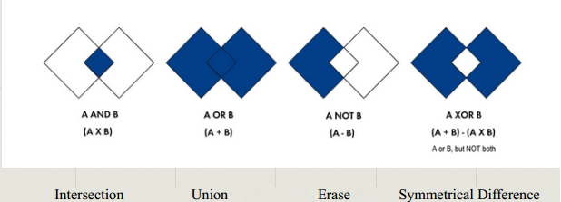
- Raster GIS operations
  - Local operations - those that work on single cell locations (basically adding 2 data points together)
  - Focal operations - those that work on cell locations within a neighbourhood (focuses on centre pixel; majority)
  - Zonal operations - those that work on cell locations within zones (takes multiple data, one has grouped zones)
  - Digital Elevation Models (DEMs) (3D representation)
    - Slope
      - Calculates maximum rate of change in value from cell to neighbours
      - Max change in elevation over distance between cell and 8 neighbours identify steepest downhill decent from the cell
      - Lower the slope value, flatter the terrain, vice versa
      - Degree of slope = Ø
      - Percent of slope = rise/run * 100
    - Aspect
      - Identifies downslope direction of the max rate of change in value from each cell to neighbours, using a DEM
      - Value of each cell in output raster indicate compass direction that the surface faces at that location
      - Measured clockwise in degrees from 0 (due north) to 360 (due north again); flat areas with no downward direction are given a value of -1
    - Aspect-Slope map
      - Simultaneously shows aspect (direction) and degree (steepness) of slope for terrain
      - Aspect categories symbolized using hues (red, orange, yellow, etc.); degree of slope classes are mapped with saturation (brilliance of colour); steeper slopes are brighter
    - Topographic Wetness Index (TWI)
      - Common index of hydrologic similarity
      - Combines terrain slope raster with hydrologic contributing area raster to indicate relative wetness in landscape
      - Slope = neighbourhood operation, neighbourhood-type hydrologic operation, combined using local operator
      - TWI = ln(contributing area / slope)
Flowcharting GIS analysis workflows
- Complex GIS analysis workflows need to be planned beforehand
- Flowcharts commonly used - distinct symbology and colours to differentiate inputs, operations and output
- Takes care of documentation, reuse and sharing of workflows
- Problem solving and decision support analysis with GIS
  - e.g. real estate development analysis
  - Retail business analysis/marketing
  - Ecological corridor analysis
  - Flood mapping
Week 10: Remote Sensing: "making visible the invisible"
Key topics:
- How does remote sensing “make visible the invisible”?
- False vs true colour composite images
- Concept of spectral signatures
- Image classification: supervised vs unsupervised

What is remote sensing (RS)?
- Definition
  - Science of acquiring and applying information about earth's surface by measuring and analyzing emitted energy
- Remote sensing measurement
  - Instrument collets information about object within instantaneous FOV without physical contact
  - Instrument normally on satellites (orbital platform) or aircraft (suborbital platform)
  - Instrument measures electromagnetic energy emitted by earth surface
  - Requires illumination source
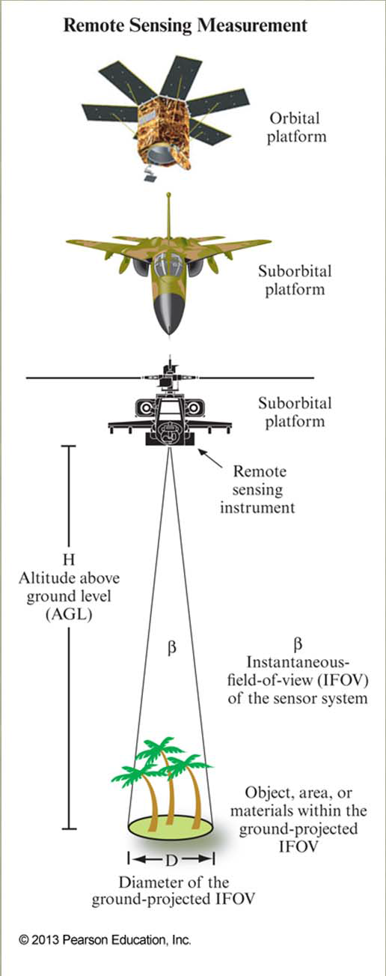
- Electromagnetic (EM) spectrum
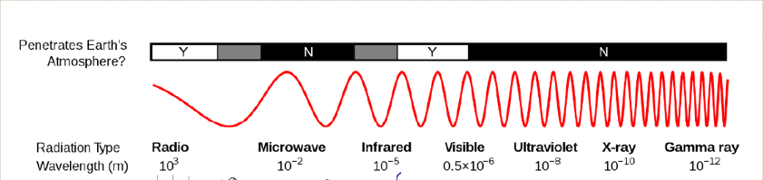

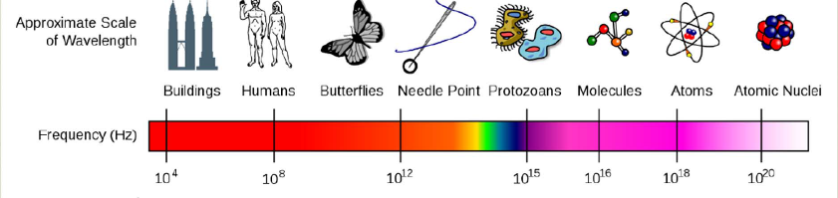
- c = λv
  - Speed of light (c) = 3 x 10^{8 m} s⁻¹
  - Wavelength (λ) = length of one wave cycle
  - Frequency (v) = number of cycles of waves passing through fixed point, per unit time
- Spectral Bands
  - Reflectance
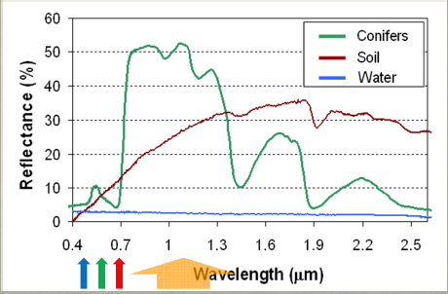
- B, G and R bands have a low reflectance %, Near Infrared has highest reflectance
- Dark colours = low reflectance
- Light colours = high reflectance
- Visible spectrum = ~390 - 700 nm (430 - 790 THz)
  - Nm = 10⁻⁹ m
  - THz = 10¹² Hz
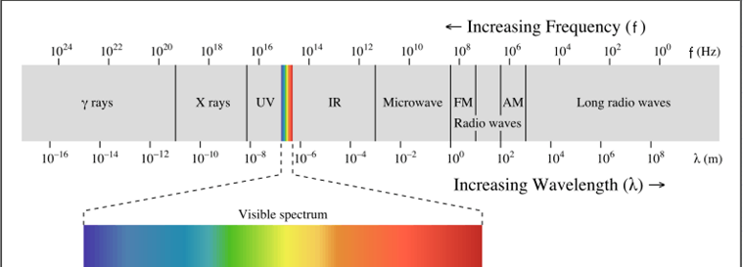

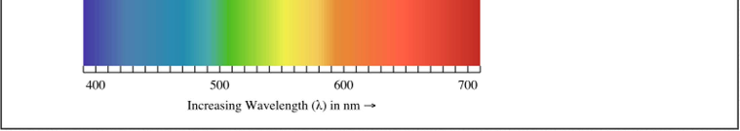

Visualizing remote sensing data
- Single channel records reflectance of one portion of EM spectrum
- Single channel contains many spatial data points in grid
- Multiple channels can be stacked to determine spectral signature at a X, Y location
- Spectral signatures - combination of EM data at different wave lengths to identify an object
- Any colour can be created by combining primary colours
  - Colours used for GIS are Red, Green and Blue (RGB)
  - Setting spectral bands to RGB colours can simulate natural colour (colour-composite)
    - Can be used to show color-infrared color composite
- Band Wavelengths (λ) (nm)
  - Blue (450 - 515 nm)
  - Green (525 - 605 nm)
  - Red (640 - 690 nm)
  - NIR (750 - 900 nm)
Remote sensing resolution
- 4 types
  - Spectral resolution
    - How finely you can divide the spectrum (measured by # of bands)
    - More divisions = higher spectral resolution
    - Higher spectral resolution increases ability to identify different land surface features
  - Spatial resolution
    - How finely you can resolve a point on the ground (measured in m)
    - Smaller spatial resolution results in better quality
    - Function of instantaneous FOV and altitude
  - Temporal resolution
    - Measured in time
    - How often a satellite can image a point on the ground
      - Depends on orbit
      - Can be reduced by changing the look angle of the sensor mechanically
  - Radiometric resolution (A.K.A. bit-depth)
    - How accurate you can measure/record the spectrum
    - Amount of precision that a sensor records electromagnetic radiation
    - Higher radiometric resolution means higher probability that object will be sensed more accurately
Image classification
- Why classify?
  - Characterize a landscape (classes)
    - i.e. forest, agriculture, water, buildings, etc.
  - To identify important features
- Classification scheme = structure of classes
  - Depends on user needs
  - Uses spectral (radiometric) differences to distinguish objects
- Types of classification:
  - Supervised classification
    - Requires analyst to select training areas of known feature types and digitize polygons within the area
      - Training areas characterize spectral properties of class
Computer creates mean spectral signatures using training areas
- Assign other pixels to classes by matching spectral properties of training sets (mean spectral signatures)
- Results in classified image
- Unsupervised classification
  - Spectral data imposes constraints on interpretation
  - No classes defined beforehand, uses statistical approach to divide data into clusters with best separation
  - After separation into pixels, you are left with distribution of pixels in clusters
  - Names assigned to clusters afterwards
    - Assignment of names requires some knowledge of the landscape and other data is useful (aerial photos, personal knowledge, etc.
  - Pros
    - Takes maximum advantage of spectral variability in an image
  - Cons
    - After separation, clusters may not match important classes on landscape
Some different types of remote sensing systems
- Multispectral
  - Landsat
    - Records earth
  - Landsat has a thermal channel
  - Discrete data
- Hyperspectral
  - Tens to hundreds of spectral bands
    - More narrow bands than multispectral
  - Continuous data
- Thermal
  - (3-14 um thermal-infrared energy)
- LiDAR (light detection and ranging)
  - Uses near infrared laser
  - Active remote sensing
    - Illumination source provided by instrument
    - Most multispectral instruments are passive (illumination from sun)
  - Dataset is very large (millions of points), must be split into tiles (grid) for computer processing
  - Exported in XYZ format
  - Gridded as "Digital Elevation Model"
  - Most LiDAR systems can record more than 1 return per pulse, allows for detecting portions of the pulse that were reflected from canopy and ground
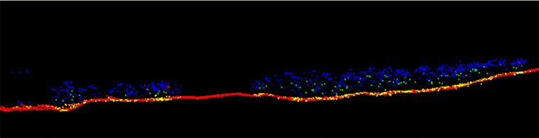
- RADAR (radio detection and ranging)
  - Active remote sensing

Conclusions
- There are many different types of remote sensing instruments, working in different parts of the EM spectrum and operating off of different types of platforms; you should be able to explain and provide examples of remote sensing platforms and understand what portion of the EM spectrum they operate within
- With respect to remote sensing imagery, there are four different types of resolution to know about – can you define and explain them?
Image classification is a typical way in which multispectral imagery is turned into useful information by exploiting the fact that different landsurface features have different spectral signatures; supervised and unsupervised classification are two general approaches to image classification
- LiDAR and RADAR are two forms of active remote sensing, which differs from more common passive forms that use the sun as the illumination source
- With reference to multispectral remote sensing imagery, could you explain in general terms how remote sensing “makes visible the invisible”

Week 11: The social, cultural and political dimensions of mapping
Key Topics:
- The power of maps
- The politics of placenames
- Counter mapping/participatory mapping
- Local geographic knowledge
- Geospatial technologies and privacy

Key Idea:
- Maps are not representations of reality?
  - All maps are selective representations of geographic spaces
  - Can have significant, often subtle political dimensions
  - Content (places, boundaries, toponyms [place name])
  - Use of symbology
  - Choice of projection
Power of maps
- Colonialism
  - Europeans made maps of new lands with boundaries claimed by different nations
  - Names given by indigenous people ignored, as well as claim of ownership
  - European words and meanings written onto map
  - European maps influenced nature of space they represented
- Colonial space in British Columbia, 19th century
  - BC couldn't have been reorganized into colonial space without some sort of map
  - Maps allowed new people to identify their location and travel
  - Used European terms to help conceptualize unfamiliar spaces
- Lie with maps
  - Can influence ones opinion by providing incorrect information
Politics of placenames
- Changes in country names after independence
- First Nation placenames in BC
  - 34 names accepted in treaty in 2000
Counter mapping
- Aimed at resisting dominant official cartographies
- Originated in Nunavut, now almost world-wide practice
  - Methods, objectives and actors vary
- Current prevalence encouraged by new technologies, awareness of indigenous rights, sympathetic NGOs and university researchers
Participatory mapping (and participatory GIS)
- Includes local people in mapping process
- Represents effort to "translate" local geographic knowledge into standard formats
- Aimed at creating maps that are a better reflection of local priorities and POV
Local geographic knowledge
- Key elements:
  - How locations, distance or routes are understood and communicated by local people (e.g. traditional wayfinding, navigation)
  - Local ways of understanding spatial organization
  - Knowledge of spatial patterns of human and environmental phenomena
  - How landscape (or seascape) is conceptualized
  - Marks (using landscape as reference)
  - Can help fill gaps and errors in existing information
- Citizen cartography
  - Online mapping applications have created enormous opportunities for amateur cartographers to participate by making their own maps and sharing data
  - Concern from professional geographers about quality
Geospatial technologies and privacy, and other concerns
- Access to geospatial technologies and spatial data
  - Digital Access Index
    - Measures the ability of people in a country to access computers and the internet, along with other information and communication technologies
      - Most prevalent in first world countries, specifically those with better technology
- Geomatics and privacy
  - 2 BC elevator companies use GPS to track mechanics
    - Employees consider it an illegal intrusion into personal privacy
    - Government says it's reasonable to use such technology to manage staff and ensure workers are where they say they are
  - Car manufacturers and insurance companies tracking drivers
    - Sensors in car allow insurance companies to monitor driving (acceleration, speed, braking) in real time
    - Company analyzes data, if driver is "good" it results in a lower rate
  - Canada considering putting GPS bracelets on more migrants
    - Canadian government is investigating whether or not to expand use of satellites to monitor asylum seekers or potential immigrants who would otherwise be detained
    - Upgrading equipment required to do so
    - Same technology used to track criminals through electronic bracelets
  - Phone company watching you
    - German man obtained information his cell phone company kept on him
      - Over 6 months, the company tracked him more than 35,000 times
    - Mobile location data presents anonymity risk
      - Researchers examined 15 months of anonymous cell phone records for 1.5 million people
        - 4 locations and times were enough to identify anyone
  - RCMP use of UAVs
    - Civil liberties advocates say that the RCMP has begun to patrol the skies without consulting the public
- Geospatial Revolution (part 3) video
  - Mapping has always been driven by war to an extent
    - Mapping and separation of ethnic areas
      - Intended to prevent conflicts
    - Geospatial intelligence for conflict areas
      - Technology provides improved area awareness for combat
        - Knowledge of landscape and buildings
        - Can help detection of IEDs
        - Can help save lives
      - Human geography can help with physical geography
        - Learning what languages are spoken where
        - Learning what is valuable to locals
  - Serving and protecting
    - Geospatial technology in 911 calls
      - Communicating with dispatchers can offer them more information on the situation
      - Police can be managed by inputting location and dispatching them accordingly
      - Information on people and areas can help assist in assessing a situation
    - Hotspot mapping
      - Crimes are mapped, the map shows hotspots for crimes
    - Tracking
      - Sex offenders are monitored
        - If they go somewhere they shouldn't be, police can know about any potential situation before it happens
      - GPS trackers help law enforcement
        - Other people can also track you
          - Can be used to hurt victims
        - Cell phone providers can provide police with location data

