ch1

True/False
Indicate whether the statement is true or false.

____ 1. One of the four functional areas of operation is Human Resources (HR).

____ 2. Historically, businesses have had organizational structures that separated the functional areas, but business schools have not been organized like that.

____ 3. Information systems that are designed so functional areas share data are called integrated information systems.

____ 4. The functional area of Supply Chain Management (SCM) sets prices.

____ 5. Sales forecasts are historical records of sales.

____ 6. Accounts receivable are recorded by the Human Resources department (HR).

____ 7. The business function of government compliance falls under the Supply Chain Management functional area of operation.

____ 8. The business process of Cash Flow Management is handled under the Accounting and Finance functional area of operation.

____ 9. When manufacturing runs out of raw materials, it’s known as a stockout.

____ 10. To avoid stockouts, manufacturers might carry extra raw materials. This excess is known as safety stock.

Multiple Choice
Identify the choice that best completes the statement or answers the question.

____ 11. Which of the following is a functional area of operation?
a. | Packaging | c. | Shipping
b. | Supply Chain Management | d. | Baking

____ 12. Which business function is performed by Accounting and Finance?
a. | Cost allocation and control | c. | Benefits
b. | Taking sales orders | d. | Plant maintenance

____ 13. What are the computers, people, procedures, and software that store, organize, and deliver information in an organization?
a. | The CPU | c. | Information systems
b. | The Process System | d. | Personnel systems

____ 14. Today’s managers are beginning to think in terms of business process. A business process cuts across which functional areas of operation?
a. | Marketing and Sales | d. | Human Resources
b. | Supply Chain Management | e. | All of the above
c. | Accounting and Finance

____ 15. Information systems that can be designed so that functional areas of operation share data are called:
a. | Integrated information systems | c. | Non-middleware information systems
b. | Complete information systems | d. | Linked information systems

____ 16. Analyses that attempt to predict the future sales of a product are called:
a. | Sales forecasts | c. | Sales diving
b. | Sales divining | d. | Sales deriving

____ 17. Which of the following is an input to the Marketing and Sales functional area?
a. | Production plans | c. | Per-unit cost
b. | Raw material orders | d. | Accounts payable data

____ 18. Which of the following outputs would emerge from the Accounting and Finance functional area?
a. | Packaging orders | c. | Regulation compliance
b. | Sales strategy | d. | Financial reports

____ 19. When purchasing a computer, the functional area responsible for handling the financial help for purchasing that computer is
a. | Marketing and Sales | c. | Supply Chain Management
b. | Accounting and Finance | d. | Human Resources

____ 20. When purchasing a computer, the functional area responsible for technical support is
a. | Marketing and Sales | c. | Supply Chain Management
b. | Accounting and Finance | d. | Human Resources

____ 21. When manufacturing runs out of raw material, it’s known as a(n)
a. | Shortfall | c. | Depletion
b. | Empty shelf | d. | Stockout

____ 22. ____ results in management overinvesting in extra raw materials
a. | Bulging raw materials | c. | Safety stock
b. | Stockup | d. | Excess baggage

____ 23. Which of the following is an input to HR?
a. | Personnel forecasts | c. | Layoff and recall company policy
b. | Sales data | d. | Travel expense company policy

Completion
Complete each statement.

24. ____________________ programs are core software used by companies to coordinate information in every area of the business.

25. A collection of activities that takes one or more kinds of input and creates an output that is of value to the customer is called a ____________________.

26. The business functions of financial accounting, cost allocation and control, planning and budgeting, and cash-flow management take place in the ____________________ functional area of operation.

27. One example of the business function that happens in the human resource area of operation would be ____________________.

28. An ____________________ includes the computers, people, procedures, and software that store, organize, and deliver information.

29. Information systems designed so that functional areas share data are called ____________________.

30. A shortfall of raw materials is known as a ____________________.

31. To avoid stockouts, manufacturers might carry extra raw materials known as ____________________.

Short Answer

32. Describe the difference between functional areas of operation and business processes. Give an example of a business process.

33. What are integrated information systems?

34. Give some examples of Marketing and Sales in a small business such as a lemonade stand or some other simple example.

35. Choose an example company and give situations for each business process in the following figure. Depending on your major or interest, choose one functional area of operation.
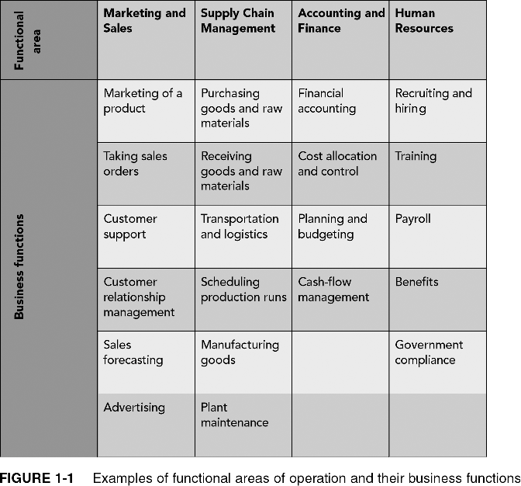

36. What departments are involved in the business process of selling a new computer?

37. Describe the material order process in the following figure:
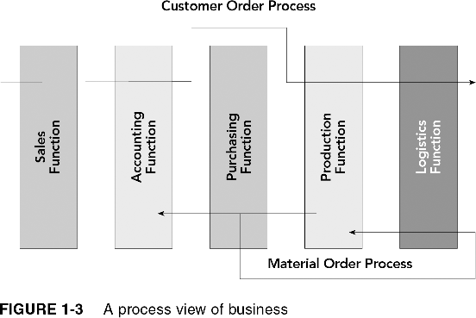
ch1
Answer Section

TRUE/FALSE

1. ANS: T PTS: 1 REF: 2

2. ANS: F PTS: 1 REF: 2

3. ANS: T PTS: 1 REF: 4

4. ANS: F PTS: 1 REF: 8

5. ANS: F PTS: 1 REF: 9

6. ANS: F PTS: 1 REF: 12

7. ANS: F PTS: 1 REF: 2

8. ANS: T PTS: 1 REF: 2

9. ANS: T PTS: 1 REF: 10

10. ANS: T PTS: 1 REF: 10

MULTIPLE CHOICE

11. ANS: B PTS: 1 REF: 2

12. ANS: A PTS: 1 REF: 2

13. ANS: C PTS: 1 REF: 3

14. ANS: E PTS: 1 REF: 3

15. ANS: A PTS: 1 REF: 4

16. ANS: A PTS: 1 REF: 6

17. ANS: C PTS: 1 REF: 9

18. ANS: D PTS: 1 REF: 10

19. ANS: B PTS: 1 REF: 3

20. ANS: A PTS: 1 REF: 3

21. ANS: D PTS: 1 REF: 10

22. ANS: C PTS: 1 REF: 10

23. ANS: A PTS: 1 REF: 13

COMPLETION

24. ANS:
Enterprise Resource Planning
ERP

PTS: 1 REF: 1

25. ANS: business process

PTS: 1 REF: 1

26. ANS:
Accounting and Finance
A/F

PTS: 1 REF: 2

27. ANS:
Recruiting and hiring
Training
Payroll
Benefits
Government compliance

PTS: 1 REF: 2

28. ANS:
Information systems
IS

PTS: 1 REF: 3

29. ANS:
integrated information systems
integrated IS

PTS: 1 REF: 4

30. ANS: Stockout

PTS: 1 REF: 10

31. ANS: Safety stock

PTS: 1 REF: 10

SHORT ANSWER

32. ANS:
Most companies have four main functional areas of operation. Each area comprises a variety of narrower business functions, which are activities specific to that functional area of operation.
Recall that a business process is a collection of activities that takes one or more kinds of input and creates an output that is of value to the customer.
Thinking in terms of business processes helps managers to look at their organization from the customer’s perspective. For example, suppose that a customer wants to purchase a new computer.

PTS: 1 REF: 2-3

33. ANS:
Sharing data effectively and efficiently between and within functional areas leads to more efficient business processes. Information systems can be designed so that functional areas share data. These systems are called integrated information systems.

PTS: 1 REF: 4

34. ANS:
For the most part, this is a cash business and does not require formal record keeping, but you still need to keep track of your customers so that you can send flyers to repeat customers or send occasional thank you notes. Thus, your records must show not only the amount of sales, but also must identify repeat customers.
Product development can be done informally in such a simple business; you gather information about who buys which kind of lemonade and note what customers say about each product. You also analyze historical sales records to spot trends that are not obvious.

PTS: 1 REF: 6

35. ANS:
Depending on the company chosen, and the major, answers will vary. For example, if a student is interested in HR in an engineering firm, they might discuss the process for recruiting and hiring a graduating senior from their university. Then they could describe some training courses the new engineer would take. Payroll and benefits to the new employee should be discussed. Finally, government compliance such as the equal opportunity act could also be mentioned.

PTS: 1 REF: 2

36. ANS:
Refer to the following figure for answers:
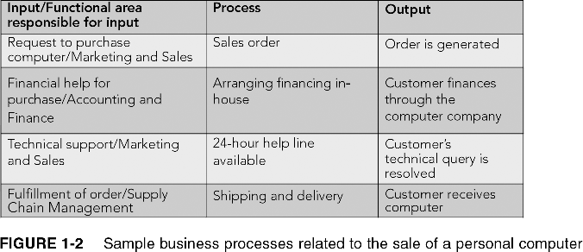

PTS: 1 REF: 3

37. ANS:
When production is alerted to a new order, if raw materials are needed for this order, then production prompts purchasing to arrange for the purchase and delivery of raw materials. Accounting must pay for those raw materials. They are delivered to the Logistics function and then sent to production to make the order.

PTS: 1 REF: 4

